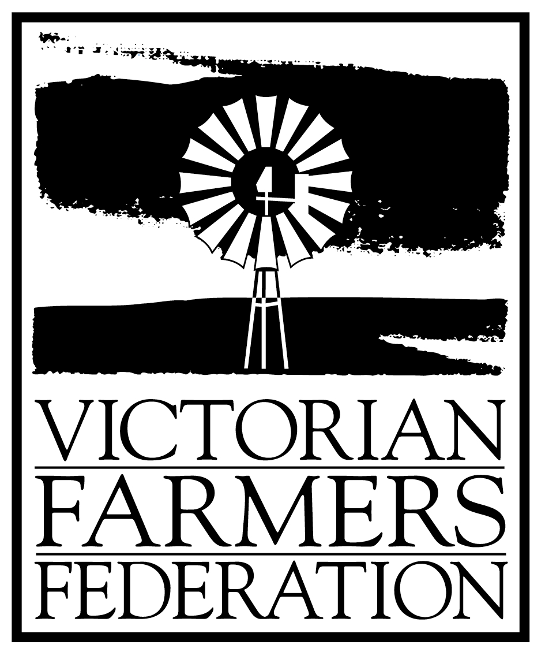

Wangaratta Branch, Secretariat, 34 Taylor St Wangaratta, 3677. Ph-BH (0429)403268 AH 57217890.

The Benalla and Wangaratta branches of the Victorian Farmers Federation would like to take this opportunity to submit the following concerns and issues of it’s membership to the Senate Rural and Regional Affairs and Transport Reference Committee Inquiry.

SUBMISSION SUMMARY

- The area of the North East catchment as defined by the N.E. Catchment Management Authority is a major contributor to flows of the Murray Darling Basin, contributing 38% of all water to this system.
- Goulburn Murray Water currently delivers 95% of its water to areas outside the Alpine Valleys; of this water 95% has being derived from the Alpine Valleys of the North East catchment area.
- The Alpine Valleys and upper catchment regions are more suited to high value crops generated from intensive agriculture. These crops are very water use efficient and income generating, with flow on effects benefiting the community through increased employment and further tourism potentials.
- The irrigation sector of the lower gravity areas has a strong political voice inhibiting justification and development of the upper catchment areas. For example the Government removal of landholder rights to freely harvest rainfall water through the Vic. Farm Dams Bill.
- The current Murray Darling Basin Commission Cap system is being misused by the other States, to the detriment of Victoria. This system needs to be controlled at a Federal level and overseen by a National Ombudsman.
- Water trade needs to be made more flexible, allowing for trading of water back into the upper catchment areas to enhance further development.
- Environmental flow is undefinable and not relevant to review, rather strategies need to be implemented to provide sufficient flows to sustain river health. If reduction of water use is required to achieve this, then reductions must be indiscriminate across all water users, funded by all in the community.
- The members of the VFF strongly encourage any community hearings into the inquiry into Water Resource Usage, be held in the North East region to allow land and stake holders to portray issues of concern and importance to the well being and equality of the review.

Signed Date
Chris Gibson
Secretary Wangaratta branch Victorian Farmers Federation

Signed Date
Alan Ashworth
President Benalla branch Victorian Farmers Federation

