Submission – Inquiry into Rural Water Resource Usage

Introduction
I am writing this submission in response to the advertisement placed in the Public Notices in The Land on Thursday, January 23, 2003.

The First 200 Years
Australia has been populated to a varying degree by a so-called civilised society for approximately the last 200 years. In that time we have managed to degrade the landscape in a manner that we should all be ashamed of. Instead of working with what we have, for some reason we seemed compelled to hang on to the very English adage of draining the swamps, clearing the land and making sure every available acre is sacrificed to agriculture for the common good. The question I pose here is “Good for what?”

Where we stand
We now find ourselves in the position whereby our greed is exceeding our resources.

There are some people (irrigators) who view our river system as nothing more then a delivery system for their water – and bugger everyone else. To be fair, it is not entirely their fault that they think like that. People who really know bugger all about the water system have given out water Licences – nor do they care (if they did the resource would be not in the mess it is now). It has been drummed into their head that water licences are a right that, in truth, is a fable. Water Licences are only good should the water be available. They are not a right to gobble up every last drop to the detriment of other users.

As to the people doling out licences for earth works at the moment – their knowledge of what really happens is very limited. Regulations are not enforced and to be quite truthful – most water regulations are a complete crock anyway. They are made up by people who have nothing to do with the land and even less to do with taking care of it.

Water Mismanagement
Most of our river systems are regulated. That put simply, means that natural flows are not mimicked. Flows are captured for later use by irrigators.

“Big deal” I hear you chorus. Well, I’m here to tell you that it is. What happened to that water before it was regulated? Where did it go? Who used it? Have those users been disadvantaged?

To answer some of those questions – the water actually flowed before it was regulated. It went down the rivers and creeks of this country and some of it actually made it into the ocean as strange as that may seem. The people, vegetation and animals along the river could actually use it and now those users have been severely disadvantaged and the lobby groups for the irrigation industry have whitewashed their concerns. Have a think about the flood plains and the ecosystems that developed within them over thousands of years – why are we so prepared to throw all that away for a quick buck? Where is the sense in that?

Now all water flows seem to go to the irrigation industry. There is no such thing as an unregulated flow on most river systems. They get allocation water, they get high flows, they get every other drop they can possibly extract and bugger everyone else. If they don’t get every last drop they whinge and whine and say how badly off they are until the Water Managers give in.

Now – as to water managers and natural events. Now you’re going to throw in the fact that there are “environmental flows”. I will tell you that those flows are next to useless. They are a static amount (ie a set number of megs), occur at the same time every year and do not mimic any natural event. Because they don’t flow a natural pattern, nor have the inherent ups and downs, these flows do not trigger natural bird breeding events or anything else that is overly beneficial. It is an absolute farce by the Water Managers in an attempt to be seen to be doing something for the environment. I hate to break the news to you but if you actually want a viable wetland – then mimic the natural flows. Don’t just piggyback environmental flows on the spillage of the irrigation water. Wake up to yourselves and find some sense.

Now – if the goal is to so severely degrade a wetland so that is no longer recognisable as at wetland then the current water management practices are going the right way. The goal in that case may be to rid the country of wetlands altogether so that all water goes to the select few!! Selfish pigs!!

The artesian basin
Letting irrigators sink bores into aquifers is ludicrous. What they hell is anyone thinking with that move? There are enough problems now with the artesian basin. Some bright spark comes up with the theory that a fall of 5m per year is sustainable. Hello thinking people. Now, in our arid western parts some people actually rely on their bores – only to have them cutting out in droves because some irrigator in the hills decided he wanted a lovely green patch. Have real, long, hard think about that one. Does “taking from Peter to feed Paul” ring any bells for you?? Hmmm??

Money seems to talk
Now, it seems that if you have the right connections (have a well known radio personality to lunch etc) you can sway a lot of public opinion. Unfortunately the public is a puppet in this debate and most will believe anything you tell them because they know no different. What is really horrendous is that a high profile radio announcer can “do lunch” with someone and then blatantly tell the listening public that he/she knows a lot about a subject. The poor unsuspecting public doesn’t even realise that the high profile radio announcer doesn’t even know which way the rivers run let alone give a damn about the people who his words harm. It’s not what you know but whom you know.

The other method that has been known to sway opinions is a well-timed bush barbecue. Makes everyone so chummy.

The other point I would like to make here is that the irrigation industry – to their credit – has a very vocal and very good publicity and public relations machine. That does not mean that it is right. It is very easy to get a group of people together if they are concentrated in a small area. It also good for photo shoots and everyone patting everyone else on the back. It is very hard to get people together when they stretch over several thousand kilometres (ie right along the Murray Darling system) especially when they are all in different industries and have different work commitments.

The other thing that is hard to gauge is the effect of water on a community. When you have an intensive industry in a small area, it is easy to see if 10 people are employed or out of a job. When you spread the same sort of thing through the community that spans the Murray Darling Basin, you are not going to be able to gauge if there are 2 people missing from one area, and 3 from another etc. The total figure may be twice that of then intensive industry. How many jobs have gone by the wayside because of irrigation? By this I mean how many farms no longer support Dad and a couple of sons or a worker or two because they no longer have the same stocking rate?

Understanding how water and ecosystems work
For some reason, water managers and those who write papers seem to think that there is some magic formula to keep an ecosystem going. There’s always a lot of numbers and dollars and megalitres. However, most educated people actually miss one vital point – and that is the dynamics of Mother Nature herself. Scientists, environmentalists, NP&WS etc all want magic numbers but never bother to stand in a paddock and check things out for themselves. It never occurs to them that most farmers in a wetland area actually know what happens within their own ecosystem. They can tell you where the water runs, how long it sticks around for with any given water level upstream. They can also tell you that when you are dealing with really flat country – any form of earthworks has a very dramatic effect on the flow of water – how long it takes to flow from place to place and how quickly it can drain.

Most people who hold 9 to 5 jobs and get a regular income tend to view farmers as dolts who know very little (this – I might add – gets a lot of people off side). For instance, where I call home is 160 metres above sea level. Walgett – 150 kms to the west, is 150 metres above sea level. That means that the landfall over 150 km’s in that area is 15 metres – or 1 meter ever 10 km’s. Pretty flat stuff. A bank 20cm high will affect people 2 km’s upstream as well as everyone below it. Think about it. Have a look at the following photo:

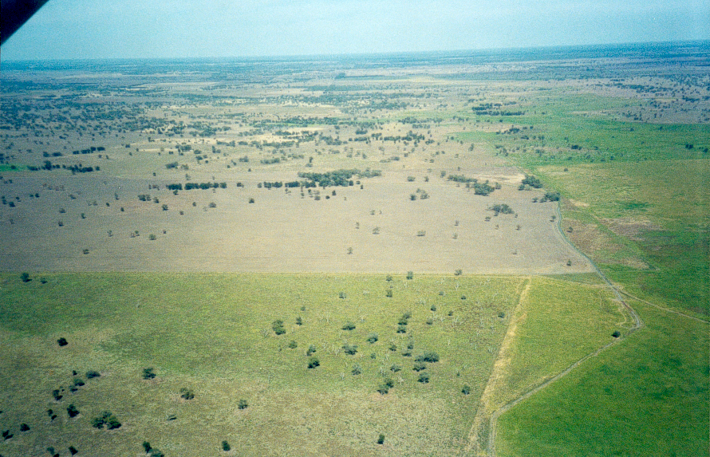
Natural waterway (depression about 10cm)
A “road” about 15cm high
Property Boundary
Cultivation
Main Gingham Watercourse
Country that would have had beneficial flooding except for the “Road”
RAMSAR listed wetland of international importance
Following photo taken about here in 1995
Photo taken in January 2000

How ticked off would you be if you were the landholder with the country downstream from the “road”? Your beneficial flooding has been cut off, your stocking numbers decreased and the productivity of your country severely reduced by a structure 15cm high across the floodplain. What’s more your country is going downhill and there is nothing you can do about it. Your neighbour still get’s his beneficial flooding – that’s in the bottom of this photo. Do you call for compensation? Unfortunately this is also a prime example of how little knowledge the water managers have, and their inability to act. This structure was reported to the DLWC but they didn’t act!!

Another point to note here – a structure 10 metres high 150 kms downstream will also affect this area – as will any structures below surface level. They redirect water to one place – whish takes it away from another (the “take from Peter to give to Paul” bit). Structure below the surface direct water to places it wasn’t heading and also drain country a lot quicker then overland flows. You don’t need to be a brain surgeon to work out why (hey – water flows downhill). And another point, whilst we’re talking of downhill – if home is 160 meters above sea level, that means that in the over 1,500 km’s to the mouth of the Murray, the water falls 160 meters – or about 1 metre every 10 km’s.

Believe it or not, wetlands need natural flows to be mimicked as much as possible to remain viable. That means that if there are high flows – wetlands need them. If there is a dry spell with no storms in the catchments, no water should be going into a wetland. Is that all that hard to understand? How much of a university education do you need to be able to grasp that concept?

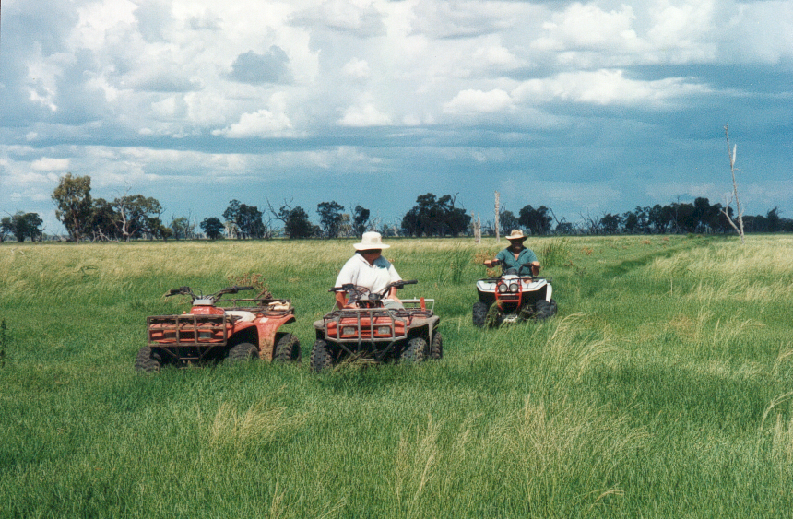
Reasonably healthy wetland - 1995

Ernie Bridges “watering Australia” project
What is this lunatic thinking? Haven’t we stuffed up enough of our waterways already with our greed? Now if this hair-brained scheme goes ahead – who really benefits – those missing out on flows now? I think not. History has shown us that at least. History has also shown us that we have stuffed up just about everything with regard to sensibly managing our country (just think huge tracts of land in Western Australia that should never have been opened up to farming but he government pushed it, just think huge area’s now under irrigation that have salinity problems – who’s going to fix that?). What resources does the northern water support now? How will they suffer if the water is diverted somewhere else? What happens when even that is not enough for the irrigators (and history, once again, has shown that that will happen)? Where does it all stop and sensible, rational thinking begin? The question should not be how do we get more – but how do we use what we have more effectively?

Learning from past mistakes
Have we learnt yet from past mistakes with this land of ours? 30 years of profits does not pay for the 150 years or so it takes to rehabilitate degraded land. It is the poor buggers that come along afterwards that have to clean up the mess too – not the ones who cause it. Do the words salinity, over clearing and land degradation mean anything at all to you?

What happens if we keep going on our current path (further out then the next election)
- Loss of biodiversity
- Increased salinity
- Landuse in decline
- 30 years to stuff it, 150 years to fix it – if we are lucky. Is the short-term profit worth it?
- Loss of something unique – us.

Floodproofing NSW
Why flood proof? Why not wake up to ourselves and realise that if we live on a floodplain, the false bank of a river etc then we are going to get flooded. We have to take responsibility for where we live. You cannot live on the bed of a river and expect not to be flooded – or get all huffy because you do get flooded and that doesn’t suit you. Bugger off to the top of a hill if you don’t want to be flooded.

Also the soils on said flood plains are rich because they get regularly flooded. Why try to stop something that is actually good for the environment just because some people are too stupid to realise that they will get flooded if they live on a floodplain?

Plan for the future
- 50% of all inflows into storage dams must continue on the natural path of the watercourse (ie not be diverted down other streams that have had work done on them to actually make the water flow and not picked up by irrigators). That still eave 50% of flows for other uses.
- All inflows downstream of storages continue on their natural path as per above point. No exceptions. It’s a case of taking the good with the bad and mimicking Mother Nature for a healthier and more sustainable environment. And there’s no point bitching about this point either. Remember that ALL irrigation water has been diverted from the natural environment and users and so they have lost out all along. It is the traditional users that have suffered the most and get hounded every time mention is made of actually getting some water back.
- Cut irrigation licence entitlements by 50% (they are over allocated anyway). Obviously permanent planting will have to remain on 100% entitlements.
- Grant no new water licences be they be for irrigation bores, pumping from rivers etc. Only in circumstances where existing entitlements are ceased can a replacement licence be issued (ie a bore caves in so another is dug to replace that one).
- The capping of bores has been advocated and is happening. Also enclose irrigations channels and use the “Watering Australia” and/or “Farmhand” funds to help fund enclosure of irrigation storages. A lot of water is lost through evaporation in these areas.
- Towns (using watering Australian/farmhand funds also) should recycle as much water as possible. No effluent etc goes back into the rivers and watercourse – all is recycled as used on town ovals etc. Would be better if it was further purified to drinking water standard.
- No structures on floodplains that can divert water – above or below ground. Remember that flood plains can stretch for 10 or 15 km’s across and that any structure on that surface changes the way the flow moves.
- Prioritise flows – 50% to natural waterway maintenance as listed above, next town water and stock and domestic (remember that there is still the other 50% that hasn't been left as natural flow so don’t get too out of your tree here), lastly irrigation. The current order is town, irrigation, stock & domestic (believe it or not even though S & D supposedly has priority over irrigation it will be cut off for irrigation), environmental flows.

Compensation
When talking compensation – think of those who have been dealt the hardest blow by river regulation – and its not the irrigators. If irrigators get compensation for having their water allocations changed – remember that they were not the traditional users of the water anyway and their business has been built on the suffering of others. If you compensation one lot – you must compensation all who have suffered, lost production and had land degradation problems as a result of one industry otherwise one lot are being favoured and they are the ones that have taken form everyone else for a start!!

Conclusion
I severely doubt that anyone will have the guts to even acknowledge this submission (it didn’t have a cheque, the keys to a car or gymnasium or even a dinner invitation attached). What’s more, the contents don’t affect the average pollie in Canberra at all (except for the reuse of town water). I have very little doubt that this will be out in the “too hard” basket because no one has the guts to admit that they are wrong. All piss and wind is the saying that is bandied around.

I also doubt the amount of common sense that will be used when looking at the submissions. Until you have stood and watched and come to understand what happens on a floodplain you will never understand the complexities of water management. It cannot be taught nor can it be reduced to facts and figures – or dollars.

What is needed is someone with enough gumption to actually stand up and say the water managers have it wrong, the politicians have it wrong and the government has it wrong. If no-one has the guts to do this – then in 30 years we will be in one hell of a mess. People need to get their heads out of their backsides, stop worrying about the next election, where they’re getting their next bribe or handout from and actually look at what is happening. They need to be strong people who are not swayed by an efficient lobby group and also people who can stand on a flat plain and pick the 10cm high knoll!! Until then – they have no understanding. Anyone can pick a rise in hilly country.

Water use and allocation in this country has favoured one group for far too long. The people that have been disadvantaged are so severely hounded every time they speak that it is not funny. There is an aura of graft and corruption within the water management regime – and a lot of damage is covered up all too well. It is time for a change.

Tracy Blackburn
27 Crown Street
Dubbo NSW 2830
Ph (02) 6885 5705
Mob (0407) 254 938
Fax (02) 6885 1867

