APPENDIX 5

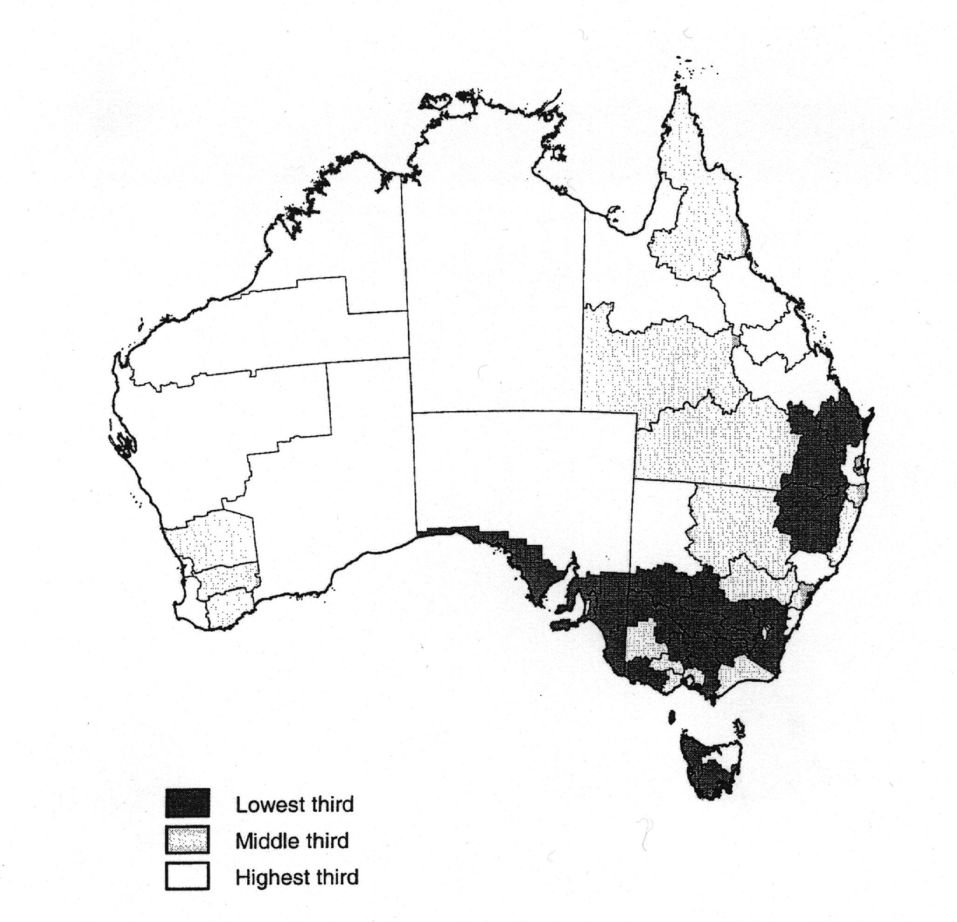Estimated Employment Effects From NCP Reforms Over The Decade to the Mid-1990’s
Key

Source: Productivity Commission, Impact of Competition Policy Reforms on Rural and Regional Australia: Inquiry Report, (Productivity Commission: No. 8, 8 September 1999) p. 309.

