Mr Jonathan Curtis
Secretary
Senate Select Committee on Medicare
Parliament House
Canberra ACT 2600
18 December 2003

Inquiry into issues relating to the Government’s MedicarePLUS proposals

Dear Mr Curtis

The Australian Council of Social Service (ACOSS) is pleased to provide this further submission to the Senate Select Committee on Medicare and congratulates the Committee on its excellent contribution to the debate about the future of Medicare.

ACOSS is the peak council of the community welfare sector. Our primary charter is to protect the interests of low income and disadvantaged people through promoting social and economic policies which raise their living standards and improve their life choices and chances.

MedicarePLUS
While ACOSS generally welcomes the initiatives to recruit and retain doctors and practice nurses in areas of need and the withdrawal of the earlier proposal to allow private health insurance to cover GP gap fees, this submission focuses briefly on three issues of major concern:
- Limiting bulk billing to specific groups will contribute to the development of a two tier health system and undermine the social support for Medicare
- The safety net arrangement will expose low-middle income families to significant health expenses at a time when they can least afford it
- The safety net arrangement would increase the capacity of specialists and diagnosticians to increase prices even further above the schedule fee.

Taken as a whole, we believe the package will expose low and middle income adults without concession cards to a health system where uncapped patient co-payments are actively encouraged. The risk of considerable financial drain in the event of chronic or severe illness is real.

Increase in the Medicare rebate for GPs who bulk bill concession card holders and children
The idea of tying Medicare payments to desirable outcomes, such as free medical consultations at the point of service, has merit.

The objection to the proposal lies with the continuing attempt to divide patients into two groups – those who are expected to make a co-payment and those who are expected to get a ‘free’ service.

This approach undermines both the concept of a universal health care system and the practice of a fair approach to meeting the costs of illness based on need. Those who are encouraged to pay out of their own pockets may start to resent those who receive ‘free’ care and it is possible that Medicare could become a source of division in the community, a form of welfare rather than a symbol of what is shared by all.

In the face of clear problems in the health system there is no point encouraging divisions between groups of patients and between public and private provision. This can only divert attention from desirable reform and create a political environment where a genuinely two-tiered system - in which the comfortably off provide for themselves under private health insurance while an underfunded public system struggles to deal with the ‘charity’ cases – becomes possible.

Our objection to a two tiered system is based on concerns that disadvantaged Australians will not receive the standard of care they need within such a system, while the rich will be encouraged to use more than they need to justify their outlays, which of course are underwritten by the private health insurance rebate.

At a more immediate level, the MedicarePLUS proposals are also poorly targeted. GPs will be encouraged to bulk bill the children of the very rich but to charge low income people without concession cards for seeing a doctor.

Our analysis shows that people without children and earning the minimum wage (around $450 a week) and part time workers earning more than the concession card cut-off point of $340 a week, will miss out on the bulk billing incentives. They face a current average co-payment of $13 for every GP visit and $45 for an x-ray.

Aside from the manifest unfairness of the proposal, the crude targeting of MedicarePLUS will create a poverty trap for people moving from government benefits to work and from very low paid to higher paid jobs.

Recommendation 1

GPs should be paid an additional amount for every bulk billed consultation. The amount should be set at a realistic level so that GPs who have abandoned or reduced their level of bulk billing are encouraged to bulk bill most, if not all, of their patients.

This approach to increasing the rate of bulk billing should be reviewed in a year if bulk billing rates do not show a significant upward trend.

The safety net
A safety net for high out-of-pocket medical expenses is an important part of the package because the package encourages patient co-payments for everyone who is not deemed ‘dependent’ – that is children and people on income support payments.

ACOSS agrees with the principle that everyone should contribute to the cost of health care according to means and that health care should be rationed according to clinical and care needs. However, we believe that this should be achieved through tax contributions and accountable public spending rather than through patient contributions and ‘price signals’ at the time of service.

Ideally, there would be no need for a safety net and doctors would be paid in new ways according to their ability to act as gatekeepers to the system as well as for providing high quality care.

However, the freedom of Australian doctors to charge above the Medicare rebate (as well as the recommended schedule fee) is part of the system’s current design. For as long as this remains the case there should be a safety net to protect patients from the financial burden of high out-of-pocket medical costs and to ensure that financial pressures do not discourage people from seeking medical help when they need it.

The current Medicare Safety Net pays 100 per cent of the Schedule fee for any out-of-hospital service for the rest of the year once patients have paid about $319 out of their own pockets. The advantage of this approach is that public money is not used to cover the fees for medical services charged in excess of the government recommended schedule fee. This arrangement signals public disapproval of excessive charging for medical services as well as controlling the level of public spending. The disadvantage is that many medical services currently charge above the schedule fee, leaving patients to pay for all costs above the schedule fee.

The MedicarePLUS safety net on the other hand would pay 80% of all medical costs over a $500 or $1000 a year threshold. While the thresholds are set at levels which mean relatively few patients will benefit from the safety net in any one year, the basic design can be expected to stimulate a rise in prices across the health system. This problem will be particularly acute in the parts of the system which already charge well above the schedule fee, such as specialist and diagnostic imaging services. The model would also allow public money to flow (uncapped) into the most richly rewarded parts of the medical system and to the parts of the country where these services are most concentrated and patients can afford to use them. This reinforces the inequitable basis of the fee for service payment system and the need to offset this through a range of other positive measures.

The proposed safety net removes the sense of public disapproval of excessive charging and makes the level of the threshold the only lever with which to control public spending. If the thresholds are reduced to a level which makes the safety net attractive to patients, it is hard to see how health price inflation would be managed.

The safety net should instead be designed to relieve the financial burden on patients as a result of a system which tolerates sick people paying for their own misfortune while controlling the public costs of private medicine.

We believe the best way of achieving greater equity within the current system is through the difficult task of ensuring that schedule fees are set at a level which meets the needs of both medical service providers and taxpayers and for the safety net to cover only excess patient costs for 100 per cent of the schedule fee.

The opportunity should also be taken to combine the Medicare and Pharmaceutical Benefits Scheme (PBS) safety nets in recognition that patient co-payments are a feature of both Medicare and the PBS and that patients ought to be protected from the combined financial impact of both schemes.

Recommendation 2
The current Medicare and PBS safety nets should be combined and the thresholds set according to an index of affordability. The development of the index should be informed by research into the impact of health-related co-payments. In the interim, the threshold should be set at $195 for concession card holders and $320 for general patients.

Beyond Medicare Plus
The issues we have raised are part of a wider argument that is becoming better articulated in the community and among a wide spectrum of interest groups. In August this year the National Health Care Summit demonstrated consensus on the current problems in the health system and a program of desirable reform. The arguments around the MedicarePLUS legislation demonstrate the need for Commonwealth leadership in initiating a more practical approach to reform which is inclusive of a wide range of interests.

Recommendation 3
The Federal Government should commit to establishing a National Health Reform Council as proposed by the Australian Health Reform Alliance. The Council would oversee a full public review of the health care system aimed at developing broad consensus on the future shape of the system - including the way in which medical and other health care professionals are paid and supported.

Thank you for inviting ACOSS to provide a submission to the Inquiry.

Yours sincerely

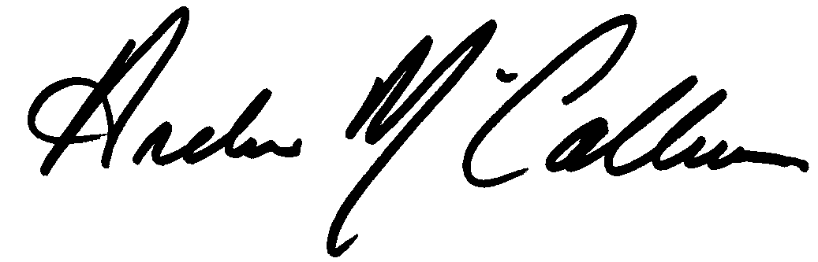

Andrew McCallum
President

