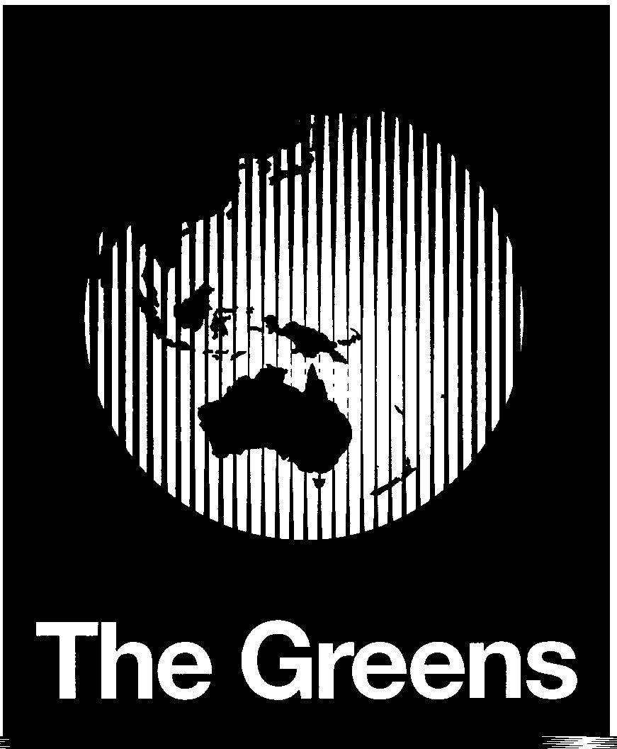

The Manly Greens

15 March 2002

The Secretary
Select Committee on a Certain Maritime Incident
Room S1.57
Parliament House
Canberra ACT 260o
Email: maritime.incident@aph.gov.au

Dear Sir/Madam,

This submission is made on behalf of The Manly Greens, a local group affiliated with the confederation of Australian Greens.

Re. the so-called ‘children overboard’ incident and issues relating to it
We submit that this incident, and the Commonwealth Government’s handling of it are an embarrassment which brings international shame to our country. Further, we submit that the Prime Minister has contravened his own Code of Conduct for Ministers, by not ensuring that his conduct was defensible, when there was doubt about the propriety of his course of action.

Substantial evidence, now in the public arena, indicates that there were no children thrown overboard, except perhaps as a means of getting off a boat that was under fire from Australian security forces and sinking. That these severely disadvantaged people should have been accused by Ministers, including our Prime Minister, of acts of inhumanity is unacceptable to all Australians who have a sense of equity or compassion.

Reports from New Zealand indicate that after prompt processing of the 130 Tampa asylum seekers taken to that country, all but one were found to be genuine refugees. To have refused the entry of those on the Tampa, and to have denied them rights to processing as legitimate asylum seekers is unacceptable.

As Senator Bob Brown highlighted in a media statement issued on 14 February 2002, the Prime Minister and other Commonwealth Ministers have a duty to exercise reasonable diligence in assessing information provided to them.

The Westminster tradition, under which our Parliaments operate, rests heavily on the principle of ministerial accountability. As identified by former Attorney General Billy Snedden in 1965, that accountability requires that, in order to be free of personal fault, a Minister must exercise “reasonable diligence” in preventing any mistake.

It has now become clear that the Prime Minister’s Department was advised by Defence Strategic Command on 10 October, that “there is no indication that children were thrown overboard”. Yet, public statements on the matter suggest that neither the Prime Minister nor his former Defence Minister exercised reasonable diligence that would have made them aware of this advice. In the absence of reasonable diligence on this matter the community has a right to expect major reparations by the Prime Minister and his Government.

Re. The so-called ‘Pacific Solution’
That the Australian Government has chosen to send significant numbers of asylum seekers reaching our shores to developing countries in the Pacific is also unacceptable. Through these actions, our relatively able and affluent nation is failing to meet its international humanitarian obligations.

That the people involved are overwhelmingly genuine refugees is demonstrated not only by the New Zealand findings mentioned above, but also by reports such as that recently published from Christmas Island Shire Councillor Gordon Thomson. His recent article states that “For 10 years prior to the Tampa arriving in our waters, Christmas Island had been in the news when the occasional group of refugees managed to land… about 900 asylum seekers arrived on Christmas Island in the 12 months to August 2001. The government’s own figures at that time show that at least 85% of claims for asylum for people entering Australia through Christmas Island were accepted.”

To turn these people away without even processing their claims for refugee status is a failure in our humanitarian responsibilities as part of the global community.

To hold them indefinitely in detention centres in conditions which resemble high security prisons, or worse still concentration camps, is immoral.

The Manly Greens urge that the Inquiry reject both the so-called ‘Pacific Solutions’ and the current mandatory detention of asylum seekers, and that
- these be replaced with a system in which those who arrive as asylum seekers have their bona fides checked rapidly, focusing primarily on health (including screens for addictive, physical and psychiatric problems and potential suicide risk) and criminal security checks;
- existing detention centres be replaced with publicly-owned reception centres, accredited by the Australian Council of Health Care Standards, meeting international standards of accommodation, and staffed by people trained in cross-cultural communication;
- after initial processing, the asylum seekers be integrated into communities in Australia with appropriate support to ensure that they are fully informed of their rights, equipped to deal appropriately with demands made on them regarding their status in Australia, and given assistance to integrate into the communities in which they are settled;
- all refugees currently holding temporary visas be immediately granted permanent residency status with full rights.

The Manly Greens also urge that, on the basis that conditions in mandatory detention centres housing asylum seekers are neither humanitarian nor consistent with international agreements to which Australia is a signatory, the Inquiry reject the current practice of billing asylum seekers (at a rate of more than $130 per day) for the time spent in mandatory detention centres, and cancel existing debts.

Further, acknowledging changed global conditions since the end of World War II, and in particular the greater impacts of war and other major global pressures (including environmental pressures associated with increased global consumption), The Manly Greens urge that the Inquiry recommend to the Commonwealth Government that it use its best endeavours in international diplomatic channels to have the definition of ‘refugee’ within the Geneva Convention broadened to include people displaced for reasons of famine, poverty, environmental degradation, war, political oppression or any other denial of Human Rights.

Dr Judy Lambert
Greens Councillor, Manly Council
For & on behalf of Manly Greens

Burnside J (17 Feb 2002). Interview transcript: ‘In the National Interest’. ABC Radio National
Thomson, Clr G (Feb 2002). Christmas Island: A story of lies & spies. Local Environs, February 2002, pp 7-10.

