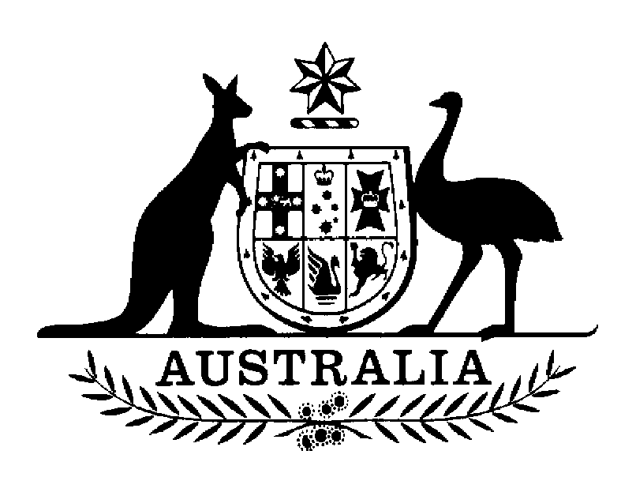

AUSTRALIAN SENATE

FINANCE AND PUBLIC ADMINISTRATION

REFERENCES COMMITTEE

MEDIA RELEASE

Inquiry into administrative review in the area of veteran and military compensation and income support

The Chair of the Senate Standing Committee on Finance and Public Administration, Senator Michael Forshaw, today confirmed that the Committee will hold public hearings on Thursday and Friday, 25 and 26 September in connection with the Committee’s inquiry into administrative review of veteran and military compensation and income support. Details of the public hearings are as follows:

Thursday 25 September 9.30am–12.00pm
Jubilee Room, Parliament House, Macquarie Street, Sydney

Friday 26 September 9.00am–3.30pm
Committee Room 2S1
Parliament House

The Committee has received submissions from Commonwealth departments and agencies, ex-service organisations, and bodies representing the legal profession. The hearings will examine the options and preferences for a revised system of administrative review within a new military rehabilitation and compensation scheme for veterans and for the Australian Defence Force.

The program for the hearings is attached.

For further details, contact:

For comment: Senator Michael Forshaw, Chair
02 6277 3805 (Parliament House, Canberra)
0418 119 526 (mobile)

For information: Alistair Sands, Secretary
02 6277 3530
fpa.sen@aph.gov.au

http://www.aph.gov.au/Senate/committee/fapa_ctte/vetsreview/index.htm

23 September 2003

Inquiry into administrative review of veteran and
military compensation and income support

PROGRAM

Thursday, 25 September 2003
Jubilee Room, Parliament House
Macquarie Street
SYDNEY

9.30–10.15am KCI Lawyers (sub. 13)
Mr Greg Isolani, Partner

10.15–10.45am Legal Aid Commission of NSW (sub. 8)
Mr Bill Grant CEO
Ms Jodie Buchanan, Senior Advocate, Veterans Advocacy Service

10.45–11.00am Morning tea

11.00–11.30am Injured Service Persons Association (ISPA) (sub. 3)
Mr Ray Brown, National President

11.30–12.00pm Vietnam Veterans’ Federation of Australia (sub. 12)
Mr Tim McCombe, President

Inquiry into administrative review of veteran and
military compensation and income support

PROGRAM

Friday, 26 September 2003
Committee Room 2S1
Parliament House, Canberra

9.00–10.15am Department of Veterans’ Affairs (sub. 10)
Dr Neil Johnston, Secretary Department of Veterans’ Affairs and President, Repatriation Commission
Mr Bill Maxwell, Division Head, Compensation and Support
Mr Mark Johnson, Branch Head, Disability Compensation
Mr Perry Phillips, Acting Director, Policy Eligibility & Review
Mr Arthur Edgar, Branch Head, New Military Rehabilitation and Compensation Scheme
Mr John Douglas, Director, New Military Rehabilitation and Compensation Scheme

10.15–11.00am Sparke Helmore Lawyers (sub. 9)
Mr Michael Snell, Partner
Mr John Wallace, Special Counsel

11.00–11.15am Morning tea

11.15–12.00pm Department of Defence
Mr Mal Pearce, Director-General, Military Compensation

12.00–12.45pm Attorney General’s Department (sub. 14)
Ms Phillipa Lynch, First Assistant Secretary, Family Law and Legal Assistance Division

12.45–1.30pm Lunch

1.30–2.30pm Administrative Review Council (sub. 11)
Professor Robin Creyke, Law School, ANU, Canberra
Ms Margaret Harrison-Smith, Executive Director

2.30–3.00pm Slater & Gordon (sub. 2)
Mr David Richards, Commonwealth Compensation Partner

3.00–3.30pm The Returned & Services League of Australian (RSL) (sub.1)
Mr Ken McKenzie, RSL National Veterans’ Affairs Committee
Legacy Australia (sub. 4)
Mr Ian Wills (Canberra legatee)
Regular Defence Force Welfare Association (sub. 5)
Mr Harry Adams, National President

