Appendix 3, part 2

Photographs from the Committee’s trip to Samoa, Tonga, Fiji, the Solomon Islands and Papua New Guinea
22–31 May 2003

SAMOA
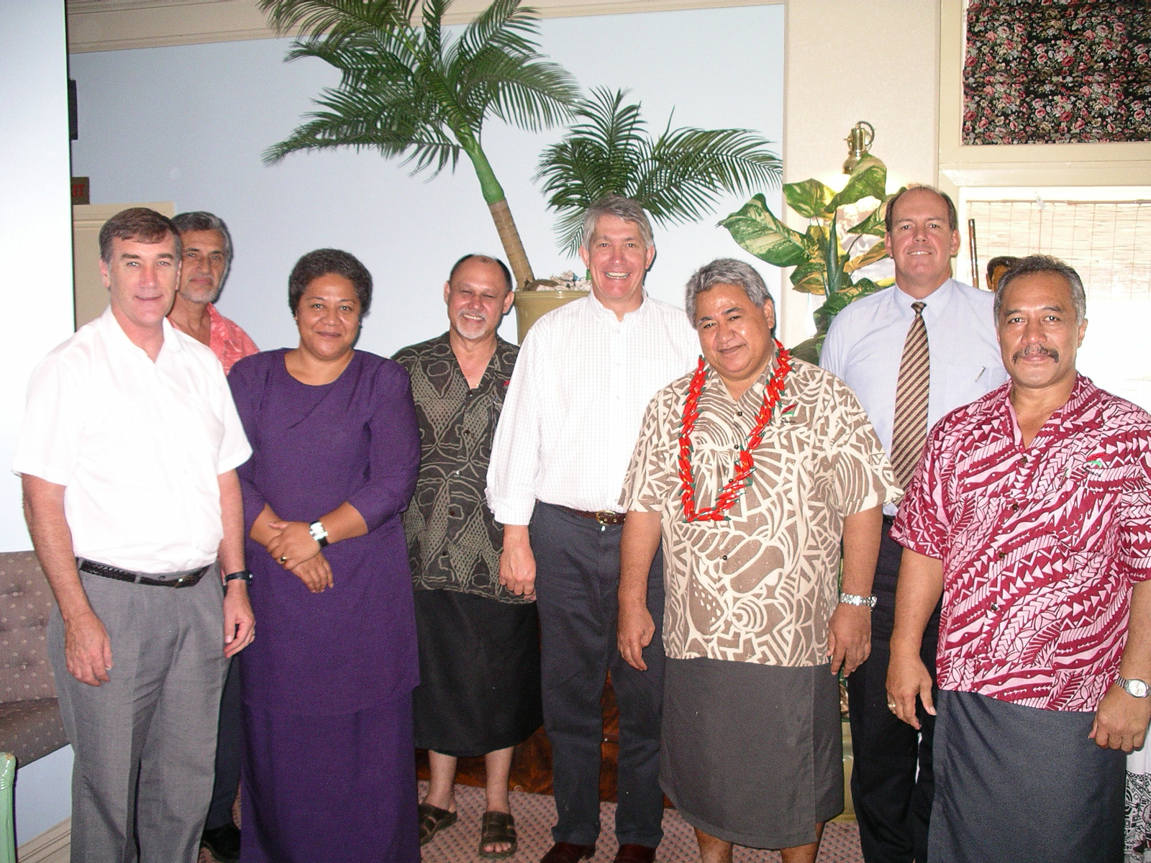
Members of the Committee with the Prime Minister, the Hon Tuilaepa Sailele Malielegaoi and Senior Ministers.

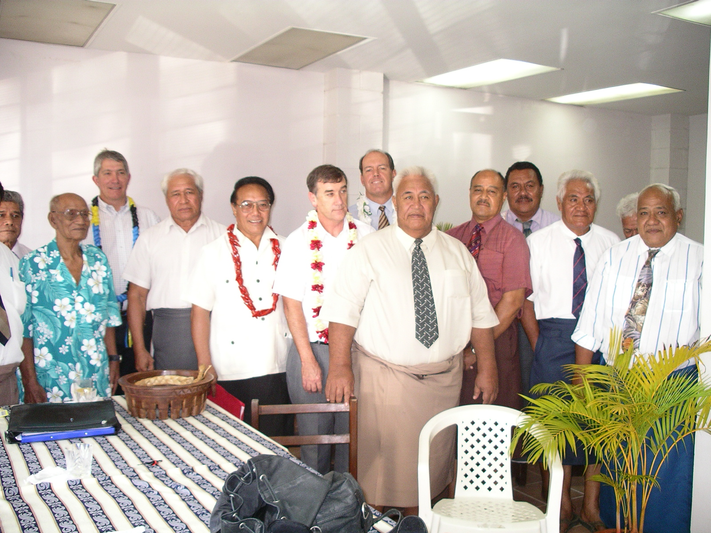
Members of the Committee with Members of the Opposition.

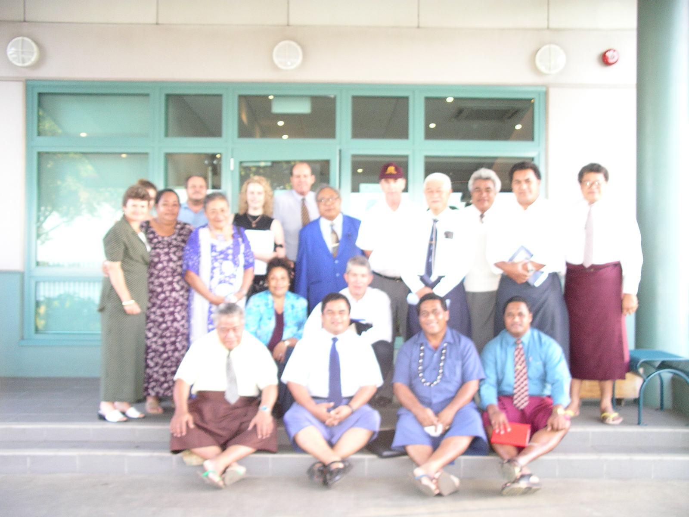
Members of the Committee with representatives of church organisations.
TONGA
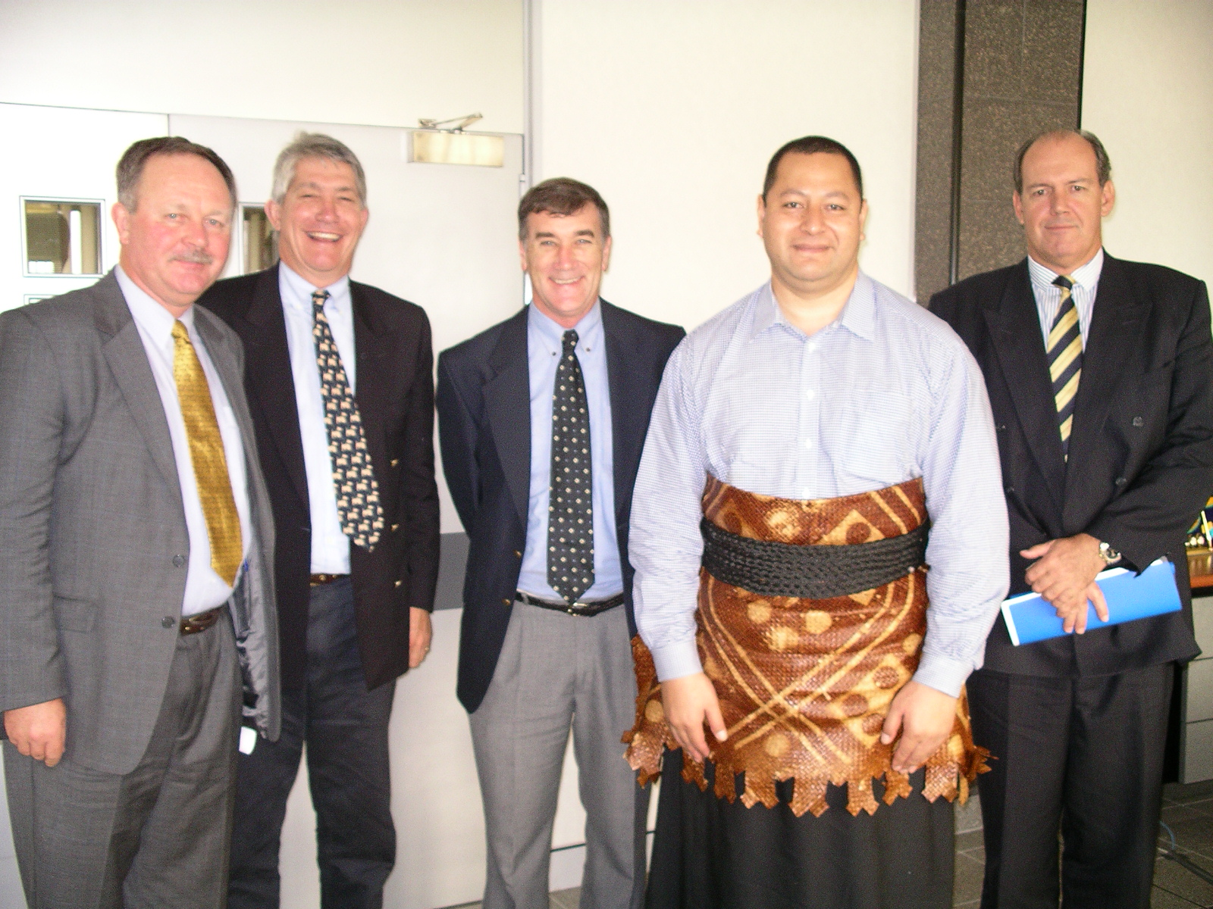
Members of the Committee with the Prime Minister, HRH Prince ‘Ulukalala Lavaka Ata and the High Commissioner to Tonga, HE Mr Colin Hill.

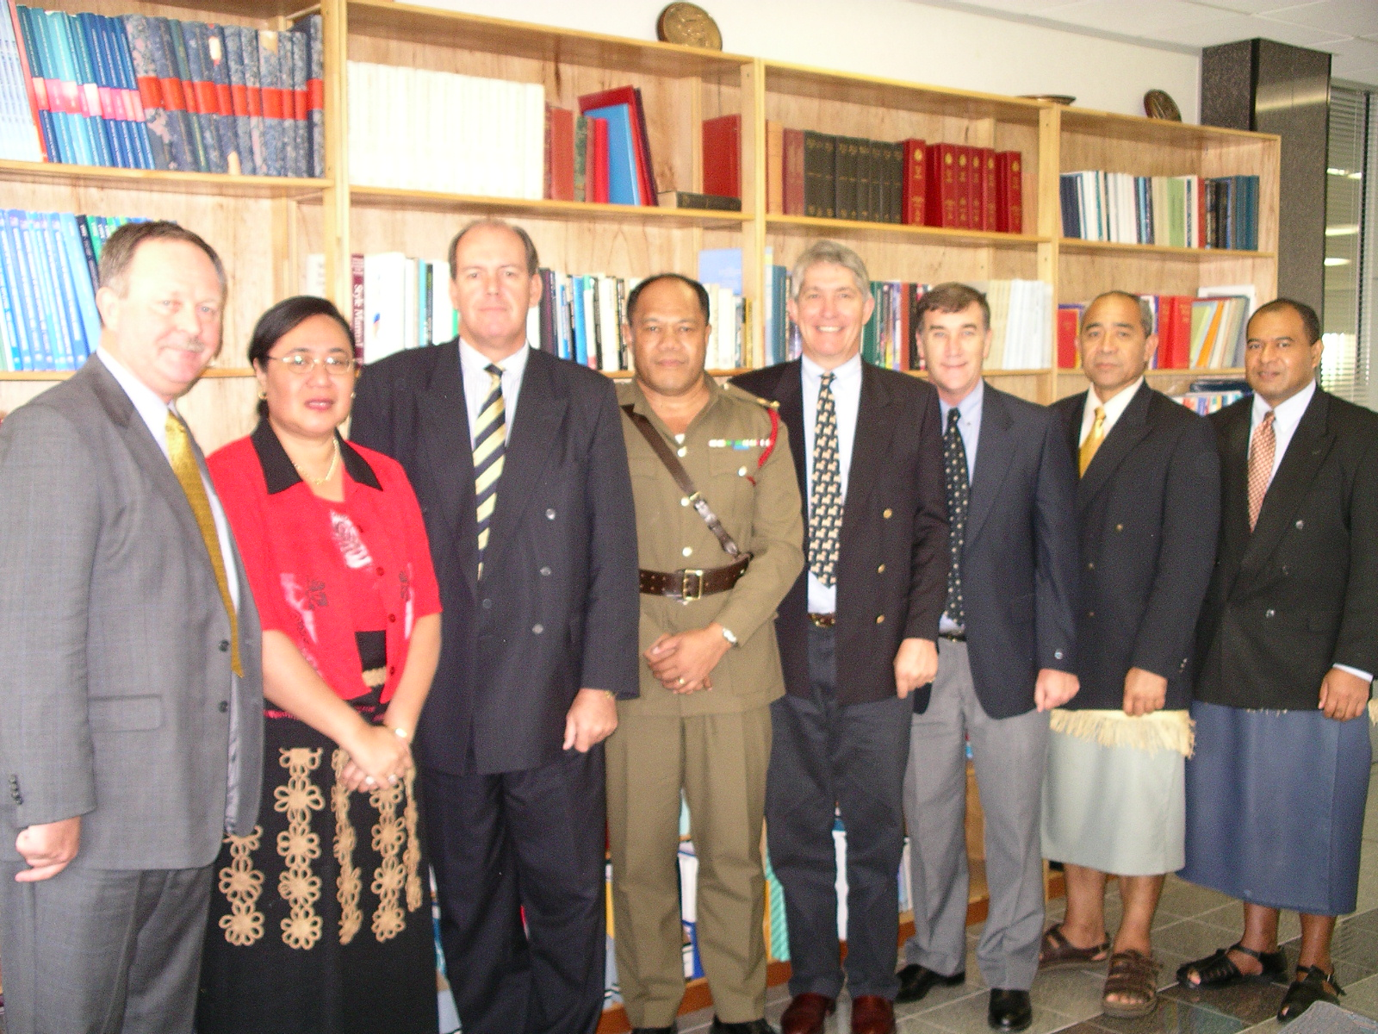
Members of the Committee with the Secretary of Foreign Affairs, Mrs Fekita ‘Utoikamanu, Commander Tongan Defence Forces, LtCol Uta’Atu and the High Commissioner, HE Mr Colin Hill.

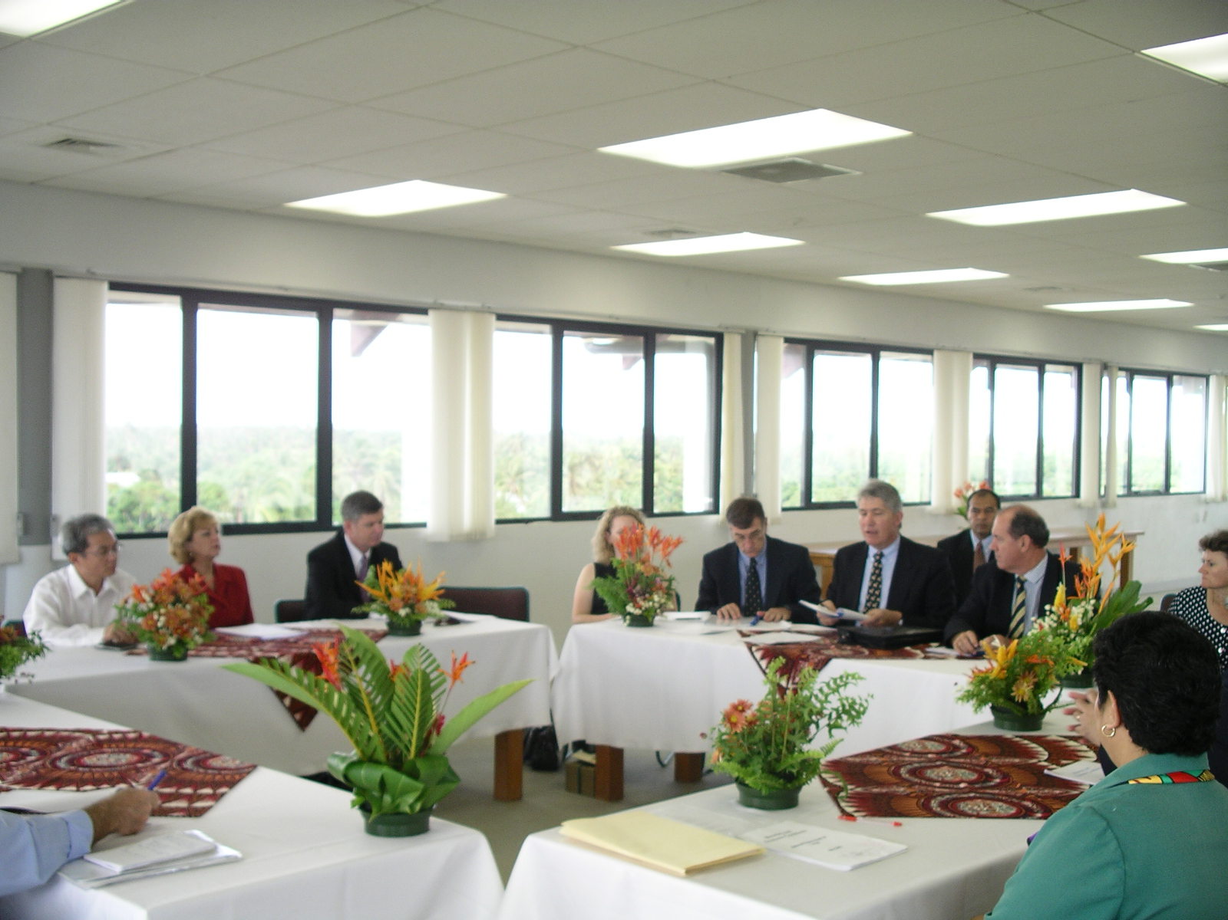
Members of the Committee meeting with the Minister for Finance, the Hon Siosiua ‘Utoikamanu and Governor of the Reserve Bank, Mrs Joyce Mafi.
FIJI
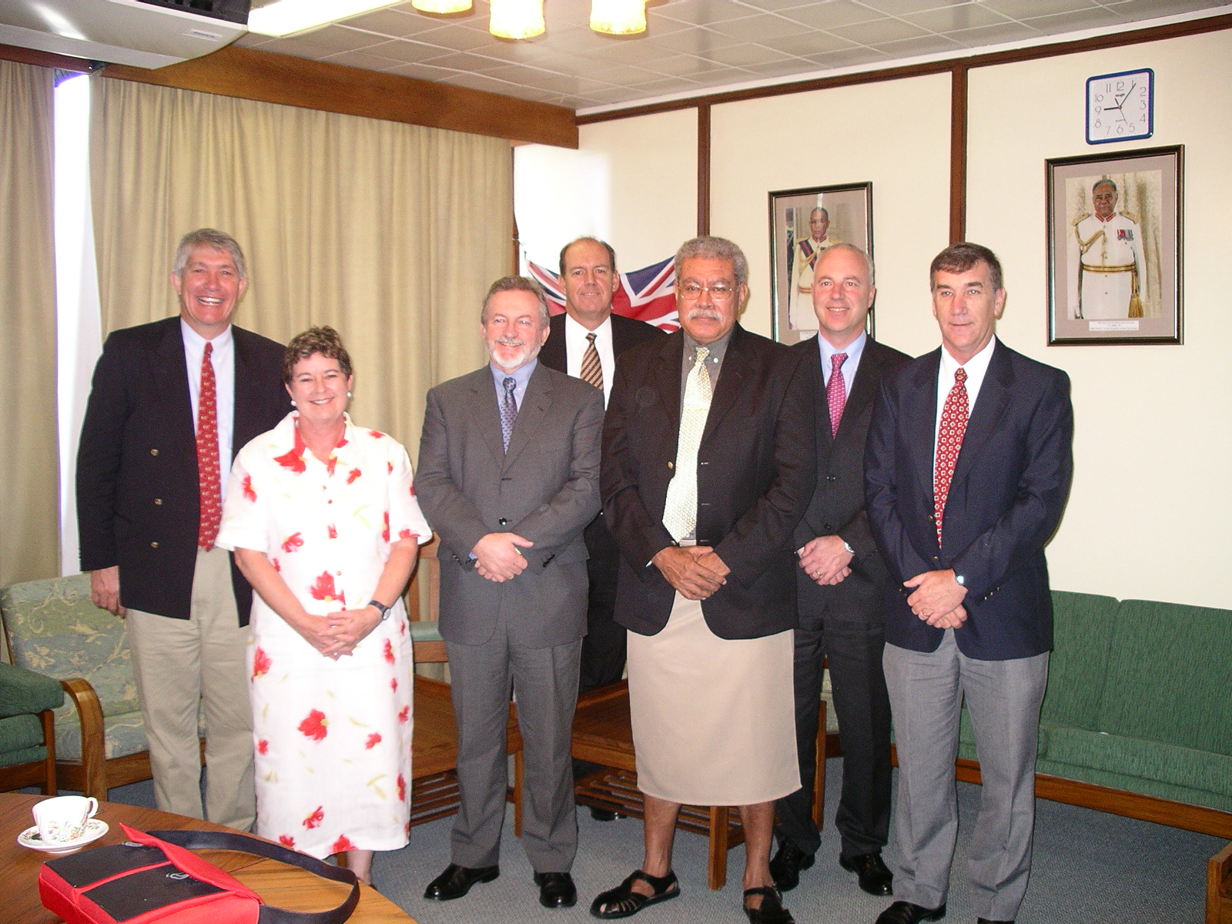
Members of the Committee with the Prime Minister, the Hon Laisenia Qarase and then High Commissioner to Fiji, HE Ms Susan Boyd.
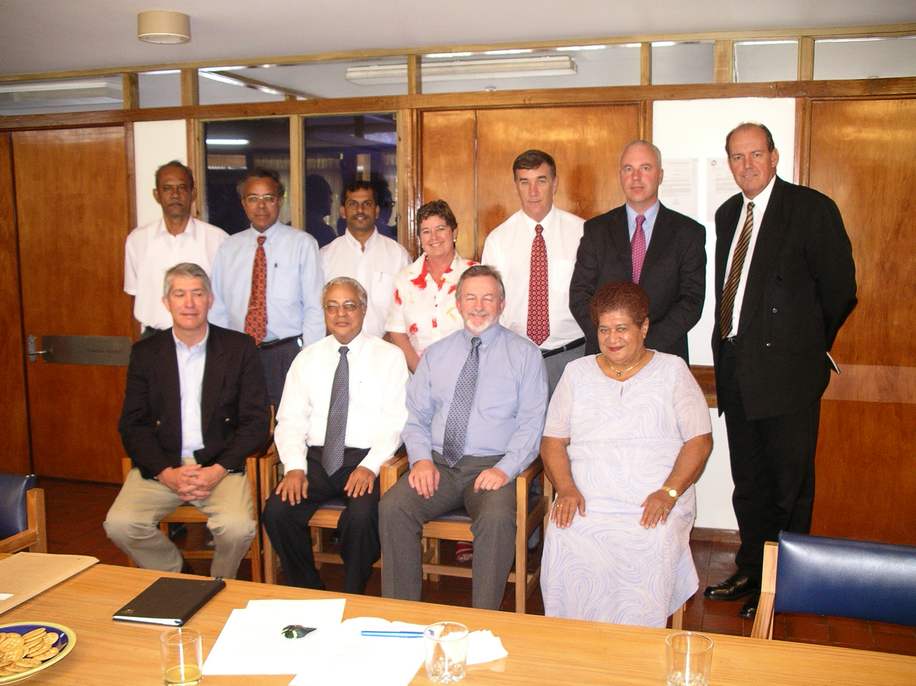
Members of the Committee with the Hon. Mahendra Chaudhry MP, Leader of the Fiji Labour Party and Members of the Opposition.

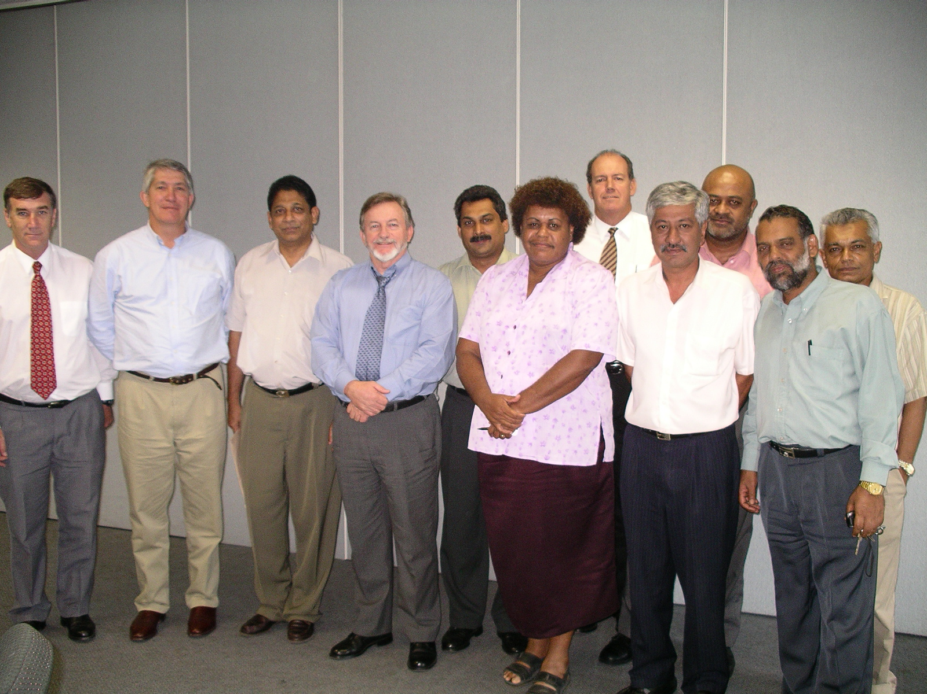
Members of the Committee with members of the Trade Union Congress.

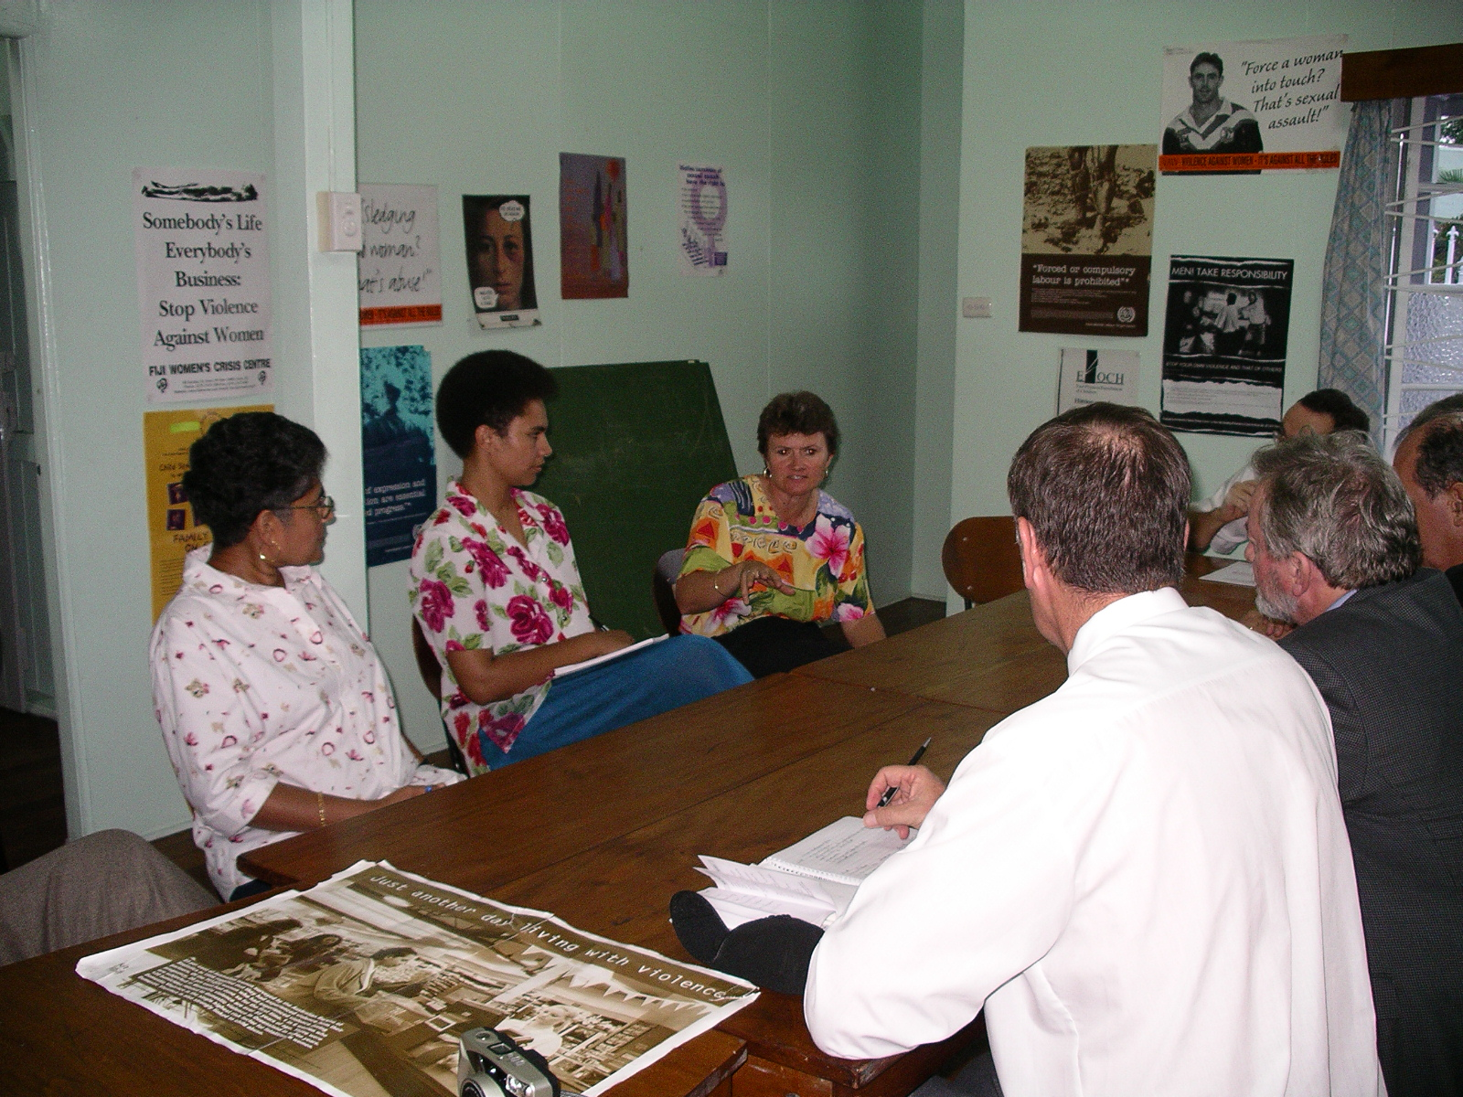
Members of the Committee meeting with the Fiji Women’s Crisis Centre.

SOLOMON ISLANDS
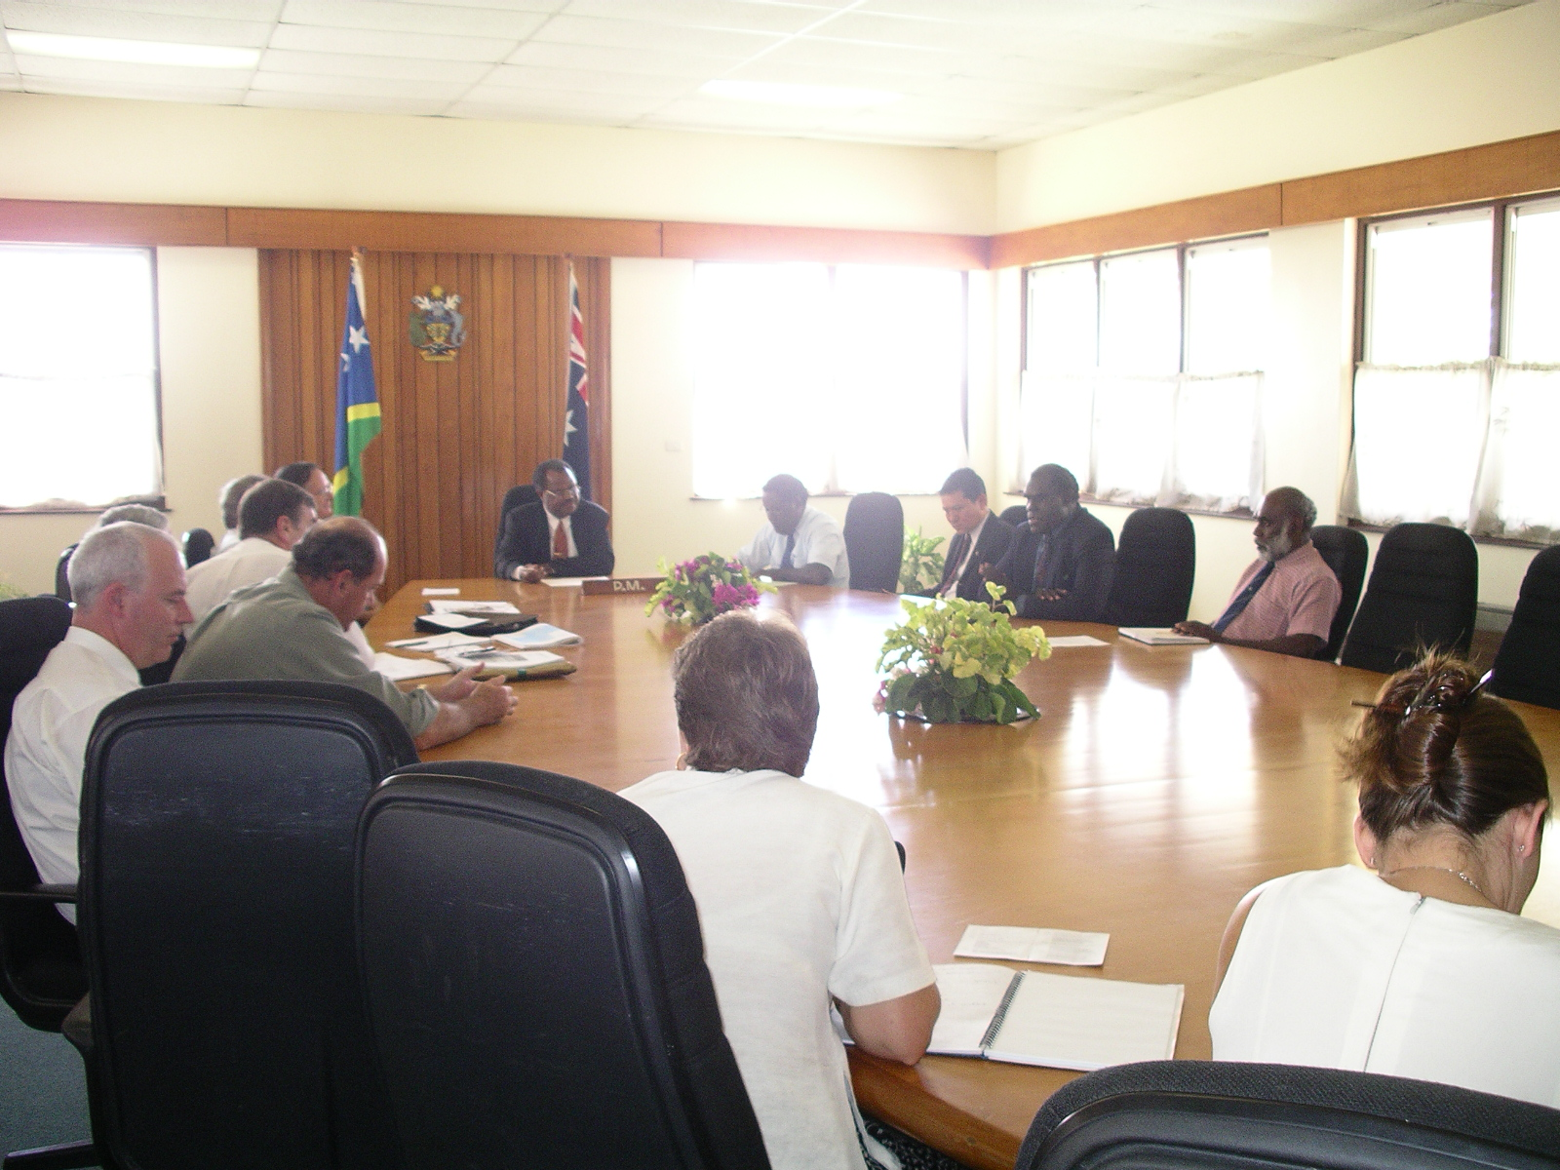
Members of the Committee meeting with the Prime Minister, the Hon Sir Allan Kemakeza, KBE, MP and Senior Ministers.

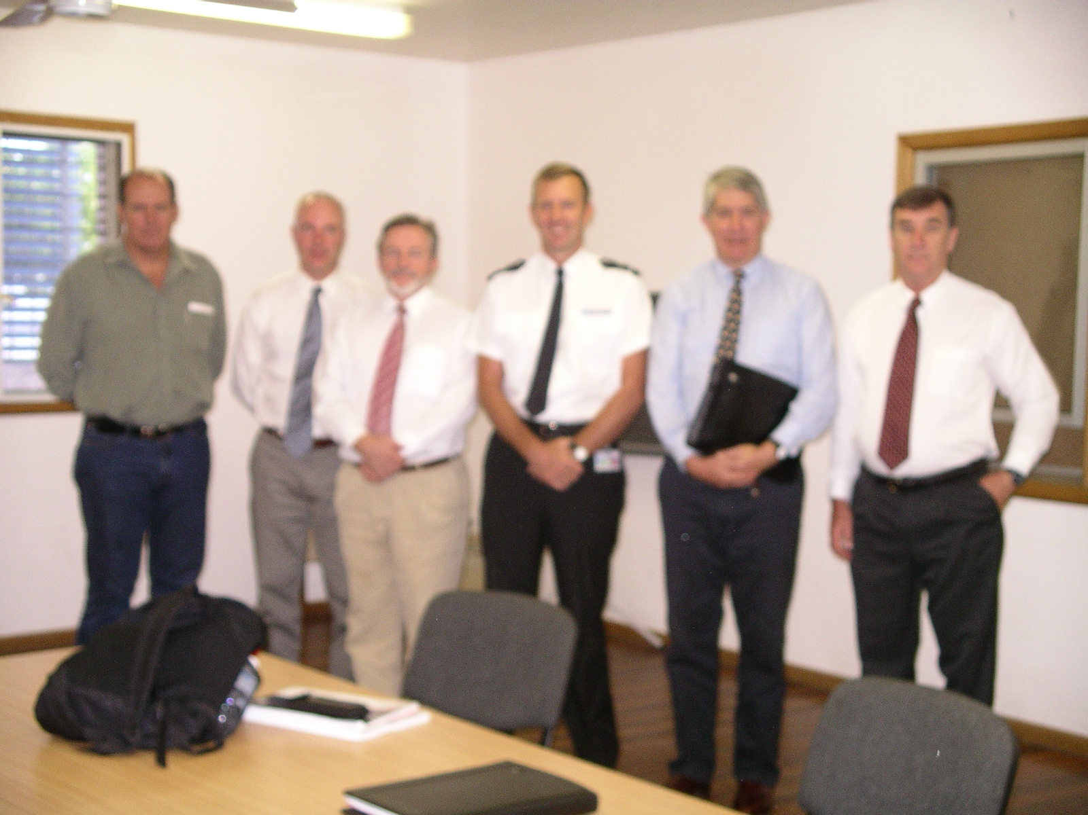
Members of the Committee with the Police Commissioner, Mr Bill Morrell.

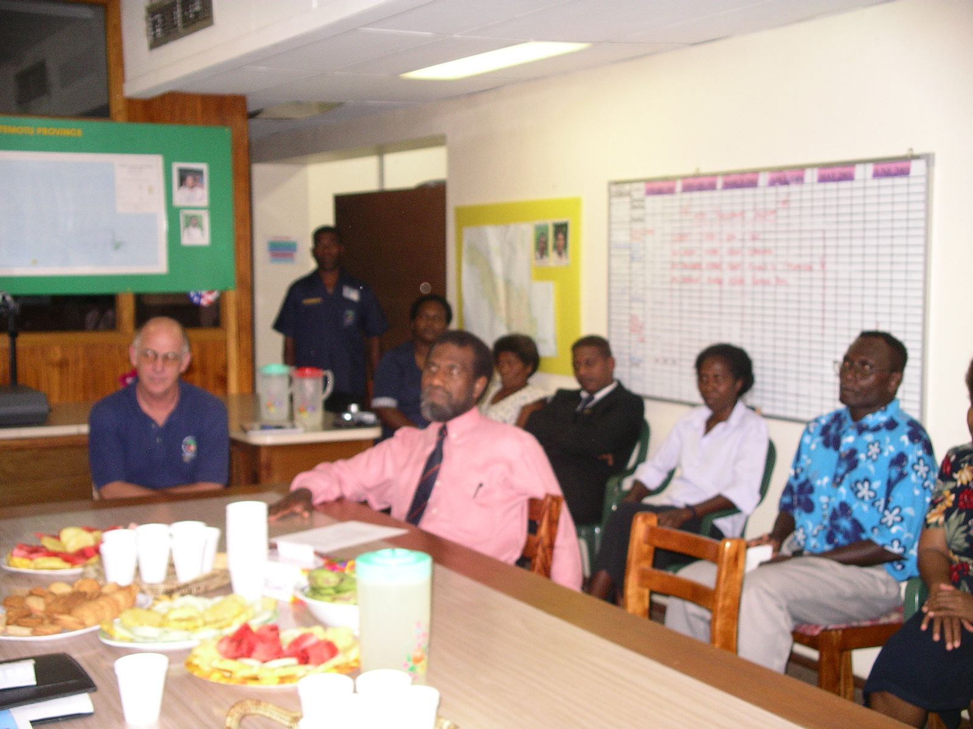
Representatives of the Community Peace and Restoration Fund.

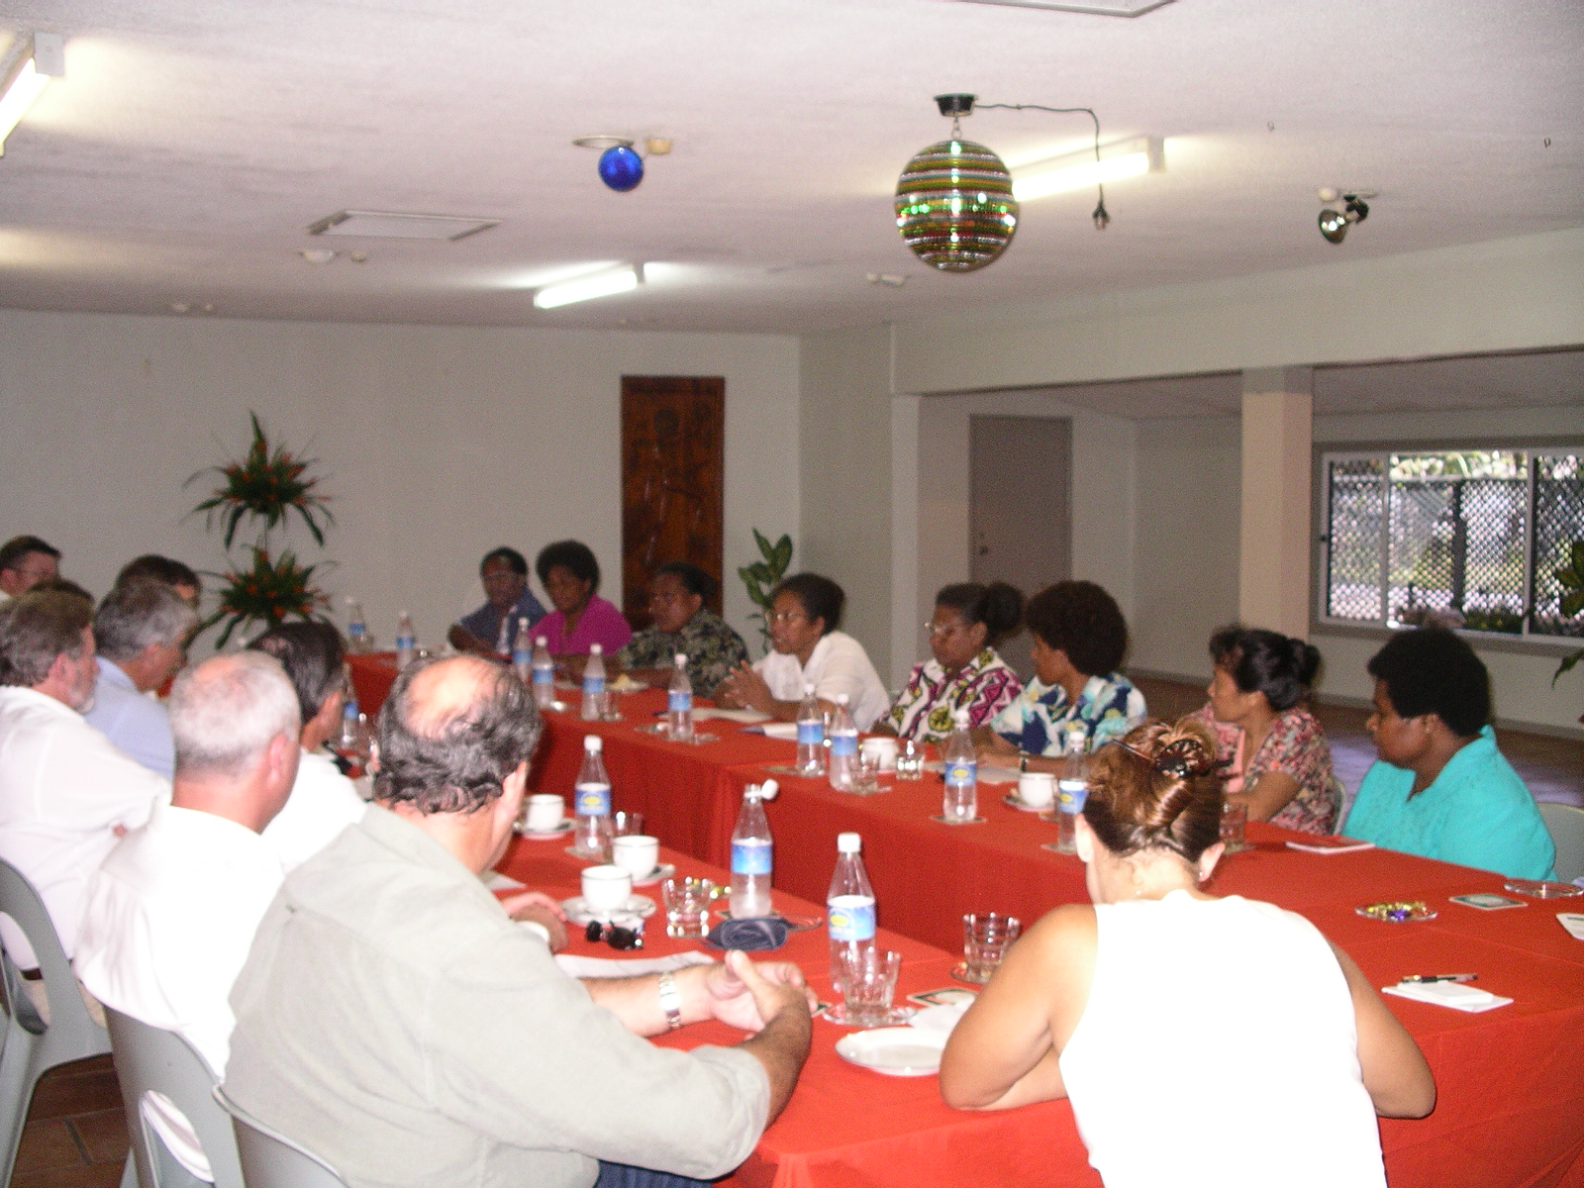
Members of the Committee with representatives of women’s organisations.

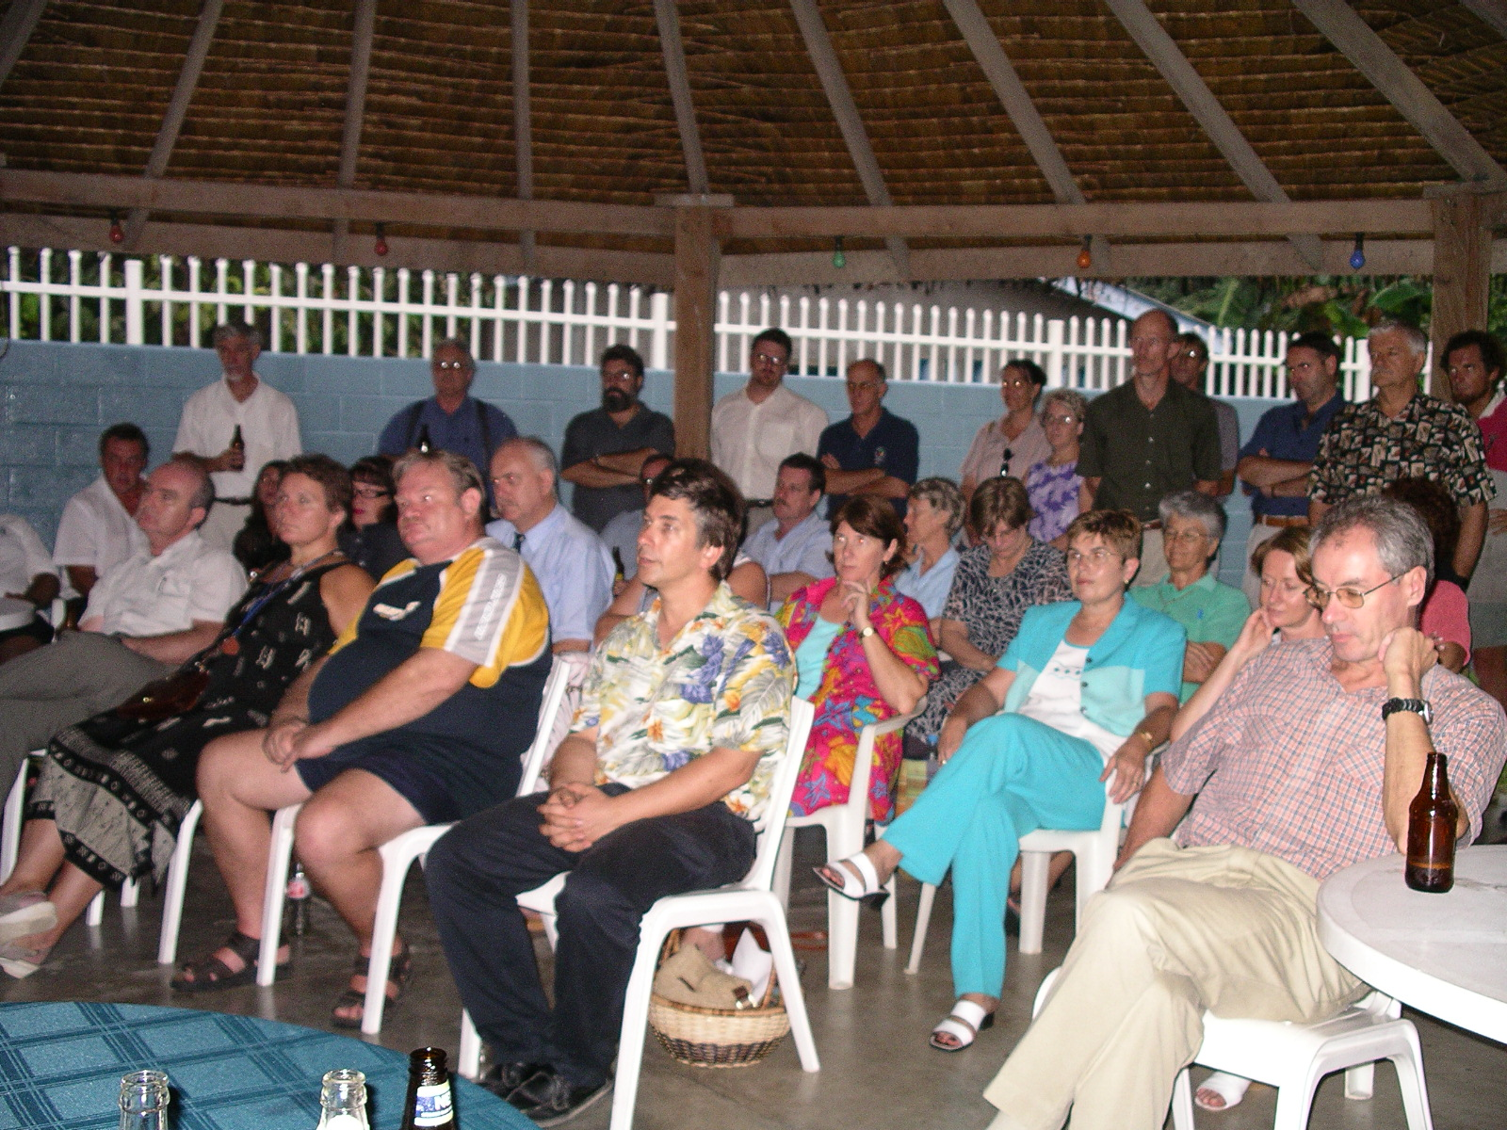
Members of the Australian community in Honiara.
PAPUA NEW GUINEA
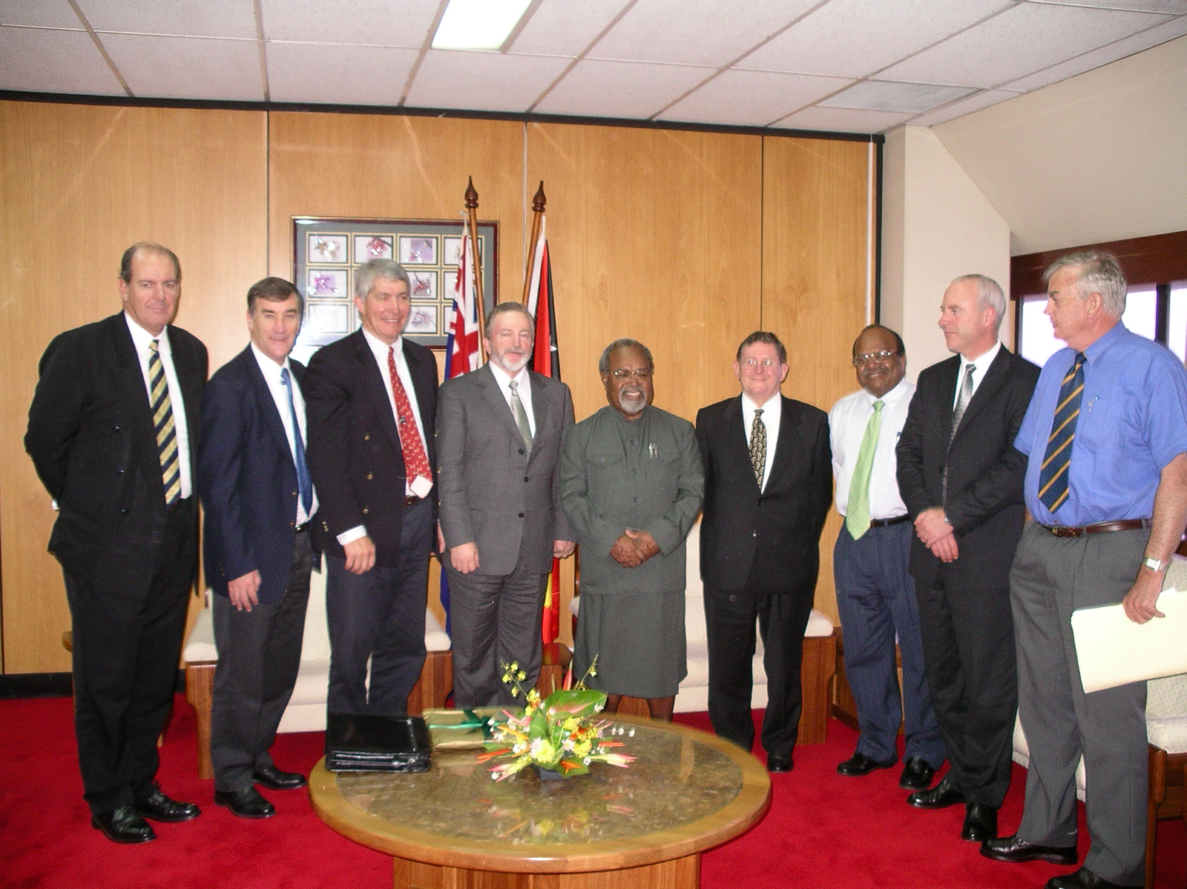
Members of the Committee with the Prime Minister, the Rt Hon Sir Michael Somare, Minister for Foreign Affairs, the Hon Sir Rabbie Namaliu, Minister for Inter-Government Relations, the Hon Sir Peter Barter and the High Commissioner, HE Mr Michael Potts.

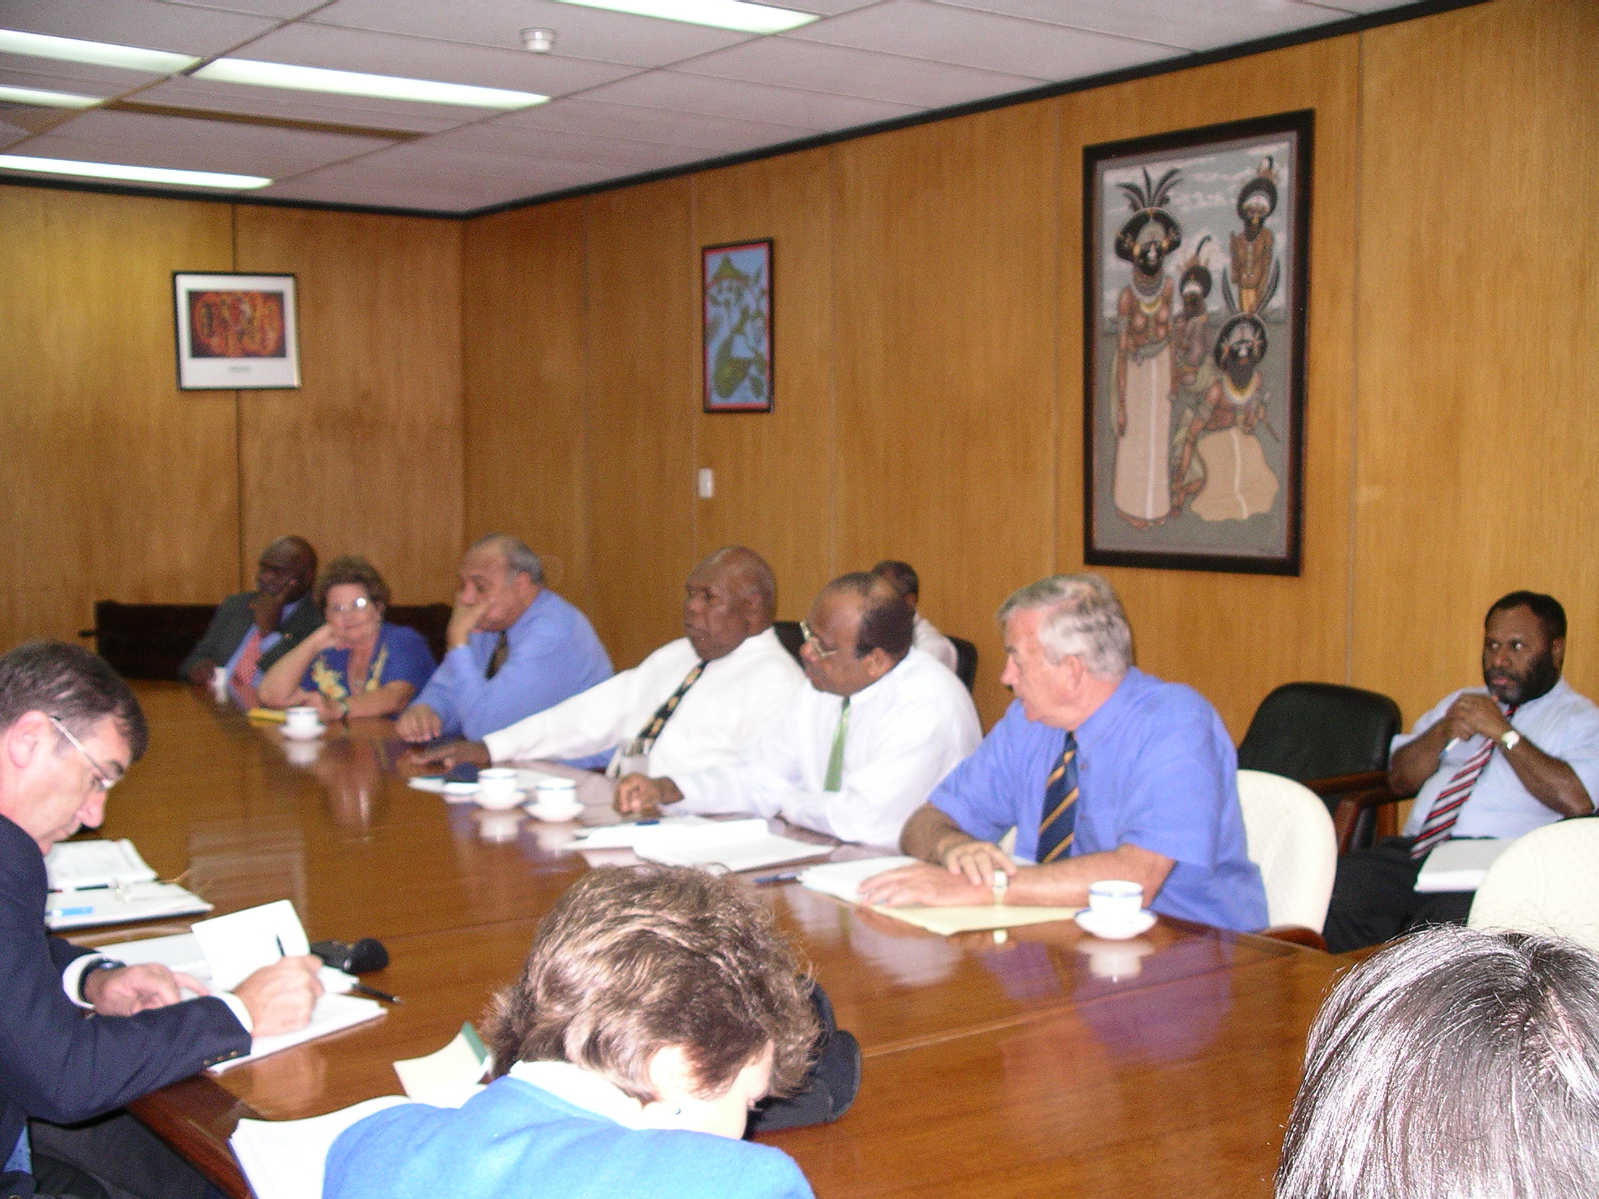
Members of the Committee meeting with Senior Ministers.

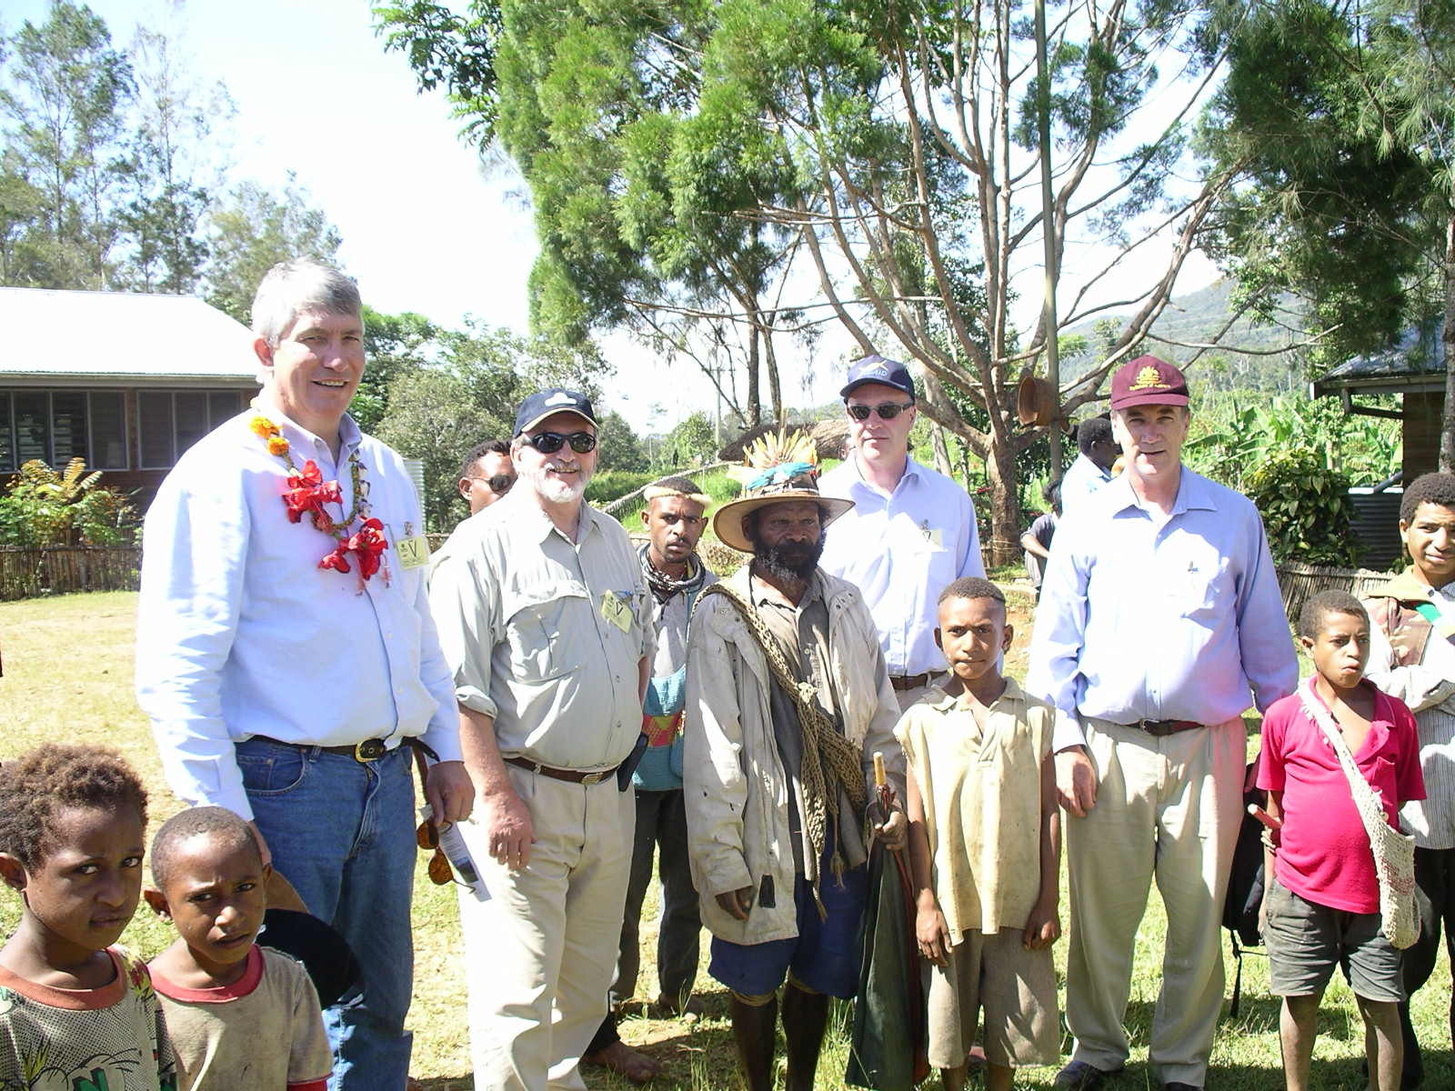
Members of the Committee at the Hides Community Development Project.

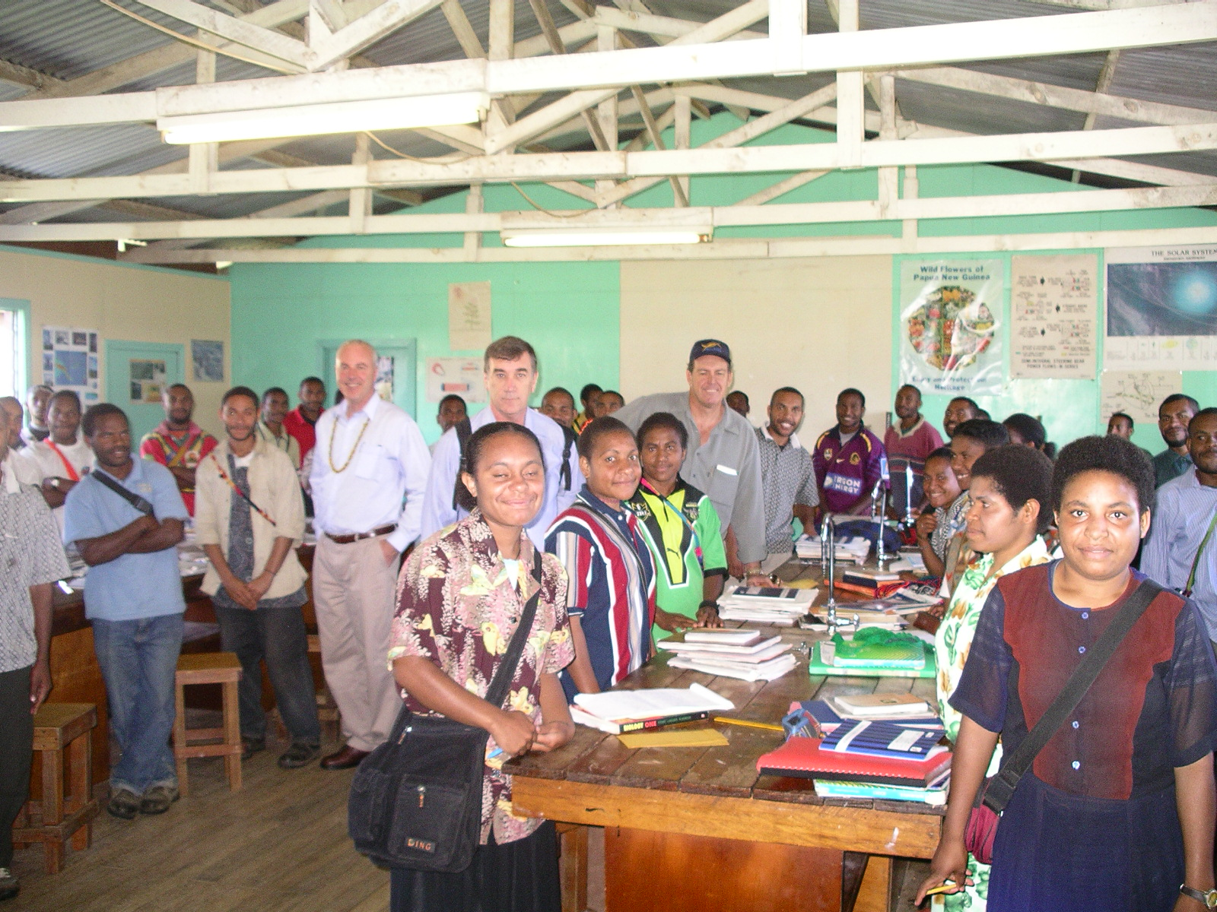
Members of the Committee with students of Tari Secondary School.

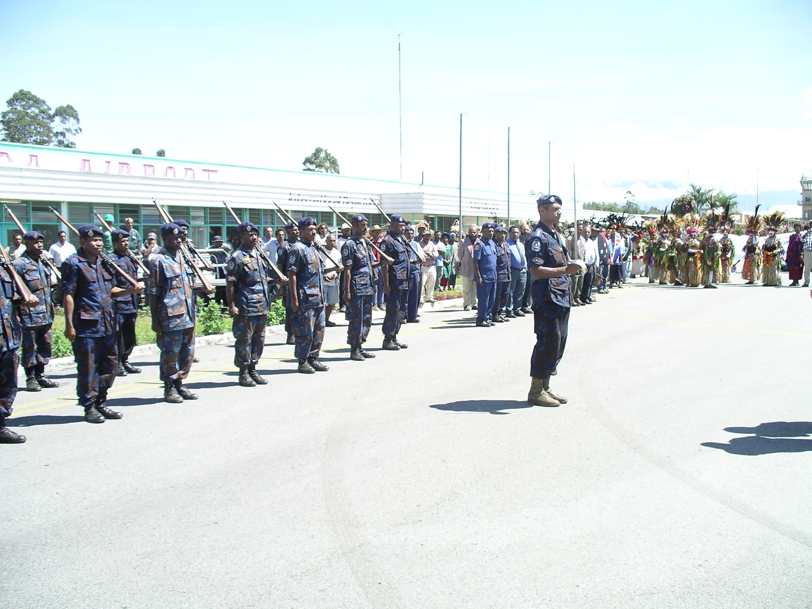
Guard of Honour for the Committee’s arrival at Kagamuga Airport, Mount Hagen, Western Highlands Province.

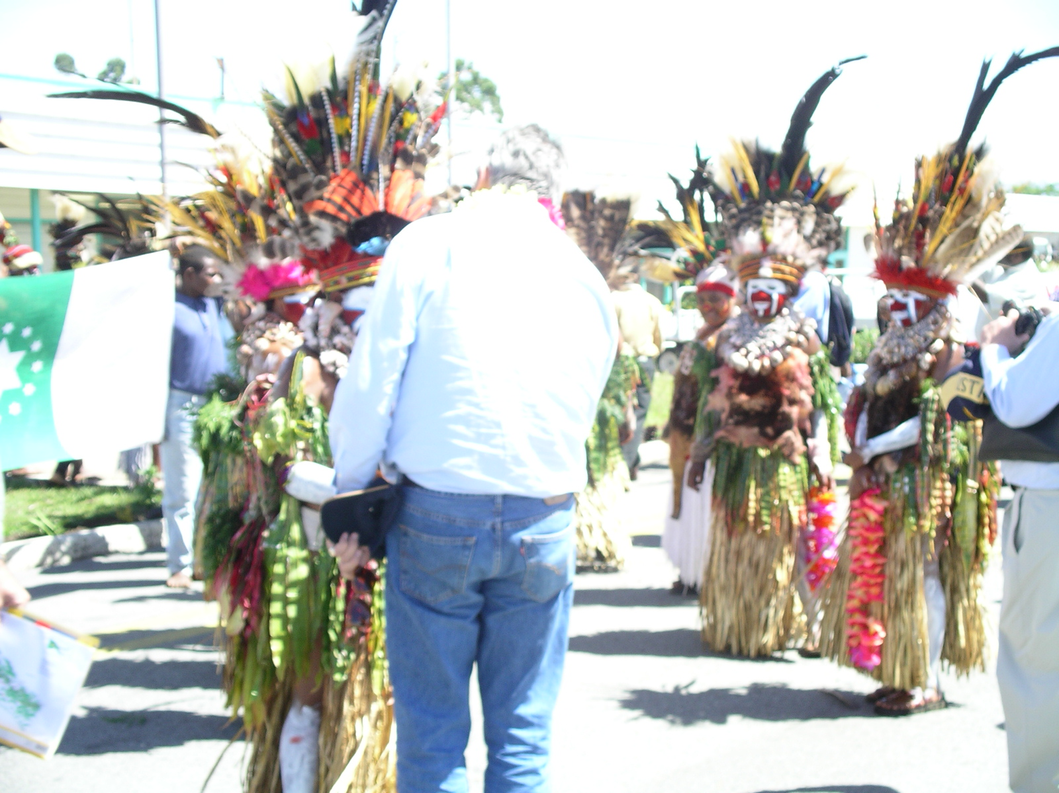
Senator Macdonald welcomed by Mount Hagen community in ceremonial dress.

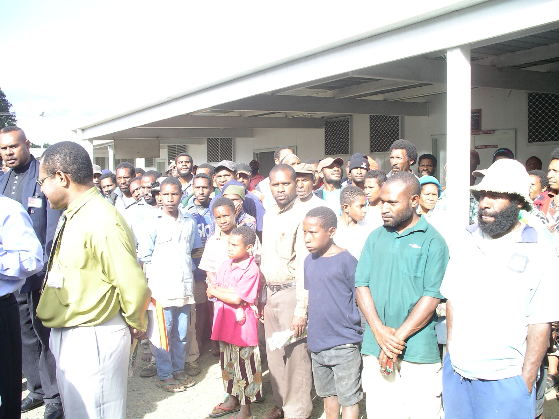
Members of the Mount Hagen community at Mount Hagen Hospital.

