Submission

to

Senate Employment, Workplace Relations and Education
References Committee

Inquiry into higher education funding
and regulatory legislation

Submission no: | 270
Received: | 15/8/03
Submitter: | Mr Theo Mackaay  Executive Officer
Organisation: | Anglican Social Responsibilities Commission, WA
Address: | GPO Box C138  PERTH WA 6839
Phone: | 08 9325 7033
Fax: | 08 9325 8969
Email: | srcperth@iinet.net.au

SUBMISSION OF THE SOCIAL RESPONSIBILITIES COMMISSION OF THE ANGLICAN PROVINCE OF WESTERN AUSTRALIA
The Social Responsibilities Commission of the Anglican Province of Western Australia wishes to take this opportunity to express its concern in relation to a number of aspects of the Commonwealth Government’s proposed reforms to the Higher Education Sector arising out of the recent Crossroads Review.
Taken as a whole the reform package solidifies a trend that starting with the introduction of HECS in the 1980’s by the Hawke Labor Government, of shifting the burden of funding the nation’s Universities away from the general community and towards the financially vulnerable student body.
Those who argue that the burden of funding universities should be met by students often over-estimate the private benefit that students obtain from pursuing higher education options. Since 1989 student numbers in Australian universities have risen by over 25%. While an increase in general student numbers is a positive trend, a result has been that the attainment of a degree entails less of a boost to a graduate’s income earning potential than it has for previous generations of graduates. As such it needs to be recognised that compared to other OECD countries Australia has a “high cost, low benefit” Higher Education Sector. The private income benefit obtained by students, while undeniable, is rivaled by high course costs. When one takes into account the enormous benefits the public receives from graduates passing through the nation’s universities (for example, the public financial windfall from increased income tax payments from graduates is often overlooked), any increase in HECS costs is simply unjustifiable. It is already the case that Law students pay 110% of the actual cost of their degree.
Thus it is with concern that the Commission notes that the Commonwealth Government plans to allow universities to lift current HECS fee levels by up to 30%. While the Government argues that universities can use this new competitive environment to lower fees and thus attract more students to select courses, the fact remains that fee reductions are unlikely to occur when one considers that the Commonwealth Government has cut $5 billion of funding from the Higher Education sector since 1996. Faced with funding short falls it is inevitable that unless that Government fills the gap with substantial increases in untied funding, universities will have no choice but to raise the level of HECS fees and thus move the financial burden onto the shoulders of students.
The reality of this scenario was clearly indicated in July of this year when the Senate of the University of Sydney decided that should the ‘Nelson Reforms’ pass through the Commonwealth Parliament unchanged, the University will move to increase HECS fees for all courses by the maximum 30%. As indicated in the recently released draft report by Aungles, Buchanan, Karmel and MacLachlan entitled HECS and Opportunities in Higher Education, increases in HECS fees do tend to deter a certain group of males from Low Socio-Economic backgrounds, along with those who are middle aged, from pursuing higher education. One can only assume that rises in HECS levels of the extent planned by the University of Sydney would have an even more serious deterrent effect upon prospective students than that discovered by Aungles et al. when examining the effect of the changes to the HECS system in 1996.
A number of other aspects of the Nelson Reforms are of great concern. In particular the Commonwealth Government’s plans to allow Universities to increase their intake of local full fee paying students by 25%, so that 50% of university places can be filled by such students. Such a proposal strikes at the very heart of the previously unchallenged notion that entry to Australian universities should be based upon merit rather than one’s ability to pay. Local full fee paying students will be able to get into courses with entrance marks substantially below those applying for HECS places. The amount charged for full fee places will be completely up to the universities, and while the Government will assist students with loans to the tune of $50,000, full fee courses are already costing some students in the Eastern States over $100,000. Clearly, such places will be not be accessible to those with limited financial means.
Conclusion:
The Government’s Higher Education reforms offer inadequate solutions to the current crisis within the Australian Higher Education sector. Rather than acknowledging the enormous public benefits derived from the nation’s Universities, and substantially boosting funding, the Government has sought to shift the funding burden to the students. Of the new funding that the Commonwealth Government has offered, substantial amounts are unfairly tied to internal industrial reforms within university workplaces that seek to remove the right of academics to negotiate collectively and strike.
Recommendations:
1. That the Commonwealth Government substantially increase untied funding to the nation’s Universities.
2. That current HECS fee levels in Bands 2 and 3 be scaled back to a standard single Band Level, corresponding to the current fee level for Band 1.
3. That the Commonwealth Government not permit universities to lift the number of full fee paying local students and that such domestic full fee paying places are gradually phased out of the Higher Education Sector.

Yours sincerely

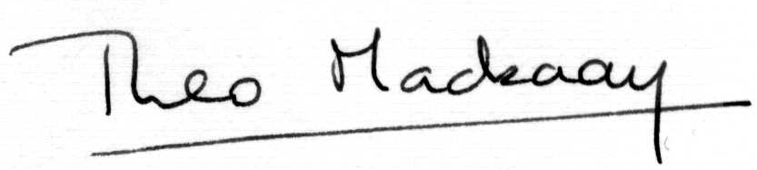

Theo Mackaay
Executive Officer

August 15th, 2003

