Submission to the Senate Employment, Workplace Relations
and Education References Committee

Inquiry into Higher Education Funding and Regulatory Legislation

Submission no: 269

Received: 15/8/03

Submitter: Mr Shane Snow

Organisation: Queensland Tertiary Education Alliance

Address P.O BOX 2036

Kelvin Grove L.P.O

Kelvin Grove, Qld 4059

Phone: (07) 3864 5529

Fax: (07) 3864 5535

E-mail: educationofficer@guildonline.net

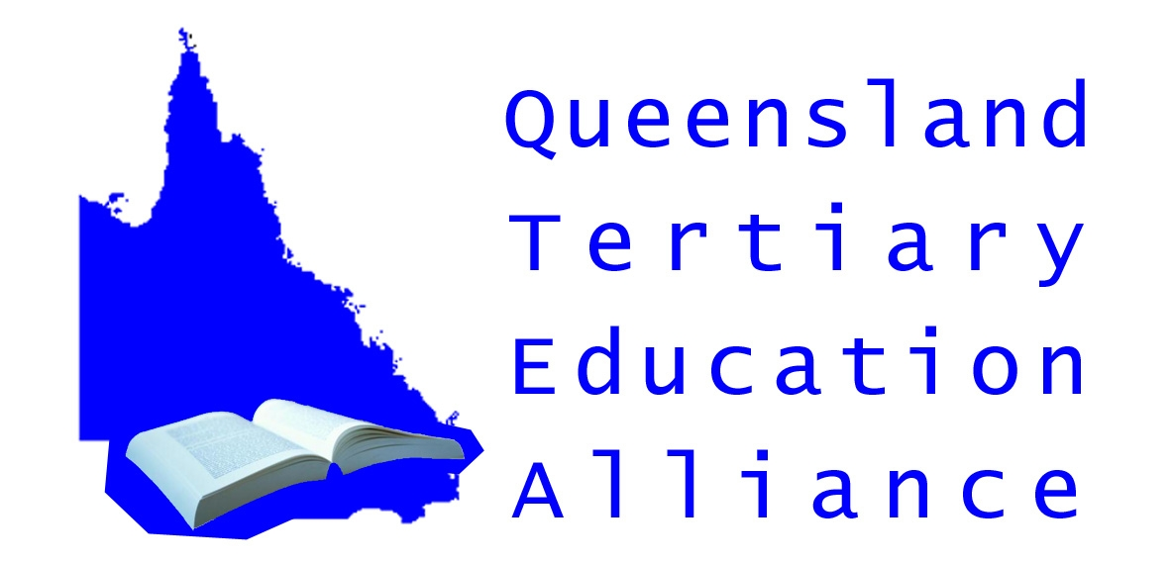

What is the QTEA?

The Queensland Tertiary Education Alliance (QTEA) is a group of community bodies that have as their goal the promotion of a high quality university sector in Queensland, where access is based on merit rather than wealth. The QTEA is made up of the National Tertiary Education Union (Queensland division), the Queensland Council of Social Services, the Queensland Parents and Citizens Association, the Queensland Teachers Union, the Queensland University of Technology Student Guild and the Griffith University Student Guild.

Why is the QTEA concerned?

It is commonly accepted that the higher education sector in this country is in serious trouble. However, in Queensland it is in such a critical condition the QTEA believes that significant action must be taken by the Federal Government to specifically redress the problems stifling the university sector in this state.

The Federal Government has tried to redress the ailing sector through a series of reforms contained in a package entitled ‘Backing Australia’s Future’. Even though the package promises an extra $1.5 billion for Australian universities, most is not offered until 2007. Furthermore this funding will not be enough to overcome cuts the Federal Government has imposed on the higher education sector since it came to power in 1996. These cuts are estimated to be approximately $5 billion.

With reference to Queensland, the QTEA believes the increased funds proposed by the Federal Government will be insufficient to ensure that this state’s residents will have the same access to a university education as anyone else from the rest of the country.

The current Queensland situation.

In terms of higher education, Queensland is at a severe disadvantage when compared to the rest of the country, as the state’s residents currently have less chance of obtaining a university education - compared to their interstate counterparts. According to a study undertaken by Philips and Curan (2002) p20, the number of Queenslanders who miss out on a university place is exceedingly high when compared to other states. Table 1 graphically illustrates the number of Queenslanders missing out on a university place.

Table 1.

Rejection Rate of Offers Advised by Admissions Centres and
Resultant Range for Unsuccessful Applicants, 2003

STATE | NUMBER OF UNSUCCESSFUL APPLICANTS
NSW/ACT | 5900 – 7900
Victoria | 3300 – 7300
Queensland | 6800 – 7100
South Australia | 1300 – 1400
Western Australia | 1300 – 1600
Tasmania | 200 - 300

These figures take on increased significance given that, despite the population of Queensland being significantly lower that of NSW/ACT and Victoria, the number of Queenslanders being denied access to a university place is comparable with the number of unsuccessful applicants in these more populous states.

Future trends

In terms of demographics, Queensland will experience exceptional growth over the next decade in the 15 – 24 year old age bracket. Those that fall within this age group will face enormous pressure to become a useful participant in the nation’s rapidly changing economy, where one must continually gain and update skills to remain economically competitive and enjoy a fulfilling life. In fact, according to Anna Bligh (the State Education Minister), almost 50% of the nation’s total growth in this age group will be from Queensland.

Consequently there will need to be a substantial increase in the number of university places available, to accommodate this population increase. If these extra places are not forthcoming Queenslanders will be denied the same opportunities of other Australian to seek a prosperous and satisfying life.

The Minister has stated the Federal Government must fully fund an additional 800 extra places for the next five years in order to ensure that this state’s participation rate keeps pace with the rest of the country. If these extra places are not forthcoming then the number of Queenslanders accessing a higher education will fall further and further behind the rest of Australia

To support her argument the Minister has produced empirical research that indicates what the participation rate of Queenslanders accessing a higher education could be if the Federal Government does not fund an increase in the number of university places available to Queenslanders. For example, for those aged 15 - 24 the number accessing higher education will fall from 127 persons per 1000 to 111 per 1000 by 2011.

What has the Federal Government proposed?

According to Ms Bligh the Federal Education Minister has made:

“ No commitment to fund new places to meet this increasing demand and has recently confirmed that no new funds will flow from this year’s Federal Budget,”

Furthermore, according to Ms Bligh, this lack of action by the Federal Government contradicts an earlier statement by the Federal Minister in October 2002 where he acknowledged the growing demand for university education in southeast Queensland, saying that university places should match population growth.

The QTEA believes that such a scenario is totally unacceptable, as Queenslanders must have the same right to a tertiary education an any other Australian citizen.

Conclusion

In conclusion the QTEA calls on the Government to increase it’s funding of Queensland universities, to ensure this state’s residents are not disadvantaged when accessing a university education.

The QTEA asks the Senate Committee the following question – How can the Federal Government justify a higher education sector where Queenslanders have less chance to access a university place in comparison to their interstate counterparts?

Biography:

Bligh, Anna, (2003), Minister Warns Queensland’s Higher Education Participation Rate Set to Fall, Media Release.

Philips, Curran, (2002), Independent Study of the Higher Education Review,

