

CFMEU Submission to Senate Inquiry Into The Quality of Vocational Education and Training in Australia

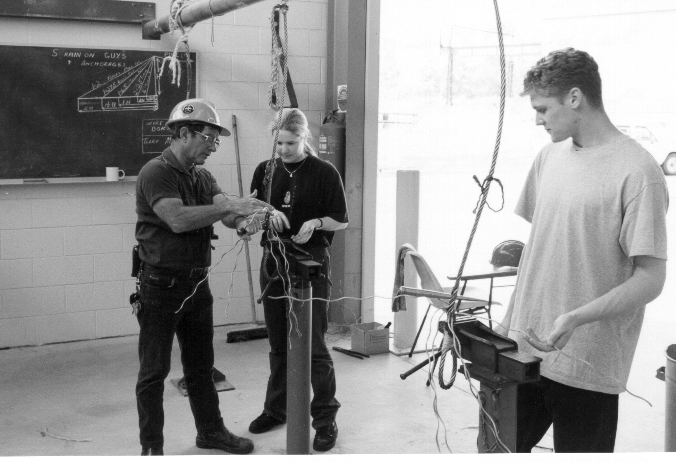

Prepared by Stuart Maxwell, National Industrial Officer
26th November 1999

Summary

The CFMEU is highly critical of the way in which the new apprenticeship system and vocational education and training are being implemented. Whilst we do not oppose the move to a competency based training system and a widening of the training provider market to encompass private providers, the lack of proper checks and balances has lead to abuse of the system and what some believe to be fraudulent practices.

We firmly believe that the interests of the industry are being supplanted by the vested interests of the state training bureaucracies and private training providers, to the detriment of the apprentices and trainees. User Choice is not working in its current format and needs major revision. Also VET in schools must be reviewed as in some instances people are more concerned about the financial gains to be made by schools rather than the training outcomes.

The union is hopeful that this inquiry can properly identify the problem areas and come up with appropriate recommendations that will improve the quality of vocational education and training in Australia.

- Introduction

1.1 The CFMEU (Construction and General Division) welcomes the opportunity to make this submission to the Senate Inquiry as for some time we have had serious misgivings about the introduction of the new apprenticeship system and its effects on the quality of training.

  - We would point out that the issue of vocational education and training is not a new idea for our industry, as the training of skilled tradespeople through on the job and off the job training has been part of the industry worldwide since the middle ages. Whilst it is encouraging to see the expansion of the concept to other industries, it is somewhat disappointing that they have not attempted to retain some of the more beneficial aspects that we believe have been developed through many years of experience.

1.3 In preparing this submission we are mindful of the fact that vocational education and training covers a very broad subject area, however we have attempted to keep our focus on training for the building and construction industry. We have also attempted to keep our comments as brief as possible and address issues in a more general approach rather than submit a lengthy detailed submission. We would of course be willing to appear in any public or private hearings of the Senate Committee to expand on any of the points made.

2. Issue (a) - An evaluation of the place of the new apprenticeships scheme within the national priorities set for Australia's vocational education system and the appropriateness of those priorities

2.1 The allocation of resources is a major problem. Two examples are the fact that resource allocations for publicly tendered VET are based on DEETYA regions (i.e. where people live and not where the work is), and secondly that in most cases the state authorities are still allocating resources and financial assistance on the basis of student contact hours. Whilst this basis of funding may be appropriate for time served apprenticeships and a rigid system of a finite number of training providers, it is incompatible with a system based on the achievement of competencies (where the number of student contact hours required may vary between individual apprentices depending on their ability) and a flexible delivery system in which training agreements can have varying time requirements and/or a range of different training providers.

2.3 Also with the development of new training courses there is an obvious need for increased funding to ensure their viability, but not at the expense of existing training programs which have been revamped to competency based. This is a particular problem for the building and construction industry where the revamped traditional apprenticeship areas are still in demand, but we have also introduced a range of new apprenticeships into areas where no formal training previously existed (eg plant operators, skilled labourers etc).

  - A further concern is the situation where the States are continuing to fund short courses that do not comply with the training packages (e.g. steelfixing courses in NSW and QLD). This point was recognised in the Independent Investigation into the Quality of Training in Queensland's Traineeship System - Final Report by Kaye Schofield, July 1999, (the Schofield Report), which included the following as one of the reasons for the diminished formal training requirements,

"the slower than anticipated implementation of Training Packages in Queensland (and in other States) and the continuing use of existing products which may not meet the requirements of the NTF" (page 49).

It is our experience that none of the States are complying with the agreement reached at the Ministerial level.

2.5 The issue of demographic distribution and equity of structured training opportunities raises a number of matters which we believe are not being adequately addressed. These include:

- Lack of available training resources, which are capital intensive, outside of the capital cities.
- Lack of industry approved training providers and employment opportunities for people in non-capital city areas.
- The costs of travel and accommodation for apprentices from non-capital city areas who have to travel.
- Whether centres of excellence in industry training should be established, with the appropriate accommodation facilities (similar to universities and NSW TAFE facilities at Kurri and Castle Hill).

The NCVER TAFE Graduate Destination Survey 1998 - National Report showed that the majority of graduates (62.1%) lived in a capital city and 64.9% of VET participants attended a provider in a capital city. Of those who relocated to undertake training (7.1%), the main reason for doing so were because the local TAFE did not offer the course they wanted to do or because there was no TAFE in the vicinity. Males, younger people (under 25 years) and those of ATSI background were more likely to relocate. Also graduates in Tasmania and Northern Territory were more likely to re-locate to do the course than in other States. (Page 8)

2.6 In regard to the issue of opportunities for youth and for older people the statistics on who is actually undertaking apprenticeships and traineeships are not encouraging. According to the NCVER Report the mean age of TAFE graduates in 1998 was 31 years and the median age 27 years. The Schofield Report in dealing with the age of trainees in Queensland found that "New approvals for traineeships over the past few years have escalated significantly across all age groups, but particularly in the 25-39 and 40-64 cohorts" and that "In 1994 young people aged 24 years and under comprised 87.92% of all traineeship commencements. By 1998/99 this had fallen to 51.65%". (Page 24)

3. Issue (b) - An evaluation of claims that the key objectives of the original new apprenticeships scheme, as agreed by the states and territories, are not being met

  - The union believes that in a number of circumstances the training outcomes are of diminishing quality. The main reason seems to be that because delivery arrangements under the contract of training are so flexible some employers and RTO's are using the system to make dollars but are not providing structured training to new apprentices. The anecdotal evidence from our Victorian Branch includes the following:

- A new apprentice in the housing sector was used as a labourer and told he was not allowed to got to school. He was sacked, lodged an unfair dismissal claim and won but the company folded.

- A new apprentice in plastering reported a ratio of trades to apprentices with the company he worked for of 60 apprentices to 28 tradespersons. He reported that he was receiving inadequate instruction and supervision on the job. And when he asked for structured training was given 3 booklets to take home, read and fill out. He left the company and found another employer who sent him to trades school. The previous employer challenged and the apprentice attended an inquiry with the State Training Board. The State Training Board found that the training provided by the first company did not breach the training contract and the apprentice was told to return to that company.

- The union received a report from a large public TAFE provider that an employer association that is also an RTO poaches their students once the students have completed their pre-apprenticeship. The apprentices are placed by the employer association with a member company where almost all training is carried out on the job, with 4 visits per year by the RTO for assessment. The TAFE reported that the private RTO has a trainer/apprentice ratio of 1 trainer to 50 apprentices. The TAFE provider also reported that they were receiving an increasing number of complaints about the quality of this RTO's training. The union has received similar complaints.

- Two new apprentices who were signed up for training with the CFMEU did not turn up. Once the apprentices were tracked down it was found that they had not been paid either.

- The Branch has dealt with 6 unfair dismissal claims for apprentices this year and lack of training has been common to all of them.

- There is a general feeling that new apprentices are being used as cheap labour and that they are only being taught the minimum skills required to carry out specific job needs and this is done with the minimum disruption to productive time.

  - The Schofield Report made similar observations as the following conclusions indicate:

"9. Notwithstanding some strengths and some quality characteristics, the investigation has concluded that, on the whole, Queensland's traineeship system is only partly effective, is not fit for its purpose, is inefficient and its accountability framework is not as strong as it needs to be. In short, it cannot reasonably be described as a quality system.

- The incidence of service failure within Queensland's traineeship system is unacceptably high. Survey interviews show that 19% of trainees receive no training from their RTO and many RTO's are minimising their obligations in terms of delivery and assessment. 27% of employers and 36.7% of trainees indicate that they had no involvement in developing the Training Plan and 39% of both groups indicate that the Training Plan has never been referred to in order to check progress.

- 22.5% of employers are not satisfied with the assessment delivered by the RTO and 18.7% do not believe that the trainees' skills have been adequately assessed. 16.8% of employers and 19.1% of employees indicate that the Training Plan did not take into account the literacy and learning needs of the trainee. 26% of trainees felt that they should have commenced their traineeship at a higher level.

- Doubts must be raised about whether skills are being properly assessed and qualifications are being validly issued at Australian qualification Framework (AQF) for some elements of level 2, and levels 3 and above where the training is provided 'fully on-the-job'. At these levels it is most unlikely that the broad range of competencies, transferable skills and underpinning knowledge could be acquired and assessed properly without a structured learning program, without the substantial and active involvement of a RTO and without the withdrawal of the trainee from daily work processes.

52. Enhance quality in the training program. Repeatedly throughout this investigation, the quality of training provided through 'fully on-the-job' training has been called into question. In the interests of the learner, disincentives to 'fully on-the-job' training delivery are necessary. Steps must also be taken to reduce the high incidence of service failure in relation to the Training Agreement, the Training Plan and training delivery."

3.3 We are further concerned at the push (under the disguise of alternative pathways) for full institutional-based training as this will not lead to trainees/apprentices meeting the requirements of being on the job competent. We are aware of the consensus reached at the JITEC meetings that there needs to be a balance between off the job training (focused on theory) and on the job training (focused on practical application under the guidance of a mentor). Totally on the job or totally off the job training is unacceptable.

3.4 The union believes the system is more complex and suffers from training providers and NAC's promoting courses that they know nothing about. A perfect example is the situation where people are being signed up for the industry Nettforce traineeships which no longer exist. Our belief is supported by the finding in the Schofield Report of "a lack of awareness by some NACs of the requirements of Training Packages and the NTF and the use of a business model which discourages the marketing and explanation of the full range of available products."

  - A further example of the complexity of the system is the way in which apprentices are signed up. Employers and apprentices no longer have a centralised system by which they can find out about what is available, get registered and have ongoing queries dealt with. Employers and parents of apprentices frequently ring the union, confused about the system. There appears to be a deal of frustration about how to access the papers to sign up an apprentice, once a NAC is located which of the variations and combinations of Certificates in building and Construction are relevant and which are redundant, what are the implications and obligations for both parties of signing the training agreement. Flexibility and user choice seem to have left employers and apprentices confused with both parties needing more direction.

  - Our suspicions are that the system is being driven by financial incentives and targets rather than the needs of the industry. The targets are being driven by the Federal Government who want to increase the number of people undertaking new apprenticeships. The problem is however that more people are undertaking short courses rather than the longer courses (such as the trade level training). The value of this shift to industry and the apprentices has not been identified by any research that we are aware of, but we believe it is detrimental.

  - In regard to the financial incentives, we believe these are driving the training providers and employers who in some cases are more concerned about the money than the quality and relevance of the training being provided. This view is supported by one of the conclusions of the Schofield Report that "Employers and trainees appear to have different expectations of traineeships from those of Government. This is most apparent where the traineeship program is marketed on the basis of employer access to financial incentives and where Registered Training Organisations (RTO's) and New Apprenticeship centres (NAC's) seek to minimise the training obligations of employers in order to maximise the take-up of traineeships." (page iii)

Also as reported in the Schofield Report some of the contract breaches identified by the Business Improvements Group, DETIR, User Choice Contractual Compliance Audits, Case Example (1999), included:

- Appointment of casual staff as trainees
- Employers were using the traineeship system to fund in-house training and programs for existing workers
- Large franchising companies inappropriately placing staff into traineeships. In most cases these had been organised by head office representatives, without consulting the local manager
- Trainees being placed in inappropriate courses simply because RTO's did not hold registration to deliver more appropriate training
- Appointment of casual staff and existing workers such as managers, supervisors, proprietors and spouses into traineeship positions
- Trainees being required to undertake training in their own time without pay
- A trainee being recorded as completing an entire traineeship in two and a half hours

- Issue (c) - An assessment of the quality of provision of technical and further education (TAFE) and private providers in the delivery of nationally recognised and non-recognised vocational education and training (VET) services and programs

  - The union is concerned that in regard to the issues relating to administration, assessment, audit arrangements, recognition and validation of registered training organisations, the various State/Territory Training Authorities are applying different criteria. This has implications not only for the industry's confidence in the quality of the training being provided and the qualifications being issued, but also the outcomes being achieved.

4.2 In regard to the use of audits there is very little statistical data available. According to the Schofield Report when the department initiated a major program of audits of User Choice contract holders in September 1998 "Of the 33 RTO's audited for compliance …… all were found to have been in breach of at least one clause, with one provider in breach of 36 clauses, and there were seven contract cancellations" (page 29). Given that there are 214 RTO's in Queensland with current contracts to deliver training, the implications nationally are horrendous.

4.3 The union would much rather see the industry (through the National ITAB and assisted by the State ITAB's) setting the criteria and standards to apply. This is particularly so in regard to industry approved assessors and training providers. In 1997 the industry through the National ITAB developed a comprehensive policy on the requirements for assessors, which is much more demanding than the requirements of ANTA and the various training authorities. Our view is supported by one of the recommendations of the Schofield Report which states "VETEC should limit the registration of providers of skills recognition (assessment only) services in Queensland to suitably qualified ITAB's or recognised industry bodies." (page xi)

  - It is our view that the non-endorsed component of the training packages is a problem affecting the quality of the training being delivered. A number of short courses being offered in rigging and scaffolding do not comply with the delivery of training required by the non-endorsed component of the training package approved by the industry (through the National ITAB). This put a question mark on the bona fides of the assessment.

4.5 The reasons for the increasing rates of non-completion of apprenticeships and traineeships are numerous and vary across industries. A particular problem in the building and construction industry is the way in which work is organised, especially the sub-contracting system. This means that employers have become more specialised in the work that they perform resulting in smaller parcels of work on major construction projects which take increasingly shorter periods of time to complete. Coupled with the boom-bust nature of the industry this leads to employers finding it difficult to offer continuity of employment.

4.6 A significant factor that has more general application has been the change from indentured apprenticeships to contracts of training. Whereas under the system of indentures it required either party to make application to the appropriate tribunal (and present a reasonable argument) to have the apprenticeship cancelled, under the system of contracts of training the contracts can be cancelled at the stroke of a pen. Where State Training Board Inquiry systems are in operation their results are not very encouraging as can be seen from the example in above. The union supports the establishment of a Disputes board to handle these issues, or as recommended in the Schofield report "a statutory position of Trainee Ombudsman to provide a free, impartial and independent office of last resort for resolving trainee complaints about the nature, scope and quality of the training they receive and the environment in which they receive it. The extension of this position to encompass protection of apprentices should be considered." (Page xiv)

4.7 Another factor is the provision of financial incentives upfront rather than as progress payments. This removes incentives for the employer to keep the trainee or apprentice on until the completion of the training.

- Issue (d) - An examination of the impact on the quality and accessibility of VET resulting from the policy of growth through efficiencies and user choice in VET

  - The union would question whether any efficiencies are being achieved. In our experience the constant series of changes to the new system both in terms of structure and terminology has led to much confusion and inefficient implementation.

  - As for the user choice system we are of the opinion that this has been an abject failure and done nothing to improve the quality and accessibility of VET. The reality is that under user choice it is still dependent on what the training provider can do in terms of having the resources available to offer the course, that impacts on accessibility. This means that in most cases the system is still provider driven. Our view is supported by the following conclusions of the Schofield Report,

"37. Under User Choice, the employer is treated as a proxy purchaser of government funded training services - theoretically making an informed decision that directs public funds in the most efficient and effective manner. In practice, the payment system is initiated by the financial beneficiary of the system (the RTO) without any validation by the proxy purchaser (the employer) and paid by the actual purchaser (DETIR). In summary, User Choice today harbours the worst features of both a voucher system and direct government procurement, with none of their benefits.

38. The second fundamental flaw relates to assumptions made about the viability of traineeship markets in Queensland. User Choice was introduced in Queensland on the assumption that it required a minimalist and purely reactive role for Government in the purchasing process. It has been shaped by the belief that greater quantity = greater competition = efficiences. This logic failed to recognise the legitimate role that Government plays in all markets: to set the rules of the market place, to ensure that buyers and sellers have the information needed to operate in the market, to recognise and act in instances of market failure, and to protect public investment in the market. In other words, the planning function that should have underpinned the introduction of User Choice was sacrificed in order to deliver an ambitious, high risk implementation plan, overly reliant on market drivers." (Page vi)

  - In regard to student services we believe that in most cases these are non existent outside of the public providers.

- Issue (e) - An evaluation of the provision of Commonwealth and state employers' subsidies

  - As to employers' subsidies in general see 4.5 above.

  - In regard to the provision of employers' subsidies to existing workers the union is not opposed to this funding being available as it has the potential to be very beneficial to our industry in up-skilling the workforce, especially through recognition of prior learning. Of the workforce in the building and construction industry over 50% of the workers have no formal qualifications. Our concern however is the potential for abuse. (See also 3.7 above)

- Issue (f) - An evaluation of the growth, breadth, effectiveness and future provision of vocational education in schools

  - The union has been supportive of the introduction of vocational education in schools however we have had a major concern as to the quality of the training being provided. There is also the question of whether the students can actually meet the competency standards in terms of being competent on the job given their limited exposure to work in the industry.

  - As the push for the provision of vocational training in schools gathered momentum the industry through the National ITAB developed a Certificate I in General Construction specifically for this purpose. This qualification took into account the limited opportunities for school students to gain on the job work experience.

  - Over recent time however we have seen the education sector push for higher qualifications to be included in the school to work program. For example OTFE in Victoria wanted students to train up to Certificate II level on the basis that only including the requirements of Certificate I would not meet their points requirement for an academic qualification (i.e. the VCE). Our argument in response is that they should build up the other academic requirements as the schools cannot provide the students with the on the job training and work experience to meet the competency levels required for the Certificate II. Also in Tasmania they are attempting to introduce a program whereby school students who complete year eleven qualify for a Certificate I and after year twelve they obtain a Certificate II with a Statement of Attainment for additional Certificate III units!

  - Our experience shows that it appears as though the push for greater vocational training in schools has more to do with empire building in terms of attracting limited government funding, rather than the demands of industry. (It is interesting to note that one of the biggest complaints concerning new entrants by employers is the lack of numeracy and literacy skills, which begs the question of what are the priorities of our secondary school system?).

  - Therefore, there is an urgent need for more dialogue between the schools and the National ITAB to ensure that there is a nationally consistent approach. Failure to adopt a national approach could ultimately lead to the industry removing its support for vocational education in schools.

- Issue (g) - An assessment of the consistency, validity and accessibility of statistical information on the performance of national VET systems, especially relating to apprenticeships and traineeships

  - Apart from some of the statistics put out by the National Centre for Vocational Education Research Ltd (NCVER) there is very little information that is readily available. One of the more urgent areas where research is needed is in regard to the number of apprentices and trainees who do not complete their contract of training and the reasons why.

__________________________________________________________

