The Association of Heads of Independent Schools
Submission to the Inquiry into the
States Grants (Primary and Secondary Education Assistance) Bill 2000

Introduction

The Association of Heads of Independent Schools in Australia (AHISA) welcomes the opportunity to contribute to this Inquiry. Our members have appreciated the extensive consultation that has been conducted before the Bill has reached this stage but find it disappointing that the time for response to the Inquiry is so short. This AHISA submission is especially concerned with the new socio-economic status based funding arrangements.

AHISA

The Association is a peak educational organization and presently its members are Heads of 280 Independent schools in Australia educating more than 232 000 students. Of these schools, half offer single sex schooling while the other half are co-educational. They are all independent in the sense that they are free to be different, not only from the government schools but also from each other.

The members of this national Association have a strong interest in the quality of the education of all Australian children and pledge their support for government schools and other non-government schools, concerned for the future education of the students in their schools.

SES Funding Arrangements

The SES Funding Arrangements are supported by an overwhelming majority of our schools because
- They model a system of funding that centres on the interests of families and students, not institutions
- They begin to address the serious inequities in the funding of independent schools
- They take into account the circumstances of the student population of a school to assess need, hence delivering greater equity for parents of independent school students because they are based on student and family need
- They use objective data related to occupation, income and education through the use of student address data, rather than school-generated data
- The methodology is credible as a measure of relative socio-economic disadvantage. It has been used for more than twenty years by Catholic Education Commissions, Independent Schools Block Grant Authorities and Government Education Departments
- They are more efficient and transparent than the ERI, which is inequitable and complex
- They give schools more flexibility to cater for a broader range of students, and to provide more diverse educational programmes
- They provide parents with greater choice of schools. Many parents of today give close attention to the educational options available for their children, and want to choose the right school for their child.

Support from Federal and State Governments

- The United Nations Convention of Human Rights accepts that the parents are the primary educators of their children
- Parents have a right to exercise choice in the education of their children
- Students in our schools have a right to support from the Federal and State Governments
- Governments benefit financially from the exercising of this choice by parents choosing independent schools for their children. There are significant savings to the taxpayer because students in independent schools do not receive funding at the level of the AGSRC.
- The general community benefits from a diverse education system. There are significant educational, social and economic benefits.
- The funding by State and Federal Governments must be considered together if comparisons are made between non-government and government schools educational funding. Under the Federal Constitution, the States have the responsibility for schooling. In the 60’s, the States asked the Commonwealth Government for assistance with the provision of resources caused by a rapidly expanding population.
- The States have been the greatest beneficiaries of the Federal Government’s involvement in school funding, because the Federal Government has played an increasingly important role in educational funding and provides the bulk of the public resources to students in independent schools.
- The SES funding arrangements will fund individual students between 13.7% and 70% of the average cost of educating a child in a government school (AGSRC) depending on the relative SES of the school attended
- It is a pity that there is often inaccurate and misleading media information on this issue.

Choice and Diversity

Fostering choice and diversity has broadened and will continue to broaden the options available to parents.
- There has been growth in the number and size of independent schools over the past thirty years. Often the cultural and religious diversity of multi-cultural Australia is mirrored in these schools
- There is a widening of the income groups accessing independent schools. Independent schools are not only for the wealthy and there is hard data to demonstrate that parents are choosing to educate their children across education sectors with many parents earning high incomes sending their children to government schools. There are also many parents making hugs sacrifices to send their children to independent schools
- Funding to independent schools is paid on behalf of parents who choose to exercise choice and who invest in their children’s education from their after—tax income.

The inequable and complex ERI Model versus SES

AHISA members agree that the ERI model is inequable, inflexible and complex and have followed with interest that various reviews that have been undertaken by successive Federal Governments in an attempt to redress these inequities.
- The new recurrent resources available under the SES funding arrangements will have more success in addressing these inequities for those schools whose needs have been inaccurately assessed using the ERI
- SES Funding is objective, transparent, understood by schools, fairly easy to explain to parents, enables efficient planning and allows a review process – all features that the ERI model lacks.

The Transition Phase from ERI to SES

AHISA supports the maintenance funding mechanism.
- The guarantee that no schools are worse off during the transition phase means that schools can plan their operations with certainty
- The funding maintenance during this period will ensure that there is no closure of schools and dislocation of students. This might well have happened if funding were cut drastically to schools who have higher SES scores than their existing funding levels
- At the end of the four-year transition period, students in independent schools will still receive less support from the Federal and State Governments than children in government schools.

Consultation and Review

Our members have welcomed the extensive consultation that has taken place in this reform process. The result of this consultation is that the SES funding arrangements are understood and seen as transparent and objective. Through the modelling that has taken place, independent schools have been able to assess the validity of SES. Hence there is widespread endorsement of the SES model. However it is vital that there is a built-in review process so that future inequities, whether perceived or real can be addressed and redressed effectively.

Conclusion

The Association of Heads of Independent Schools of Australia recommends that the Parliament of Australia debate and pass the State Grants (Primary and Secondary Education Assistance) Bill 2000 as quickly as possible. There is a need to move to a more equitable system of funding as soon as possible and there is a need for parents and schools to know with certainty how to plan and budget for the school year 2001.

Submitted and approved by

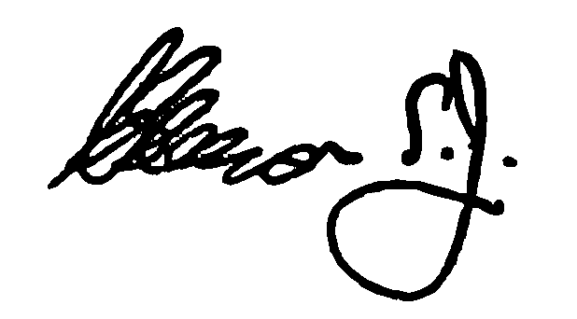

Fr Christopher Gleeson S.J.
Chairman of AHISA

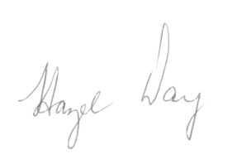
Prepared by Hazel Day

Executive Assistant to the Chairman of AHISA

Association of Heads of Independent Schools of Australia
Mercer House, 82 Jolimont Street
Jolimont Vic 3002

Direct line 03 9650 8679
hazelday@ahisa.com.au
www.ahisa.com.au

