Kakadu - World Heritage undermined

An update for the World Heritage Committee prepared by Australian Environment NGO’s

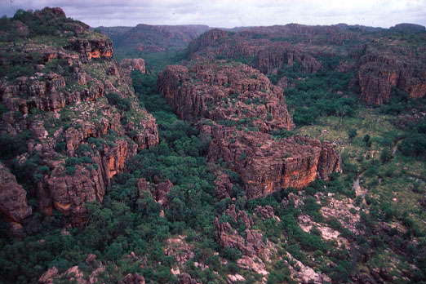

Escarpment country on the Jabiluka mineral lease Photo: Sandy Scheltema

This document summarises key developments that have taken place in relation to Kakadu National Park and the Jabiluka uranium mine proposal since the 24th session of the World Heritage Committee in Cairns, Australia in December 2000.


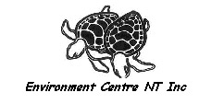



Developments since the 24th session of the World Heritage Committee - Kakadu National Park.

This document summarises key developments that have taken place in relation to Kakadu National Park and the Jabiluka uranium mine proposal since the 24th session of the World Heritage Committee in Cairns, Australia in December 2000.

Australian environment NGO’s believe that Kakadu’s natural and cultural World Heritage values and properties continue to be actively threatened by the Jabiluka project despite the World Heritage Committee’s consideration and actions on this issue to date.

1. Environment groups concerns re impacts of Jabiluka project.

Australian environment groups have highlighted major concerns about the environmental impacts of the proposed Jabiluka mine since the development of the mine was recommenced in 1996 by mining company Energy Resources of Australia (ERA). Traditional Owners of the Jabiluka area have also consistently expressed their opposition to the mine and the associated social, cultural and environmental impacts. Environment groups share and support the concerns of the Mirrar Traditional Owners as represented by the Gundjehmi Aboriginal Corporation and respectfully acknowledge their continuing efforts to protect their estate and living culture.

Some of the outstanding environmental concerns related to the mine proposal include:

- The mining lease and project area is inappropriately located within the external borders of the World Heritage area (see map overleaf). The very existence of uranium mining operations within the external boundaries of the Kakadu World Heritage area, upstream of its internationally significant (RAMSAR-listed) wetlands and within the World Heritage cultural precinct threatens both cultural and natural World Heritage values and properties and the integrity of the World Heritage area.

- Whilst additional scientific studies prompted by international intervention have further quantified some of the impacts of the Jabiluka mine proposal there remains no publicly available current mine plan. As the project has changed considerably from the approved proposal it is impossible to quantify the potential impacts of the mine. Key issues such as whether or not a uranium mill will be constructed at Jabiluka and where tailings would be disposed of post-mining have yet to be determined.

- Many of the key recommendations attached to the approval of Jabiluka under Australian law and procedures have yet to be satisfied. Australia has further failed to meet a number of important commitments made to the World Heritage Committee.

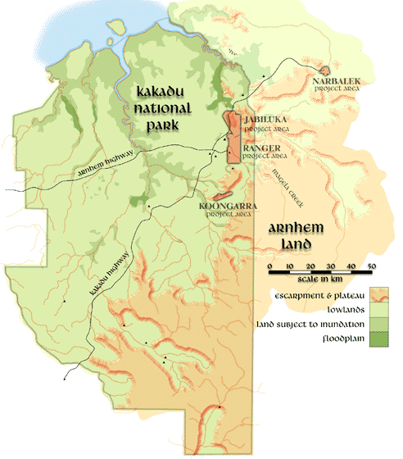

The Jabiluka, Ranger and Koongarra leases surrounded by the World Heritage listed Kakadu National Park. Source: ANAWA.

- The Jabiluka lease shares the natural values of the surrounding World Heritage area. The conservation values of the lease area epitomise the natural values of the region. Prior to the commencement of construction Swift Creek, directly downstream from the mine site, had a River disturbance index of zero. This is the highest Wild River value. The Jabiluka lease contains important wetlands and waterways that are interconnected with, and in some cases the same waterbody as, the Ramsar-listed wetlands of Kakadu. Disturbance or destruction of the natural and cultural values of the Jabiluka site would directly impact upon the integrity of the interconnected and co-dependent natural and cultural values of Kakadu.
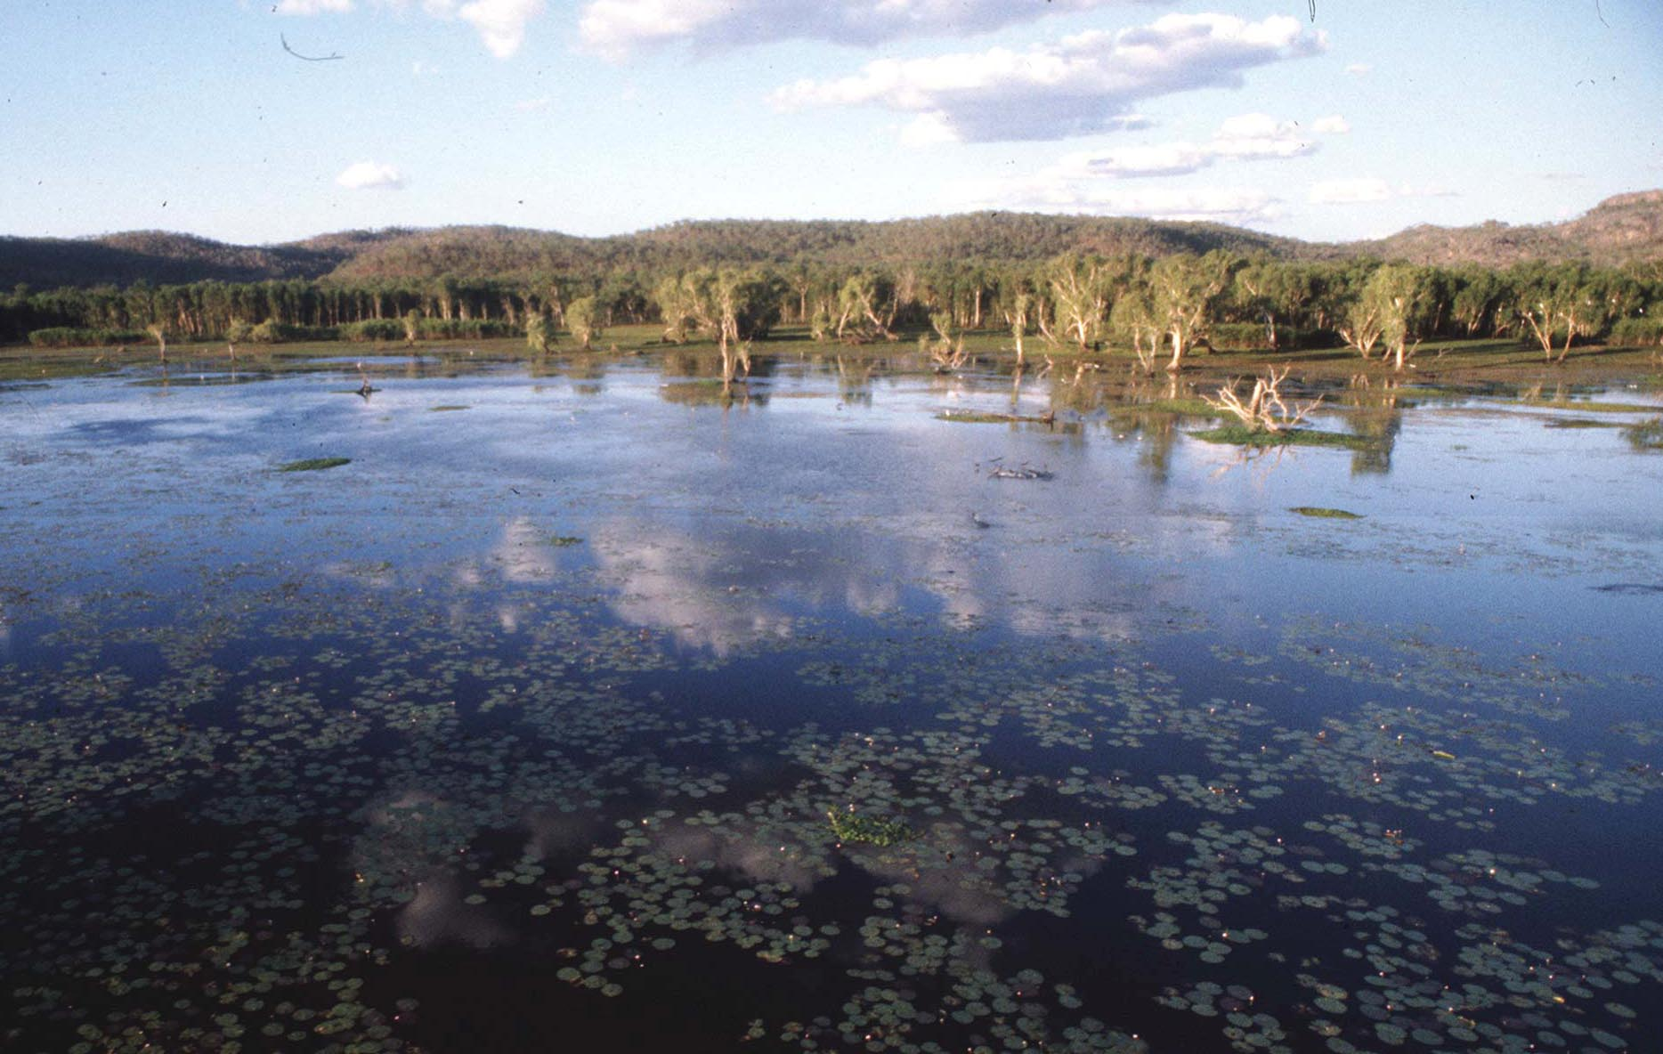

The Magella floodplains downstream of the Jabiluka mine Photo- S.Scheltema

- The flawed assessment and approvals process for the Jabiluka mine enabled construction of the mine to begin prior to the company receiving all necessary approvals to develop the mine or without the full range of project configurations being given adequate consideration. This has led to the current situation where potential environmental hazards including the mineralised ore stockpile and the ‘interim’ water management pond have been created on site.

In its September 2000 report the Independent Science Panel stated:

“the Supervising Scientist has indicated that, should further developments at Jabiluka be delayed for a protracted period or, if the mining company propose to mothball the site, the SS would consider what arrangements would be necessary to ensure that the site continues to pose no significant threat to the World Heritage property. Options that the SS would consider would include re-vegetation of the waste rock stockpiles, emplacement of the mineralised material stockpile in the decline, sealing of the decline, and decommissioning the water management facilities.”

Discussions to date over necessary short-term rehabilitation initiatives at Jabiluka have been blocked by the mine’s primary regulator, the Northern Territory Government, in the Minesite Technical Committee. This is despite the fact that majority project shareholder Rio Tinto has ruled out the short-term development of Jabiluka and that calls for staged rehabilitation have subsequently been formally made by both the regions Traditional Owners and key environment NGO’s.

2. Current situation at Jabiluka as at September 2001.

There has been no further construction at the Jabiluka mine site since September 15 1999. In March 2001 Leigh Clifford, the CEO of Rio Tinto (68% owner of Energy Resources of Australia), stated that because of the lack of Aboriginal traditional owner consent, wider community opposition and record low market prices for uranium “it would be hard for us to support a development in the short term”.

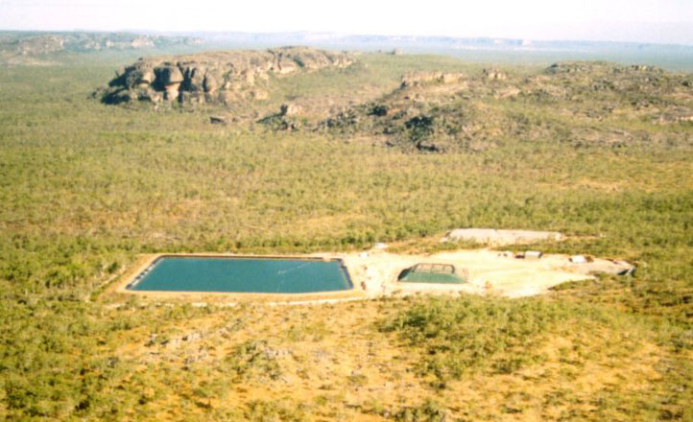

The Jabiluka mine site July 2001. Photo: G. Mudd

- Environmental hazards at Jabiluka

The principal environmental hazards at the Jabiluka site are the mineralised ore stockpile and the ‘interim’ water management pond (IWMP). The estimated 50,000 tonne stockpile of mineralised ore unearthed during the construction of the Jabiluka decline is currently covered with a tarpaulin. This is not an acceptable long-term management option for radioactive materials inside a World Heritage area in a monsoonal region.

Water management problems emerged at Jabiluka over the 1999/2000 wet season with the interim water management pond (IWMP) filling almost to capacity. The water in this holding pond is contaminated with elevated levels of uranium and other materials. Following the 1999/2000 wet season Energy Resources of Australia committed to installing a Reverse Osmosis (RO) plant in early 2000 to capture contaminants and filter the water to a standard suitable for irrigation on the Jabiluka mineral lease. After several months of delay the company finally got an RO system in place towards the end of 2000 but this did not happen in time for ERA to process enough water before the 2000/2001 wet season.

In mid-February 2001 the company was forced to resort to pumping water from the IWMP into the mine decline and underground shafts in order to avoid the IWMP overflowing. This process has led to further contamination of accumulated water at the Jabiluka site with a subsequent significant elevation in the contaminant load. According to the Supervising Scientist “the contact with the ore body at the very bottom has increased the concentration of uranium in the water in the decline to 1,500 parts per billion.” By the end of the wet season around 20ML of water was in the decline. It is unlikely that ERA will be able to treat all of the contaminated water prior to the 2001/2002 wet season.

The IWMP is now serving as the primary component of a long-term water management system at Jabiluka, despite the fact that, as the term "interim" suggests, it was only designed to be operational for a period of 12 months. As identified in the ISP reports, project delays could result in the use of the interim pond for a much greater period than it was designed for. The fact that Jabiluka is experiencing major water management problems at this stage of development does not bode well for either future water management at the mine site or for the protection of the region’s World Heritage values. Moreover the water management problems emerging at Jabiluka once again highlight the inadequacy of the Jabiluka assessment and approvals process.

Further detail and documentation regarding the flawed and failed Jabiluka assessment and approvals process is contained in a series of earlier reports tabled for the World Heritage Committees consideration including Kakadu: World Heritage under Threat and Jabiluka: The Undermining of Process: Inquiry into the Jabiluka Uranium Mine Project”

As noted earlier discussions over the rehabilitation of Jabiluka have been stalled to date due to the former NT Government’s political commitment to the development of the Jabiluka project and its unwillingness to consider the necessary rehabilitation options.

b) Corporate and political uncertainty surrounding the future of the project

Corporate uncertainty- In August 2000 North Ltd, the then parent company of Energy Resources of Australia, was taken over by Rio Tinto. This has meant that Rio Tinto is now the majority shareholder in ERA with a 68% holding and that ERA is currently directly managed by Rio Tinto's Energy Product Group8. Following its take-over of North Ltd. Rio Tinto undertook a review of all North’s operations and assets, including ERA. In March 2001 Chief Executive Officer Leigh Clifford stated that “it would be hard for us to support development (of Jabiluka) in the short term” because of the lack of Aboriginal traditional owner consent, wider community opposition and record low market prices for uranium.

It is encouraging that Rio Tinto has acknowledged the clear opposition of both the Aboriginal Traditional Owners and the wider community to the development of Jabiluka. However this announcement in itself does not actively mitigate or adequately address the threats posed by Jabiluka to the World Heritage values and properties of Kakadu National Park.

Rio Tinto essentially have two broad options in relation to Jabiluka. One scenario involves Rio Tinto, supported by the Australian Government and the World Heritage Committee, moving away from attempts to develop the mine. This scenario includes the staged rehabilitation of the site and the incorporation of the Jabiluka mineral lease into Kakadu National Park and the surrounding World Heritage area. This approach was supported in a recent resolution adopted by the Australian Senate and discussed in more detail later in this report.

Alternatively Rio Tinto may attempt to either sell or develop ERA and/or the Jabiluka mineral lease. Such a scenario could see the mine either actively developed or mothballed for an extended period. The emerging water and other management problems at Jabiluka means that any scenario which resulted in the site being left in its current state would be a poor environmental outcome. At the same time it is clear that any attempt to develop the mine would severely exacerbate the existing environmental, social and cultural impacts of the project.

The corporate uncertainty surrounding the future of the Jabiluka project has been highlighted by the continuing poor market performance of ERA. A recent company report has shown a marked slump in company dividend, earnings and profit. This is the latest in a series of downward indicators for ERA and has heightened concerns over both the company's financial capacity and the potential adverse impacts of operational cost cutting initiatives.

The current corporate situation at Jabiluka is highly fluid and clearly demonstrates that the project is not a fait accompli. Considerable scope exists for the Australian Government and the newly elected NT Government to work with Rio Tinto and the appropriate domestic and international agencies to address and avert the certain, probable and possible impacts to both the Jabiluka mineral lease and the surrounding World Heritage Area.

Such an approach would be most fully realised by foregoing development at Jabiluka and incorporating the lease area into Kakadu National Park. The Australian and NT Governments have a clear and decisive course of action available should they choose that would guarantee the protection of the natural and cultural World Heritage values and properties of the Jabiluka lease and Kakadu National Park. Such an approach would also be consistent with demonstrated community concern and expectation in Australia and would accordingly enjoy wide support.

Political uncertainty - The uncertainty that surrounds the Jabiluka project has been further heightened since the Cairns World Heritage Committee meeting. There has been a strengthening of opposition to the development of Jabiluka within the Australian domestic political context, especially from the previous party of Australian Government and current principal Opposition Party, the Australian Labor Party (ALP). At its most recent national conference the ALP deplored plans for the development of Jabiluka and committed to opposing the mine whilst “seeking a permanent outcome for the Jabiluka mineral lease which protects the outstanding natural and cultural values of both the lease areas and the surrounding National Park”.

In March 2001 in the wake of Rio Tinto’s announcement the Australian Senate passed the following motion:

“That the Senate-
- notes the announcement by Rio Tinto in the week beginning 18 March 2001 that it would not support mine owner Energy Resources of Australia's development of Jabiluka in the short term;

- advises the Government that it is unacceptable for this major mine site including retention dams, mine construction and associated works to remain in this state for any length of time; and

- calls on the Government to commence discussions with Rio Tinto immediately with a view to an early rehabilitation of the site and for it to be handed back to the traditional owners as soon as possible.”

Furthermore there has been an historic change in Government in the Northern Territory with the first ever election of an NT ALP Government in August 2001. Previously the NT Government has unequivocally supported the Jabiluka project and fast-tracked the granting of all necessary development approvals over the past 30 years. More recently the previous NT Government had actively opposed rehabilitation at the Jabiluka site. The new NT Government’s level of commitment to the Jabiluka project is currently unclear, however nationally the Australian Labor Party is opposed to the development of all new uranium mines and has stated that it will oppose Jabiluka and "any application for the export of ore from the mine".

Given the high levels of corporate and political uncertainty surrounding the Jabiluka project it is imprudent and unacceptable to pursue development of the project at the risk or expense of World Heritage values and properties. The cessation of construction and the future uncertainty of the project raise considerable opportunities for the Australian Government to prevent further development at Jabiluka and safeguard the region’s World Heritage values and properties.

Conclusion

It is the view of the Australian environment NGO's that the Jabiluka project remains, as stated by the World Heritage Centre assessment mission in 1998, a source of “severe ascertained and potential dangers to the cultural and natural values of Kakadu National Park”.

We believe that these dangers are such to warrant the immediate inscription of the area on the List of World Heritage Properties In Danger.
We believe that the current impasse over rehabilitation requirements at the Jabiluka lease further threatens Kakadu’s natural values. Uncertainty about both the configuration of the current project proposal and the broader future of the project exacerbates the threat to Kakadu’s unique and living World Heritage values and properties.

The convergence of political and corporate uncertainty provides opportunities for the Australian Government to prevent further development at Jabiluka and work with Traditional Owners, relevant domestic and international agencies and the mining companies towards incorporating the Jabiluka mineral lease into Kakadu National Park and actively achieving an environmental and culturally just and considered resolution to this issue.

ISP of ICSU Report no. 3, p.24.
Jabiluka Minesite Technical Committee, Minutes, 23 January 2001.
Clifford, Leigh, The Australian, 23/03/01, p.22.
Commonwealth of Australia, Proof Committee Hansard, Senate Environment, Communication, Information Technology and the Arts Legislation, Consideration of Budget Estimates, Monday 4 June 2001.
Kakadu: World Heritage Under Threat, Report to the World Heritage Committee of UNESCO by Australian environment NGO’s, November 2000.
Jabiluka: The Undermining of Process. Inquiry into the Jabiluka Uranium Mine Project Report of the Senate Environment, Communications, information Technology and the Arts References Committee, June, 1999.
8 Energy Resources of Australia, Statement to the Australian Stock Exchange, 24/04/01.
The Australian, 24/03/01, p.22.
ALP Policy platform, http://www.alp.org.au/policy/platform2000/index.html
Senate Hansard, Commonwealth of Australia, Parliamentary debates, March 29th 2001, http://www.aph.gov.au/hansard/senate/dailys/ds290301.pdf
ALP Policy platform, http://www.alp.org.au/policy/platform2000/index.html
WHC-98/CONF.202/INF.3,p.6.

