ERA | Energy Resources of Australia Ltd
 | ABN 71 008 550 865

17th March 2003

Mr Michael McLean
Secretary
Senate ECITA Legislation Committee
Parliament House
Canberra ACT 2600

(via facsimile)

Dear Mr McLean,

Thank you for your letter of 7th March, with the supplementary submission from the Gundjehmi Aboriginal Corporation attached. I would appreciate you conveying the following reply from ERA to the Committee.

The Committee would be aware that the Traditional Owners are directly represented on the Minesite Technical Committee by the Northern Land Council (NLC). The NLC are funded to a large extent by mining royalties so that they have the resources to employ the specialist expertise necessary to be able to carry out their role in representing and protecting the interests of the Traditional Owners.

In this particular case, it seems that there may have been some miscommunication between the NLC and the GAC. While this is unfortunate, ERA does not consider that this provides a clear example of the “inadequacies of the MTC process” at all.

ERA did not “change its mind”, and has acted consistent with the undertaking given to the Mirrar last September when we agreed to investigate the Mirrar’s preferred option of backfilling the decline, as well as other options.

Anything that the committee can do to encourage the GAC and NLC to resolve any differences of opinion with regard to their roles in representing the Traditional Owners, would be most welcomed by ERA. It is in ERA’s interest that the Traditional Owners are well informed in relation to matters involving our operations.

For our part, we remain happy to discuss environmental matters with the NLC, the GAC and the Mirrar, either formally through the MTC, or informally.

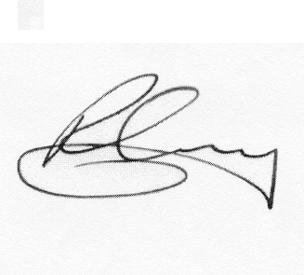
Yours sincerely,

Mr Robert Cleary

Chief Executive

