
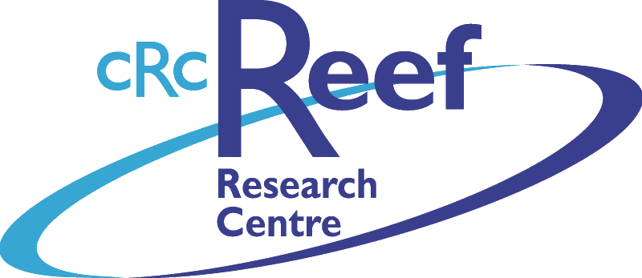
AMANDA HODGSON BSc (Hons I) (EnvSc)
PhD Candidate (Marine Mammal Biology)
School Of Tropical Environment
Studies And Geography
James Cook University
TOWNSVILLE QLD 4811
Phone (07) 4781 6941
Fax (07) 4781 4020
Email Amanda.Hodgson@jcu.edu.au

Submission to Senate Enquiry on Senator Bob Brown’s bill for a levy on plastic bags

I am in support of the proposal by Senator Brown to introduce a levy on plastic bags. I feel that to make people more aware of the number of plastic bags they use by way of charging for them would drastically reduce the number of plastic bags used in Australia. As a marine mammal biologist I am well aware of the devastating effects that plastic bags can have on our rare and endangered wildlife. I also have a degree in Environmental Science and thus am also aware of the incredible number of plastic bags that contribute to land fill and pollution.

The sight of plastic bags littering roadsides is now commonplace, indeed it is almost part of the landscape. However, these bags are not just unsightly they are a major hazard to wildlife. Discarded rubbish, including plastic bags, has to go somewhere. Sadly, much of it is washed into gutters and down storm drains, and eventually ends up floating down our waterways and into the ocean. This has been proven in clean-up efforts, during which plastic bags are commonly the most numerous items collected.

The danger to marine animals is enormous, as several species ingest plastic bags floating in the ocean, thinking they are jellyfish. The results are catastrophic for the animal. The tragedy is that this is preventable, by reducing the number of plastic bags available and educating people not to allow the bags to become rubbish in the first place.

The problem of reducing the number of plastic bags used in Australia is not impossible to solve. Recently, in Ireland, a levy placed on plastic bags has made a huge positive environmental impact by greatly reducing the number of plastic bags used.

One of the major problems facing any attempt to clean-up the environment or protect Australian wildlife, is the cost involved. A levy on plastic bags would have a twofold effect. It would reduce the number of plastic bags littering the landscape and becoming hazards to wildlife, and the money raised from the levy could be used to finance environmental projects, similar to present NHT grants for community based environmental projects. It would involve no extra costs to the government and could make a massive difference to Australian wildlife.

The initiative would appear to be timely as well as practical. The Australian public are concerned about what is happening to the unique environment of this country but often feel powerless to do anything about it. A levy on plastic bags would be an excellent starting point. Every shopper in Australia could contribute to helping the environment. A recent Roy Morgan survey showed that approximately 79% of Australians supported the idea.

The idea of a levy on plastic bags might at first seem harsh on shoppers. However, making people pay for this resource places a more accurate value on our environment. Only those who use plastic bags would pay the levy. Shoppers who make the effort to bring thing own bags would not only by economically rewarded, but would also contribute to a healthier environment and thus better lifestyle for everybody. It is fantastic to see that many supermarkets are encouraging their shoppers to bring re-usable bags. This makes excellent economic sense for the supermarkets and excellent environmental sense.

I think that the proposed levy on plastic bags is an excellent initiative and should be supported by all parties in parliament. I would also be in full support of any proposal to ban all use of plastic bags in shops. It is not difficult for people to supply their own bags, it just takes a small amount of effort. Unfortunately people will not make this effort until there is a reward involved.

Yours Sincerely

Amanda Hodgson

