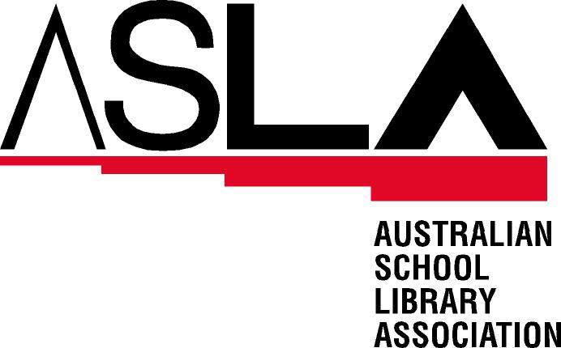
The Australian School Library Association offers the following responses to the Senate inquiry into the role of libraries in an online environment

Introduction
School libraries provide more than information services to students in today’s online world. School libraries through their multiple programs for the whole school community also provide both access to information and the learning required for the community to use the information acquired.
The most important aspect of the role of libraries in an online environment is the ability to develop information literacy programs. Information literacy is the ability to recognise an information or learning need, access and use the information in order to create a knowledge product and then present this product in an appropriate format. Within this concept, the necessary information and communication (ICT) skills are critical as is the development of critical thinking. Teacher librarians are specifically trained in this area and are a critical resource for the development of an information literate society.
Terms of Reference
The role of libraries as providers of public information in the online environment, having particular regard to:
(a) The current community patterns of demand for public information services through libraries, including the provision of such information online;
School libraries are playing a critical role in meeting the information needs of their communities by addressing increased student, parent and teacher requirements for electronic access to electronic resources beyond the school environs. This equates to community sectors within the local government area that is traditionally serviced by the public library sector.
School library websites are providing portals to school intranets that provide access to information for students to improve learning. Students and their families are increasingly seeking access to schools’ intranets and Internet sites to facilitate access to well organised and relevant materials to support home learning.
(b) The response by libraries (public, university, research) to the changing information needs of Australians, including through the provision of online resources;
Individual school libraries are developing a web presence that supports the curriculum needs of their schools for both staff and students. This includes information to support effective web-based searching, access to online databases and relevant online resources including web sites forums etc, access to school generated documents and email accounts. Many teacher librarians have responded to the needs of their school community and have become leaders in the effective use of information and communication technologies to enhance learning.
(c) Possible strategies which would enhance the wider use and distribution of information resources held by libraries, including the establishment of library networks, improved online access in libraries, online libraries, and greater public knowledge and skill in using library resources;
- Acknowledge and promote the role of the teacher librarian in establishing online learning resources to meet the demands and needs of their immediate and wider communities.
- Support the ongoing training of current teacher librarians in the area of information access, use and production – these factors are critical in the development of information literate citizens.
- Provide financial and time support for teachers to undertake further education in the field of information literacy and management
- Financial support to schools to further develop Internet presences and for promotion to the local and wider community.
- Technical support in moving beyond local area networks to wider online provision to facilitate access to school online information repositories to local communities.
- Provisioning of schools and teacher librarians to facilitate the development of an information literate community.
(d) The use of libraries to deliver information and services over the Internet to more effectively meet community demands for public information in the online environment;
The type of information required by students, especially in the senior years, also includes the current affairs areas and specific knowledge areas that the wider community requires access to. Community demands for information in an online environment can be enabled through appropriate infrastructure provisioning with a high emphasis on skill development though the use of existing school networks.
The development of portals can provide the community with rich content specifically selected for their use. This content could include online databases, websites, access to people with expertise and the ability to collaborate with other knowledge seekers.
(e) the roles of various levels of government, the corporate sector and libraries themselves in ensuring the most effective use of libraries as a primary public information resource in the online environment.
- State government Departments of Education to meet the recommendations of Learning for the future: information services in schools 2nd edition in the employment of teacher librarians in schools.
- Federal government provision of resources that emphasise the skill development or learning required with the infrastructure as the next priority.
Reference:
Australian School Library Association and Australian Library and Information Association (2001) Learning for the Future: Developing Information Services in Schools Melbourne: Curriculum Corporation

June Wall
President
Australian School Library Association

