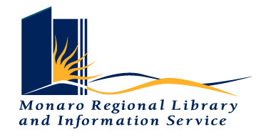
The Secretary
Senate ECITA References Committee
Parliament House
CANBERRA ACT 2600

July 31, 2026

Dear Secretary

Please find enclosed a submission to the Role of Libraries in the Online Environment Senate Inquiry. It has been prepared on behalf of the Monaro Regional Library and Information Service – a small regional library in southern New South Wales.

The Monaro Regional Library and Information Service is a joint operation provided by the Bombala, Cooma-Monaro Shire and Snowy River Shire Councils. The Library has been serving the residents and visitors to the Monaro and Snowy Mountains areas since 1963. This area covers over 15,000 square kilometres and has a resident population of about 18,500. The service currently operates the Cooma, Bombala Branch and Mobile Libraries as well as the Cabramurra Library Station.

Our submission is an attempt to give members of the enquiry an insight into how our library service has adapted to the challenges of the on-line environment. Enquiries to the undersigned would be most welcome.

Yours sincerely

Kathy Stapleton
Library Manager



