The Secretary
Senate ECITA Reference Committee

Parliament House
CANBERRA ACT 2600

SUBMISSION TO SENATE INQUIRY ON THE ROLE OF LIBRARIES IN THE ONLINE ENVIRONMENT

Central Murray Regional Public Library

In response to the Senate Inquiry the Central Murray Regional Public Library submits the following for the Committee’s consideration.

Background

Central Murray Regional Public Library services a population of about 12,000 people in the local government areas of Deniliquin, Conargo and Murray in South Western NSW.

The two branch Libraries are vital access points for recreational, informational and educational needs for all age groups and all levels of ability. Materials are provided in all print and audio-visual formats and through online resources. We have a commitment to ensure equity of access to information as part of our community obligation. Libraries are also social hubs and enjoy a position of trust in their communities and provide a ‘gateway’ to other government and community service providers.

Issues for Central Murray Regional Public Library in response to these needs includes:

- The public library’s role in matters of equity and access was the impetus for initiating public access to on-line services. Personal computers with Internet access online databases and e-mail facilities are not universally affordable for individuals or families.
- High speed, reliable Internet access is still unavailable for farming families in some rural areas
- The skills needed for using PCs and the Internet are often lacking, therefore clients rely on the help provided by library staff for accessing needed information
- The Library has high levels of use for education and training purposes which is often unavailable elsewhere in rural towns – online services are a vital component of our service for these people
- Federal and state governments and major corporations are making information available electronically, as opposed to hard copy, and negating their responsibility once the information is available online. Library staff are trained to help search and access electronic information and play a significant role in accelerating electronic access to government services
- Clients come to the Library because access to needed information is increasingly complex and many do not have the experience or higher level of skills to retrieve the needed data
- Timeliness has become an imperative for our clients – many clients expect solutions to information requests the same day or within a day or two

Current community demand patterns for use of online services in our library are as follows:

- E-mail
- Medical information
- Legal information
- Community information databases
- Government information from 3 levels of government including legislation, Australian Bureau of Statistics data etc.
- Employment related databases
- School and university assignments
- Banking services
- Bill paying services
- Genealogy
- Travel, tourism and accommodation booking
- Real estate searches
- Free Business databases
- Recreational and general information sites promoted by various media

There is a continual escalation of demand by clients for access and help in using this resource. This has placed pressure on physical spaces and staff resources.
For instance at Deniliquin Branch Library in 1996 Internet access was introduced on 2 public access terminals with a yearly total of 270 hours used. In 2001/02- 8 public access terminals - 3,435 hours used.

The technology has revolutionised the role of public libraries and the way that our services are delivered. The down side is that local government has largely borne the basic set-up and maintenance costs for these new services but the costs of exploiting further opportunities for development is prohibitive for many council libraries.

The difficulties our library is facing in relation to the above include:

- Balancing the provision of traditional library services whilst introducing the new online services with static or very limited funding support from state or federal governments. This includes selection and purchase of electronic resources when budgets are not meeting the needs for print materials
- Funding the provision of ancillary hardware needed for online service delivery, including fax machines, photocopiers and printers
- Funding the recurrent costs of necessary hardware, software and telecommunications
- Identifying the necessary infrastructure for provision of cost effective on-line services
- Inequities of costs and availability of communication infrastructure within regions and states
- Ongoing training or upskilling of staff in a rapidly changing environment
- Development and delivery of user information and education to meet rapidly changing needs
- Re-education of clients to access the best available information including the traditional print based and online materials
- The disparity of solutions to IT infrastructure and communication links between regions and states restricts networking opportunities. Delivery of online information between branch libraries is a problem for many
- Sufficient or affordable technical support for public libraries in rural areas
- Cost of commercially supplied electronic information. At present access to online databases is limited by costs of subscriptions rather than need
- Budgetary limitations for staffing and physical constraints. Local Government provides the majority of funding for public library services while councils are bleeding to death through devolution of services and costs of maintaining aging infrastructure
- Issues of sustainability. There are grants for establishment of technical services but not for ongoing maintenance or development

Possible strategies that would enhance the wider use and distribution of information sources held by libraries

- Improved resourcing for all public libraries from State and Federal governments to provide more equity of access for all Australian residents

- Facilitate an interactive web presence for all public libraries through targeted funding for hardware and technical and professional support, with a plan for recurrent support

- Provide fast communication infrastructure for delivery of online information in country areas at a price that public libraries can afford

- Facilitate consortium purchasing and maintenance contracts for public libraries for components such as hardware, software and ancillary machinery

- Provision of resources for capital works that would allow the development of buildings that will meet the changing needs and expectations of public library clients

- Facilitate free access for public libraries to Kinetica

- Subsidise subscriptions and licences for networking full text commercial data bases between co-operating libraries

- Development of online training packages and then fund the delivery of training through appropriate community organisations

- Facilitate digitisation of special collections held by libraries. This would allow sharing of and access to collections wherever and whenever clients want it

- Develop strategies for low cost sharing of resources between libraries of all kinds, including TAFE, university and public libraries

The roles of government, public sector and libraries in ensuring the most effective use of libraries

- Provide support for public libraries in NSW to comply with legislation including free access to the Internet

- Facilitate and fund national advertising to promote the roles and use of public libraries in the online environment

- Recognition and support by all government departments of the role that public libraries play in the dissemination of information and delivery of online services

- Identification of and provision of implementation and maintenance costs for new initiatives provided for libraries by government departments and the private sector to ensure more consistency and equity of services throughout Australia

- Collaboration by all governments for online initiatives to avoid unecessary duplication services or resources

- Consultation with public libraries as part of the continuing development on new online initiatives

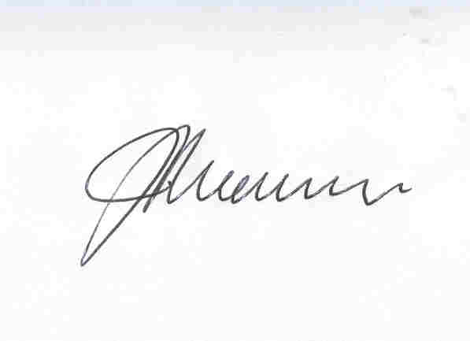
JOYCELYN HOLSCHIER
MANAGER PUBLIC LIBRARY SERVICES

CENTRAL MURRAY REGIONAL PUBLIC LIBRARY
DENILIQUIN NSW 2710

Telephone: (03) 5881 1449
Fax: (03) 5881 4833
Email: jholschier@deniliquin.nsw.gov.au

PO Box 206 DENILIQUIN NSW 2710

16 August 2002

