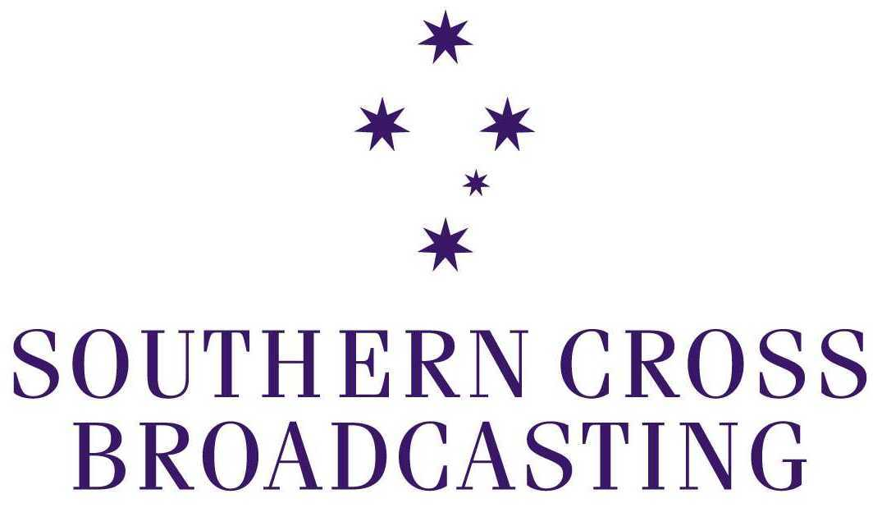

Submission to

Senate Committee for Environment, Communications, Information Technology and the Arts Inquiry into the Broadcasting Services Amendment
(Media Ownership) Bill 2002

Southern Cross Broadcasting

Melbourne, April 2002

Introduction

Southern Cross Broadcasting is one of Australia’s leading media companies with diversified media interests in metropolitan and regional television, metropolitan radio and related businesses. Southern Cross Broadcasting is a high growth media company with a clear strategic direction concentrating on brand and product excellence, cost containment and real earnings growth. These objectives are inherent in the company’s culture and are driven by management. This focus and shared vision has evolved over the past nine years to position Southern Cross Broadcasting as a company that has consistently delivered robust growth and high profitability along with a dynamic working environment. With a potential reach of more than 93% of Australia’s population, Southern Cross Broadcasting owns and operates:

Television Stations:
- Channel Nine in Adelaide;
- Ten Victoria in regional Victoria;
- Ten Capital in Canberra and Southern New South Wales;
- Ten Queensland;
- Ten Northern New South Wales;
- Seven Darwin;
- Seven Central;
- Spencer Gulf Television; and
- Southern Cross Television covering the entire state of Tasmania.

Radio Stations:
- 2UE in Sydney
- 4BC in Brisbane
- 3AW and Magic 693 in Melbourne
- 6PR and 96FM in Perth

(Details of these television and radio services are set out as an appendix to this submission).

Other Businesses:
- Sky Radio, a radio service and program syndication provider;
- Tricom Group, an audiotext service provider; and
- 22.5% interest in ntl Telecommunications, a broadband network carrier.

Executive summary

- Southern Cross Broadcasting (Southern Cross Broadcasting) is the only media group in Australia to hold substantial interests in both television and radio. It has vast experience in each medium.

- Southern Cross Broadcasting believes that the removal of the limits on foreign ownership of commercial television services and newspapers will benefit Australian media and the Australian community. It should be accompanied by thorough reform of the cross-media restrictions, to avoid placing Australian media at a significant disadvantage in terms of day-to-day competition and expansion.

- Experienced operators may be able to achieve significant operational efficiencies by combining radio and television operations. That is probably true in most markets, but it is particularly so in the lean markets in which Southern Cross Broadcasting’s television stations operate. Operators face quite different cost and revenue problems in those markets. They will approach cross-media expansion not so much in terms of technological convergence or as a step towards international expansion, but simply as a way of improving the viability of their services.

- Southern Cross Broadcasting does not object to the formal editorial separation proposed by the Bill for any cross-media operation.

- Cross-media expansion can be expected to produce economic benefits, but the potential benefits should not be exaggerated. An operator may be able to reduce some operational costs, market itself more effectively, and achieve an improved revenue share, but this will not transform the difficult economics of small regional markets. This has particular relevance for local news. The only viable news services will still be those that can attract a substantial of the available audience, and the strong revenue flow that goes with that.

- The mandatory localism requirements proposed by the Bill as a condition of any regional cross-media exemption ignore these economic realities. This means that cross-media expansion will be unattractive in practice. Regional broadcasters will continue to be denied the opportunity to expand locally. Foreign and city-based media groups will be able to acquire regional electronic media at a preferential price, as the localism requirements will not apply to them.

- As it stands, the Bill will simply not achieve its objective of facilitating cross-media expansion. The mandatory localism requirements should be abandoned.

- There are cogent grounds for allowing sensibly conceived and regulated cross-media expansion in metropolitan and regional markets. But if political objections to cross-media expansion in metropolitan markets threaten the legislation, Southern Cross Broadcasting believes that there should be separate legislation for regional markets (though without the onerous and unworkable localism requirements of the present Bill).

- Local television news is very costly to provide in regional Australia, and few markets can support multiple local news services that have any prospect of long term viability. Quotas are not a sensible response to concerns about the level of local news. If the Government is serious about wanting more localism in regional Australia, it should look at ways to improve the operation of the market and the viability of regional media. It should remove the cross-media restrictions and other artificial barriers to the expansion and growth of regional media. It should abolish punitive licence fees on regional television (and radio, where much the same economic pressure exist). It should consider targeted subsidies for localism in the many markets where licence fee relief will not be enough to encourage greater levels of localism.

Southern Cross Broadcasting’s credentials

- Southern Cross Broadcasting (Southern Cross Broadcasting) is the only media group in Australia to hold substantial interests in both television and radio. We believe that we understand each medium as well as any company in the industry.

- Our radio stations include Australia’s leading news radio stations. We have also been successful in operating metropolitan FM stations, and in recent years we have operated multiple radio stations in several capital cities.

- Our television stations operate in difficult markets that range from medium sized (Adelaide, regional Queensland) to very small (Darwin, Central Australia). The largest of these markets (Adelaide) attracts only 20 per cent of Sydney’s revenue. The others are much smaller, but most of them have three highly competitive commercial television services.

- Southern Cross Broadcasting operates affiliates of the Seven, Nine and Ten television networks in different markets. As affiliate station performance across the country broadly reflects metropolitan network ratings, we are familiar with market leadership as well as the challenge of operating the second or third rating service in a very competitive small market.

- Because of the operation of the cross-media restrictions, Southern Cross Broadcasting currently has no cross-media holdings in any market. It is not open to Southern Cross Broadcasting to control:
- A commercial television station in Melbourne, Sydney, Brisbane or Perth
- A commercial radio station anywhere in regional Queensland, regional NSW, regional Victoria, Tasmania or Adelaide.

Southern Cross Broadcasting supports reform of the ownership and control rules

- The current ownership and control rules are not working in the best interests of the Australian community, for the reasons spelt out in the Explanatory Memorandum.

- Southern Cross Broadcasting supports the changes proposed in the Broadcasting Services Amendment (Media Ownership) Bill 2002 (“the Bill”) to foreign ownership regulation for commercial television services and newspapers. Unrestricted foreign competition in commercial radio for the past decade has not had unwelcome cultural or economic consequences. Opening up television and press to potential foreign ownership should benefit the community.

- However, this reform should be accompanied by thorough reform of the cross-media restrictions. Regional Australian media must not be disadvantaged vis-à-vis foreign interests (or non-local Australian media interests) in acquiring local regional media, subject to meeting any reasonable public interest requirement. (This is discussed in more detail later in this submission).

Cross-media expansion in smaller markets is about improving service viability

- Experienced operators may be able to achieve significant operational efficiencies by combining radio and television operations. That is probably true in most markets, but it is particularly so in the lean markets in which our television stations operate. In those markets, operators will consider cross-media expansion not so much in terms of technological convergence or as a step towards international expansion, but simply as a way of improving the long-term viability of the service.

- Even for a market leader – as we are in Tasmania - the economics of regional television are very different from metropolitan television. It is a high cost, limited revenue environment, and in the decade or so since full-scale competition was introduced to these markets, the industry has had to reinvent itself to survive. Most regional stations have to provide a service to localities scattered across thousands of square kilometres. Government assistance (mainly in the form of television licence fee rebates) helped aggregated market stations to establish themselves, but they have to support an expensive transmission infrastructure and the service they provide over it from the revenue they earn.

- Almost all of their programming comes from the metropolitan network to which they are affiliated, and network affiliation fees have more than doubled in the past decade. The current surge in affiliation fees reflects the huge costs the metropolitan networks are incurring in the transition to digital television.

- Regional stations are incurring very considerable costs of their own as they build the digital infrastructure required by law. As happened with regional television aggregation, Government assistance will help to meet the cost of each regional network’s digital transmission infrastructure, but the ongoing costs of operating dual analog and digital networks for many years will have to be met by the regional broadcasters. Regional stations are also required by law to meet the substantial costs of captioning all of the local news programs they produce.

- The skewing of revenue to the highest rating station in regional markets has forced lower rating stations to fundamentally reassess the service they provide, simply to survive. This reassessment has necessarily focussed on local news, which is the major cost element of local service. Because large regional markets cover huge areas, may require up to six separate local news services. Experience has shown that only one – or in a handful of cases, two – local news services can attract the high viewing levels that make them viable long-term. It is not uncommon for stations to find that the cost of providing local news equals (or even exceeds) the revenue they attract from local advertisers in the sub-market.

- This is due to the small size of these sub-markets (under 200,000 people in many cases, with only the Newcastle area exceeding half a million). Even in metropolitan markets of well over one million people, the lowest-rating news service finds it hard to remain viable. Introducing three services could never realistically have been expected to triple the amount of local news available. But it has still seen an overall increase in the number of local news services and the resources devoted to them (for example, the number of journalists employed by regional television has more than doubled since the 1980s).

- As the third-rating regional service in mainland aggregated markets, Southern Cross Broadcasting invested many millions of dollars in local news services over the past decade before finally concluding that its news services would never be commercially viable. Southern Cross Broadcasting has made its name in radio for news and current affairs, so it has gone against the grain to have to drop local news in many of our television markets.

- We concluded that we could best serve our viewers by providing alternative programming that appealed to more viewers, and by focussing on other areas of localism – such as the extensive local sponsorship and community-support programs we provide throughout our markets. (All of our television services broadcast many no-charge local community service announcements each week). Where our news services attract acceptable viewing levels – as in Adelaide and Tasmania – they remain a key part of our service.

- Regional commercial radio has encountered similar pressures as solus operation has given way to competition. Both radio and television are searching for cost savings and more efficient ways of operating, to put themselves on a more secure financial footing. That is the only way in which they will be able to provide a viable local service in the future, faced as they are with increasing competition from other media and - for television - the huge costs of digital conversion and other expenses over which operators have little control.

- Southern Cross Broadcasting’s experience in operating radio and television suggests that we can improve the performance of any service we acquire. It would be to the benefit of the industry, and the community generally, if we were able to expand into other media in markets in which we operate.

- But the economic benefits of cross-media operation should not be exaggerated. They will not be substantial enough to transform the difficult economics of small regional markets. The only really viable news services will still be those that can attract the bulk of the available audience, and a correspondingly strong revenue flow. Cross-media expansion will not change this. At best, it will allow an operator to reduce some operational costs, market the services more effectively, and perhaps improve revenue to some extent.

The cross-media proposals are fatally marred by the conditions that will apply to regional electronic media

- Southern Cross Broadcasting has no particular concern about the proposed public interest requirement for all cross-media operations – the formal separation of editorial processes. This will formalise the sorts of arrangements that will probably emerge in practice anyhow, because of the significantly different news gathering and assembly processes of radio, television and press. The requirement will impose an additional regulatory cost on station management, but not a huge one.

- The other conditions that the Bill proposes for cross-media exemptions apply only to regional media. In Adelaide, Southern Cross Broadcasting will be able to consider acquisition of a radio station on its economic merits, subject only to agreeing to introduce separate editorial processes. In any regional market in which we have television stations, Southern Cross Broadcasting would have to assess the additional long-term regulatory costs of an acquisition, which would be huge.

- As we read the Bill, it requires both the acquiring company’s existing radio or television station and the radio or television station that is being acquired to provide statutory amounts of local news and other localism. (If a transaction involves a newspaper, the requirement will apply only to the television or radio station involved in the cross-media transaction). If neither station currently provides local news, this condition would impose an annual surcharge running into millions of dollars, even if the requirement applied only to the locality in which both services operated.

- However, the Explanatory Memorandum suggests that the requirement would apply throughout the licence area of each service. This would mean, for example, that if a regional television operator in regional Queensland wished to acquire a radio station in Cairns, the combined operation would have to undertake to provide the required levels of local news and other localism on radio and television in Cairns, but also in all other major transmission points of the television service throughout regional Queensland (ie in Townsville, Mackay, Rockhampton, Sunshine Coast and Toowoomba, as well as Cairns).

- The cost of this requirement would virtually rule out cross-media expansion. Since the localism requirements will be a permanent legal condition of licence, an acquisition would be feasible only where both media properties already provided the proposed localism requirements, and they were likely to remain viable at that level indefinitely.

- We do not believe that there are any current circumstances where those conditions apply. We would be surprised if other media groups see things differently. This means that cross-media expansion simply will not occur in regional markets. All regional media groups will be denied the opportunity to expand locally by acquiring new or existing regional broadcasting licences. Prospective purchasers without cross-media concerns (eg foreign or city-based media groups) will be able to acquire regional media much more cheaply, because there will be no localism conditions. Over time, the result can only be a significant contraction of regionally based media.

- This is an ill thought out provision that will damage regional radio and television, and ultimately the community in regional Australia. The requirement for localism as a condition of regional cross-media expansion should be dropped.

Relaxation of regional cross-media limits should not be delayed by political concerns about national media

- Properly conceived cross-media expansion in regional markets will strengthen regional media and benefit regional communities. It should go ahead regardless of the fate of the Bill as a whole. Cross-media ownership in metropolitan markets is obviously much more contentious politically, though Southern Cross Broadcasting strongly believes that it, too, should go ahead. However, if there is not Senate support for metropolitan cross-media reform, we believe that the provisions on regional cross-media reform should still proceed (though without the misconceived requirement for localism as a condition of any cross-media exemption).

More local news will only come about if the financial constraints on regional stations are reduced and targeted subsidies are introduced

- Such public concern as there is about regional television and radio news will not be allayed by misconceived “quick fixes” such as this Bill attempts. If there really was solid public demand for more radio and television news in regional markets, it would be reflected in viewing figures. The viewers are simply not there for three local news services (or even two in smaller markets).

- That is not due to a lack of interest or skill on the part of broadcasters: all stations approached aggregation with the view that providing a successful local news would be one of the keys to successful operation. Southern Cross Broadcasting’s stations experimented with different news formats and time slots over a long period before terminating local news services that consistently failed to justify their high cost.

- Quotas or other mandatory requirements for more news services will force many stations to spend large amounts of money on programs that most viewers choose not to watch. Stations will be subsidising the few who want more local news. The majority of viewers who have demonstrated that they do not want a daily choice of three local news services will face reduced service in other areas.

- If the current level of regional television and radio news is seen as unsatisfactory in public interest terms, there are more appropriate responses than quotas. If the Government is serious about wanting more local news, it should consider a range of measures to improve the operation of the market and improve the viability of regional media. For example, it should:
- Remove artificial barriers to the expansion and growth of regional media (notably the cross-media restrictions);
- Remove broadcast licence fees from regional television and radio. This punitive tax – to which the press is not subject –extracts millions of dollars each year, regardless of the profitability or otherwise of the businesses involved. Over the past decade, the Government has rebated television licence fees for regional aggregation and for regional digital transmission, in acknowledgment of the burden licence fees impose on regional media. It should now remove regional television and radio licence fees altogether or at least rebate them for all expenditure on localism.
- Consider targeted subsidies for localism in markets where licence fee rebates will not be enough to encourage greater levels of localism. This will be the case in many small markets, but also in large regional markets, where there are likely to be demands for costly local television news services in up to seven sub-markets.

Appendix: Southern Cross Broadcasting’s broadcasting operations

1. Television

NWS-9 Adelaide

Population: 1.3m
Television Market Revenue: $161m
Markets: Metropolitan Adelaide

Southern Cross Ten

Queensland:

Population: 1.2m
Television Market Revenue: $133m
Markets: Townsville Toowoomba
Sunshine Coast Cairns
Bundaberg Rockhampton
Mackay Hervey Bay

Northern New South Wales

Population: 1.7m
Television Market Revenue: $137m
Markets: Coffs Harbour Taree
Gold Coast Newcastle
Tamworth Lismore
Port Macquarie.

Southern New South Wales

Population: 1.4m
Television Market Revenue: $114m
Markets: Canberra Wollongong
Orange Dubbo
Wagga Wagga

Victoria

Population: 1m
Television Market Revenue: $91m
Markets: Bendigo Ballarat
Shepparton Albury/Wodonga
Gippsland

Southern Cross Television Tasmania

Population: 0.5m

Markets: Launceston
Hobart

Southern Cross Seven

Darwin

Seven Central

Satellite delivery throughout Australia wherever terrestrial services are not available.

Spencer Gulf Television

Markets: Port Pirie Broken Hill
Imparja Riverland
Mount Gambier Mt Isa
Alice Springs

2. Radio

2UE News/Talk Sydney
3AW News/Talk Melbourne
Magic 693 Melbourne
4BC News/Talk Brisbane
6PR News/Talk Perth
96FM Perth

