

families
australia

The Secretary
Senate Community Affairs References Committee
Suite S1 59
Parliament House
CANBERRA ACT 2600

Dear Secretary

INQUIRY INTO CHILDREN IN INSTITUTIONAL CARE

Please find attached the Families Australia Child Abuse and Neglect Campaign Document – “Our Children: our concern, our responsibility”, which we wish to submit to the Inquiry into Children in Institutional Care. The Campaign was launched on 3 September 2003.

It is of great concern that over the last decade there has been a 42% increase in the number of substantiated cases of child abuse and neglect. Furthermore, children who are unable to be cared for at home by their parents can be further traumatised by their experiences in out-of-home care. In many cases, this system is unable to provide the stability and support these children require.

The Families Australia Campaign intends to seek solutions to the issue of child abuse and neglect through the adoption of a national approach to the issue. Families Australia proposes this be done through the development of a National Strategy for the Prevention of Child Abuse and Neglect, based on a similar model to the National Drug Strategy.

Families Australia is also asking the Commonwealth to support the national approach by investing a national regional-based network of Family Centres to support families to care for their children before problems escalate to abuse and neglect. The current array of children’s and family support and welfare services in Australia are not well co-ordinated nor integrated in a way that can systematically enable ease of access by families, especially those with particular needs. There is limited capacity at the local level to create an integrated system of services.

Families Australia believes child abuse and neglect is an issue of national concern. We need to seek solutions through the adoption of a national approach to the issue. We believe that the State, Territory and Commonwealth Governments must come together to find solutions to help Australia’s most vulnerable children.

We would be pleased to expand on the issues raised in our Campaign document at a public hearing, if required. If you require additional information, please contact Ms Anne-Marie Mioche, Chief Executive Officer on 02 6273 4885.

Yours sincerely

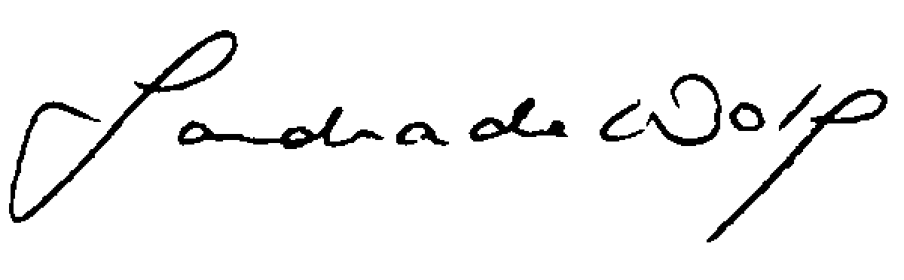
Sandie de Wolf
Chair

15 September 2003.

