Question: P13
Outcome: GEN
Topic: Details of the Semi-circular bookcase in the Hansard Office
Hansard Page: 38

Senator Murray asked:

‘I just cannot see how that [the semi-circular bookcase] is not a piece of furniture capable of being dismantled, taken out the door, reassembled, and sold for a very considerable sum of money.’

Mr Bolton responded:
‘… I would like to look at the exercise, look at what it is made of and respond to the senator with some detail’; advised that ‘… if we thought there were some way to reuse it later, there would be not problem holding on to it’.
Mr Bolton undertook to advise the committee.

ANSWER:
The existing semi-circular bookshelf (photographs shown at Attachments 1 and 2) was constructed in 1992 as part of JHD Project Number 1226—Hansard Accommodation Modifications. The bookshelf is constructed of Medium Density Fibre (MDF) board with a Tasmanian Myrtle veneer. It replaced the original bookshelves (Attachments 3 and 4), which were also constructed from MDF board with a painted white finish.
MDF board is a fibre board similar to chip or particle board but with higher strength and better workability properties. MDF is used in the manufacture of doors for wardrobes and kitchen cupboards, and for furniture. MDF comes in various finishes, including raw, painted and veneered. It is slightly more expensive than chip or particle board.
The cost of the unit now being replaced was $4 700 in 1992.
When removing the unit (regardless of what will become of the unit) it will be necessary destroy the centre section and damage the end pieces. It is estimated that to transport the unit to a joinery shop and refurbish it for future use could take up to a week and cost between $3 000 and $5 000. It may be possible to auction the unit and receive up to $300. The costs involved in this action may be more than the potential financial return.
The bookcase has been assessed as having no design-integrity value and it is not believed that the unit has any heritage value.
Contractors competitively bid for the work being completed in the Hansard area. The terms of the tender were that the contractor was responsible for removal and disposal of the old bookcase. As such, the winning contractor would have priced into their bid any residual value for the bookcase. The bids were competitively based; the best value for money tender was accepted; and the contractor would have included any potential savings to be made from the salvage of the bookcase.

It is currently proposed that the contractor will remove the unit on Monday 8 July 2002.

Attachment 1
Hansard Office—Existing semi-circular bookshelf

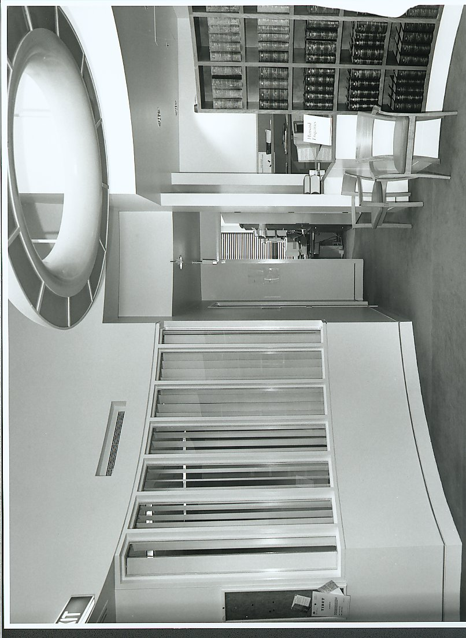

Attachment 2
Hansard Office—Existing semi-circular bookshelf

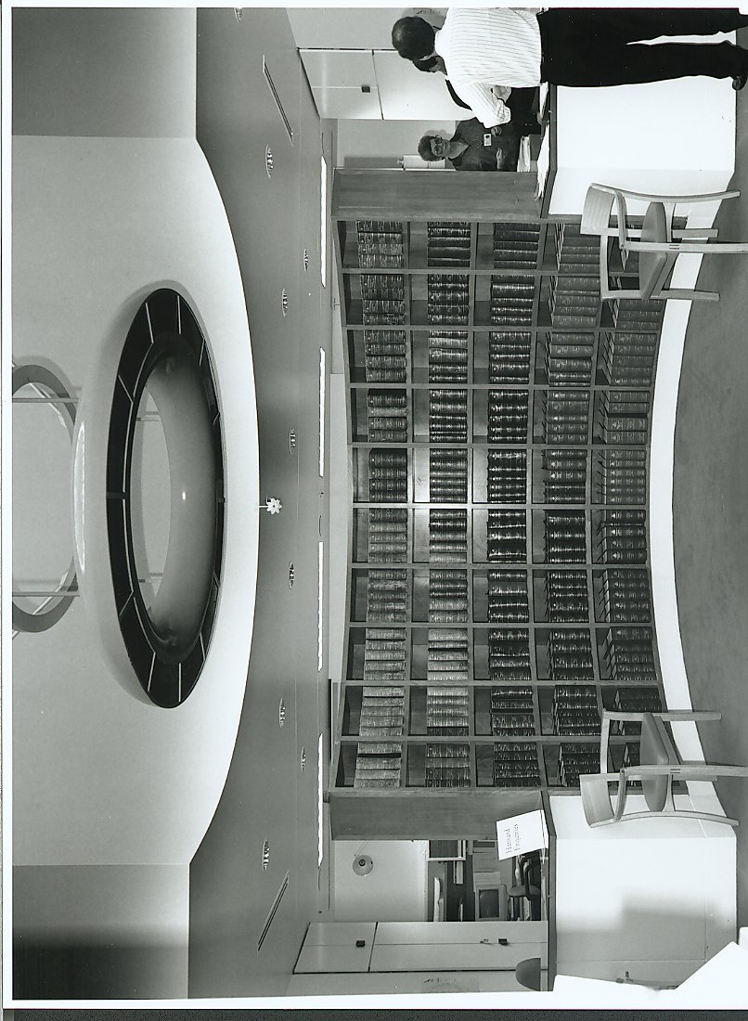

Attachment 3
Hansard Office—Original Bookcase

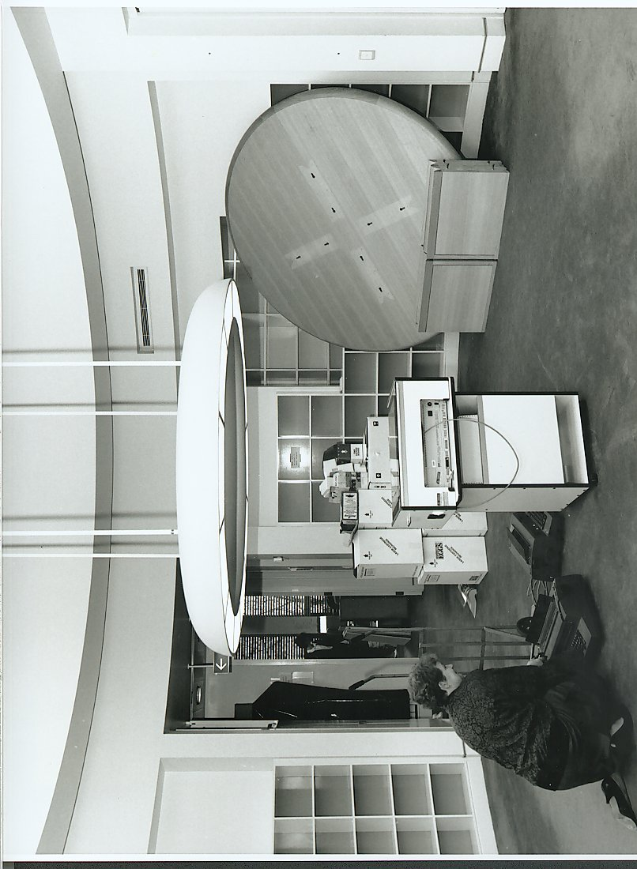

Attachment 4

Hansard Office—Original Bookcase
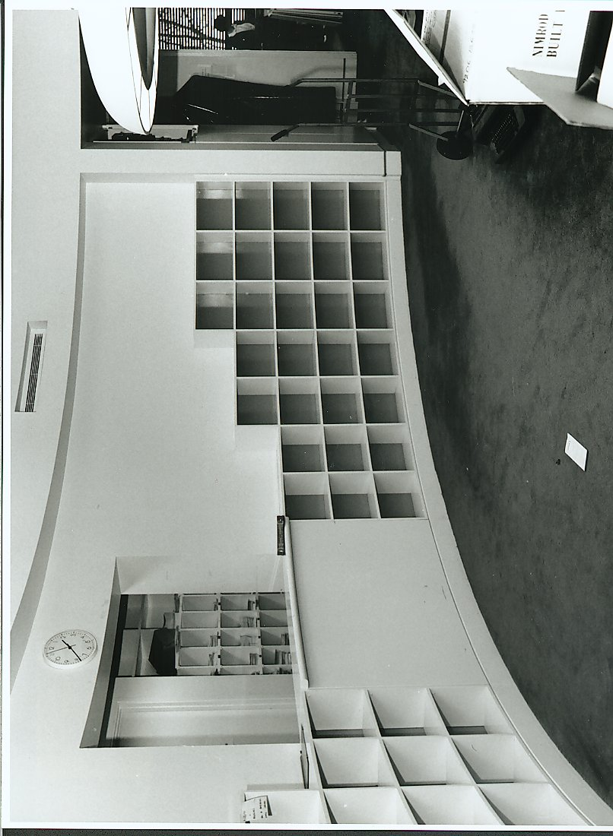

Question: P 12
Outcome: GEN
Topic: Major Capital Works in Parliament House
Hansard Page: 43

Senator Faulkner asked:

What are the current major capital works around the building that Joint House is involved in—apart from what is happening in the foyer of Hansard, which we know about?

ANSWER:
The Joint House Department allocated $11.49 million of administered funds to capital works in the year 2001–02. The funds were allocated to 90 projects; including projects for refurbishment, asset replacement and minor new works. There are currently 22 administered works projects in construction. These range from replacing the timber handrails in a number of stairwells and relocating the pager rack at the House of Representatives entry to replacing dishwashers in the kitchens. The 22 projects are listed in the table below.

The majority of these projects are expected to be completed during the winter recess.

Project Number | Description
WM-1482 | Reps Entry Security
WM-1602 | Dishwasher Replacement
WM-1626-11 | Backup Heating
WM-1626-12 | Lifting and Access
WM-1626-13 | Gas Detection
WM-1626-15 | Ministerial Communications Room
WM-1626-17 | Light Fittings Upgrade
WM-1626-20 | Fabrics Workshop
WM-1626-21 | Recreation Centre
WM-1626-25 | Fire Upgrade—Upgrade Vesda
WM-1626-26 | Fire Upgrade—Smoke Seals
WM-1626-27 | Fire Upgrade—Sliding Fire Doors
WM-1628-22 | Lighting Control
WM-1629 | Timber Handrail Replacement
WM-1630 | Humidifier Sprays Upgrade
WM-1633-22 | Tennis Court Resurfacing
WM-1637-28 | Ministerial Security
WM-1637-30 | Hansard Ground Floor
WM-1637-40 | Reconfiguration of Fire Doors
WM-1639 | Water Treatment Water Features
WM-1650-20 | Air Flow Measurement
WM-5188 | Senate Entry Security

Question: P 11
Outcome: GEN
Topic: Ministerial Offices involved in White Powder Incident of 18 April 2002
Hansard Page: 41

Senator Faulkner asked:

‘Which were the other ministerial offices involved there?’

Mr Lucas replied:

‘I cannot recall offhand. I can certainly give you that on notice.’

ANSWER:
(Answer Provided by Mr Mike Lucas, Security Controller)

The three other ministerial offices involved in the ‘white powder’ incident at the Treasurer’s office on 18 April 2002 were the offices of: Minister for Health and Ageing; the Special Minister of State; and the Minister for Industry, Tourism and Resources.

