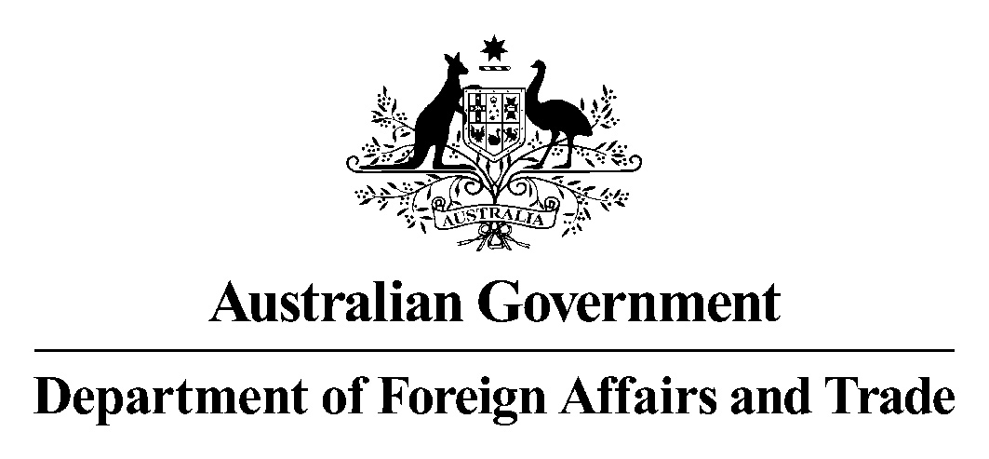

28 November 2003

Mr Brenton Holmes
Secretary
Senate Foreign Affairs, Defence and Trade Committee
Parliament House
CANBERRA ACT 2604

Dear Mr Holmes

I am writing to clarify an aspect of evidence given by Mr John Quinn, Assistant Secretary, Iraq Task Force, to the Committee during the Supplementary Budget Estimates hearing on 6 November 2003.

Mr Quinn said, in paragraph 2 on page 37, that the order promulgating the Coalition Provisional Authority in Iraq was 10 May. Mr Quinn has advised that in fact that date was 16 May.

Yours sincerely

Douglas Foskett
Parliamentary Liaison Section

