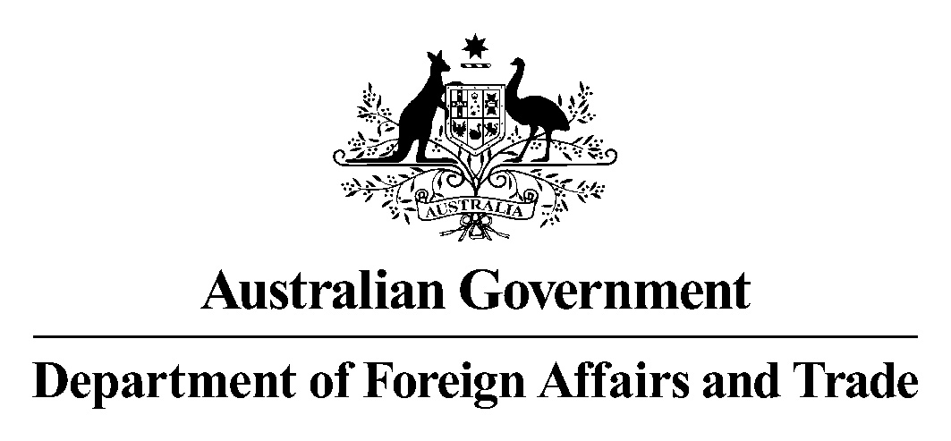

21 June 2006

Senator David Johnston
Chair
Senate Foreign Affairs, Defence and Trade Legislation Committee
Department of the Senate
PO Box 6100
Parliament House
Canberra ACT 2600
Australia

Dear Senator Johnston

I write to clarify and correct certain evidence I gave to the Senate Foreign Affairs, Defence and Trade Legislation Committee budget estimates hearing on 29 May 2006.

The first area of evidence I wish to clarify concerns the number of statements prepared by staff for the Inquiry into certain Australian companies in relation to the UN Oil-for-Food Program (the Cole Inquiry). In answer to Senator Faulkner’s question regarding how many statements were prepared by staff (page FAD&T 41 of Proof Hansard 29 May 2006) I stated that there were about half a dozen to a dozen statements. I would like to clarify that this number referred to statements prepared by ministerial staff (this evidence was provided in the context of questions regarding the department’s role in preparing Minister Vaile’s statement). I would like to clarify that the number of statements prepared by current DFAT staff is about 140.

I would also like to clarify my evidence relating to the legal budget. In response to a question from Senator Faulkner concerning the legal budget for outside (external) legal advice (page FAD&T 34 of Proof Hansard 29 May 2006), I stated that the legal budget was $600,000 for this year. I would like to clarify that that sum referred to the Legal Branch’s legal services budget for actual expenditure on external legal services to 30 April 2006.

I would also like to correct my evidence relating to one element of the Kennedy Code of Conduct inquiry concerning Mr Trent Smith. In response to a question from Senator Ray concerning whether legal advice prepared by the Australian Government Solicitor (AGS) for Mr Kennedy during his investigation was passed to me or to the Department (page FAD&T 20 of Proof Hansard 29 May 2006), I stated that the Department had not received this advice. I have been advised that the Department did receive copies of legal advice prepared by AGS for Mr Kennedy. Mr Kennedy passed copies of the AGS advice to the Department, under cover of letters dated 17 June 2004 and 13 April 2005. The remainder of my response describing the arms-length relationship between the Department and Mr Kennedy’s investigation (including the different AGS lawyers acting for each) is correct.

Yours sincerely

(signed)

Chris Moraitis
Senior Legal Adviser
Department of Foreign Affairs and Trade

cc. Dr Kathleen Dermody, Committee Secretary, Senate Foreign Affairs, Defence and Trade Committee

