Question 1
Outcome 1, Output 1.1.1
Topic: North Korea—nuclear testing
Question taken on notice (see Senate Hansard page 11)

Senator Robert Ray asked on 02/06/05:
- Have we made any recent bilateral representations to the government of North Korea on reports of underground nuclear testing?
Answer:
- First Assistant Secretary, North Asia Division, Lydia Morton met with DPRK Ambassador Chon Jae–hong on 8 June 2005. During the meeting, Ms Morton sought a reassurance from Ambassador Chon that the DPRK was not planning to test a nuclear device. In reply, Ambassador Chon said he had no information about such a test, and that to date his government had made no official comment about such an event.

Question 2
Outcome 1, Output 1.1.2
Topic: Aceh
Written question

Senator Natasha Stott Despoja asked on 03/06/05:
- What information does the Government have regarding the Indonesian Government’s plans to relocate displaced persons in Aceh?
- What is the Australian Government’s position on this initiative?
- Has the Government sought any information from the Indonesian Government about whether it has taken any measures to protect the human rights of these displaced persons and whether it will guarantee their right of return home?
- If yes, what was the Indonesian Government’s response to these queries?
- Has the Government sought any assurance from Indonesia that no person will be relocated without first obtaining their free and informed consent?
- Has the Government sought any indication from the Indonesian Government as to who will carry out the registration of individuals, what the information will be used for and who will have access to this data during and after the process?
- Is the Government aware of any restrictions on the ongoing work of humanitarian organisations in Aceh? For example, is the Government aware of organisations which are no longer permitted to work in Aceh?
- There have been allegations of ongoing violence on the part of the Indonesian military within Aceh since the tsunami, including the abduction and murder of civilians and the torture and summary execution of GAM fighters. Does the Government have any information which would substantiate these allegations?
- Is the Government aware of restrictions on access to certain parts of Aceh by journalists?
- Has the Government raised any concerns with the Indonesian Government regarding the security situation in Aceh, including restrictions on free speech and humanitarian aid?
- What decisions have been made in relation to how Australian aid to Aceh will be allocated?
Answer:
  - We have been advised by the Indonesian Government that it has a policy of voluntary relocation of displaced persons in Aceh.
  - This is a matter for the Indonesian Government.
  - Yes.
  - See answer to question 1 above.
  - See answer to question 1 above.
  - Yes. We have been advised by the Indonesian authorities that the registration of IDPs will be conducted by the provincial administration and the social welfare department. This registration information will be used for several purposes including provision of assistance, voter registration and land title. We understand the information will be public.
  - Some security-related restrictions apply to travel to certain areas in Aceh. (ii) No.
  - No.
  - Yes. Journalists visiting Aceh are required to apply to the Indonesian Department of Foreign Affairs for a press card, specific to Aceh, prior to travelling to the province. Journalists are required to list sites within Aceh which they intend to visit. Journalists are not permitted to travel to sites where there is active conflict.
  - The Government has urged both the Indonesian Government and the Free Aceh Movement to seek a peaceful solution to the conflict in Aceh, including respect for the rights of all parties.
  - See www.budget.gov.au-2005-2006 and www.ausaid.gov.au

Question 3
Outcome 1, Output 1.1.2
Topic: Kopassus
Written question

Senator Natasha Stott Despoja asked on 03/06/05:
- What is the Government's current position on the resumption of military ties with Kopassus?
- Have Australian and Indonesian military personnel participated in any joint exercises in the previous year?
- Does the Government maintain its commitment not to engage directly with Kopassus officers who have been involved in human rights violations?
- If so, how does the Government propose to practically implement this policy in rapid response, high risk situations, such as hostage situations?
Answer:
- Please see my answer to supplementary budget estimates 2004–2005 Question 5, part 1.
- A combined maritime air surveillance exercise, Ex ALBATROS AUSINDO, was conducted with the Royal Australian Air Force and the Indonesian Air Force from 11 to 15 April 2005.
- Yes.
- We would form a judgement on the basis of information available to the Australian Government at that time.

Question 4
Outcome 1, Output 1.1.2
Topic: East Timor
Written question

Senator Kerry Nettle asked on 03/06/05:
- Did the Australian Consulate in Dili or the Department provide any assistance to recent protests in Dili regarding Timorese government education policy?
- Who made the request for such assistance?
- What form did that assistance take?
- Did it include provision of toilet facilities?
- How much did the assistance cost?
- Who made the decision to provide such assistance?
- Was the Minister briefed by the Department about such assistance?
Answer:
- No.
- No request for such assistance was received.
- See answers 1 and 2 above.
- See answers 1 and 2 above.
- See answers 1 and 2 above.
- See answers 1 and 2 above.
- See answers 1 and 2 above.

Question 5
Outcome 1, Output 1.1.2
Topic: Afghanistan—security and assistance
Question taken on notice (see Senate Hansard pages 45 and 48)

Senator John Faulkner asked on 01/06/05:
- Provide a broad assessment of the strength of al–Qaeda forces in Afghanistan as an element in the context of the broader security picture.
- Have there been formal responses by the Australian government to the requests for assistance from the Afghan government, that is, responses by letter or other forms of formal communication?
Answer:
  - DFAT is not in a position to assess the strength of Al Qaida. The intelligence assessment agencies are best placed to make such an assessment. In line with long-standing government policy, DFAT does not comment on intelligence matters.
  - DFAT does not hold any letters or formal communications to the Afghan government relating to requests for Defence assistance.

Question 6
Outcome 1, Output 1.1.2
Topic: Kabul—diplomatic visits
Question taken on notice (see Senate Hansard page 46)

Senator Robert Ray asked on 01/06/05:
- When was the last time Australia had diplomatic officials visit Kabul?
Answer:
  - The last time an Australian diplomatic official visited Kabul was 17 May 2005.

Question 7
Outcome 1, Output 1.1.4
Topic: PNG—Enhanced Cooperation Program
Written question

Senator John Hogg asked on 08/06/05:
- Why did it take some six months to get from Australia and Papua New Guinea’s initial agreement to an Enhanced Cooperation Program, to actually signing the treaty?
- What issues were being discussed over those six months?
- What positions were the Australian officials advancing?
- What concerns were expressed from the PNG side about the positions the Australian officials were advancing?
- What proposals did the PNG side advance for dealing with Australian concerns?
- Given the PNG side were worried about the constitutional issues, did the Australian side not take into account those proposals?
- During the negotiations, was any consideration given to making the ECP a two–way exchange, so that PNG police officers could work in Australia as well? If agreement was reached on this point, why was it not implemented?
- What sort of legal advice did the Department itself generate, or obtain from outside the Department, about PNG’s enabling legislation for the ECP? What issues did this legal advice canvas, and what conclusions did it reach?
- How involved were Australian officials in drafting the PNG enabling legislation? What assistance did they provide?
- What proposals are Australian and PNG officials working on to try and resurrect the ECP?
- Are any of these proposals similar to the ones that PNG suggested in the first six months of 2004? Which ones?
- What is your latest estimate of when Australian police will return to PNG?
- What has been the total cost of the ECP thus far?
- Pages 3 and 4 of the answers to questions on notice from the Additional estimates 2003-2004, 19–20 February, 2 March 2004 provide a breakdown of the costs between the policing and non-policing components of the ECP, in terms of salaries and accommodation, logistics and technical assistance, for 2003–04 to 2007–08. Please provide an updated table reflecting the Department’s latest estimates of these costs.
- If the police component of the ECP had continued, what would have been the total cost, per Australian Federal Police Officer, per year? What would have been the breakdown of the various components—salary, allowances, accommodation and so on, per individual officer?
- On average, how long was the rotation for each Australian Federal Police Officer in PNG, prior to the suspension of the program?
- What is the average annual salary of a Papua New Guinean police officer?
- What are some of the logistical challenges they face?
- We understand that the leases for the Australian Federal Police are being maintained—how much is this costing each week?
- What is happening to the equipment used by the Australian Federal Police, such as cars?
- We understand some PNG police were unhappy about the ECP. For example, the Police Union passed a motion, demanding the Australian police be withdrawn within 48 hours. Given the difference in salaries between the Australian and PNG police, the equipment and cars that the Australian police were using, what did DFAT suggest to try and counter these perception problems?
- Did Australia make any representations to Governor Wenge? What was said in these representations? What was Governor Wenge’s response?
Answer:
(1) The ECP Treaty was the subject of detailed negotiations between Australia and PNG. The issues involved were difficult and complex. Time was taken to ensure that the Treaty accurately reflected the positions of both Australia and PNG, and met the respective needs and concerns of both countries.
(2) The content of treaty negotiations is confidential between the Parties.
(3) Positions advanced by the Australian officials are reflected in the Treaty.
(4) The content of treaty negotiations is confidential between the Parties.
(5) The content of treaty negotiations is confidential between the Parties.
(6) On 4 June 2004, it was made clear by the PNG Foreign Minister publicly that PNG had worked through the constitutional issues, and no longer had any concerns.
(7) Two-way exchanges were considered, but not as part of the ECP package. In considering the ECP, both Governments agreed that the program would have the most impact if Australia provided police and public servants to work in PNG.
(8) Under Standing Order 73, the Department is unable to answer questions relating to legal opinions.
(9) Australian officials provided some suggested text to assist PNG in the drafting of the enabling legislation. However, the PNG Government took responsibility for the drafting of the legislation.
(10) Australian and PNG officials have considered a number of proposals to maintain the ECP. The content of the negotiations is confidential.
(11) The content of treaty negotiations is confidential between the Parties.
(12) It is not possible to predict a return date for Australian police to PNG.
(13) The total cost of the non–police component of the ECP thus far is A$21.14m (as at 30 June 2005). The total cost of the ECP for the AFP as at 30 June 2005 is $48.210m. (Information provided to DFAT by, respectively, AusAID and AFP)
(14) These tables have been updated to reflect the actual costs incurred for the 2003–04 and 2004–05 years. Given that police have been withdrawn and negotiations are on–going, future policing costs are not estimated.

Non–policing component (all figures in $millions):
 | 2003–04 | 2004–05 | 2005–06 | 2006–07 | 2007–08
Salaries and Accommodation | 1.26 | 8.0 | 20.4 | 25.4 | 25.4
Logistics, Operational Costs | 2.06 | 9.4 | 11.6 | 14.1 | 14.1
Technical Assistance | 0.02 | 0.4 | 18.0 | 19.5 | 19.5
Total (estimated) | 3.34 | 17.8 | 50.0 | 59.0 | 59.0

Contribution to AFP  (RPNGC infrastructure  support) | - | - | 9.0 | 5.0 | 5.0
(Information provided to DFAT by AusAID).

Policing Component:
 | 2003–04 | 2004–05 | 2005–06 | 2006–07 | 2007–08
AFP Salaries & Accommodation | - | $21,106,546 | - | - | -
AFP Logistics, Operational Costs | - | $26,606,221 | - | - | -
RPNGC Technical Assistance | - | $497,379 | - | - | -
Total (Including Capital) | - | $48,210,146 | - | - | -
(Information provided to DFAT by AFP).
(15) The average cost of deploying an AFP officer to PNG as part of the ECP is $156,400. This is made up of:
Employee costs $117,000
Allowances $ 39,400

It should be noted there are also a range of additional overhead expenses incurred by the AFP in deploying personnel to a foreign country including accommodation, uniforms, travel, medical care and selection and administration costs. These costs are not allocated on an individual basis. (Information provided to DFAT by AFP).

(16) Most Assisting Australian Police in PNG had completed one or two sixteen week rotations by May 2005. (Information provided to DFAT by AFP).

(17) We understand that the average annual salary of a Papua New Guinean police officer ranges from a 1st year constable’s salary of 8422.52 Kina (or A$3369), to a 7th year Deputy Commissioner’ salary of 55243.24 Kina (or A$17598.57). PNG police officers are also able to claim a number of allowances for holding particular positions. (Information provided to DFAT by AFP).

(18) The RPNGC has been under-resourced for a significant period of time. The lack of resources include basics such as fuel for patrol vehicles, office supplies and consumables, uniforms and equipment for police officers. (Information provided to DFAT by AFP).

(19) The weekly cost for AAP living accommodation is $55,515.50 per week. The AAP also pays $8,988 per week in office accommodation. (Information provided to DFAT by AFP).

(20) A wide range of operational equipment including firearms has been returned to Australia. AAP motor vehicles are being stored in Port Moresby. On Bougainville, given the limited availability of transport to the RPNGC, the AAP have given the RPNGC permission to use the vehicles. Decisions about the remaining equipment in PNG will be influenced by the outcome of negotiations on the future of the ECP. (Information provided to DFAT by AFP).

(21) Feedback from members of the AAP indicate that their counterparts in the RPNGC understood that the basis for the difference in salary levels, terms and conditions was related to the comparative differences between Australia and PNG. Most RPNGC officers appeared to appreciate the additional equipment and improvement in their conditions, which were directly related to the ECP. (Information provided to DFAT by AFP).

(22) The Australian Government did not make representations to Governor Wenge.

Question 8
Outcome 1, Output 1.1.4
Topic: RAMSI associated costs
Written question
Senator John Hogg asked on 08/06/05:
- What is the latest estimate of the year–by–year costs associated with RAMSI, from its commencement to its projected conclusion? What is the breakdown of these costs, year–by–year?
Answer:
RAMSI Expenditure and Budget
($million) | 2003-04 | 2004-05 | 2005-06 | 2006-07 | 2007-08 | 2008-09 |  | Total
 | (actual) | (budget) | (budget) | (budget) | (budget) | (budget)
AFP | 63.6 | 143.3 | 145.3 | 134.1 | 128.7 | 129.9 |  | 744.9
AusAID | 54.1 | 66.7 | 72.2 | 73.8 | 69.8 | 66.4 |  | 403.0
Defence | 90.4 | 39.7 | 8.9 | 3.4 | 0 | 0 |  | 142.4
DFAT | 4.0 | 4.5 | 3.8 | 3.9 | 4.0 | 3.4 |  | 23.6
Customs | 0 | 0 | 1.4 | 1.3 | 1.2 | 1.3 |  | 5.2
Total | 212.1 | 254.2 | 231.6 | 216.5 | 203.7 | 201.0 |  | 1319.2
Note:
(1) Actual figures are based on total resourcing (capital, operating and depreciation)
(2) Forward estimates figures are based on impact on fiscal balance
(3) AFP forward estimates include capital

The forward budget estimate for RAMSI provides for funding for four years, lapsing on 30 June 2009, with a need for a review of the program to be considered in the 2008/09 budget.

Question 9
Outcome 1, Output 1.1.4
Topic: Nauru assistance
Written question

Senator John Hogg asked on 08/06/05:
- What is the latest estimate of the year-by-year costs associated with our enhanced assistance to Nauru, from its commencement to its projected conclusion? What is the breakdown of these costs, year–by–year?
Answer:
  - Australia has provided enhanced development assistance to Nauru under the First Administrative Agreement (FAA) with Nauru (signed on 10 September 2001) and three subsequent Memoranda of Understanding (MOUs) on the Offshore Processing Centres (OPCs). The current MOU with Nauru (MOU III) expires on 30 June 2005.
While the initial focus of Australia’s development assistance was on measures to ensure continued provision of essential services to meet immediate needs (eg, water and fuel), there has been a growing focus on assisting Nauru to undertake economic and governance reforms.
The breakdown of the costs associated with our enhanced assistance to Nauru is set out in the attached table. Australia’s enhanced development assistance to Nauru over the past four years to 30 June 2005 totalled almost $70 million. The table below provides a breakdown of these year–on–year costs:

Nauru: Australian Development Assistance Summary: September 2001 to June 2005
 | FAA  Sep 01–  Dec 01 | MOU I  Jan 02–  Dec 02 | MOU II  Jan 03–  Feb 04 | MOU III  Feb 04–  Jun 05 |  | Total
Water infrastructure and supplies¹ | 4,400,000 | 202,000 | 728,000 | 1,792,000 |  | 7,122,000
Procurement, refurbishment and maintenance of power generators |  | 1,000,000 | 1,030,000 | 10,075,400 |  | 12,105,400
Diesel and consumables for power station | 10,590,000 | 2,355,000 | 8,060,000 | 7,753,000 |  | 28,758,000
Port refurbishments and infrastructure | - | 780,000 | 200,000 | 1,143,000 |  | 2,123,000
Airport infrastructure repairs | 197,700 | - | 100,000 | 58,000 |  | 355,700
Telecommunications | 114,000 | - | 16,000 | 88,000 |  | 218,000
Health | 1,031,000 | 3,978,000 | 1,600,000 | 2,728,500 |  | 9,337,500
Education, including scholarships | 153,700 | 1,120,000 | 1,326,000 | 767,700 |  | 3,367,400
Law and justice | - | 13,000 | 300,000 | 1,600,000 |  | 1,913,000
Economic governance reforms | 13,600 | 552,000 | 1,140,000 | 1,521,000 |  | 3,226,600
Public service salary payments | - | - | - | 1,250,000 |  | 1,250,000
Total | 16,500,000 | 10,000,000 | 14,500,000 | 28,776,600 |  | 69,776,600
Note: 1: Power & desalination (water) combined in FAA
Cabinet has authorised Australian officials to negotiate a new two year MOU with Nauru on the OPCs and associated Australian assistance. The MOU negotiations are expected to take place in July and will determine the scale of Australia’s package of assistance beyond June 2005.

Question 10
Outcome 1, Output 1.1.4
Topic: Pacific Island Forum—Trade and economic cooperation
Written question

Senator John Hogg asked on 08/06/05:
- What will be involved in the joint study on the potential impacts of a comprehensive framework for trade and economic cooperation between Pacific Island Forum countries, Australia and New Zealand, announced by Parliamentary Secretary for Foreign Affairs and Trade Bruce Billson on 27 May? Who will be conducting the study? What issues will be considered?
Answer:
  - At their meeting on 27 May 2005, Pacific Islands Forum Trade Ministers directed the Pacific Islands Forum Secretariat, in close consultation with Forum members, to commission a joint study to investigate the potential impact of a move towards a comprehensive framework for trade and economic cooperation between Australia, New Zealand and the Forum Island countries. The terms of reference of the study have not yet been developed, and possible tenderers/consultants have yet to be identified.
Question 11
Outcome 1, Output 1.1.4
Topic: Iraq security issues
Question taken on notice (see Senate Hansard pages 69, 71 and 76)

Senator John Faulkner asked on 01/06/05:
- Can you confirm if the dinner that took place on 2 March 2004 in Baghdad was the same or a separate event to the recorded meeting between Dr Gee, Mr Barton, John Quinn and Neil Mules? If not, can you advise who attended the dinner?
- Can you indicate when DFAT first became aware of Dr John Gee's concerns about the reporting and operations of the Iraq Survey Group?
- Was a record or other information kept of a lunch-time meeting between then DFAT Secretary, Dr Ashton Calvert, and Dr Gee on 14 April 2004?
- If so, can DFAT provide further details?
Answer:
(1) We understand that it was the same event.
(2) DFAT first became aware of Dr John Gee's concerns about the ISG in the second half of February 2004.
(3) We can confirm that Dr Gee and Dr Calvert met over lunch on 14 April 2004, and that no record was prepared.
(4) No (see answer to question three)

Question 12
Outcome 1, Output 1.1.4
Topic: Libya—Australian residents
Question taken on notice (see Senate Hansard page 55 and 72)

Senator Natasha Stott Despoja asked on 01/06/05:
- What kind of consular services are available to those Australians residing in Libya?
- With the increase in the number of Australians now residing in Libya because of renewed diplomatic ties (post estimates 60 Australians), has the number of Australians registered with the post increased (latest post figures indicate 15 Australians registered)?
Answer:
  - At present, the Australian Ambassador in Cairo has non-resident accreditation to Libya and the Cairo Embassy has consular responsibility for Australians in Libya. The full range of consular services is available within the limitations of non–resident accreditation. Contact between the post and the Australian community is by correspondence and telephone. Consular officials make visits as required.
  - The number of Australians registered as Libyan residents with the Embassy in Cairo in July 2002 was two, following the restoration of diplomatic relations in late June of that year.
In May 2004, when the announcement was made that Australia would open a mission in Tripoli, there were 14 Australians registered as Libyan residents with the post in Cairo.
In late June 2005, 16 Australians were registered as residents of Libya but the post estimates there are up to 60 Australians in-country. This is likely to increase substantially in the next 12 months following further deployments by Australian companies.

Question 13
Outcome 1, Output 1.1.4
Topic: Western Sahara and Algerian desert
Question taken on notice (see Senate Hansard page 54)

Senator Lyn Allison asked on 01/06/05:
- Is DFAT aware of reports of violent clashes between the Moroccan military and police, and protestors over peaceful protests that have been conducted right around Western Sahara in the occupied territories?
- Has there been any change in the Government's position on providing assistance to the 190,000 people who are currently in exile in the Algerian Desert?
Answer:
- DFAT is aware from media sources of the clashes between the Moroccan security forces and protestors beginning around 22 May 2005.
On 26 May, the President of the Saharawi Arab Democratic Republic (SADR), Mohammed Abdelaziz, wrote to the President of the United Nations Security Council (UNSC) urging the UN to press the Moroccan Government to adhere to UNSC and General Assembly resolutions. In that letter, various allegations of abuse by the Moroccan military were also made.
Prior to those protests, the most recent UNSC action on Western Sahara was the adoption of Resolution 1598 of 28 April 2005 which extended the mandate of the United Nations Mission for the Referendum in Western Sahara (MINURSO) until 31 October 2005. Further UNSC action is considered unlikely until then.
- Australia does not provide direct assistance or support for those in the camps to which Senator Allison referred.
The Government would like to see an early and durable political settlement to the unresolved issues of the Western Sahara that is acceptable to all directly interested parties. Australia supports the earliest possible holding of a referendum which would allow the population of Western Sahara to exercise its right of self–determination, provided that remains the only process fully endorsed by the UN for resolution of the dispute.
Question 14
Outcome 1, Output 1.1.4
Topic: ECP—Aid budget
Written question

Senator Kerry Nettle asked on 03/06/05:
- As the Enhanced Cooperation Program has been cancelled due to the ill consideration of the Australian government imposing the program on PNG without proper regard for the PNG constitution;
- What impacts will this have on the Australian aid funding to PNG?
- What has been the total cost of the ECP thus far?
- How much of this funding went to:
  - The salaries and accommodation of Australian Federal Police?
  - Funding Logistics of Australian Federal Police?
  - The Royal Papua New Guinean Constabulary?
- What is the expected budget outcome for the ECP in 2005/06 considering the failure of the ECP?
- What will be the expected total funding for PNG in 2005/06 considering the failure of the ECP?
- What is the estimated cost of sending an Australian Federal Police Officer to PNG as part of the Australian aid program and what is the breakdown of that cost?
Answer:
(1)
- There has been no impact on aid funding to date. The impact on future years is yet to be determined.
- The total cost of the non-policing component of ECP to the end of 2004/05 (from inception) was $21.14 million. The total cost of the Australian police participation in the ECP as at 30 June 2005 was $48,210,146. (Information provided to DFAT by, respectively, AusAID and AFP)
- (i) Employee expenses for Australian police participation in the ECP as at 30 June 2005 were $17,765,534.
The accommodation costs for Australian police participation in the ECP as at 30 June 2005 are as follows:
- One–off costs including initial leasing costs and refurbishment totalled 3,195,841 Kina—approx AUD$1,360,000. On–going costs including rental and associated costs for the year to 30 June 2005 total 4,655,147 Kina—approx AUD$1,981,012.
(ii) The cost of funding logistics (excluding accommodation) of the AFP for the ECP to 30 June 2005 was $9,141,464.
(iii) As at 30 June 2005 approximately 1,170,000 Kina ($497,379 AUD) had been spent on equipment provided to the RPNGC. (Information provided to DFAT by AFP)

- It is not possible to estimate the budget outcome until the future of the ECP has been decided.

- See previous answer.

f) The average cost of deploying an AFP officer to PNG as part of the ECP is $156,400. This is made up of:
Employee costs $117,000
Allowances $ 39,400

It should be noted there are also a range of additional overhead expenses incurred by the AFP in deploying personnel to a foreign country including accommodation, uniforms, travel, medical care and selection and administration costs. These costs are not allocated on an individual basis. (Information provided to DFAT by AFP)

Question 15
Outcome 1, Output 1.1.5
Topic: US–FTA
Written question

Senator Stephen Conroy asked on 03/06/05:
- Is the Department familiar with proposals from the Screen Producers Association of Australia (SPAA) for the introduction of an independent production quota on Australian free to air television?
SPAA has proposed that the Government should require that 75 per cent of all qualifying Australian content broadcast on television (excluding news, current affairs and sport) must be produced by an Australian independent production entity.
I understand that they do not suggest that this requirement should apply to existing media players but rather only to future majority purchasers of broadcasters, regardless of the nationality of the purchaser.
    - Would this proposal be consistent with the US FTA? If not why?
Another proposal made by SPAA is that the ABC should be made subject to the local content quotas that apply to commercial broadcasters.
    - Is such a course of action open to the Australian Government under the FTA?
    - Would the standstill provisions in the US FTA prevent the imposition of these quotas on the ABC?
Answer:
- The Department is aware of the SPAA proposal.
- Under the AUSFTA, Australia has reserved, with regard to free–to–air commercial television, the right to maintain existing local content requirements ie, transmission quotas, and to introduce new measures on multi–channelled commercial television services, subject to certain conditions specified in Annex II.
From the information available about SPAA’s proposal for an independent production quota, it would appear that it would be possible to implement such a proposal in a manner consistent with the transmission quotas provided for in the AUSFTA. However, it would be important to look at the detailed implementation of such a proposal to ensure that this was done in conformity with the AUSFTA.
- Australia’s commitments under the AUSFTA do not prevent the ABC from continuing to carry out its mission as set out in its Charter. There is nothing in the AUSFTA which would prevent the application of local content requirements to the ABC.
- The so–called “standstill provisions” in the AUSFTA have no implications for the ABC.

Question 16
Outcome 1, Output 1.1.5
Topic: Vietnam WTO accession
Written question
Senator Stephen Conroy asked on 03/06/05:
Further to the answers provided at Estimates hearing on evening 2 June in relation to progress on Vietnam’s WTO accession
- Did the offer put forward to Australia by Vietnam in regard to periodicals and books also include newspapers and music products?
Answer:
- Vietnam’s tariff offer includes newspapers and music products.

Question 17
Outcome 1, Output 1.1.6
Topic: APEC 2006—Government assistance
Question taken on notice (see Senate Hansard page 84)

Senator John Hogg asked on 02/06/05:
- During this year's visit by the Prime Minister of Vietnam, Prime Minister Howard indicated in a speech, an offer of some assistance to Vietnam in hosting APEC in 2006. Can DFAT confirm:
- if there is an offer of assistance
- what is the quantum or type of assistance
- what will be the level of support
- when will the decision to assist be made, and
- who will make the decision?
Answer:
(1)
- Yes
- There are three elements to the offer
  - a package of capacity building assistance, including logistical and English language training, trade policy development assistance and a facility to respond to emerging needs, is being provided by AusAid. The package is still in the design phase but is expected to be finalised shortly.
  - an offer of a DFAT officer to work with Vietnam during 2006 to assist with management of the APEC year policy agenda. This is the subject of continuing bilateral discussions with the Vietnamese Government at senior official level.
  - an offer to cooperate more intensively with Vietnam in APEC to develop joint initiatives that might be pursued over the two year period, 2006–2007
- the value of the above three elements is as follows:
  - approximately $500,000
  - approximately $ 180,000
  - not quantifiable
- it has already been made and final elements of the package are under discussion with the Vietnamese Government.
- the decision was made by both AusAID and DFAT in consultation with the Minister for Foreign Affairs.

Question 18
Outcome 1, Output1.1.6
Topic: Avian influenza
Question taken on notice (see Senate Hansard page 48)

Senator Andrew Bartlett asked on 01/06/05:
- Provide a general overview of DFAT's assessment of the outbreak of avian influenza and whether the assessment included details concerning the potential impact on tourism into Australia.
Answer:
  - Epidemics of highly pathogenic Avian Influenza (due to H5N1 viruses) in poultry have been reported in several countries in Asia, since mid–December 2003, including Cambodia, China, Indonesia, Japan, Laos, Republic of Korea, Thailand and Vietnam. Since December 2003, bird flu has been linked to 53 human deaths. While the human and livelihood cost has been significant, the macroeconomic impact has to date been minor with many affected regions largely on the margins of the formal economy.
The economic impact of the epidemic has been primarily restricted to the poultry sectors in the region. There has been no confirmed human to human transmission of the disease. Should human to human transmission become prevalent, the impact (both in human and economic terms) would depend on the efficacy of health and quarantine arrangements in the region. While this could lead to a downturn in regional travel, including inbound tourism to Australia, the extent to which this occurs would depend on the effectiveness of containment measures and the impact the epidemic has on consumer confidence.
There have been no significant commercial impacts on Australian interests at this stage. The avian influenza epidemic in Asia has not coincided with significant variations in the number of inbound tourists to Australia.
Australian export sectors have not been affected directly by the Avian Influenza epidemic in Asia because Australia does not export any significant amounts of feed grains, poultry products, or other poultry inputs to the region. In addition, Australia has not been a major exporter of chicken products and does not import cooked or uncooked chicken meat.
While there may be market opportunities for disease free chicken producing countries to supply product to the affected region, and into other markets, Australia is unlikely to benefit given the domestic focus of the local industry.

Question 19
Outcome 1, Output 1.1.7
Topic: Guantanamo Bay
Written question

Senator Natasha Stott Despoja asked on 03/06/05:
- Can you advise on the current status of the prosecution against David Hicks? Is it still in adjournment awaiting the outcome of legal proceedings in the United States?
- Has the Government made any representations to the United States regarding the charges against Mr Hicks, his proposed trial before a military commission, or his welfare since the beginning of 2005?
- Does the Government have any concerns in relation to the length of time that Mr Hicks has spent detained at Guantanamo Bay without being brought to trial?
- I understand that, following reports that a Koran was flushed down a toilet during interrogations conducted at Guantanamo Bay, a US investigation found that, although this had never occurred, there were numerous incidents involving an offensive mishandling of the Koran during interrogation.
  - Has the Australian Government taken any steps to ascertain from US authorities exactly what occurred in these circumstances?
  - If yes: what has the Government been able to ascertain?
  - If no: why not? Is it the case that the Australian Government has no concerns regarding the offensive use of the Koran during interrogation procedures?
Answer:
    - The military commission trial of Mr Hicks has been stayed pending legal proceedings before the United States federal courts.
    - Yes. The Australian Embassy in Washington has consistently made representations to a range of United States agencies reiterating the Government’s concern that Mr Hicks’s case be resolved as expeditiously as possible and to discuss improvements to the military commission process. The Embassy continues to make consular visits to Mr Hicks to confirm that he is being treated humanely. The most recent consular visit was made in the week of 16 May 2005. Additionally, Mr Downer raised the matter of Mr Hicks’s detention with United States counterparts during his visit to Washington in May 2005.
    - The Government has consistently emphasised to the United States the need for Mr Hicks’s case to be resolved as expeditiously as possible.
    - This is a matter for the United States. The Government notes, however, that the Pentagon investigation identified five occasions of mishandling of the Koran, and that appropriate action had already been taken by US authorities.

Question 21
Outcome 1, Output 1.1.7
Topic: Charter of United Nations Act 1945 (Cth)—Consultation and submissions
Written question

Senator Kerry Nettle asked on 03/06/05:
In an answer to a question on notice provided to me, Supplementary budget estimates 2004-2005, Senate Foreign Affairs, Defence and Trade Legislation Committee (November 2004), the Department of Foreign Affairs and Trade stated that ‘(e)ach decision of the Minister (to list a person or entity under s 15 of the Charter of United Nations Act 1945 (Cth)) is made on the merits and is accompanied by a detailed submission prepared by the Department of Foreign Affairs and Trade in consultation with other relevant agencies’.
- Please specify the relevant agencies that the Department of Foreign Affairs and Trade (DFAT) normally consults in this context.
- Please provide copies of the submissions DFAT made in relation to the listing of:
  - New Peoples Army / Communist Party of the Philippines;
  - Jose Maria Sison;
  - Mujahedin–E Khalq Organization;
  - all organisations prescribed as ‘terrorist organisations’ under the Criminal Code 1995 (Cth) and the Criminal Code Regulations 2002 (Cth).
Answer:
    - DFAT may consult with the Attorney–General’s Department, the Australian Federal Police and intelligence agencies.
    - We are unable to provide copies of advice given to the Minister due to its confidential nature.

Question 22
Outcome 1, Output 1.1.7
Topic: Charter of United Nations Act 1945 (Cth)—Terrorist Act
Written question
Senator Kerry Nettle asked on 03/06/05:
In an answer to a question on notice provided to me, Supplementary budget estimates 2004-2005, Senate Foreign Affairs, Defence and Trade Legislation Committee (November 2004), the Department of Foreign Affairs and Trade stated that the term, ‘terrorist act’ in s 15 of the Charter of United Nations Act 1945 (Cth) as well as cognate terms are ‘understood in accordance with their ordinary meaning taking into account the context, object and purpose of the Act’.
- Please explain DFAT’s understandings of the ordinary meaning of these terms.
- Are such understandings premised upon the belief that the meaning of a ‘terrorist act’ in s 15 of the Charter of United Nations Act 1945 (Cth) is identical to the phrase, ‘terrorist act’ in s 100.1 of the Criminal Code 1995 (Cth)?
Answer:
Under Senate Standing Order 73, and as a matter of long–standing practice, the Department will not provide responses to questions seeking a legal opinion.

Question 23
Outcome 1, Output 1.1.7
Topic: International Whaling Commission
Question taken on notice (see Senate Hansard page 6 and 8)

Senator John Faulkner asked on 02/06/05:
- Since the International Whaling Commission meeting in Adelaide in 2000, when DFAT brought to the delegates attention a journal article by Professor Gillian Triggs ("Japanese scientific whaling: an abuse of right or optimum utilisation"), has any effort been made to use Professor Trigg's expertise?
- Did DFAT have any awareness that Professor Triggs was going to publish the above article before its publication?
Answer:
- No.
- Yes.

Question 24
Outcome 1, Output 1.1.8
Topic: Security—Interdepartmental meetings
Question taken on notice (see Senate Hansard page 24)

Senator John Faulkner asked on 02/06/05:
- Are there any established interdepartmental committees or task forces that DFAT is involved with, that is, agencies such as Customs, that broadly deal with issues such as security problems at airports?
Answer:
  - Yes. DFAT participates in the following interdepartmental committees and task forces that broadly deal with aviation and airport security issues:
    - Inter–Departmental Committee supporting the SCNS’ Aviation Security Assessment, incorporating the MANPADS Threat
    - Advisory Committee of Senior Officials for the Aviation Security and Policing Review
    - Australian Government Transport Security Policy Committee
    - Air Security Officer Working Group

Question 25
Outcome 1, Output 1.1.8
Topic: Safeguarding of nuclear material
Question taken on notice (see Senate Hansard page 11)

Senator Robert Ray asked on 02/06/05:
- In regard to the reports detailing possible poor safeguarding of nuclear material since the breakdown of the Soviet Union into 15 nation states, is the Australian government aware of whether any material has disappeared and/or has been on–sold and could later eventuate as a terrorist threat but more likely as a basis for a sovereign nation’s nuclear weapons program?
Answer:
- As stated in response to this question in the Senate Foreign Affairs, Defence and Trade Legislation Committee hearing on 2 June 2005 (Senate Hansard reference, Leask, page 12), there is no evidence of any significant trafficking in materials which could contribute to a nuclear weapon or nuclear weapon program. Compared with the “significant quantities” used by the International Atomic Energy Agency (IAEA) as the notional quantity of fissile material needed to make a nuclear explosive device—that is, 8kgs of plutonium, or 25kgs of uranium–235 in the form of highly enriched uranium (HEU)—the quantities known to have been trafficked are small. Quoting from the IAEA’s web site:
“As of December 2003, the IAEA database includes 205 confirmed incidents since 1 January 1993 that involved nuclear material. Of those 205 incidents with nuclear material, less than 10% (17 incidents) involved highly enriched uranium (HEU) or plutonium, materials that could be used for the fissile core of a nuclear explosive device. During the first half of the 1990s, quantities of a kilogram or more of HEU were seized in a few cases, and in one case about 0.3 kgs of plutonium was seized. By contrast, no confirmed theft or seizure from 1995 to today has involved more than 1% or 2% of what would be needed for constructing a nuclear bomb”.
The Australian Safeguards and Non–Proliferation Office has monitored the IAEA’s illicit trafficking database reports for the period January 2004 to August 2005 and notes that there have been no further reports of trafficking in plutonium or HEU.

Question 26
Outcome 1, Output 1.4.1
Topic: Airport protocol for visiting dignitaries
Written question

Senator John Hogg asked on 08/06/05:
- Following the ‘shoe incident’ with Papua New Guinea Prime Minister Michael Somare at Brisbane Airport, what protocol arrangements have been put in place for his future visits?
- When US President George Bush and Chinese President Hu Jintao visited Australia in 2003, what were the security, protocol and general departure procedures for them when they departed the country?
Answer:
- Prime Minister Somare’s private and transit visits to Australia, will continue to be facilitated by the Department of the Prime Minister and Cabinet in coordination with relevant Federal, State and airport authorities.
- Both President Bush and President Hu visited Australia as Guests–of–Government, and the visits were facilitated by the Department of the Prime Minister and Cabinet, in coordination with relevant Federal, State and airport authorities. President Bush travelled on a US State aircraft and was therefore exempt from security screening procedures under the Air Navigation Act 1920. Chinese President Hu Jintao travelled to and from Australia on an Air China Flight chartered for the sole purpose of transporting the President and his party, and an exemption from screening procedures for the President was granted under the Air Navigation Act 1920.

Question 20
Outcome 2, Output 2.1.1
Topic: Mamdouh Habib
Written question

Senator Natasha Stott Despoja asked on 03/06/05:
- On the Sunday program on 13 February this year, Minister Downer confirmed the Government’s belief that Mr Habib had spent time in custody in Egypt. However when he was asked how Mr Habib came to be transferred from Pakistan to Egypt and by whom, his response was “I just do not have that information”.
  - Does the Department have that information?
  - Given that this matter involves the welfare of an Australian citizen and involves allegations of serious torture, exactly what investigations has the Government undertaken to ascertain how Mr Habib came to be in Egypt?
- Has any representative of the Australian Government asked Pakistani authorities, or been informed by Pakistani authorities, why and how Mr Habib was removed from Pakistani custody?
- If the answer to 2 is no, why not?
- If the answer to 2 is yes, what information did the Pakistan Government provide?
- Has any representative of the Australian Government asked the United States, or been informed by the United States, what information it has about how Mr Habib came to be moved from Pakistan to Egypt?
- If the answer to 5 is no, why not?
- If the answer to 5 is yes, what information did the US Government provide?
- On what information did the Government reach the view that Mr Habib was being held in Egypt?
- Has any representative of the Australian Government asked the United States, or been informed by the United States, whether any representative of the United States had any contact with Mr Habib, or was present at any interrogation of Mr Habib, while he was in Egypt?
- If the answer to 9 is no, why not?
- If the answer to 9 is yes, what information did the United States provide?
- In relation to Mr Habib’s transfer from Egypt (or anywhere else) to Guantanamo Bay, has any representative of the Australian Government asked the United States, or been informed by the United States, how and when Mr Habib came to be in American custody?
- If the answer to 12 is no, why not?
- If the answer top 12 is yes, what information did the United States’ provide?
- Has any representative of the Australian Government asked the United States, or been informed by the United States, about the vehicle(s) which transported Mr Habib from Egypt (or anywhere else) to Guantanamo Bay?
- If the answer to 15 is no, why not?
- If the answer to 15 is yes, in what vehicle(s) was Mr Habib transported from Egypt (or anywhere else) to Guantanamo Bay?
Answer:
The Department sought access to Mr Habib to check on his welfare in Pakistan, Egypt and Guantanamo Bay during the periods in which he was, or was thought to be, in each of those locations. Despite numerous requests by the Australian Government, including representations at the highest levels, the Government of Egypt has never acknowledged that it has ever held Mr Habib in its custody. The Department of Foreign Affairs and Trade has no information as to how Mr Habib was transferred from Pakistan to Egypt.
As the Director-General of ASIO testified before the Senate Legal and Constitutional References and Legislation Committee on 15 February 2005, ASIO formed a view in mid to late November 2001 that Mr Habib was probably in Egypt. ASIO established to its satisfaction that he was definitely there in February 2002. The Department of Foreign Affairs and Trade has no further information about this assessment.
The Government was informed on 17 April 2002 that Mr Habib was in US custody in Afghanistan. The Department is not aware how Mr Habib came to be in Afghanistan. The United States advised Australian officials that Mr Habib had been transferred to Guantanamo Bay on 6 May 2002.

Question 27
Outcome 2, Output 2.1.1
Topic: Schapelle Corby
Written question

Senator Natasha Stott Despoja asked on 03/06/05:
- In the wake of Schapelle Corby’s arrest, Minister Downer indicated that the reason why the CCTV tapes were not available was because they are, as a matter of course, usually destroyed within a few hours. Yet during Estimates last week, the Minister for Justice and Customs suggested that they were usually retained for about a month. Which is the case?
- If the answer to 1 is a month, why was it not possible to obtain the CCTV tapes for the day on which Schapelle Corby departed Australia?
- If the answer to 1 is a few hours, doesn’t this raise serious security concerns given that a terrorist could board a plane headed for LA or London or New York and attempt a hijacking half–way through that journey, yet the CCTV tapes from the airport would be destroyed before the plane touched down in its destination city?
- Have Australian consular officials visited Schapelle Corby since her conviction on Friday 27 May? If so, what can you tell us about her current state of health and welfare?
- In relation to the Government’s statement that it offered two QCs to assist Ms Corby’s legal team, when was this offer first made?
- Was the offer communicated directly to Ms Corby or one of her legal representatives?
- If the answer to 6 is yes:
  - How was this communicated?
  - Who phoned whom?
  - When?
  - Exactly who was the offer communicated to?
- It has been reported that the Attorney-General approached the two QCs and asked them to consider providing pro bono services to Ms Corby. Is this a usual request in relation to an Australian charged with an offence in a foreign nation?
- Has this Government ever made a similar request to a legal practitioner to provide pro bono services to an Australian imprisoned overseas?
- Is it accurate to say that when Minister Downer stated that the Government had offered 2 QCs to assist Ms Corby, the Government had simply obtained the agreement of the QCs to provide their services free of charge to her?
- Is it the Government's view that individual legal practitioners—rather than the Commonwealth—should bear the financial burden of providing legal representation to Australian prisoners overseas?
- The Department indicated during Estimates that Australian prisoners overseas may apply for financial assistance from the Commonwealth to fund their legal representation.
  - How are these applications assessed?
  - Are they means-tested in the same way as legal aid?
- Has the Government ever given consideration to funding legal representation for all Australians charged with offences overseas, given the significantly higher stakes involved in these cases? (ie the potential to be imprisoned outside of Australia for many years?)
- Did the Government pay for Queens Counsel, Mr Tom Percy’s flight to Bali?
Answer:
(1) & (2) The Department of Transport and Regional Services (DOTARS) has advised that there was no “industry standard” for the retention of (unregulated) video surveillance records in October 2004. Since that time, Qantas has adopted a standard of retaining such records for 30 days and this is likely to be adopted as the “industry standard” following an extensive review of surveillance practices by airports and airlines. An announcement by the Deputy Prime Minister and Minister for Transport and Regional Services on 7 June 2005 included reference to work to be done by the Attorney–General’s Department and DOTARS on developing advice on video surveillance law.
Qantas advised that closed circuit television (CCTV) where activated is used for general surveillance purposes only and not to link passengers with their baggage. Generally such footage is kept for 30 days however in the Brisbane Domestic Terminal in October 2004 there was a malfunction in the digital CCTV system rendering much of the footage unrecoverable, including any footage of relevance to Ms Corby.
  - The Department of Transport and Regional Services has advised that at this stage there is no regulated standard for the retention of CCTV image, although the development of new legislation dealing with workplace surveillance was part of an announcement made by the Deputy Prime Minister, Attorney–General and Minister for Justice and Customs on 7 June 2005. Some images have been retained for a matter of hours rather than days because aviation security issues are identified within such a timeframe. This extends to allow for the time taken for international flights to reach their destinations.
  - Consular officials from the Australian Consulate-General in Denpasar have been visiting Ms Corby regularly since her conviction to ensure her welfare and continuing access to her lawyers and any medical services she may require.
  - 24 March 2005.
  - The offer was communicated to Ms Corby’s legal representatives while they were in Bali.
(7) (a) By telephone.
(b) An adviser from the Attorney-General’s office telephoned Hoolihan’s Lawyers and was instructed to contact Matthew Gibson as the designated point of contact. The adviser subsequently contacted Matthew Gibson.
(c) 24 March 2005.
(d) Matthew Gibson of Hoolihan’s Lawyers.
(8) & (9) Consular assistance can vary on a case-by-case basis within the framework of the Consular Service Charter, and consistent with the Government’s commitment to provide appropriate assistance to Australians in need overseas.
- The two QCs offered to provide their services free of charge to Ms Corby.
- Financial assistance may be available to Australians overseas to cover overseas legal and related costs if an application for financial assistance falls within the scope of the Special Circumstances (Overseas) Scheme. This scheme is administered by the Attorney-General and applications are treated as being confidential.
- (a) Applications for financial assistance under the Special Circumstances (Overseas) Scheme are assessed in terms of the guidelines for that Scheme.
Assistance may be granted when it is determined that there are special circumstances that either:
- lead to the conclusion that there is a moral obligation on the Commonwealth to make payment, and/or
- constitute compassionate grounds for the Commonwealth’s meeting all or some of the costs taking into consideration:
  - the merits of the applicant’s case of which assistance is sought
  - the applicant’s lack of means to pay the costs
  - the lack of legal aid for the applicant in the country where the costs have been or are to be incurred, and
  - the applicant’s connection with Australia.
(b) No. However, the applicant’s lack of means to pay the costs is a relevant consideration.
- All Australians charged with offences overseas are eligible to apply for financial assistance under the Special Circumstances (Overseas) Scheme.
- No.

Question 28
Outcome 2, Output 2.1.1
Topic: Ahmed Aziz Rafiq
Written question

Senator Kerry Nettle asked on 03/06/05:
I refer to the Department’s answers to previous questions on notice in February Estimates regarding Mr Rafiq.
- Is Ahmed Aziz Rafiq still detained in Iraq?
- Where is he being detained?
- How do you know he is being detained there?
- Has he been or is there an intention to transfer him to detention in Guantanamo Bay?
- Is the Australian government aware of claims that he has been held in Guantanamo Bay?
- What is the government doing to investigate these claims?
- Has there been a consular visit to him since August 2004?
- If not, why?
- Is the purpose of the ADF security detachment in Baghdad to escort consular officials in their duties?
- Can they not provide security for consular visits to an Australian citizen detained in Iraq?
- When will he be charged or released?
- Has he appeared before a court?
- If not when is he scheduled to do so?
- Does he now have legal representation?
- Will the family of Mr Rafiq be provided with government assistance to obtain legal advice and support to facilitate his answering charges or obtain his release?
- Are there any other Australian citizens detained in Iraq?
Answer:
  - Yes.
  - Camp Bucca, Iraq.
  - Mr Rafiq has confirmed it to our Embassy in Baghdad.
  - No.
  - Yes.
  - We have sought and received confirmation from US authorities that they are not true.
  - Yes. With the assistance of US authorities, Mr Rafiq was temporarily transferred to Abu Ghraib to enable consular officials to visit him on 31 July 2005.
  - See answer to question 7.
  - The ADF Security Detachment provides security for the Australian Embassy and for diplomatic personnel in Iraq. Their role includes mitigating the risks faced by Embassy personnel in the normal course of their duties. This includes assessing the relative safety of any proposed travel and advising whether travel should proceed.
  - The ADF does not have a presence or normally operate in the Camp Bucca area.
  - We do not know when he will be charged or released. We continue to press US authorities for a speedy resolution to his situation.
  - No.
  - No court hearing has been scheduled to date.
  - No.
  - Mr Rafiq’s family is able to apply for financial assistance through Special Circumstances (Overseas) Scheme managed by the Attorney–General’s Department.
  - Yes.
Question 29
Outcome 2, Output 2.1.1
Topic: Mohamed Amin Abbass Farahat
Written question

Senator Kerry Nettle asked on 03/06/05:
- Is Mr Abbass, an Australian citizen, currently detained in Egypt?
- If not where is he being detained?
- Who is he being detained by?
- What steps has the government taken to establish where he is being detained and by who?
- Is the government aware of claims by Mr Abass’s family that he was detained after his passport was stamped to say he had left Egypt?
- What progress has been made in investigating these claims?
- Is the Department aware of any Interpol report that claims Mr Abbass is in Turkey?
- On what evidence does Interpol believe Mr Abbass is in Turkey?
- What evidence has the Australian government received from the Turkish government that he is in Turkey?
- What assistance is the government providing to the family to find Mr. Abbass?
- Is the government aware of an Egyptian court decision of January this year critical of the Egyptian Government’s failure to take steps to establish what has happened to Mr Abass?
- Has the Australian government communicated their concerns for Mr Abbass’s welfare to the Egyptian government since this court decision?
- Will the family of Mr Abbass be provided with government assistance to obtain legal advice and support to facilitate identifying where he is detained and secure his release?
- What conclusions has the Department reached about Mr Abbass’s situation?
- What next steps will the government take to find Mr Abbass?
Answer:
  - The Government has been unable to establish whether Mr Abbass is currently detained in Egypt. Egyptian authorities deny he is in Egypt and records indicate he entered Turkey from Egypt in 1999.
  - The Government has been unable to establish whether Mr Abbass is currently detained in any country.
  - See answer to question 2.
  - The Australian Government has made a number of representations to the Governments of Egypt and Turkey since 1999, along with enquiries through police channels, trying to establish Mr Abbass’ whereabouts. These efforts continue, in consultation with Mr Abbass’ family’s legal representatives.
  - Yes.
  - See answer to question 1.
  - Yes. Interpol has advised that Mr Abbass departed Egypt on 2 February 1999 for Turkey and entered Turkey through Ataturk Airport in Istanbul on the same day. In further communications, Interpol advised that Istanbul police had no unidentified bodies or records of a missing person and that searches were continuing to try to locate Mr Abbass.
  - Airline and immigration records.
  - See answers to questions 7 and 8.
  - See answer to question 4.
  - Yes.
  - The Government has made known to the Egyptian Government on a number of occasions its concerns about Mr Abbass’ welfare. The Government’s continuing efforts on Mr Abbass’s case are being managed in consultation with the family’s legal representatives.
  - Mr Abbass’ family currently has legal representation in Egypt and Australia. Mr Abbass’ family are able to apply for financial assistance through Special Circumstances (Overseas) Scheme managed by the Attorney–General’s Department.
  - See answer to question 2.
  - See answers to questions 4 and 12.

Question 30
Outcome 2, Output 2.1.1
Topic: Fiji—Thomas McCosker
Written question

Senator Kerry Nettle asked on 03/06/05:
- When was the department first informed of the arrest and charging of Thomas McCosker in Fiji?
- Why was Mr McCosker not provided consular assistance immediately after his arrest?
- What assistance has been provided to Mr McCosker?
- What representations has the government made to Fiji authorities regarding the charging of Mr McCosker?
- How many representations have been made and by whom?
- On what dates did such representations take place?
- What were the substance of the representations?
- Did such representations include concerns regarding the conflict between the freedom from discrimination on the basis of sexuality recognised in the Constitution and the Fijian criminal laws with which Mr McCosker has been charged?
- If not, why not
- Does Australia have a prisoner transfer agreement with Fiji?
- If not, will the government negotiate such an agreement?
- If Mr McCosker’s appeal is unsuccessful what will the government do to assist Mr McCosker?
- If Mr McCosker’s appeal is unsuccessful will he be able to serve any custodial sentence in Australia?
Answer:
- 5 April 2005.
- Mr McCosker was arrested on 3 April 2005. He did not request consular assistance at that time and the Australian High Commision was not advised of his arrest.
- On 6 April 2005 consular officers visited Mr McCosker to provide assistance and a list of lawyers. The list of lawyers was also provided to Mr McCosker’s nominated next–of–kin in Australia to assist with the selection of a lawyer. Consular officers have closely monitored Mr McCosker’s appeal process and maintained frequent contact with Mr McCosker, his next-of-kin and his lawyer.
- Representations have not been made on the charging of Mr McCosker. Representations have been made, however, on the failure of the Ministry of Foreign Affairs and External Trade (MFAET) to advise the Australian High Commission (AHC) in Suva of Mr McCosker’s arrest and imprisonment, as required by the Vienna Convention on Consular Relations.
- Two representations have been made by the Deputy Head of Mission and Consul from the AHC in Suva to Acting Chief of Protocol, MFAET.
- Representations were made on 7 and 14 April 2005.
- Mr McCosker was not advised of his right to consular access, nor was the AHC advised of his arrest and as a result was not able to provide consular assistance.
- No. This would be a matter for Mr McCosker’s lawyers to take up through the legal process.
- See answer (8).
- No.
- The Australian Government is committed to expanding the scope of its international law enforcement cooperation, including the application of the international transfer of prisoner scheme as appropriate.
- The government will continue to provide consular assistance to Mr McCosker. The government is not able to intervene in the judicial processes of another country.
- No. Australia can only transfer prisoners to and from countries with which it has a prisoner transfer agreement.

Question 31
Outcome 2, Output 2.1.1
Topic: Australian prisoners overseas
Question taken on notice (see Senate Hansard pages 18–19 and page 33)

Senator John Faulkner asked on 01/06/05:
- How often has the Australian government intervened with another government after the conviction of an Australian individual to seek either a pardon or clemency?
- In how many cases during the last five years, has the Australian government sought a pardon for an Australian imprisoned overseas?
- Provide a breakdown by country of the 90 Australian prisoners overseas who are in detention awaiting trial or further investigation.
Answer:
- To collect and assemble such information solely for the purpose of answering the Senator’s question would be a major task and I am not prepared to authorise the expenditure of resources and effort that would be involved.
- To collect and assemble such information solely for the purpose of answering the Senator’s question would be a major task and I am not prepared to authorise the expenditure of resources and effort that would be involved.
- Argentina 4 Lebanon 2
Brazil 2 Mexico 1
Brussels 1 New Zealand 7
Cambodia 3 Nigeria 1
Chile 2 Peru 4
China 2 Philippines 4
Czech Republic 1 Poland 2
France 1 Russian Federation 1
Germany 1 Serbia & Montenegro 1
Ghana 1 Sweden 1
Greece 1 Switzerland 1
Hong Kong SAR 3 Taiwan 1
Hungary 2 Thailand 1
India 3 United Arab Emirates 1
Indonesia 10 United Kingdom 1
- Iraq 2 United States of America 12
Japan 3 Uruguay 1
Kuwait 1 Vietnam 4
Laos 1 TOTAL 90
NB. The above figures do not contain Australians detained in Immigration Detention Overseas (eg. refused entry, overstaying visas or being deported)

Question 32
Outcome 2, Output 2.1.1
Topic: Maldives—Prime Minister's meeting
Question taken on notice (see Senate Hansard page 21)

Senator Robert Ray asked on 01/06/05:
- In addition to discussing Mr Scanlon's pardon at the Prime Minister's meeting in the Maldives with the Maldives Foreign Minister in September 2002, were there any other issues discussed that required DFAT to take action?
Answer:
  - Discussions between the Prime Minister and foreign dignitaries are confidential in nature.

Question 33
Outcome 2, Output 2.1.1
Topic: Australian prisoners overseas
Question taken on notice (see Senate Hansard page 27)

Senator Robert Ray asked on 01/06/05:
- Provide the broad catagories of offences committed by Australian prisoners who are serving overseas.
Answer:
  - Assault, attempted murder, child pornography, corruption, currency violations, drugs, espionage, fraud, indecency, kidnapping, manslaughter, motor vehicle offence(s), murder, paedophilia, people smuggling, prostitution, rape, sexual assault, theft and terrorism.

Question 34
Outcome 2, Output 2.1.1
Topic: Anti–drug information programs
Question taken on notice (see Senate Hansard page 27)

Senator Joe Ludwig asked on 01/06/05:
Have other departments asked DFAT for information about the anti–drug trafficking messages DFAT uses through consular information programs?
Answer: No.

Question 35
Outcome 2, Output 2.1.1
Topic: Ms Alvarez Solon
Question taken on notice (see Senate Hansard page 29 and 31)

Senator Joe Ludwig asked on 01/06/05:
- Can a copy of the email, sent on 20 July 2001, by the Philippines desk officer in SED to the Australian embassy in Manila concerning Ms Alvarez Solon, which has been provided to the Palmer inquiry, be released to the Senate Foreign Affairs, Defence and Trade Legislation Committee?
- On what date did the Philippines embassy first ask for assistance, which subsequently led to the sending of the email on 20 July 2001 in (1) above?
- Can a copy of the same email which was annotated by hand by an officer in Manila (believed to be from DIMIA) be provided to the Committee, if necessary with the name of the public servant obsecured?
- Can you provide the Committee with copies of the documents (emails and letters) sent by DIMIA to DFAT in September 2004 (and DFAT's response) seeking information about Ms Alvarez Solon from her passport dossier?
- Can you provide the Committee with a copy of the handwritten file note and subsequent emails arising from a request for assistance from the Queensland Police Missing Persons Unit as part of their whereabouts investigation on Ms Alvarez Solon in September 2003?
Answer:
  - See document (1).
  - From document (1) we can infer that the date was 19 July 2001 but we have no other records to confirm this.
  - It was the same email as document (1). The DIMIA officer’s hand-written notation is at document (2).
  - See documents (3) to (5).
  - See documents (6) to (10).

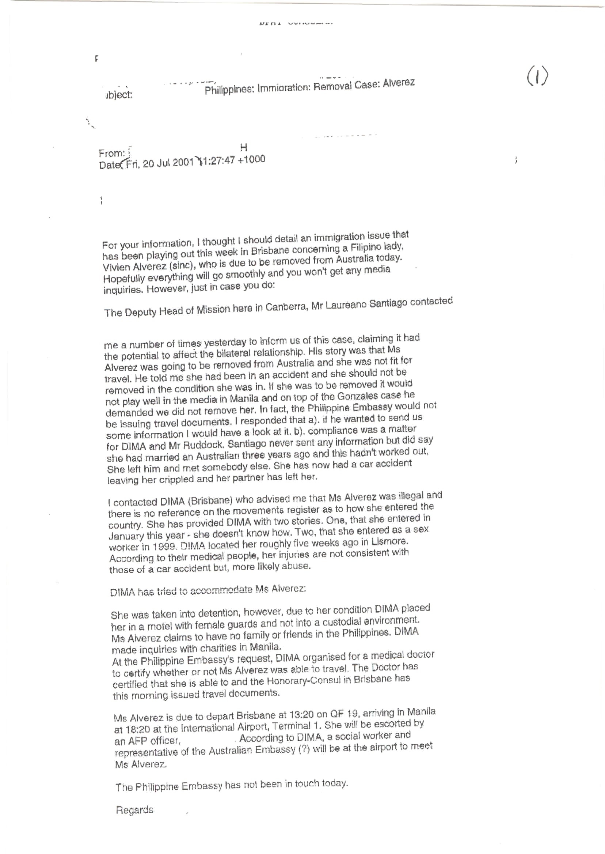
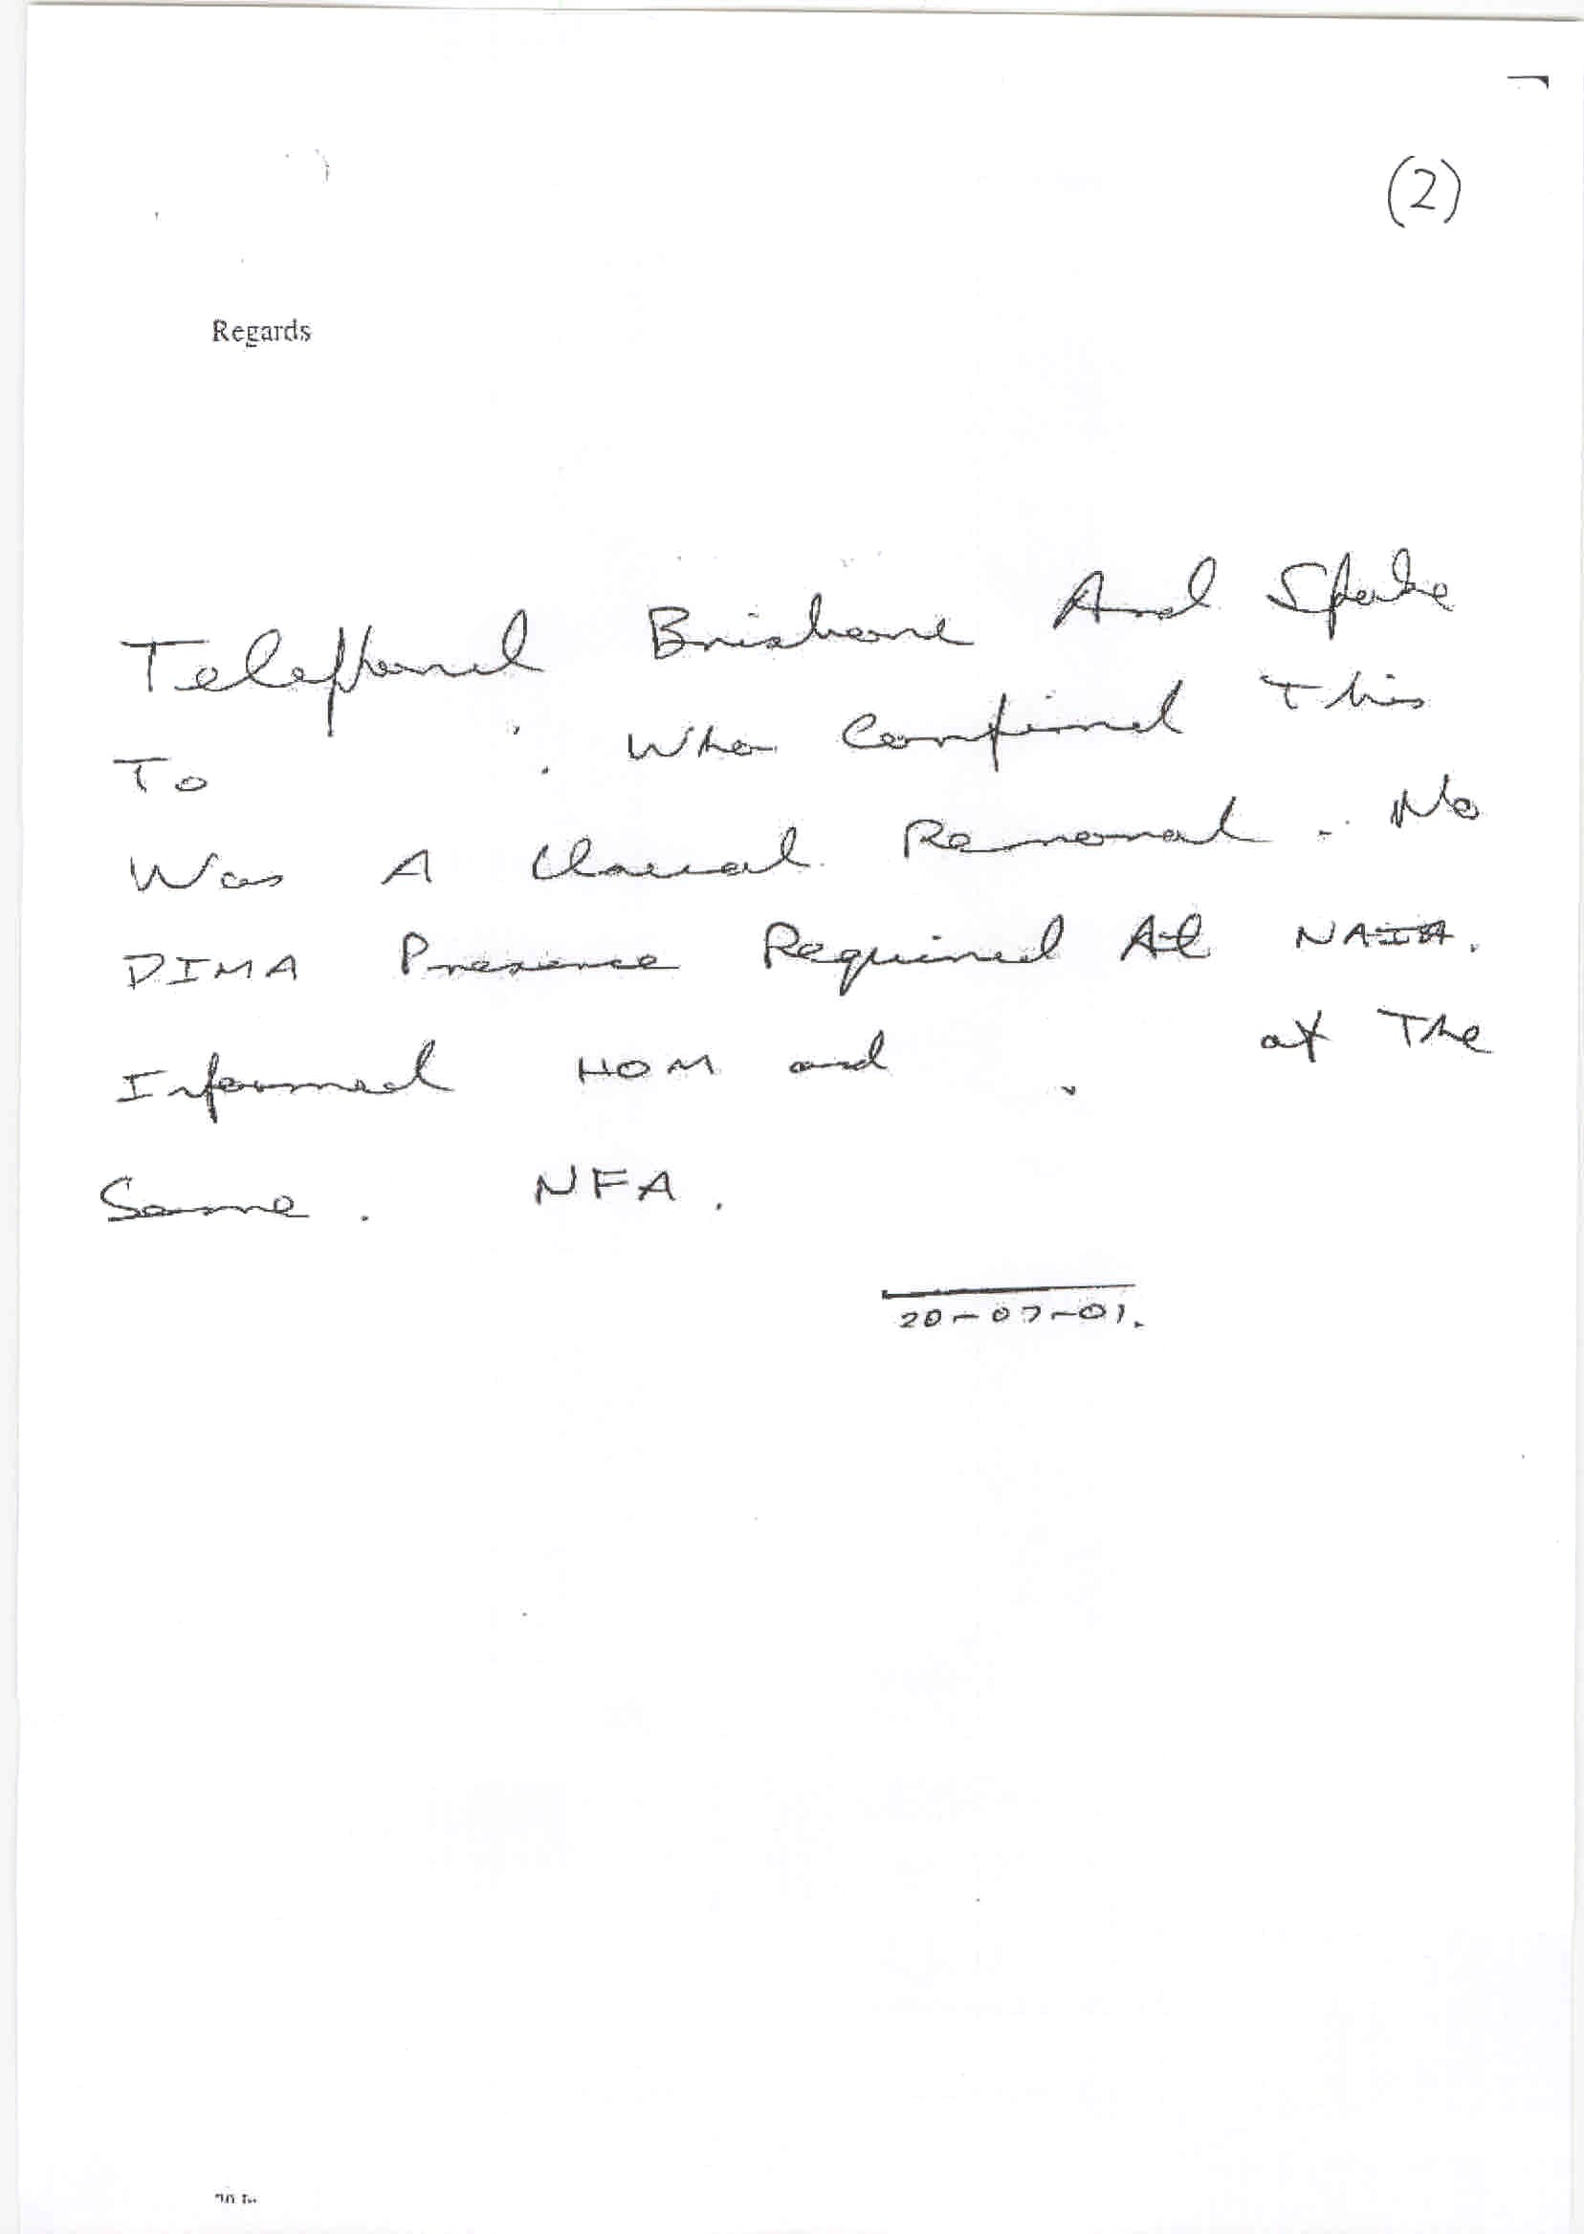
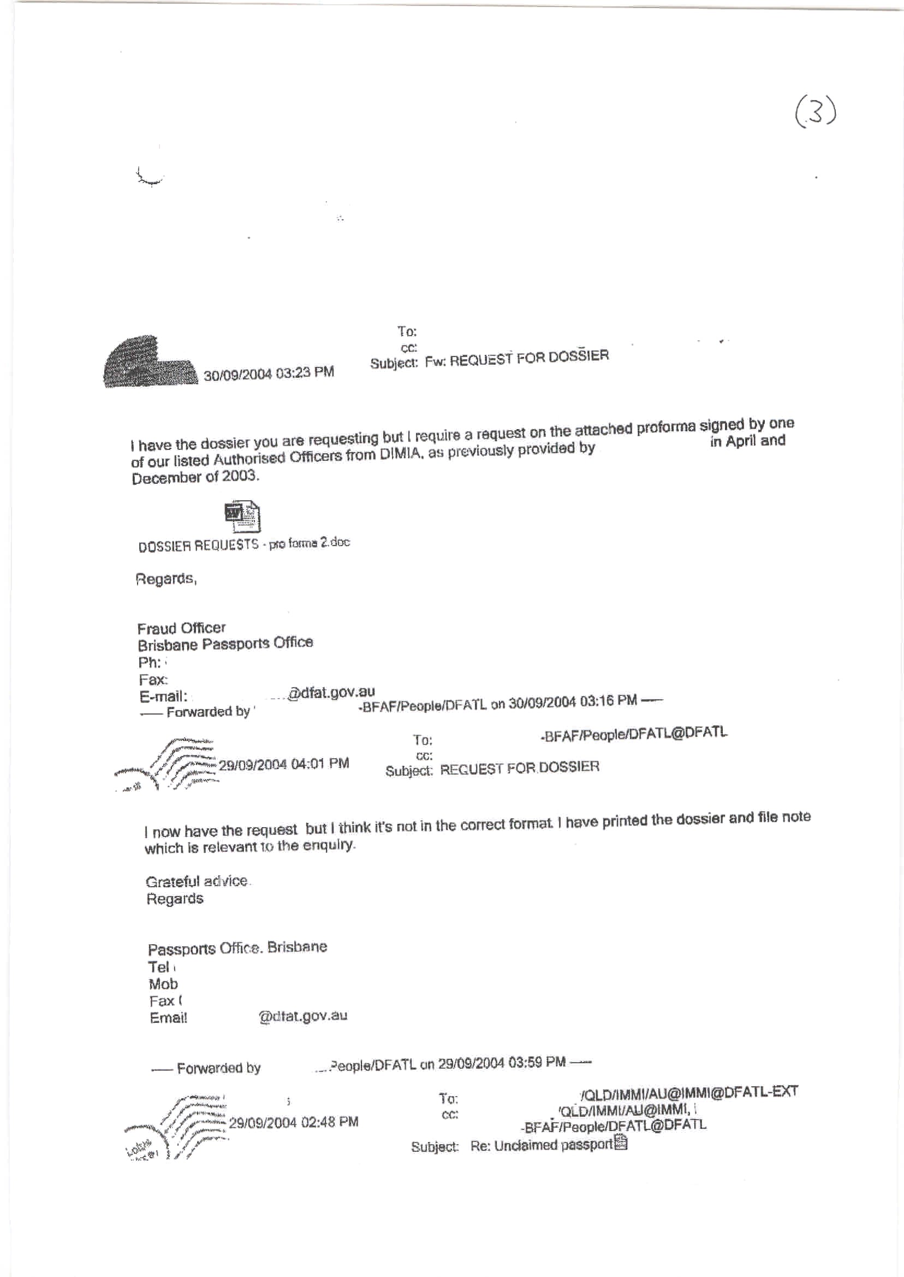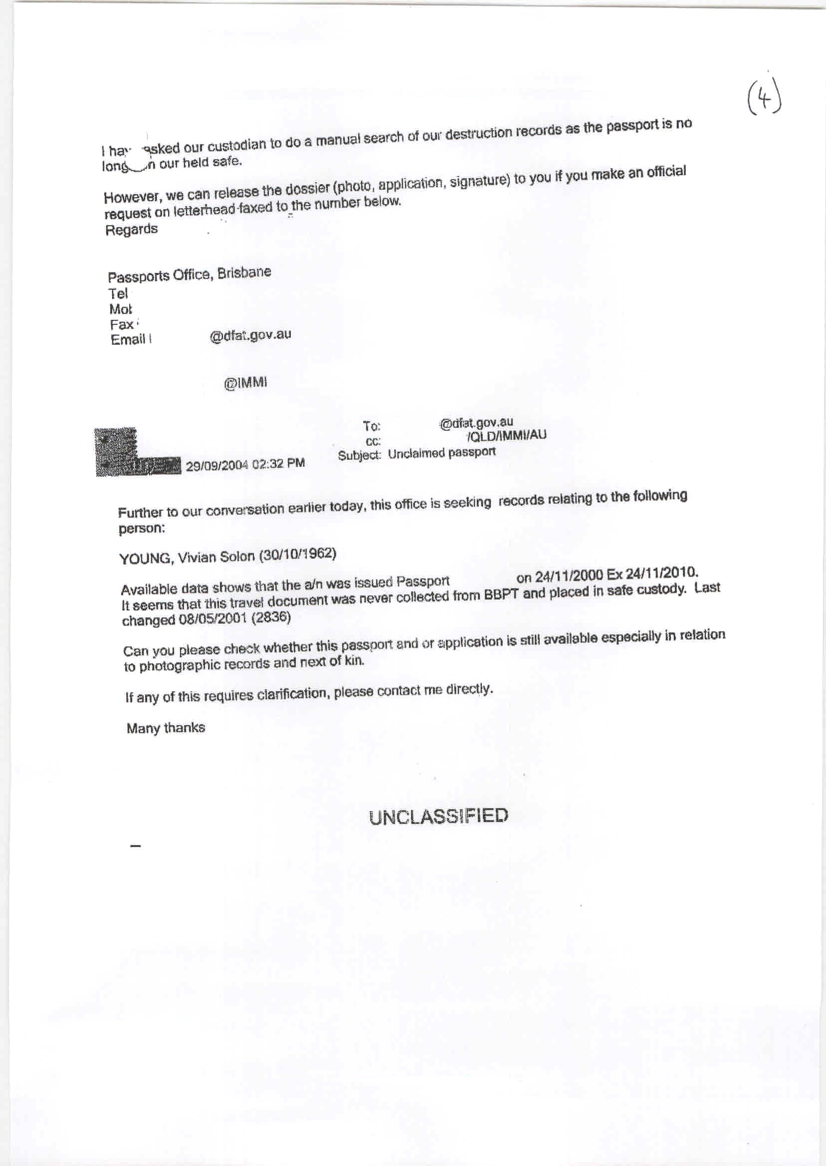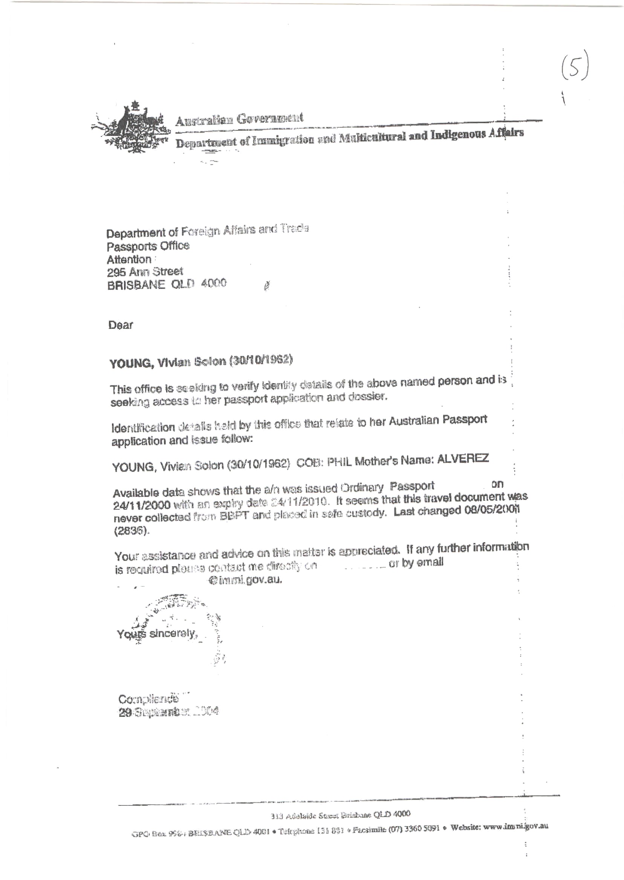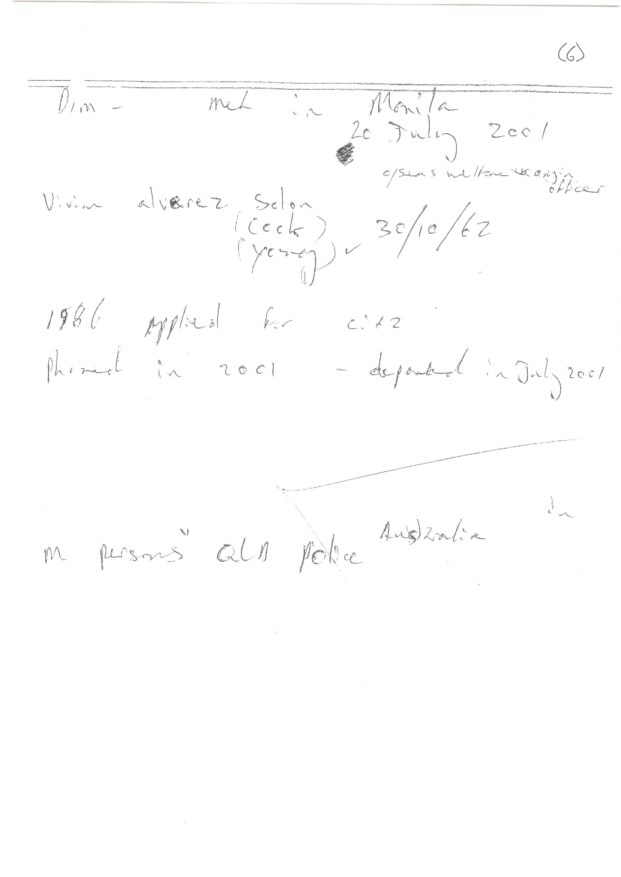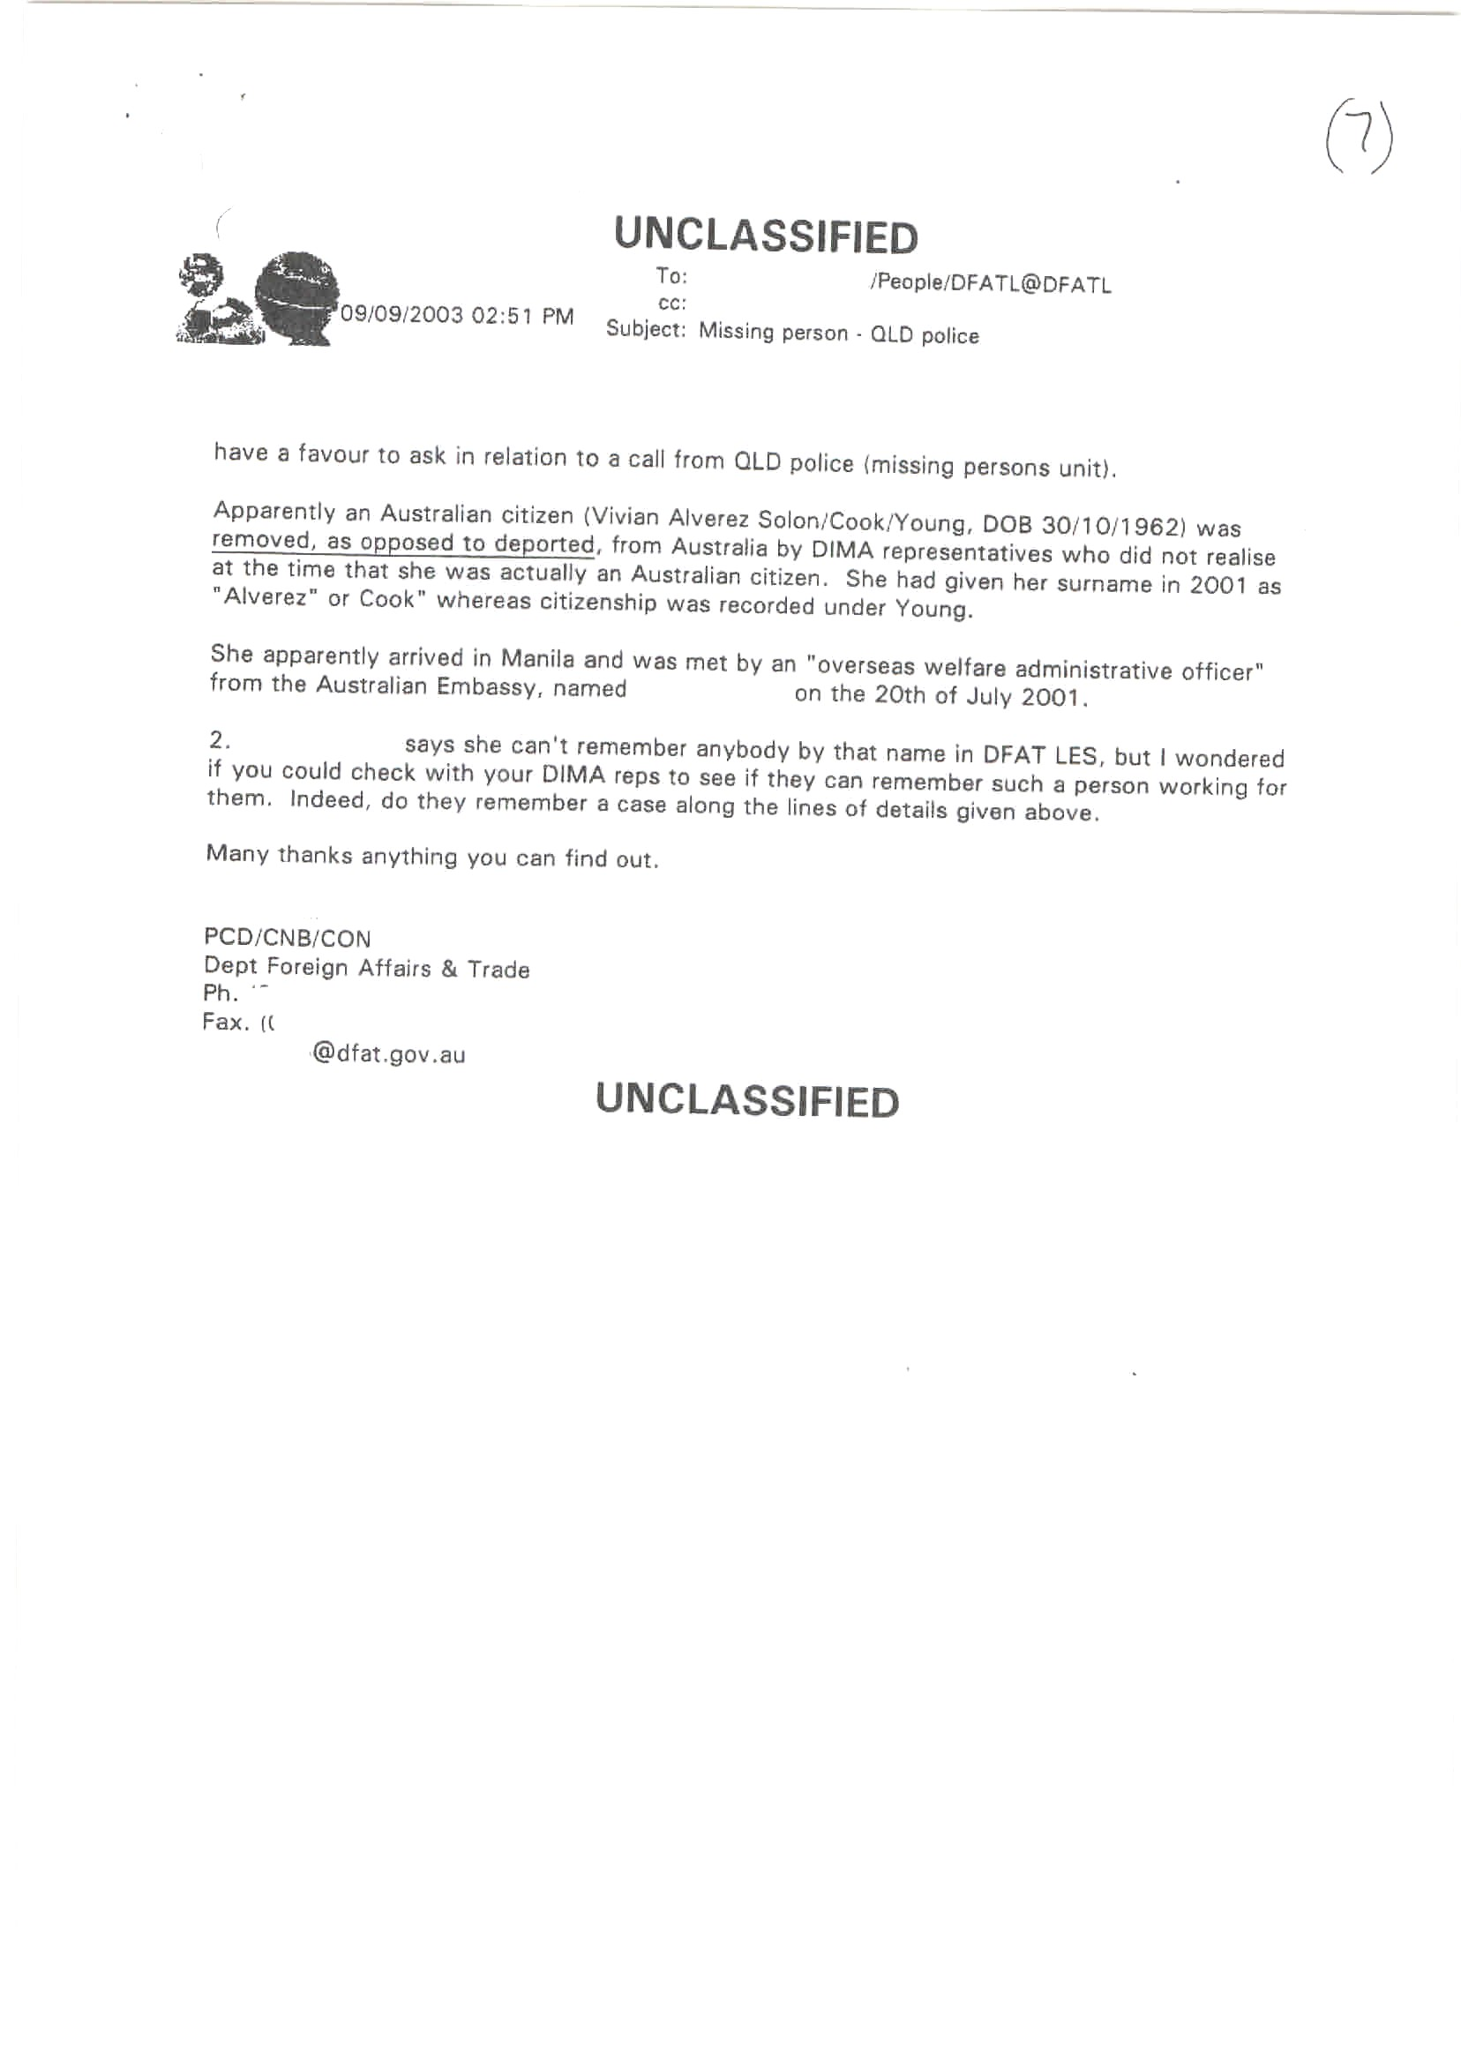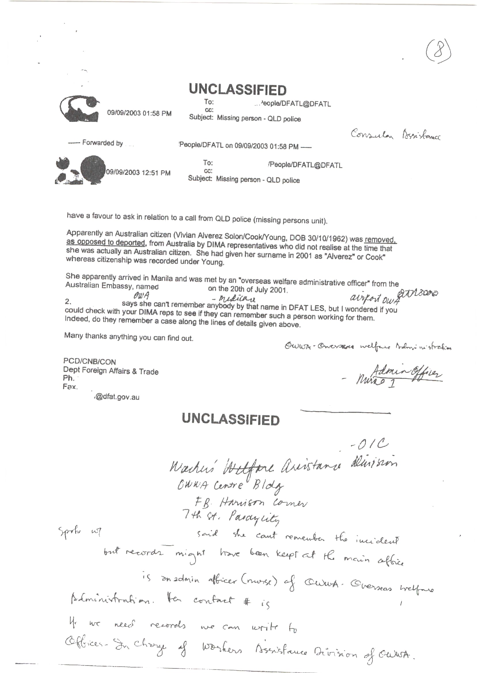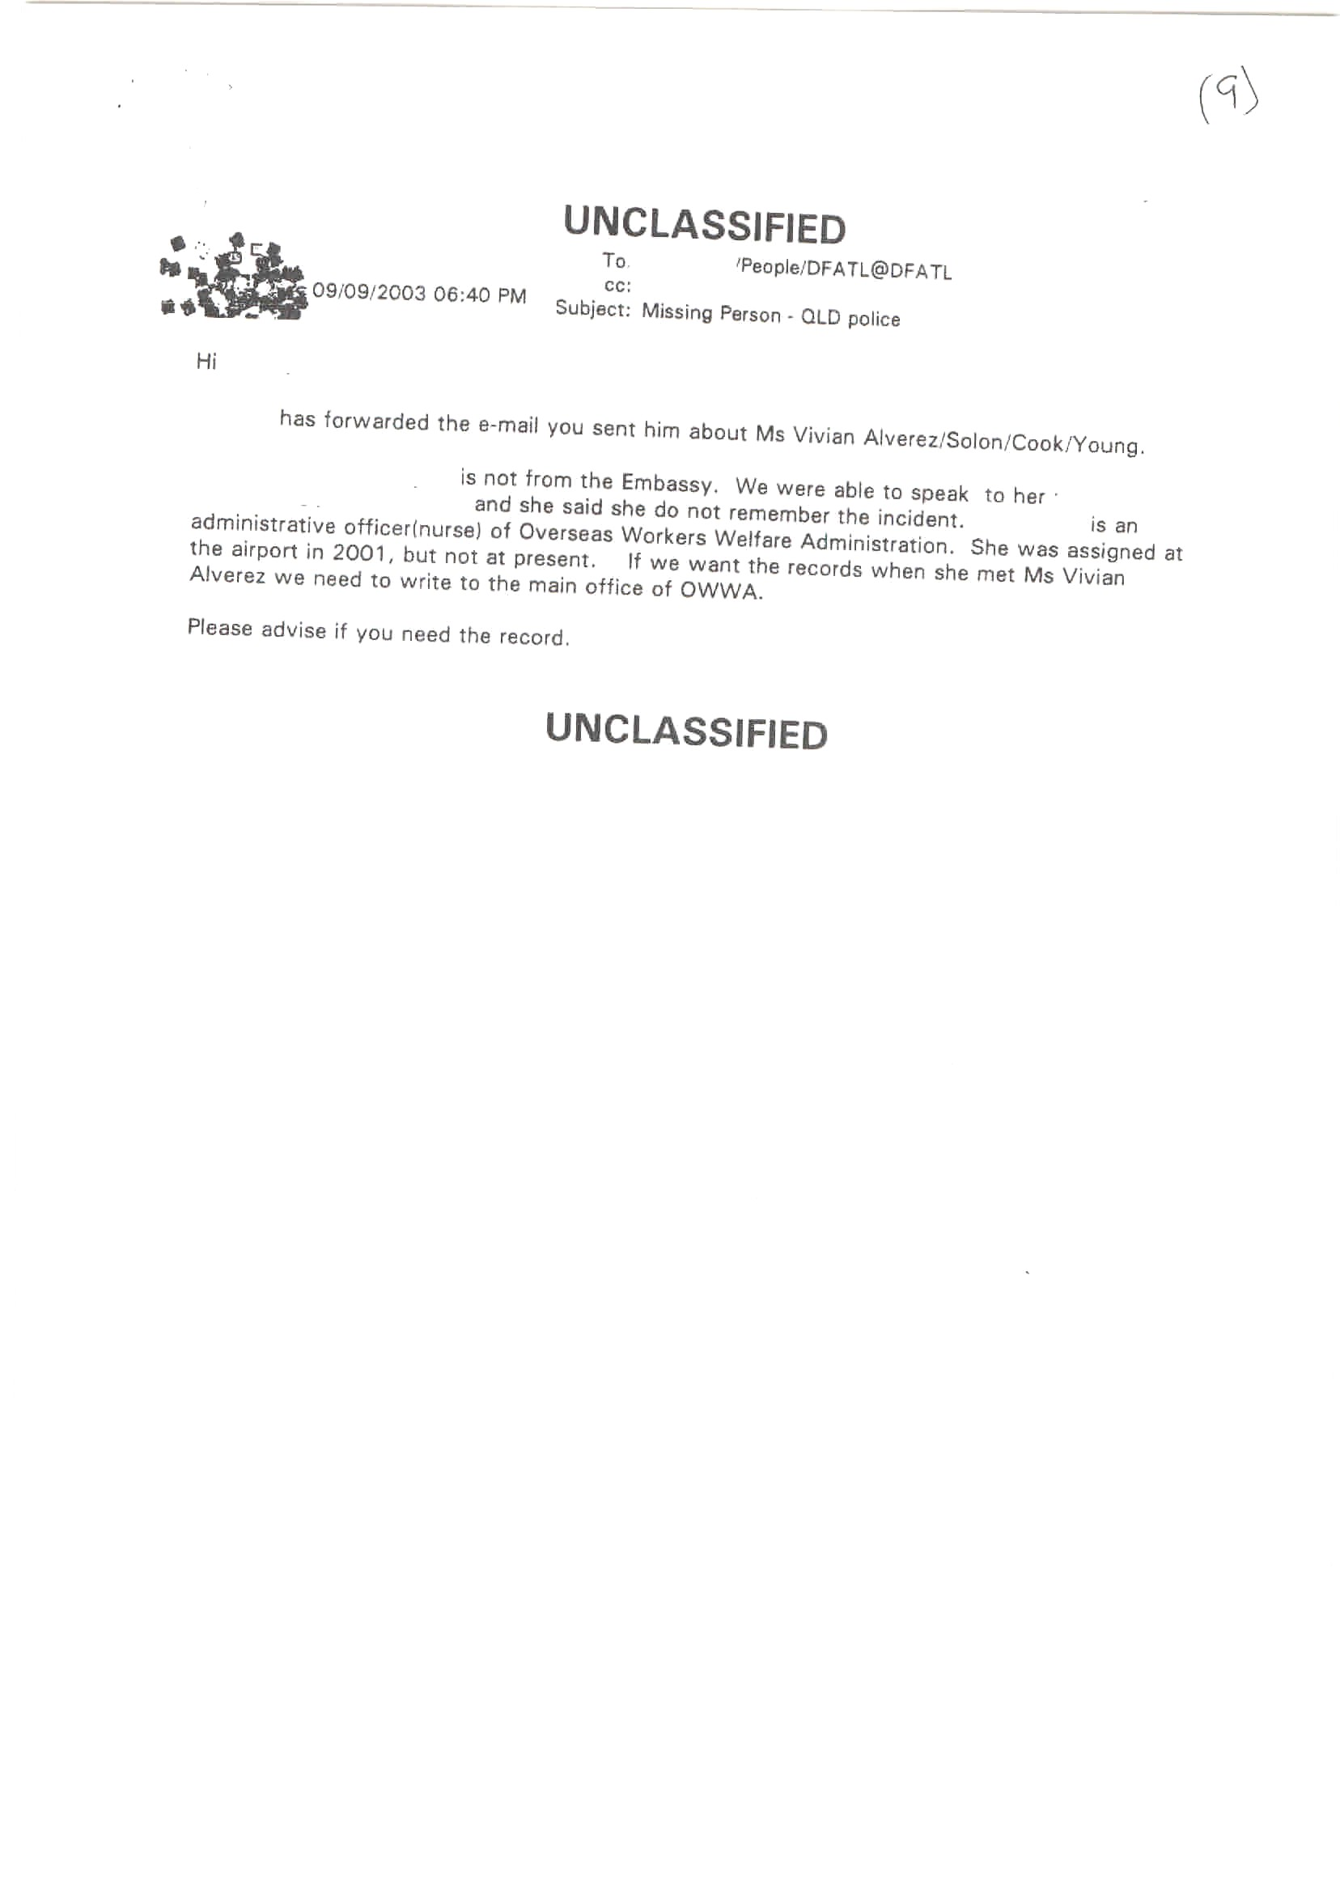
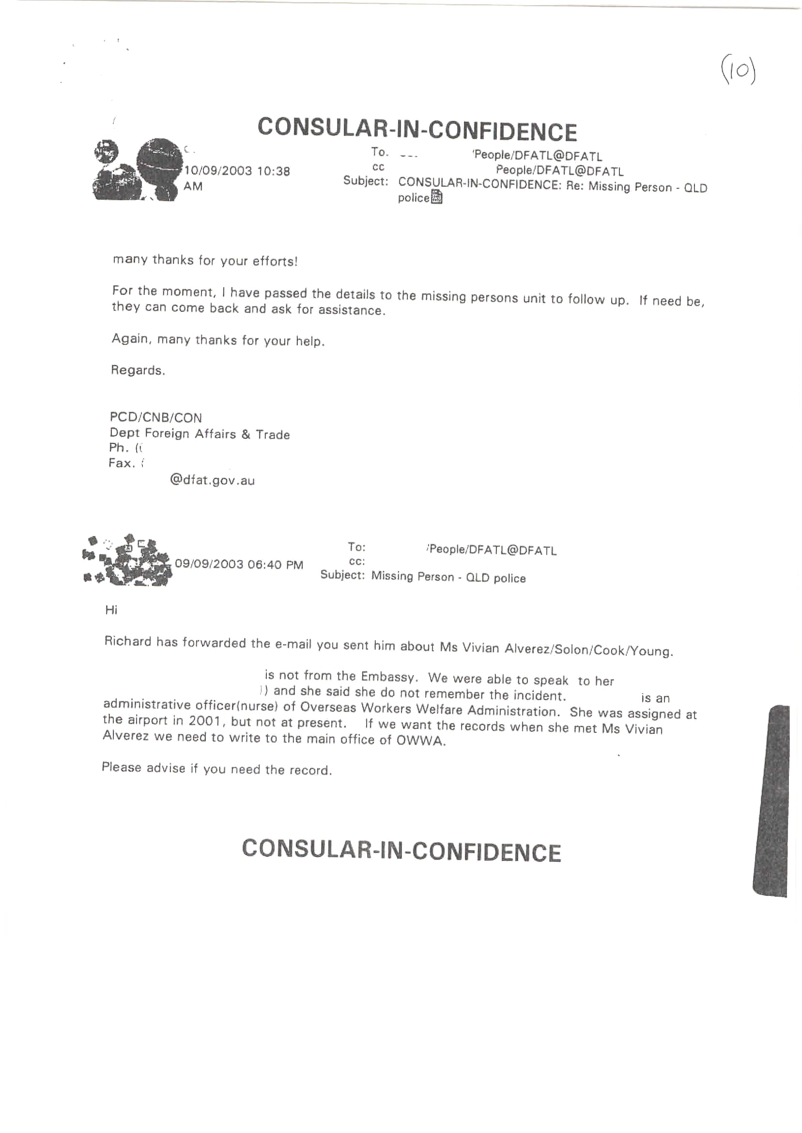
Question 36
Outcome 2, Output 2.1.1
Topic: Government assistance following bomb attack in Jakarta
Question taken on notice (see Senate Hansard page 52)

Senator Robert Ray asked on 01/06/05:
- Provide a follow-up on the assistance program (coordinated by AusAID) for the families of those non-Australian nationals who were injured following the bomb attack on the Australian embassy in Jakarta in 2004.
Answer:
  - On 9 September 2004, a bomb was detonated outside the Australian Embassy in the Kuningan area of Jakarta. 10 Indonesians died as a result of the blast, and over 220 were injured, 30 of those seriously. In the several days following the bombing, AusAID staff visited all of the seriously injured as well as the families of all of the deceased, providing money for immediate needs such as transport costs and funerals.
Shortly after the bombing, the Prime Minister announced that Australia would provide $1 million from the Australian aid program to Indonesia towards a joint fund with the Australian Red Cross (ARC) to help the Indonesian victims of the bombing.
- $50,000 was provided to the local Indonesia Red Cross in Jakarta for immediate medical supplies to treat victims.
- $300,000 was allocated to provide trauma counselling to all victims through the International Medical Corps (IMC). This trauma counselling program concluded on 31st March 2005 with the IMC reporting that the program had been successful in addressing the counselling needs of victims.
- $650,000 was allocated to the Family Assistance Program for victims of the bombing. This program is implemented through an Indonesian welfare NGO ‘Aisyiyah, (the women’s arm of the Islamic organisation Muhammadiyah), with monitoring of the program undertaken by the Jakarta Office of the International Federation of the Red Cross and Red Crescent societies. The program is due to conclude in March 2006 but will be extended as required to deal with any outstanding needs. As at June 2005:
  - 47 victims and families of deceased victims continue to receive a monthly living assistance allowance. The program will continue to provide payments until victims have recovered or been retrained for alternative paid employment or assisted to start up a small business.
  - ‘Aisyiyah will continue to undertake regular assessment of the immediate and longer term economic and medical needs of the victims and their families. ‘Aisyiyah conducted its third needs assessment at the end of May to determine the progress of victims in terms of health and economic recovery. This information has been used to determine whether victims should continue to receive a monthly living allowance and whether they are eligible for retraining or support to start a small business.
  - In June 2005, based on the above needs assessment and after completing training and workshops, 22 families of deceased victims and seriously injured victims received the capital to establish a small business.
Ongoing Medical Care
On 2 November 2004 Mr Downer approved an additional amount of up to $2 million to support specialized medical treatment overseas and ongoing care in Indonesia for the most seriously injured victims of the bombing. To date, Australia has supported medical evacuations and/or specialized treatment in Singapore and Australia for 6 Indonesian victims. Five of these victims continue to receive ongoing medical care. One victim died as a result of her injuries while hospitalised in Singapore.
All patients receiving inpatient treatment in Indonesia have now been released from hospital. Six Embassy guards injured in the blast have returned to light duties at the Embassy as of 28 June, while the last injured guard is due to return in July.
However, a number of the most seriously injured victims will continue to require significant and ongoing treatment. They include:
- Ms Nanda Olivia Daniel, a student who has recently returned to Jakarta after receiving extended treatment in Perth and who will require ongoing physical therapy and follow up treatment.
- Mr Asep Wahyudi, a police officer who returned from Singapore to Indonesia in June but due to the severity of his injuries will require ongoing care, medical treatment and physical rehabilitation. He will return to Singapore in October for additional treatment.
- Mr Diki Maulana, a police officer who continues to make return trips to Singapore for follow up treatment (hand surgery in December 2005).
- Mr Mulyono, an IT manager who lost his entire lower jaw in the bombing and had been receiving treatment in Singapore, will complete his treatment in Melbourne. He will begin his treatment on 2 July and it is anticipated that most major surgery will be concluded in November 2005.
- In addition to the above, eight other patients require follow up surgery and other treatments in Jakarta.
Of this $2 million commitment, approximately $1.1 million remains available to support the continuing treatment needs of victims.

Question 37
Outcome 2, Output 2.1.1
Topic: Prisoner Transfer Scheme
Written question directed to DFAT but answer provided by the Attorney–General’s Department.

Senator Natasha Stott Despoja asked on 03/06/05:
- What is the average time it takes for a person to return to Australia following a request under the prisoner transfer scheme?
- How many prisoners have been transferred back to Australia pursuant to prisoner transfer schemes?
- How many Australians have requested a transfer but remain in custody overseas?
Answer:
- To date there have been three prisoner transfers to Australia under the international transfer of prisoner scheme. All three transfers were from Thailand to Australia. On average these first three transfers took 20 months to complete.
- See answer to question (1).
- The Attorney–General’s Department is currently processing 101 applications for transfer. Of these applications, 19 applications are requests for transfer to Australia. These applications are at various stages.

Question 38
Outcome 2, Output 2.1.1
Topic: Bali 9 and the death penalty
Written question

Senator Kerry Nettle asked on 03/06/05:
In relation to the eight men and one woman known as ‘the Bali 9’, who were arrested by Indonesian authorities on 17 April 2005 and charged with heroin related offences, who now may face the death penalty:
- Can the Minister or Department provide details of the types of assistance provided by the Australian Federal Police or the Australian Government to the Indonesian Authorities?
- Was a request for assistance received from Indonesia? If so when?
- Did the Minister consider his obligations, in relation to the request, under section 8 of the Mutual Assistance in Criminal Matters Act 1987 (the Act)?
- If the answer to the above question is no, why not?
- If the Minister considered that section 8 was relevant, can the Minister confirm that a decision was made to not refuse Australian Government assistance to the Indonesian authorities pursuant to section 8 of the Act? Mutual Assistance in Criminal Matters Act 1987?
- If the answer to the above question is yes in the negative, why not?
- If the Minister is of the view that the Act does not apply to the Bali 9, why not?
- Can the Minister provide a copy of the decision to not refuse assistance to the Indonesian authorities pursuant to section 8 of the Act?
- If the answer to the above question is in the negative, why not?
- What special circumstances of the case existed that satisfied the Attorney General to not refuse assistance to the Indonesian authorities?
- When was the decision to not refuse to grant assistance to the Indonesian authorities made?
- When was the Minister aware that the Bali 9 may face the death penalty?
- Can the Minister guarantee that any assistance provided to the Indonesian authorities from Australian Government will not increase the likelihood that the Bali 9 will face the death penalty?
- If the answer to the above question is in the negative, why not?
- Does the Australian Government condone the use of the death penalty in Australia?
- Does the Australian Government condone the use of the death penalty in other countries?
Answer:
  - The assistance provided by the Australian Federal Police (AFP) to the Indonesian National Police (INP) has been on a police-to-police basis. The AFP has provided the INP with evidentiary material relevant to the prosecution of the 9 persons arrested in Bali. This material includes statements from police officers and witnesses, statements from travel agencies and hotel staff, and immigration records relating to the travel movements of alleged defendants.
  - Yes. There has been ongoing exchange and requests for information between the AFP and INP. In the days leading up to the arrest of the 9 Australians, the INP requested through the AFP Senior Liaison Officer in Bali, information about the travel movements and hotel bookings made by the suspects. Post arrest, the INP has continued to request information from the AFP. On 21 April 2005, a formal invitation was received from the INP through Interpol for the AFP to assist. This invitation facilitated the travel of AFP agents to Bali.
  - This matter has been dealt with on a police to police basis and not as a result of a request from Indonesia for mutual assistance in a criminal matter. Accordingly, section 8 of the Mutual Assistance in Criminal Matters Act 1987 is not applicable.
  - See answer to (3).
  - See answer to (3).
  - See answer to (3).
  - See answer to (3).
  - No such decision exists – see answer to (3).
  - No such decision exists – see answer to (3).
  - No such decision exists – see answer to (3).
  - No such decision exists – see answer to (3).
  - 18 April 2005.
  - The Department of Foreign Affairs and Trade provides consular assistance to Australians arrested overseas. Consular officers have been active in working with the relevant Indonesian authorities to ensure the welfare of all Australian consular clients, including access to medical services and legal advice.
  - See answer to (13).
  - No.
  - No.

Question 39
Outcome 2, Output 2.1.2
Topic: Passports—missing or stolen
Question taken on notice (see Senate Hansard page 24)

Senator Robert Ray asked on 02/06/05:
- How many Australian (a) diplomatic passports, (b) official passports and (3) ordinary passports are currently recorded as missing or stolen?
Answer:
(1) As of 18 May 2005:
a) 108
- 1097
- 157,574
Passports reported lost/stolen are cancelled in the system immediately and cannot be used to depart or re–enter Australia. These passports continue to be listed as ‘lost/stolen’ until their notional validity expires.
Question 40
Outcome 2, Output 2.1.2
Topic: Passport fraud and appeals
Question taken on notice (see Senate Hansard page 27)

Senator John Faulkner asked on 02/06/05:
- Can you provide the figures for: (a) the number of judicial trials for passport fraud, (b) how often these trials happen and (c) and the conviction rate.
- How many passport decisions have been: (a) challenged in the Administrative Appeals Tribunal (AAT), (b) how many matters are currently before the AAT and (c) what is the success rate of these appeals?
Answer:
(1)
(a) In FY 2004-05, the number of judicial trials for passport fraud was: 14
(b) On average, these trials occurred at a rate of slightly more than 1 per month.
(c) In 2004-05, the conviction rate was 11 out of 14 cases.
(2)
(a) In FY 2004-05, the number of passport decisions challenged in the Administrative Appeals Tribunal (AAT) was: 3
(b) The number of matters currently before the AAT is: 1
(c) In 2004-05 the success rate of appeals was: nil

Question 41
Outcome/Output Enabling Services
Topic: Staff sick leave and unscheduled absences
Written question

Senator Brett Mason asked on 3/06/2005:
- For each of the last four financial or calendar years for which this information is available:
- what was the average number of sick leave days taken per full-time equivalent employee;
- what was the average number of days of unscheduled absence (encompassing all types of leave) taken per full–time equivalent employee.
  - Does the department collect, collate and analyse data about unscheduled absence and/or sick leave, for example, which days of the week that employees are away, reasons for absence, dates of absence, employee’s age, gender, length of service and work unit location?
  - Does the department record the number and/or percentage of working days lost due to unscheduled absence and/or sick leave in the Annual Report?
  - Does the department record the cost of unscheduled absence and/or sick leave in annual financial statements?
Answer:
DFAT (Includes Australia–Japan Foundation (AJF))
(1) For each of the last four calendar years:
(a) The average number of days of sick leave taken per full-time equivalent employee of the department was:
- 2004, 5.67 days;
- 2003, 6.16 days;
- 2002, 5.59 days; and
- 2001, 5.48 days.
(b) The average number of days of unscheduled absence (encompassing all types of leave) taken per full-time equivalent employee was:
- 2004, 5.72 days;
- 2003, 6.20 days;
- 2002, 5.62 days; and
- 2001, 5.53 days.
(2) Yes.
(3) No.
(4) No.
Australian Centre for International Agricultural Research (ACIAR)
(1) For the last four calendar years:
a) 2001 3.45 days b) 2001 4.94 days
2002 5.42 days 2002 7.63 days
2003 5.0 days 2003 7.44 days
2004 6.67 days 2004 9.54 days
(2) No
(3) Yes
(4) No
Export Finance and Insurance Corporation (EFIC)
- Sick leave and other unscheduled leave for the last four financial years is as follows:
  - Average number of sick leave days per FTE
Year | Number of sick leave days taken
July 2001 – June 2002 | 6.50
July 2002 – June 2003 | 6.12
July 2003 – June 2004 | 7.94
July 2004 – May 2005 | 4.72
  - Average number of unscheduled leave days (other than sick leave) per FTE
Year | Number of other unscheduled days taken
July 2001 – June 2002 | 0.41
July 2002 – June 2003 | 0.63
July 2003 – June 2004 | 0.46
July 2004 – May 2005 | 0.52
- EFIC’s records would enable us to do the analysis detailed in the question but as an organisation of around 60 people we focus on individuals.
- No.
- No.

Question 42
Outcome/Output Enabling Services
Topic: Efficiency dividends
Written question

Senator Kim Carr asked on 06/06/05:
- What financial impact will the increased efficiency dividend have on your Department/agency this financial year and in the out years?
- The increase in the efficiency dividend was announced in last year's elections, what plans have you made to meet it?
- What will this mean for staff numbers?
- Will any specific programs be cut? Please specify which ones and the size of the estimated savings?
- Will any core functions be affected by these savings measures?
- How will meeting the efficiency dividend affect your graduate recruitment plans?
- How will meeting the efficiency dividend affect your ability to retain experienced staff?
Answer:
DFAT
- The increase in the efficiency dividend from one per cent to 1.25 per cent will have a financial impact of $1.445 million in 2005–06, $2.94 million in 2006–07 and $4.52 million in 2007–08.
- The department regularly assesses its planned activities against its available budget and emerging priorities.
- The department regularly assesses its staff profile against its available budget and emerging priorities.
- No.
- No.
- No impact.
- The efficiency dividend is not expected to affect the department’s ability to retain experienced staff. The department continues to be a competitive Australian Public Service employer.
AJF
- The increase in the efficiency dividend from one per cent to 1.25 per cent will have a financial impact of $3,000 in 2005–06; $5,000 in 2006–07; and $7,000 in 2007–08.
- The Foundation regularly assesses its planned activities against its available budget.
- The increase in the efficiency dividend will not impact on staff numbers.
- No.
- No.
- The Foundation does not have a graduate recruitment process.
- The efficiency dividend is not expected to affect the Foundation’s ability to retain experienced staff.
ACIAR
(1) Financial impact of increase in efficiency dividend
2005–06  $’000 | 2006–07  $’000 | 2007–08  $’000
122 | 124 | 126
- Revised budget funding has been taken into account in formulating a new Certified Agreement for 2005–2008. Costings for the new Agreement take account of restructuring savings as well as productivity savings over the term of the new agreement. Operational costs have been reviewed to absorb the increased efficiency dividend and allocations for new projects have been adjusted accordingly.
- The impact on staffing numbers is estimated as less than one staff unit. Restructuring arrangements, including the move to part–time hours by some staff will produce the necessary savings.
- No
- Nil
- Nil
- No impact on ability to retain experienced staff.
EFIC
(1) – (7) Not applicable to EFIC. Nil response.

Question 43
Outcome/Output Enabling Services
Topic: AWAs
Written question

Senator Kim Carr asked on 06/06/05:
- How many staff are covered by AWAs in your Agency/Department?
- Can you provide a break down of AWAs by gender and by classification?
- Can you tell me how many of the staff on AWAs are paid more than the band for their classification under the certified agreement?
- Why were these staff not simply promoted to a higher classification?
Answer:
DFAT
- 210.
- The break down of AWAs by gender and by classification is as follows:
SES Band 3 - 16 (Male 14; Female 2)
SES Band 2 – 56 (Male 45; Female 11)
SES Band 1 – 101 (Male 71; Female 30)
EL2 – 29 (Male 21; Female 8)
APS6/EL1 – 6 (Male 3; Female 3)
APS5 – 1(Female)
Medical Officer – 1 (Male)
The SES and EL2 figures include heads of mission and post at the 86 posts managed by the department.
- 37 staff on AWAs are paid more than the band for their classification under the certified agreement.
- These staff are performing tasks requiring specialised skills and/or experience for a specific period only.
AJF
- The Australia–Japan Foundation has one non-ongoing staff member covered by an AWA.
- The staff member is female and employed at the BB4 (EL2) level.
- The staff member’s salary is in accordance with the Department of Foreign Affairs and Trade’s certified agreement as it applies to EL2 staff.
- Not applicable.
ACIAR
(1) 5
(2) SES1 1 male; EL1 1 male; EL1 1 female; APS6 1 female; APS4 1 male
(3) Four
(4) These AWAs provide for payment of an allowance in recognition of an employee’s value to the organisation or to acknowledge gaining of formal qualifications.
EFIC
- 26.
- 14 are female and 12 are male. EFIC does not have a classification or banding system.
- Not applicable.
- Not applicable.

Question 44
Outcome/Output Enabling Services
Topic: Performance pay
Written question

Senator Kim Carr asked on 06/06/05:
- Is performance pay available under your department/agencies certified agreement?
- If not how many staff in your Department/Agency are eligible for performance based pay?
- Please provide a breakdown of performance pay awarded for this financial year to date including the following details:
  - How many staff have received performance pay?
  - What levels are those staff at?
  - What gender, a breakdown please?
  - How much has each staff member received?
  - When did they receive it?
  - What was the rationale for the awarding of performance pay in each instance?
  - Did the Department/Agency head receive performance pay?
  - How much?
  - When?
  - On what grounds?
Answer:
DFAT (Includes AJF)
- Yes.
- Not applicable.
- Performance pay to be awarded for this financial year to date will be determined after the end of the financial year, in August.
ACIAR
(1) Yes
(2) N/A
(3) Bonus paid to employees in fin yr 2004-05 for the organisation’s performance in 2003–04.
(a) 46
(b) APS2 to SES1
(c) 25 females and 20 males
(d) $1300 to each full-time employee; pro rata for part-time employees
(e) 12 August 2004
(f) Based on the organisation meeting a specified number of objectives
(g) Yes
(h) $24,749
(i) 23 September 2004
(j) Individual performance, as assessed by Board of Management
EFIC
- Yes, provided that the employee has been employed with EFIC for a minimum of nine months of the review year.
- Not applicable.
- EFIC performance incentives paid for the 2004–2005 financial year are as follows:
  - 46 of 58 staff were awarded performance incentives.
  - EFIC does not operate under the Public Service classification or banding system. We do not have a structured banding system. The bonuses were across the whole organisation.
  - 20 females and 25 males.
  - The following amounts were awarded:
Bonus amount as a percentage of salary | Amount of staff received
0 - 1% | 4
1 – 3% | 9
>3 – 6% | 18
>6 – 9% | 14
>9 – 12% | 1
  - Performance incentives were paid in September 2004.
  - Performance incentives were paid to individuals who exceeded the objectives set by their managers at the beginning of the financial year.
  - Yes.
  - 9.4% of the salary package was awarded.
  - September 2004.
  - The EFIC Board awarded the bonus payment based on a review of performance.

Question 45
Outcome/Output Enabling Services
Topic: Languages
Written question

Senator Ludwig asked on 06/06/05:
A follow-up to a question Senator Ludwig asked in December.
- Regarding the employees that your department or agency has identified as having:
  - fluency
  - accredited translator
  - accredited interpreter
- Of these employees, please indicate what the department is doing in order to make full use of its employees skills in this regard, and please provide a breakdown of this between employees whose accreditation was paid for by the department and those whose were not?
Answer:
DFAT
(1) and (2) Foreign language proficiency is a relevant factor in the selection of departmental staff for service overseas. Staff with language proficiency are also regularly called upon to perform ad hoc translating and interpreting duties, for example for visiting officials. The one NAATI–qualified employee, whose accreditation was funded by the department, has performed a range of ad hoc translating and interpreting duties involving the language of accreditation.
AJF
- The Director of the Australia-Japan Foundation (AJF) based in Tokyo is fluent in Japanese. Fluency in the Japanese language (S3 R3) is a requirement for the director position.
- The Director, AJF in Tokyo uses her Japanese language skills on a daily basis.
ACIAR
(1) and (2) Nil – ACIAR does not identify language proficiency.
EFIC
(1) and (2) EFIC has identified existing employees who are fluent in languages other than English. Due to the nature of EFIC’s business and typical client profile, EFIC does not have a need to identify the non-English language skills accreditation of employees. External assistance would be sought should translator or interpreter services be required.

Question 46
Outcome/Output Enabling Services
Topic: Legal service expenditure
Written question

Senator Ludwig asked on 06/06/05:
- What amount did the Department/agency spend during the financial year 2004/2005 on outsourced legal practitioners (including private firms, individuals, the Australian Government Solicitor, and any others)?
- What was the budgeted amount for outsourced legal practitioners in 2004/2005?
- What amount did the Department/agency spend on internal legal services? (Provide an estimate if exact amount is unavailable.)
- Does the Department/agency have an in-house legal section? If so, what was the 2004/2005 actual cost of this section? What was the budgeted amount for this section in 2004/2005? What is the budget amount for this section in 2005/2006?
- What is the total projected expenditure on legal services for 2005/2006 for the Department/agency?
- Which organisations or individuals were contracted to provide legal services to the Department/agency in 2004/2005?
- In each instance, how much was each organisation or individual paid for these services?
- Does the Department/agency use an open tendering or select tendering process (as described in the Commonwealth Procurement Guidelines, p 42) when procuring legal services?
- If a select tendering process is used: (a) which method of select tendering is used and (b) which firms or individuals are currently eligible to tender for legal services?
- If a multi–use list is used: (a) which firms or individuals are currently on that list and (b) when was the list last opened for applications?
- In 2004/2005 did the Department/agency obtain any legal services using a direct sourcing procurement process? If so, provide details including the name of the provider, the work involved and the cost?
- In 2004/2005 did the Department/agency procure any legal services under the thresholds required for ‘covered procurements’ (within the meaning of 8.6 of the Commonwealth Procurement Guidelines)? If so, provide details including the name of the provider, the work involved and the cost.
- In 2004/05 did the Department/agency contract any legal firms to provide services other than legal services (such as consulting, conduct of policy reviews etc)? If so, provide details including the name of the firm, the project involved and the cost of the contract.
Answer:
DFAT
- $1.67 million as at 31 May 2005, which includes payments to overseas legal practitioners.
- $ 1.87 million, which includes payments to overseas legal practitioners.
- $ 1.52 million as at 31 May 2005, covering salary and salary–related costs only.
- Yes. As at 31 May 2005, salary and salary–related costs for the in–house legal section were $532,861. Its budget for salary and salary-related costs for 2004–05 is $ 707,545 and for 2005–06 is $ 735,846.
- Estimated external legal expenditure for 2005–06, in Australia and overseas, is currently projected to be similar to 2004–05: $1.87 million.
(6/7) The Department contracted the following organisations and law firms to provide legal services in Australia during 2004–05. As at 31 May 2005, fees paid, excluding GST, were as follows:
- Australian Government Solicitor: $482,567
- Blake Dawson Waldron: $ 6,021
- Clayton Utz: $ 12,512
- KPMG: $ 1,650
- Mallesons Stephen Jaques: $413,638
- Minter Ellison: $ 77,735
- Phillips Fox: $ 2,583
(8) An open tender process.
(9) Not applicable.
(10) Not applicable.
(11) Yes. The Department directly sourced legal advice from Phillips Fox Lawyers for specialist legal advice on an insurance matter, from KPMG for specific taxation advice, and from Clayton Utz and Blake Dawson Waldron for property related legal advice. The fees paid for these services (excluding GST) are shown in the response to question 7 above.
- Yes. All individual procurements of legal services were under the threshold required for “covered procurement”. The names of these providers and total expenditure for 2004–05 are provided in the answers to question 6 and 7. To provide further information on the work involved would entail a significant diversion of resources and in the circumstances I do not consider the additional work can be justified.
- To provide the information sought would entail a significant diversion of resources and in the circumstances I do not consider the additional work can be justified.
AJF
  - The Australia–Japan Foundation spent $10,632 during the 2004–05 financial year on outsourced legal services.
  - The Foundation budgeted for $15,000 in 2004–05 for outsourced legal services.
  - Not applicable to the Foundation, which does not have internal legal advisors.
  - No.
  - Projected expenditure on legal services for 2005–06 is $7,000.
  - and (7) The Foundation obtained legal advice from the following law firms during 2004–05. Fees paid (excluding GST) were as follows:
Clayton Utz $4,800
Mallesons Stephen Jaques $5,832
- As the legal services required by the Foundation have been less than the covered procurement threshold, the Foundation has not used an open or select tendering process.
- Not applicable.
- Not applicable.
- Yes, as in (6/7). The Foundation consulted both legal firms for advice on legislative matters.
- Yes. Both items in (6/7) fall beneath the relevant threshold.
- No.
ACIAR
- $15,246
- $20,000
- Not applicable
- No
- $40,000
- Clayton Utz and Sage Legal Services Pty Ltd
- Clayton Utz: $8,046; Sage Legal Services: $7,200
- Not Applicable. Our legal services are below the threshold for covered procurements.
- Not applicable.
- Not applicable.
- Not applicable.
- Clayton Utz: General Advice, $8,046; Sage Legal Services: General Advice, $7,200
- Not applicable
EFIC
- EFIC’s projected spend (the financial year having not yet ended) on outsourced legal practitioners during 2004/05 is $937k, being $267k for Australian lawyers and $670k for overseas lawyers (required for specialist work in foreign jurisdictions). These figures do not include amounts spent on outsourced legal practitioners where the costs were recovered from EFIC’s clients.
- $422k.
- EFIC’s projected spend on internal legal services in 2004/05 is $485k. This figure is net of amounts recovered from EFIC’s clients in reimbursement of internal legal services provided on client specific transactions.
- Yes. Refer to Q3. The budgeted amount for this section in 2004/05 was $470k. This figure is net of amounts expected to be recovered from EFIC’s clients in reimbursement of internal legal services provided on client specific transactions. The budgeted amount for this section in 2005/06 is $570k. This figure is net of amounts expected to be recovered from EFIC’s clients in reimbursement of internal legal services provided on client specific transactions.
- $1,590k, being $570k for internal legal services and $1,020k for external legal services (of which at least $720k is for specialist overseas lawyers required for work in foreign jurisdictions).
- Refer Q7.

Australian Lawyers
Abbott Tout | $120,000 (projected)
Australian Government Solicitor | $4,000
Coudert Bros | $7,403
Freehills | $22,980
Middletons | $2,360
Minter Ellison | $19,673
Norton White | $4,224
PricewaterhouseCoopers Legal | $19,250
RG Foster, SC | $23,601
R Beech Jones | $11,720
R Dubler SC | $6,050
DL Williams SC | $5,730
J Duncan | $20,350

Overseas Lawyers
Francis Gray, USA | $7,477
Lee & Ko, Korea | $54,070
Loyes & Loeff, Netherlands and France | $20,000
Nagashima Ohno & Tsunematsu, Japan | $4,469
Pantazis–Kanellopoulos, Greece | $73,495
Shimazaki International Law Office, Japan | $20,444
Yoshida & Partners, Japan | $390,000 (projected)
Allen & Gledhill, Singapore | $100,000 (projected)
- Neither. EFIC selects Australian based law firms from a preferred lawyer list settled in response to expressions of interest requested in prior years; or where required, may engage specialist lawyers.
- Not applicable.
- Not applicable.
- No.

- Refer Q7.
- No.

Question 47
Outcome/Output Enabling Services
Topic: Staffing figures
Question taken on notice (see Senate Hansard, page 4)

Senator John Faulkner asked on 01/06/05:
- Provide the annual figures for the number of ongoing and non-ongoing staff employed on a part–time and full–time basis by DFAT, from 1996 to 2005.
- Provide the annual figures for the number of locally engaged staff employed by DFAT, from 1996 to 2005.
Answer:
- The breakdown of ongoing and non–ongoing staff in the department from 1996 to 2004 can be found in DFAT’s Annual Reports.
- The following table shows the number of locally engaged staff (LES) employed by, and performing duties for, my department from 1996 to 2005.

Year * | DFAT LES
30-Jun-96 | 1606
30-Jun-97 | 1524
30-Jun-98 | 1599
30-Jun-99 | 1610
30-Jun-00 | 1580
30-Jun-01 | 1519
30-Jun-02 | 1472
30-Jun-03 | 1413
30-Jun-04 | 1406
18-May-05 | 1401

*DFAT LES numbers from 1996–2004 are as at 30 June as reported in the DFAT Annual Report. 2005 DFAT LES numbers are as at 18 May 2005.
Question 48
Outcome/Output Enabling Services
Topic: Language training
Question taken on notice (see Senate Hansard, pages 8–9)

Senator John Faulkner asked on 01/06/05:
- Provide a statistical breakdown, into the three language tiers, of the 30 per cent of staff who have tested professionally proficient (S3R3) in the last six years.
- Provide a comparison of the most recent figures from the above statistics and those for 1994–95.
- What level (APS level/SES band) are the staff who have S3R3 or above, language proficiency?
- For each post, what is the number of language designated positions and language desirable positions?
- Do the Australian ambassadors or Heads of Mission in the East Asian posts meet the S3R3 language ability level?
Answer:
(1) and (2)
The following table provides a comparative statistical breakdown of staff who tested as professionally proficient (S3 R3 and above) in tier one, two and three languages in 1994 and in the six years to 2005, including staff professionally proficient across more than one language tier.
 | 1994 (per cent of staff) | Current (per cent of staff)
Tier one languages | 3.4 | 8.9
Tier two languages | 8.3 | 9.2
Tier three languages | 3.2 | 9.2
Total | 14.9 | 27.3
(3)
Level | Number of staff tested at S3 R3 level or above in the six years to 2005
BB1 (includes Graduates) | 20
BB2 | 42
BB3 | 171
BB4 | 87
SES Band 1 | 50
SES Band 2 | 16
SES Band 3 | 3
Total | 389
Note: Staff with proficiency in more than one language have been counted once only.
(4)
Post | Language Designated Positions | Language Desirable Positions
Abu Dhabi | 1
Abuja |  | 1
Amman | 2
Athens | 1
Baghdad | 1
Bali | 2
Bangkok | 7 | 1
Beijing | 12 | 1
Berlin | 4 | 3
Brasilia | 3
Brussels | 3 | 3
Buenos Aires | 3 | 1
Cairo | 1
Dili | 3 | 1
Guangzhou | 2
Hanoi | 3
Ho Chi Minh City | 1 | 1
Holy See |  | 1
Hong Kong | 4
Honiara | 4
Jakarta | 19 | 3
Kuala Lumpur | 5
Kuwait City | 1
Lisbon | 1
Madrid | 3 | 1
Manila | 3
Mexico City | 4 | 1
Moscow | 2
Noumea | 3
Paris | 6 | 1
Phnom Penh | 1
Port Louis | 1 | 2
Port Moresby | 13
Port Vila | 4
Ramallah | 1
Rangoon | 1
Riyadh | 1
Rome | 3 | 1
Santiago | 5
Seoul | 3
Shanghai | 2
Taipei | 6
Tehran | 1
Tokyo | 10 | 3
Vienna | 2 | 1
Vientiane | 1
Warsaw | 1
Totals | 160 | 26

(5) Six Heads of Mission/Heads of Post in East Asia have language proficiency at S3 R3 level or above. Two have proficiency at S3/R3 level in more than one language.
Question 49
Outcome/Output Enabling Services
Topic: Guidelines for firearms
Question taken on notice (see Senate Hansard page 64)

Senator John Faulkner asked on 01/06/05:
In regard to DFAT's guidelines for staff travelling overseas, what are the guidelines in relation to firearms?
Answer: None.

Question 50
Outcome/Output Enabling Services
Topic: Staff reductions
Question taken on notice (see Senate Hansard page 5–6)

Senator Robert Ray asked on 01/06/05:
- According to Annual Report figures, DFAT has 562 fewer staff now, than it did in 1996. Where have these staff reductions occurred? That is, where have staff losses been in terms of overseas versus Australia, administrative versus policy.
- Since 1996, how have staff reductions impacted on the department (have higher salary bands remained fully occupied or increased and have lower salary bands gone)?
Answer:
- DFAT’s Annual Report figures show staff reductions of 571 between 1995–96 and 2003–04. This is made of 397 less staff in Australia and 174 at overseas posts. The majority of staffing reductions have occurred where technological advances and efficiency gains have been most advanced—especially in the areas of communications and administrative support. Reflecting this, while some overseas policy positions have been withdrawn, the majority of these have been IT positions or administrative support positions, some of which have been localised. A similar pattern is evident with regard to changes in our offices in Australia.
- Staff reductions have not impacted adversely on the Department. Staffing resources are constantly under review and adjusted according to organisational priorities. With the exception of APS 1, all salary levels are represented in the DFAT broadband system and the majority of staff continue to be at the APS 6 and EL1 levels. A number of new higher level positions have been created for particular policy priorities such as the Ambassador for Counter Terrorism, and to lead the trade task forces.
Question 51
Outcome/Output: Enabling Services
Topic: FTA Task Force staffing arrangements
Question taken on notice (see Senate Hansard page 80)

Senator John Hogg asked on 02/06/05:
- Provide a break–up of the staff arrangements, including the number and level of officers, for each of DFAT's Free Trade Agreement Task Forces'.
Answer:
  - The Asia Trade Task Force (ATTF) will focus on FTA negotiations with ASEAN and Malaysia. The China FTA Task Force will be dedicated to the FTA negotiations with China. Both of these task forces will be headed by an SES Band 2 officer and comprise five other staff. A smaller group of staff in Trade Development Division, headed by an SES Band 2 officer has been established to negotiate the FTA with the United Arab Emirates.
The task forces will be the core resource for carrying forward negotiation of a series of trade and economic arrangements with China, ASEAN, Malaysia and the UAE. The number and level of staff required from trade and geographic divisions will vary during the negotiations depending on the skills set required and intensity of negotiations.
The task forces will be supported by an FTA Unit compromising seven sectoral coordinators or lead negotiators, supported by three other policy staff and three administrative staff. The FTA Unit will enable the Department’s sectoral expertise to be deployed in a coordinated way in support of the different negotiations.

