Question
Senator Hogg asked how much Australian aid went to Fiji through multilateral and regional programs.

Response
We are unable to provide information on multilateral programs as this funding is not disaggregated by country or region.
The total value of the Pacific Regional program in 1999/2000 is estimated to be $36.16 million. Of this it is estimated that $5.370 million is of direct benefit to Fiji. In 2000/2001 the total value of the program is estimated at $A35.7 million. Under current arrangements, approximately $A5 million will benefit Fiji directly.

Question
Senator Hogg asked for a list of the aid program’s public sector reform projects in Fiji, including their duration.

Response
Current projects that have public sector reform as their primary focus are:
Fiji Bureau of Statistics Institutional Strengthening Project - five years, concluding in December 2002.
Civil Service Reform Project - three years, concluded on 30 June 2000.
Fiji Customs Institutional Strengthening Project - three years, concluding in August 2000.
Fiji Mineral Resources Department Institutional Strengthening Project - 3.5 years, concluding November 2000.
National Planning Office Institutional Strengthening Project -2.5 years, concluding June 2001.
Current projects that have elements of public sector reform are:
Fiji Islands Revenue and Customs Authority Project, Phase 1 - two years, concluding in February 2001.
Health Management Project - five years, concluding January 2004.
Question
Senator Hogg asked how much was spent through the aid program on a parliamentary library project in Fiji.

Response
Australia has provided $237,388 for the Information and Advisory Services for Parliamentarians Project, in cooperation with the UNDP, to strengthen the ability of Fiji parliamentarians to fulfil their legislative roles effectively. The primary goal of this project has been to strengthen information services at Parliament House, particularly through the parliamentary library. UNDP has been using the Australian Parliamentary Library to provide technical assistance and training.

Question
Senator Hogg asked for details of a training activity for the Fijian police.

Response
The following assistance has been provided to the Fiji Police since 1996:
- The $A2.8 million Fiji Police Training Project commenced in April 1996 and concluded in April 1999. The project aimed to upgrade professional skills throughout the Fiji Police Service. The major project components were:
- the establishment of systems to support the training function,
- the establishment of a capacity to develop and deliver more and better training, and
- the establishment of human resource management (HRM) and policing practices more in line with contemporary procedures.
Key project outcomes were:
- creation of a training infrastructure at the Fiji Police Academy,
- development of a strategic plan for police training,
- adoption of competency based training, and
- enhancement of HRM and capacity to manage change through a comprehensive review of the organisational structure and work practices of the Fiji Police.
- The provision of a Change Management Adviser to the Fiji Police for a period of two years from May 1999 to assist in finalising the process of introducing and bedding down the new organisational restructure developed as a part of the Police Training Project. Due to security concerns, this adviser is currently withdrawn.
- A short in-country training course in Fingerprint Development Techniques and Scene of the Crime Investigation was scheduled to be conducted from 13 to 23 June. This course has been postponed in view of the current situation.

Question
Senator Harradine asked about expenditure on water supply and sanitation, and infectious disease control.

Response
The 1999-2000 direct expenditure (latest estimates) on infectious disease control, and water supply and sanitation is $18.1 million and $41.5 million respectively. These figures represent an increase from the original budget estimates of $15.7 million and $36.2 million.
Forecasts for direct expenditure in 2000-2001 on infectious disease control, and water supply and sanitation are $15.3 million and $35.8 million respectively. These figures are indicative only.

Question
Senator Harradine asked for a pie chart of the breakdown of 1999-2000 health expenditure.

Response
The pie chart below provides a breakdown of health expenditure for 1999-2000 (latest estimates). This data is substantially different from the original budget estimates. Estimated figures have changed during the course of the year as a result of programming decisions.
*Total sub-sector expenditure is less than total direct aid flows for health for 1999-2000. Additional expenditure comes from activities that could not be coded to the sub-sector level. This refers to some cash payments to multilaterals and estimates for NGOs.

Question
Senator Harradine asked for a list of drugs or devices used in family planning projects that were using Australian aid monies.

Response
The Government's policy on contraceptives in the aid program restricts purchases to contraceptives that are readily available and in wide use in Australia. The current list of permissible drugs and devices is as follows:
- normal monthly cycle oral contraceptive pills;
- condoms (including female condoms);
- Depo Provera (three monthly injectable);
- two types of intrauterine devices (IUDs) registered in Australia (Copper T and Multiload);
- Implanon (hormonal implant).

In the cases of monthly cycle oral contraceptive pills and condoms, it is not necessary that the brand or formula be registered in Australia.

Question
Senator Harradine asked for a breakdown of funding to international agencies such as the UNFPA, IPPF and other population-related agencies.

Response
In 1999/2000 Australia provided $A2,140,000 to UNFPA and $A1,570,000 to IPPF.
Question
Senator Harradine asked for confirmation that contraceptive goods were the sixth most purchased item by UN agencies while water purification equipment did not make the top 10.

Response
AusAID has requested this specific information from UNFPA, and will provide a response to the Committee when it is available.

Question
Senator Harradine asked for a list of every population and family planning project funded under the current budget and an assessment of their compliance with the population checklist.

Response
Attachment A lists all current activities in the DAC population and reproductive health sub-sector. This sub-sector includes family planning, reproductive health, STD control including HIV/AIDS, and population policies and administrative management. Direct activities refer to activities whose prime purpose is population and reproductive health. Indirect activities are activities which have a minor population and reproductive health component.
AusAID has developed detailed monitoring requirements for family planning projects to ensure that they are implemented in accordance with Australian Government aid policy. A Population Checklist, used to monitor family planning activities, seeks to ensure that activities comply with Australia's Guiding Principles. All family planning activities on the attached list have satisfactorily completed a Population Checklist.
(Electronic version: see separate document on the frontpage entitled ‘AusAID Attachment A—Population and reproductive health’.
Question
Senator Harradine asked for details of the dissemination of information on the lifting of targets and quotas in counties where the UNFPA program in China was operating and its overall effect on promoting voluntarism.

Response
The UNFPA China program document, which was signed on 11 September 1998, stipulates that:
"briefing kits will be prepared to advocate the new client-centred RH/FP approach and will be widely distributed to key officials and service providers at provincial and county level. Similar kits will be developed for the public at large. The kits for the 32 counties will also contain information about the ICPD-POA, population and sustainable development, contraceptive methods and other appropriate messages, including the announcement of the removal of birth quotas and targets."
In response to a 9 June 1999 question on notice from Senator Harradine we provided a copy (in English and Chinese) of the public announcement by county and provincial authorities of the suspension of targets and quotas. This announcement was distributed house to house throughout the 32 counties covered by the UNFPA project.
This was supported by AusAID's report on the Informal Executive Board monitoring visit to China in November 1999 which found that:
"In the two counties visited, the lifting of targets and quotas was evidenced by: county or town project workplans specifying their removal; local and UNFPA IEC material informing the public and service providers of the change; and discussions with officials, service providers and clients which tested the awareness and understanding of the change".
AusAID has requested UNFPA to provide additional details of the dissemination of information on the lifting of targets and quotas in counties where the UNFPA program in China is operating. We have asked for the names of any newspapers and other media where information has been published and publication dates. We have also asked UNFPA for additional reporting on the overall effect of this information on promoting voluntarism. We will provide this information to the Committee when it is available.

Question
Senator Schacht asked which NGOs were delivering Australian aid on the Burmese border.

Response
AusAID provides aid to refugees and displaced communities in the Burma border areas, mainly through funding subsidies to non-government organisations (NGOs). This assistance is channelled through four main AusAID programs: Humanitarian and Emergency Assistance (HES); the AusAID NGO Cooperation Program (ANCP); the South East Asia Regional Program (SEARP); and the Burma Country Program (BCP).

Humanitarian and Emergency Assistance
In January 1999, AusAID approved the following accountable cash grants to Australian NGO's operating on the Thai Burma border.
Medecins Sans Frontieres received funds totalling $900,000 over three years to improve the health status of refugees by controlling communicable diseases and improving sanitation conditions in camps along the border. Activities include a malaria control program, training and supervision of local medics and nurses, public health education and an expanded program of immunisation.
The National Council of Churches in Australia received $3 million over three years for their program to provide food and basic commodities such as blankets and mosquito nets to people living in the refugee camps.

AusAID/NGO Cooperation Programs on the Thai/Burma border: 1999/2000
Australian People For Health, Development and Education (APHEDA) Refugee Health and Education (Thailand) Project provides 1,000 people with medical treatment, health education classes and nursery education for 435 infants: AusAID contribution $60,000.
Australian Baptist World Aid (ABWA) is implementing the Karen Educational Program (Thailand) to improve the quality of teaching in 42 Karen refugee camp schools which provide education for 19,000 children: AusAID contribution $90,600.
Adventist Development and Relief Agency Australia (ADRA) is implementing the Sop Moei Food Security Project (Thailand): AusAID contribution $22,164.
Family Planning Australia (FPA) is implementing the Karen Reproductive Health (Thailand) Program to improve the quality of training programs in reproductive health conducted by partners in the region; develop services and increase the involvement of men in reproductive health activities: AusAID contribution $15,500.
World Vision Australia (WVA) Borders Capacity Building Project (Myanmar) is part of WVA’s Support to its national World Vision offices program: AusAID contribution $169,835.

South East Asia Regional Programs
World Vision of Australia is undertaking the Mekong Subregional HIV/AIDS Care & Support Project in various border areas of Burma (along with Laos PDR, Vietnam and China). The project cost for Burma is estimated at $100,000 over two years (June 2000-July 2002).
CARE Australia is implementing the Training for Community-Based Health Care in the Wa Region. This project aims to develop local capacity to provide basic health care services and information through community health workers in 60 villages. Project duration: 15 June 2000- 28 February 2001; total AusAID contribution: A$86, 207.

Burma Country Program
Australian Volunteers International (AVI) is managing the Australian component of the Distance Education Project delivering Community Management and English language courses for Burmese refugees in Thailand. Duration is 3 years from January 1998 to December 2000; total AusAID contribution: A$556,000.

Question
Senator Schacht requested a copy of OECD guidelines for ODA eligibility.

Response
A full copy of the guidelines, document DCD/DAC/(2000)10), entitled DAC statistical reporting directives, 23 May 2000, has been provided to the Committee Secretariat.
Question
Senator Schacht asked whether the aid program was currently providing funding to the Fistula Hospital in Ethiopia.

Response
Australia has been supporting the hospital since 1984 by providing funds for a variety of facilities including laboratories, a library, a post-operative ward and a doctor’s residence. Most recently the aid program provided funding of about $1.2 million for extensions and upgrade work. This work has now been completed. The official opening took place on 21 January 1999.

Question
Senator Schacht asked for the amount of Australian aid spent on family planning.

Response
Estimated direct expenditure on family planning activities for 1999-2000 is $3.8 million. Increasingly, Australia's family planning assistance is delivered through larger, integrated reproductive health projects. Total direct expenditure on reproductive health in 1999-2000 is estimated to be $13.5 million.

Question
Senator Schacht asked how much UNFPA funding was provided for contraceptive devices.

Response
AusAID has requested this specific information from UNFPA, and will provide a response to the Committee when it is available.

Question
Senator Schacht asked how much of Australia’s bilateral aid to Vietnam and China was used for the procurement and provision of safe and effective contraceptive devices.

Response
Australia's bilateral aid to China is not used to procure or provide contraceptive devices.
A$3246 of bilateral aid to Vietnam has been used for the procurement and provision of safe and effective contraceptive devices to date in 1999-2000. This includes:
- A$1934 in 1999-2000 on the procurement and provision of condoms through the NGO: Vietnam-Australia (NOVA) Program funded World Vision National Highway One HIV/AIDS prevention project;
- A$492 in 1999-2000 on the procurement and provision of condoms through the NOVA funded Australian Red Cross Participatory HIV/AIDS Prevention Youth Peer Education Project (Phase 2); and
- A$820 in 1999-2000 on the procurement and provision of condoms through the NOVA funded Australian Red Cross Participatory HIV/AIDS Prevention Youth Peer Education Project (Phase 1).

Answers to supplementary questions from Senator Harradine

Question 1
ECPAT Australia is committed to the elimination of sexual exploitation of children and particularly child sex tourism in Asia. Until October 1998 the Government contributed a small amount to ECPAT's budget. Could the Department advise why it does not continue to provide some budget support for ECPAT's worthy activities?

Response
The Government is supporting the work being undertaken by ECPAT to end child sex tourism in Asia. During 1999-2000, ECPAT has been funded to undertake a $140,000 project to run training courses to sensitise the tourism industries in Cambodia, Indonesia and the Philippines to child sexual exploitation issues, and a $30,000 project to run a similar course in Thailand and Vietnam
With the increasing emphasis on funding for specific outcomes, AusAID no longer provides core budget funding to Australian non-government organisations. Instead, funding is provided for specific programs or projects.
ECPAT has been encouraged to consider applying for accreditation to AusAID. Successful application would enable ECPAT to participate in NGO funding programs throughout the aid program, and to receive funding from the AusAID-NGO Cooperation Program. Accreditation is available to those organisations that meet agreed criteria on development capacity and management systems. ECPAT has not applied for accreditation and so remains ineligible to be considered for a range of NGO programs.

Question 2
In the first paragraph of page 12 of the "Blue" book, the statement is made "Thirty percent of people in developing countries are malnourished and nearly 30 million children world-wide have inadequate immunisation and nearly 600,000 women die each year from pregnancy related causes". Could the Department provide a detailed breakdown of the 600,000 figure by country and by cause of death?

Response
The table below is taken from the Revised 1990 Estimates of Maternal Mortality: A new Approach by WHO and UNICEF. World Health Organisation, Geneva, 1996. It provides information on the country breakdown of the maternal mortality.
Attachment B has further information on maternal mortality from WHO and UNICEF.

CAUSES OF MATERNAL DEATH WORLDWIDE
Causes | Percent
Severe bleeding/haemorrhage | 25
Infection/sepsis | 15
Unsafe abortion | 13
Eclampsia/hypertension | 12
Obstructed labour | 8
Other direct causes* | 8
Indirect causes** | 20
Total | 100
* Other direct causes include ectopic pregnancy, embolism, and anaesthesia-related complications
** Indirect causes include anaemia, malaria and heart disease.

Source: Reproductive Health Interventions: Which Ones Work and What Do They Cost? Policy Occasional Paper No 5, USAID, March 2000, p. 8.
Attachment B

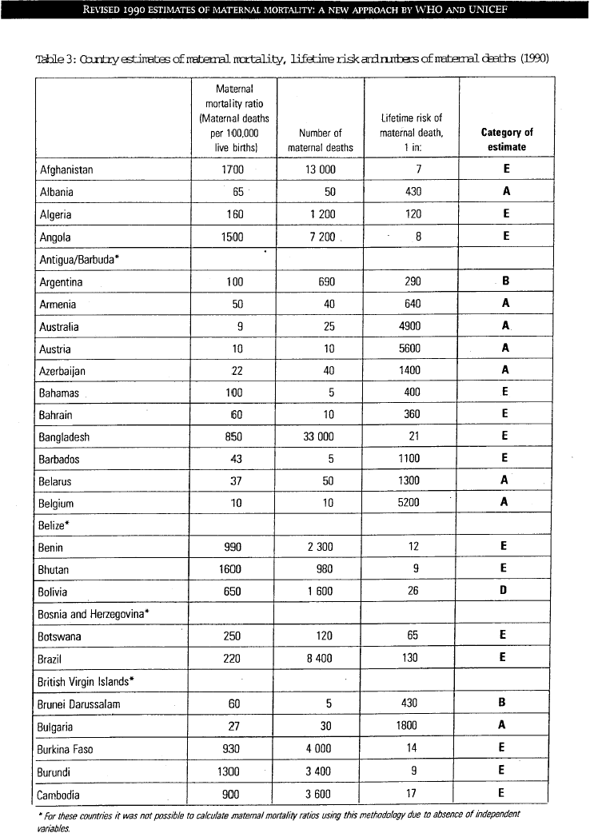

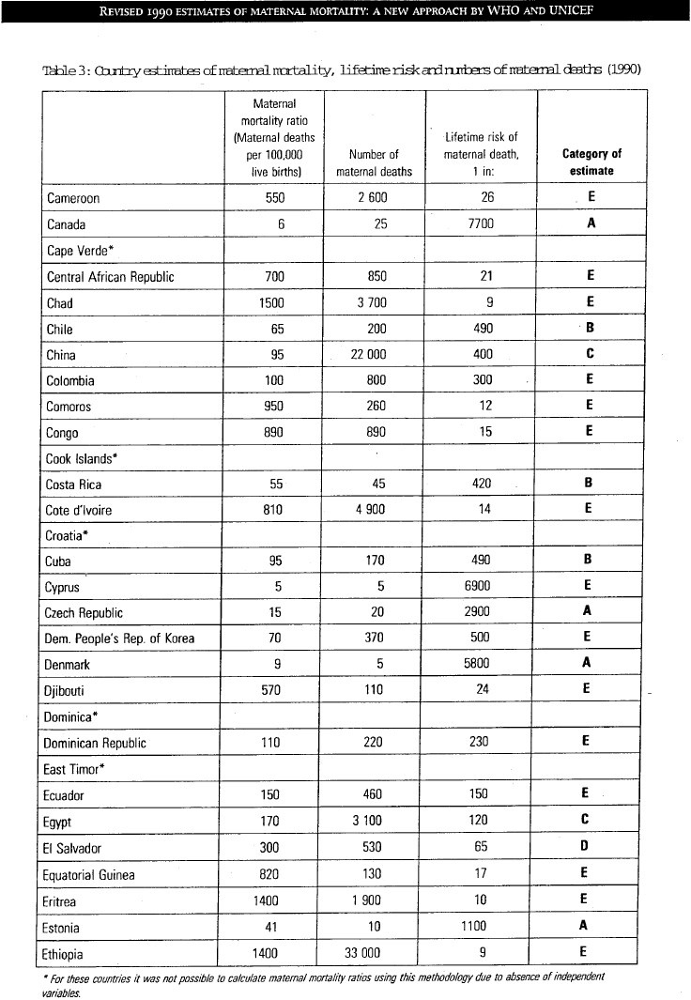
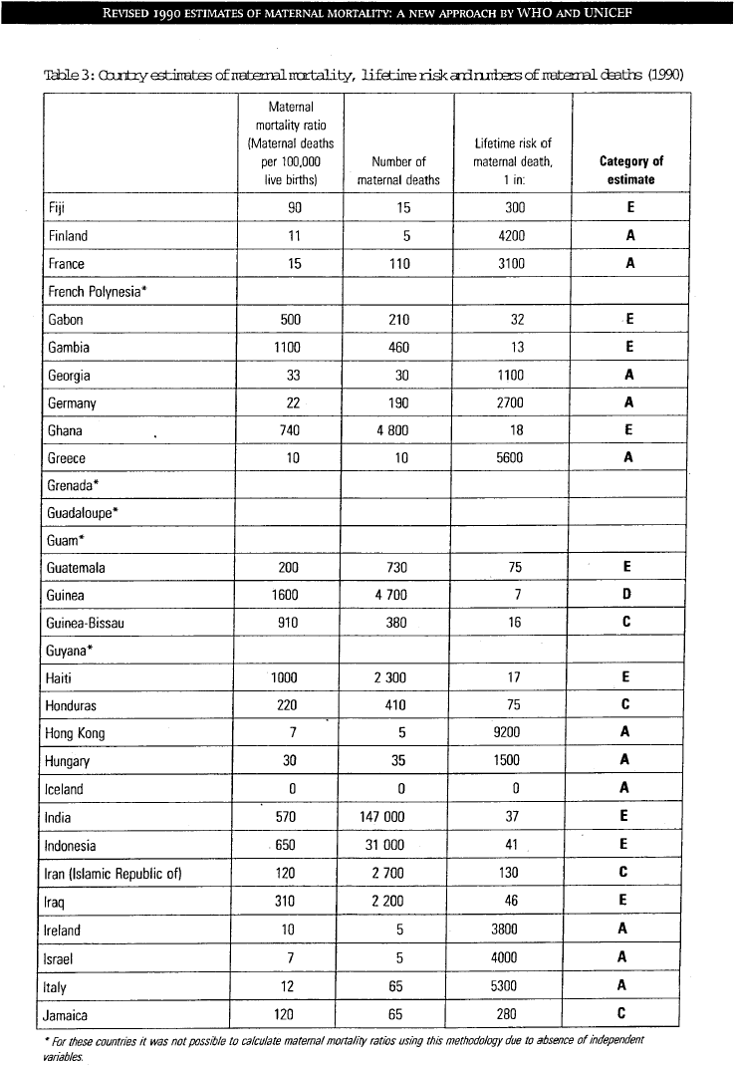
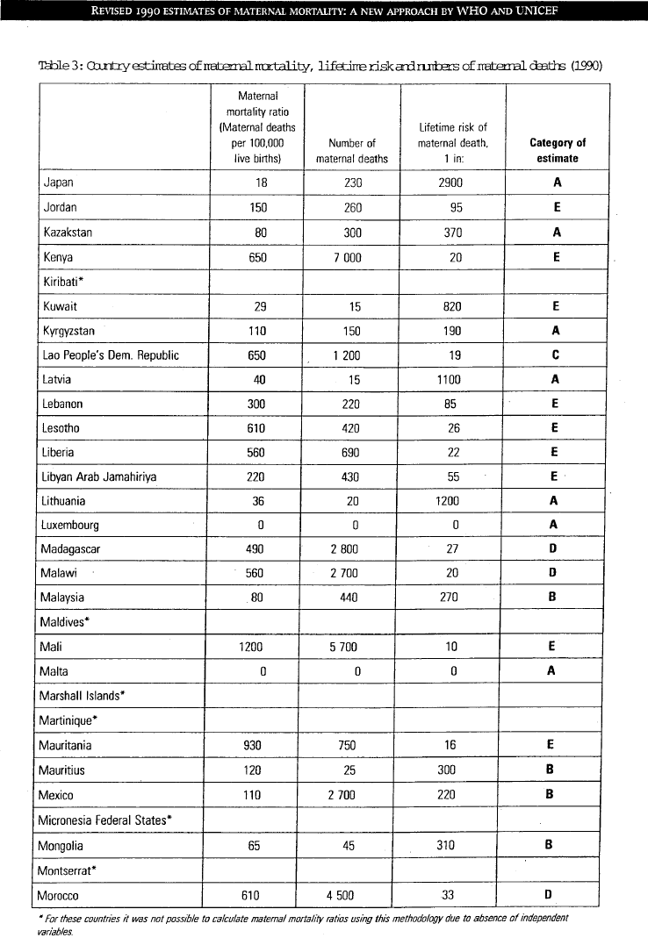

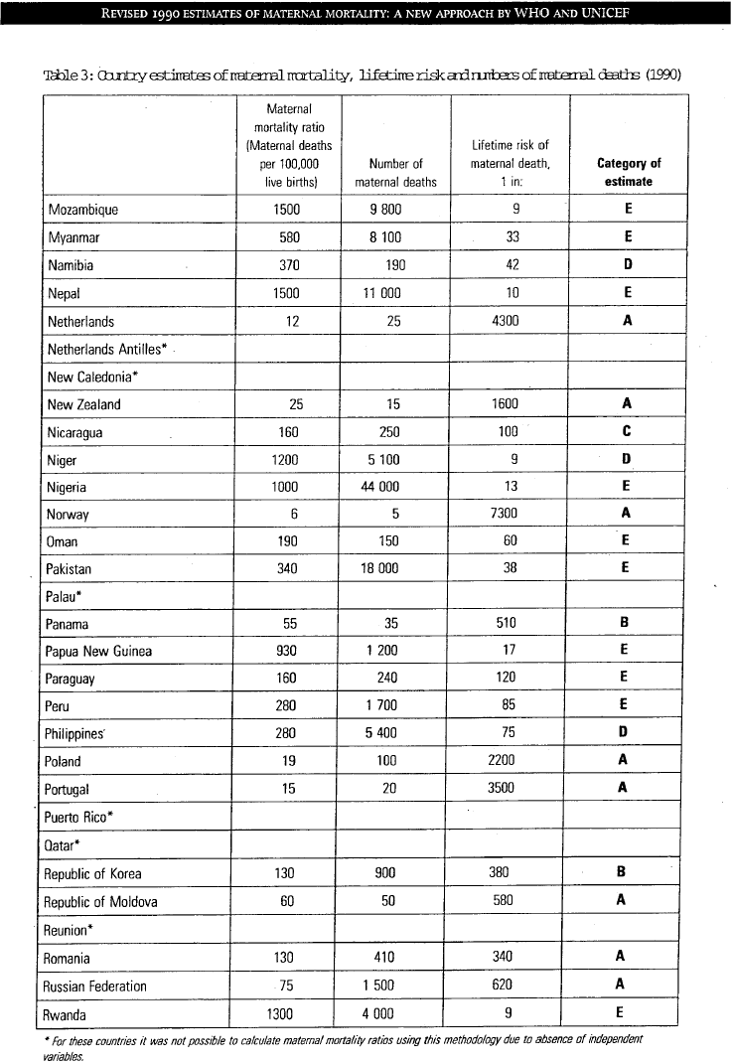
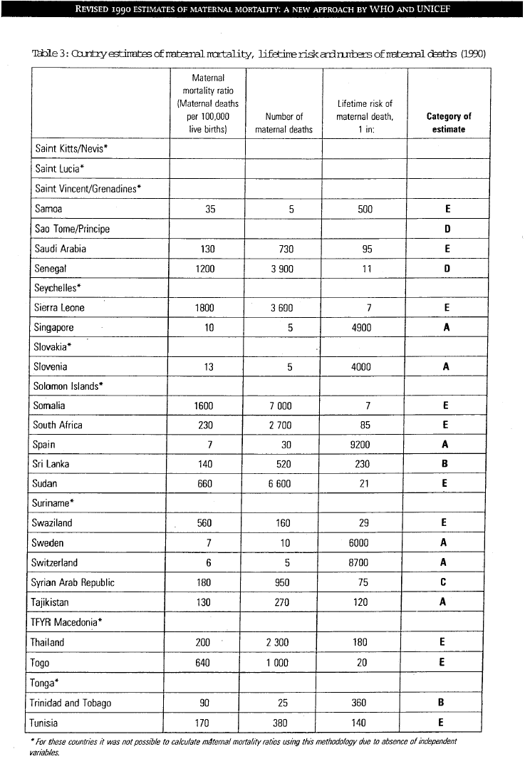

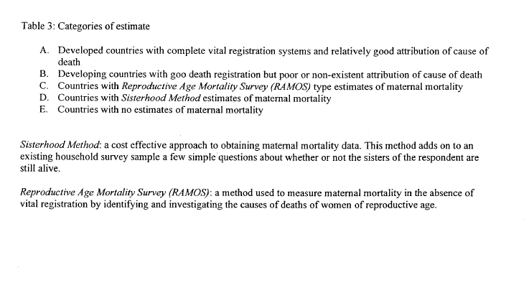
Question 3
On the same page 12 the pie chart shows that 10% of budget for the health sector goes to "family planning, reproductive health care". Could the Department please tell us what percentage of that and of monies allocated for international family planning/population organisations go directly to dealing with direct causes of maternal mortality? Could those figures be supplied country by country, cause by cause?

Response
Australian family planning and reproductive health activities are normally part of large integrated primary health projects that aim to improve to improve maternal and child health services. The main components of family planning and reproductive health activities supported by Australia's aid program are training, improved access to health care and capacity building.
Such activities include training for traditional and public health personnel and allied health professionals to provide quality, integrated women and children's health services including antenatal, postnatal and delivery care. They also include the management of other women's health issues such as infection control, reproductive tract infections, family planning, nutrition, immunisation, and hygiene in relation to safe motherhood. By improving women's access to good quality pre and postnatal care and supervised births, these programs directly address the conditions that contribute to high levels of maternal mortality.
In relation to monies allocated to international family planning/population organisations we have requested this specific information from UNFPA and IPPF, and will provide a response to the Committee when it is available.

Question 4
One of the implementing agents for the Women’s Health and Family Welfare Project is Marie Stopes Australia. Could the Department please advise of that organisation’s abortion policy and activities world-wide?

Response
Marie Stopes Australia (MSA) is an affiliate of Marie Stopes International (MSI). As outlined in their website, www.mariestopes.org.uk, MSI’s stated mission is to ensure the fundamental human right of all people to have children by choice.
MSI supports access to legal safe abortion services, and provides treatment for the complications of unsafe abortion elsewhere. It is MSI’s stated policy not to use donor funds to provide abortion or related services where that is contrary to the policy of that donor. Further details of MSI’s policy and activities are available at its website.
MSA is part of a consortium of four Australian agencies that jointly developed the Technical Proposal for the implementation of the AusAID funded project Indonesia Women's Health and Family Welfare(WHFW) Project. The Overseas Projects Corporation of Victoria Ltd (OPCV) is the lead firm for management of this project. A detailed program of project activities is currently being developed by OPCV.
To date MSA has not been directly involved in WHFW project activities but is a member of the project’s Technical Advisory Team. It is planned that MSA’s role in the project will be in the form of short-term advice on mobilisation and participation of community organisations and NGOs in project activities.
Consistent with the Government's family planning aid policy, the Women’s Health and Family Welfare project does not support abortion services or abortion-related training of any kind. The project consortia has been briefed on the Government’s policy on family planning aid and regular monitoring and reporting on AusAID’s Population Checklist is a contractual obligation.
Answers to supplementary questions from Senator Bourne concerning micro-credit

In June 1999, the Parliamentary Secretary to the Minister for Foreign Affairs provided a list of micro credit activities funded through Australia’s overseas aid program in the 1998/99—1999/00 budget years.
With regard to this list of projects:

Question 1
How many of the 42 projects have as their prime objective microcredit programs and what is the dollar value of those projects.

Response
Of the 42 microcredit projects listed 17 projects have as their primary objective microcredit. The dollar value of the microcredit portion of these projects for 1998/99 is $4 million and for 1999/00 is estimated to be $4.1million.
While final figures are not yet available, the revised estimate for total microfinance expenditure in 1999/2000 has increased to $7.4 million from the original estimate of $5.9 million. The major reason for this increase is additional microfinance expenditure expected under the AusAID-NGO Cooperation Program (ANCP).

Question 2
How many of the 42 projects do not have microcredit as their primary focus and are components of a larger project.

Response
Twenty five of the 42 projects do not have microcredit as their primary focus and are components of a larger project.

Question 3
Where the microcredit funding is part of another program, what is the specific purpose of the other part of the project.

Response
The purposes of the 25 projects where microcredit is a component of a larger program include improving health, sanitation, and education, supporting NGOs in peace building and training in crop and livestock production.

Question 4
Has an impact study been done on each of the 42 projects to ascertain, in particular:

- how effective the project is
- whether the project is till operating, and
- who has benefited from the project and in what quantifiable ways.

Response
Impact assessments of completed projects are done selectively on a sample basis. A recent impact assessment was undertaken of the Qinghai Community Development project in China. This assessment found that the microfinance component of the Project had been effective in raising incomes of the poor households who took out loans and improved their access to both financial services and markets. The study also highlighted a number of problems that need to be addressed to ensure the sustainability of the program. AusAID will be following up the study’s recommendations later this year.
AusAID is also providing funds through the Microfinance Seed Fund to an Australian NGO to look at the impact on vulnerable groups of a range of microfinance projects in Vietnam.
Question 5
How often are the projects reviewed?

Response
Project deliverers are required to report on a regular basis progress against objectives. AusAID’s overseas posts also undertake project monitoring visits and prepare regular project monitoring reports. The majority of microfinance projects are either managed by an Australian Managing Contractor (AMC) or implemented through Australia NGOs. There are regular scheduled reviews for AMC-managed projects, usually on a six-monthly basis. For larger microfinance projects mid term reviews are also undertaken. For projects funded under the ANCP, NGOs themselves assess their program performance against guidelines provided by AusAID. NGO programs are also reviewed as part of the 5-year NGO accreditation process and through periodic cluster evaluations.

Question 6
What were the costs involved in lending/funding each of these microcredit projects?

Response
The Australian Government’s approach to microfinance is to provide long-term access to financial services that can really make a difference to the lives of the poor. Providing funds for onlending to weak organisations is not a recipe for successful microfinance. Training and technical assistance to help local delivery organisations to become self-sufficient is therefore considered to be a vital part of Australia's support for microfinance, equally important to the provision of loanable funds per se. AusAID therefore does not keep data on the proportion of microfinance funding provided in the form of loanable funds.
Question 7
Can the Minister provide assessments for all the projects in CGAP form (Consultative group for assisting the poorest)?

Response
CGAP has developed a comprehensive appraisal format to determine whether it will provide funds to microfinance organisations (MFOs) that apply to it for funding. The appraisal framework is designed for specialist MFOs, and requires information on financial performance, institutional factors and services provided by an MFO. AusAID has used the appraisal format in assessing whether to provide long-term support to the Lik Lik Abitore Trust in PNG. The mid-term review undertaken in 1997 of the Opportunity International Zambuko Trust project in Zimbabwe also used a number of indicators taken from the CGAP appraisal format, including the portfolio at risk, a key measure of the health of an MFO’s loan portfolio.
Most of the 42 activities on the list have not been assessed against the CGAP appraisal format. In some cases this would not be appropriate, since support was through generalist NGOs or through a project team. However, as the Government moves to strengthen its microfinance portfolio, it is requiring microfinance providers to report their performance in terms set out by CGAP.
At the CGAP annual meeting that has just taken place, in-principle agreement has been given to a set of guidelines on financial disclosure developed by CGAP for use by all donor-funded MFOs. These guidelines are shortly to be field-tested. If field-testing proves them to be a valuable tool, AusAID will consider adopting the guidelines for the MFOs that it funds.

Answers to supplementary questions from Senator Bourne concerning governance

Question 1
Which programs were funded by the 16% of the aid budget in 99/00 dedicated to good governance?

Response
The following governance activities were funded in the 1999-2000 financial year. The activities have been classified according to the four sub-sectors comprising AusAID’s governance portfolio: public sector reform, economic management, legal and judicial reform and civil society.

Public sector reform

Country | Project | Form of Aid | Est. Exp. 99/00 $A
China | Capacity Building Program | Bilateral | 4,000,105
Cook Islands | Public Sector Reform Program | Bilateral | 42,050
East Asia Unallocated | UNDCP: Mekong Region Drug Control | Bilateral | 870,000
East Timor | UNTAET Trust Fund | Bilateral | 10,000,000
Fiji | Police Training Project | Bilateral | 10,011
 | Civil Service Reform | Bilateral | 343,445
 | Customs Dept Institutional Strengthening | Bilateral | 494,959
 | MRD Institut'l Strengthening Proj. | Bilateral | 1,077,670
 | Fiji Revenue and Customs Authority | Bilateral | 1,464,457
India | India-Aust Training & Capacity Building | Bilateral | 4,788,845
 | Participatory Municipal Gov & Services | Bilateral | 150,000
Indonesia | Land Administration Project | Bilateral | 2,644,512
 | Government Sector Linkages Program | Bilateral | 648,082
 | State Audit Agency (BPKP) TA | Bilateral | 777,750
Laos | Immigration Computers and Training Proj | Bilateral | 5,306
 | Land Titling Project - Phase 1 | Bilateral | 1,940,979
Mozambique | Mozambique Capacity Building Program | Bilateral | 1,499,999
Pacific Islands Unallocated | PMR Small Activities | Bilateral | 349,877
 | Tax Administrators Training Program | Bilateral | 61,500
 | SPC-Statistical Training Specialist | Bilateral | 86,766
 | Meteorological Services Needs Analysis | Bilateral | 100,000
Papua New Guinea | Pensions & Other Payments By AGRBO | Bilateral | 20,696,059
 | Land Mobilisation Project (ACLMP) | Bilateral | 3,450,000
 | RPNGC Development Project Phase 2 | Bilateral | 1,173,261
 | RPNGC Project Technical Advisory Group | Bilateral | 2,911
 | Review of Royal PNG Constabulary Project | Bilateral | 252
 | Renovation of RPNGC Buildings & Infrast | Bilateral | 159,285
 | Prov. Fin. Mgmnt. Training Program | Bilateral | 1,811,092
 | Provincial Government Reform | Bilateral | 104,131
 | RPNGC DP: Joint Review & Design | Bilateral | 8,184
 | RPNGC Development Project Phase III | Bilateral | 4,136,255
 | Bougainville Support to Civil. Policing | Bilateral | 502,621
 | PNG Public Sector Reform Project | Bilateral | 500,000
 | Bougainville-District Development Office | Bilateral | 60,635
 | IT Assistance to ONPI and DPLGA | Bilateral | 12,838
 | Centre for Democratic Institutions | Bilateral | 90,000
 | PNG-Australian Treasury Twinning Scheme | Bilateral | 300,000
 | State, Society & Governance in Melanesia | Bilateral | 80,000
Samoa | Customs Department Project | Bilateral | 258,997
 | PS Reform Project Monitoring Group | Bilateral | 91,706
 | Public Works Institutional Strengthening | Bilateral | 11,710
 | Court Reporting and Transcription | Bilateral | 540,000
 | Police Project | Bilateral | 100,000
Solomon Islands | Public Financial Mgmt Strengthening | Bilateral | 814,750
 | Customs Assistance | Bilateral | 1,566,687
 | Ministry of Lands Technical Assistance | Bilateral | 1,311,655
 | Auditor General's Technical Assistance | Bilateral | 956,721
 | PSRP Support Activities | Bilateral | 332,300
South Africa | Capacity Building Program | Bilateral | 5,000,011
Sri Lanka | Land Registration and Cadastral Project | Bilateral | 66,928
 | Training and Capacity Building Project | Bilateral | 616,522
Sub-Saharan Africa Unallocated | Africa Good Governance Fund | Bilateral | 1,061,431
Thailand | Land Titling Project Phase 3 | Bilateral | 842,439
 | Thailand: Public Sector Reform | Bilateral | 95,227
 | Large Taxpayer Office Support Project | Bilateral | 201,396
Tonga | Australian Staffing Assistance Scheme | Bilateral | 95,480
 | Civil Service Pension Scheme Review | Bilateral | 253,079
 | Strengthening Program Budgeting Project | Bilateral | 90,542
Tuvalu | In-country Training | Bilateral | 262,504
 | Assets M'ment & Maint'ce, & Statistics | Bilateral | 545,259
 | Pacific Technical Assistance Facility | Bilateral | 64,000
 | Public Sector Reform Project | Bilateral | 115,415
Vanuatu | Australian Staffing Assistance Scheme | Bilateral | 484,400
 | Comprehensive Reform Program | Bilateral | 475,489
 | Natural Resources Sector Assistance | Bilateral | 55,750
 | Institutional Strengthening MFEM | Bilateral | 2,061,630
 | Institutional Strengthening PSC | Bilateral | 1,397,583
Vietnam | Governance Sector Program Development | Bilateral | 209,529
World Unallocated | UN Inter. Drug Control Program (UNDCP) | Multilateral | 971,100
 | C'wealth Assoc. for Pub. Admin. & Man. | Multilateral | 197

Economic management

Country | Project | Form of Aid | Est. Exp. 99/00 $A
China | English Language for Ministry Officials | Bilateral | 1,045,000
 | Economics & Foreign Trade Training | Bilateral | 1,562,635
 | IFC Technical Assistance Trust Fund | Bilateral | 1,500,000
East Asia Unallocated | APEC Support Program | Bilateral | 2,031,024
 | IFC Mekong Project Development Facility | Bilateral | 568,971
 | ACF Contribution to the ACTF | Bilateral | 7,989
 | ACCC ASEAN Competition Policy | Bilateral | 200,000
 | Asia Recovery Information Centre | Bilateral | 198,658
 | Searp - Governance | Bilateral | 12,000
 | APDN - VWU Microenterprise Training Ph-2 | Bilateral | 340,000
 | UNDP:LAOS INTEGRATION INTO WTO | Bilateral | 400,000
 | ACF OECD Insolvency Workshop | Bilateral | 242,351
 | Australia-IMF Scholarship Program, Asia | Bilateral | 620,000
 | ACF Enhancing Regulatory Regimes in Asia | Bilateral | 300,000
 | Cambodian Law on Investment Project | Bilateral | 100,000
East Timor | Technical Services | Bilateral | 374,994
 | Consultants Trust Fund for East Timor | Bilateral | 2,000,000
Fiji | Bureau of Statistics Institutional Stren | Bilateral | 943,645
 | National Planning Office Inst. Strength. | Bilateral | 536,999
India | Native Lands Trust Board | Bilateral | 150,478
 | District Poverty Initiatives - WB | Bilateral | 1,000,000
Indonesia | Private Sector Linkages Program | Bilateral | 254,621
 | Tourism training skills centre | Bilateral | 89,794
 | Australia-Indonesia Development Area | Bilateral | 100
 | Technical Advice Management Facility | Bilateral | 1,434,626
 | Asia Crisis Fund (ACF) Indonesia | Bilateral | 307,584
 | Investor Services Centre | Bilateral | 93,400
Kiribati | Australian Staffing Assistance Scheme | Bilateral | 120,000
 | Strengthening Planning and Accounting | Bilateral | 390,822
Mozambique | ILO Microfinance capacity building | Bilateral | 300,000
 | Human Resource Development Program | Bilateral | 97,846
Niue | Public Sector Management Strengthening | Bilateral | 100,000
Pacific Islands Unallocated | Forum Support | Bilateral | 200,000
 | Economic Analysis of Pics | Bilateral | 100,000
 | IFC South Pacific Project Facility | Bilateral | 640,000
 | Channel Financing Facility: ADB | Bilateral | 100,000
 | FIAS Financial Investm't Advisory Serv | Bilateral | 400,000
 | South Pacific Trade Commission | Bilateral | 1,000,000
 | ANU/Melanesia Project | Bilateral | 129,363
 | PFTAC - EFMAR | Bilateral | 300,000
 | Credit Union Developm't in the SP | Bilateral | 10,000
 | Regional Customs Project | Bilateral | 2,880,500
 | Certificate in Enterprise Development | Bilateral | 109,320
 | Aust-IFC Pacific TA. Facility | Bilateral | 188,000
 | SPC Small Activities | Bilateral | 133,500
 | Year 2000 TA for the Pacific islands | Bilateral | 494,262
 | Pacific Outreach&Publication Activities | Bilateral | 50,200
Papua New Guinea | Immigration/citiz. Division Development | Bilateral | 112,238
 | PNG Economic Analysis | Bilateral | 467,706
 | SYB/IYB Business Development Project | Bilateral | 221,300
 | PNG-Aust. Consultants Trust Fund | Bilateral | 551,727
 | Advisory Support Facility | Bilateral | 6,500,410
 | PNG Private Sector Development Program | Bilateral | 105,187
 | SNDPS Project | Bilateral | 227,000
 | LikLik Dinau Micro Credit Project | Bilateral | 377,640
 | Support for SPPF Office -Port Moresby | Bilateral | 119,993
 | Assistance to CIMC | Bilateral | 150,000
 | WTO Trade Policy Review of PNG | Bilateral | 20,000
 | Bougainville Haus Moni Microfinance | Bilateral | 222,831
Philippines | Private Sector Development Project | Bilateral | 97,000
 | Philippines-Aust Governance Facility | Bilateral | 3,613,535
Samoa | ASAS | Bilateral | 67,448
 | Training - In-country | Bilateral | 667,349
 | DTC & I Investment Promotion Unit | Bilateral | 226,042
 | Treasury Institutional Strengthening | Bilateral | 1,093,330
 | Public Service Comm. Instit. Strnghtning | Bilateral | 1,226,916
Solomon Islands | High Level Consultations | Bilateral | 30,000
South Africa | Private Sector Linkages Program | Bilateral | 169,997
 | Khuphuka: Incubator Programme | Bilateral | 175,000
Thailand | Financial Institutions Supervision | Bilateral | 270,822
 | Strengthening Macroeconomic Statistics | Bilateral | 366,000
 | Economic Governance: APEC Initiative | Bilateral | 64,420
 | Securities and Exchange Commission | Bilateral | 40,000
 | Financial Institutions Rationalisation | Bilateral | 15,970
Tonga | MOF Strengthening of Revenue Depts | Bilateral | 799,424
 | Tourism Development Project | Bilateral | 1,105,171
Vietnam | CARE: Khmer Minority Women | Bilateral | 130,000
 | IWDA Credit & Micro Ent Dev for Women | Bilateral | 75,350
 | Monitoring & Evaluation Strengthening | Bilateral | 600,000
 | HCMNPA Public Policy Research & Training | Bilateral | 150,000
 | IWDA - NOVA99 - Rural Womens Credit | Bilateral | 120,572
World Unallocated | National Centre for Development Studies | Bilateral | 367,000
 | World Bank Consultant Trust Fund | Bilateral | 550,000
 | Business Linkages - Management Costs | Bilateral | 30,000
 | Maintenance of Assets Study | Bilateral | 46
 | Microfinance Assess. - ASKI, Philippines | Bilateral | 27,225
 | Oxfam Development Finance Institution | Bilateral | 55,000
 | Microfinance Seed Fund | Bilateral | 1,000,000
 | Cwlth Partnership for Tech Mgmt (CPTM) | Multilateral | 50,000
 | Cwealth Joint Office for Small States | Multilateral | 265,000
 | C'th Trade & Investment Access Facility | Multilateral | 500,000
Zimbabwe | Capacity Building: Ministry of Finance | Bilateral | 200,000

Legal and judicial reform

Country | Project | Form of Aid | Est. Exp. 99/00 $A
Cambodia | Criminal Justice Assistance Project | Bilateral | 2,959,907
East Asia Unallocated | Commercial Law Training Project | Bilateral | 500,000
 | Asia Crisis Fund Insolvency Law Project | Bilateral | 30,000
 | Commercial Law Training Project | Bilateral | 5,000
Pacific Islands Unallocated | Judicial Strengthening | Bilateral | 158,002
Palestinian Territories | Rule of Law Assistance Project | Bilateral | 640,100
Papua New Guinea | AG's Dept Institutional Strengthening | Bilateral | 486,983
 | Correctional Services Phase 2 | Bilateral | 8,693,961
 | Law and Justice Sector Support Program | Bilateral | 847,830
 | Ombudsman Commission Project | Bilateral | 1,792,631
 | Access to Laws Project | Bilateral | 1,324,000
 | PNG Justice Sector Review | Bilateral | 100,000
 | Legal Capacity Building Project | Bilateral | 168,000
 | Legal Inst. Project Monitoring & Review | Bilateral | 50,000
 | Justice Program Development (JPROD) | Bilateral | 75,000
Solomon Islands | RSIP Interim Institutional Strengthening | Bilateral | 534,211
Tonga | Legal Institutions Strengthening | Bilateral | 98,201
Uganda | Uganda Constitutional Adviser | Bilateral | 48,725
Vanuatu | Legal Sector Assistance | Bilateral | 625,453

Civil society

Country | Project | Form of Aid | Est. Exp. 99/00 $A
Bangladesh | Chittagong Hill Tracts Assistance | Bilateral | 25,676
Cambodia | Small Activities Scheme | Bilateral | 450,000
 | Human Rights Education Program | Bilateral | 110,000
 | CCDP3: SCA: Friends Street Children | Bilateral | 326,205
China | Human Rights Technical Assistance | Bilateral | 1,422,145
 | Tianjin Laid-Off Women Workers | Bilateral | 683,000
East Asia Unallocated | ECPAT Preventing Exploitation in Tourism | Bilateral | 100,000
 | UNDP: Trafficking in Women & Children | Bilateral | 250,000
 | Aust Social Safety Net Survey for APEC | Bilateral | 397,050
 | ACF ASEAN Social Safety Nets | Bilateral | 500,000
East Timor | UNICEF Institutional Capacity Building | Bilateral | 740,000
 | Staffing Assistance Program | Bilateral | 750,000
 | UNHCR Shelter Program Phase Two | Bilateral | 5,000,000
 | Community Assistance Scheme | Bilateral | 500,000
 | UN Consultation Process goods & services | HES | 4,491,090
 | UN Consultation Process Goods & Services | HES | 3,049,548
 | Assistance for Peace & Justice Commission | HES | 65,448
Fiji | Australian Community Assistance Scheme | Bilateral | 100,000
 | Fiji Elections Project | Bilateral | 12,414
Indonesia | Institutional Support for Komnas HAM | Bilateral | 561,574
 | Electoral Assistance | Bilateral | 270,578
 | Civil Governance | Bilateral | 1,250,000
 | Red Cross IHL Visit and Training | HES | 6,120
Mongolia | National Institution for Human Rights | Bilateral | 340,000
Mozambique | UNDP Mine Clearance Project | Bilateral | 1,400,000
Pacific Islands Unallocated | South Pacific Media Initiative | Bilateral | 570,000
 | Consumer Protection Program | Bilateral | 60,000
 | S.P Electoral Administrators Workshop | Bilateral | 75,000
 | Child Abuse in the Pacific | Bilateral | 112,882
 | Fiji Women's Crisis Centre Phase 3 | Bilateral | 395,092
Palestinian Territories | Training and Income Gen. for Pal. Women | Bilateral | 58,578
Papua New Guinea | Strengthening Communities for Peace | Bilateral | 179,695
 | PNG Community Development Scheme | Bilateral | 3,989,765
 | Bougainville NGO Project | Bilateral | 567,433
 | Human Rights Commission Project | Bilateral | 2000
 | Communication Sector Support Program | Bilateral | 1,238,686
 | Bougainville Support for Peace Process | Bilateral | 2,361,879
 | Bougainville Instit. Stregthening Proj. | Bilateral | 300,000
 | Bougainville Peace Related Transport | Bilateral | 504,402
 | Bougainville Community Projects Scheme | Bilateral | 500,000
 | Radio Bougainville Rehabilitation Projec | Bilateral | 685,819
 | Electoral Commission ISP | Bilateral | 1,156,380

Country | Project | Form of Aid | Est. Exp. 99/00 $A
Philippines | Community Assistance (PACAP) | Bilateral | 4,300,000
 | UNDP: Program of Assistance to the MNLF | Bilateral | 2,113,265
 | Vulnerable Groups Facility | Bilateral | 8,029,399
Sri Lanka | Community Resettlement Program | Bilateral | 4,100,000
Thailand | Democratic Governance Support Program | Bilateral | 135,171
Uganda | Gulu District Relief & Rehabilitation | HES | 192,796
Vanuatu | Radio Vanuatu Transmitter Project | Bilateral | 15,000
Vietnam | Small Activities Scheme | Bilateral | 653,402
 | HCMNPA - Human Rights Training Phase 2 | Bilateral | 204,273
World Unallocated | Human Rights Fund | Bilateral | 360,740
 | The Centre for Democratic Institutions | Bilateral | 1,750,000
 | Human Rights Ad Hoc Fund | Bilateral | 75,000
 | Human Rights Fund Small Grants Scheme | Bilateral | 9,898
 | Commonwealth Media Development Fund | Multilateral | 50,000
 | Commonwealth Foundation | Multilateral | 600,000

Other governance

Activity | Form of Aid | Est. Exp. 99/00 $A
IDA Act 1990 (IDA9)* | Multilateral | 1,448,100
Commonwealth Youth Program (CYP) | Multilateral | 515,000
Comm. Fund for Tech. Co-operation (CFTC) | Multilateral | 6,946,500
ADF Act 1992 (ADF VI)* | Multilateral | 5,568,480
IDA Act 1993 (IDA10)* | Multilateral | 2,368,800
ADF VII (SIXTH REPLENISHMENT)* | Multilateral | 792,000
IDA 11 1997* | Multilateral | 2,755,800
IDA 12 1999* | Multilateral | 510,000
AusAID-NGO Cooperation Program (ANCP) | NGO Program | 7,754,305
OGDs - total estimate | OGD | 5,958,936
Sectors not yet specified |  | 12,047,447

* These figures are imputed based on total amounts provided by AusAID to the specified organisations and the estimated percentage of their total income spent on governance activities.

Question 2
What criteria does AusAID use to select good governance projects?

Response
In developing a program of assistance in the governance sector, AusAID assesses the partner government’s own commitment to reform, the state of governance in priority areas (selected in discussion with the partner government), other donor activities and Australia’s capacity to assist.
Aid interventions are selected and developed with attention to the following guiding principles: careful selection of interventions; a gradualist approach to implementation and long-term support, to ensure that reforms are sustainable; ensuring there is good local leadership of reform; promotion of local participation and ownership of governance reforms; setting realistic objectives and timeframes; a flexible approach to accommodate changes in local circumstances; achieving balance between Australian principles and values and partner country circumstances and needs; involvement of the private and community sectors and the public in governance initiatives.

Question 3
Which organisations or companies delivered good governance projects?

Response
In the course of managing the Australian Government’s overseas aid program, AusAID contracts a diverse range of organisations and individuals to provide goods and services in relation to aid program activities. These include Commonwealth and State Government agencies, academic institutions, non-government organisations (NGOs) and private businesses. Most contracts are for the design or implementation of aid projects, including projects in the area of governance.
The names of organisations and individuals contracted by AusAID are contained in an AusAID publication entitled Business Participation in Australia’s Aid Program (September 1999) (IBSN: 0642 41421 1). A copy of the latest (1998-99) edition of that publication has been provided to the Committee. Please note in particular the lists of activities in Tables 5, 6, 7, 12 and 13 of the publication. A relevant sub-sector is identified for each activity. The sub-sectors are based on those used by the Development Advisory Committee (DAC) of the Organisation for Economic Cooperation and Development (OECD) to classify aid activities, and are summarised in Table 2 of the publication. Of these sub-sectors, the ones under which governance projects may appear include ‘Social Infrastructure & Services’, ‘Government & Civil Society’, ‘Communications’, ‘Banking & Financial Services’, ‘Business & Other Services’, ‘Industry, Mining & Construction’ and ‘Trade & Tourism’.
Question 4
What expertise do each of these organisations have in good governance, how is it verified?

Response
The expertise that organisations draw upon in implementing governance activities varies considerably, in view of the breadth of disciplines covered by the sector, the characteristics and needs of the particular counterpart organisation, and the country concerned. Typically, however, the following broad categories of expertise are drawn upon for governance activities: economics; public policy; public sector management; legal reform; financial planning and management; human rights; civil participation; training and human resource development; gender analysis; and project management.
With respect to verification it is normal AusAID practice to engage contractors for governance activities through a competitive tendering process in accordance with Commonwealth Procurement Guidelines. The selection process involves an independent technical assessment panel comprising AusAID staff as well as technical experts in the relevant field.
AusAID generally requires tenderers to provide referees for the organisation to substantiate claims made in proposals. It usually also requires nominated project personnel to provide curriculum vitae and referees who will comment on the quality of work performed by the team member on previous AusAID or other relevant projects.

Question 5
Does AusAID require project deliverers to provide standard financial statements including profit and loss on each project?

Response
AusAID follows the Commonwealth Procurement Guidelines in selecting contractors to undertake activities, including governance projects. This means AusAID makes purchasing decisions on criteria that give emphasis to value for money and open and competitive tendering. As part of AusAID’s risk management strategy, consideration is given to the overall financial viability of firms bidding for Australian Government aid projects. This can include an assessment of the profitability of an organisation as a whole. However, profit and loss statements are not required on a project-by-project basis.
Question 6
Will AusAID in the interests of the corporate governance process of transparency and accountability make these financial statements public?

Response
AusAID does not require contractors to identify profit margins and does not, therefore, possess such information.

Question 7
What profit margin does AusAID consider to be reasonable for a private company to make from aid projects?

Response
AusAID does not have the capacity or mandate to make judgements about what is an appropriate profit margin for companies tendering for projects, nor does it require tenderers to indicate profit margins in their tenders. AusAID does have a very strong interest in, and responsibility for, ensuring the Australian Government’s aid program represents value for money. For this reason, in using competitive tendering and considering price as a factor in tender evaluation, AusAID undertakes a like-for-like price assessment of the proposals considered technically suitable.

Question 8
How does AusAID ensure that profit is not excessive?

Response
AusAID focuses on value for money through open and competitive tendering, in keeping with the Procurement Guidelines. Value for money is enhanced through the design and tendering process. Project design documents for overseas activities are usually costed by experts, allowing AusAID officers to have estimates of the likely cost of project implementation. This allows the agency to assess whether tender prices for a given project are reasonable. Requests for tenders are widely advertised, with all eligible and interested organisations in Australia and New Zealand encouraged to bid. Bidding firms are notified in advance that price will be a factor—usually around 20 percent—in selecting the preferred tenderer.
Question 9
What processes does AusAID have in place to ensure the accountability of good governance project deliverers?

Response
AusAID has developed systems and procedures to ensure quality, transparency and accountability in the development and delivery of all its activities, including governance activities.
Design procedures for AusAID activities require the use of the logical framework approach, which is characterised by the identification of clear outputs and performance indicators and milestones for each project, against which implementation by project deliverers is assessed.
AusAID's monitoring and accountability procedures for the supervision of the implementation phase of activities include a public tender process for firms bidding to implement projects; accreditation processes for non-government organisations that deliver AusAID-funded activities; a monitoring framework for the supervision of project implementation; and contractual requirements for those implementing the activity to maintain detailed financial records of project expenditure. There is also a standard requirement that allows AusAID to audit the financial records of project deliverers.
Project monitoring is an ongoing task during implementation. Contractors implementing projects are required to report on a regular basis on progress against objectives. Reporting is in terms of agreed indicators and benchmarks. AusAID also undertakes on-site project monitoring.
If required, periodic technical supervision of progress is provided through an independent Technical Advisory Group of technical specialists. Where corrective action is required, it is agreed with the partner government and then negotiated with project deliverers.
AusAID's risk management and quality assurance procedures are outlined in a manual for the management of activities through the project cycle. The manual, AusGUIDE, is available widely through the AusAID Internet site at (www.AusAID.gov.au/ausguide/index.html)
Accountability is also assured through AusAID’s active internal audit program and AusAID’s Audit Committee, which includes a representative of the Australian National Audit Office and a private sector participant.

Question 10
How does AusAID quantify and measure the impact on poverty of its good governance programs? Have impact assessments been done on the outcomes of good governance programs?

Response
At the programmatic level, the link between good governance and sustainable development is now well-accepted. A country’s progress towards achieving sustainable development goals depends to a considerable degree on the quality of government and the extent to which the capacities of civil society organisations are harnessed to work towards these goals.
Governance projects can reform the institutional and policy environment which often determines how effectively aid is used; they therefore can play a key role in ensuring that aid addresses the needs of the poor and that government services can be more effectively delivered. A landmark 1998 study by the World Bank - Assessing Aid: What Works, What Doesn't, and Why found that aid works best where there is a good policy environment. The study found that with sound country management, an additional one per cent of GDP in aid translates into a one percent decline in poverty and a similar decline in infant mortality.
At the activity level, the impact of governance projects on poverty is more difficult to measure. Because governance projects often work on reforming and strengthening central government institutions, their links with poverty are often indirect and long-term. As changes in performance and institutional culture are difficult to quantify, objectives and performance indicators of governance projects tend to be described in qualitative terms, but considerable effort goes into ensuring that there are still objective benchmarks against which progress can be measured.
In common with other donors, AusAID is undertaking further analytical work on a Poverty Reduction Framework. The framework will assist in the selection of governance initiatives that have the highest poverty impact and will help make more explicit the linkages between improving aspects of governance and reducing poverty.

Question 11
Were any ‘opportunity cost’ studies undertaken when good governance programs were funded, i.e. to study whether good governance or more direct forms of aid, such as sanitation, or microcredit programs, would have a greater effect on poverty reduction?

Response
AusAID does not conduct ‘opportunity cost’ studies when undertaking governance activities through the Australian aid program. While care is taken to select an appropriate mix of activities across various sectors in any given country program, and while all activity proposals/designs should demonstrate that the activity will have a real impact on poverty, it is extremely difficult to directly compare the relative poverty reduction effect of activities in different sectors. It is also of questionable value to attempt such a comparison, given that development is a comprehensive process requiring efforts and initiatives across all sectors of society that will, in combination, promote poverty reduction and improved human well being.
Moreover, the developmental impacts of activities aimed at achieving better governance typically extend beyond the governance ‘sector’ and have a ‘multiplier effect’ across the whole of society, because governance institutions are such a fundamental part of a country’s economic, social and political fabric. For example, an activity to improve the statistical collection/analysis capacity of relevant government agencies is likely to lead to more effective outcomes for government programs generally (including social programs). An activity that strengthens the rule of law is likely to lead to increased business confidence and promote economic activity throughout the society, as well as having a positive impact on the realisation of human rights.

Question 12
Where a country does not participate in good governance programs will other aid programs be withdrawn as a result?

Response
Promotion of local participation and ownership of governance reforms is crucial to the credibility and sustainability of reforms. Foreign aid is usually not effective in promoting change in partner countries unless there is strong local support. Australia’s aid program therefore aims to provide positive support for reform efforts in the region, rather than applying a conditional approach.
Question 13
What inter-agency planning is occurring to ensure consistency of good governance policy across portfolio areas? For example is the Export Finance and Insurance Corporation subject to the same focus on good governance in its operations? Do the two agencies share common guidelines? Does the Asian Development Fund also consider good governance to be a vital part of its project funding assessment?

Response
AusAID liaises with many other government departments and agencies to ensure that the Government’s priorities, and the skills that reside in Australian Government agencies, are reflected in the aid program.
For example, AusAID participates in regular meetings and discussions with DFAT in relation to aspects of good governance. AusAID collaborated with DFAT in preparing a resolution on good governance which was accepted almost unanimously at the United Nations Commission on Human Rights earlier this year. This was a ground-breaking resolution, heralding new international thinking on the connections between human rights and transparent, accountable and participatory government.
AusAID also works closely with the Treasury on a range of governance issues. For example, AusAID and the Treasury share responsibility for Australia’s dealings with the multilateral development banks, such as the World Bank and the Asian Development Bank (ADB). The Treasury has worked closely with AusAID and DFAT to ensure that Australia is able to play a constructive and informative role in dialogue with these institutions about the scope and nature of their engagement in Asia and the Pacific. In the Pacific, AusAID has worked with the Treasury in establishing the successful Forum Economic Ministers Meeting (FEMM) process and in facilitating Asian Development Bank support for national economic reform programs.
Other government departments are routinely consulted as new aid programs and activities are being developed. For instance, in developing the Australian aid program for East Timor, AusAID has coordinated closely with the Department of Finance and Administration (DoFA) and the Treasury on the design and implementation of economic and financial management activities. We are funding a team of DoFA staff to assist UNTAET and the East Timorese to write the first consolidated East Timorese budget, which was recently announced at the Lisbon Donor Meeting. We will be continuing this cooperation with DoFA for 18 months and will be supplementing it as required with training advisers. The Australian Tax Office (ATO), Australian Customs Service (ACS), Australian Quarantine Inspection Service (AQIS), Agriculture, Fisheries and Forests Australia (AFFA) and the Department of Education, Training and Youth Affairs (DETYA) are also closely involved in the development and implementation of aspects of Australia’s aid program in East Timor.
Export Finance and Insurance Corporation
The Export Finance and Insurance Corporation (EFIC) is a statutory authority that has a commercial focus to the delivery of its products and services. EFIC's mission is to increase Australian exports by providing internationally competitive insurance and finance services, particularly for countries, companies and contracts which the commercial market may not have the capacity to cover.
In the context of the promotion of good governance in developing countries or the delivery of aid, EFIC has no direct relationship with AusAID or the aid program. The two agencies therefore do not share common guidelines.
EFIC takes into consideration the level of good governance present in any one country in the context of assessing the risk that may be attached to specific transactions. In relation to medium to long term transactions EFIC requires its clients to declare whether they have given or agreed to give (directly or indirectly) any credit, commission, or other payment or incentive to any person or entity in relation to the transaction, and to declare any other material matters. The amount and nature of any payments declared is reviewed prior to EFIC entering into a transaction. EFIC would not enter into a transaction if it was believed that the export business had been obtained in an improper manner. Short term insurance applicants have a duty to disclose things which are material to the risk to be taken on by EFIC.
In accordance with the OECD Convention on Combating Bribery of Foreign Public Officials in International Business Transactions (February 1999), the Australian Parliament passed legislation that prohibits the bribing of foreign public officials. The relevant legislation is entitled Criminal Code Amendment (Bribery of Foreign Public Officials) Act 1999 (the Bribery Code). This legislation applies to EFIC's operations.

Asian Development Fund
In conducting project funding assessment, the Asian Development Bank is guided by its Governance and Anticorruption Policies. These policies are applicable to both the ADB's ordinary lending and its concessional lending from the Asian Development Fund. Further, the Bank is currently finalising the introduction of a Performance-based Lending scheme for its ADF resources which is in large part determined by the governance performance of the borrowing country.
The Asian Development Bank has strict rules in relation to procurement of goods and services for all its loan and technical assistance projects to stamp out corrupt practices. Increasing effort is being made by the Bank through training and capacity building to lift the performance of government agencies in developing countries where problems have been identified. Capacity building is now regarded as a vital component of assistance, particularly for poorer countries eligible for ADF.

