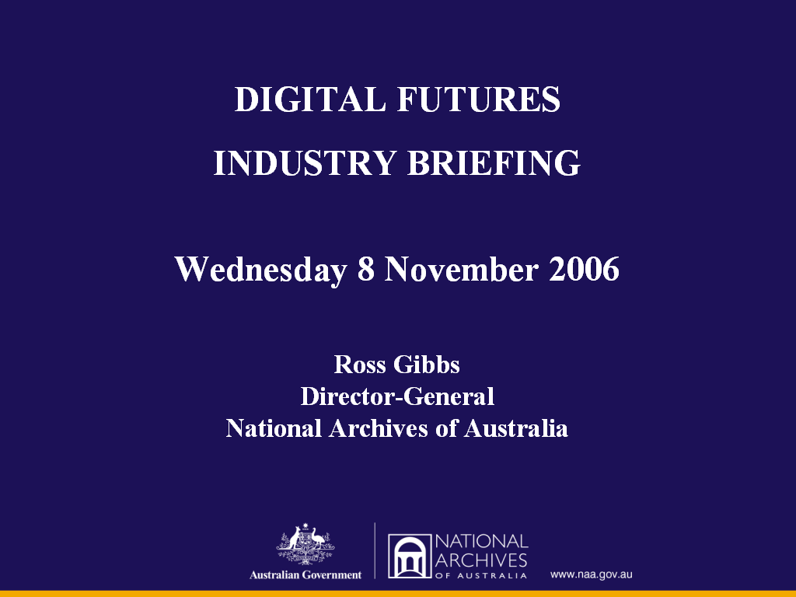

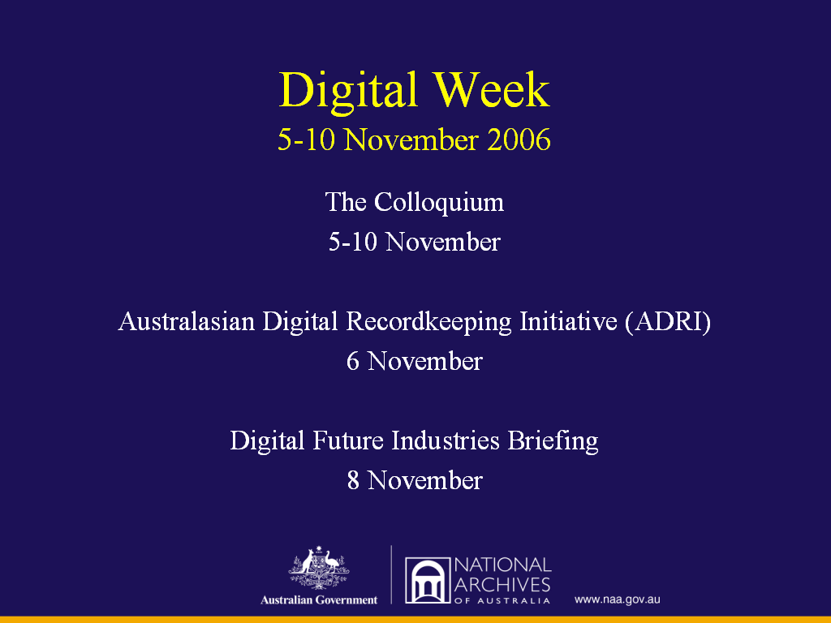
Archives, including the National Archives, have done and are doing a lot about digital collections.
Archives recognise:
(1) The fundamental importance of the impact of digital technologies on archives and

(2) The need for archives to demonstrate leadership by seizing the opportunities that the digital agenda has presented.

Celebrate - our achievements
Learn - there is still a lot to do!
Hence - Digital Week

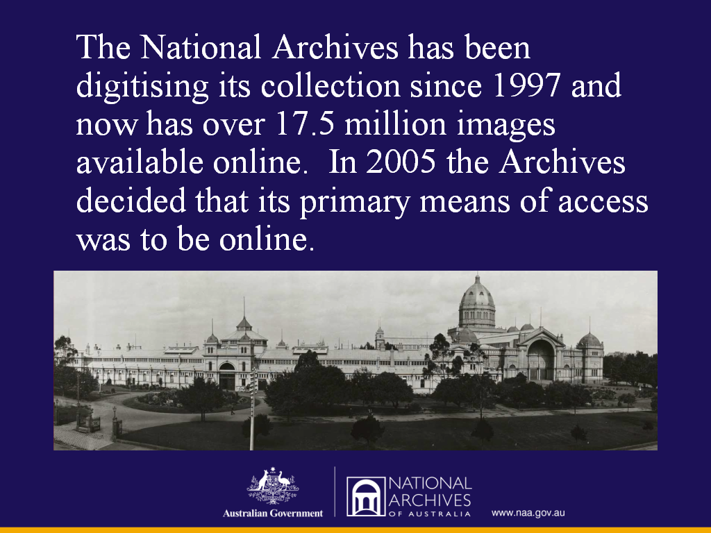

Individually Archives are:

Creating Digital images (digitisation) – NAA is providing 24 hour worldwide online access to the holdings of the Archives through the digitisation of paper-based holdings, thus making our collections much more accessible to a broader range of users (the NAA now has 17.5 million digitised images available on its website and 84% of the usage of our holdings is now made online).

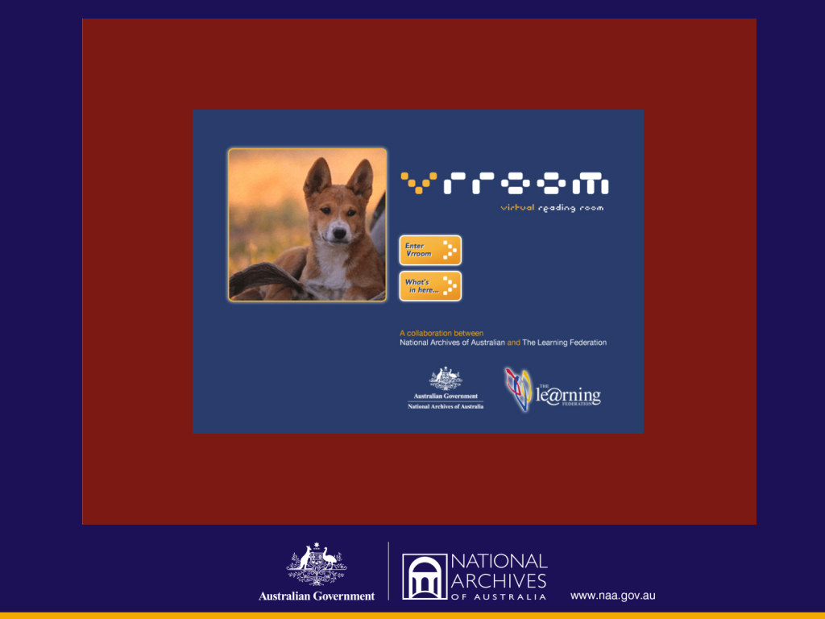

The NAA is committed to delivering our education products only via the web. Virtual Reading Room (VROOM) is the main product.

Vrroom is targeted at K-12; but is being used as well by undergraduates.
The attraction of Vrroom is the “ease” of having “original” archives online to work with and learn from.

Vrroom won Best Education website in The Australian Awards for Excellence in Educational Publishing for 2006 by the Australian Publishers Association.
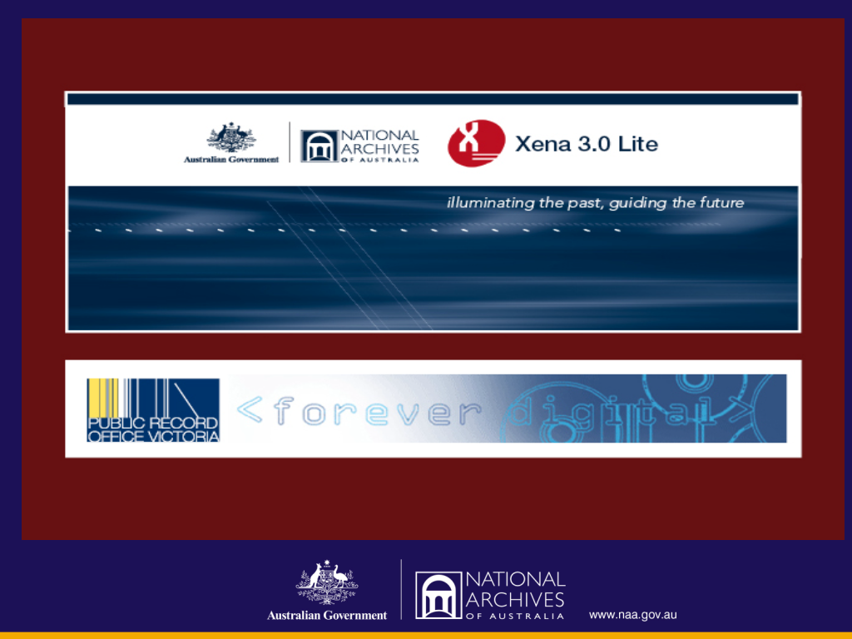

Archives are also committed to collecting the digital (Born Digital) – the preservation and management of born digital information (the overwhelming majority of information created by governments now is born digital).

The NAA has built a prototype digital repository and has developed a suite of open source software products that can be used to help preserve born digital records as archives – these products include XENA (XML Electronic Normalisation of Archives) and DPR (Digital Preservation Recorder).

ADRI was launched in the NAA’s Menzies Room at the Commonwealth Chief Information Officer’s Forum in June.

Victorian Electronic Recordkeeping Strategy – Andrew Waugh, from the Public Record Office Victoria, will explain the work of the other Australian Archives collecting digital records later in this session.
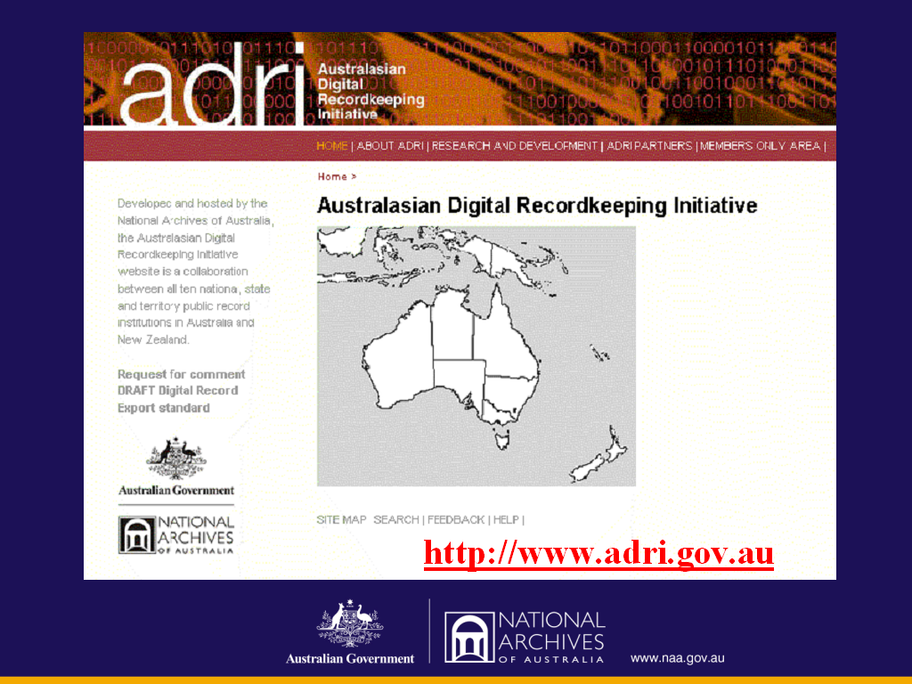

Collectively archives are:
The need for Archives to work in partnership to access the digital agenda collaboratively was recognised early. For example, we work with other archives, libraries, museums, universities, e-government policy specialists and also with international colleagues.

National Online Archival Network (NOAN)
October 2002 – NOAN was launched to provide online access for all Australian archival collections. NOAN was established in NAA’s Menzies room at a similar broad, representative archival sector meeting.
Collections Australia Network (CAN)
With Powerhouse Museum and the Museum sector, Archives have decided that the best way to provide online service to small community and regional archives is via CAN.

Australasian Digital Recordkeeping Initiative (ADRI)
We established ADRI in 2004 to develop and implement a common Australasian approach to born-digital recordkeeping. ADRI unites the 10 public records/archival institutions in Australia and New Zealand. More information about ADRI can be found on the ADRI website at http://www.adri.gov.au
- Launched in 2004 by Peter Shergold, Secretary, Prime Minister and Cabinet
- ADRI Website launched by Alan Hawkes, Australian High Commissioner to NZ, (and now Chancellor of ANU) in 2005.

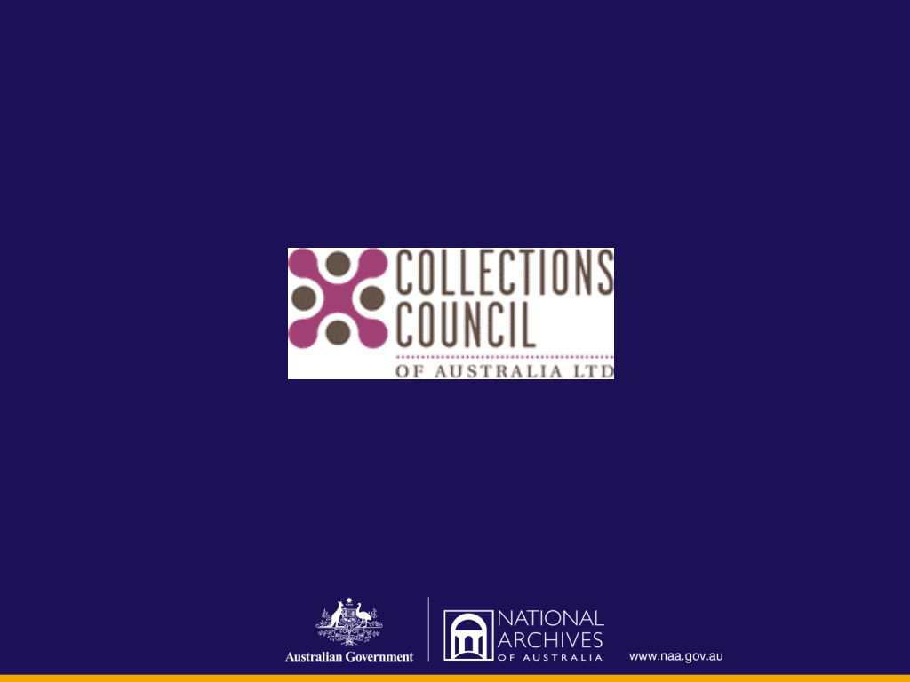

A new cooperative player in the digital space is the Collections Council of Australia.
- The organisation was initiated by the Cultural Ministers Council, and is supported by the federal, state and territory governments through the Cultural Ministers Council for three years.
- The Collections Council’s charter focuses on the collections sector throughout Australia, and includes libraries, museums, archives and galleries
- I was the foundation archives representative on the CCA
- Archives member on CCA is now Tony Caravella, Director, State Records Western Australia
- Why CCA is important to Archives:
- On the CCA’s predecessor, the Heritage Collections Council, archives were only an observer.

- On CCA we are an equal partner with museums, art galleries and libraries.
- Archives commitment to the CCA is reflected in Margaret Birtley’s, CEO of the CCA, address to the Australian Society of Archivists (ASA) Conference in Port Macquarie last month and with me at the New Zealand Society of Archivists (NSA) conference in Wellington in 2005.

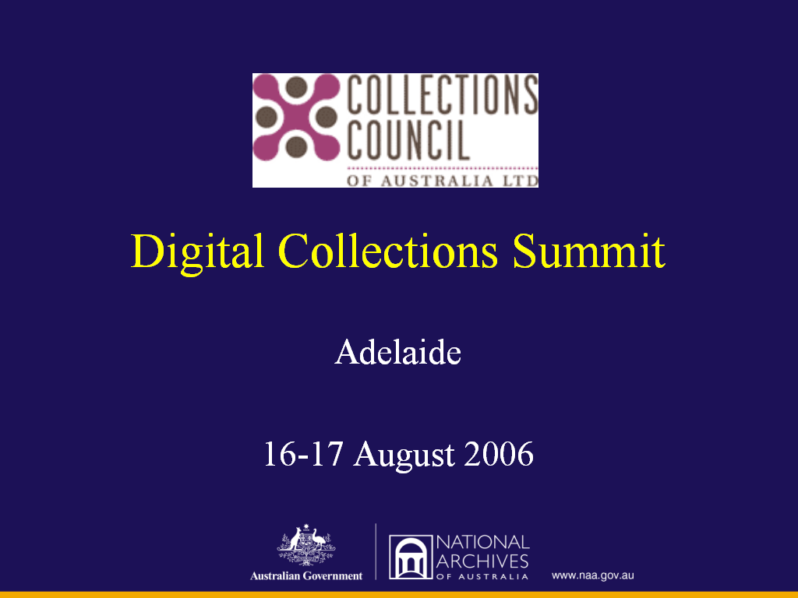

February 2006 – a CCA meeting to begin the development of an agenda for the Digital Collections Summit was held (again) in the Menzies Room at NAA Adrian Cunningham and Cornel Platzer from NAA made the presentation on behalf of archives.

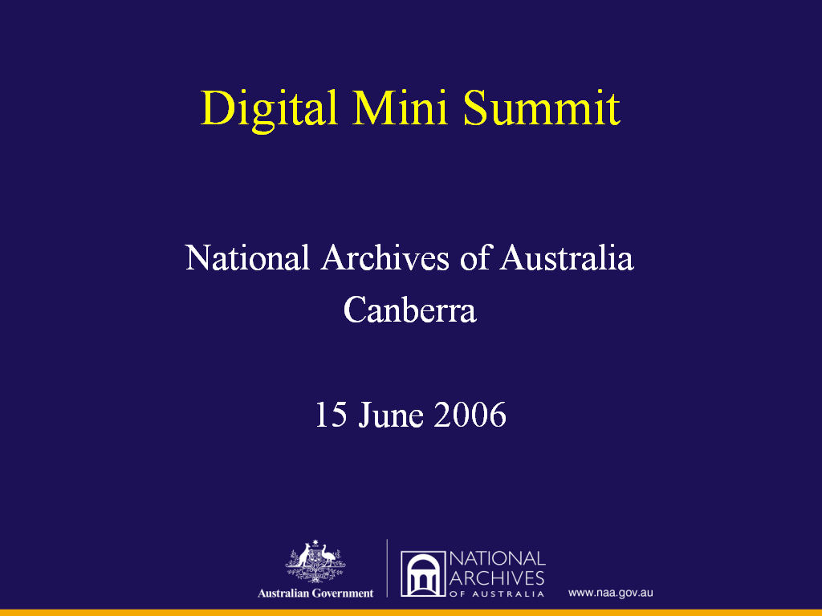

Archives have been very collegiate in our support for the Digital Collections Summit. On 15 June 2006 an Archives Mini Summit was held again in the Menzies room to establish:

- What are we particularly good at? What expertise do archives have to offer the broader cultural sector in Adelaide in August?
- Where can we lead?
- What is the line in the sand? What can’t/won’t we compromise on?

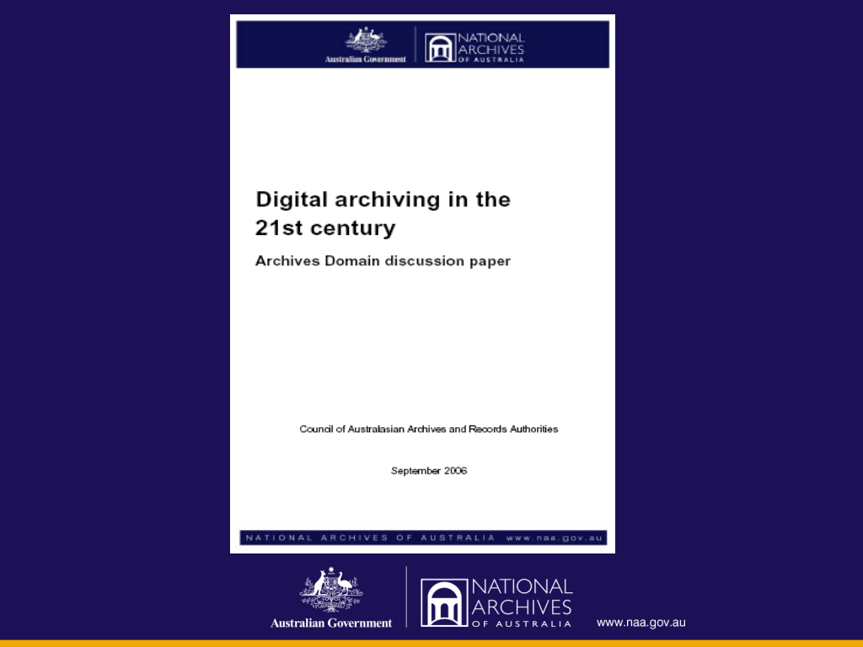

In preparation for the August summit the NAA with the Council of Australasian Archives and Records Authorities (CAARA) prepared a discussion paper “Digital Archiving in the 21st Century”. This was discussed at the Archives domain “mini-summit” in Canberra.

Copies of this discussion paper were distributed to delegates at the CCA Summit. The paper has also been published on the CAARA website at: http://www.caara.org.au

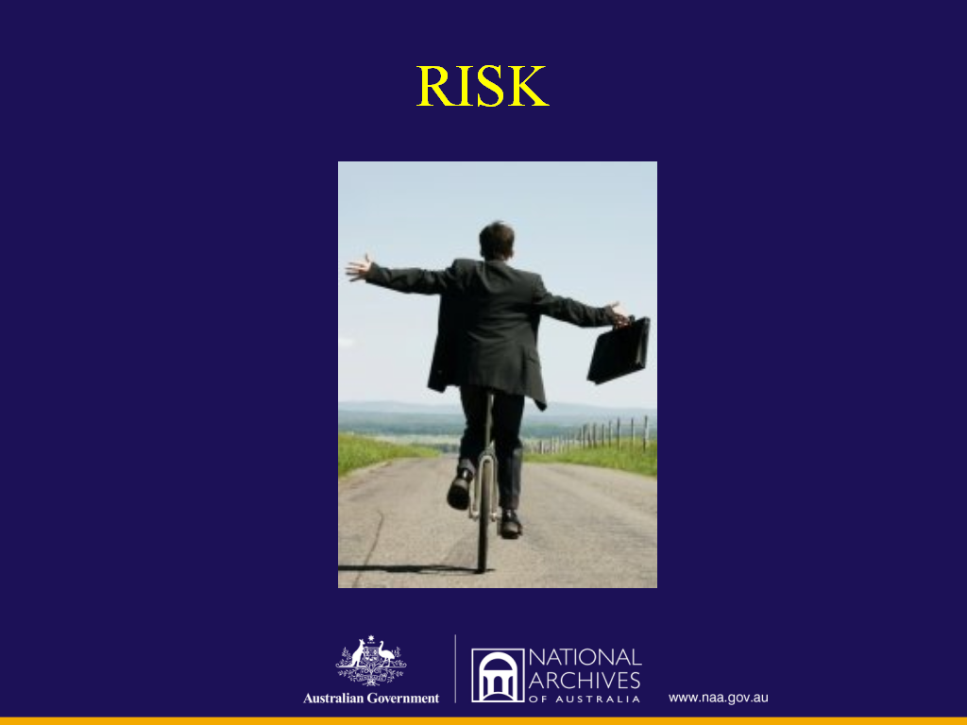

The messages of “Digital Archives in the 21st Century”, presented to the CCA summit, was that we are doing a lot of things, more than most of the cultural institutions, that we still have a way to go but we have five key messages to share with other cultural collecting institutions.

Five Key Messages
1. RISK

Australian culture and cultural content is at risk
Two sides to risk

  - Users expect online access. If we cannot deliver this as an integral part of the national digital information infrastructure we run the risk of our cultural content being marginalised.

  - Without urgent attention born digital Australian cultural content is likely to be lost.

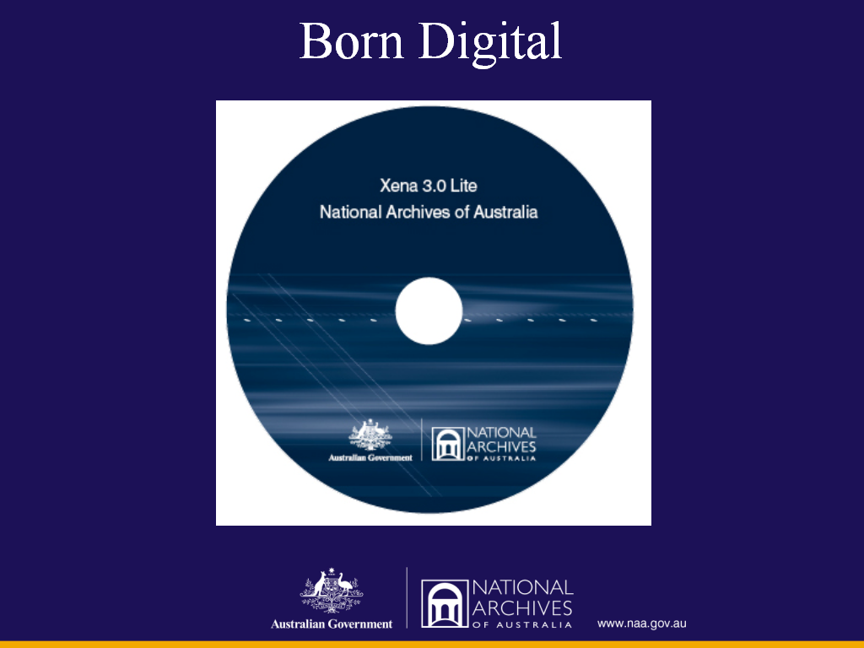

2. Born Digital
Archives in Australia are confident that they know the challenges, risks and solutions for long-term digital archiving and are willing to offer leadership in this area, eg VERS and Xena
- Digital preservation
- Dealing with ‘bulk’ scale, industrial scale
- Digital recordkeeping and archiving, frameworks, standards, etc.

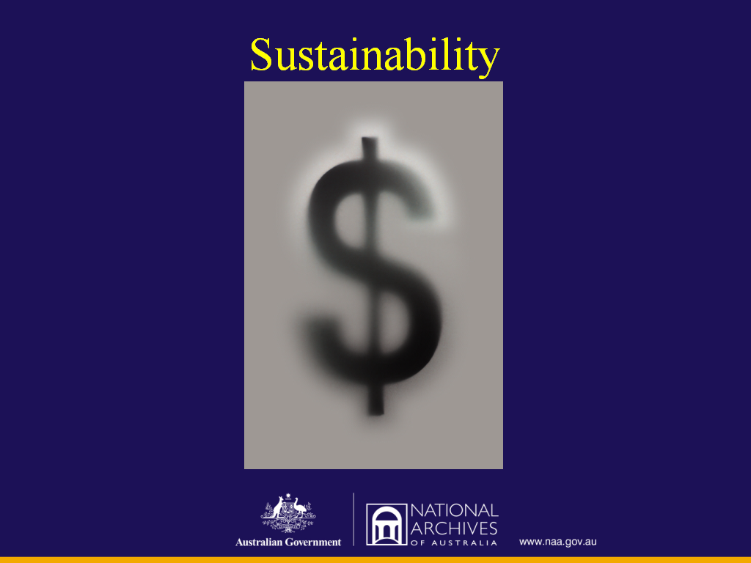

3. Sustainability
Archives in Australia are not confident that we have the capacity to implement the solutions in a scalable and sustainable way across the whole archives sector (small and large archives, government and non-government) because of:

  - Lack of resources
  - Lack of skills; and
  - Lack of awareness.

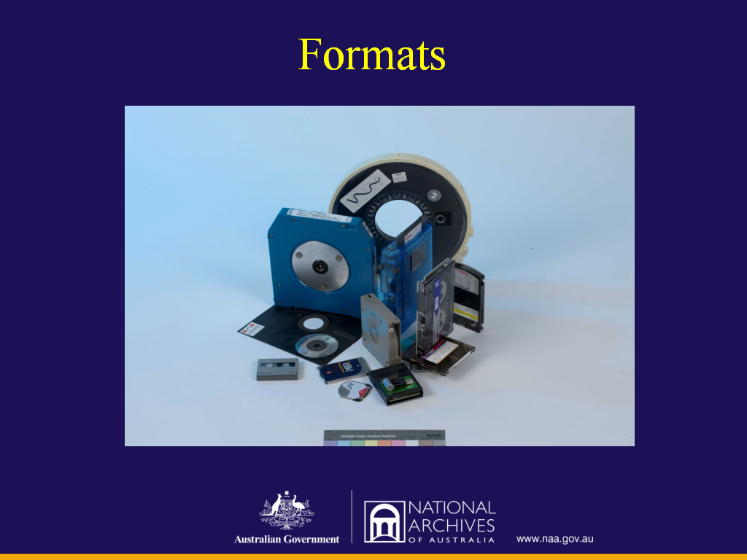

4. Formats

Archives in Australia have significant quantities of content in all formats. But most of this content is not available online because of:

  - Lack of digitisation
  - Lack of metadata and supporting information online; and
  - Lack of money.

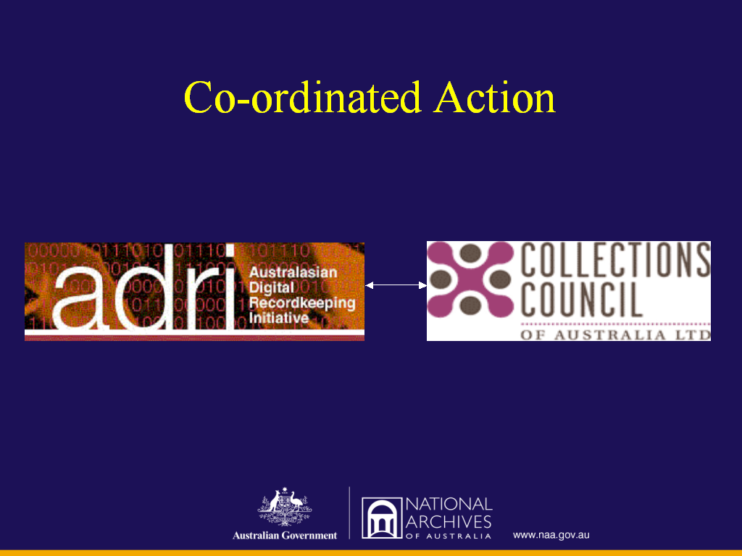

5. Co-ordination
There is an urgent need for co-ordinated action and advocacy across various sectors, including:
  - ADRI (archives)
  - Collections Council of Australia (all cultural collecting institutions)
But also:
- Information and Communications Technology industry and professions
- Producers of Digital content
- Education Sector.

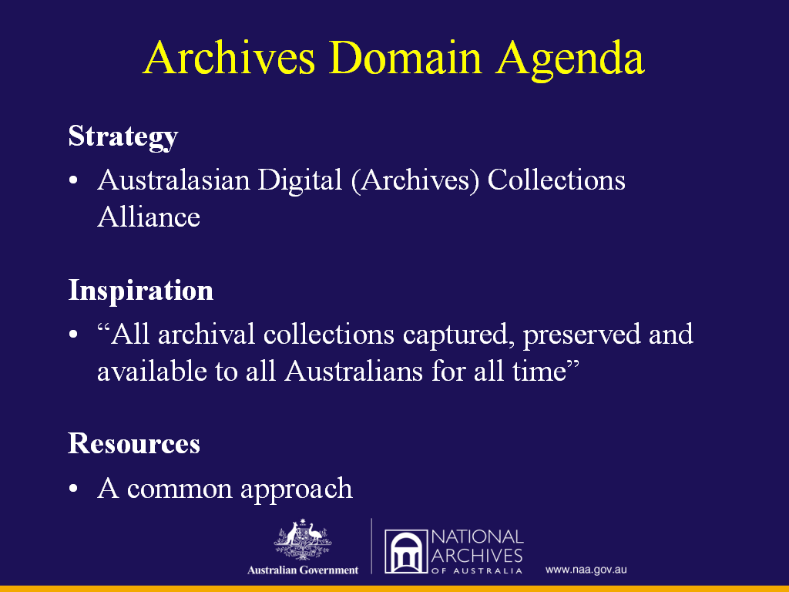

The Archives Domain Agenda for the Collections Council Summit was:

Strategic: proposed an Australasian Digital Archiving Alliance (ADAA) for our archives sector or for the CCA (an Australasian Digital Collections Alliance)?

Aspirational: “all archival collections captured digitally, preserved, and available to all Australians for all time”?

Resource driven: we do not have access to the Lottery Fund of the UK or the generous project funds of the EU. Archives and CCA require an Australian solution to the resource issue. This may be the matter where there is most shared ground with other three collecting domains.

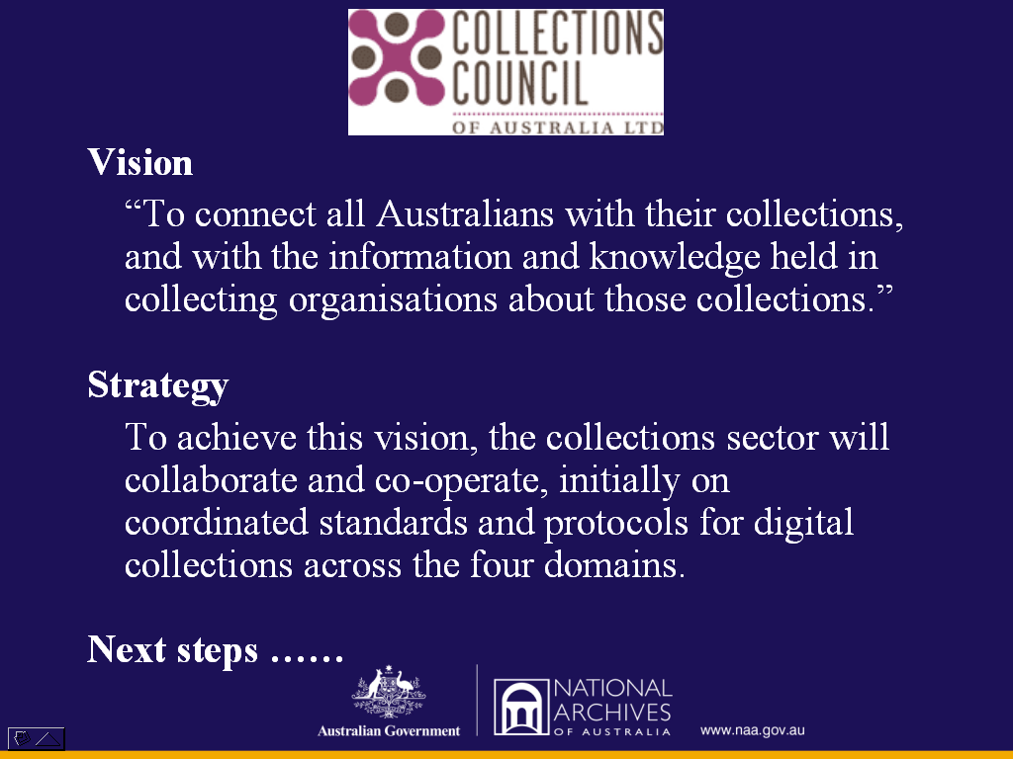

Summit on Digital Collections Outcomes

Vision: To connect all Australians with their collections, and with the information and knowledge held in collecting organisations about those collections.

Strategy: To achieve this vision, the collections sector will collaborate and co-operate, initially on co-ordinated standards and protocols for digital collections across the four domains.

Next steps….

- Margaret Birtley, CEO of the Colections Council of Australia will tell you about the ongoing work arising from the Digital Collections Summit.

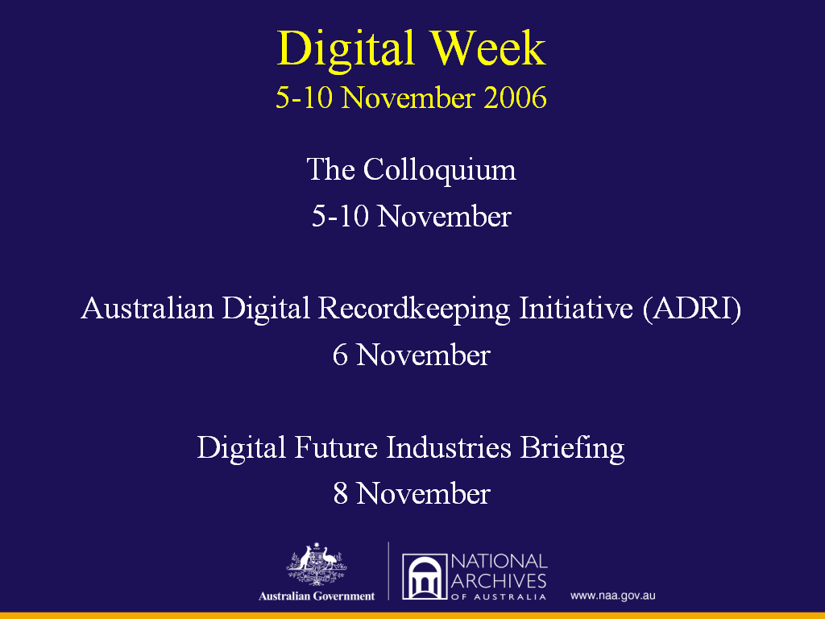

Archives next steps:

Digital Week 5-10 November 2006
- The National Archives of Australia/Council of Australasian Archives Records Authorities (CAARA) Colloquium
- The Digital Futures Industry Briefing - 8 November
- Australasian Digital Recordkeeping Initiative Plenary - 6 November
- And a proposed seminar/conference series is planned for 2007; and

Archives/CAARA - are committed to progressing the Collections Council of Australia agenda and the initiatives that have been put in place since the Digital Summit in Adelaide last August and others that will be put in place following this week.

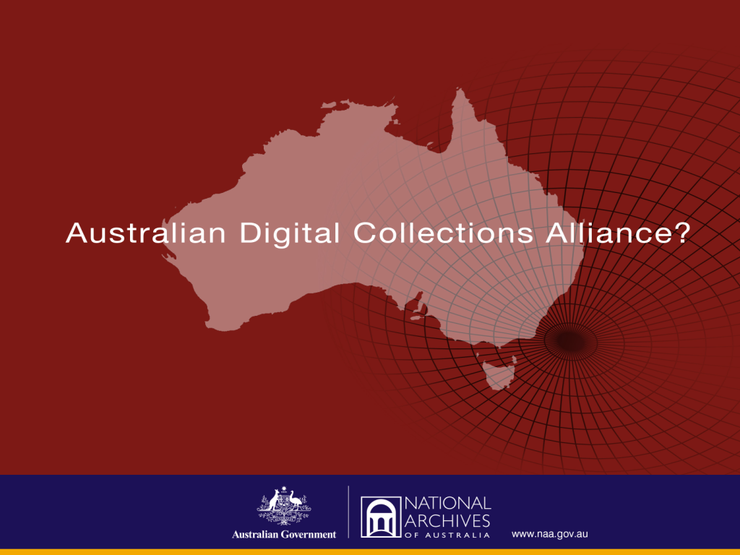

Archives believe that an ongoing digital partnership between the cultural institutions of Australia should form one of the important next steps.

