Outcome 3, Output 3.1 Question: 138
Topic: Revenue from Licensed Post Offices
Hansard Page: ECITA 108

Senator Parry asked:

Can you estimate what the revenue from Licensed Post Offices would be?

Answer:

In 2005/2006, revenue from the Licensed Post Office network was $829.1m or around 18.3% of total revenue.

Outcome 3, Output 3.1 Question: 139
Topic: Electronic Point of Sale (EPOS) equipment
Hansard Page: ECITA 109

Senator Parry asked:

Do you know the cost involved for each LPO to install and have or maintain or be given, or whatever the licence agreement is?

Do you have one charge for each LPO? Is it a standard charge across the nation?

Answer:

Australia Post supplies LPOs with the base EPOS equipment package at a subsidised, standard charge of $1080 per annum. The Australia Post subsidy is approximately $6,400 per terminal, per annum.

Outcome 3, Output 3.1 Question: 140
Topic: LPO Contract - Competitive Services
Hansard Page: ECITA 109

Senator Parry asked:

What does that agreement (licensee’s agreement with Australia Post regarding core services) specify?

Answer:

The LPO Agreement specifies that licensees must seek/gain approval before conducting non-Australia Post third party agency business within the LPO premises.

If a licensee fails to seek/gain approval, the standard EPOS subsidy of approximately $6,400 per terminal, per annum no longer applies.

Outcome 3, Output 3.1 Question: 141
Topic: Bill EXPRESS
Hansard Page: ECITA 110

Senator Parry asked:

Are you familiar with the Bank@Post scheme? They are three-year agreements, I understand. If someone had signed up for a three-year agreement and then also took on Bill EXPRESS, what would happen to the three-year agreement?

Ms Button – I think, and I will have to confirm this, we do go through a process. It is a similar process to any other instance where a licensee might take on a service that is in competition with a core service. We would go through the local area manager, providing advice and reasoning and then escalating it if necessary.

Answer:

Under the Bank@Post scheme, the Federal Government is funding the installation of EPOS equipment and paying normal shortfall and technology costs until June 2008 for some 266 smaller Licensed Post Offices (LPOs). Australia Post will then meet those costs until June 2015.

If such a LPO were to conduct non-Australia Post third party agency business without approval, the standard EPOS subsidy of approximately $6,400 per terminal, per annum would no longer apply.

Outcome 3, Output 3.1 Question: 142
Topic: Bill EXPRESS
Hansard Page: ECITA 110

Senator Parry asked:

I have information that, in relation to the current payment of $90 per month - $1,080 per annum – to have an EPOS terminal with Australia Post, if the same LPO installed Bill EXPRESS because a certain client base needed it for other clientele who were not in competition with Australia Post, the LPO now has to pay $7,500 per annum because they have Bill EXPRESS. Are you familiar with that fairly high increase in annual rentals or annual agreement fees?

Ms Button – No. We will have to take that on notice. We have a different charge depending on the number of transactions a licensee might bring in through the outlet, but I do not have the details with me.

Answer:

Australia Post will not give approval to a licensee to install any system that can be used to conduct transactions in direct competition to EPOS. If a licensee installs a competitive system without approval, the standard EPOS subsidy of approximately $6,400 per terminal, per annum no longer applies.

Outcome 3, Output 3.1 Question: 143
Topic: Bill EXPRESS
Hansard Page: ECITA 110

Senator Parry asked:

I understand that 10 Licensed Post Offices in one State are affected and that, through the Licensee Advisory Council, Australia Post has been made aware of the matter but that there has been no further progress. I would appreciate it if you could look at that as well and provide that information to the committee.

Answer:

A licensee in Tasmania sought approval to install a competitive system (BillEXPRESS) in the LPO premises in order to conduct a range of agency transactions. Australia Post denied the request.

Ten licensees, including the licensee mentioned above, subsequently sought and received Australia Post approval to conduct agency business for one third party agency principal without the installation of this competitive system.

Outcome 3, Output 3.1 Question: 144
Topic: Bill EXPRESS
Hansard Page: ECITA 110

Senator Parry asked:

Ms Button – there was a situation where they wanted to go through Bill EXPRESS to be able to offer certain agency principal bills, but then I think Bill EXPRESS pulled out of it and they were able to deal directly with the agency principal. Again, I can give you details of those.

I would be interested – and I am sure the committee would – in any policy or guidelines or directives you may have in relation to dealing with competitors.

Answer:

Under the LPO Agreement, only Australia Post approved products and services can be sold within the post office portion of the premises.

Non-Australia Post products and services can be sold in the non-post office portion of the premises in in-conjunction outlets, unless they compete with Australia Post’s protected products and services (eg banking, PO Boxes, philatelic products, acceptance/delivery of mail etc.)

Non-Australia Post third party agency business can be conducted in the portion of the premises where the licensee seeks and gains approval to undertake such business. If a licensee undertakes non-Australia Post third party agency business without such approval, the standard EPOS subsidy of approximately $6,400 per terminal, per annum does not apply.

Outcome 3, Output 3.1 Question: 145
Topic: Principal Determination – Legal Advice
Hansard Page: ECITA 112

Senator Conroy asked:

Mr McCloskey, are you willing to table your legal advice?

Mr McCloskey – I think we would need to take that on notice.

Answer:

The advice is legally professionally privileged.

Outcome 3, Output 3.1 Question: 146
Topic: Medical Information Previously Obtained Under Award Provisions
Hansard Page: ECITA 113

Senator Conroy asked:

Will some compensation claims need to be reopened because they were determined on the basis of information that was illegally obtained? Have you taken legal advice on that?

Ms Walsh – We have not taken legal advice on that. My initial view would be that, no, we would not, but I am happy to take that point on notice.

Answer:

In Australia Post’s view, there is no need for any compensation claims to be re-opened because no information was illegally obtained.

Outcome 3, Output 3.1 Question: 147
Topic: Mr Garfarth
Hansard Page: ECITA 114 - 116

Senator Conroy asked:

Mr Garfath does not know what the conversation consisted of because he was not allowed to participate in it or listen to it.

Mr McDonald – We would need to look into that Senator.

The supervisor buys him crutches and he still gets sent back to work.

Mr McDonald – That would need to be looked at. I do not know the circumstances of that case. I am happy to take it on notice to have it looked at and to see what the context was.

Answer:

The background to this matter is as follows:

- Mr Garfarth reported a pain in his leg while attempting to start his delivery motorcycle on 1 August 2006. He voluntarily accepted the offer of treatment by a Facility Nominated Doctor (FND) and was transported to the surgery in Castle Hill by his supervisor.

- The FND assessed Mr Garfarth as fit for restricted (eg seated) duties from 2 to 7 August 2006 and subsequently telephoned Mr Garfarth’s manager to ask if there were suitable duties available.

- Mr Garfarth remained in the room throughout the telephone conversation between the FND and his manager.

- The FND and Mr Garfarth’s manager did not discuss Mr Garfarth’s personal medical details – the conversation was solely about the nature of duties that would be available should Mr Garfarth return to work.

- The FND recommended that Mr Garfarth be provided with crutches to assist his mobility, which the supervisor hired from a local chemist after the consultation.

- Mr Garfarth was not sent back to work after the consultation. He returned to work on restricted duties on 3 August 2006.

Outcome 3, Output 3.1 Question: 148
Topic: Principal Determination - FNDs
Hansard Page: ECITA 115 - 117

Senator Conroy asked:

They present themselves for a standard medical examination: eye test, temperature, blood pressure, stand on one leg etc. They do not allow them to treat or conduct an examination of the work injury and direct the FND in writing that they have no authorisation to forward personal, private medical information to Australia Post. Would Post seek to discipline this employee?

If a person presents under your determination and follows the three points I have mentioned will Post seek to discipline the employee?

Answer:

If an employee is directed to undergo a medical examination pursuant to clause 10 of the Principal Determination and subsequently seeks to hinder the process, Australia Post would consider applying the Employee Counselling and Disciplinary Process.

Outcome 3, Output 3.1 Question: 149

Topic: FNDs

Hansard Page: ECITA 117

Senator Conroy asked:

- How many employees, state by state, have been directed to attend a Facility Nominated Doctor (FND) under your Principal Determination?

(b) How many of these employees have made workers’ compensation claim for lost time, injury treatment or medical consultation/examination?

(c) How many of these employees have been denied liability for incapacitation or partial incapacitation payments with their workers’ compensation claim?

(d) How many of these employees have exercised an appeal against Post’s refusal to accept liability or make total or part workers’ compensation payments?

(e) And of these appeals, how many have been revoked at the reconsideration level, AAT proceedings or entered into a settlement?

Answer:

The following figures cover the period 1 July to 31 October 2006:

 | NSW/ACT | VIC/TAS | QLD | WA | SA/NT
a. | 61 | 83 | Nil | 2 | Nil
b. | 41 | 36 | Nil | 1 | Nil
c. | 9 | 10 | Nil | Nil | Nil
d. | 4 | 3 | Nil | Nil | Nil
e. | Nil | 2 | Nil | Nil | Nil

Outcome 3, Output 3.1 Question: 150
Topic: Firearms Prohibition
Hansard Page: ECITA 122

Senator Ronaldson asked:

Can you provide me with correspondence that went anywhere immediately after this decision was made, whether it was to people who complained about the decision?

Mr McCloskey – I can certainly do that.

Answer:

A copy of the letter that was sent in response to the initial round of representations to the corporation on the matter is attached.

Attachment
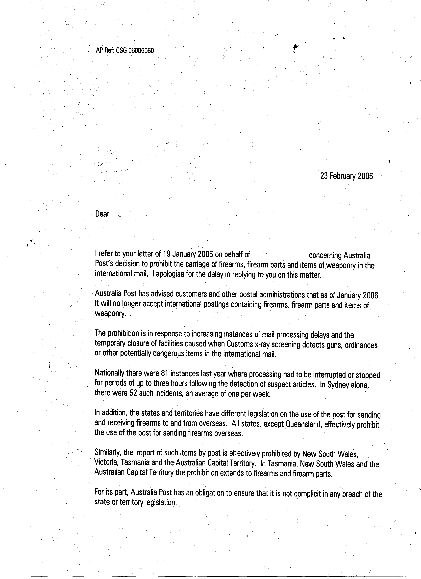
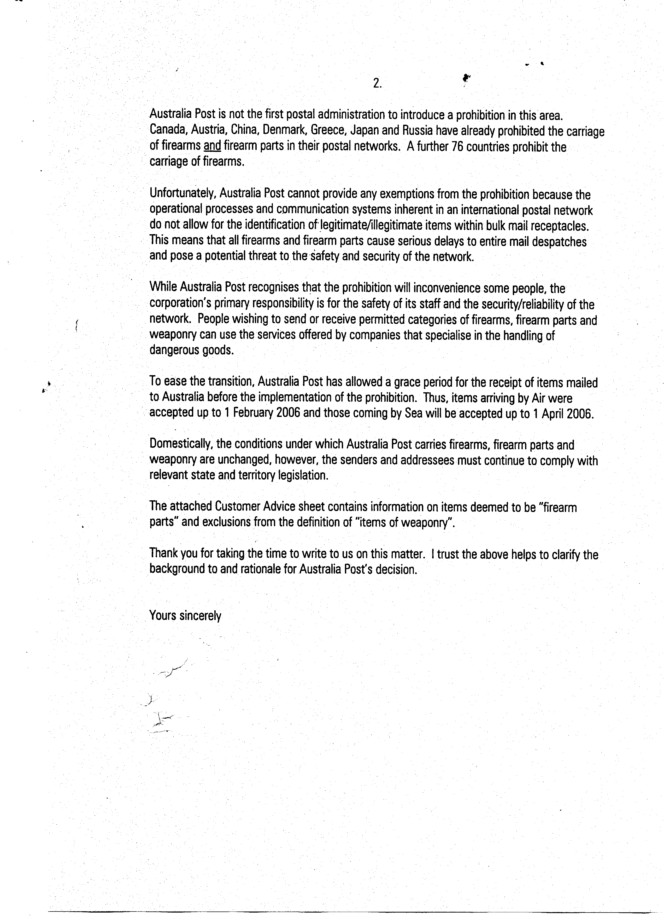

Outcome 3, Output 3.1 Question: 151
Topic: Tripartite meetings with AQIS/Customs
Hansard Page: ECITA 123

Senator Ronaldson asked:

Can you take on notice whether there was a tripartite meeting on 2 December 2005 at which Australia Post undertook to provide details of the proposed prohibition?

Answer:

The minutes of the tripartite meeting on 2 December 2005 record Australia Post representatives as advising that they expected a policy prohibiting all guns and military type items in the international mail to be approved shortly, with effect from 1 January 2006. The minutes further indicate that Australia Post would advise Customs and AQIS about the details of the prohibition at the earliest possible time.

The Determination giving effect to the prohibition was signed on 4 January 2006. Customs and AQIS were advised of the detail on 6 January 2006.

Outcome 3, Output 3.1 Question: 152
Topic: Agreement with Australian Booksellers Association
Hansard Page: ECITA 126 - 127

Senator Wortley asked:

What is the term of the new agreement (with the Australian Booksellers Association)? Would you be able to provide me with the term, that being the time frame of that new agreement?

Answer:

The term is 12 months, which is standard for this type of agreement.

Outcome 3, Output 3.1 Question: 153
Topic: Non-delivery of bulk mail of a political nature
Hansard Page: ECITA 127

Senator Parry asked:

Could the committee receive, on notice, any information you have, in particular in relation to mail maybe of a political nature, as to the variety of complaints, if you can release that information without names, but concerning types and individuals and locations?

Answer:

A search through our central complaints database has shown that since January 2006 there have been two complaints from Federal Parliamentarians in relation to delivery of mail of a political nature, both in Victoria. One of the complaints was concerned with 32 unaddressed mail items (leaflets) that were found in a carpark and brought to the attention of the local MP. The second related to the inadvertent destruction of 800 unaddressed mail pieces by an LPO following incorrect distribution by Post into a neighbouring electorate.

Outcome 3, Output 3.1 Question: 154
Topic: Complaints by Members of Parliament
Hansard Page: Written Question on Notice

Senator Parry asked:

If a Member of Parliament went to a local post office and made a formal complaint in person to the local manager, it would stay within the confines of that post office?

Answer:

The customer would be asked to complete a “Customer Complaint Form”, which the outlet would then forward to the relevant Customer Contact Centre for investigation/resolution of the complaint.

Outcome 3, Output 3.1 Question: 155
Topic: Franchised Post Shops
Hansard Page: Written Question on Notice

Senator Conroy asked:

Has Australia Post opened any Franchised PostShops? If so, where and when?

Answer:

The postal outlets in Carlingford and Edgecliff (NSW) commenced trading as franchised PostShops on 30 October and 6 November 2006 respectively.

Outcome 3, Output 3.1 Question: 156
Topic: Franchised Post Shops
Hansard Page: Written Question on Notice

Senator Conroy asked:

Is Thornlie corporate post office in WA to be converted to franchised operations?

Answer:

Yes.

Outcome 3, Output 3.1 Question: 157
Topic: Franchised Post Shops
Hansard Page: Written Question on Notice

Senator Conroy asked:

What are Australia Post’s future plans for franchised Post Shops?

Answer:

Australia Post envisages there will be network of around 150 franchised PostShops within the next four years. The initial phase of the implementation program involves:

- converting 20 under-performing corporate outlets, as provided for under EBA6;

- formalising four pilot franchises;

- on an opportunity basis, voluntarily buying-back some Licensed Post Office licences and establishing new outlets at “greenfield” locations.

The buy-back of licences and establishment of outlets at greenfield locations will continue on an opportunity basis over subsequent years. The extent of further corporate conversions will be determined once arrangements for conversions under the initial phase of the program are finalised.

Outcome 3, Output 3.1 Question: 158
Topic: Franchised Post Shops
Hansard Page: Written Question on Notice

Senator Conroy asked:

Does AP still have four pilot franchised Post Shops in operation?

Have the owners of those outlets indicated their willingness to purchase the outlets?

Answer:

Yes.

All pilot franchisees, bar one, have expressed a willingness to enter into formal franchise agreements.

Outcome 3, Output 3.1 Question: 159
Topic: Franchised Post Shops
Hansard Page: Written Question on Notice

Senator Conroy asked:

Has Australia Post involved both the CEPU and POAAL in further discussions about the franchised Post Shop concept?

Have their views been sought?

Answer:

Australia Post has a standing offer to discuss the franchised PostShop system and implementation program with both organisations.

It has had numerous meetings and exchanges of communications with the state and national levels of the CEPU throughout 2006. It has also provided a great deal of information to POAAL over an extended period and made repeated offers to provide face-to-face briefings. To date, POAAL has declined these offers.

Outcome 3, Output 3.1 Question: 160
Topic: Self Service Centres
Hansard Page: Written Question on Notice

Senator Conroy asked:

What are Australia Post’s plans for self-service centres?

How many trial sites are operational, how many are planned?

Answer:

Australia Post is currently trialing the service centre concept to determine whether it meets customer expectations/demand and provides an economically sustainable outlet type within the future retail network structure.

There are three trial sites operating at South Melbourne and Keysborough (VIC) and Woden (ACT). There are no current plans to extend the number of trial sites, pending a full evaluation of the existing sites.

Outcome 3, Output 3.1 Question: 161
Topic: Self Service Centres
Hansard Page: Written Question on Notice

Senator Conroy asked:

What assessments will be done on these outlets and how frequently?

Answer:

Customer and staff research was undertaken at the end of November 2006 to gather post-opening data. This will be followed by regular assessments and ongoing monitoring of key financial indicators during the trial period, which is due to be completed by end of the 2006/2007 financial year.

Outcome 3, Output 3.1 Question: 162
Topic: Self Service Centres
Hansard Page: Written Question on Notice

Senator Conroy asked:

What impact will these centres have on staff numbers?

Answer:

There have been no changes to staff numbers at the trial sites. Australia Post’s current assessment is that while the mix of business may change the volume of work, and therefore staff numbers, is likely to stay the same.

Outcome 3, Output 3.1 Question: 163
Topic: Street Posting Boxes
Hansard Page: Written Question on Notice

Senator Conroy asked:

What is Australia Post’s policy on installing “gold” Express Post street posting boxes?

Answer:

Australia Post has guidelines for the provision of Gold Express Post boxes, which ensure that the number and placement of boxes is optimised in terms of convenience and cost efficiency.

In so far as numbers are concerned, the guidelines provide that:

- in Capital City central business districts - no business address should be more than 400 metres from a box.

- in Capital City metropolitan areas and other cities, where an average of 1.5 or more Express Post items are posted per person per year - a minimum of one box is to be provided for every 20,000 persons who live in that city.

- in Capital City metropolitan areas and other cities, where an average of less than 1.5 Express Post items are posted per person per year, a minimum of one box is to be provided for every 30,000 persons living in that city.

In so far as locations are concerned, the guidelines provide that boxes should be installed in major shopping centres, large industrial estates/industrial areas, well used transport hubs, other areas of high concentration of business addresses and universities and other major educational institutions.

Outcome 3, Output 3.1 Question: 164
Topic: Street Posting Boxes
Hansard Page: Written Question on Notice

Senator Conroy asked:

Australia Post has a policy of clearing street posting boxes in most city and suburban areas at an announced clearance time of 6.00pm. Obviously, it will be impossible to clear all boxes by 6.00pm and the actual clearance times probably extend for a further couple of hours. However, in some areas Australia Post staff commence clearing prior to 6.00pm, thus customers who post their mail close to the clearance time are deprived of having their mail picked up that day. As these customers are unaware of this fact, could not AP provide some indication on street posting boxes that the mail has been cleared from that box?

Answer:

Australia Post advertises a common “post by” time on street posting boxes (SPBs), which is generally 6.00 pm Monday to Friday in city and suburban areas.

While some SPBs are cleared more than once daily, final clearance should not be prior to the advertised “post by” time.

Outcome 3, Output 3.1 Question: 165
Topic: Licensed Post Offices
Hansard Page: Written Question on Notice

Senator Conroy asked:

How many LPOs have been closed or converted to Community Agencies or corporate post offices during the past year?

Could the committee be supplied with the names, please?

Answer:

The following changes to the Licensed Post Office network occurred during 2005/2006:

LPOs closed:
Heidelberg (VIC) Sylvester (VIC) Ovens (VIC)
Stony Creek (VIC) Yaapeet (VIC) Rossmore (NSW)
Grafton West (NSW)

LPOs converted to CPAs:
Tumbulgum (NSW) Rye Park (NSW) Toolamba (VIC)
Dalyston (VIC) Nullawarre (VIC)

LPOs converted from corporate outlets:
Lindisfarne (TAS) North Perth (WA) Hamilton Hill (WA)
East Maitland (NSW)

Outcome 3, Output 3.1 Question: 166
Topic: Licensed Post Offices
Hansard Page: Written Question on Notice

Senator Conroy asked:

Is there a payment to Licensees who store depot bags or other items (not mail for delivery from that LPO) for Australia Post?

Answer:

Payment for the acceptance and security of depot bags is included in the annual representation allowance paid to licensees. In exceptional cases where large quantities of depot bags are involved, an additional negotiable payment may apply.

