Outcome 1, Output 1.1, 1.2 Question: 129
Topic: Classification of Film ‘Lolita’ Broadcast on SBS TV
Hansard Page: ECITA 90

Senator Joyce asked:

Senator JOYCE—In May you had Lolita on. Lolita is rated R, if you got it from a video store. How did you manage to get that on?
Mr Brown—It was not rated R for—
Ms Eisenberg—Was that the Stanley Kubrick version?
Mr Brown—The Stanley Kubrick 1960s film.
Ms Eisenberg—I think we would need to take that on notice. There was another version of it which was made a number of years later which had a different rating. R rated content is not permitted on SBS under our codes of practice.

Answer:

The version of Lolita broadcast by SBS in May 2005 was Stanley Kubrick’s 1962 black and white film, starring James Mason, Shelley Winters, Sue Lyon and Peter Sellers. It was classified M (recommended for mature audiences 15 years and over).

M rated programs may be broadcast between 8.30pm and 5.00am. Lolita was transmitted at 10pm.

Outcome 1, Output 1.1, 1.2 Question: 130
Topic: SBS Documentary “Lost Worlds: the Real Family of Jesus”
Hansard Page: ECITA 92

Senator Joyce asked:

Senator JOYCE—………... What is the factual content of this? This is all new information. Would you stand by this? Do you think this is a factually precise document? You have done the research into it and it has passed your imprimatur as being a factually worthwhile thing to put on television.
Mr Brown—I would have to take that on notice. I have not seen the program. I am reliant on the description you are giving me.
Senator JOYCE—You will get to see it on Sunday night. What is put to me as a representative of the people of Queensland is that this sort of thing prompts them to ask why we bother sponsoring SBS. They give it so much latitude in so many areas, but then it always manages to go that step that just takes it from questioning to insulting.
Mr Brown—I think before one forms that judgment one should see the program.
Senator JOYCE—I am reading what it says. It is on your web site. It is a statement. It makes a statement. It deals with a ‘common misconception that Jesus was the single child of a nuclear family’. That is a statement. It does not say ‘We question’; it says it deals with the ‘common misconception that Jesus was the single child of a nuclear family’. It also states:
Evidence from the Gospels, history and archaeology as well as the interpretations of religious experts reveal ...
It does not question, it does not say it needs to be discussed or that there is an area of doubt. It says ‘reveal that not only did Mary have other children, but that Joseph’ must have been married before and have had children from that marriage. That is interesting. I have grabbed my bible— I cannot find anywhere Joseph’s previous marriage. So where did it come from? It is on your program. It is taxpayers’ money that is going to sponsor this trash.

Mr Brown—As I said, I have not seen the program. I am quite happy to take on notice the consideration of whether that particular listing that you have taken from the web accurately reflects the program.

Answer:

The documentary does not present the substance of the Senator’s concerns as fact. To the extent that the publicity material expressed the findings presented in the documentary as statements of fact, it was inaccurate.

SBS has since revised the publicity material to more accurately reflect the purpose and nature of the documentary, and taken internal action to prevent a recurrence of the kind of publicity material generated in relation to the program in question.

Outcome 1, Output 1.1, 1.2 Question: 131
Topic: Outsourcing of program production
Hansard Page: ECITA 97

Senator Conroy asked:

Senator CONROY—How many jobs have been lost in SBS because of outsourcing of program production in the last two years?

Mr Brown—I will have to take that on notice.

Answer:

There has been a reduction of three positions in the internal production unit.

Outcome 1, Output 1.1, 1.2 Question: 132
Topic: SBS Extensions
Hansard Page: ECITA 98

Senator Eggleston asked:

CHAIR—I will ask a question about the extent of SBS coverage now. I know that you are now covering towns with quite small populations, but how dense is your coverage across Australia now? Basically, are you in rural areas, regional areas?
Mr Brown—I think we have a solid reach into communities of 5,000 and we are starting to move that down into the 3,000 level.
CHAIR—Are towns like Pemberton and Manjimup, in the south of WA, where there is a high Italian population, covered?
Mr Broderick—We have a number of services going into WA at the moment. There are four new services going in over the next six months.
CHAIR—Where are they going into?
Mr Broderick—Margaret River, Derby, Exmouth and Tom Price.
CHAIR—Exmouth and Derby—that is very interesting. Carnarvon is covered now, I gather?
Mr Broderick—I would have to take that on notice.

Answer:

Manjimup receives SBS analogue and digital services. The analogue service operates on UHF CH54 and is transmitted from the Shire Depot. It began broadcasting on 6 March 2004 as part of the analogue extension to towns with a population of 5000 rollout. The digital service operates on UHF CH55 is transmitted from the same site as the analogue service and began broadcasting on 1 May 2005.

Pemberton, which is approximately 25 to 30 kilometres further south than Manjimup, may receive SBS coverage from the Mt Barker transmitter (analogue television on UHF CH28 and digital television on UHF 29) and from Manjimup, as detailed above. Coverage from these areas may occur with the appropriate high gain antennas pointed in the right direction(s).

There are no current plans to establish new SBS services to specifically service Pemberton, which recorded a population of 948 at the 2001 Census.

Carnarvon receives both SBS analogue and digital television services. The analogue service operates on VHF CH12 and is transmitted from the ex-Radio Australia site on the Brown Range. The digital service operates on VHF CH11 and is transmitted from the same site as the analogue service and began broadcasting on 4 January 2005.

In clarification to the response given at the Supplementary Budget Estimates Hearing on 31 October 2005 the scheduled dates for new services in Margaret River, Derby, Exmouth and Tom Price are as follows: Margaret River - 1 December 2005; Derby, Exmouth and Tom Price - 1 June 2006 (expected).

Outcome 1, Output 1.1, 1.2 Question: 133
Topic: Memo dated 21 January 2005 from SBS Radio
Hansard Page: ECITA 100

Senator Santoro asked:

Senator SANTORO—And the memo is dated 21 January 2005. It appears to show that Dianne Wilman is encouraging Sydney and Melbourne language program broadcasters to use musical satire to lampoon President Bush on the day of his inauguration. It states, and I quote, ‘The following links have satirical songs about George W Bush, which may be appropriate for coverage about today’s inauguration.’ One of the links, Mr Brown, is called internationalterrorist.com. I have gone to that link, Mr Brown, and what I found was a picture of the president with a large caption: ‘international terrorist’. It then goes on to provide what it calls a profile of a terrorist, about President Bush. Mr Brown, was that memo sent?
Mr Brown—I’ve never heard of that memo.
Senator SANTORO—I have a copy here of what appears to be a genuine memo from Cheryl McGee to melbournebroadcasters.melpo.SBS@SBS.com.au, Melbourne Radio, etc.
Mr Luu—I would like to take that on notice, if I may.

Answer:

SBS has investigated the allegations made by the Senator. It has found that:
- the National Editor (SBS Radio) did not direct nor did she instruct broadcasters to 'lampoon' President Bush or to describe him as an international terrorist;
- the correspondence was generated in the ordinary course of research for a range of material relevant to the inauguration of President Bush in 2005.

The use of diverse materials to give different perspectives on a current affairs story is normal practice. The obligation of the broadcaster is to use such materials with discretion, as part of balanced reporting. In the case of satire, the phenomenon of satirical material relating to the presidential elections in 2004 and the inauguration in 2005 (including online satire) had become newsworthy and was reported on widely in local and international media at the time, as well as becoming the subject of academic study.

SBS is satisfied that the circumstances in which the research for satirical material was instigated were appropriate and in line with its obligations.

Outcome 1, Output 1.1, 1.2 Question: 134
Topic: Memo dated 21 January 2005 from SBS Radio
Hansard Page: ECITA 101

Senator Santoro asked:

Senator SANTORO—Would you undertake, for the committee, to find out how many programs broadcast the material referred to in the memo?
Mr Brown—Yes.
Senator SANTORO—Would you provide us with specific—would you perhaps go to the librarian, as Senator Conroy has just suggested? I appreciate your assistance, Senator Conroy, very much. Would you provide very specific details as to how many—
Mr Brown—We will look fully into the allegation contained in that email and the consequences of it.

Answer:

Following an internal inquiry, SBS has not found any instances where musical satires of the re-inauguration of President Bush were broadcast on SBS Radio.

Outcome 1, Output 1.1, 1.2 Question: 135
Topic: Report on World News Australia
Hansard Page: ECITA 103

Senator Santoro asked:

Senator SANTORO—…………….Can I ask about a report on World News Australia on October 20 by one Aarti Betigeri, who as I understand it, is quite a junior reporter. She put forward the controversial theory called ‘peak oil’, which is all about the beginning of the end of the world as we know it—starting in five years, I believe. Your report says she talked to, and I quote, ‘oil experts’. It turned out to be an anti-government academic from Sydney—who is actually an expert in management, not oil—and a proponent of the theory himself, who was introduced on your program as an ‘oil geologist’, when in fact he is retired. Why didn’t this report tell us that the ‘peak oil’ doomsayers’ theory is regarded by many as a myth and has been dismissed by the actual experts: the oil industry.
Mr Brown—I need to take that one on notice as I am not familiar with the report.
Senator SANTORO—Why didn’t your reporter tell us that doomsayers’ theories about the end of oil had been around since 1875 and that the most notorious of these, the Hubbert curve, predicted that ‘peak oil’ would happen in 1970?
Mr Brown—Again, Senator, I will take that on notice.

Answer:

Ms Aarti Betigeri is an experienced reporter having worked for over eight years as a journalist.

While the timeline for when global oil production will peak is disputed, a point acknowledged in the news report, SBS can find no evidence to support the suggestion that Peak Oil theory is regarded by many specialists in the field as a myth and has been dismissed by the oil industry. Indeed, the World News Australia report covered a publicity campaign by one major oil company which acknowledges the pressure on oil reserves, and reported that oil companies are looking at alternative sources of oil/energy. The web story identifies the company that launched the advertising campaign as major US oil company Chevron.

In relation to estimates for when peak oil will happen, the news report states that “OPEC and oil companies say it won’t be for another 20 years, giving us plenty of time to develop alternatives.”

The news item was about the theory of Peak Oil (also known as Hubbert peak theory), which developed from the work of geophysicist M. King Hubbert in the 1950s.
The prediction to which the Senator refers was Hubbert’s prediction that oil production would peak in the United States around 1970, a forecast which proved accurate.

Outcome 1, Output 1.1, 1.2 Question: 136
Topic: Report on SBS Website
Hansard Page: ECITA 103

Senator Santoro asked:

Senator SANTORO—Yes, okay. Staying with SBS TV, and you have a report reviewing the meeting between President Bush and Palestinian leader, Abbas. And you had presented two direct quotes from the White House spokesman, Mr McLennan. I mean, they are there in inverted commas on your web site. I checked the White House web site too, and the quotes you presented are not the same quotes as are on the White House web site. And I have both transcripts here. Now, I am not suggesting you have changed them or anything, but are you in the habit of presenting as direct quotes items which in fact are not direct quotes?

Would you like to take that on notice?

Mr Brown—I’ll take that on notice…..

Answer:

No. SBS Television does not present “as direct quotes items which in fact are not direct quotes.”

The direct quotes in SBS’s web news story of 20 October 2005 reproduce verbatim the words of White House Spokesman Scott McClellan, as they appear in the transcript of his Press Briefing on 18 October 2005 published on the White House website.

Due to international time differences, the wire story for the 18 October press conference would have provided the most recent copy for SBS’s web story, rather than the press briefing given on October 19, the transcript of which forms the basis of the Senator’s question, as advised by the Senator’s office.

Outcome 1, Output 1.1, 1.2 Question: 137
Topic: Dateline Item 19 October 2005
Written Question on Notice

Senator Santoro asked:

Regarding a programme on October 19 on Dateline called “The Psych War in Afghanistan”. The thrust of the story was that American soldiers had deliberately laid down the bodies of two dead Taliban facing Mecca and set fire to them simply as an act of desecration.
Did George Negus, the host, call it a military atrocity and potential war crime?

Did he do so in the knowledge that the man who filmed the burning told the programme that the soldiers believed they were doing so for reasons of hygiene. “Later on, when I was down with the PsyOps operations people they used it as psychological warfare”. Could SBS please provide the exact timeline between the cameraman filming the burning and the PsyOps people making their statement to the cameraman?

SBS reporter John Martinkus, whose anti-American attitudes are well known, said the following: “The burning of the corpses and the fact that they’ve been laid out facing Mecca is a deliberate desecration of Muslim beliefs”. Is this suggesting a different and concurrent timeline, contrary to what the cameraman has said both on the programme and in subsequent interviews?

Is the cameraman - who was there - right; or is Mr Martinkus, who was not?

Why didn’t Mr Martinkus point out that in such rock-hard and stony ground a burial might have been difficult?

Answer:

The feature report for the Dateline program broadcast on 19 October 2005 was an investigation into the Afghanistan elections and the nature of the American operation in Afghanistan. This was followed by an interview by George Negus with Australian photojournalist Stephen Dupont, who recorded the video footage, broadcast in the report, of US troops burning the bodies of two dead Taliban fighters and reading messages broadcast over a loudspeaker to taunt other Taliban fighters and draw them out of hiding.

Following the broadcast of the Dateline program, the US Army Criminal Investigation Division initiated an investigation into “alleged misconduct” of US forces. As a result of that investigation, four American soldiers will be subject to disciplinary action - two officers for burning the bodies of the two dead Taliban fighters (officially reprimanded for “poor decision-making and judgement, poor reporting and lack of knowledge and respect for local Afghan customs and tradition”) and two officers for broadcasting the loudspeaker messages “designed to incite fleeing Taliban to fight” (both of whom were issued General Officer Memorandums of Reprimand – “the most serious administrative action that the command can impose”).
(Source: Executive Summary “Investigation into the Gumbad Incident.”)

George Negus did not call it a military atrocity and potential war crime. In introducing the program, George Negus referred to Guantanamo Bay, Abu Ghraib, Fallujah and possibly Bagram in Afghanistan as “all places we now associate with human rights violations or worse - military atrocities and possibly potential war crimes” (italics added). He then went on to say that Gonbaz in southern Afghanistan could now be added to that list of placenames.

In his interview with Mr Dupont, Mr Negus explicitly raised this issue, referring to John Martinkus’ report: “...the guys who burned the bodies probably did think that they were doing it for reasons of hygiene that was mentioned in the story?”

It was made clear, both in Mr Martinkus’ story and in Mr Negus’ interview, that US soldiers burned the bodies of two dead Taliban soldiers and that the burning of the corpses was then used, by the army’s “PsyOps” forces, as part of a psychological warfare operation against the insurgents.

SBS understands that the bodies of the two dead Taliban were burnt the day after the soldiers were killed, and that the announcements broadcast by the psychological operations unit were made several hours after the soldiers began burning the corpses.

SBS rejects the imputation against Mr Martinkus.

Mr Martinkus does not suggest a timeline different from that of Mr Dupont.

Mr Martinkus reported the soldiers’ explanation that the bodies were burnt for hygiene reasons.

Outcome 1, Output 1.1, 1.2 Question: 138
Topic: SBS Radio
Written Question on Notice

Senator Santoro asked:

Why did the programme World View on October 19 or 20 this year suggest that the government’s proposed anti-terror laws included the following: assimilation, banning the Burka, stopping the teaching of languages other than English and abolishing SBS.
Where did she get that information and can I obtain a transcript please?

Answer:

The interview referred to in the above question was conducted with the Professor of Education at RMIT University, Ms Mary Kalantzis. The above statements were not made in the context suggested but referred to broader comments in the course of debate on these issues by the Federal Liberal Member for Kooyong, Mr Petro Georgiou. They were made in an interview with the ABC Lateline Reporter, Rachel Carbonell. Transcripts of both the Worldview introduction and interview and the Lateline interview are provided.

Transcript of Worldview interview:

INTRO: Federal Liberal MP, PETRO GEORGIOU has again broken ranks with the Federal Government - this time on the proposed anti-terrorism laws. The outspoken MP has serious concerns about the impact the government's laws will have on Muslims and on the civil rights of all Australians. Mr GEORGIOU argues that assimilation leads to alienation and would only contribute to violent behaviour.

Instead, he has endorsed multiculturalism as a tool Australians should use to fight terrorism.
He says abolishing SBS, stopping the teaching of languages other than English, and banning burkas, is not going to make people safer. So how will multiculturalism protect Australians against terrorism?

I put the question to Professor of Education at RMIT University MARY KALANTZIS.

Professor of Education at RMIT University MARY KALANTZIS

MARY KALANTZIS: I think it’s really important that umm, people like Petro Georgiou remind us that we have produced a cohesive society out of our great diversity as a consequence of public policies like multiculturalism. And at this moment when terrorism and anxiety prevail in the world, it’s important to see what the real causes and solutions are of the kind of tragedy and fear that exists in the world and I think to be reminded that policies like multiculturalism create cohesion and understanding and are probably as important if not more important than bombs and war in solving terrorism.
JOURNALIST: The government’s proposed anti-terrorism laws don’t seek to outlaw multiculturalism, so why is there a presumption on behalf of people like Petro Georgiou that multiculturalism is under threat?
MARY KALANTZIS: I think the, the alarm bells rang when the ACT Chief Minister released the details of the new legislation and he, he was concerned that in the detail was an implied direction, arr, and he felt that communities in Australia, that might feel more threatened by this legislation, needed to be alerted to the detail of it. Now you know in these, this new terror legislation who is the enemy how do we know who the enemy is? Arr and is there a coded enemy in it and at the moment some people fell that that coded enemy is Islam or the people associated with Islam. If you don’t have strong multiculturalism to make people feel belong and you have terrorist laws that suggest that you know there are people out there unnamed, arr but who in this historic moment might be associated with a group then you have an unbalanced public policy.
JOURNALIST: Now Petro Georgiou claims that alienation is a contributing factor to violent behaviour, but many have argued that multiculturalism fosters ethnic or community allegiance, and actually works against the idea of a united Australian society and identity.
MARY KALANTZIS: Oh well look, um, multiculturalism as played in out in Australia has never been about groups being separate. It has always been about excess and equity, it has always been about enabling people to feel that they belong and that their difference isn’t a, a barrier to belonging. That’s the reality of multiculturalism in Australia, you go to the policies you go to the practices.
JOURNALIST: Then, then why is it still debated though, why is this still an issue?
MARY KALANTZIS: I think there is still a group of people in Australia who have a, a, it’s not a very large group but a very a powerful group because they tend to be swinging voters, that have anxiety about Australia remaining essentially an Anglo society um and arr, with a very narrow view of what that might mean. Now Australia was never just an Anglo society it was always Irish and Scottish and Welsh as well as English and it always had an Indigenous ah heritage and it invited people from all over the world. In that context you have to create another sense of what it is to be Australian and diversity has to be at the heart of it. Having people who feel secure and good Australians in their difference, will be the basis for securing our country.
JOURNALIST: Petro Georgiou says abolishing SBS won’t make us safer, but clearly there are people on both sides of politics that have called for the abolition of SBS or to have the corporation merge with the ABC. In the context of this debate, why do we need SBS?
MARY KALANTZIS: Oh dear, um look, I was one of those that argued against setting up SBS at the beginning because I argued in, if, if we are truly a diverse Australia then every radio station and every channel needed to deal with diversity and therefore we didn’t need a special broadcaster. However, I like many people have come to recognise that it wasn’t going to happen that way. That you did need to have the special broadcasting commission that was focussed on what Australia was becoming that it wasn’t just a country that sourced all its entertainment and information from either England or America as do the commercial television channels so it has played a very important role and it’s not over, it’s not time to merge the SBS with the ABC, ah the ABC has ah been slower to address these issues because it ah been attacked ah, strongly for being politically correct and if one looks at the programming of the ABC you would hardly call it politically correct. It still continues to source um most of its um material from the United Kingdom and so it isn’t capable of doing what the SBS can do in a very low key kind of way and with much fewer resources.
JOURNALIST: But specifically looking at this discussion of multiculturalism and terrorism, what role does it play, why does it need to exist in this context?
MARY KALANTZIS: Well SBS provides a wider range of news and information right, it, it actually genuinely wants, connects itself with the globe and the perspective of the world plus the variety of people that are here in terms of the way it sources um, you know talent and, and commentary. And in terms of the entertainment and the cultural side of it, again it has a broader mirror of the values that exist in the world of the lifestyles that exist in the world and at this point in time if people are to understand each other that media plays a vital role in presenting to us in way which are very compelling. The largest Islamic community is to our North in Asia and we need to be understanding and connecting with that part of the world, arr, and forging strong ties and SBS radio and television are able to bring that world to us at home through the people that are part of our community here.

Transcript of ABC Lateline interview:
Australian Broadcasting Corporation
TV PROGRAM TRANSCRIPT
LOCATION: http://www.abc.net.au/lateline/content/2005/s1485284.htm
Broadcast: 18/10/2005

Georgiou questions anti-terror laws
Reporter: Rachel Carbonell

TONY JONES: In June, the Liberal Party backbencher Petro Georgiou made a speech describing mandatory detention as "a cruel policy, damaging the health of vulnerable children, women and men." Tonight a new speech and this time he's revealed significant concerns about the Government's proposed anti-terror laws. Mr Georgiou is worried about the impact on Muslims and on civil rights, especially the danger of "racial or religious profiling". The outspoken MP says the laws need parliamentary oversight and he's recommended a permanent review committee to report to MPs. Rachel Carbonell reports.
RACHEL CARBONELL: Petro Georgiou's speech, 'Multiculturalism and the War on Terror', was delivered in Melbourne for Monash University's Castan Centre for Human Rights this evening. Mr Georgiou used the talk to deride the public attacks on multiculturalism in the name of fighting terror, saying the alternative policy of assimilation risks creating alienation and division.
PETRO GEORGIOU, LIBERAL PARTY BACKBENCHER: Abolishing SBS, stopping the teaching of languages other than English and banning burkas is not going to make us safer. On the contrary, I believe that our response to the threat of terrorism demands a strong commitment to multiculturalism in both principle and in practice.
RACHEL CARBONELL: Words that ring true for many of the country's Muslim leaders.
WALEED ALY, ISLAMIC COUNCIL OF VICTORIA: I think that he's got it right on multiculturalism. One of the most crucial elements in anyone striking out with violent anti-social behaviour, whether that be terrorism or otherwise, is a feeling of intense alienation and social exclusion, and multiculturalism is something that can actually counter that.
RACHEL CARBONELL: It's well known that there has been some division within the federal Coalition about its new terror laws, but tonight Mr Georgiou publicly articulated some of those concerns.
PETRO GEORGIOU: We must take care that the substance of the law and its implementation do not impact unfairly on Muslim and Arab Australians.
RACHEL CARBONELL: And he detailed which parts of the legislation he finds most disturbing.
PETRO GEORGIOU: I am concerned about some of the proposals, and particularly preventative detention and control orders, and will be looking to ensure that effective safeguards against inappropriate and abusive use of new powers are prescribed.
RACHEL CARBONELL: He also fired what sounded like a subtle warning shot over racial profiling.
PETRO GEORGIOU: But the possibility does exist that the law may impact disproportionately on some groups. It is important that the Prime Minister, the Attorney-General and the chief of the Federal Police have all exclusively and strongly ruled out the use of profiling to identify an act against people who may be involved in terrorism. These assurances are important and they are very welcome.
RACHEL CARBONELL: Mr Georgiou went on to propose possible solutions.
PETRO GEORGIOU: It seems to me that, in view of the concerns about the potential impact of the legislation from a number of sources, the idea of an independent statutory monitor reporting regularly to the Parliament has much to commend it.
RACHEL CARBONELL: He outlined several potential safeguards, including reviewing the new laws by a parliamentary committee, which could also involve sending detailed and regular reports to members of Parliament, the appointment of an independent reviewer, similar to the that which operates in the UK, and the extension of the one-off review committee including a retired judge, the Human Rights Commissioner, and two lawyers nominated by the Law Council. Waleed Aly from the Islamic Council of Victoria is not so much surprised by Mr Georgiou's statements as grateful, but now he hopes that the comments will be backed up with some political muscle.
WALEED ALY: If this brings nothing more than debate, that will be welcome because there's just been no debate on what is pretty serious legislation and that should be of concern to everyone in Australia, I think. But, of course, I have problems with these laws as drafted, and even before they were drafted I had problems with them and I think that if Mr Georgiou can back up the statements that he's making with political action, then that will be a significant step for Australia.
RACHEL CARBONELL: But the Islamic Council of Victoria would prefer the laws not to be passed at all as they stand, and it won't get support from Petro Georgiou there. Mr Georgiou spent the question and answer session after his speech defending the need for the laws, saying he couldn't dismiss the possibility of a terrorist attack in Australia. Rachel Carbonell, Lateline.

Outcome 1, Output 1.1, 1.2 Question: 139
Topic: SBS News Report 17 October 2005
Written Question on Notice

Senator Santoro asked:

Why did the SBS TV News reports misquote and misrepresent Israel on October 17 in a report headlined "Three Israelis Shot Dead"? SBS reports the following from Defence Minister Shaul Mofaz: '"The Palestinians are not doing anything serious – these measures will remain in force until they take real steps" against militant groups'. The selective usage of quotation marks is at question here. Minister Mofaz never referred to militants, he referred to terrorists. Has SBS used a bit of journalistic jiggery-pokery with the placement of quotation marks to avoid using a term the SBS would prefer not to use– namely "terrorists"?

The same report then goes on to say “Ahead of the meeting Mr Mofaz accused militants….”

In another report from September 29: “An Israeli military source said a leading traffic artery for militants had been wrecked.”

However, on none of these occasions did Israel actually refer to militants. They referred to terrorists. Has SBS misrepresented what was actually said?

Answer:

SBS would like to clarify that the stories in question are not SBS Television news reports as referred to by the Senator, but web stories posted on the World News Australia website.

In relation to the story posted on 17 October 2005, SBS did not “misquote and misrepresent Israel” as asserted by the Senator.

The use of quotation marks in SBS’s story is not selective, but accurately reproduces the use of quotation marks in the original wire copy, as supplied to SBS by the news agency. SBS has not removed any reference to “terrorists” from the statement in question, but has copied, precisely, both the text and quotation marks from the source material.

SBS notes that the quotation in question is not from Israel’s Defence Minister Shaul Mofaz, as attributed by the Senator, but from an unnamed “defence establishment source” talking to AFP. This is made clear in the story. Later in the same story, SBS does include a quote from Mr Mofaz in which he twice refers to “terror organisations.”

Neither of the other statements mentioned by the Senator are direct quotes. Where the source material used the word “terrorist” as part of a direct quote, this was included in SBS’s web story. For example, the 29 September story includes a quote from an Israeli army spokeswoman, speaking to AFP, in which a reference is made to “PFLP terrorists responsible for the many anti-Israeli attacks in Bureij camp.”

SBS has not misrepresented what was said in either of the news stories cited.

Outcome 1, Output 1.1, 1.2 Question: 140
Topic: Use of Term “Terwrorist”
Written Question on Notice

Senator Santoro asked:

On several occasions (October 12 and October 25 this year) SBS mentioned Israel referring to Hamas terrorists as “activists.” Why?

Death squads armed to the teeth with bombs and guns shooting and blowing up innocent civilians and SBS calls them “activists.”

If the SBS was reporting a Palestinian referring to "militants" would the reporter or editorial team change it to "terrorist"?

Answer:

SBS would like to clarify that the news reports in question are web stories, not World News Australia television reports.

The use of the term “activists” in both the 12 October and 25 October 2005 stories reflects the use of the term in the original wire copy of the story, as supplied to SBS by the news agency. SBS did not edit the text to include the word or to replace one word with another. Rather, SBS reproduced the word as it appeared in the source material.

Nowhere in either of the web stories referred to was the term “activist” directly attributed to an individual or organisation. In a direct quote from Israel’s Vice Premier Shimon Peres in the October 12 story, the word “terrorism” was used, as follows: “We deeply dread the idea that the terrorism will move from Gaza to the West Bank...”

In the reporting of conflicts, SBS Television news and current affairs journalists and producers are guided, in the use of the terms “terrorist” and “terrorism”, by an internal News and Current Affairs policy guideline, which provides for the term to be used in some circumstances and not others.

In accordance with the guidelines, SBS journalists do not themselves label a group or individual as a "terrorist", except in circumstances where:

- Directly quoting individuals using the words "terrorist" or "terrorism".

- Individuals or organisations describe themselves as "terrorists" or as being responsible for acts of "terrorism".

- The term is applied to the reporting of general issues such as "anti-terrorism" measures or "anti-terrorism" laws.

If the SBS was reporting a Palestinian referring to “militants,” the report or editorial team would not change it to terrorist.

Outcome 1, Output 1.1, 1.2 Question: 141
Topic: Broadcast of Documentary “Jenin Jenin” in June 2003
Written Question on Notice

Senator Santoro asked:

1) Why did the SBS broadcast a program called “Jenin, Jenin” in June 2003 when:
a) it was actually produced by a known terrorist Taher Samodi, a member of the Al-Aqsa Martyrs Brigade, and;
b) it contained numerous instances of incitement to hate Jews including referring to Jews as “the killers of prophets”.
2) Does the SBS think that this is responsible behaviour by Australia's multicultural broadcaster?
3) How does this programming decision square with the following statement from the SBS mission statement: “To contribute to a cohesive, equitable and harmonious Australian society”?
4) Are references to Israel and the United States exempt from those provisions?

Answer:

In response to the Senator’s questions:

1) SBS notes that the program “Jenin, Jenin” was the topic of Written Questions on Notice from Senator Santoro at Senate Estimates Hearings in November 2003 (QoN 14) and February 2004 (QoN 56). SBS’ responses to those questions covers many questions raised in this Question on Notice, and are consequently attached.

2) The then Australian Broadcasting Authority (ABA) dealt with this issue in response to a complaint in 2003. The ABA found SBS did not breach its Codes of Practice broadcasting this program. The ABA finding is attached.

3) In addition to the matter noted in 1 and 2 above, SBS advises it has since broadcast the documentary “Jenin – Massacring Truth” (on 10 May 2005) as a counterbalancing program. This program examines the widespread misreporting of the confrontation between the Israeli Army and Palestinian militants in Jenin. It looks at the misrepresentation by the media of events at Jenin. SBS notes that three formal complaints were received in relation to this documentary claiming it had shown insufficient balance. SBS considers that over time a range of perspectives has been presented on the subject.

4) In accordance with its obligations, SBS applies its codes and guidelines equally across all issues.

Outcome 1, Output 1.1, 1.2 Question: 142
Topic: Complaint SBS World News February 2001
Written Question on Notice

Senator Santoro asked:

I understand that the SBS received a complaint about the following on SBS World News from February 19, 2001: Reporter Richard Mason said “America and Israel are going ahead with their provocative Patriot Missile tests.”
The complainant quite rightly pointed out that this was commentary and not news. The patriot is a defensive missile and it does not become objectively provocative because some people choose to allege that it is.
The complaint was summarily dismissed, why?

Answer:

SBS is unable to identify the complainant and therefore the complaint in question from the AIJAC report “SBS-TV and the Middle East”, which the Senator’s office has advised is the source of this question.

Outcome 1, Output 1.1, 1.2 Question: 143
Topic: Complaint about Item Broadcast 20 February 2001
Written Question on Notice

Senator Santoro asked:

The SBS also summarily dismissed a complaint from February 20, 2001 in relation to this coverage: "Ariel Sharon’s rule has seen both sides lock horns in a spiralling war of attrition” even though the complainant pointed out Mr Sharon had not even taken office and decisions were being taken by the caretaker Prime Minister Mr Barak.
Why was this complaint dismissed?

Answer:

SBS is unable to identify the complainant and therefore the complaint in question from the AIJAC report “SBS-TV and the Middle East” which the Senator’s office has advised is the source of this question.

Outcome 1, Output 1.1, 1.2 Question: 144
Topic: Paolo Totaro, Political Commentator SBS Radio Italian program
Written Question on Notice

Senator Santoro asked:

Did Mr Totaro launch a number of attacks on the Coalition Government? Did the programme interview Mr Totaro on July 31, 2005 and introduce him as an ex-President of Friends of Labor?

Answer:

While the Italian Language programs (morning and evening) on 31 July 2005 originated from both Melbourne and Sydney respectively, Mr Totaro was not interviewed on that day. SBS Radio no longer has an audio copy of that program. However, written records indicate there may have been a short excerpt (within a weekly review segment) from an interview conducted in an earlier program. The program’s Executive Producer advises that Mr Totaro was “…introduced most likely as ex-President of Friends of Labor or an ALP sympathiser”.

There is no record of Mr Totaro launching a number of attacks on the Coalition Government in that program. However, SBS program producers are aware of the need, under SBS’ Codes of Practice and Editorial Guideline, for balance within their programs.

SBS has had no formal complaints in relation to this issue.

Outcome 1, Output 1.1, 1.2 Question: 145
Topic: Political Commentators SBS Radio Language Programs
Written Question on Notice

Senator Santoro asked:

Could the SBS please provide me with a list of all political commentators engaged by the Italian programme?

Could the SBS please also do the same for the following radio programmes: Aboriginal, Arabic, Cantonese, Croatian, Dutch, Filipino, German, Greek, Indonesian, Portuguese, Russian, Serbian, Tamil, Vietnamese and World View?

Answer:

- Senator Concetta Fierravanti-Wells, Felice Montrone, Franca Arena, Paolo Totaro, Rochelle Porteous, Carlo Carli MP, Luca Giribon, Dino de Marchi, Carlo Furletti, Robert Traffcante.

- The following programs engage political commentators:
Croatian Fran Visnar (Croatia)
German Maria Radner (Austria), Jochen Weik (Germany) and Margarete Magiera (Jordan)
Greek Dr Helen Stamata-Evagelopoulou (Greece)
Indonesian Professor Aref Budiman, Dr George Aditjondro (Indonesia)
Russian Dr Gennadi Kazakevich, Alexey Muraviev
Tamil Jnani Sankaran (India)

There were no regular political commentators engaged by the Aboriginal, Arabic, Cantonese, Dutch, Filipino, Portuguese, Serbian, Vietnamese and Worldview programs.

Outcome 1, Output 1.1, 1.2 Question: 146
Topic: Complaints Upheld Against SBS Radio Program
Written Question on Notice

Senator Santoro asked:

Could the SBS please provide me with details of all complaints upheld against SBS Radio programmes in the past 12 months?

Answer:

In the past twelve months there were 8 complaints that were partially upheld and 3 complaints that were upheld. Another 8 formal complaints regarding SBS Radio programs were dismissed.

Arabic language program – broadcast January 2005 – complaint partially upheld.
SBS received one complaint with 110 complainants listed, regarding the Arabic language program. The complaint alleged that one reporter was provoking hatred and racism among some Iraqi religious groups. After reading through the transcript of the report referred to, and speaking to the reporter concerned, SBS found that there was a lack of attribution of sources relied on in the report. However the report complied with the Codes of Practice.

Urdu language program – broadcast February 2005 – complaint partially upheld.
SBS received five complaints that the broadcast of commentary of a speaker and songs on the tenth day of Muharram was offensive and biased towards some sections of the Muslim community. In its response, SBS acknowledged the various interpretations that exist within Islam regarding the importance of this day. The Acting Program Manager in Melbourne had apologised on air for any offence the coverage may have caused. The Urdu program is a language program, not a religious program. As a result, SBS had broadcast a range of commentaries on a range of topics on this day, which was consistent with the exposure to a range of cultures, values and perspectives, referred to in Code 1 of the Codes of Practice.

Russian language program – broadcast February 2005 – complaint partially upheld.
SBS received two complaints about the Russian language program. Both complaints were concerned about a series of interviews done with the Israeli journalist and writer Israel Shamir. The concern was that a disproportionate amount of airtime was given to the view of Mr Shamir and that Mr Shamir promoted racist views.

The investigation concluded there were problems with the presentation and content of the interview in question. The transcript of the interview had earlier been removed from the SBS Radio website.

One complainant was also concerned that the program did not adequately address the needs of the Russian Jewish community, which the complaint claimed was now the majority of the program’s audience. Census data did not support this view and this claim was dismissed. The complainant also expressed concerns that the content of the program did not meet the needs of the Russian Jewish community. The complainant was invited to participate in SBS Radio’s community consultation process later in the year.

Hungarian language program – broadcast February 2005 – complaint upheld.
SBS received a complaint that a segment of the program lacked objectivity and impartiality and did not involve a range of opinions. This arose from the reading out of an unedited statement from a minor political organisation and other supporting materials.

SBS determined that the broadcast lacked sufficient impartiality and objectivity. It was a lapse in judgment to read out an unedited statement from a minor political organisation, without appropriate context within a program. SBS considered the audience would have been better served by a more detailed and balanced report presenting a range of perspectives.

Vietnamese language program – broadcast March 2005 – complaint upheld.
The complainant was concerned that the broadcast on 20 March 2005 contained a biased view of the Vietnamese Government and as a result, was prejudicial. The broadcast contained material from a community meeting in Bankstown where long sections of an address by a former high ranking officer of the former South Vietnamese Army was broadcast. SBS considered the material lacked balanced and was prejudicial.

Greek language program – broadcast August 2005 – complaint upheld.
SBS received a complaint that a commentary broadcast as part of the general programming within the Greek language program represented a negative and erroneous description of Israel, violating provisions of the SBS Codes of Practice by having the potential to create tensions between the Greek and Israeli/Jewish communities in Australia.

SBS found that while the topic of the commentary was appropriate for broadcast, the commentary ought to have been balanced by an alternative point of view within a reasonable time period, which was not done. As a result the broadcast may reasonably have been seen to be promoting negative stereotypes, and did not comply with the requirement in Code 1, that language groups, while endeavouring to be responsive to the needs of their particular community, are also expected to remain impartial and objective.

Outcome 1, Output 1.1, 1.2 Question: 147
Topic: Appointment of Ms Olya Booyar as Community Relations Executive in SBS TV.
Written Question on Notice

Senator Santoro asked:

The job is a senior one and as I understand it a new one. Why was it only advertised internally?
Why was it advertised internally on the December 17 last year, with the closing date of December 31st?
Does the SBS believe that this time frame represents a sufficient period of time for potential applicants to apply?
Was the job deliberately advertised at Christmas to limit other applications so Mrs Booyer could get the job?
How many people applied?
Who was on the selection panel?
Who was the delegate who approved the appointment?
Is this in fact a case of a job where SBS only wanted Mrs Booyer for the job?

Answer:

The decision to advertise the position internally was based on a judgement of the potential field for this particular position. The person with all the requisite attributes was highly likely to be found within SBS and unlikely to be found outside it.

The vacancy was advertised as soon as possible after approval had been given for creation of the position. The closing date was two weeks from the date of advertising, as is standard practice for positions advertised.

SBS believes this time frame represents a sufficient period of time for potential applicants to apply.

This position was not deliberately advertised at Christmas to limit other applications. There were two applicants for this position. The following staff were on the selection panel: Tim Burke, Acting Head of Television; Helen Mayne, Manager Human Resources; and Jennifer Allen, Manager Programming. Shaun Brown, Head of Television, was the delegate who approved the appointment. This was not a case where SBS only wanted Ms Booyar for the position.

Outcome 1, Output 1.1, 1.2 Question: 148
Topic: SBS Community Advisory Committee
Written Question on Notice

Senator Santoro asked:

How many times has the SBS Community Advisory Committee met in the past year and how many recommendations did it make to the Board?

Answer:

During 2005 the CAC met three times and made 29 recommendations or comments on issues raised in these meetings.

Outcome 1, Output 1.1, 1.2 Question: 149
Topic: Copies of SBS Editorial Policies
Written Question on Notice

Senator Santoro asked:

Would the SBS be so kind as to provide me with two copies each of your editorial policies, charter, and any style guide or rule book for your journalists?
All of the relevant books please.

Answer:

Two copies of the SBS Charter, Codes of Practice and Editorial Guidelines are attached. SBS Radio has a guide to news style for radio journalists referring mainly to copy, audio and work practices and is attached. SBS Television News and Current Affairs does not have a style guide or rule book as such. However, from time to time SBS issues guidelines to deal with sensitive issues as they arise.

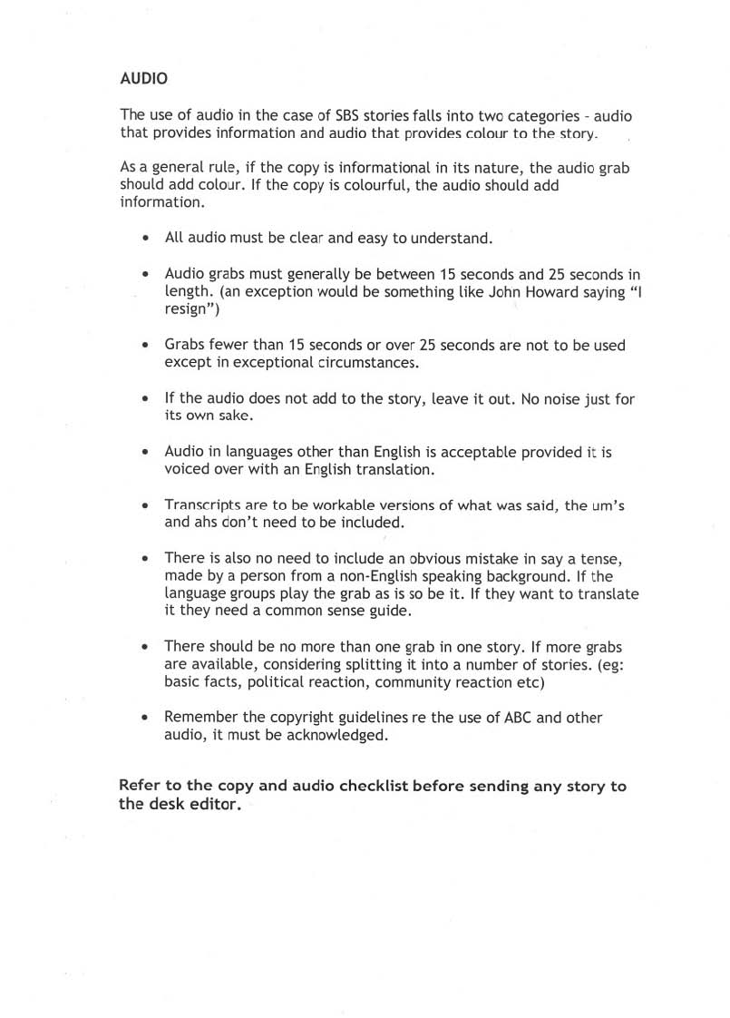
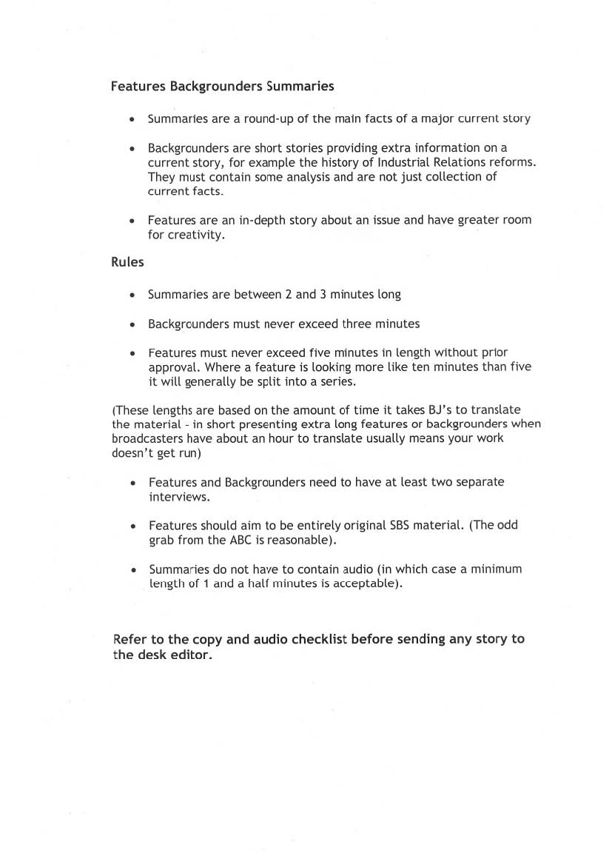
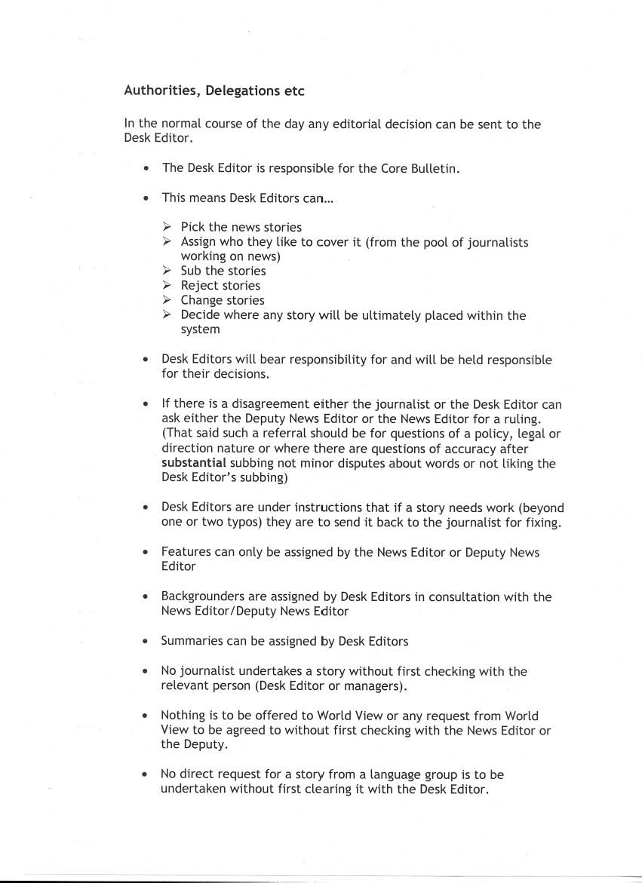
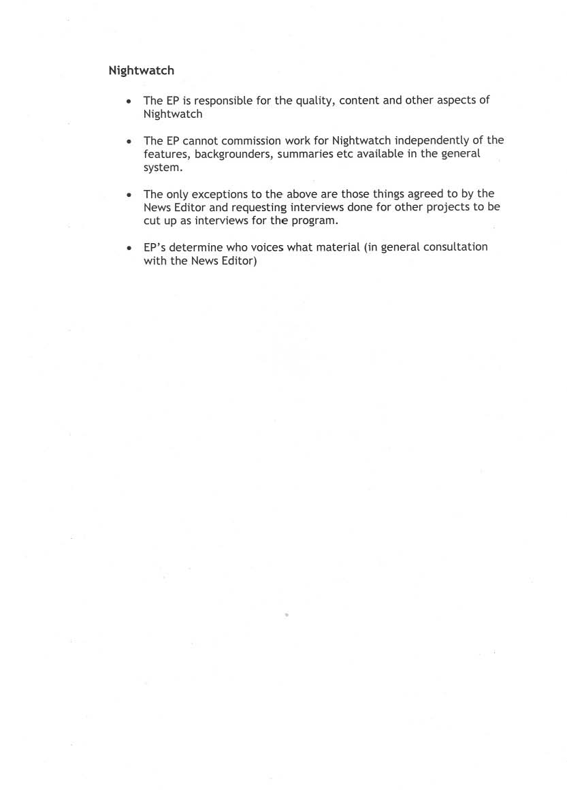

Outcome 1, Output 1.1, 1.2 Question: 150
Topic: Performance of Information Technology outsourcing arrangements
Written Question on Notice

Senator Conroy asked:

- Please provide details of total departmental/organisational spending on Information and Communications Technology products and services during the last 12 months.

- Please break down this spending by ICT function (eg communications, security, private network, websites).

- Was this spending in line with budget forecasts for this 12 month period?
  - If not, please provide details of:
- The extent that ICT spending exceeded budget forecasts for this 12 month period;
- Details of on specific ICT contracts which resulted in department/organisation spending in excess of budget forecasts for this 12 month period;
- The reasons ICT spending exceeded budget forecasts for this 12 month period.
- Please provide details of any ICT projects that have been commissioned by the Department/organisation during the past 12 months that have failed to meet designated project time frames (ie have failed to satisfy agreed milestones by agreed dates).
  - For such projects that were not completed on schedule, please provide details of:
    - The extent of any delay;
    - The reasons these projects were not completed on time;
    - Any contractual remedies sought by the Department/organisation as a result of these delays (eg penalty payments).
- Please provide details of any ICT projects delivered in the past 12 months that have materially failed to satisfy project specifications.
- Please provide details of any ICT projects that were abandoned by the Department/organisation within the last 12 months before the delivery of all project specifications outlined at the time the project was commissioned.
  - For such abandoned projects, please provide details of:
- Any contractual remedies sought be the Department as a result of the abandonment of these projects.
Any costs of re-tendering the ICT project.

Answer:

1. Total spending for 2004-05: $4,870,282

2.
Expenditure | $
Communications – Leased Lines | $454,725
Communications – Telephones | $1,460,399
Communications – Mobile phones | $375,520
Hardware Maintenance – Admin systems | $220,025
Software Maintenance – Admin systems | $673,358
Security – hardware, software and SPAM services | $131,087
Equipment Lease Corp IT equipment | $282,000
Equipment lease – PC, Laptops, Projectors | $934,739
General software | $58,827
Consumables | $123,543
Consultants | $80,341
Contracts | $63749
Repairs | $11,969
Total | $4,870,282

3. Yes

4. None

5. None

6. None

Outcome 1, Output 1.1, 1.2 Question: 151
Topic: SBS Air Travel
Written Question on Notice

Senator Fielding asked:

1. How much money has the portfolio spent on domestic airfares for each of the last three financial years?

2. How much money has the portfolio spent on overseas airfares for each of the last three financial years?

3. How much money has the portfolio spent on economy class domestic airfares for each of the last three financial years?

4. How much money has the portfolio spent on business class domestic airfares for each of the last three financial years?

5. How much has the portfolio spent on first class domestic airfares for each of the last three financial years?

6. What would be the estimated financial year dollar saving if all public servants in the portfolio travelled economy class for flights of less than one and a half hours duration?

Answer:

1. Domestic airfares
2002/03 $568,840
2003/04 $559,088
2004/05 $687,934

2. Overseas airfares
2002/03 $637,075
2003/04 $788,089
2004/05 $749,315

3. Economy class domestic airfares
2002/03 $448,981
2003/04 $499,759
2004/05 $607,543
Note: the figures above include economy and discount economy fares.
4. Business class domestic airfares
2002/03 $119,859
2003/04 $59,329
2004/05 $80,391

5. First class domestic airfares
2002/03 $Nil
2003/04 $Nil
2004/05 $Nil

6. SBS introduced a policy in April 2003, whereby business class can generally only be used for domestic flights greater than 2 hours duration.

Following the introduction of this policy, expenditure on business class travel in 2003/04 went down $64,530 from 2002/03. Business class travel now represents 11% of the total domestic travel expenditure, compared to 21% in 2002/03.

Previously the Greek Language program engaged two political commentators including Professor Yannis Varoufakis. Professor Varoufakis is presently not appearing on the program pending a review.

