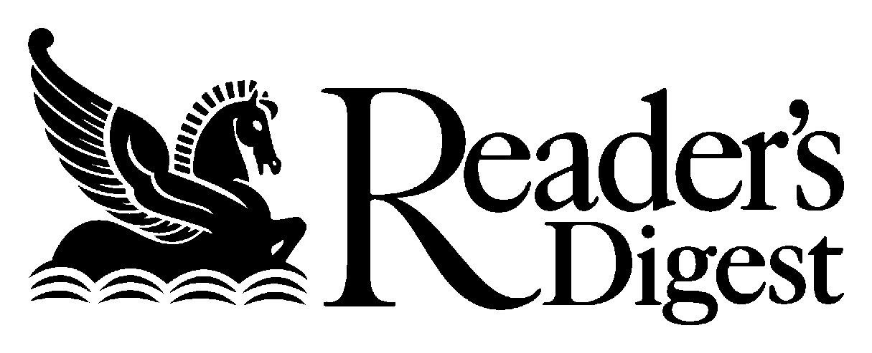

Most Trusted Brands 2002 – Why We Trust Them

Respondents were asked to nominate their most trusted brand in each of 29 different categories. The research was unprompted – they didn’t choose from a list.

For each brand nominated as the most trusted, respondents were asked to indicate the quality – from a list of five – that was most important in establishing trust with that brand.

The following table shows the most trusted brands and the top reason for trusting that brand over others in its category.

Category | Brand | Why do I trust this brand?
- Airline | Qantas | Safety
- Arthritis treatment | Celebrex | Meets expectations
- Bank | Commonwealth | Customer service
- Breakfast cereal | Kelloggs | Taste
- Camera | Pentax | Reliability
- Car | Holden | Reliability
- Computer (PC or portable) | IBM | Reliability
- Cough & colds | Codral | Meets expectations
- Credit card | Visa | Security
- Department store | Myers | Product range
- Detergent | Morning Fresh | Cleans well/performance
- Entertainment equipment | Sony | Performance
- Health insurance | Medibank Private | Security
- Home loan/mortgage provider | Commonwealth | Security
- House & car insurance | NRMA | Customer service
- Large appliance | Westinghouse | Reliability
- Mobile handset | Nokia | Reliability
- Motel | Flag Inn | Customer service
- Newspaper | Daily Telegraph | Honesty
- Pain reliever | Panadol | Meets expectations
- Small appliance | Sunbeam | Reliability
- Soft drink | Coca Cola | Taste
- Supermarket | Woolworths | Product range
- Tea | Lipton | Taste
- Telephone company | Telstra | Reliability
- Toothpaste | Colgate | Taste
- TV news & current affairs | Channel 9 | Local content
- Vitamins | Blackmores | Reputable company
- Watch | Seiko | Reliability

