Outcome 3, Output 3.1 Question: 37
Topic: Content filtering in Public Libraries

Question:

Senator FIELDING - I will just return back, Minister. You said you had written to the states. When was that?

Senator Coonan - The intent of the communication was to encourage filters to be made available - of course there are some available now, although we say that they can be improved - and to alert them to the fact that we are going to have this initiative.

Senator FIELDING - Can I get a copy of that?

Senator Coonan -I will see whether I have got copies of the letters that I can make available to you.

Senator FIELDING - Thank you. What has been the states’ response to that letter?

Senator Coonan - My understanding is that a couple of the states have implemented some of those library and indeed even school initiatives. I will have to take it on notice so that I can give you a proper response because I am really relying on my memory as to where they are up to.

Answer:

Senator Coonan’s letter of 3 February, 2006 to State and Territory Ministers is attached.

The following table summarises the responses received from State and Territory Ministers.

This issue was on the agenda of the Online and Communications Council Officials’ Standing Committee Meeting on 23 March 2007 and is on the agenda for the forthcoming Online and Communications Council Ministerial Meeting on 29 June 2007.
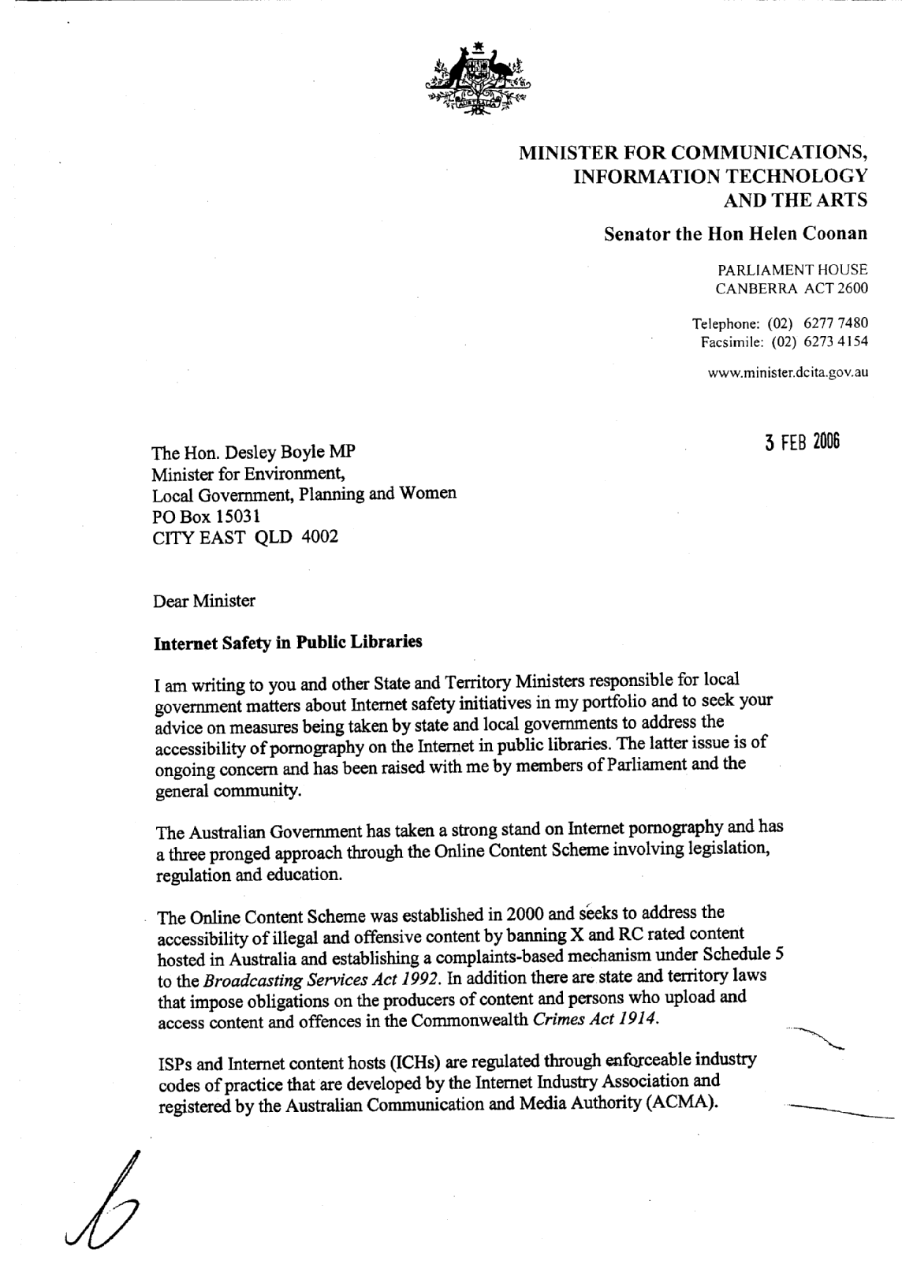
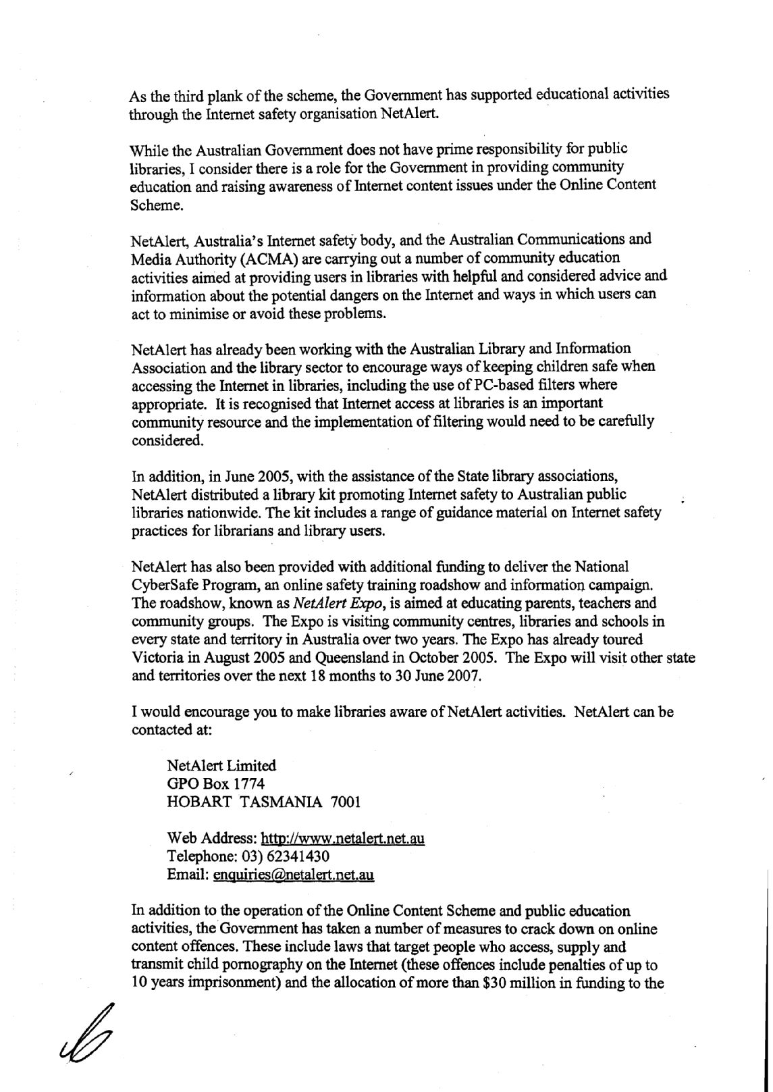
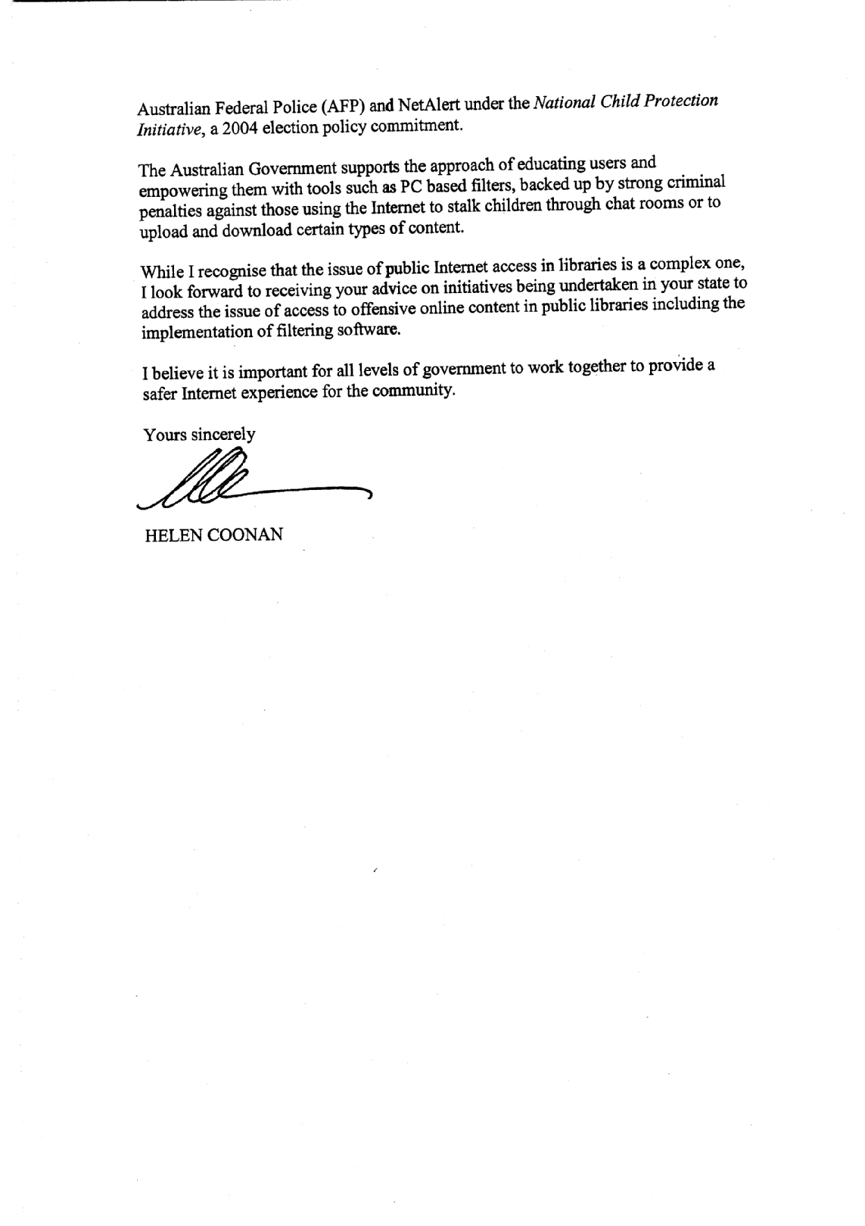

Protecting Australian Families Online

Summary of responses from States/Territories
to Senator Coonan’s letter of 3 February 2006

State/Territory | From | Summary of Response
ACT | John Hargreaves MLA, Minister for Disability, Housing and Community Services. (2/3/2006)  Katy Gallagher, Minister for Education and Training. (22/2/2006) | In February 2003, the ACT Public Library Service (ACTPLS) installed an Internet filtering system called Content Keeper on all public Internet access terminals.  ACTPLS also has an Internet Acceptable Use Policy, and library customers must read and accept these conditions of use before accessing the Internet terminals.  Section 2.1.1 of the Policy states that it is unlawful to gain access to “any material that is pornographic, offensive or objectionable.”
NSW | Kerry Hickey MP, Minister for Local Government. (20/3/2006)  Bob Debus MP, Minister for the Arts. (24/4/2006)  Carmel Tebbutt MP, Minister for Education and Training. (13/4/2006) | Kerry Hickey, Minister for Local Government, advised that the Public Library Services of the State Library has taken steps to ensure council libraries in NSW are aware of NetAlert and the issues surrounding Internet access.  Bob Debus, Minister for the Arts, advised that the State Library has developed a framework with key stakeholders on Internet use. It comprises a legislative basis in the Library Regulation 2005, guidelines developed by the Library Council of NSW and policy statements endorsed by peak and professional organisations.  No information provided on filtering in public libraries.
QLD | Desley Boyle MP, Minister for Local Government and Planning. (8/3/2006)  Rod Welford MP, Minister for Education. (14/3/2006) | Advised that officers from Local Government, Planning, Sport and Research would write to the State Library and local governments informing them of NetAlert’s activities.  No information provided on filtering in public libraries.
TAS | Paula Wriedt MHA, Minister for Education. (15/3/2006) | A three prong approach is used to assist children using the Internet, including:  - provision of a policy framework;  - provision of appropriate tools and guidelines to schools; and  - provision of online resources within a controlled environment.  Filtering extends to public libraries and online access centres to block access to pornographic and other inappropriate websites.
WA | Ljilijanna Ravlich MLC, Minister for Education and Training. (24/2/2006) | No response in relation to public library filtering.
NT | Elliot McAdam MLA, Minister for Local Government. (9/3/2006)  Syd Sterling MLA, Minister for Employment, Education and Training. (16/3/2006) | Mr McAdams’ response outlines that public libraries are generally the responsibility of municipal and local councils.  The Northern Territory Library (the Territory’s equivalent of a State Reference Library) actively promotes NetAlert initiatives and endorses the Australian Library and Information Association (ALIA) policy statements and guidelines.  No information provided on filtering in public libraries.
SA | Kevin Foley MP, Acting Premier. (24/5/2006)  Jane Lomax-Smith MP, Minister for Education and Children’s Services. (23/3/2006)  Garry Le Duff. Executive Director, Association of Independent Schools. (6/4/2006) | Mr Foley advised that the responsibility for public libraries is shared between the State Government via Public Library Services (PLS) and local governments.  While filtering is not performed by PLS, it has published a document on Internet access. This document recommends that libraries install filters, implement registration for users under 18, and place computers in view of staff.  Many libraries have local policies that include banning offenders who breach the conditions of use.
VIC | Jacinta Allan, MP  Minister for Education Services. (12/5/2006) | No response in relation to library filtering.

Outcome 3, Output 3.1 Question: 58
Topic: Digital Australia

Senator Conroy asked:
With respect to the government’s decision to create the group Digital Australia, please provide the forward estimates and forward commitments for 2006-07, 2007-08, 2008-09 and 2009-10.

Answer:

The forward estimates for Digital Australia are:

 | 2006-07  ($'000) | 2007-08  ($'000) | 2008-09  ($'000) | 2009-10  ($'000)
Non-capital appropriation | 1,540 | 4,382 | 4,828 | 5,105
Capital appropriation | 1,442 | 6 | 3 | -

At this stage, commitments relate to executive search services for Digital Australia SES recruitment and lease and fit-out of Digital Australia premises. The forward commitments for Digital Australia as of 23 March 2007 are approximately:
- up to $1 355 567 in 2006-07;
- $362 917 in 2007-08
- $377 816 in 2008-09
- $393 328 in 2009-10

Outcome 3, Output 3.1 Question: 59
Topic: Digital Australia

Senator Conroy asked:

Of the $22 million allocated to Digital Australia how much is allocated to community education/advertising campaign?

Answer:

Nil.

Outcome 3, Output 3.1 Question: 60
Topic: “Manchester Report”

Senator Conroy asked:

On February 12 during estimates the Minister stated:

“I imagine that because you are so interested in this, Senator Fielding, you would have caught up with the Manchester report two days ago which showed something like about 42 per cent was missed with ISP filtering. 42 per cent of what they purported to be able to block was missed.”

Can the Minister provide details of the ‘Manchester report’?
Who conducted the research?
When was it released?
Can the Department advise the Committee on where the report can be found?

Answer:

Can the Minister provide details of the ‘Manchester report’?

The Department understands the report referred to was “Unwanted and Wanted Exposure to Online Pornography in a National Sample of Youth Internet Users” which was published in Pediatrics the official journal of the American Academy of Pediatrics.

Who conducted the research?

The research was conducted by the Crimes against Children Research Centre, University of New Hampshire, Durham, New Hampshire by Janis Wolak, JD, Kimberly Mitchell, PhD, and David Finkelhor, PhD.

When was it released?

The report was published in Pediatrics Volume 119, Number 2, February 2007.

Can the Department advise the Committee on where the report can be found?

An electronic version of the report may be downloaded for a fee from the website: http://www.pediatrics.org/cgi/content/full/119/2/247.

Outcome 3, Output 3.1 Question: 61
Topic: Television Blackspots Programs

Senator Conroy asked:

- Did the TVBS [Television Blackspots] program aim to provide local television services to communities with poor or no TV reception?
- Is there a sunset clause for funding in the ATS program?
- What TV blackspots have been or will be completed in the ATS program with the $6 million in the 06/07 budget?
- Was the $6 million in the 06/07 budget a carry over from the original $13 million to complete ATS projects, or was it a new allocation for blackspot solutions or was it for other purposes?
- What are the Alternative solutions available in the ATS program?
- Is the option of DTH satellite solution suitable for remote and regional areas?
- Does the TV Blackspots ATS program have as its first priority to provide local television services to communities?
- Before any other Alternative solution in the ATS program was offered to a co-ordinating body, would the existing digital TV coverage be tested by DCITA to confirm it is a digital blackspot as well?
- Would a digital retransmitter of local services option be pursued as a second priority under the ATS program?
- Before any other Alternative solution in the ATS program were offered to a co-ordinating body, would the normal spectrum planning process for a digital transmitter be fully followed with a written report to confirm a minimum 80% adequate coverage to dwellings in the Blackspots and possible interference concerns were addressed?
- Would a solution be offered with only a 40 – 60% effective coverage of blackspot dwellings?
- If an area was confirmed as both an analogue and digital black spot under the existing Blackspots programs, should a community have to wait years for a solution in a possible subsequent digital Blackspot program alluded to in the Digital Action Plan?
- Is a reflected digital signal an effective solution for less than 4 out of 5 TV services?

Answer:

Each part of the question has been addressed separately.

Part 1. Yes. The guidelines for the analogue Television Black Spots Program stated that:

“The Television Black Spots Program aims to provide access to locally available television services. This can include the ABC, SBS and up to three commercial television services”.

Part 2. Yes. Funding for the Television Black Spots—Alternative Technical Solutions Program has been approved until 30 June 2007.

Part 3. Solutions funded under the Television Black Spots—Alternative Technical Solutions (ATS) Program have been implemented in the communities of Crystal Brook (QLD), Edith (NSW), Lavers Hill (VIC), Mingoola/Glenlyon (NSW/QLD border region), Port Stephens (NSW), Rosebank (NSW), Wisemans Ferry (NSW) and Woomargama (NSW).

A digital television retransmission facility has been established under the ATS Program in Springbrook on the Gold Coast for the Queensland communities of Mudgeeraba/Bonogin/ Worongary and Tallebudgera. Due to the nature of the topography in this area, signal testing will be conducted to assess the reach of the coverage into these communities. Signal testing will also be conducted to determine the reach of the digital television signal coverage provided by Gold Coast transmitters into the television blackspots of Banora Point, Helensvale/Oxenford, Nerang, Parkwood and Tugun in Queensland. If the signal testing reveals coverage to at least 80 percent of households in these television blackspots, there will be no need to consider them further under the ATS Program. If the signal testing reveals coverage to less than 80 percent of households in these television blackspots, other possible solutions will be considered as provided for under the ATS guidelines.

Part 4. Yes. A total of $5.997 million of the original $13.3 million was re-phased from 2005-06 into 2006-07 to assist in the implementation of solutions for remaining ATS Program projects.

Part 5. The guidelines for the Television Black Spots—Alternative Technical Solutions Program state that:

“The following options have been identified as possible alternative technical solutions for locations that could not be provided services using the analog[ue] retransmission model of the TVBSP project:

- digital retransmission facilities;
- direct-to-home satellite reception equipment for individual homes; or
- cabling (in the event other solutions are not viable).”

Part 6. Yes. See answer to “5”. Direct-to-home viewers are provided with access to the Remote Area Broadcast Services which are intended for viewers in remote licence areas.

Part 7. Yes. See answer to “1”.

Part 8. Yes.

Part 9. No.

Part 10. Yes.

Part 11. No.

Part 12. No – options as listed in “5” would be considered. It is also open to communities to establish self help television facilities, or for individuals to install direct-to-home satellite reception equipment at any time.

Part 13. The Department is not aware of any circumstance where a reflected digital signal has been put forward as a possible ‘effective solution’ for any of the blackspots communities considered under the ATS program.

Outcome 3, Output 3.1 Question: 80
Topic: Digital Television

Senator Conroy asked:

The law was passed back in October. I know you say it is early days; it is February now. It is four to five months, and no-one has registered an interest in starting an HD channel?

Senator Coonan replied:

I do not know whether that is correct. I think you need to look at the take-up figures, and they are certainly growing very significantly. We can give you those.

Answer:

The most recent industry estimates indicated that at the end of December 2006 over 2 million digital television receivers had been supplied to retailers and installers. This figure represents a household take-up rate of around 25%. At the end of December 2005 approximately 1.3 million digital receivers had been supplied to retailers and installers.

Figures recently released by ACMA, based on surveys of users, indicate nearly 30% of Australian households may have access to digital free to air television.

