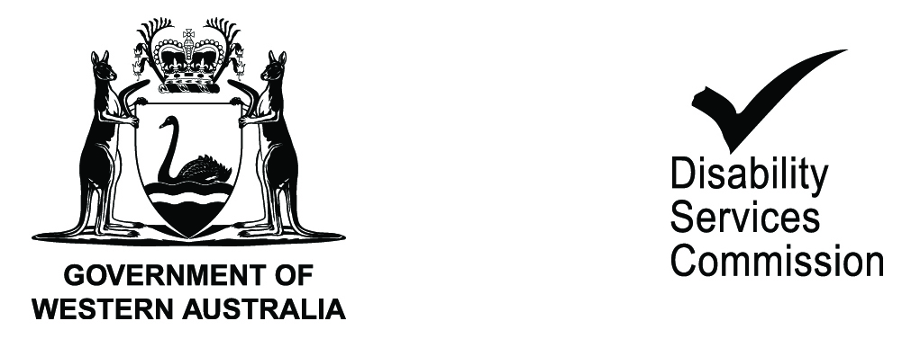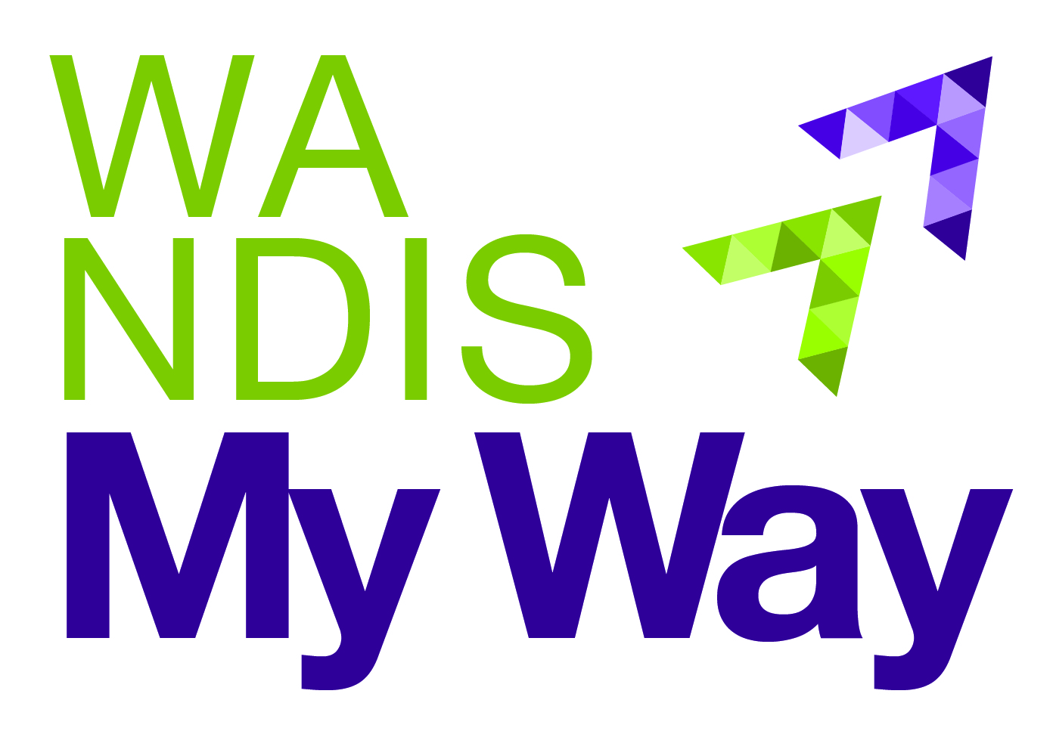

**Disability Services Commission**

**WA NDIS My Way Quarterly Report (Q2)**

**Key achievements**

* The second quarter results indicate that the implementation of the WA NDIS My Way trial is progressing smoothly.
* Stakeholder feedback remains positive - no complaints, reviews or appeals reported.
* 623 people have transitioned into the trial (as at 31 Dec 2014). 595 have approved plans.
* Whilst this 623 is below the Productivity Commission’s estimate of 777 in the NPA, it is important to note that all people who were eligible for disability services prior to the commencement of the trail, have phased in and there is no waitlist. A number of strategies have been undertaken to ensure all people who are potentially eligible, are aware of the WA NDIS My WA trial and the opportunities available to them.
* Local knowledge suggests that the total number in the LSW is likely to be below the Productivity Commission estimate and is likely to be closer to 950 than 1404. So, this gap between the projected phase - in numbers and the target in the schedule is a trend that is likely to continue in future quarters.
* 44 people with a psychosocial disability as their primary disability have been found eligible in this quarter and the number of people is continuing to grow in Q3. Up to 150 may be eligible in the LSW
* $22,872 is the average annual package cost across all approved plans. This includes 112 plans for individuals who have not requested any funding at this point. As In Kind funding issues are resolved, it is likely the number of plans with no funding will drop, however based on the amount and nature of In kind funding in the LSW, these will predictably be small packages of funding.
* $28,176 is the average annual package cost for all plans with funding. This is consistent with Q1 and looks likely to be an ongoing trend.
* 33% of people choose to self-manage their plans and 27% combination-manage their plans. The model whereby people can access support from their My Way Coordinator, a technical support officer or other identified specific expertise available in the community to assist with self-management, is working well.
* 15 new disability and mental health service providers were endorsed in the quarter, bringing the total number to 35 in the LSW trial site.