APPLICATION TO USE FORMAL GARDENS [YY/XXX]
Please complete and return in a typed Word Doc format
All requests will be acknowledged within 3 working days

I have read and understand the attached information sheet, Wedding Ceremonies and Other Private Events Held in the Eastern Formal Gardens (Attachment A)

EVENT NAME
EVENT DATE
TIME
START – FINISH
REQUEST/EVENT NAME
REQUEST/EVENT DATE(S)
REQUEST/EVENT TIME(S)
START – FINISH
REQUEST/EVENT CONTACT(S)
NAME/TEL/EMAIL
DESCRIPTION OF REQUEST/EVENT
PURPOSE OF EVENT
NUMBER OF PEOPLE INVOLVED
# ORGANISERS AND # VISITORS
OTHER RELEVANT INFORMATION
MEDIA ATTENDANCE, INVITED MP’S/SENATORS
DO YOU HAVE AN EVENT LOG/RUNNING PLAN
DEPARTMENTAL CONTACT | Engagement & Public Programs  Department of Parliamentary Service | Email: aphevents@aph.gov.au  Telephone: 02 6277 8000

If filming/photography will be conducted, please complete APPLICATION TO FILM AND PHOTOGRAPH on page 3.

APPLICATION TO FILM & PHOTOGRAPH [YY/XXX]
Please complete page 1 of the application and return it in a typed MS Word document format.
We will generally tell you the outcome of your request within 5 working days.
Applicant declaration
I, , , have read and understand the Rules for Media Related Activity in Parliament House and its Precincts prior to submitting this form. I agree to follow all Rules for Media Related Activity in Parliament House and its Precincts, as well as all standard conditions and special conditions outlined in this form.

OFFICE USE ONLY
Date of outcome
APPROVED
CONDITIONALLY APPROVED | Special conditions:
NOT APPROVED
APPLICANT DETAILS
Organisation name
Applicant contact details
name/tele/email
Event name if applicable
Request dates and start and finish times
Description of request, including how footage and photography will be used
E.g. for personal use, publication, print
Locations of filming or photography
Number of people involved
# organisers and # visitors
Equipment to be used

ADVICE TO APPLICANT
Standard conditions:
- Where the terms ‘film’ and ‘filming’ appear in this application, they include video recording and all other filming technologies, as well as all forms of photography including the use of digital technology.
- Do not film any areas of Parliament House that are not detailed in this form.
- Do not use footage or photography for any purpose that is not outlined in this form.
- Do not place any equipment, including tripods, on the:
  - Marble Foyer
  - mosaic pavement on the Forecourt.
- If you’re filming inside of Parliament House, you must enter the building through the Main Front Public Entrance. You must present all your filming equipment for security screening before you enter.
- Report to the Security Team Leader before you start filming by calling 02 6277 3299.
- Do not film any security areas or operations, including the screening processes at entrances.
- Do not film building entrances or restrict access to and from the building.
- Do not film members of the Australian Federal Police (AFP).
- Do not film any Members of Parliament, building staff or visitors unless you have their permission.
- Do not interfere with the operations of the Parliament or the people who work in the building.
Departmental contact | Communications  Department of Parliamentary Services | Email: communication@aph.gov.au  Telephone: 02 6277 2686

ATTACHMENT A
INFORMATION SHEET
WEDDING CEREMONIES AND OTHER PRIVATE EVENTS HELD IN THE EASTERN FORMAL GARDENS

  - The following parameters are the guidelines for wedding ceremonies and other private functions held in the Eastern Formal Gardens:
    - Parliament House does not make special facilities or alternative venues available for events in the case of inclement weather. It is the responsibility of the applicants requesting use of the Gardens to make these arrangements.
    - The Gardens are only available during daylight hours (after hours security lighting does not provide adequate illumination for functions held after dark).
    - The Gardens are open to all members of the public and all bookings will be made on the understanding that they are for the non-exclusive use of the client.
    - Parking is not allowed on Parliament Drive. Guests should use the public underground car park at the northern end of the building.
    - As Parliament Drive is now restricted to one way traffic, please note that vehicles must stop on the opposite side of the road to the Gardens. There is a set down time of up to 10 minutes, providing a person stays with the vehicle.
    - Confetti and/or rice must not be used within the Parliamentary Precincts, (this is an offence under the Litter Act 2004). Rose petals are also not permitted.
    - Clients must respect the gardens by leaving them untouched. Particular care should be taken while posing for wedding photographs.
    - The Gardens must be left clean and tidy at the end of an event.
    - All areas of the Eastern Formal Gardens may be used. However, the viewing platform on the upper level may not be used for wedding ceremonies.
    - Toilet facilities for able-bodied persons are available on the lower level of the Gardens. However, the closest facilities for disabled persons are situated within the Public Underground Car Park at the northern end of Parliament House. Refer attached plan for details.
    - The floral displays in the Gardens are normally changed at least twice a year. The summer display is planted approximately mid to late October and the winter display in approximately mid to late March of each year. Notification of change of plans or cancellation of the event would be appreciated as this will allow others to use the space.

ATTACHMENT B
LAYOUT OF EXTERNAL PRECINCTS
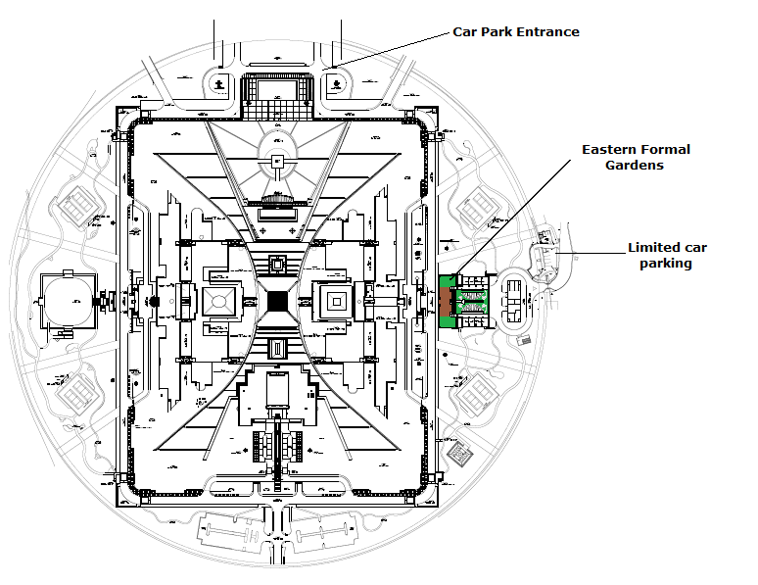

LAYOUT OF FORMAL GARDENS EAST

