2019–20 National Fiscal Outlook | At a Glance
National
Net operating, fiscal balance and net capital investment | Revenue and expenses – real growth | Net debt
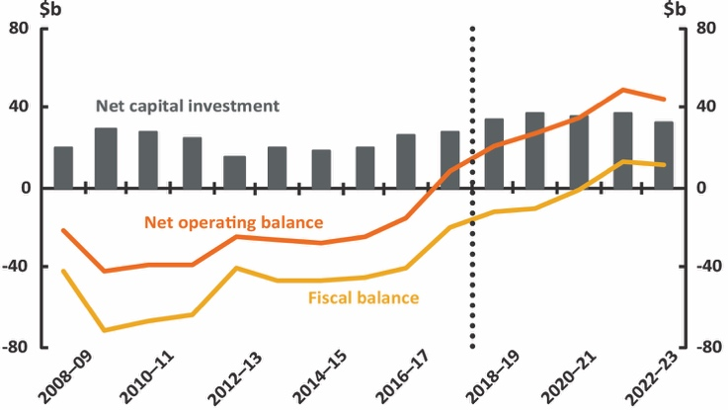 | 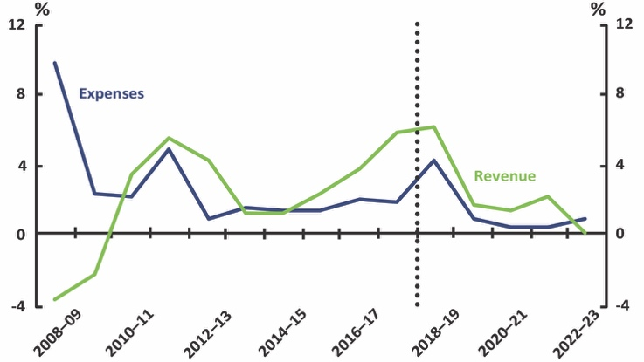 | 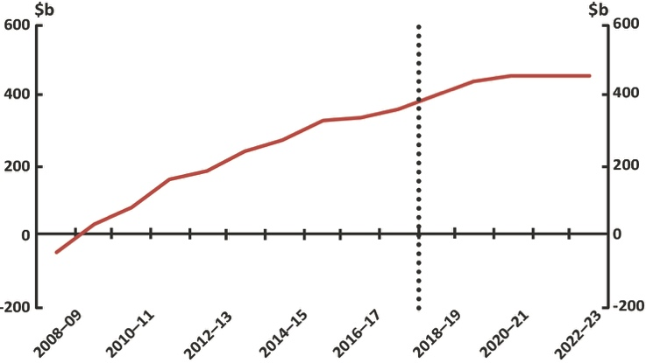
Commonwealth
Net operating, fiscal balance and net capital investment | Revenue and expenses – real growth | Net debt
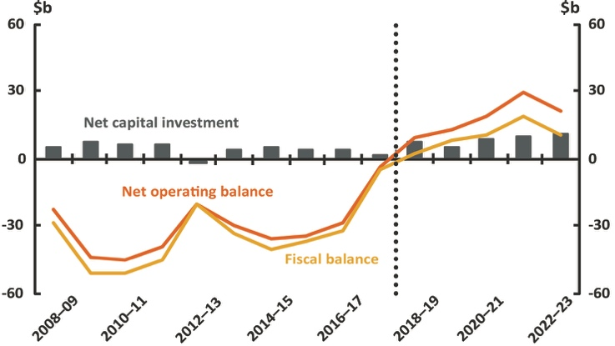 | 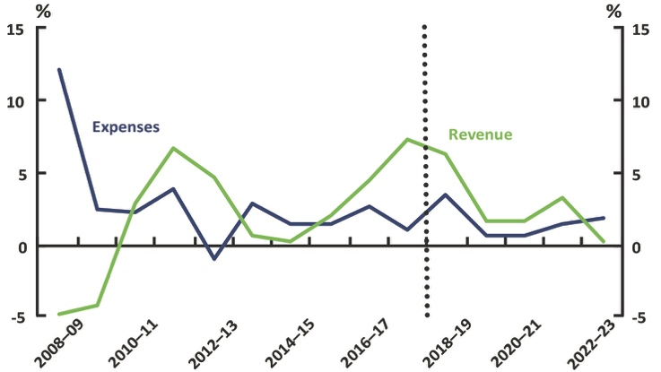 | 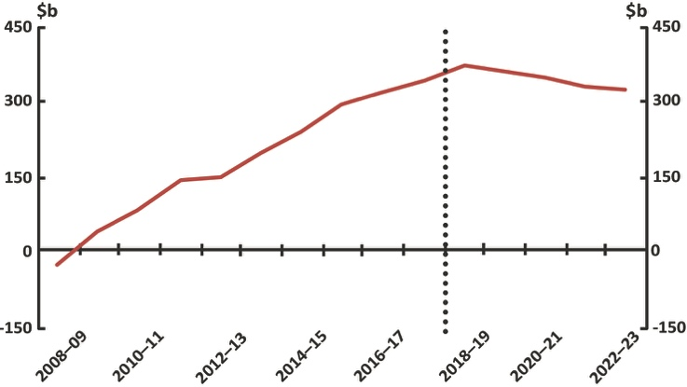
New South Wales
Net operating, fiscal balance and net capital investment | Revenue and expenses – real growth | Net debt
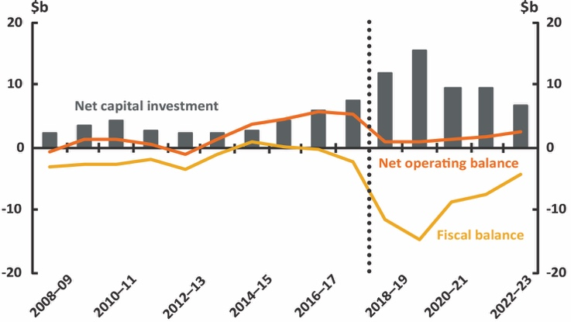 | 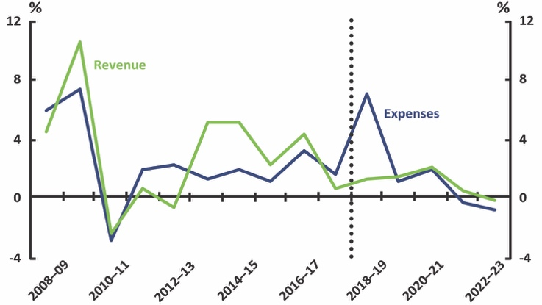 | 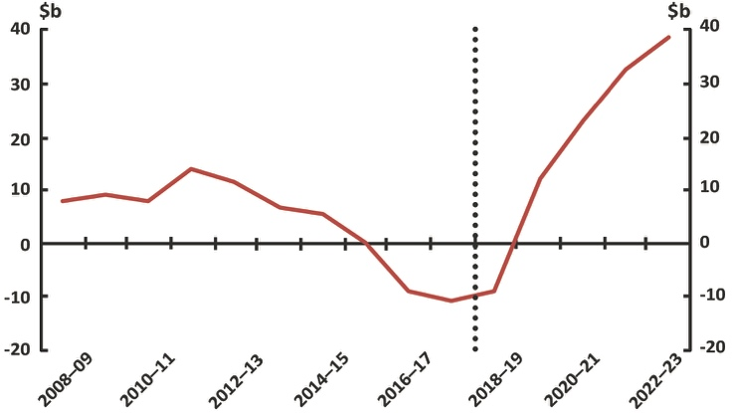
Victoria
Net operating, fiscal balance and net capital investment | Revenue and expenses – real growth | Net debt
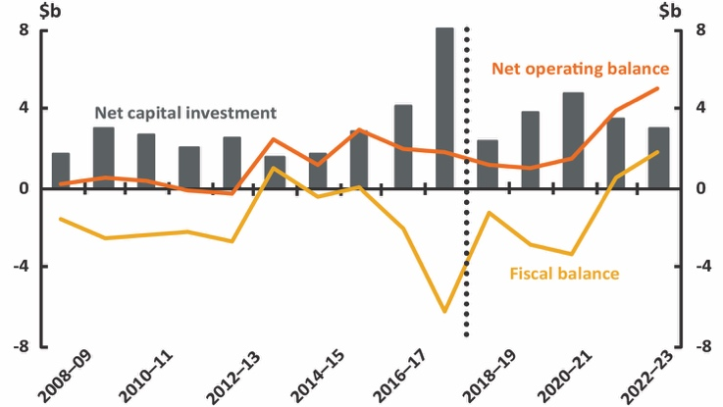 | 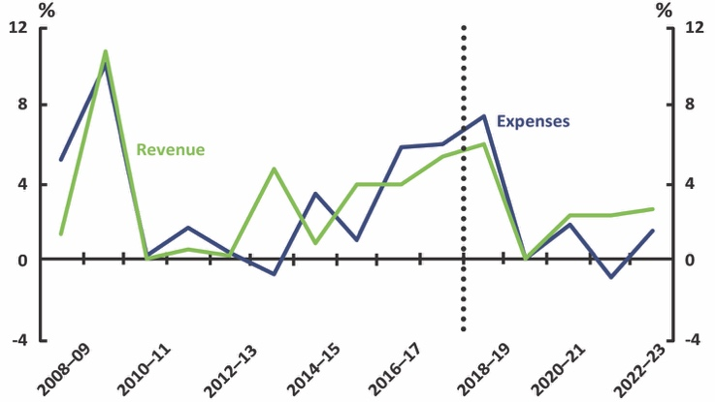 | 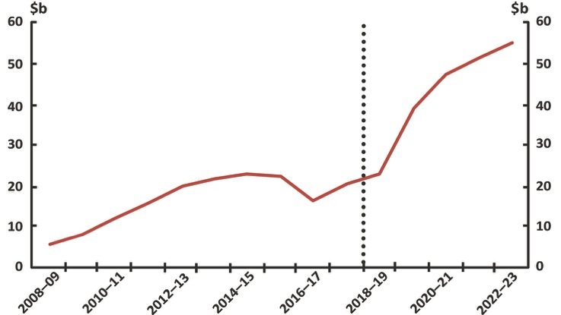
Queensland
Net operating, fiscal balance and net capital investment | Revenue and expenses – real growth | Net debt
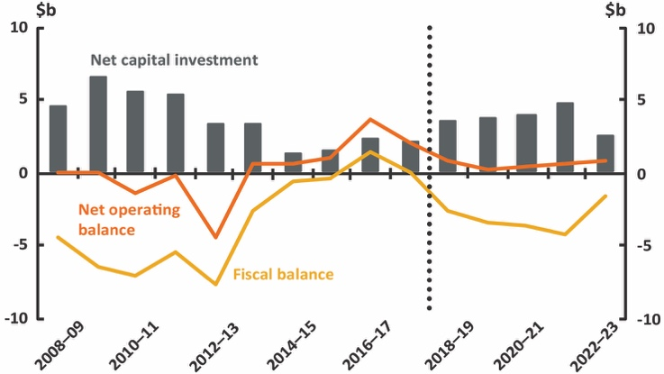 | 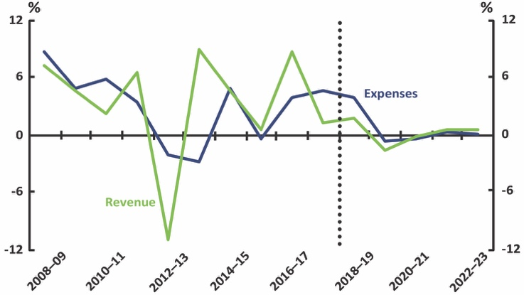 | 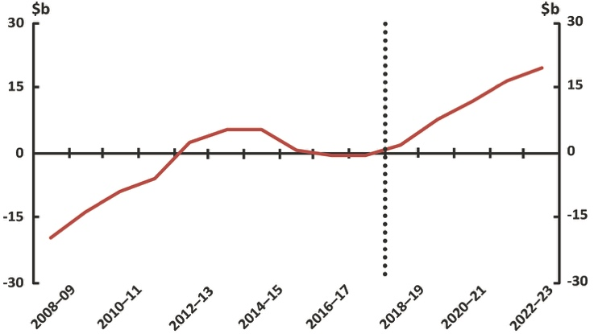

2019–20 National Fiscal Outlook | At a Glance
Western Australia
Net operating, fiscal balance and net capital investment | Revenue and expenses – real growth | Net debt
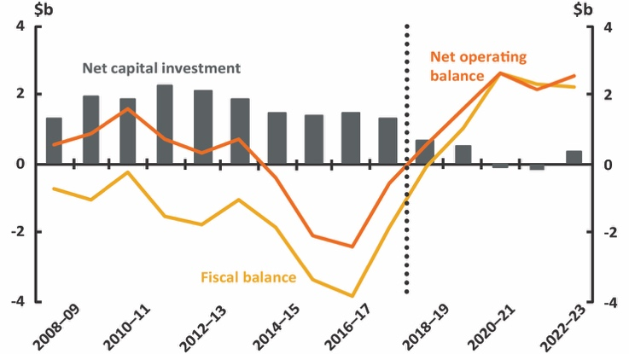 | 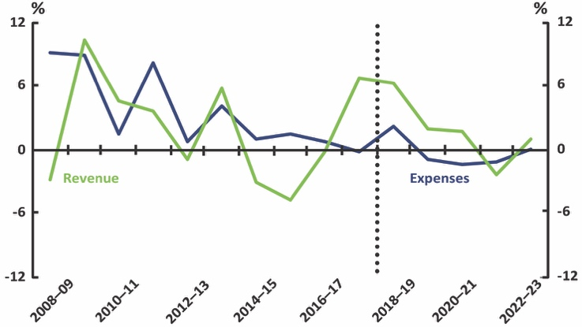 | 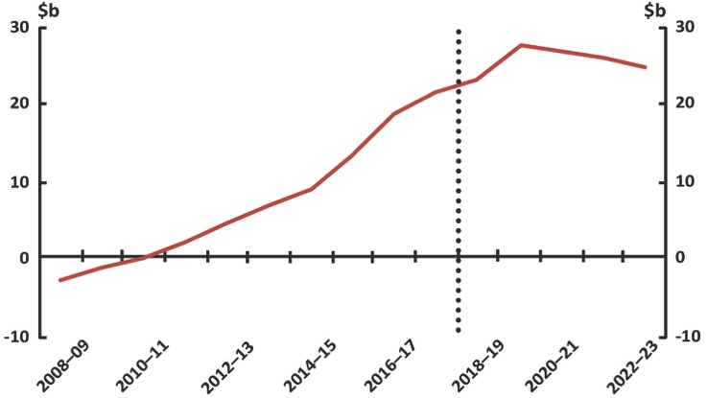
South Australia
Net operating, fiscal balance and net capital investment | Revenue and expenses – real growth | Net debt
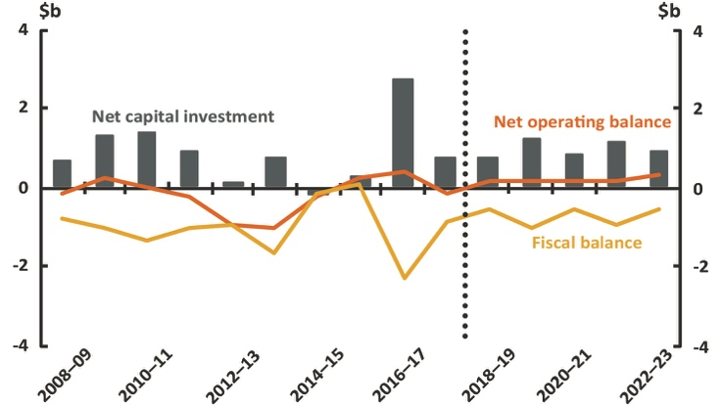 | 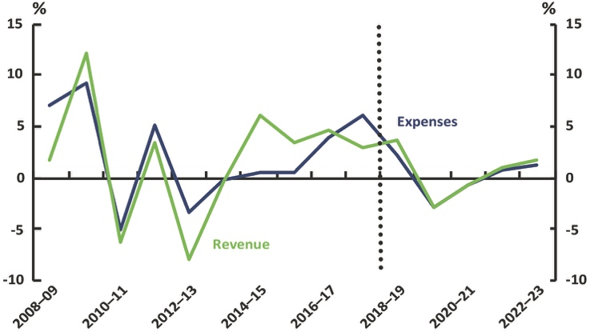 | 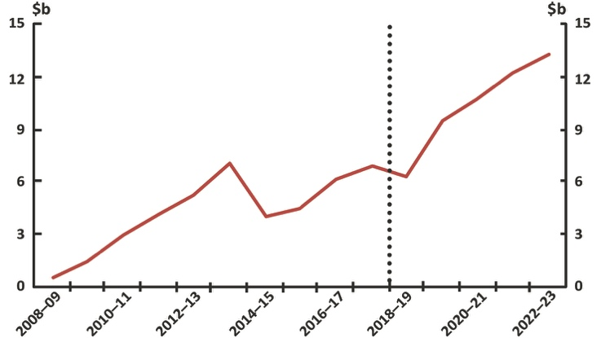
Tasmania
Net operating, fiscal balance and net capital investment | Revenue and expenses – real growth | Net debt
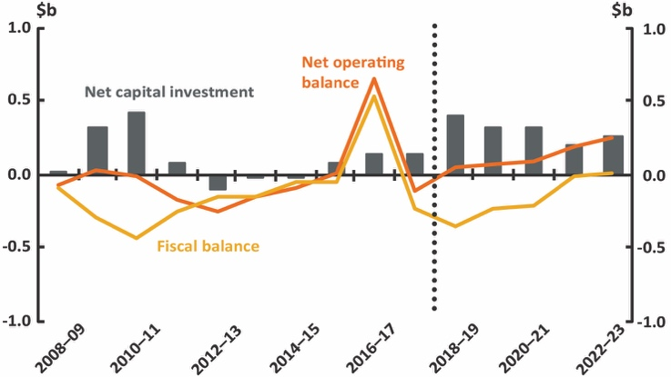 | 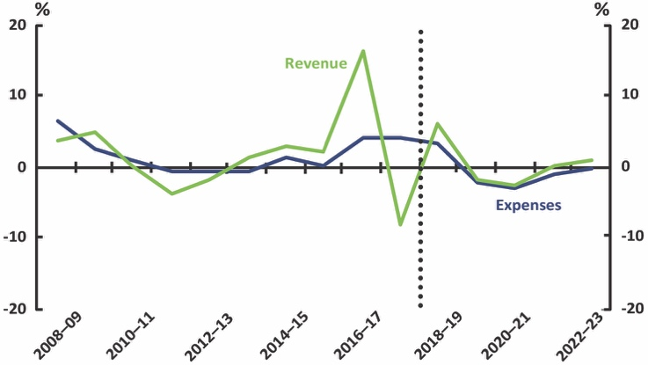 | 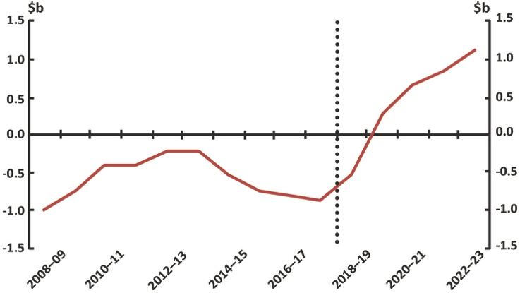
Australian Capital Territory
Net operating, fiscal balance and net capital investment | Revenue and expenses – real growth | Net debt
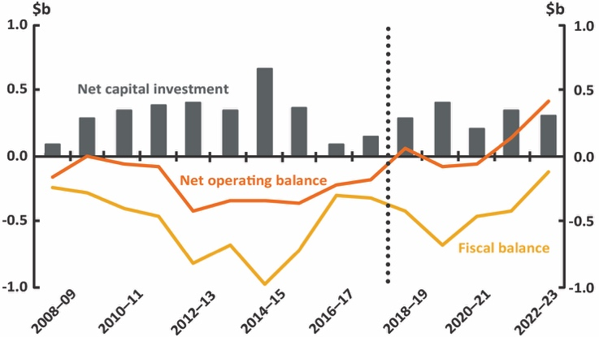 | 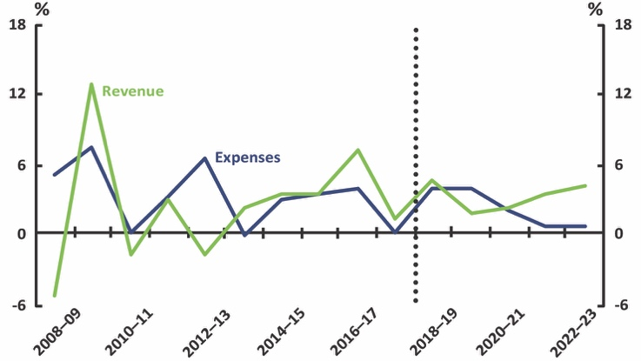 | 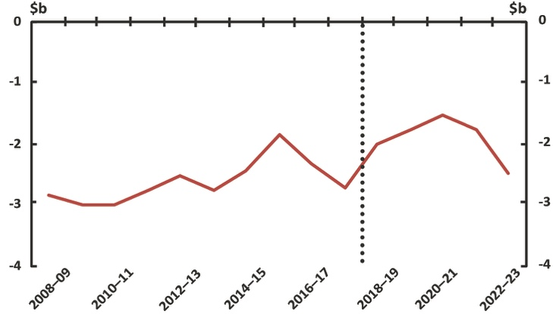
Northern Territory
Net operating, fiscal balance and net capital investment | Revenue and expenses – real growth | Net debt
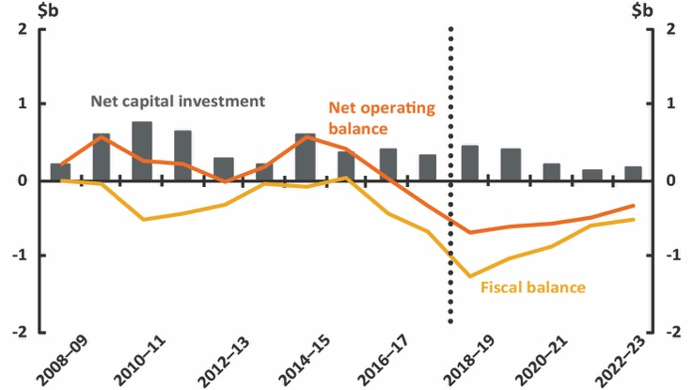 | 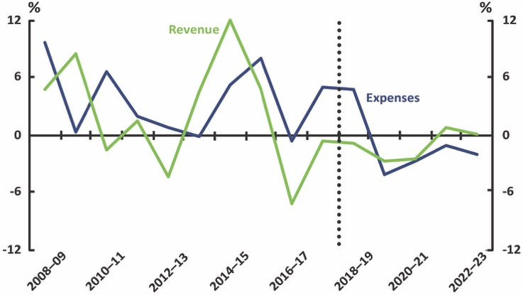 | 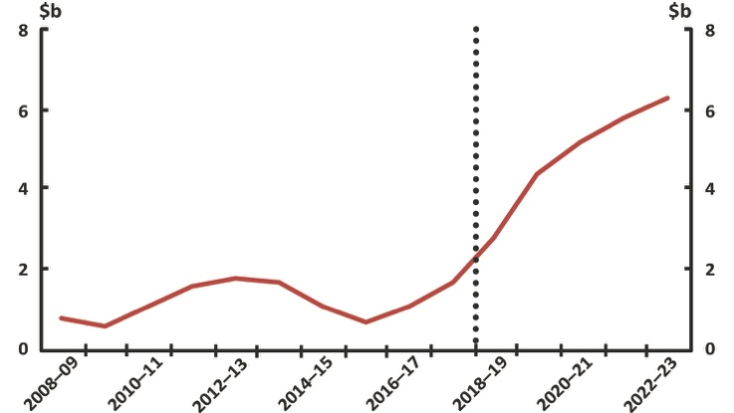

This snapshot accompanies the PBO’s 2019–20 National Fiscal Outlook report. Data from 2008–09 to 2017–18 are sourced from Australian Bureau of Statistics Government Finance Statistics 5512.0. Data from 2018–19 to 2022–23 are sourced from 2019–20 Commonwealth, state and territory budget papers. Data are generally comparable across the two periods, but there are differences in the budget treatment of items across jurisdictions. The data in these charts do not incorporate 2018–19 final budget results of the Commonwealth, states and territories. Further information about data and methods, and a glossary of the budget terms used here, is provided in the report.
The national charts include Commonwealth, state, territory and local governments and eliminate transfers between levels of government to arrive at a consolidated national fiscal position.
The New South Wales projections of revenue and expenses have been adjusted by the PBO to improve comparability across periods.
The Western Australian projections of revenue and expenses have been adjusted by the PBO to improve comparability across periods.

