NaTIONAL FISCAL OUTLOOK: AS AT
2019–20 BUDGETS

Report No. 04/2019

© Commonwealth of Australia 2019
ISBN 978-0-6483701-4-7 (online)
Copyright notice
This work is licensed under the Creative Commons Attribution-NonCommercial-NoDerivs
3.0 Australia License http://creativecommons.org/licenses/by-nc-nd/3.0/au/
Attribution
This publication should be attributed as follows: Parliamentary Budget Office,
National Fiscal Outlook as at 2019–20 Budgets.
Use of the Coat of Arms
The terms under which the Coat of Arms can be used are detailed on the following website: https://www.pmc.gov.au/government/commonwealth-coat-arms
Feedback
If you found this report useful, or have suggestions for improvement, please provide feedback to feedback@pbo.gov.au.

Contents
Overview 1
1 National fiscal outlook: what has changed since last year’s budgets? 2
1.1 Budget balance 2
1.2 Net capital investment 4
1.3 Net debt 5
1.4 Net financial worth 6
2 Trends in Commonwealth and state fiscal outlooks 8
2.1 Commonwealth trends 8
2.2 State trends 10
Appendix A – Glossary, data and method 23
Glossary 23
Data and method 24

This report was authored by Anthea Guthrie, Lok Potticary and Kathryn Smith, with the benefit of comments from Linda Ward. The contents of the report are the sole responsibility of the Parliamentary Budget Office.

Overview
This annual publication, which provides a complete picture of the nation’s fiscal outlook, reveals a strengthened national budget position, with a return to surplus on the back of restrained growth in expenses.
Relative to last year’s outlook, the national net operating balance has been revised upwards and is forecast to reach a surplus of over $20 billion for 2018–19 (1.1 per cent of gross domestic product (GDP)) — the first time a surplus of this magnitude has been reached since the global financial crisis (GFC).
This surplus is projected to grow to $45.2 billion (2.0 per cent of GDP) by the end of the 2019–20 forward estimates period, largely due to restrained growth in expenses across all levels of government.
On the revenue side, Commonwealth revenue is expected to remain relatively constant as a share of GDP, but to decline moderately at the state and territory level due largely to falls in own-source revenue.
Infrastructure investment is projected to approach record levels...
National net infrastructure investment is projected to peak at $37.9 billion in 2019–20. This largely reflects a substantial investment in public transport, roads, and health and education infrastructure by New South Wales and Victoria. As a share of GDP, national net infrastructure investment is projected to peak just below that recorded during the GFC stimulus period.
…resulting in a change to the composition of national net debt; from around 10 per cent state-held in 2018–19 to over 30 per cent state-held by 2022–23.
State and territory net debt is projected to reach its highest level for two decades. At the same time, Commonwealth net debt is projected to decline, reflecting the projected move to budget surpluses.
To the extent that this additional borrowing is being used to fund investment in productive assets, and given the low level of long-term interest rates, this increase in debt should not adversely affect the fiscal sustainability of state and territory governments over the medium term.
Despite the improved fiscal outlook at the national level, risks remain.
While the projected surpluses are larger than anticipated in the previous outlook, there are risks
to both the revenue and expenditure projections that underpin those surpluses. Factors such as weaker-than-projected economic conditions or wage growth would deteriorate budget positions. The reverse is also true. For example, a strengthening in the housing market or ongoing strength in commodity prices would be expected to improve budget outcomes.
As with all Parliamentary Budget Office reports, this analysis reflects only current government policies as at the respective budgets. Pressures for additional expenditure could mean that the ongoing spending restraint forecast by governments could be difficult to maintain.
A complementary product, the 2019–20 National Fiscal Outlook at a Glance, provides a graphical snapshot of the Commonwealth, state and territory budgets in three charts, plus national aggregates.

National fiscal outlook: what has changed since last year’s budgets?
The national fiscal outlook provides a comprehensive national perspective on Australia’s historical and projected fiscal position by examining all levels of government: Commonwealth, state and territory (‘state’), and local. The analysis uses the budget papers as published, so that only current government policies at the time of the respective budgets are included. The PBO does not speculate on future decisions of governments or subsequently announced policies, which could change the outcomes presented here.
This section examines the national fiscal outlook as at the 2019–20 budgets, and how it has changed since jurisdictions released their 2018–19 budgets.

Budget balance
The national net operating balance was in surplus in 2017–18 for the first time in more than a decade, with a surplus of over $20 billion projected for 2018–19. That surplus is projected to keep growing, from a surplus of $21.5 billion (1.1 per cent of GDP) in 2018–19 to a surplus of $45.2 billion (2.0 per cent of GDP) by 2022–23. This reflects restrained growth in expenses across all levels of government and is an improvement from the previous national outlook of $20.8 billion for the period 2018–19 to 2021–22 (Figure 1–1), largely due to lower projected Commonwealth expenses.
Figure 1–1: National net operating balance | Figure 1–2: Change in net operating  balance since 2018–19 outlook
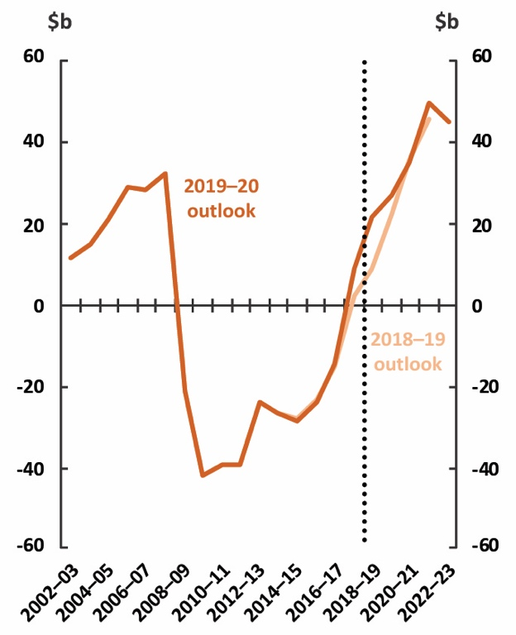 | 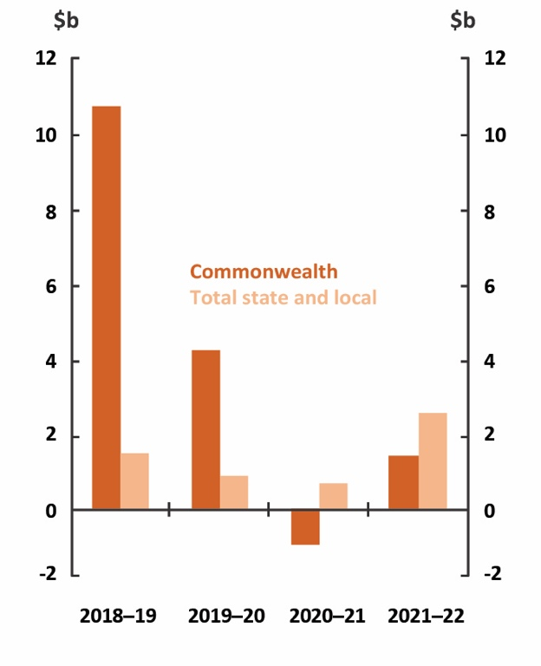
Source: Australian Bureau of Statistics (ABS), Commonwealth and state budget papers and  Parliamentary Budget Office (PBO) analysis. | Source: ABS, Commonwealth and state budget papers and PBO analysis.
Around three quarters of the improvement in the national net operating balance is due to an upward revision of around $15.1 billion in the Commonwealth net operating balance (Figure 1–2), mainly reflecting a decrease in Commonwealth spending in 2018–19 due to lower-than-expected spending on the National Disability Insurance Scheme (NDIS). Commonwealth expenses were also revised downward over the following three years, mainly driven by reduced public debt interest payments, reflecting both a lower bond yield assumption and the improved budget position.
An increase in expected Commonwealth revenue in 2018–19 and 2019–20 has also contributed to the improvement in the net operating balance, mainly due to upward revisions to personal income tax, company tax and superannuation fund taxes. In 2020–21 and 2021–22, revenue has been revised downward, mainly due to the Commonwealth Government’s second round of personal income tax cuts.
Commonwealth revenue and expenses relating to the goods and services tax (GST) have both been revised downward over the forward estimates, reflecting downward revisions to the forecast growth in prices and consumption. As the revisions to Commonwealth revenue and expenses are offsetting, this has had no net effect on the Commonwealth’s net operating balance, however the decline will reduce state revenue and therefore the national net operating balance. A number of changes to
the distribution of the GST pool will be implemented over the forward estimates period
(see Section 2.2.1).
The rest of the improvement in the national net operating balance since last year’s outlook is
due to an upward revision of $5.7 billion in the aggregate net operating balance of states and local governments for the period 2018–19 to 2021–22 (Figure 1–2). Upwards revisions to projected state and local government revenue more than offset upwards revisions to their expenses.
Upwards revisions to projected state revenue since the previous outlook are driven by higher forecast revenue in Queensland and Western Australia. In Queensland the upward revision is primarily the result of higher royalty revenue, due to coal prices remaining higher than expected in 2018–19, in combination with new policies related to land tax and petroleum royalties. The upward revision in Western Australia is also attributable to higher-than-expected royalty revenue, due to continued strength in iron ore prices. Section 2.2.1 provides further analysis of revisions to state revenue.
The upwards revisions in expenses are partly due to a rise in depreciation expenses in all states.
This reflects a one-off change to accounting standards which has resulted in additional depreciable assets being recognised (see Box 1). The upward revision in Queensland’s expenditure also reflects the cost of natural disaster recovery efforts, increased education expenses (reflecting student enrolment and enterprise bargaining outcomes), and growth in demand for public hospital and health services.

Net capital investment
The level of national net infrastructure investment, as measured by net capital investment, is at record levels and higher than those during the post-GFC stimulus. Infrastructure investment has been revised up by a total of $20.9 billion for the period 2018–19 to 2021–22, largely due to an upward revision in state and local net capital investment of $16.8 billion (Figures 1–3, 1–4).
Net investment in infrastructure is projected to peak at $37.9 billion in 2019–20. As a share
of GDP, national net capital investment is projected to reach levels just below those recorded
during the GFC stimulus period.
The substantial increase in state net capital investment is largely driven by New South Wales and Victoria, whose net capital investment for the period has been revised upwards by $7.8 billion and $6.5 billion respectively. These increases reflect significant investment in public transport, roads, health and education.
Figure 1–3: National net capital  investment | Figure 1–4: Change in net capital  investment since 2018–19 outlook
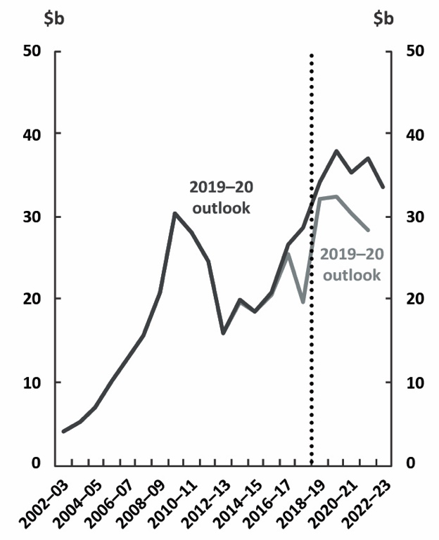 | 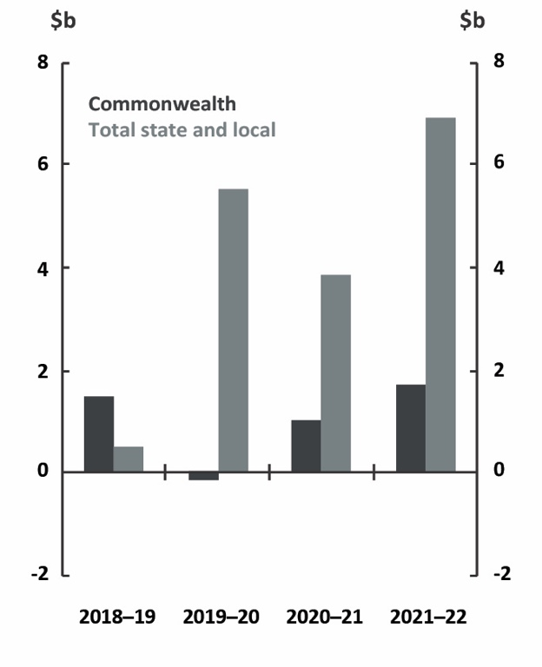
Source: ABS, Commonwealth and state budget papers and PBO analysis. | Source: ABS, Commonwealth and state budget papers and PBO analysis.

Net debt
National net debt as a share of GDP is projected to peak in 2019–20 at 22.1 per cent of GDP ($443.1 billion), 1.3 percentage points ($27.9 billion) higher than the projected peak in the 2018–19 outlook (Figure 1–5). There have been large upward revisions in both Commonwealth and state net debt over the period (Figure 1–6).
Commonwealth net debt is projected to be $333.2 billion in 2021–22, $14.0 billion higher than
projected in the previous national outlook. This deterioration is primarily caused by a lower bond yield assumption, which resulted in an upward revaluation of the existing stock of government net debt.,
State and local net debt is projected to be $144.2 billion at the end of 2021–22, $32.1 billion higher than projected in the previous national outlook. The change in the state net debt profile in Figure 1–6 partly reflects the impact of the implementation of the new accounting standard relating to leases, which has resulted in a once-off rise in the level of total state net debt each year. This rise does not reflect a change in states’ underlying budget positions (see Box 1). The upward revision also reflects a significant increase in Victoria’s net debt, driven by funding requirements for major capital projects including the North East Link, Melbourne Airport Rail and the removal of level crossings.
Figure 1–5: National net debt | Figure 1–6: Change in net debt since  2018–19 outlook
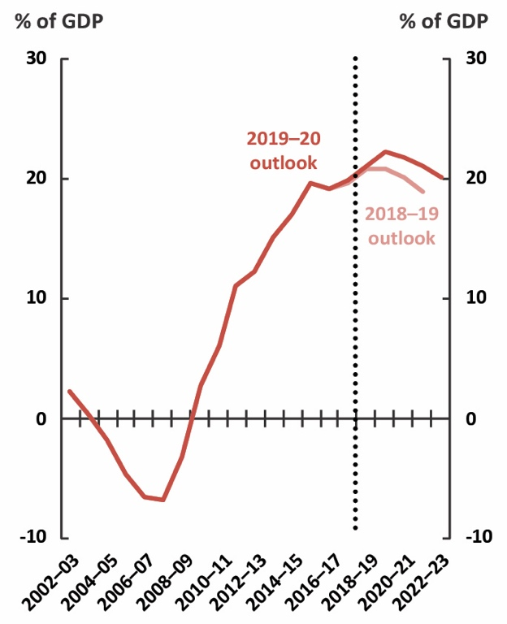 | 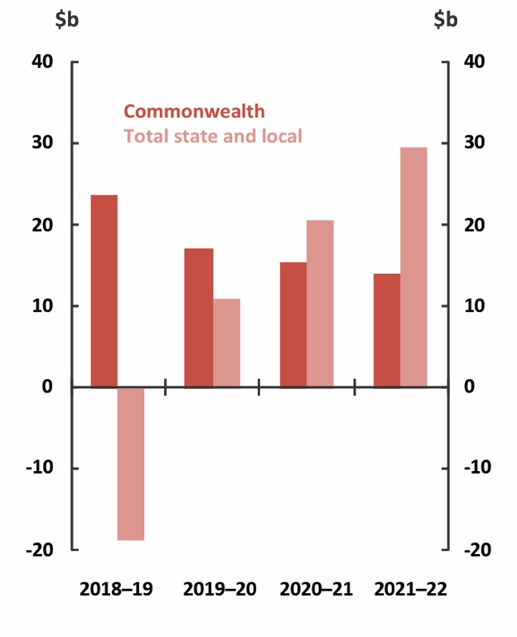
Source: ABS special data service, Commonwealth and state budget papers and PBO analysis. | Source: ABS, Commonwealth and state budget papers and PBO analysis.

Net financial worth
Net financial worth is a broader measure of the strength of a government’s balance sheet than net debt as it includes all of the government’s financial assets and liabilities, including equity investments and unfunded superannuation liabilities.
While national net financial worth is projected to improve over the forward estimates, it has been revised downward to -19.1 per cent of GDP (-$415.7 billion) in 2021–22, 3.2 percentage points ($69.2 billion) lower than was projected in 2018–19 (Figure 1–7). This is mainly due to downward revisions in state net financial worth.
State and local net financial worth is projected to be $15.9 billion in 2021–22, $66.4 billion lower than projected in the previous national outlook (Figure 1–8). This substantial decrease is largely driven by Victoria and New South Wales whose net financial worth in 2021–22 has been revised downwards by $23.9 billion and $22.1 billion, respectively. The revision to state net financial worth is caused by the same factors driving the upward revision in net debt, including higher infrastructure investment and changes to accounting standards, in combination with revaluations of defined benefit superannuation liabilities.
Figure 1–7: National net financial worth | Figure 1–8: Change in net financial worth since 2018–19 outlook
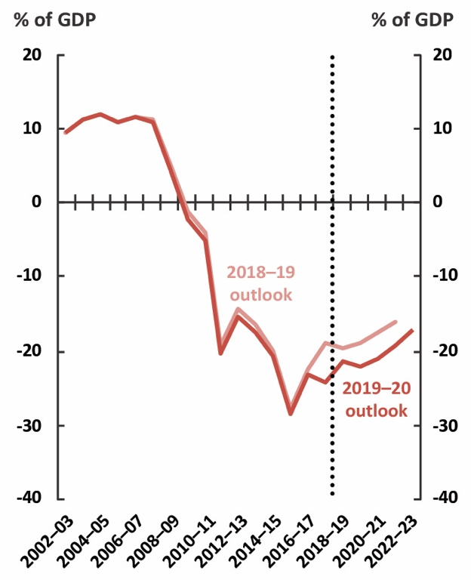 | 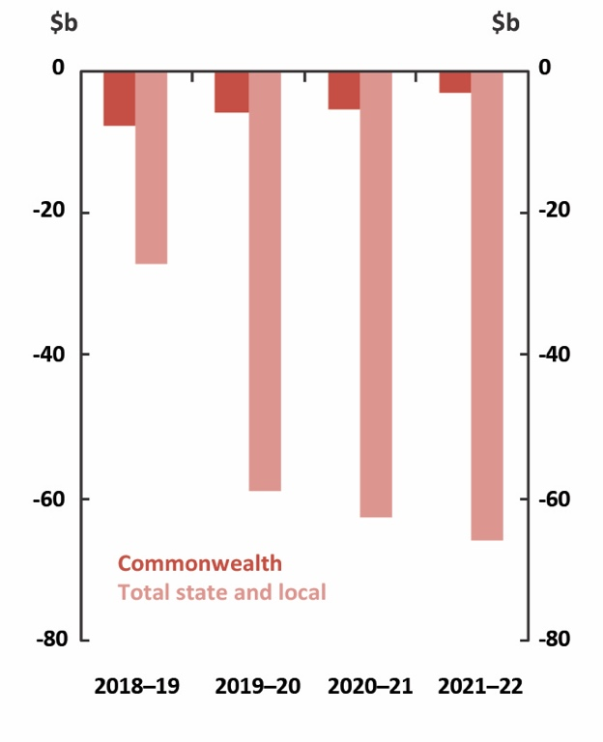
Source: ABS, Commonwealth and state budget papers and PBO analysis. | Source: ABS, Commonwealth and state budget papers and PBO analysis.

Box 1: Impact on net debt of new accounting standards for leases
Multiple changes to accounting standards have come into effect since the previous outlook. While accounting standards are continuously improved, their impacts on fiscal measures are mostly minor. In this case, however, a new standard relating to leases is expected to increase state net debt by around 1 per cent of GDP in 2019–20. New standard AASB 16 Leases requires lease commitments to be included upfront as liabilities on the balance sheet (previously most lease payments were recognised as they were made).
The impact on net debt is expected to be significant in most states (Figure 1–9) as operating leases are often used when renting office space and in other areas, such as vehicle fleet arrangements. The total increase in aggregate state net debt from this change is expected
to be around $20.0 billion (1.0 per cent of GDP) in 2019–20.
Figure 1–9: Impact of new lease accounting standard on net debt in 2019–20
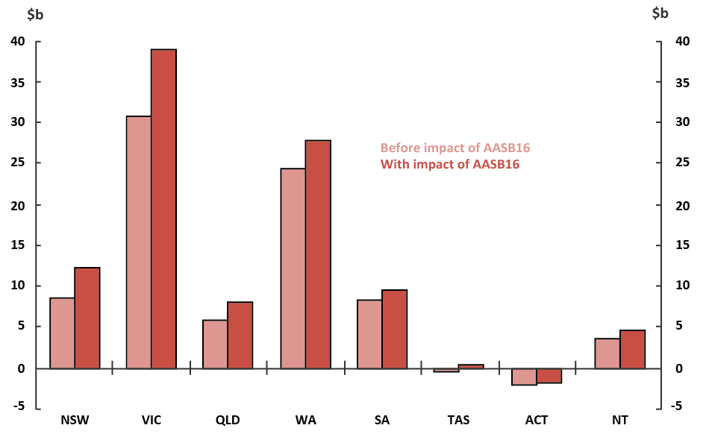
Note: Estimate of net debt for Victoria with impact of AASB16 includes the impact of other new accounting standards that came into effect in 2019–20.
Source: State budget papers and PBO analysis.
The absolute impact on net debt is greatest in Victoria, New South Wales and Western Australia, where it is expected to increase net debt by $8.1 billion, $3.8 billion and $3.4 billion respectively in 2019–20.
These changes were not reflected in the most recent budget update for the Commonwealth. The 2019–20 Budget stated that future estimates would be updated to reflect the changed treatment of leases ‘following finalisation of implementation arrangements’.

Trends in Commonwealth and state fiscal outlooks
This section breaks down the national fiscal outlook between the Commonwealth and the states.
It analyses trends in revenue, expenses, net capital investment, net debt and net financial worth over the forward estimates period.

Commonwealth trends

Trends in Commonwealth revenue and expenses
The Commonwealth budget projects that expenses will fall over the period 2018–19 to 2022–23, from 25.1 per cent of GDP to 24.6 per cent of GDP, driven by ongoing spending restraint and a decline in public debt interest payments. Revenue is projected to remain relatively stable at around 25.6 per cent of GDP, with the profile reflecting the Government's personal income tax cuts (Figure 2–1).
Over the forward estimates, the ongoing impact of previous policy changes across a number of key payments, including family tax benefit and the disability support pension, is a significant source of spending restraint, as is spending on government administration. While overall spending is projected to fall as a share of GDP, spending on the NDIS is forecast to increase as it approaches maturity, despite underspends in 2017–18 and 2018–19.
The Commonwealth’s direct net capital investment is largely related to defence and is projected to increase from 0.3 per cent of GDP ($6.5 billion) in 2018–19 to 0.5 per cent of GDP ($10.8 billion) in 2022–23 (Figure 2–2).
While the Commonwealth makes up only around 5 per cent of net capital investment, this
measure understates the Commonwealth Government’s total contribution to infrastructure investment because it omits three other large investment channels: grants to the states, equity injections into Commonwealth Government corporations, and concessional loans made for infrastructure investment. Equity injections into Commonwealth Government-owned corporations for infrastructure investment include investments in the NBN Co, Australian Rail Track Corporation and Western Sydney Airport Corporation. Concessional loans for infrastructure include the loan to the New South Wales Government for the WestConnex project. Commonwealth grants to the states are captured in Commonwealth expenses and state net capital investment (see Section 2.2.3), while debt and
equity funding is more fully captured in net financial worth.
Figure 2–1: Commonwealth revenue  and expenses | Figure 2–2: Commonwealth net capital investment
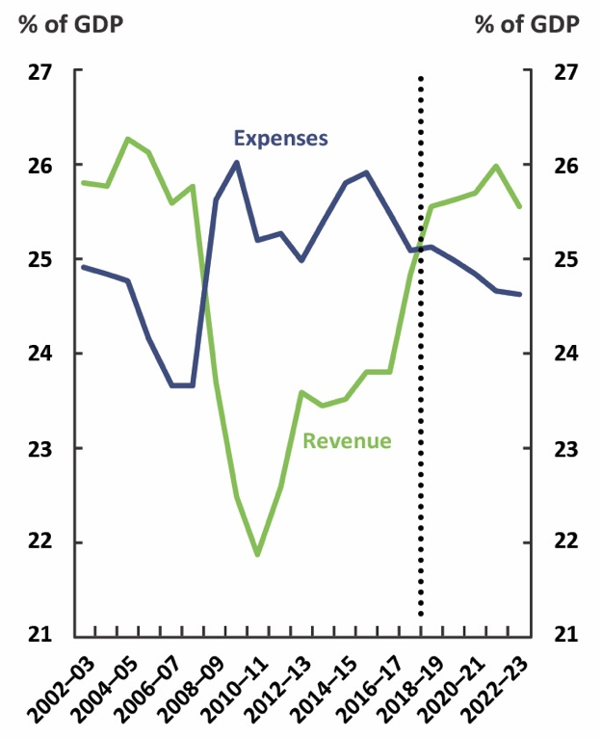 | 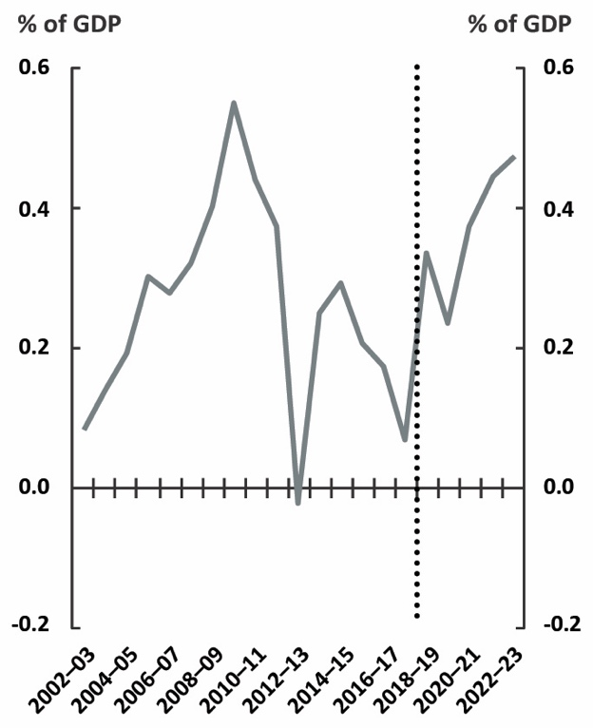
Source: ABS, Commonwealth budget papers and PBO analysis. | Source: ABS, Commonwealth budget papers and PBO analysis.

Trends in Commonwealth net debt and net financial worth
Commonwealth net debt is projected to fall from a peak of 19.2 per cent of GDP ($373.5 billion)
in 2018–19 to 14.4 per cent of GDP ($326.1 billion) by 2022–23 (Figure 2–3), primarily reflecting
the reduced interest payments from the projected move to budget surpluses early in the forward estimates period.
Commonwealth net financial worth is projected to improve from -25.3 per cent of GDP (-$490.8 billion) in 2018–19 to -19.7 per cent of GDP (-$446.8 billion) by 2022–23 (Figure 2–4). The improvement in net financial worth is driven by the same factors driving the reduction in net debt, along with a projected increase in the value of the Future Fund.

Figure 2–3: Commonwealth net debt | Figure 2–4: Commonwealth net  financial worth
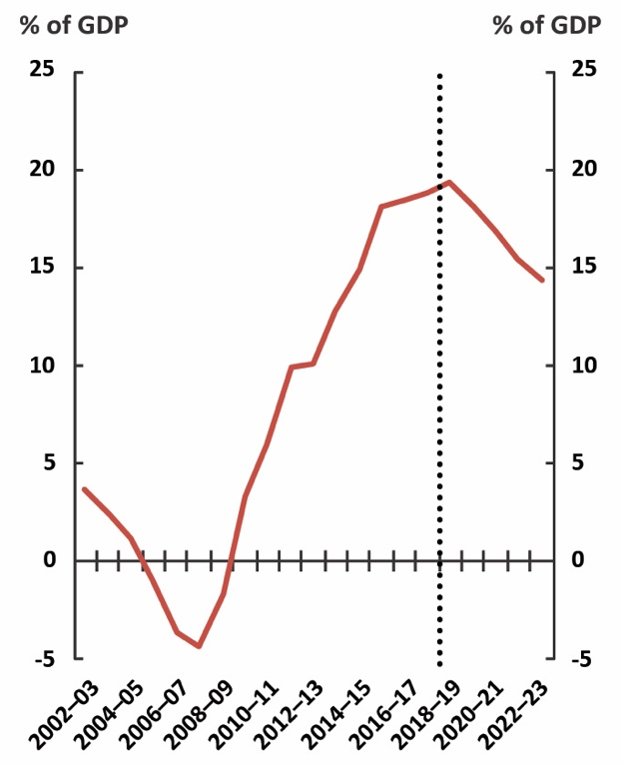 | 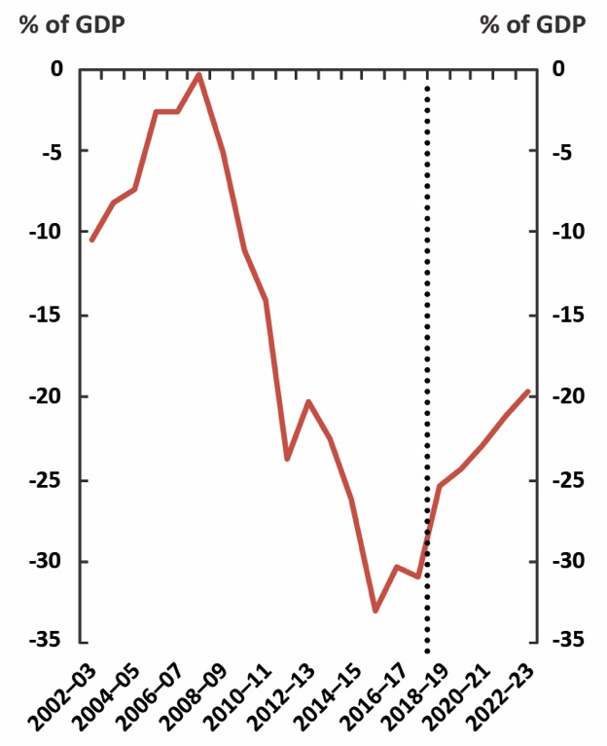
Source: ABS special data service, Commonwealth budget papers and PBO analysis. | Source: ABS, Commonwealth budget papers  and PBO analysis.

State trends
State budget papers estimate that their revenue and expenditure will decline as a share of GDP over the next four years (Figure 2–5). Aggregate state revenue and expenses have historically moved in line with each other, unlike the countercyclical nature of Commonwealth revenue and expenditure.
State net capital investment as a share of GDP is projected to reach levels just below that reached during the GFC stimulus period (Figure 2–6). Investment is projected to peak in 2019–20, with the profile over the forward estimates largely due to new spending and then projected finalisation of projects in New South Wales.
State figures are presented as a share of GDP rather than Gross State Product because
the focus of this publication is on trends in, and drivers of, the national fiscal outlook.
Figure 2–5: State revenue and expenses | Figure 2–6: State net capital investment
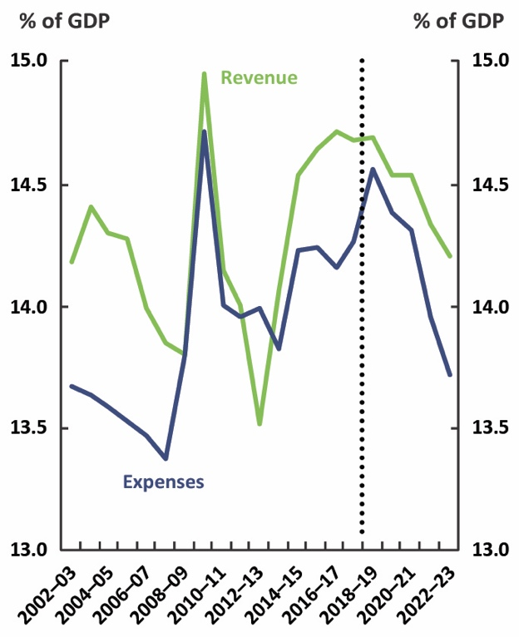 | 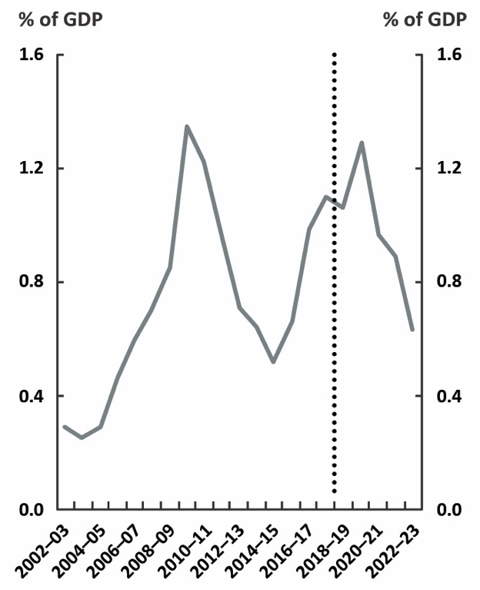
Source: ABS, state budget papers  and PBO analysis. | Source: ABS, state budget papers  and PBO analysis.

Trends in state revenue
State government revenue is made up of transfers (payments) from the Commonwealth Government and revenue raised by the states themselves (own-source revenue). According to state budgets, state revenue is projected to decline from 14.7 per cent of GDP ($285.0 billion) in 2018–19 to 14.2 per cent of GDP ($322.8 billion) in 2022–23, largely due to projected declines in own-source revenue as a share of GDP. Over the forward estimates, only Victoria and the Australian Capital Territory are forecasting an increase in revenue as a share of GDP (Figure 2–7).
Figure 2–7: State revenue
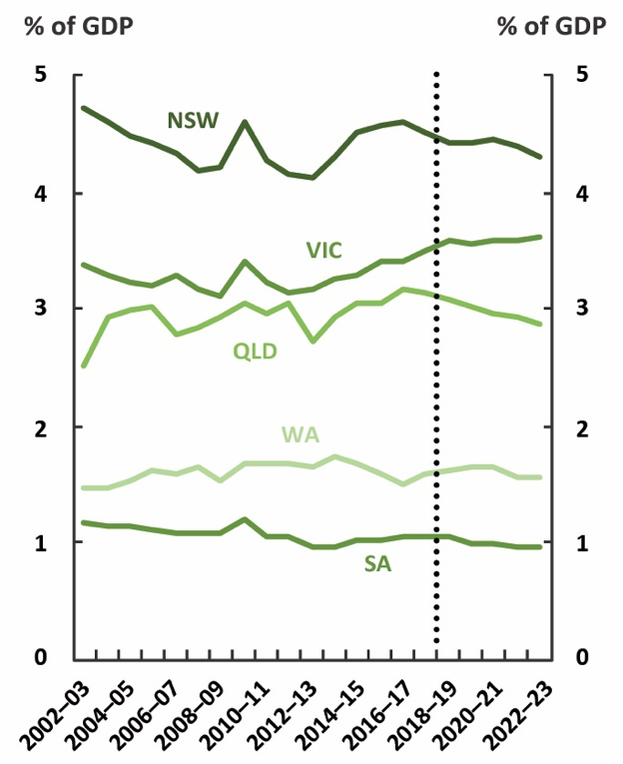 | 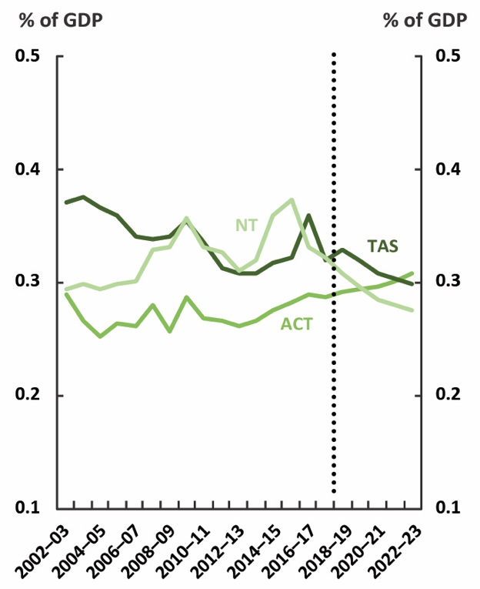
Source: ABS, state budget papers and PBO analysis.

Transfers from the Commonwealth Government to the states
Around 45 per cent of total state revenue in 2018–19 was a transfer from the Commonwealth Government. This proportion is projected to remain constant over the forward estimates. Transfers provided by the Commonwealth consist of general revenue assistance, for
use at the discretion of the recipient state government (largely the GST), and payments for specific purposes, which are to be used in particular sectors or to deliver programs agreed in partnership with the Commonwealth (Figure 2–8). Payments for specific purposes include funding for public hospitals under the National Health Reform Agreement and funding for schools under the Quality Schools package. Box 4 provides further analysis of the composition of Commonwealth and state expenses, including payments for specific purposes.
Figure 2–8: Trends in the composition of Commonwealth transfers
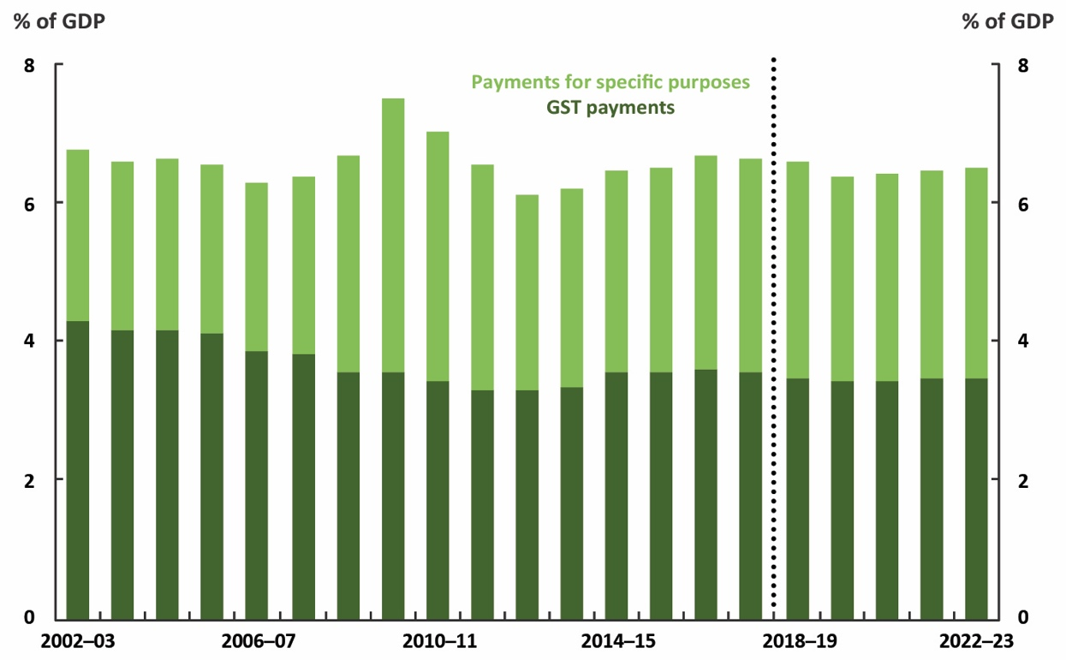
Note: The GST component also includes some other relatively small payments (primarily for royalties).
Source: ABS, Commonwealth budget papers and PBO analysis.
Commonwealth transfers to the states are projected to remain relatively steady at around 6.5 per cent of GDP over the forward estimates period. Over half of these transfers are GST payments, which are expected to remain flat at around 3.5 per cent of GDP over the same period. This is a downward revision from the previous outlook, reflecting lower forecast growth in prices and consumption.
The extent to which states depend on these transfers from the Commonwealth differs. For example,
on average over the five years to 2017–18, transfers from the Commonwealth made up around three quarters of the Northern Territory’s total revenue compared with around one-third for Western Australia (Figure 2–9). Box 2 provides further information on the distribution of GST among the states.
On a per-person basis, most states averaged around $10,000 of revenue per person over the period 2013–14 to 2017–18 (Figure 2–10). The Northern Territory recorded the highest revenue per person, at around $23,500.
Figure 2–9: State revenue  Average 2013–14 to 2017–18 | Figure 2–10: State revenue per person  Average 2013–14 to 2017–18
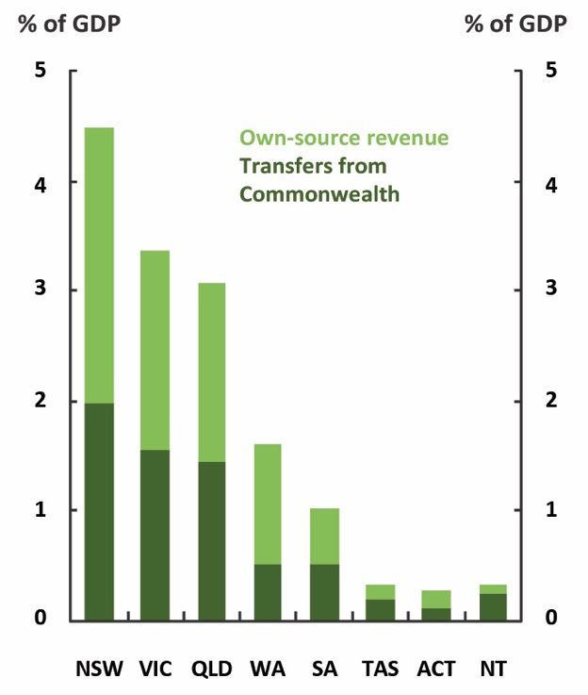 | 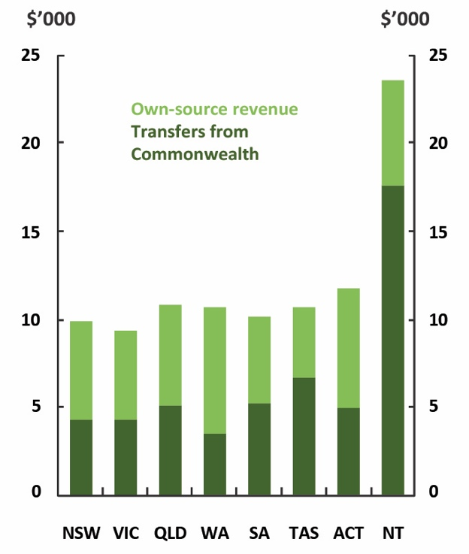
Source: ABS, Commonwealth and state budget papers and PBO analysis. | Source: ABS, Commonwealth and state budget papers and PBO analysis.

Own-source revenue
The remainder of state revenue is derived from their own sources. Key revenue sources for the states are taxes on property (including taxes on transfers and land tax), payroll tax, revenue from sales of goods and services, and, for resource-rich states, royalty revenue (Box 3).
Own-source revenue has been strong in recent years, but is projected to fall from 8.1 per cent of
GDP in 2018–19 to 7.7 per cent of GDP by 2022–23, with drivers varying by state.
In New South Wales, the plan to gradually increase the payroll tax threshold will slow growth in the state’s main source of tax revenue. A forecast return to positive house price growth in 2019–20 will support growth in transfer duty, but this will be partly offset by the indexation of transfer duty thresholds starting in that year.
In Queensland, royalty revenue has been supported by high coal prices in 2018–19, which are assumed to decline to long-term averages over the forward estimates. Queensland will also increase the payroll tax threshold, which will slow revenue growth over the forward estimates, however this is more than offset by a rise in the petroleum royalty rate and increases in land tax surcharge.
In Victoria, transfer duty and land tax revenue is forecast to decline by 1.1 per cent in 2019–20, reflecting declining property prices and transaction volumes, before increasing in line with a projected recovery in the property market in 2020–21.

Box 2: GST distribution to the states
The amount of GST revenue distributed to a particular state each year depends on four things: the total amount of GST revenue collected by the Commonwealth, each state’s share of the population, the particular concept of equality used to achieve ‘horizontal fiscal equalisation’, and the specific methods used by the Commonwealth Grants Commission when assessing each state’s fiscal capacity. The last two factors will change over the period ahead.
- The concept of horizontal fiscal equalisation will change from a ‘full’ to ‘reasonable’ equalisation system over a five-year transition period commencing in 2021–22, with revenue distributed so that all states have the capacity to provide services equal to whichever of
New South Wales or Victoria is fiscally stronger. Transition arrangements include a minimum share (floor) in the GST revenue that a state will receive. The Commonwealth will also ‘top up’ the pool of GST revenue each year from 2021–22. Additional arrangements are in place,
if required, to ensure no state is worse off as the system shifts. The operation of the new arrangements will be reviewed by the Productivity Commission at the end of the
transition period.
- The methods used to work out the fiscally strongest state will likely change somewhat
as a result of the Commonwealth Grants Commission’s regular five-yearly review of its approach. Any changes would be implemented from 2020–21. While multiple state budgets noted potential changes as an unquantifiable risk, the Commission’s recent
draft report on these changes describes them as ‘evolutionary’.
Trends in GST revenue
While GST revenue as a share of GDP is projected to be relatively stable over the forward estimates, higher consumption of some GST-free services such as health and education may place downward pressure on GST revenue over time. Since the introduction of the GST, the volume of household consumption subject to the tax has fallen a little, however the price of goods and services subject to the GST has grown significantly more slowly than the price of goods and services that are exempt from GST (Figure 2–11).  The PBO intends to undertake further work to quantify the fiscal impact of these trends to inform the 2020–21 medium-term fiscal projections. Other analysis on a similar timeframe includes the independent review on federal financial relations commissioned by the New South Wales Government,  which will report in the first half of 2020. | Figure 2–11: Share of household spending subject to GST  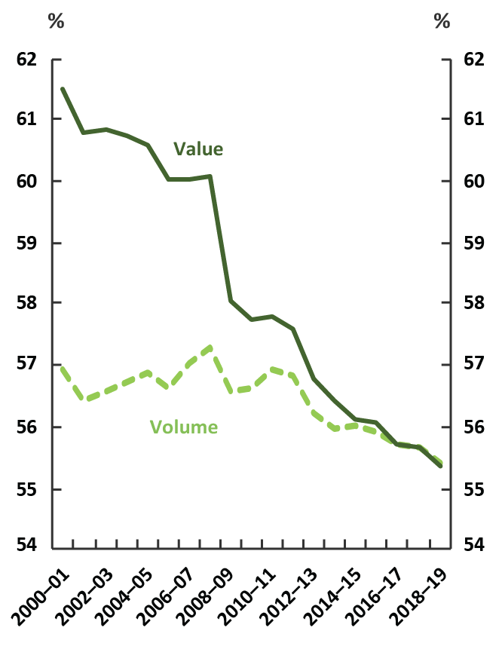  Source: ABS and PBO analysis.

Box 3: Revisions to state revenue
Between their 2018–19 and 2019–20 budgets, states have revised their revenue projections upward by a total of $27.1 billion or 2.3 per cent of total revenue for the period 2018–19 to 2021–22 (Figure 2–12). This is about double the upward revision from last year, but revisions of this size have been observed in the past five years.
Western Australia, Queensland and Victoria had the largest revisions between their 2018–19 and 2019–20 budgets, collectively accounting for over 70 per cent of the upward revision to state revenue.
Figure 2–12: Change in total state revenue between the 2018–19 and 2019–20 state budgets
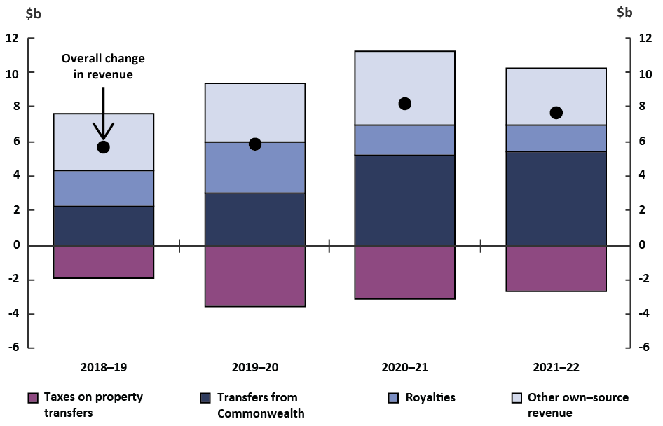
Source: State budget papers and PBO analysis.
Housing price cycles directly affect state government revenue and upward revisions to revenue from some sources were partly offset by a downward revision to transfer duty across all states, largely reflecting weaker-than-expected residential property prices and transaction volumes. This is in contrast to the previous two outlooks, when stronger-than-expected housing markets meant transfer duty contributed to upward rather than downward revisions to revenue in some states.
The main source of the upward revision to state revenue was grant revenue (mainly comprising transfers from the Commonwealth) which has been revised up by a total of $15.9 billion for the period 2018–19 to 2021–22. While the states have revised down the total value of the GST revenue grants that they expect to receive, consistent with Commonwealth forecasts, this
was more than offset by upward revisions in the value of non-GST grants.
Upward revisions to royalties in Queensland and Western Australia were also a significant contributor, reflecting upward revisions to forecast commodity prices, particularly coal and iron ore. Both states highlight in their budget papers that their commodity price forecasts
are in line with the Commonwealth’s 2019–20 Budget forecasts.

Trends in state expenses
State expenditure is projected to trend downward, declining from 14.6 per cent of GDP ($282.5 billion) in 2018–19 to 13.7 per cent of GDP ($311.6 billion) in 2022–23 (Figure 2–13), driven by additional targeted savings measures across a range of states. Most states are projecting growth in expenses to slow from 2019–20 onwards and real expenditure per person is projected to decline slightly over the forward estimates in all states.
Figure 2–13: State expenses
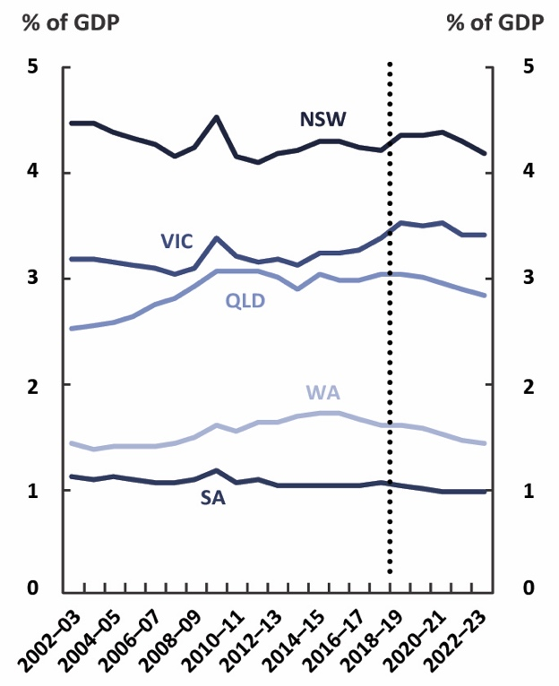 | 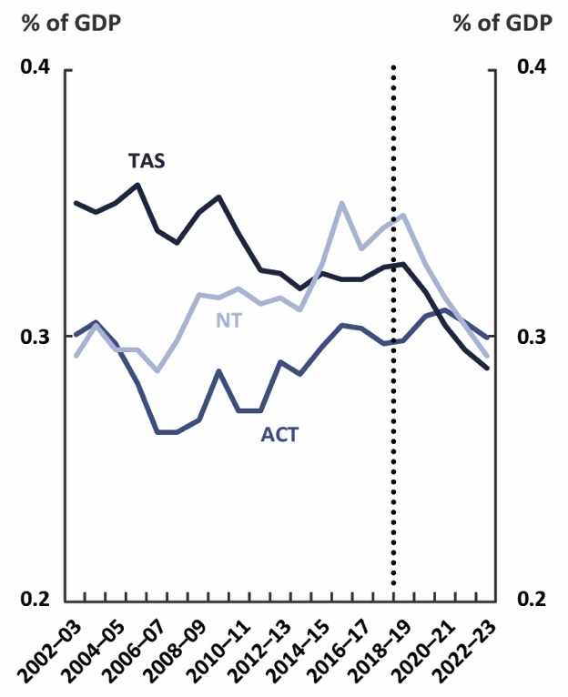
Source: ABS, state budget papers and PBO analysis.
Savings measures vary by state. For example, in New South Wales a reduction in spending on the public service, and reform of government administration and procurement arrangements has offset additional spending for the delivery of election commitments and new assistance measures to regional areas, such as drought relief.
In Queensland, expenditure in 2018–19 has been revised upward due to continued strong growth in demand for health and education services as well as increased natural disaster expenditure related to the North and Far North Queensland Monsoon Trough. Over the forward estimates, growth in expenses remains below growth in revenue, following reviews of public sector agencies and existing programs.
In Victoria, spending is estimated to have grown strongly in 2018–19, largely due to payments
to the National Disability Insurance Agency for disability services as part of the full rollout of the NDIS, and an increase in employee expenses due to increased spending in the education, health
and community service sectors associated with Victoria’s relatively high population growth.
These expenses are projected to moderate as a share of GDP over the forward estimates period.

Box 4: Composition of Commonwealth and state expenses
To understand the composition of government spending in Australia, it is useful to look at total expenses across both the Commonwealth and state governments (Figure 2–14). Looking at only one level of government would substantially underestimate total expenses in some areas, and the Commonwealth and states are joint funders of important sub-functions that states are responsible for delivering, such as public hospitals and state government schools. Only in one major area, defence, is expenditure undertaken by a single level of government, which is also responsible for delivery.
Figure 2–14: Commonwealth and state expenses by function in 2017–18
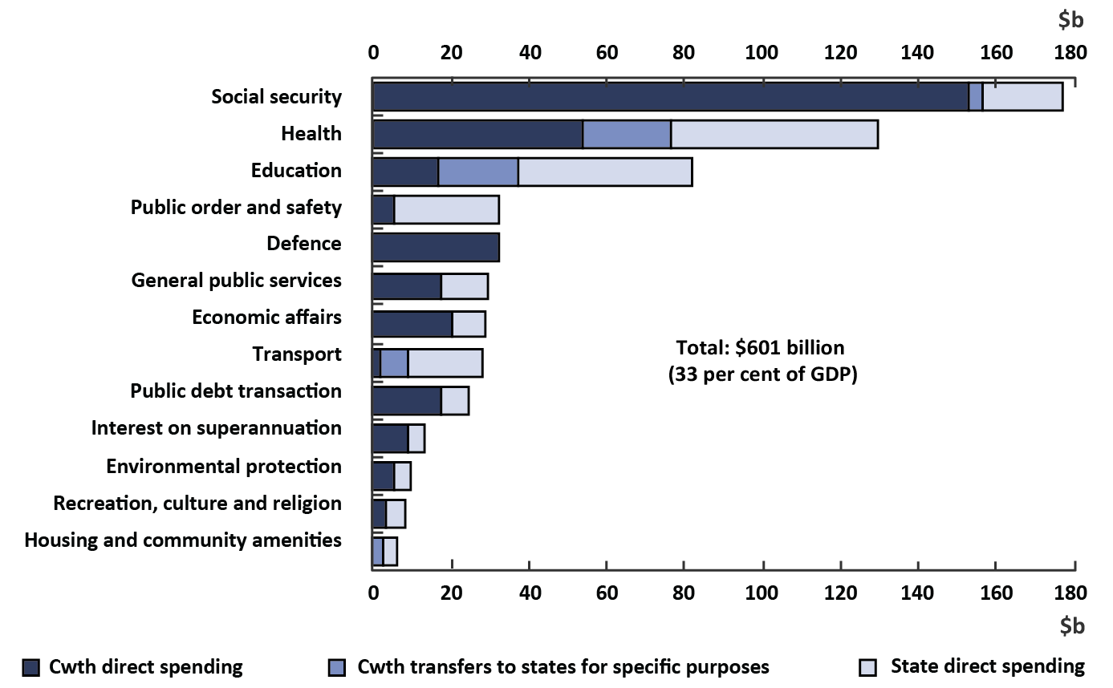
Note: The ‘Cwth (Commonwealth) transfer for specific purposes’ component only includes grants related to specific functions. As a result, some state direct spending may be funded by untied transfers from the Commonwealth (mostly GST). Excludes all infrastructure investments, which are classified as capital investment rather than expenses. The education function omits expenses by public universities that are not transfers from Commonwealth or state governments.
Source: ABS and PBO analysis.
Looking at final budget outcomes, total spending across both levels of government and
all functions was around 33 per cent of GDP (about $601 billion). The largest category of expenditure across Commonwealth and state governments is social security. This mostly reflects Commonwealth transfer payments, such as the age pension, with state payments including contributions to the NDIS.
The largest category of expenditure for the states is health, where state direct spending, largely on public hospitals, accounted for around 40 per cent of total health expenses.
The Commonwealth directly spent around $50 billion on health care, largely on Medicare
and the Pharmaceutical Benefits Scheme. Commonwealth transfers for specific purposes, largely public hospitals funding, bring the Commonwealth’s total health-related spending
to around $75 billion.
More than half of the total spending on education is state direct expenditure, mainly on funding state government schools for which states are responsible and for which they are the majority funder. This is supplemented by around $20 billion of total Commonwealth transfers for specific purposes, for both state and non-government schools and for early childhood education.
The Commonwealth’s direct education expenditure of around $17 billion is mainly on higher education and vocational education and training.

Trends in state net capital investment
States account for almost all government net capital investment in Australia, making up around 95 per cent of total net capital investment by governments in 2017–18. The main areas of investment are road, rail, health and education infrastructure.
Over the first half of the forward estimates, aggregate state net capital investment is projected to rise sharply, peaking at 1.3 per cent of GDP ($25.9 billion) in 2019–20, before declining to 0.6 per cent of
GDP ($14.5 billion) by the end of the forward estimates (Figure 2–15), with the profile driven by new spending and then projected finalisation of projects in New South Wales.
The increase in spending from 2014–15 reverses a trend of declining state investment since the peak in 2009–10. Investment during the peak period was driven by the Commonwealth’s fiscal stimulus packages that supported state infrastructure projects. The proportion of state investment was more weighted to Queensland in that period, which had large transport infrastructure spending as well as reconstruction spending following natural disasters in 2010–11.
Figure 2–15: State net capital investment
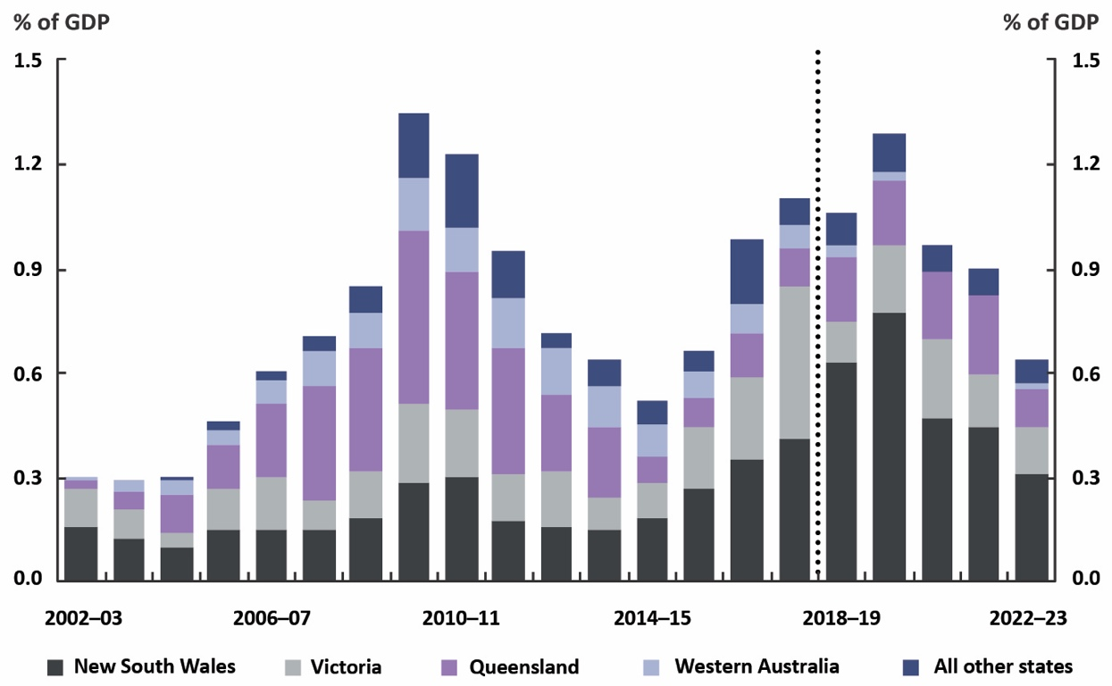
Source: ABS, state budget papers and PBO analysis.
Transport infrastructure in the largest states dominates net capital investment over the
forward estimates.
The New South Wales Government is projecting net capital investment to increase from 0.6 per cent of GDP in 2018–19, peaking at 0.8 per cent of GDP in 2019–20, $4.1 billion higher than previously estimated. Key drivers of this increase include new spending initiatives resulting from election commitments, the acceleration of existing projects, and the impact of new accounting standards on capitalising operating leases. Net capital investment is then projected to decline over the remainder of the forward estimates, to 0.3 per cent of GDP by 2022–23, reflecting the projected completion of current infrastructure projects. Overall, 60 per cent of infrastructure investment over the forward estimates will be related to transport, including major road and rail projects such as Westconnex and the Pacific Highway upgrade program, Sydney Metro West and the North South Metro Rail Link. Other projects include multiple hospital expansions and redevelopments, and capital works in schools and TAFEs.
Victoria is the second-largest contributor to net capital investment over the forward estimates, with
net capital investment peaking at 0.2 per cent of GDP in 2020–21, $2.6 billion higher than previously estimated. The main driver is new infrastructure investments announced in the lead-up to the 2018 Victorian state election, including three major projects delivered through the Victorian Transport Fund: North East Link, Melbourne Airport Rail, and the removal of level crossings. Queensland is also a significant contributor to net capital investment over the forward estimates, with steady growth over most of the forward estimates period before peaking at 0.2 per cent of GDP in 2021–22. This includes spending on major transport projects, such as the Brisbane Cross River Rail project, and health and education infrastructure.

Investment in new infrastructure
An interesting way of looking at investment data is to examine the funding sources for new projects. Some of this new investment is funded by the Commonwealth through either capital grants to the states (such as for specific road projects), GST revenue (which can be used by the states for capital expenditure), or through financing assistance to the states for capital projects.
Direct state capital investment is expected to continue at elevated levels over the forward estimates (Figure 2–16). Direct state expenditure is projected to reach 2.1 per cent of GDP in 2019–20 and, while trending down, will remain relatively high at 1.3 per cent of GDP in 2022–23. Commonwealth capital grants are projected to remain steady at around 0.4 per cent of GDP over the forward estimates.
Figure 2–16: State and local government new infrastructure investment by source of funds
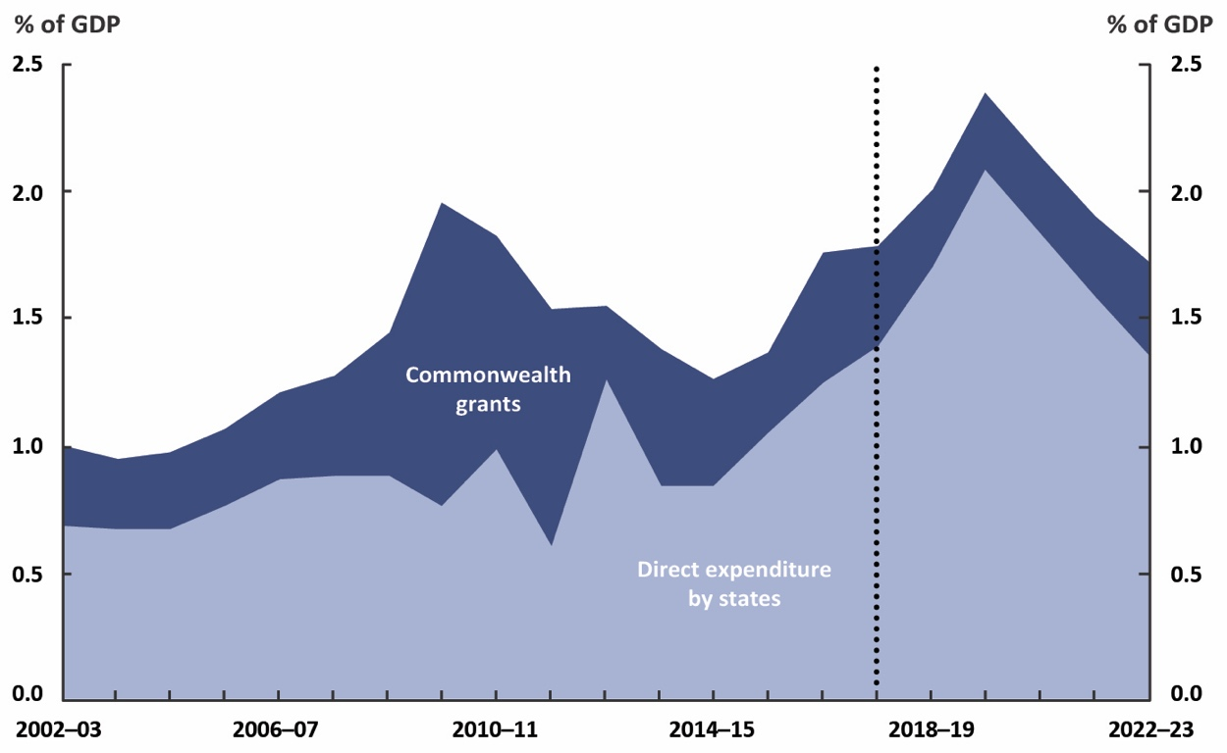
Note: Shows gross fixed capital formation. The states component includes a small amount of local
government direct expenditure. From 2018–19, the Commonwealth grants component includes all
capital grants to states readily identifiable in Commonwealth Budget Paper No.3.
Source: ABS, state budget papers and PBO analysis.

Investment by government-owned corporations
More broadly, state government-owned corporations play a large role in undertaking net capital investment in some states. This means that projected average annual state net capital investment over the forward estimates is around 0.4 per cent higher as a share of GDP once government-owned corporations are included. On average over the forward estimates period nearly 60 per cent of the projected net capital investment by the Victorian and Tasmanian public sectors will be undertaken by government-owned corporations, while a much higher proportion of investment will be undertaken by the general government sector in the other states (Figure 2–17). The investment in Victoria and Tasmania is the result of transport, water and sewer-related infrastructure projects.
Differences in the shares of investment undertaken by government-owned corporations partly reflect differences in the investment structures chosen by states. For example, while water utilities are generally government-owned corporations, the governance arrangements that states choose for delivering major transport projects vary by project and include independent authorities within the general government sector and government-owned corporations which are outside the general government sector.
Figure 2–17: Annual state net capital investment by general government
and government-owned corporations
Average over the period 2018–19 to 2022–23
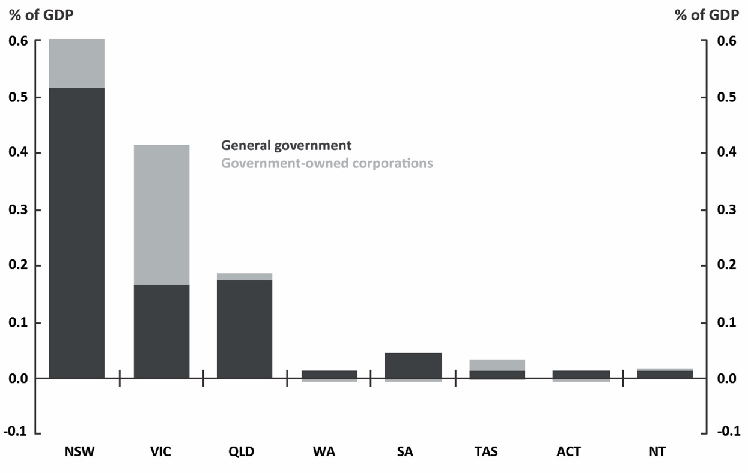
Source: State budget papers and PBO analysis.

Trends in state net debt
The small operating surpluses expected in most states are insufficient to fund the strong level of investment the states plan to undertake over the forward estimates. States will need to sell assets
or borrow to fund their planned investment, with a consequent impact on their net debt positions.
The aggregate net debt of the states is projected to rise from around 10 per cent of national net
debt in 2018–19 to over a third of national net debt by 2022–23. Over this period, state net debt is projected to increase sharply while Commonwealth net debt is projected to decline. Aggregate state net debt is projected to rise from 2.4 per cent of GDP ($45.7 billion) in 2018–19 to 6.9 per cent of GDP ($156.4 billion) in 2022–23 (Figure 2–18)—its highest level in over two decades.
Figure 2–18: Commonwealth and aggregate state net debt
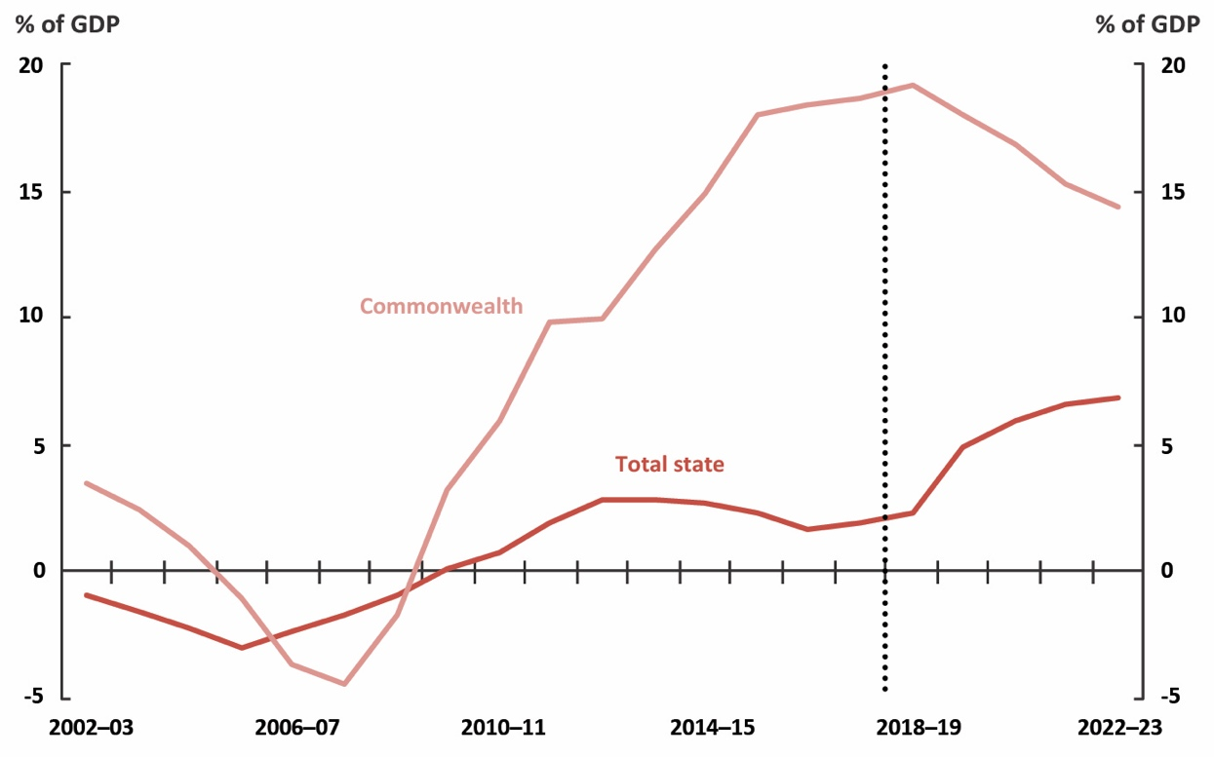
Source: ABS special data service, state budget papers and PBO analysis.
This increase in net debt largely reflects infrastructure investment commitments in New South Wales and Victoria, and to a lesser extent, Queensland (Figure 2–19). Differing trajectories for net debt by state mean that states’ net debt rankings are projected to change over the period 2018–19 to 2022–23.
For example, Western Australia’s net debt is projected to peak and decline during the period, while infrastructure investments are projected to see net debt in the other large states increasing.
Figure 2–19: State net debt
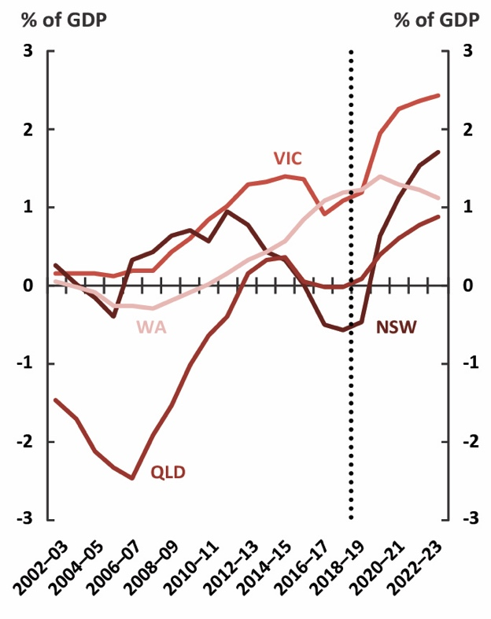 | 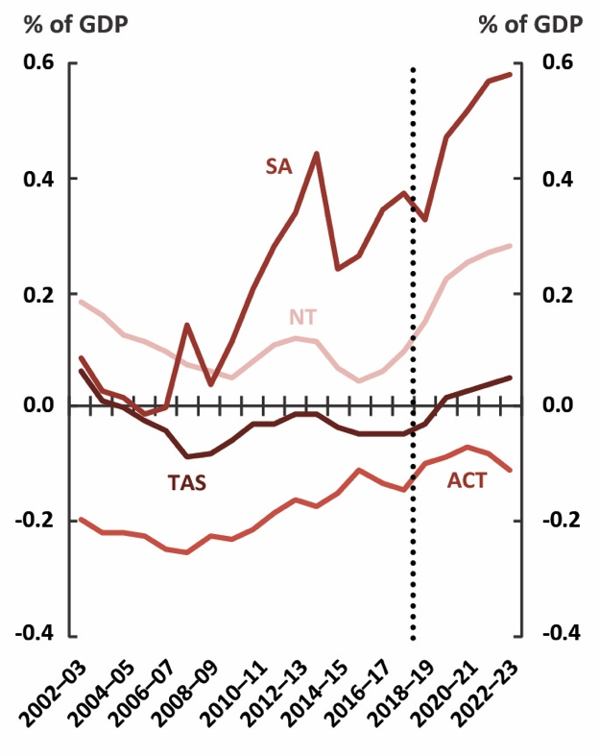
Note: Historical net debt figures provided by the ABS are consistent with the presentation in ABS 5512.0 – Government Finance Statistics, Australia, 2016–17. Queensland and the Australian Capital Territory include assets held to meet their defined benefit superannuation liabilities in their estimates of net debt.
Source: ABS special data service, state budget papers and PBO analysis.

Trends in state net financial worth
In contrast to the Commonwealth, which has been running a negative net financial worth position, the aggregate net financial worth of the states has been positive over the past 20 years. State net financial worth is projected to decline over the forward estimates from 3.2 per cent of GDP ($62.5 billion) in 2018–19 to 1.2 per cent of GDP ($27.5 billion) in 2022–23 (Figure 2–20).
Figure 2–20: Aggregate state net financial worth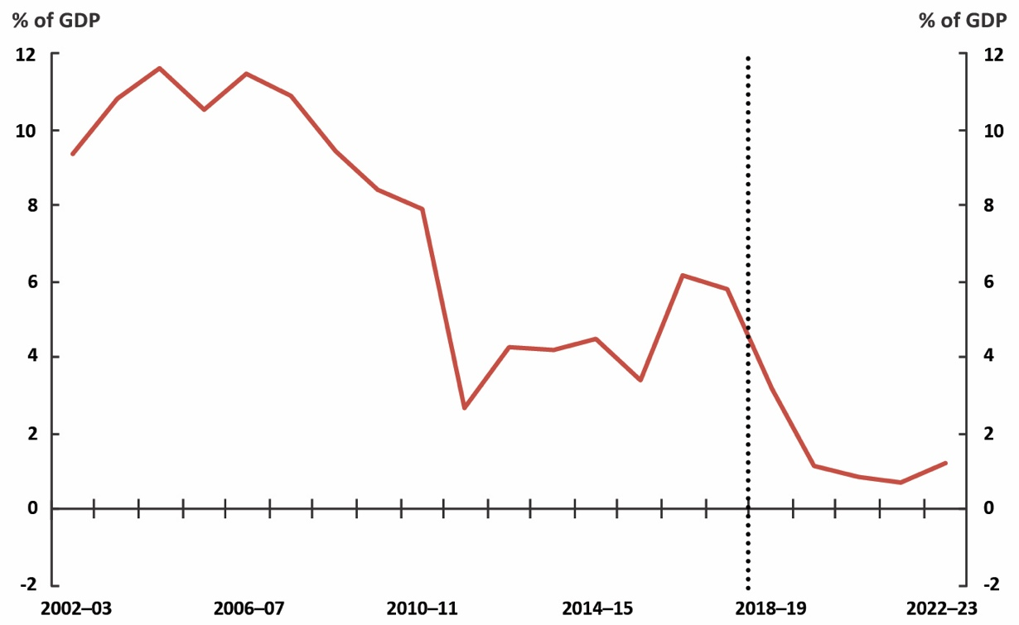
Source: ABS, state budget papers and PBO analysis.
This decline largely reflects infrastructure investment commitments in Victoria, and to a lesser extent New South Wales and Queensland (Figure 2–21), driven by the rise in borrowing required to fund planned infrastructure investment. To the extent that the additional borrowing relates to investment in productive assets, a short-term deterioration in net financial worth would not be expected to adversely affect the fiscal sustainability of state governments over the medium term.
Figure 2–21: State net financial worth
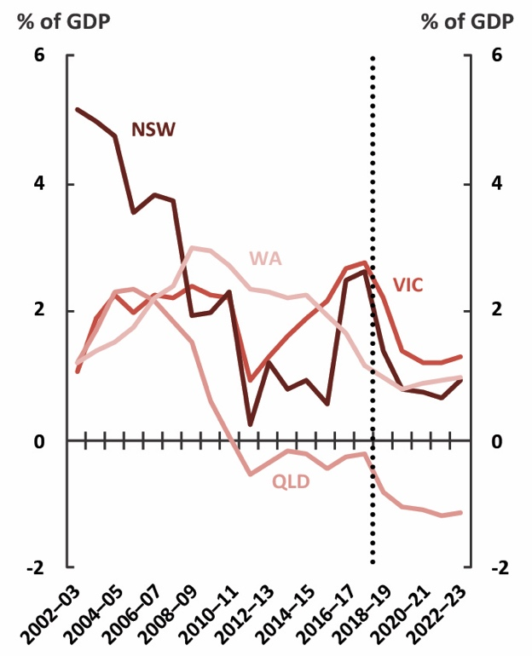 | 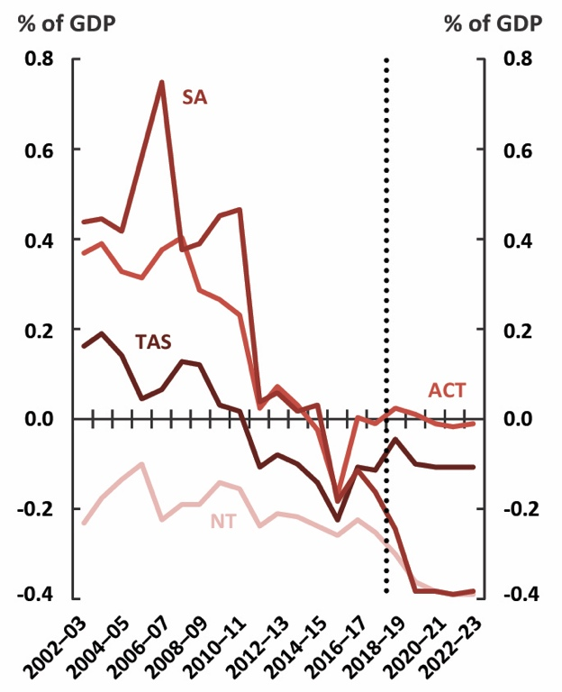
Source: ABS, state budget papers and PBO analysis.

Appendix A – Glossary, data and method

Glossary

Fiscal balance
An accrual budget aggregate equal to the net operating balance less net capital investment.
It is an accrual measure of the government’s investment-saving balance.

General government sector
The general government sector consists primarily of government departments and agencies providing non-market public services that are funded mainly through taxes.

Government-owned corporations
Government-owned corporations, also known as public non-financial corporations, are corporations that provide services to consumers on a fee-for-service basis. These corporations are funded through a combination of revenue from the provision of goods and services and government grants.

Gross fixed capital formation
Gross fixed capital formation is expenditure on new fixed assets plus net expenditure on second-hand fixed assets. This may include additions to, or replacement of, existing assets.

Net capital investment
Net capital investment, sometimes referred to as net acquisition of non-financial assets, is primarily the purchase of non-financial assets, less asset sales and depreciation. ‘Capital’ and ‘infrastructure’ are used interchangeably in this report.

Net debt
Net debt is a widely used measure of the strength of the government’s balance sheet. Net debt is the sum of selected financial liabilities (deposits held, advances received, government securities, loans and other borrowings) less the sum of selected financial assets (cash and deposits, advances paid, and investments, loans and placements). It does not include superannuation-related liabilities but may include superannuation-related assets where these would be classified as one of the ‘selected financial assets’ listed above.

Net financial worth
Net financial worth is a broader measure of the strength of the government’s balance sheet than
net debt. Net financial worth is the sum of all financial assets less the sum of all financial liabilities, (including superannuation-related liabilities).

Net operating balance
The net operating balance is an accrual budget aggregate that measures the difference between revenue and expenses arising from transactions. It does not include net capital investment, but does include the consumption of capital (depreciation). The net operating balance plus net capital investment is equal to the fiscal balance.
The net operating balance is the measure of budget balance used in the annual national fiscal outlook while the PBO’s annual medium-term projections for the Commonwealth budget uses
the underlying cash balance as its main measure of budget balance.
The primary reason for presenting the net operating balance in this publication is that presenting
the net operating balance and net capital investment allows a clear distinction between recurrent and capital expenses, which is particularly important for understanding state budget positions.
The snapshot that accompanies the national fiscal outlook presents the net operating balance, fiscal balance and net capital investment for each state and the Commonwealth as well as national totals.

Data and method
The budget aggregates in Section 1 of the report comprise Commonwealth, state and territory, and local government. Section 2 does not include local government, unless indicated. With the exception of local government projections, this report does not include any PBO projections. The PBO adjusts historical data and budget projections to improve comparability across jurisdictions and over time as discussed below, but does not otherwise adjust historical or budget data. The analysis uses the budget papers as published, so only current government policies at the time of the respective budgets are included.

Data sources
With the exception of the material on state-owned corporations, the scope of this report is
the general government sector. Historical data, from 2002–03 to 2017–18, are from ABS 5512.0
– Government Finance Statistics, Australia, 2016–17. Data for the forward estimates period,
from 2018–19 to 2022–23, are sourced from Commonwealth, state and territory budgets.
Historical net debt figures were provided to the PBO through the ABS’ special data service consistent with the presentation in ABS 5512.0 – Government Finance Statistics, Australia, 2016–17. The ABS no longer publishes a single measure of net debt, and has instead introduced a debt matrix presentation
for public sector debt statistics, disaggregated by government sector and debt instrument. Under the matrix presentation, L2 is the closest comparable measure to government reporting of net debt under Australian Accounting Standards.

Method
Data are generally comparable across the historical and forward estimates periods, but there are differences in the budget treatment of items across jurisdictions.
The projections of revenue and expenses for New South Wales and Western Australia have been adjusted by the PBO to improve comparability across periods. These budget estimates exclude Commonwealth transfers that ‘pass through’ their state accounts and, as such, their reported revenue and expenses do not include these amounts (these mainly relate to payments to non-government schools and local governments which the Commonwealth makes through the states). In contrast,
the ABS requires that the full ‘grossed up’ amount be reported. In this edition of the outlook, the PBO has revised its adjustment for these transfers to gain a more consistent series. Revenue and expenses for New South Wales and Western Australia from 2018–19 onwards are adjusted using the estimates
of these transfers in state and Commonwealth budget papers.
Charts in Section 1 comparing variables from the previous and current outlook (for example, Figure 1–5), use the GDP projections underpinning the corresponding Commonwealth Budget when calculating shares of GDP. For example, the net debt projections from the 2018–19 outlook are expressed as a share of the GDP projection in the 2018–19 outlook.
From 2018–19, aggregated local government data are projected by the PBO using historical trends. This is included in the analysis in Section 1 only.

Final budget outcomes not included for 2018–19
The data in this report do not incorporate 2018–19 final budget results of the Commonwealth
and states. The figures in this report also do not incorporate any announcements since budgets.
Partially updating the forward estimates for final budget results may misrepresent trends across the forward estimates. For example, the Commonwealth’s 2018–19 Final Budget Outcome contained underspends on the NDIS. As least some of this funding is likely to be shifted to subsequent years. Factoring in only the 2018–19 reduction in expenses without any change in the other years would create an inconsistency within the forward estimates period.

The data in this report do not incorporate 2018–19 final budget results because partially updating the forward estimates for final budget results may misrepresent trends across the forward estimates. See the Data and method section for further explanation. Data and figures in Section 1 have been adjusted to eliminate transfers between levels of government.
This publication uses the net operating balance as the measure of budget balance. The net operating balance is an accrual aggregate which measures the difference between revenue and expenses from transactions. It does not include net capital investment, but does include the consumption of capital (depreciation). See the Glossary for a comparison with other measures.
Net capital investment is primarily the purchase of non-financial assets less asset sales and depreciation. Of these components, only depreciation is included in the net operating balance. Net capital investment is sometimes referred to as net acquisition of non-financial assets. ‘Infrastructure’ and ‘capital’ are used interchangeably in this report.
The difference in 2017–18 values is driven by a reconciliation difference with the acquisition of new non-financial assets when comparing financial reporting of the Victorian Government to final Government Finance Statistics (GFS) outputs produced by the ABS. This difference relates to the conceptual treatment of asset transfers in GFS.
The ten-year bond yield assumption used in the 2019–20 Budget was 1.9 per cent, 0.9 percentage points lower than the assumption of 2.8 per cent used in the 2018–19 Budget.
Lower interest rates, or bond yields, have two impacts on net debt. On the one hand, lower bond yields lead the existing stock of government debt to be revalued upwards, initially increasing net debt. On the other hand, lower interest rates result in lower public debt interest payments on new borrowings, which increase the net operating balance and reduce future requirements for raising debt, so net debt improves over the long run. For more details see PBO Report no. 05/2017 2017–18 Budget medium-term projections: economic scenario analysis.
The financial statements presented in government budgets are generally reported in line with the accounting standards released by the Australian Accounting Standards Board (AASB). While changes to these standards can have a significant impact on budget indicators, they are usually technical changes and do not reflect material changes in the economic or legal circumstances of governments or the underlying budget position.
For more details on the drivers of, and risks to, Commonwealth receipts and spending see the PBO’s 2019–20 Medium-term fiscal projections report (PBO report no. 03/2019), which includes the Commonwealth’s final budget outcomes for 2018–19.
Government-owned corporations are formally referred to as public non-financial corporations and provide services to consumers on a fee-for-service basis. The general government sector primarily consists of government departments and agencies providing non-market public services that are funded mainly through taxes.
Equity injections and concessional loans are ways of paying for policies that do not involve direct financing. In 2019–20, the PBO intends to publish a report examining these kinds of ‘alternative’ financing arrangements, the use of which has increased over time.
The PBO’s alternative estimate of net debt, which ‘looks through’ to all underlying assets held by government investment funds, regardless of the investment structures used, is around 21.7 per cent of GDP in 2019–20, 3.7 per cent of GDP higher in 2019–20 than the standard projection. For more details, see the PBO Report no. 01/2019 Net debt and investment funds – Trends and balance sheet implications.
The 2018–19 Final Budget Outcome reported net financial worth of -$694.4 billion (-35.7 per cent of GDP), much larger than estimated at the 2019–20 Budget. These revisions since the Budget largely reflect differing valuations for the Government’s defined benefit superannuation liability, due to differences between budget and accounting methodologies. For more details on the drivers of, and risks to, Commonwealth net debt and net financial worth see the PBO’s 2019–20 Medium-term fiscal projections report (PBO report no. 03/2019).
Broadly speaking, that fiscal disparities between states, beyond their control, should be removed or reduced.
This analysis on new infrastructure investment uses gross fixed capital formation by the general government sector. Gross fixed capital formation largely reflects capital purchases, so is a better measure of infrastructure investment decisions than net capital investment, which is affected by the disposal and depreciation of assets.
There are inevitably timing inconsistencies between when grants are recognised as paid by the Commonwealth and when they are received by the states. The implementation of AASB 15 Revenue from Contracts with Customers has cemented timing differences for certain grants by requiring the states to recognise revenue when a performance obligation is met.

