2017–18 Budget medium-term projections:
economic scenario analysis
Report no. 05/2017

© Commonwealth of Australia 2017
ISBN 978-0-6482138-0-2 (Online)
This work is licensed under the Creative Commons Attribution-NonCommercial-NoDerivs 3.0 Australia License.
The details of this licence are available on the Creative Commons website: http://creativecommons.org/licenses/by-nc-nd/3.0/au/
Use of the Coat of Arms
The terms under which the Coat of Arms can be used are detailed on the following website: www.itsanhonour.gov.au/coat-arms
Parliamentary Budget Office
Parliament House
PO Box 6010
CANBERRA ACT 2600
Phone: (02) 6277 9500
Email: pbo@pbo.gov.au

Contents
Foreword iv
Overview v
1 Introduction 1
1.1 Scenarios in the report 2
2 The economy, interest rates, government debt and fiscal sustainability 3
3 Temporary economic shock scenarios 5
3.1 Background 5
3.2 Scenarios 5
3.3 Economic results 7
3.4 Budget results 8
4 Permanent economic growth shock scenarios 12
4.1 Background 13
4.2 Scenarios 15
4.3 Economic results 16
4.4 Budget results 17
5 Interest rate scenarios 23
5.1 Background 23
5.2 Scenarios 25
5.3 Budget results 26
Appendix A – Technical notes 29
Appendix B – Economic parameter deviations 38
References 40

Foreword
This report examines the sensitivity of medium-term budget projections to changes in economic parameters. It seeks to provide additional detail on the impacts of economic scenarios on the medium-term budget position, including the effects on major revenue and expenditure areas of the budget.
In this report, we illustrate the consequences of economic growth being either temporarily or permanently higher or lower than the central projections. We also analyse the impact on the budget of persistently lower interest rates.
The report was prepared by Paul Gardiner, Lok Potticary, Vijay Murik and Sam Pelly with comments by Tim Pyne. The report was prepared for publication by Lauren Pratley.
I also wish to thank the external referees who provided helpful comments and suggestions on the report, namely Robert Carling, Saul Eslake and the Grattan Institute.
The assistance of external reviewers does not imply any responsibility on their part for the content of the final report, which rests solely with the Parliamentary Budget Office.
Jenny Wilkinson
Parliamentary Budget Officer
7 December 2017

Overview
Returning the Australian Government’s finances to a sustainable position following the global financial crisis continues to present a challenge for government. While the 2017–18 Budget projects a return to surplus and a decline in net debt, these projections are subject to risk and uncertainty.
Australia’s fiscal position is sensitive to changes in economic growth. Government revenue, in particular, is sensitive to variation in the growth rate of the nominal economy. Changes in economic growth can be temporary, where a shock affects the current level of activity but does not affect the long-run level of output of the economy. Alternatively, a change in economic growth can reflect a structural change in the economy, such as an enduring change in the rate of productivity growth, and hence affect the ongoing growth in output.
This report analyses the impacts on the budget of different economic growth scenarios over the medium term. It also looks at the effects of lower long-term interest rates, which affect the cost of servicing government debt.
Temporarily stronger or weaker economic growth compared with the central projection has only a small impact on the government’s budget position over the medium term. This is because the impact of the shock on the level of real GDP dissipates over time and the budget impact is limited to the effect of the shock on prices.
In contrast, permanent changes in economic growth due to changes in the rate of productivity growth have significant impacts on the budget which will increase over time.
Permanently stronger economic growth benefits the budget position to the extent that the additional revenue is not spent or given back as tax cuts (beyond the assumed tax cap of 23.9 per cent of GDP). Permanently weaker economic growth has a significant impact on the budget position as tax receipts weaken with slower economic growth while government spending remains broadly unchanged and rises further as debt servicing costs rise.
These results reinforce the importance to the budget of continuing efforts to enhance the long-run productive potential of the economy.
There is also uncertainty around the level of long-term interest rates which underlie the medium-term budget projections. Interest rates, internationally and domestically, remain persistently low and it is unclear when (or whether) rates will rise back to long-run averages.
Lower interest rates on Commonwealth issued debt, all other things being equal, reduce public debt interest costs and improve the underlying cash balance. However, these improvements would be small because the stock of Australian Government net debt as a proportion of GDP is relatively low.
These scenarios highlight the need to consider the uncertainty around medium-term economic projections in managing the fiscal position. Taking into account uncertainty is particularly relevant in the current economic circumstances given the ongoing debate around whether the subdued economic outcomes of the past several years reflect a temporary or permanent phenomenon.

Introduction
A risk to the medium-term outlook for the budget and hence the sustainability of the fiscal position is the likelihood of the economic projections being achieved. Growth in nominal GDP is the main driver of growth in personal income tax and company tax and hence the budget position. Payments are less affected by nominal GDP growth, instead increasing in line with wages or inflation, while some payments are fixed in nominal terms. The medium-term budget position can also be affected by the level of long-term interest rates because of its impact on the cost of servicing government debt.
The medium-term fiscal projections presented in the budget are based on technical assumptions that the economy grows to absorb any spare capacity over the five years following the forecast period and then grows at its long-run potential rate. The projections also assume that interest rates on government debt converge to long-term historical levels over the next two decades.
There is a fair amount of uncertainty in these assumptions. The potential rate of economic growth over the medium term is heavily dependent on productivity growth as labour force participation is unlikely to continue to contribute to growth. Labour force participation is at close to historical highs and is projected to fall reflecting the impact of the ageing of the population.
Productivity growth has fluctuated over the past decade which makes it difficult to discern the underlying trend. It posted a strong recovery, averaging around 2¼ per cent per annum over the period 2011–12 to 2013–14, reflecting a rebound across a number of industries including agriculture and mining. Recent outcomes have seen labour productivity growth average around 1 per cent over the period 2014–15 to 2016–17. This is not a uniquely Australian phenomenon, across advanced economies questions are being asked about why measured productivity growth appears to be so weak.
There is also uncertainty about the extent to which recent weakness in economic growth is due to temporary factors that are part of the economic cycle or longer-term structural factors. Furthermore, interest rates, internationally and domestically, remain persistently low and it is unclear when or whether rates will rise back to assumed long-run averages.
To analyse how the economy affects the budget, we have generated different projections for economic growth around the 2017–18 Budget central projection for the years 2019–20 to 2027–28. In these scenarios, economic growth is either temporarily or permanently higher or lower than the central projection. We also look at the impact on the budget of the current low level of interest rates persisting.
Section 2 provides a discussion of fiscal sustainability in the context of an economy’s debt position and its relationship with economic growth and interest rates. The remaining sections investigate the outlook for the sustainability of the Government’s budget position of a number of economic and interest rate scenarios.

Scenarios in the report
The scenarios in this report assess the budget impact of shocks to the economy that would result in changes to the central budget assumptions around major economic parameters such as the rate of economic growth (real and nominal GDP), growth in wages, the inflation rate and interest rates on government debt.
Section 3 investigates the impact on the budget over the medium term of temporary differences in economic growth. In these scenarios, economic growth is faster or slower than the central projection at the beginning of the projection period. Because these scenarios are temporary, the level of real GDP is the same as the central projection in the long run.
Section 4 investigates the impact on the budget over the medium term of permanent differences in economic growth. To produce these permanent differences in economic growth we assume that labour productivity growth is either permanently stronger or weaker than the central projection. These permanent changes in the growth rate of real GDP result in permanent differences in the levels of real GDP in the medium term compared with the central projection.
Section 5 investigates the impact on the budget of different interest rate profiles over the medium term than assumed in the 2017–18 Budget. This is a partial analysis when compared to those discussed in sections 3 and 4 as we have assumed that the central economic projections remain unchanged despite a lower interest rate profile. We set the different assumptions for interest rates by using financial market expectations and assuming a lower long-term equilibrium interest rate.
The scenarios in this report have similarities to some of the scenarios published in the
2017–18 Budget. The motivation for this report is to illustrate the different impact of temporary compared with permanent economic shocks on the budget and to detail the transmission mechanisms through which these budget impacts occur. The report also provides details on how the economic scenarios flow through to changes in the heads of revenue and major payments, as well as the budget aggregates.
The discussion of the economic scenarios covers the impacts on key economic parameters including real and nominal GDP, wages, inflation and interest rates and highlights how these vary from the central projection. The economic scenarios in this report were modelled using Chris Murphy’s macroeconometric model and are available on the PBO website (Murphy, 2017).

The economy, interest rates, government
debt and fiscal sustainability
Fiscal sustainability refers to the ability of the government to meet both current and future financial obligations, or to efficiently finance current and future expenditure programs. Sustainable fiscal policy facilitates a stable macroeconomic environment as it lessens the uncertainty facing individuals, firms and financial markets and thus supports economic growth.
Based on the 2017–18 Budget central projections for economic growth and interest rates, government debt is projected to decline as a per cent of GDP from 2018–19. In considering risks to the central projection and therefore fiscal sustainability, this report examines the sensitivity of the fiscal position to plausible economic growth and interest rate scenarios.
One key measure of fiscal sustainability is the rate at which the stock of government debt as a share of the size of the economy changes over time. The key factors that influence the level of government debt as a per cent of GDP include:
- the primary budget balance (revenue less expenses, excluding interest expenses)
- nominal GDP growth
- the interest rate on government debt measured as the weighted average interest rate by maturity of government debt.
Any one of these factors alone does not determine the sustainability or otherwise of the outlook for debt. If a government is running a primary balance (that is, revenue is equal to expenditure), new debt will only be issued to fund the existing stock of debt. In this instance, if interest rates on government debt are equal to nominal GDP growth, the ratio of debt-to-GDP will remain constant.
If the budget is in deficit, the stability of the debt level will depend on the level of the interest rate on government debt relative to the nominal GDP growth rate. If GDP growth is significantly greater than the interest rate, the debt-to-GDP ratio could be stable even with a primary balance deficit. However, if the GDP growth rate is lower than the nominal interest rate then without corrective action the debt-to-GDP ratio will increase.
This relationship is further explained in Box 1.

Box 1: What determines the level of debt as a share of output?
The path of government debt over time can be expressed as follows:
$$\frac{D_{t}}{{GDP}_{t}}=\frac{1+i_{t}}{1+γ_{t}}×\frac{D_{t-1}}{{GDP}_{t-1}}-\frac{P_{t}}{{GDP}_{t}}+\frac{S_{t}}{{GDP}_{t}}.$$
In this expression:
$D_{t}$ is the stock of government debt at year $t$
${GDP}_{t}$ is the level of nominal GDP at year $t$
$i_{t}$ is the effective nominal interest rate on the stock of government debt in year $t$
$γ_{t}$ is the growth rate of nominal GDP in year $t$
$P_{t}$ is the level of the primary budget balance at year $t$, where a positive (negative) outcome represents a surplus (deficit)
$S_{t}$ captures residual factors influencing the level of debt (“stock-flow adjustments”)
This expression illustrates that the level of debt as a share of the economy depends on its previous level, the level of the nominal interest rate, the nominal GDP growth rate, the budget balance and stock-flow adjustments which include revaluation effects. Budget surpluses clearly reduce the stock of debt and budget deficits increase it.
The interest rate and the economic growth rate can be expressed either in nominal terms as they appear above, or in real terms as follows:
$$\frac{D_{t}}{{GDP}_{t}}=\left(1+\frac{r_{t}-g_{t}}{1+g_{t}}\right)×\frac{D_{t-1}}{{GDP}_{t-1}}-\frac{P_{t}}{{GDP}_{t}}+\frac{S_{t}}{{GDP}_{t}}.$$
In this expression, $r_{t}$ is the effective real interest rate on the stock of government debt and $g_{t}$ is the growth rate of real GDP. This form of the equation shows that the difference between the real interest rate on the stock of government debt and the real growth rate of the economy is a key determinant of the path of the stock of debt through time. Moreover, the effect of any difference between the interest rate and the growth of the economy on the change in debt is amplified when the debt-to-GDP ratio is higher.
Assessing the sustainability of a given fiscal position clearly requires an assessment of what the long-run real interest rates and real economic growth rates are likely to be in addition to an assessment of the likely path of primary budget balances.
At the net debt levels that have been experienced in Australia, the main driver of changes in the ratio of debt to GDP has been the primary budget balance. The debt-to-GDP ratio is forecast to increase in 2017–18 and 2018–19 due to primary budget deficits. In 2019–20, the debt-to-GDP ratio is projected to fall as the primary budget moves into surplus and nominal GDP growth is projected to be significantly higher than the nominal interest rate.
An assessment of the sustainability of the budget over the medium term involves judgments about the likely change in the debt-to-GDP ratio over that period. Prudent fiscal management needs to take into account not only the projected outcomes for the key determinants of sustainability (primary budget balance, nominal GDP growth and interest rates) but the risks around those outcomes.

An unforeseen negative shock to nominal GDP can render a sustainable fiscal situation unsustainable. It would negatively affect the debt-to GDP ratio in two ways. First, it would reduce the primary budget balance because of the impact on government revenue. Second, if interest rates on government debt did not fall, the ratio of those rates to the rate of economic growth would increase, also pushing up the debt-to-GDP ratio.
Similarly, unforeseen increases in interest rates can affect sustainability, particularly if the existing levels of government debt are high. On the other hand, lower interest rates can allow debt-to-GDP ratios to fall even if nominal economic growth rates are below long-term trends.

Temporary economic shock scenarios
This section demonstrates the economic and budget impacts over the medium term of temporary changes to the rate of economic growth. The temporary changes in economic growth are assumed to be due to different rates of growth in non-mining investment. As there are no changes to the underlying drivers of economic growth, there is no permanent impact on the level of real GDP in the long run.
Temporarily faster or slower economic growth compared with the central projection has small impacts on the government’s budget position over the medium to long term.

Background
The 2017–18 Budget projects real GDP growth to accelerate from 1¾ per cent in 2016–17 to
3 per cent by 2018–19 and beyond. The acceleration in economic growth for a period above estimated potential real GDP growth of 2¾ per cent reflects the Budget technical assumption that spare capacity (often referred to as a negative output gap) is absorbed over a five year period from 2019–20 (that is, following the forecast years of the 2017–18 Budget). This results in the economy reaching its potential, or ‘full employment’, level where the output gap is closed, within the medium term.

Scenarios
Projections of economic growth are subject to risk and the projected closing of the negative output gap could happen sooner or later than suggested by the 2017–18 Budget central projection. A key risk as outlined in the 2017–18 Budget is the speed with which non-mining investment recovers from subdued levels following the mining investment contraction.
This section examines the sensitivity of the budget to temporarily faster or slower economic growth scenarios due to different projections of non-mining investment growth over the period 2019–20 to 2027–28. Two specific scenarios are modelled:
- Real GDP growth is projected to be faster than the central projection for the first two years of the medium-term projection period. This results in the economy reaching potential earlier than in the central projection.
- Real GDP growth is projected to be slower than the central projection for the first two years of the medium-term projections period. This results in the economy reaching potential later than in the central projection.
Both of these shocks are temporary and while the projected economic growth rates are different to the central projection (Figure 3–1) all three projections eventually converge on the same level of real GDP. The initial temporarily faster or slower growth in real GDP is offset by slower or faster growth beyond the period in which the shocks are imposed on the model.
Figure 3–1: Real GDP growth—2017–18 Budget and temporary shock scenarios
Temporarily faster growth | Temporarily slower growth
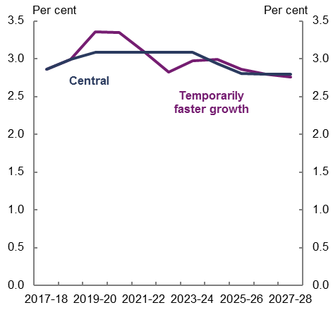 | 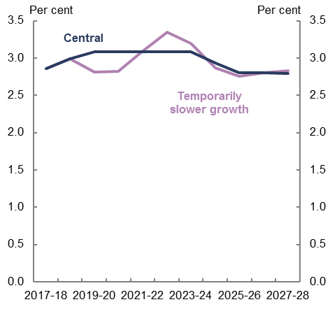
Source: 2017–18 Budget, Murphy (2017) and PBO analysis.

While the level of real GDP will be unchanged in the long run, given that these investment shocks affect the capital stock, they have real impacts that last beyond the medium term.
Figure 3–2 shows the percentage deviation in the level of real GDP between the temporarily faster or slower economic growth scenarios and the central projection. In these scenarios, the real GDP impact takes around two decades to largely dissipate. A shorter adjustment period would be expected for a shock to consumer spending, although many temporary shocks are likely to have quite long lasting effects due to rigidities in markets.

Figure 3–2: Percentage deviation in the level of real GDP from the central projection
Temporarily faster growth | Temporarily slower growth
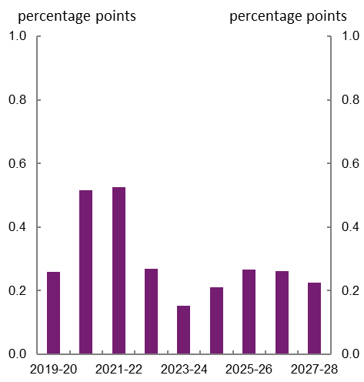 | 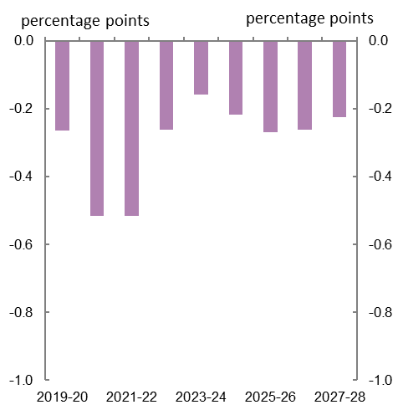
Source: 2017–18 Budget, Murphy (2017) and PBO analysis.

Economic results
The temporarily faster and slower economic growth scenarios build to a peak level impact on real GDP over three years and then eventually converge on the same level of real GDP as the central projection. There is a small permanent impact on the level of nominal GDP as the level of prices remains permanently higher or lower depending on the scenario.
As the economic results for the temporarily faster and slower real GDP growth scenarios are broadly symmetric, the results for the temporarily faster growth scenario are outlined below.
In this scenario, the growth rates in real and nominal GDP are stronger than the central projection for the first two years of the scenario. Real GDP growth is stronger by a ¼ percentage point in 2019–20 and 2020–21 resulting in growth of 3¼ per cent in both years.
Nominal GDP growth is stronger by a ¼ percentage point in 2019–20 and a ½ percentage point in 2020–21, resulting in growth of 4¾ per cent in 2019–20 and 5¼ per cent in 2020–21. The stronger growth in nominal GDP in 2020–21 reflects both higher real GDP and prices growth compared to the central projection.
These stronger growth rates have a cumulative impact on the level of both real and nominal GDP which rises to a peak impact in 2021–22 at which time the level of real GDP and nominal GDP are 0.5 per cent and 0.8 per cent higher than the central projection.
The impacts on the levels of aggregate wages and business profits peak in 2021–22 at
0.7 per cent and 0.9 per cent above the central projection. The result for aggregate wages is driven equally by average wages growth and employment growth. Average wages growth is stronger than the central projection by a ¼ percentage point in 2021–22 and 2022–23.
Due to the temporary nature of the shock, real GDP growth then slows below the central projection over the rest of the medium-term period which results in the level of real GDP being the same in the long run.
The temporarily faster economic growth scenario has a permanent impact on the level of prices and therefore the level of nominal GDP. This result is due to the Reserve Bank mandate of targeting inflation rather than the price level. As inflation is higher than the central projection, the Reserve Bank raises interest rates to slow the economy and return inflation to the mid-point of its target range, 2.5 per cent. While inflation returns to the central projection, the level of prices is permanently higher.
For a more detailed discussion of the economic impacts of the temporarily faster or slower economic growth scenarios, see Murphy (2017) on the PBO website and Appendix B for outcomes for key economic parameters.

Budget results
The temporarily faster and slower economic growth scenarios flow through to both receipts and payments since the levels of nominal GDP, the Consumer Price Index (CPI) and wages all diverge from the central projection. The maximum impacts on receipts and payments occur in the first few years of the temporary economic shocks and then fade as real GDP returns to the same level as the central projection.
The faster economic growth scenario is projected to result in the underlying cash balance (UCB) reaching a surplus of 0.4 per cent of GDP in 2027–28. This compares with the central projection of a surplus of 0.3 per cent in 2027–28. The slower economic growth scenario is projected to result in the underlying cash balance reaching a surplus of 0.2 per cent of GDP in 2027–28.
Figure 3–3 highlights the difference in total receipts and payments from the central projection due to the temporarily faster economic growth scenario. The impact on total receipts builds to a peak of just over $4 billion in 2021–22 when the difference in the level of nominal GDP is at its peak. As the difference in the level of nominal GDP declines so does the difference in total receipts. There is an ongoing higher level of total receipts than in the central projection as the level of nominal GDP is permanently higher as discussed in the preceding Economic results section.
The difference in total payments rises to a peak of around $1.2 billion in 2022–23 before declining to a small difference at the end of the medium term.
Figure 3–4 shows the main drivers of this profile in total payments. Initially the indexation impact of higher wages and inflation results in higher total payments compared with the central projection as demonstrated by the age pension payment profile which is the largest contributor to higher total payments. In contrast, lower public debt interest payments cumulatively build over the medium term and eventually offset higher age pension and other payments.

Figure 3–3: Change in total receipts and total payments—temporarily faster growth
Receipts | Payments
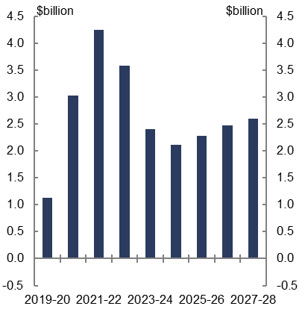 | 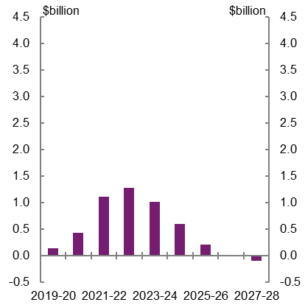
Source: PBO analysis.
Figure 3–4: Change in age pension and public debt interest payments—temporarily faster growth
Age pension | Public debt interest
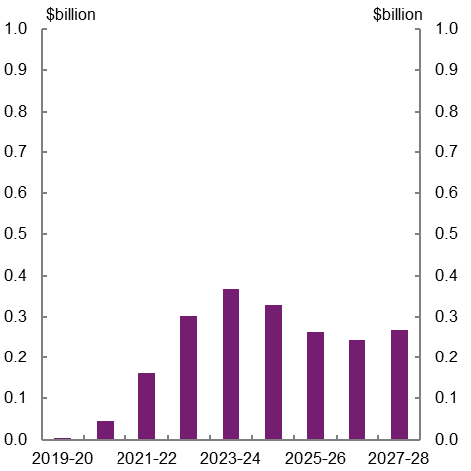 | 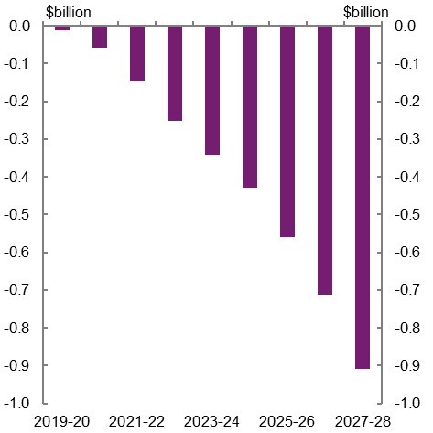
Source: PBO analysis.

Figure 3–5: Change in total receipts and total payments—temporarily slower growth
Receipts | Payments
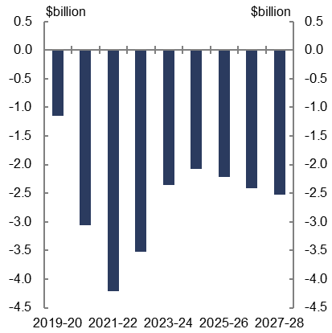 | 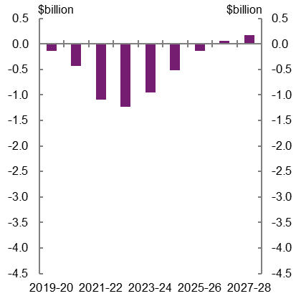
Source: PBO analysis
As can be observed in Figure 3–5 the total receipts and total payments impacts from the temporarily slower economic growth scenario are broadly symmetrical and result from the same drivers as the temporarily faster economic growth scenario.
The budget aggregates of total receipts, total payments, the underlying cash balance and net debt are typically scaled by the size of the economy by expressing them as a per cent of nominal GDP. This provides a means for comparisons over time and also across countries.
As a per cent of GDP, total receipts are fairly constant under the scenarios as tax receipts move broadly in line with the nominal economy and the tax cap of 23.9 per cent of GDP constrains tax receipts to the growth in nominal GDP over the medium term (Figure 3–6 and Figure 3–7). Since each scenario uses the level of nominal GDP relevant to that scenario, the level of nominal GDP used in the charts for each scenario is different to its level in the central projection.
Under all three projections, the tax cap binds in 2022–23. The timing of the application of the tax cap is not affected by the shocks because tax receipts vary proportionately with the changes in nominal GDP. This is the case for both faster and slower economic growth.
In contrast with receipts, some payments are assumed to be fixed in nominal dollars, for example defence expenditure, and changes in other payment types are partially offsetting. For this reason, payments either fall marginally as a per cent of GDP under the temporarily faster growth scenario as the level of nominal GDP is slightly higher, or rise marginally as a per cent of GDP under the temporarily slower growth scenario as the level of nominal GDP is slightly lower.
Figure 3–6: Payments and receipts—temporarily faster growth
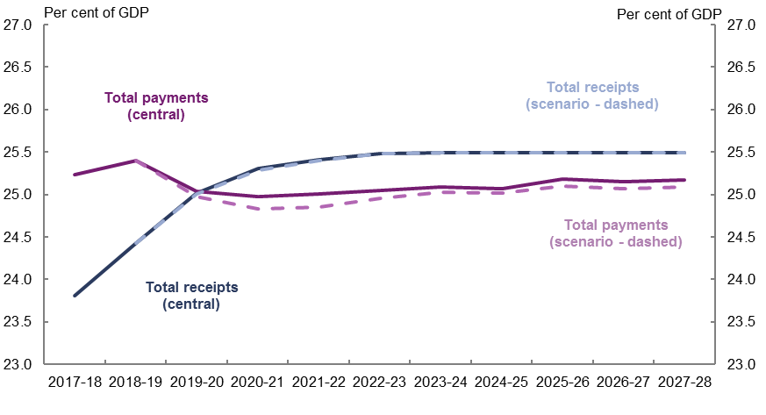
Source: PBO analysis
Figure 3–7: Payments and receipts—temporarily slower growth
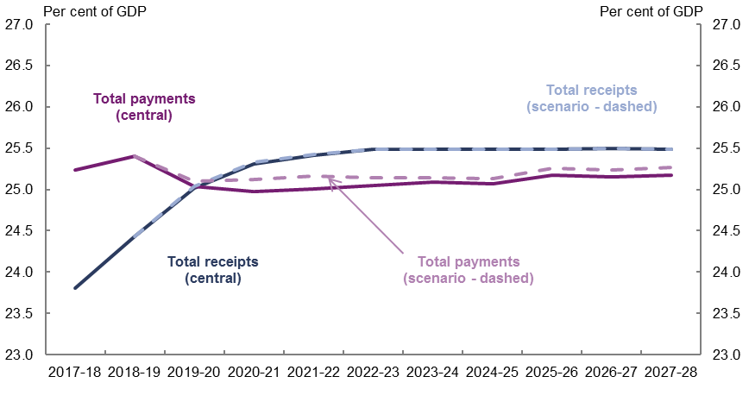
Source: PBO analysis.
As shown in Figures 3–8 and 3–9 the resulting impacts on both the underlying cash balance and net debt are small and tend to narrow over time due to the temporary nature of the economic growth shocks.
The small differences in the underlying cash balance as a per cent of GDP in 2027–28 reflect slightly higher or lower nominal GDP in the scenarios with largely unchanged total payments. Total receipts move in line with the higher or lower levels of nominal GDP. As a consequence of the small deviations in the underlying cash balance, the differences in net debt profiles are also very small.

Figure 3–8: Underlying cash balance projections—temporary shock scenarios
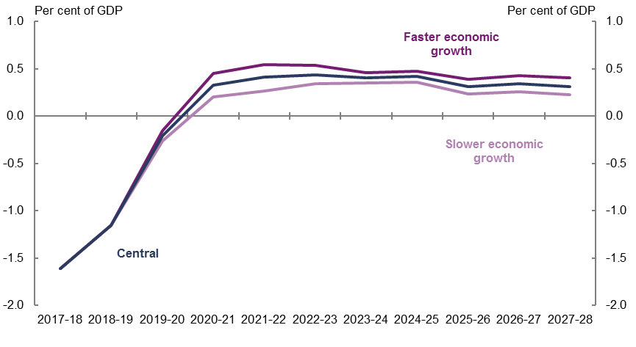
Source: PBO analysis.
Figure 3–9: Net debt projections—temporary shock scenarios
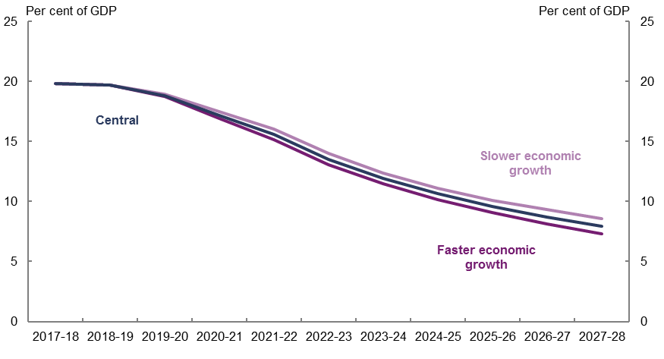
Source: PBO analysis.

Permanent economic growth shock scenarios
This section demonstrates the economic and budget impacts of permanent changes in the rate of economic growth, assumed to be driven by changes to labour productivity growth.
Permanent changes in the economy’s rate of economic growth have significant and compounding impacts on the budget. Permanently stronger economic growth benefits the budget position due to receipts increasing in line with stronger economic growth, while the increase in total payments is much smaller.
On the other hand, permanently weaker economic growth has a negative impact on the budget position as tax receipts weaken with slower economic growth while total payments decline marginally. This deterioration also results in higher debt servicing costs.

Background
Labour productivity refers to how much is produced, on average, for each hour worked. Labour productivity growth is a combination of capital deepening (growth in the ratio of capital to labour inputs) and multifactor productivity growth (a broader measure of productive efficiency that accounts for both labour and capital inputs).
Growth in labour productivity is a key determinant of national income growth. Together with population growth and growth in workforce participation, labour productivity growth determines the potential growth rate of the economy.
Labour productivity in Australia has grown by a factor of over five in the past century, and has more than doubled over the past 30 years (Productivity Commission, 2017). Australia’s labour productivity growth since 1981–82 is illustrated in Figure 4–1.
Figure 4–1: Australian labour productivity growth
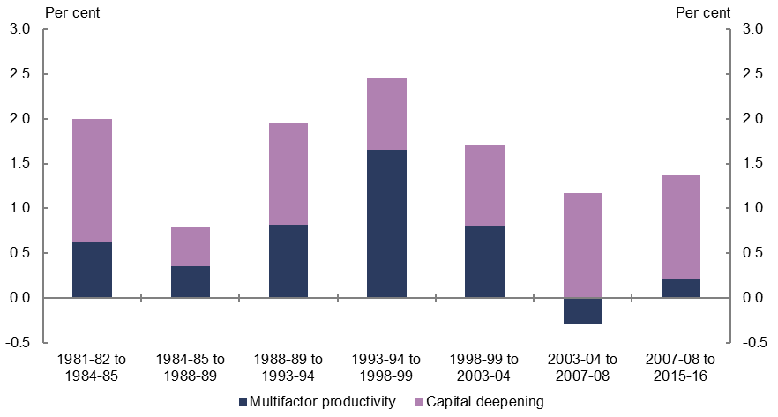
Source: Treasury (2017).
Previous analyses from the PBO (2014), Treasury (2017) and the Productivity Commission (2017) highlight that the slowing in productivity growth over the first half of the 2000s was experienced across most industries and while there is no single explanation for why this occurred, a number of factors have been identified:
- the significant investment in the mining sector and the lag that is often experienced between capital investment and output growth in these large and lumpy investments
- the contribution of ICT technologies in services industries that make significant use of them, beginning to slow
- the prolonged period of drought experienced in the early 2000s, which affected production in much of the agriculture industry
- the significant investment in the utilities sector that occurred, which is characterised by long and lumpy investment cycles with capital-output lags similar to those in mining.
The recent low growth in labour productivity is not unique to Australia and is being experienced across advanced economies (see Figure 4–2).
Figure 4–2: Labour productivity growth in advanced economies
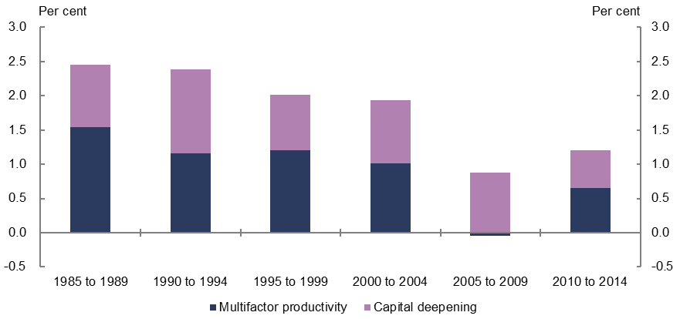
Source: OECD iLibrary and PBO analysis.
Notwithstanding some recent improvements in productivity growth internationally, advanced economies as a group have seen a slowdown in productivity growth dating back to before the Global Financial Crisis.
The OECD has noted that labour utilisation (hours worked per capita) has risen markedly in a number of countries in recent years and that this has been the most important driver of GDP per capita growth in many economies rather than increases in labour productivity. Weaker global labour productivity growth is partly the result of weaker investment that has seen capital deepening stall in many countries (OECD, 2017). The OECD highlights that the global weakening of labour productivity growth has occurred across sectors, but that declines have been sharpest in manufacturing, information and communication services, and in finance and insurance (OECD, 2017).
The International Monetary Fund also points to the broadly synchronised slowdown in productivity growth in advanced economies being linked to weakened technological innovation or diffusion, resulting from factors including the waning effects of the earlier boom in the adoption of information and communications technologies, population ageing, decelerating global trade integration, slowing human capital accumulation and taxation policies (IMF, 2017).

Scenarios
A key question is whether the low growth in labour productivity experienced in Australia over the past decade is the result of long-lived structural changes in the economy and internationally and will therefore continue, or whether labour productivity growth will pick up as short-term factors wash out. As outlined in the Productivity Commission’s 5 year productivity review, Government policy would also be expected to have an impact on the rate of future labour productivity growth.
The 2017–18 Budget central projection uses a technical assumption that labour productivity will grow at a trend rate of 1.6 per cent annually, in line with the 30-year historical average. This assumption contributes to an estimated annual potential growth rate for the economy of 2¾ per cent.
This section examines the sensitivity of the budget to labour productivity growth through two scenarios that have a permanent impact on the growth potential of the economy
(Figure 4–3):
- Labour productivity growth that is ¼ of a percentage point higher than the 2017–18 Budget assumption in each year, resulting in annual labour productivity growth of
1.85 per cent and an estimated annual potential economic growth rate of 3 per cent
- Labour productivity growth that is ¼ of a percentage point lower than the 2017–18 Budget assumption in each year, resulting in annual labour productivity growth of 1.35 per cent and an estimated annual potential economic growth rate of 2½ per cent.
Annual labour productivity growth of 1.35 per cent is consistent with the average growth in annual labour productivity over the past decade and both the higher and lower labour productivity growth scenarios used in this analysis are well within the historical range experienced over the past 40 years.
Figure 4–4 shows the percentage point deviation in the level of real GDP between the labour productivity growth scenarios and the central projection.

Figure 4–3: Real GDP growth—2017–18 Budget and labour productivity growth scenarios
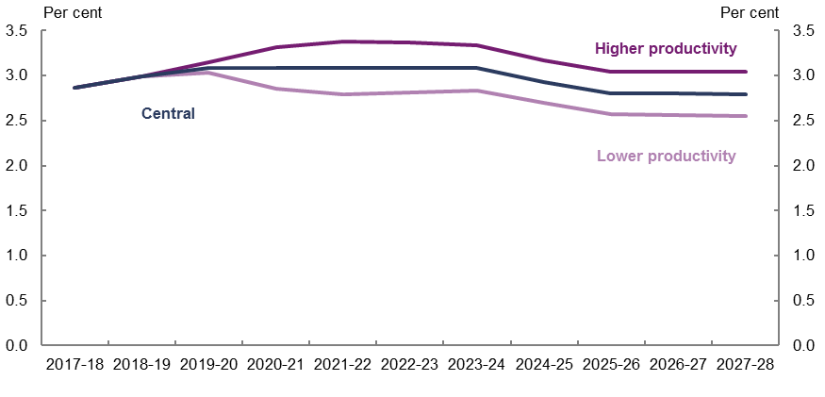
Source: 2017–18 Budget, Murphy (2017) and PBO analysis.
Figure 4–4: Percentage deviation in the level of real GDP from the central projection
Higher productivity | Lower productivity
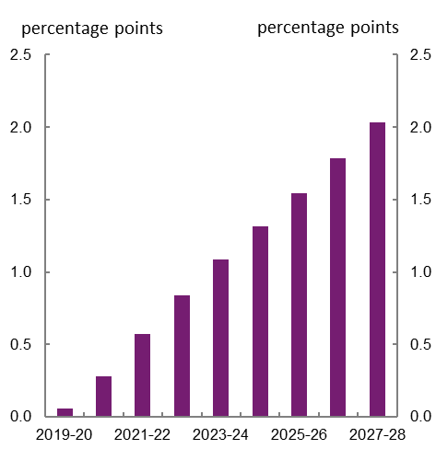 | 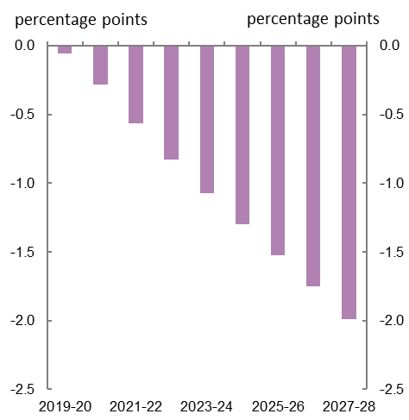
Source: 2017–18 Budget, Murphy (2017) and PBO analysis.

Economic results
The labour productivity scenarios have a permanent impact on the potential rate of economic growth in Australia. As the economic results for the two productivity growth scenarios are broadly symmetric, the results for the lower productivity growth scenario are outlined below.
As labour productivity growth is assumed to be lower than the central projection in each year from 2019–20 under this scenario, there is a compounding effect which results in the level of output per hour worked being 2 per cent lower in 2027–28 than the central projection.

Consistent with the cumulative effects on the level of labour productivity, the size of the economy (as measured by real GDP) is also around 2 per cent smaller in 2027–28 than the central projection.
Lower productivity initially leads to higher inflation. While the Reserve Bank responds through higher interest rates to achieve its inflation target, the price level is permanently higher by 0.3 per cent compared to the central projection.
The level of nominal GDP is 1.7 per cent lower in 2027–28 than in the central projection, reflecting the combined impact of lower real GDP of 2.0 per cent, and prices being 0.3 per cent higher. Lower economic growth results in a lower level of business profits which are 1.4 per cent lower in 2027–28 than in the central projection.
Lower labour productivity growth flows through to a lower level of aggregate wages, which are 1.9 per cent lower in 2027–28 compared to the central projection. As wages growth moves in line with labour productivity growth, at the end of the medium term wages are growing by 3¾ per cent annually compared with the long-run assumption of 4 per cent annually.
For a more detailed discussion of the economic impacts of the labour productivity scenarios, see Murphy (2017) and Appendix B for the outcomes for key economic parameters.

Budget results
As outlined above, the labour productivity growth scenarios are examples of shocks that deliver permanent changes in the rate of economic growth in Australia. They result in permanent and cumulative impacts on the budget compared to the central projection. Permanent changes in the economy result in ever increasing impacts over time on receipts and payments in contrast to the temporary economic growth shocks discussed in section 3.
The lower labour productivity growth scenario is projected to result in a broadly balanced underlying cash balance by 2027–28, compared to a surplus of 0.3 per cent of GDP under the central projection. Higher labour productivity growth is projected to result in the underlying cash balance reaching 0.6 per cent of GDP by 2027–28.
Figure 4–5 and Figure 4–6 show the increasing difference in total receipts and payments compared to the central projection over the period 2019–20 to 2027–28 under the lower and higher productivity growth scenarios. The change in receipts is over twice as large as the change in payments. Weaker growth in aggregate wages and nominal GDP results in total receipts being $13 billion lower in 2027–28 than in the central projection.
Figure 4–5: Change in total receipts and total payments—lower productivity growth scenario
Receipts | Payments
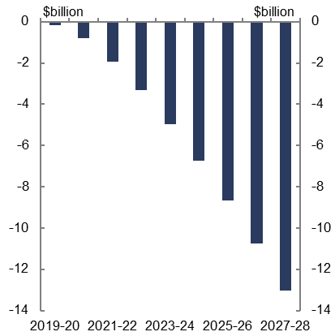 | 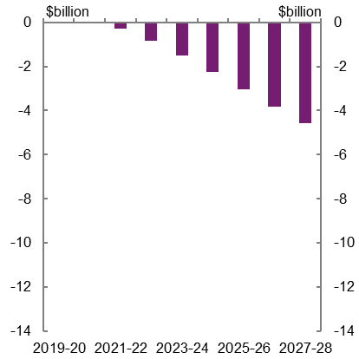
Source: PBO analysis.
Figure 4–6: Change in total receipts and total payments—higher productivity growth scenario
Receipts | Payments
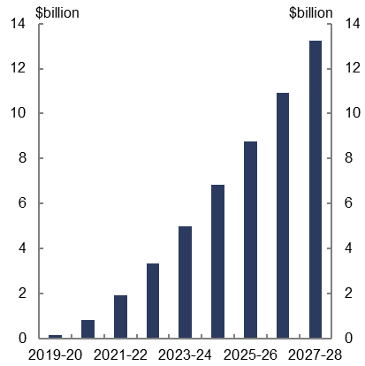 | 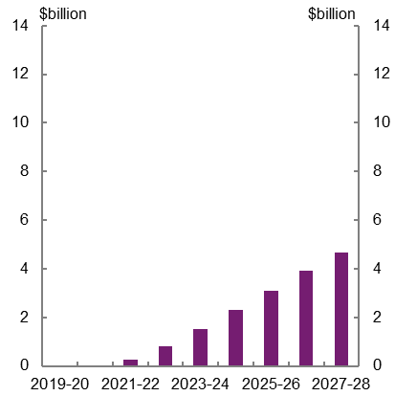
Source: PBO analysis.

Figure 4–7 and Figure 4–8 show the main drivers of the differences in receipts and payments. Personal income tax receipts are lower under the lower productivity growth scenario as a result of lower aggregate wages and less ‘bracket creep’ whereby income earners face higher average tax rates as their incomes rise. Personal income tax receipts are around $7 billion lower in 2027–28 compared to the central projection, accounting for around half of the total lower receipts of $13 billion. The PBO adjusts the personal income tax receipt projections such that total tax receipts remain at 23.9 per cent of GDP, consistent with the Government’s technical assumption of a tax-to-GDP cap.
Figure 4–7: Change in receipts and payments in 2027–28—lower productivity growth scenario
Receipts | Payments
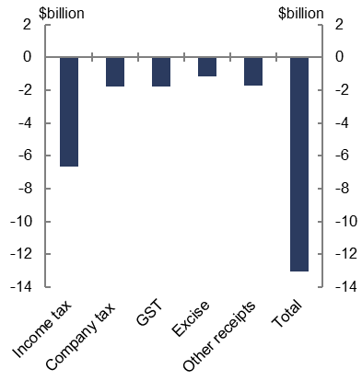 | 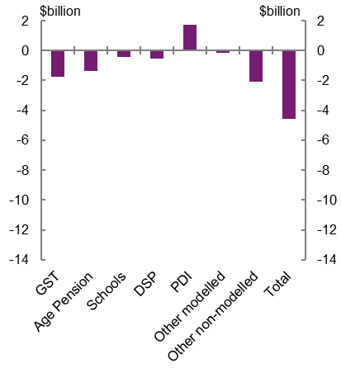
Source: PBO analysis.
The change in total payments is partly linked to changes in receipts. GST transfers to the states decrease in line with receipts, contributing to lower total payments than under the central projection, but with no net effect on the UCB. As total receipts decrease by more than total payments (excluding public debt interest payments), the level of government debt is higher than under the central projection leading to higher public debt interest (PDI) payments. Higher public debt interest payments partly offset the decrease in other payment categories.
Lower productivity growth drives lower wages growth which affects pension payments including the age pension, disability support pension (DSP) and the carer’s payment that are benchmarked to average weekly earnings. Thus pensions and other payments such as schools funding that are linked to wage outcomes are lower over the medium term than under the central projection.
Higher inflation under the lower productivity growth scenario results in some other payments that are linked to CPI including Family Tax Benefit, Job Seeker Income Support, Private Health Insurance Rebate and the Commonwealth Grants Scheme of university subsidies, being slightly higher than under the central projection.
The higher productivity growth scenario responds in a corresponding manner with higher pension payments, GST transfers and other payments being partly offset by lower PDI payments due to the movements in receipts being larger than the movements in payments, resulting in a stronger underlying cash balance.
Figure 4–8: Change in receipts and payments in 2027–28—higher productivity growth scenario
Receipts | Payments
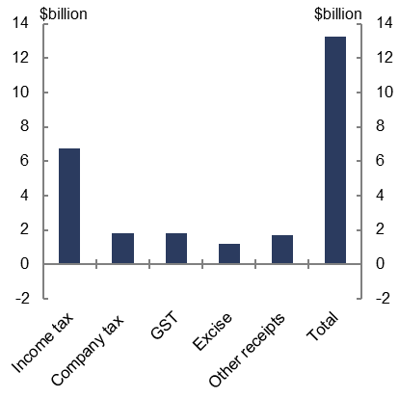 | 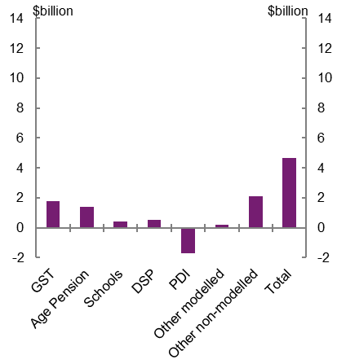
Source: PBO analysis.
As outlined in Section 3, the budget aggregates of total receipts, total payments, the underlying cash balance and net debt are often scaled by the size of the economy by expressing these aggregates as a per cent of nominal GDP. This provides a means for comparisons over time and across countries.
As a per cent of GDP, total receipts are fairly constant under the scenarios as receipts move broadly in line with the nominal economy and the tax cap of 23.9 per cent of GDP constrains tax receipts to the growth in nominal GDP over the medium term (Figure 4–9 and
Figure 4–10). The tax cap binds in 2022–23 under the central projection and both scenarios.
In contrast, because some payments are assumed to be fixed in nominal dollars, for example defence expenditure, and changes in other payment types are partially offsetting, payments either rise significantly as a per cent of GDP with a smaller economy or fall significantly as a per cent of GDP with a larger economy.
Figure 4–9: Payments and receipts—lower productivity growth scenarios
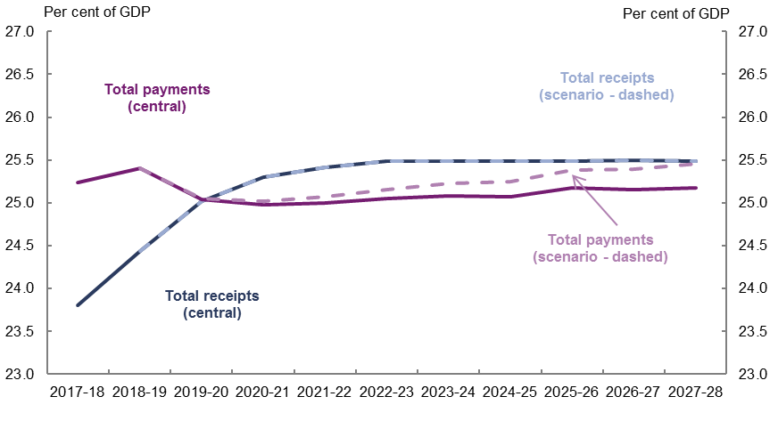
Source: PBO analysis.
Figure 4–10: Payments and receipts—higher productivity growth scenarios
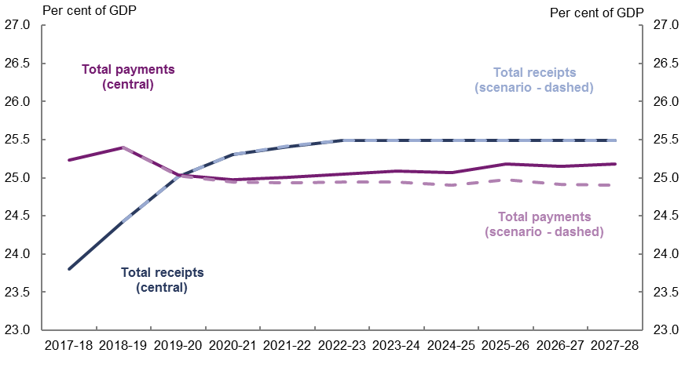
Source: PBO analysis.
The combination of the effects on total receipts and payments results in significant and enduring impacts on the underlying cash balance (Figure 4–11) and net debt (Figure 4–12). Permanently weaker economic growth through lower labour productivity growth is projected to result in a broadly balanced budget position by 2027–28, albeit on a deteriorating trajectory, compared to a surplus of 0.3 per cent of GDP under the central projection. Permanently stronger economic growth under the higher labour productivity growth scenario is projected to result in the underlying cash balance reaching 0.6 per cent of GDP by 2027–28.
Figure 4–11: Underlying cash balance projections—productivity growth scenarios
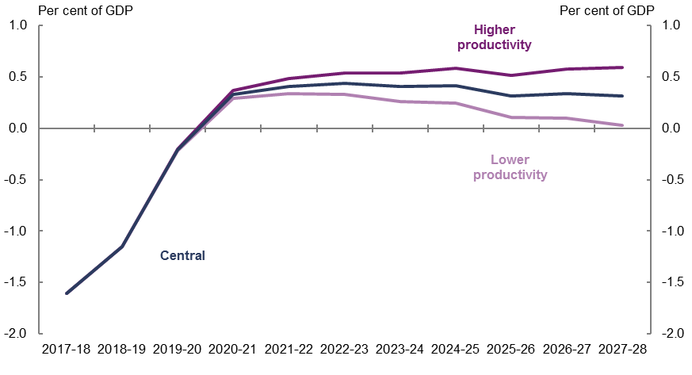
Source: PBO analysis.
Permanently stronger economic growth benefits the government’s budget position only to the degree that the additional revenue is not spent or given back as tax cuts (beyond the assumed tax cap of 23.9 per cent of GDP).
Sustained weaker economic growth and a lower underlying cash balance under the lower productivity growth scenario leads to higher net debt. Conversely, the sustained higher underlying cash balances under the higher productivity scenario results in lower net debt (Figure 4–12).
Figure 4–12: Net debt projections—productivity growth scenarios
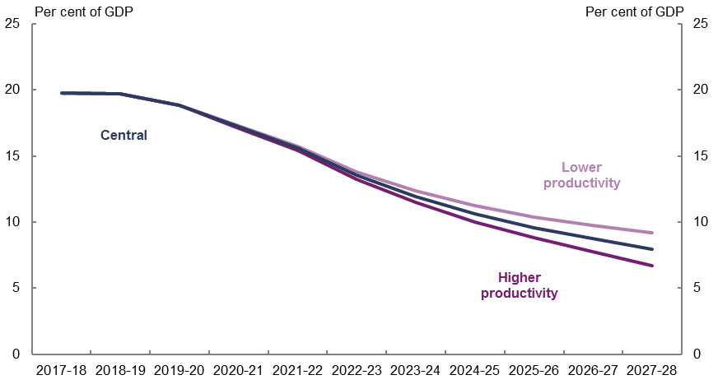
Source: PBO analysis.

Interest rate scenarios
This section considers the budget impacts of lower interest rate assumptions on government debt over the medium term.
Lower interest rates, or bond yields, result in lower public debt interest payments on new borrowings, which increase the underlying cash balance. The impact on net debt is less straightforward. On the one hand, lower public debt interest payments on account of lower bond yields means lower government borrowing to fund interest payments—this decreases net debt. On the other hand, lower bond yields lead the existing stock of government debt to be revalued upwards—this increases net debt. The net impact of these results is net debt being broadly the same as the central projection in 2027–28.

Background
Short-term interest rates and bond yields are currently around record lows (Figure 5–1), due to monetary policy easing, compressed risk premia, subdued inflation expectations and a fall in the neutral real interest rate in the years following the Global Financial Crisis.
Figure 5–1: 10-year Government bond yields
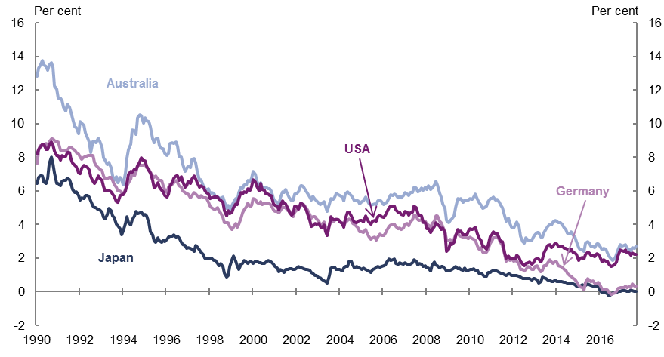
Source: Federal Reserve Bank of St Louis FRED database.
Despite the current low levels of bond yields, market participants and policymakers anticipate an increase in yields as economic and financial conditions improve and monetary stimulus is withdrawn by central banks.
Government bond yield assumptions have a significant influence on the market value of Government debt and public debt interest payment projections and are therefore a determinant of budget aggregate projections. Box 2 contains background information on the bond market, bond yields and their impact on the budget.
Box 2: Bond market and debt management concepts
What are bonds?
Bonds are the most significant source of debt finance globally across the public and private sectors. Governments sell bonds to finance budget deficits and maintain sovereign bond markets. In return, the purchaser of the bond is entitled to receive periodic interest payments, and full repayment of the principal when the bond matures.
Bonds issued by the Australian Government are known as Commonwealth Government Securities (CGS). The Australian Government issues the following types of bonds via auctions: fixed coupon nominal bonds (Treasury Bonds); short term instruments (Treasury Notes); and inflation-linked bonds (Treasury Indexed Bonds).
CGS are issued across a series of maturities (up to 30 years in time to maturity) to manage risk in the debt portfolio and promote liquidity in the bond market for investors and financial intermediaries.
Bond yields
In the context of the budget papers, bond yields are interest rates on CGS. Bond yields determine the Government’s interest costs for servicing its debt portfolio. The interest payments on CGS are called public debt interest (PDI) payments.
Bond yields change frequently according to financial market developments and at any given point in time there is likely to be a different bond yield for each bond maturity date.
Commonwealth Government Securities and the Australian Government’s fiscal position
The face value of a Commonwealth Government Security such as a Treasury Bond is the amount that its purchaser is entitled to receive when the security matures. The market value is the market’s pricing of that security, which is the market’s appraisal of the value of the security, as reflected by its bond yield. Government debt is recognised on the Government’s balance sheet at its market value. The market value of CGS on issue is the face value of CGS on issue, adjusted for current market pricing, as reflected in bond yields. This adjustment is known as the revaluation effect.
When investors demand a higher rate of return on their investment (in this case yields on CGS), they reduce the price they are willing to pay for existing government securities on issue. This reduces the market value of government securities on issue. Hence, as bond yields rise, a revaluation effect results in the market value of CGS on issue falling. This reduces net debt. As bond yields fall, a revaluation effect results in the market value of CGS on issue rising. This increases net debt.
Public debt interest payments are a key component of Government payments, and affect the underlying cash balance. As bond yields rise, public debt interest payments on new borrowings (including for refinancing activity) increase. This decreases the underlying cash balance. As bond yields fall, public debt interest payments on new borrowings
(including for refinancing activity) decrease. This increases the underlying cash balance.

Scenarios
The 2017–18 Budget assumes that the yields on Commonwealth Government Securities will gradually rise over the medium term. Over the forward estimates, bond yields are assumed to remain at the levels observed in April 2017, just prior to the release of the Budget. From 2021–22, yields are assumed to rise from these levels and converge towards a long-run yield curve based on historical average yields. The yield on 10-year bonds is assumed to rise from 2.6 per cent in 2017–18 towards a long-run level of 6 per cent over the projection period (solid dark blue line in Figure 5–2).
Figure 5–2: 10-year Commonwealth Government Security yields—2017–18 Budget and interest rate scenarios
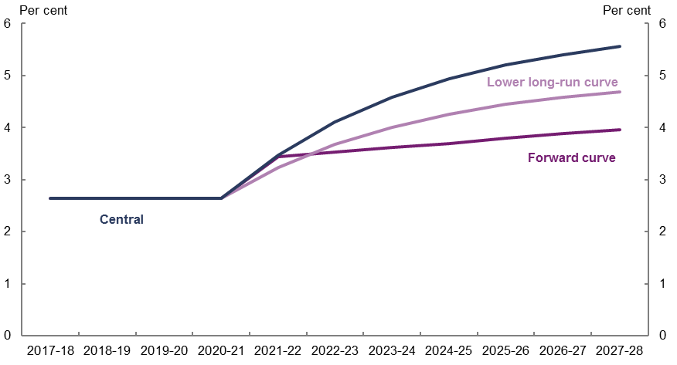
Source: PBO analysis.
This section analyses the effects on the budget of alternative Government bond yield assumptions over the medium term. Two scenarios are considered:
- Lower long-run yield curve: This scenario maintains the current approach of converging towards a long-run yield curve over the projection period, but uses a lower long-run yield curve based on a 10-year yield of 5 per cent (Figure 5–2).
- Forward yield curves: This scenario applies the current forward yield curve over the medium term. Forward yield curves reflect market participants’ current views regarding the future path of the yield curve. Forward yield curves use the information in the current yield curve to derive the level and shape of the yield curve at any date in the future, out to the longest outstanding bond maturity. Using the current forward yield curve provides an outlook for interest rates consistent with the current expectations of financial market participants (Figure 5–2 illustrates that the 10-year yield rises to around 4 per cent over the projection period in the forward yield curve scenario).
Both interest rate scenarios commence in 2021–22 and cover the 2017–18 Budget medium-term projection period. Both scenarios maintain the April 2017 yield curve over the forward estimates, consistent with the central projection.
The PBO has assumed that the central economic projection remains the same despite the different yield curve assumptions. That is, projected economic growth and inflation are assumed not to vary in the different interest rate scenarios. Also as a reduction in bond yields is typically associated with falls in real interest rates and/or inflation, and inflation projections are assumed to remain unchanged in the scenarios, this implies that the lower bond yields in the scenarios are due to falls in the real interest rate. These falls in the real interest rate are assumed not to affect payment and receipt projections other than public debt interest payments.

Budget results
The aggregate projections for the budget are sensitive to bond yield assumptions. Lower bond yields over the medium term would be projected to lower PDI payments and consequently increase the underlying cash balance.
PDI payments in these scenarios are lower for two reasons (Figure 5–3). First, there is the immediate effect of the government facing lower interest payments on its new borrowings. Second, the lower PDI payments reduce the amount of new debt that needs to be issued to fund those interest payments, further reducing PDI payments compared to the central projections. This effect compounds over time.
The underlying cash balance projections presented in Figure 5–4 reflect the lower PDI payments under the two alternate bond yield scenarios.

Figure 5–3: Public debt interest projections—Interest rate scenarios
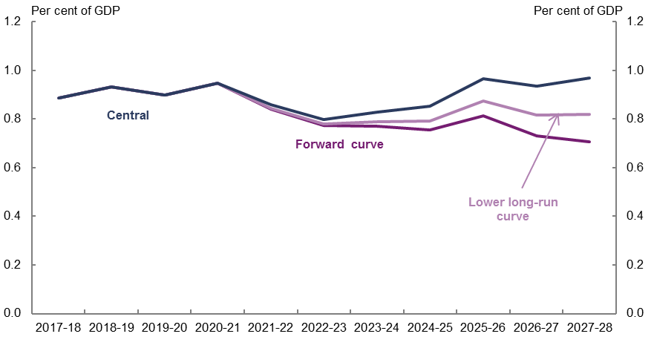
Source: PBO analysis.
Figure 5–4: Underlying cash balance projections—Interest rate scenarios
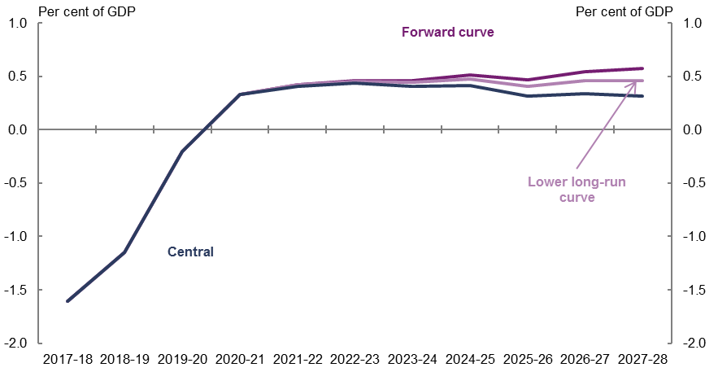
Source: PBO analysis.
Lower bond yields also result in a temporarily higher market value of the government’s debt portfolio due to a revaluation effect, because lower yields lead to an increase in the market value of the debt portfolio. As net debt captures the market value of the Commonwealth Government Securities portfolio, net debt is temporarily elevated under the bond yield scenarios compared to the central projection (Figure 5–5).
Over time, this revaluation effect from lower yields is offset because the lower PDI payments mean that less new debt has to be issued to finance those payments. As the effect of reduced PDI payments from lower bond yields has a more persistent effect on the stock of debt than the revaluation effects, lower bond yields will result in lower net debt and a stronger Government balance sheet over the long term.
In Figure 5–5, the forward yield curve has higher net debt due to the revaluation effect until 2026–27. From this point onwards, the compounding effects of lower PDI payments reduces the market value of the government’s debt portfolio by more than the revaluation effect increases it.
Figure 5–5: Net debt projections—Interest rate scenarios
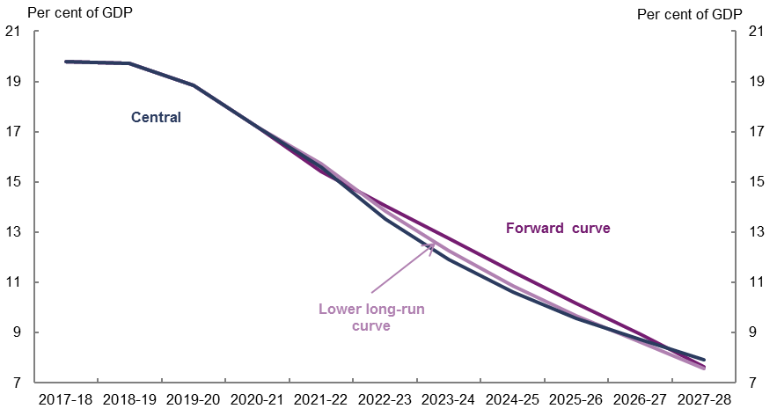
Source: PBO analysis.
The lower long-run curve scenario projections are between the forward curve and central projections across all results charts. As such, the lower long-run curve scenario can be thought of as an intermediate scenario capturing the spectrum of possible outcomes between the central yield curve profile over the medium term and the forward curve scenario.
In summary, lower bond yields improve the underlying cash balance via lower interest payments, and improve net debt over the long run. While there is a temporary increase in net debt relative to the central projection due to a revaluation effect, this washes out by the end of the medium term as lower PDI payments lead to reduced issuance. This result is subject to the underlying assumption that the central projection economic parameters are still maintained under the bond yield scenarios, meaning that receipt and payment projections that are not sensitive to interest rates are unchanged from the central projection.

Appendix A – Technical notes
The scenario analysis uses the central economic and budget projections consistent with those published in Parliamentary Budget Office report no. 02/2017, 2017–18 Budget: medium-term projections, with the exception of the public debt interest payments projections (see the payment projection methodology section below for further information). Any government decisions announced since the release of the 2017–18 Budget have not been reflected in the central projection or the scenarios.

Methodology for economic scenarios
The four distinct economic scenarios in this report (higher labour productivity growth, lower labour productivity growth, faster economic growth, slower economic growth) are based on changes to the economy which affect key economic parameters and therefore fiscal outcomes.
The modelling approach involves varying the labour productivity growth rate and non-mining business investment to produce four alternative economic scenarios over the medium-term.
The impacts of the scenarios were produced by independent modeller Chris Murphy using his Macro-econometric Model. The impacts of the scenarios on the economic parameters were expressed as percentage deviations from the central projection levels, and were presented on an annual basis. For further information on the economic modelling approach, refer to
Murphy (2017) Economic impact of selected macroeconomic shocks, available on the PBO website.
The PBO then applied percentage deviations from the baseline provided by Murphy to the central economic projection to generate the economic parameters for each scenario. The impact on each receipt and payment type for each scenario were then calculated using the scenario economic parameters and the methodology outlined in sections A2 and A3 below.

Receipt projection methodology
The PBO’s projections comprise individual receipt projections of all of the Commonwealth Government’s major heads of revenue.
The PBO’s projections of receipts are generally prepared using a base plus growth methodology. Economic parameters are used to estimate growth rates which are then applied to the relevant base. For policy decisions where the impact is not already factored into the base year data or the economic parameters, the projected impact of these measures are added to the base projections.
Details of the methodology used to arrive at projections for individual revenue heads are outlined in the table below.
Model | Description | Methodology
Gross income tax withholding and gross other individuals and refunds | These revenue heads broadly cover all personal income tax, including revenue from salary and wages, the Medicare Levy and Medicare Levy Surcharge, personal income tax offsets, income from profits from unincorporated businesses, primary production and investment activities, as well as capital gains. | The aggregate taxable income for individuals over the medium term is calculated by growing individual income items from the ATO’s Taxation Statistics data by the relevant economic parameters, most notably compensation of employees.  For each year, an average gross tax rate is applied based on the parameters of the 2017–18 Budget and current Government policy.  Projected tax offsets are applied and the timing of tax collections is taken into account to arrive at the receipts projections.  The PBO adjusts the individual and other withholding tax receipt projections such that total tax receipts remain at  23.9 per cent of GDP, consistent with the Government’s technical assumption of a tax-to-GDP cap.
Company tax | Tax on profits, including capital gains, of incorporated businesses. | The projections are based on an approach whereby company tax revenue is recognised at the point that a company tax payable liability arises for a company from its underlying economic activity. Three industry groupings, Mining, Finance and all Other companies are utilised in the projection modelling, to reflect structural differences in companies from different industries.  The tax base across the three sector groupings (itself derived from the 2014–15 company tax return unit record data), is grown with the Gross Operating Surplus economic parameter corresponding to the relevant industry grouping. Adjustments are made to capture depreciation and net capital gains.  The timing of tax collections is taken into account to arrive at the receipts projections.  Adjustments are made to account for other elements (principally the R&D tax offset) that are reported against company tax receipts.
Superannuation fund taxes | Tax on super fund contributions and investment earnings, including capital gains, of Australian Prudential Regulation Authority funds and self-managed super funds. | Projections for the taxable income of  APRA-regulated superannuation funds and  self-managed superannuation funds are based on the structure of a superannuation fund’s tax return.  Historical data from APRA’s Annual Superannuation Bulletin and the ATO’s Taxation Statistics data are grown by relevant economic parameters for projections of taxable income. Statutory tax rates are then applied to the projections of taxable income.  Projected tax offsets are applied and the timing of tax collections is taken into account to arrive at the receipts projections.
Customs and excise | Includes customs duties on textiles, clothing and footwear, passenger motor vehicles and other imports, excise on fuel and excise and customs duties on tobacco and alcohol (except wine, for which WET applies). | Receipts from each category of excise and customs duty are projected in a similar way: a growth rate is determined using a quantity parameter, and where appropriate, prices are grown using the appropriate price parameter.  The relevant parameters are:  - fuel—private consumption of fuel, real GDP and the Consumer Price Index  - textile, clothing and footwear—imports of textiles, clothing, footwear  - passenger motor vehicles—imports of non-industrial transport equipment  - other imports—imports of endogenous goods less imports of non-industrial transport equipment and imports of textiles, clothing, footwear  tobacco—private consumption of cigarettes and Adult Ordinary Time Earnings  - alcohol—private consumption of alcohol and the Consumer Price Index.
Petroleum Resources Rent Tax (PRRT) | Tax on profits from sales of petroleum products. | PRRT receipts are projected based on volume and AUD price of oil (Malaysian Tapis) in the forward estimates period, and AUD price of oil only beyond the forward estimates period.
Goods and services tax (GST) | Indirect tax on the consumption of certain goods and services. | GST receipts are projected based on the growth in consumption subject to GST using the following parameters: consumption subject to GST, private dwelling investment, and ownership transfer costs.
Wine equalisation tax (WET) | A value-based tax on wine consumed in Australia. | WET receipts are projected based on the growth in private consumption of alcohol.
Luxury car tax (LCT) | A tax on luxury cars sold or imported, where their value exceeds a threshold. | LCT receipts are projected based on the growth in sales of cars and station wagons and the motor vehicle price indicator.
Other taxes and charges | Other indirect taxes and levies, including the major bank levy, agricultural levies and the Skilling Australians Fund levy. | Other taxes and charges are projected based on the growth in nominal GDP.
Non-tax receipts | Includes interest and dividend earnings (including Future Fund earnings), NDIS contributions from the States and Territories, sale of non-financial assets, and other non-tax receipts. | The largest component of receipts from the sales of goods and services are NDIS contributions from the States and Territories, which are consistent with the PBO’s profile of NDIS expenditure over the medium-term.  Future Fund earnings are projected over the medium-term using the projection methodology from PBO Report No. 01/2017. Reflecting the Government’s decision to delay the drawdown of the Future Fund and to reduce its target return to at least the Consumer Price Index (CPI) plus 4 to 5 per cent, drawdowns are assumed to occur once the projected Fund balance reaches its projected target asset level in 2027–28. Under the Future Fund Act 2006, net Future Fund earnings will be available to meet the Government superannuation liability in 2020–21. Consistent with the 2017–18 Budget assumption, the underlying cash balance includes expected net Future Fund earnings from 2020–21.  The remainder of non-tax receipts are assumed to remain as a constant share of nominal GDP over the medium-term.

Payment projection methodology
The PBO’s payments projections comprise 23 individual projections of key Government payments, which in total comprise approximately 80 per cent of total government payments.
Details of the methodology used to arrive at projections for individual programs are outlined in the table below.
Model | Description | Methodology
National Disability Insurance Scheme (NDIS) | The coverage of the NDIS projections is the administered and departmental spending of the National Disability Insurance Agency and transitional funding. The projections also include the Commonwealth contribution to the Western Australian NDIS. | Expenditure projections of recipients’ care and support are based on projections of the number of recipients and the average disability package costs of two cohorts, those aged 0–64 years and those aged 65 years and over.  The departmental spending of the NDIA is assumed to be relatively flat over the medium-term.
Aged Care | Consists of subsidies for residential care, the Commonwealth Home Support Program and subsidies for Home Care Packages. | The number of subsidised aged care places follows Government policy to provide 125 aged care places per 1,000 persons aged over 70 years old by 2021–22 and maintains this ratio beyond 2021–22. The value of residential care and home care packages subsidies are assumed by the PBO to grow by the CPI beyond the forward estimates period.  The Commonwealth Home Support Program is an annual appropriation projected to grow at a wage cost index plus 3.5 per cent (in line with the aged care measure announced in the 2014–15 Budget).
Child Care | Includes the Child Care Benefit and Child Care Rebate for 2017–18 becoming the Child Care Subsidy in  2018–19. | The number of recipients of the Child Care Subsidy is projected based on the rate of population growth of young children plus an additional growth factor (based on historical data) which takes into account that child care hours used has grown faster than eligible population growth.  Child care prices are projected to grow in line with recent historical trends in child care fees, declining to the rate of wages growth over the medium term.
Defence spending | The net cost of service for the Department of Defence including employee costs, supplies and purchases of capital including specialist military equipment. | Projections of defence spending over the medium term are based on long-term funding commitments to 2025–26 made in the 2016 Defence White Paper updated for developments in subsequent budgets.  From 2026–27 the PBO has assumed Defence spending maintains its share of nominal GDP.
Schools | Comprises the National Specific Purpose Payment from the Commonwealth to states and territories (states) for government schools and the non-government sector. | Projections are based on the 2017–18 Budget Quality Schools policy, which does not include subsequent amendments passed by the Parliament.  Schools expenditure projections over the medium term are calculated based on achieving target levels of the Schooling Resource Standard (SRS) by sector over  10 years and projected growth in student enrolments.  Funding for government schools is calculated based on increasing per student SRS funding for government schools from 17 per cent in 2017 to 20 per cent by 2027 and 76.8 per cent in 2017 to 80 per cent by 2027 for non-government schools.
Payments to individuals | Social security payments including the Family Tax Benefit; Disability Support Pension; Carer income support (primarily Carer Payment and Carer Allowance); Parenting Payments (Single and Partnered); and Job Seeker Income Support (Newstart, Youth Allowance (Other), Sickness Allowance, becoming Jobseeker Payment). | Projected expenditure on these payments is calculated as projected recipients multiplied by the average payment rate.  Recipient numbers are projected by grouping them into age and gender cohorts and calculating the historical per capita growth in take-up of the payment. This  per-capita take-up growth is applied to medium-term population projections. Job seeker income support also adjusts for projected changes in unemployment.  The average rate of payment is grown by the legislated indexation factor for that program (which is either CPI or wages).
Medicare Benefits Schedule | Includes non-DVA related expenditure under the Medicare Benefits Schedule. | Detailed historical data is used to model expenditure by age, gender and service type (e.g. GP services, allied health etc.). The MBS projection methodology is described in detail in Appendix C—Technical Notes and Sources of the PBO report 04/2015 Medicare Benefits Schedule.
Public hospitals | Commonwealth funding of public hospitals | Projected Commonwealth funding for public hospitals over the medium term is set with reference to the annual determination of the National Efficient Price (NEP).  The current National Health Reform Agreement on Commonwealth funding for public hospitals will expire in 2020 with a commitment to consider a subsequent long-term agreement in 2018. The PBO has made an indicative assumption that current funding arrangement will continue over the projection period.  The projection of price growth in providing hospital services is based on the indexation rate in the latest NEP determination.  Growth in the number of patient services is projected based on the trend of historical number of services provided annually.
GST transfers to states | GST receipts less non-general interest charge penalties collected. | See Receipts projection methodology, GST receipts.
Fuel Tax Credit Scheme | Credits for the excise or customs duty on fuel a business uses in machinery, plant, equipment, heavy vehicles and light vehicles travelling off pubic roads or on private roads. | Fuel Tax Credit Scheme expenditure is calculated by applying credit scheme rates on projected fuel excise and customs duty revenue collections (see Receipts projection methodology, Customs and excise). Credit scheme rates are projected by indexing them in line with the CPI.
Government superannuation | Cash payments associated with the unfunded civilian and military schemes. | Projections are based on the Long Term Cost Reports adjusted for changes to the indexation of retirement benefits.
Age Pension | Includes the Age Pension under the Income Support for Seniors program. | Projected expenditure for the Age Pension is calculated as projected recipients multiplied by the average payment rate.  Historical Age Pension recipient data is used and grown at the same rate as the growth in the Australian population of Age Pension age. The impact of the increase to the Age Pension eligibility age is included over the medium term.  The projected average rate of payment is based on projections of MTAWE, CPI and Pensioner and Beneficiary Cost of Living Index and the proportions of full-rate and part-rate Age Pension recipients. It is assumed that the proportion of part-rate Age Pension recipients gradually increases over the medium term in line with increasing superannuation balances.
Private Health Insurance (PHI) rebate | Department of Health and Australian Taxation Office payments related to the PHI rebate. | Detailed historical PHI data is used to project the proportion of persons covered by health insurance. These coverage ratios are then applied to future population estimates. The coverage ratios remain fixed over the medium term, reflecting the recent flattening in PHI coverage.
Official Development Assistance | Comprises expenditure on foreign aid administered by the Department of Foreign Affairs and a small component for associated spending in other departments. | After a two-year indexation freeze introduced in the 2017–18 Budget, Official Development Assistance expenditure over the medium term is projected by indexing it to growth in the CPI from 2021–22 to 2027-28.
Commonwealth Grants Scheme | Grant funding to higher education providers for each student enrolled in a Commonwealth Supported Place (CSP) at the institution. | Commonwealth Grants Scheme (CGS) expenditure is calculated based on recent trends in CSP student enrolment projections across eight clusters with varying per student amounts for areas of study reflecting associated course costs. Projections are adjusted for the impact of 2017–18 Budget measures.
Pharmaceutical benefits | Comprises the special appropriation of the Pharmaceutical Benefits Scheme. | PBS projections are calculated by taking historical expenditure data grouped by age and gender cohorts and calculating the historical per capita growth in PBS expenditure. This is then used to derive a trend growth for PBS spending per capita over the medium term.
Veterans Support | Comprises expenditure on income support and health programs for veterans. | Projections of expenditure on veterans support are based on projected growth in recipient numbers and the average payment for the service provided.  Recipient projections are based on 10-year Pensioner Beneficiary Statistics prepared by the Department of Veterans Affairs.  The average rate of payment is grown by the relevant indexation factor for that program.
Road and rail Infrastructure | Comprises expenses for road and rail projects. | From 2017–18 to 2020–21 infrastructure expenditure is assumed for this analysis to represent spending budgeted for announced projects and not sensitive to economic changes absent Government policy decision. Beyond 2020–21 road and rail expenditure is projected to grow in line with the growth rate of nominal GDP over the medium term.
Public debt interest | Interest paid on Commonwealth Government Securities on issue. | Since the publication of PBO Report no. 02/2017, 2017–18 Budget: medium-term projections, the PBO has developed a separate debt projection model to project Public Debt Interest (PDI) payments and the market value of Commonwealth Government Securities (CGS) over the entire forward estimates and medium-term period. The integration of the forward estimates and medium-term periods into a single model means that there is a small difference between the public debt interest payment projections in the central projections from this report and those published in PBO report no. 02/2017.  Public debt interest payments are projected based on the financing task implied by PBO projections of receipts and all other payments. All scenarios, except those in section 5, adopt the same assumptions regarding interest rates on Commonwealth Government Securities as the 2017–18 Budget.
Other payments | Other payments include payments that are not modelled by the PBO. | Payments not modelled by the PBO are grown by the growth rate of nominal GDP over the medium term.

Appendix B – Economic parameter deviations
Table B–1: Temporarily slower economic growth scenario: percentage deviation in the level of key economic parameters from the central projection
 | Real GDP | Nominal GDP | Compensation of employees | Gross operating surplus | Consumer Price Index | Average weekly earnings
2018-19 | 0.0% | 0.0% | 0.0% | 0.0% | 0.0% | 0.0%
2019-20 | -0.3% | -0.3% | -0.1% | -0.5% | 0.0% | 0.0%
2020-21 | -0.5% | -0.7% | -0.5% | -0.9% | -0.2% | -0.1%
2021-22 | -0.5% | -0.8% | -0.7% | -0.9% | -0.4% | -0.3%
2022-23 | -0.3% | -0.6% | -0.7% | -0.4% | -0.4% | -0.5%
2023-24 | -0.2% | -0.4% | -0.5% | -0.2% | -0.3% | -0.6%
2024-25 | -0.2% | -0.3% | -0.4% | -0.3% | -0.2% | -0.5%
2025-26 | -0.3% | -0.3% | -0.3% | -0.4% | -0.1% | -0.4%
2026-27 | -0.3% | -0.3% | -0.3% | -0.4% | -0.1% | -0.3%
2027-28 | -0.2% | -0.3% | -0.3% | -0.3% | -0.1% | -0.4%
Source: Murphy (2017).
Table B–2: Temporarily faster economic growth scenario: percentage deviation in the level of key economic parameters from the central projection
 | Real GDP | Nominal GDP | Compensation of employees | Gross operating surplus | Consumer Price Index | Average weekly earnings
2018-19 | 0.0% | 0.0% | 0.0% | 0.0% | 0.0% | 0.0%
2019-20 | 0.3% | 0.3% | 0.1% | 0.5% | 0.0% | 0.0%
2020-21 | 0.5% | 0.7% | 0.5% | 0.9% | 0.2% | 0.1%
2021-22 | 0.5% | 0.8% | 0.7% | 0.9% | 0.4% | 0.3%
2022-23 | 0.3% | 0.6% | 0.7% | 0.4% | 0.4% | 0.5%
2023-24 | 0.2% | 0.4% | 0.5% | 0.2% | 0.3% | 0.6%
2024-25 | 0.2% | 0.3% | 0.4% | 0.3% | 0.2% | 0.5%
2025-26 | 0.3% | 0.3% | 0.3% | 0.4% | 0.1% | 0.4%
2026-27 | 0.3% | 0.3% | 0.3% | 0.4% | 0.1% | 0.3%
2027-28 | 0.2% | 0.3% | 0.3% | 0.4% | 0.1% | 0.4%
Source: Murphy (2017).
Table B–3: Lower productivity growth scenario: percentage deviation in the level of key economic parameters from the central projection
 | Real GDP | Nominal GDP | Compensation of employees | Gross operating surplus | Consumer Price Index | Average weekly earnings
2018-19 | 0.0% | 0.0% | 0.0% | 0.0% | 0.0% | 0.0%
2019-20 | -0.1% | 0.0% | 0.0% | -0.1% | 0.0% | 0.0%
2020-21 | -0.3% | -0.1% | -0.2% | -0.1% | 0.2% | -0.1%
2021-22 | -0.6% | -0.3% | -0.4% | -0.3% | 0.3% | -0.3%
2022-23 | -0.8% | -0.6% | -0.6% | -0.5% | 0.3% | -0.5%
2023-24 | -1.1% | -0.8% | -0.9% | -0.6% | 0.4% | -0.8%
2024-25 | -1.3% | -1.0% | -1.1% | -0.8% | 0.4% | -1.0%
2025-26 | -1.5% | -1.3% | -1.4% | -1.0% | 0.4% | -1.3%
2026-27 | -1.8% | -1.5% | -1.6% | -1.2% | 0.4% | -1.6%
2027-28 | -2.0% | -1.7% | -1.9% | -1.4% | 0.4% | -1.8%
Source: Murphy (2017).
Table B–4: Higher productivity growth scenario: percentage deviation in the level of key economic parameters from the central projection
 | Real GDP | Nominal GDP | Compensation of employees | Gross operating surplus | Consumer Price Index | Average weekly earnings
2018-19 | 0.0% | 0.0% | 0.0% | 0.0% | 0.0% | 0.0%
2019-20 | 0.1% | 0.0% | 0.0% | 0.1% | 0.0% | 0.0%
2020-21 | 0.3% | 0.1% | 0.2% | 0.1% | -0.2% | 0.1%
2021-22 | 0.6% | 0.3% | 0.4% | 0.3% | -0.3% | 0.3%
2022-23 | 0.8% | 0.6% | 0.6% | 0.5% | -0.3% | 0.5%
2023-24 | 1.1% | 0.8% | 0.9% | 0.7% | -0.4% | 0.8%
2024-25 | 1.3% | 1.0% | 1.2% | 0.8% | -0.4% | 1.1%
2025-26 | 1.5% | 1.3% | 1.4% | 1.0% | -0.4% | 1.3%
2026-27 | 1.8% | 1.5% | 1.7% | 1.2% | -0.4% | 1.6%
2027-28 | 2.0% | 1.7% | 1.9% | 1.5% | -0.4% | 1.9%
Source: Murphy (2017).

References
International Monetary Fund (IMF), 2017. World Economic Outlook April 2017: Gaining Momentum? Washington DC: International Monetary Fund.
Murphy, C., 2017. Economic impact of selected macroeconomic shocks. Report prepared for the Parliamentary Budget Office. This report is available on the PBO website.
Organisation for Economic Cooperation and Development (OECD), 2017. OECD Compendium of productivity indicators 2017, Paris: OECD.
Parliamentary Budget Office, 2014. The sensitivity of budget projections to changes in economic parameters: Estimates from 2014–15 to 2024–25, Canberra: Parliamentary Budget Office. This report is available on the PBO website.
Productivity Commission, 2017. Shifting the Dial: 5 year productivity review, Report No. 84, Canberra: Productivity Commission.
The Treasury, 2017. Economic Roundup August 2017, Australian productivity trends and the effect of structural change, Canberra: The Treasury.

www.pbo.gov.au

Previous PBO analysis highlighted the risks presented by a number of different economic scenarios (PBO, 2014). This paper does not re-present a terms of trade scenario as the risks to the budget associated with the current level of the terms of trade appear much smaller than in 2014.
The projections are based on the nominal dollar commitments contained in the 2016 Defence White Paper and updated for developments in subsequent budgets.
This is sometimes referred to as the 3Ps framework. Under this framework, real GDP growth is a function of: population—the number of people of working age, which is determined by demographic assumptions about fertility, mortality and migration; participation—the average hours worked by each working person, which is determined by assumptions around work patterns for different age-gender cohorts; and labour productivity—the average output per hour worked. For more information, see the 2015 Intergenerational Report, https://treasury.gov.au/publication/2015-intergenerational-report/.
Advanced economies in this graph includes Australia, Austria, Belgium, Canada, Denmark, Finland, France, Germany, Ireland, Italy, Japan, Korea, the Netherlands, New Zealand, Portugal, Spain, Sweden, Switzerland, the United Kingdom and the United States.
See Parliamentary Budget Office Report no. 03/2017, Changes in average personal income tax rates: distributional impacts, for further information on personal income tax and bracket creep.
The concept of a yield curve can be described as follows. Generally, bonds with a shorter maturity date (for example a bond maturing in three years’ time) tend to have a lower yield than a bond with longer maturity date (for example a bond maturing in thirty years’ time). The range of bond yields at any given point in time for bonds of different maturities is depicted by the yield curve, which is a plot of yields against ‘time until maturity’ for all outstanding bonds at a given point in time.
This long-run curve is consistent with the Long Term Cost Reports prepared by the Australian Government Actuary. The gap between the yield curve in each year and the long-term yield curve is reduced proportionately every year over the medium term.

