Medicare Benefits Schedule
Spending trends and projections
Report no. 04/2015

© Commonwealth of Australia 2015
ISBN 978-0-9925131-6-0 (Online)
This work is licensed under the Creative Commons Attribution-NonCommercial-NoDerivs 3.0 Australia License.
The details of this licence are available on the Creative Commons website: http://creativecommons.org/licenses/by-nc-nd/3.0/au/
Use of the Coat of Arms
The terms under which the Coat of Arms can be used are detailed on the following website: www.itsanhonour.gov.au/coat-arms
Produced by: Parliamentary Budget Office
Designed by: Studio Tweed
Assistant Parliamentary Budget Officer
Fiscal Policy Analysis Division
Parliamentary Budget Office
Parliament House
PO Box 6010
CANBERRA ACT 2600
Phone: (02) 6277 9500
Email: pbo@pbo.gov.au

Contents
Foreword v
Overview vi
1 Medicare Benefits Schedule 1
2 Trends in aggregate Medicare Benefits Schedule spending 4
3 Medicare Benefits Schedule spending by category 13
List of tables
Table 2–1: Medicare Benefit Schedule spending, 1993–94 to 2025–26 6
Table C–1: Historical average level changes used for Medicare Benefit Schedule
projections 27
List of figures
Figure 1: Cumulative real growth in spending per person on the
Medicare Benefits Schedule vi
Figure 2: Cumulative real growth in spending per person on the Medicare Benefits Schedule, by category, actuals and projections ix
Figure 1–1: Medicare Benefits Schedule spending by category in 2014–15 3
Figure 2–1: Annual real growth in government spending per person on the Medicare Benefits Schedule 4
Figure 2–2: Medicare Benefits Schedule spending per person by category
(2014–15 dollars) 5
Figure 2–3: Cumulative real growth in spending per person on the
Medicare Benefits Schedule 7
Figure 2–4: Medicare Benefits Schedule, benefit paid per service (2014–15 dollars) and services per person 9
Figure 2–5: Proportion of the Australian population by age group 10
Figure 2–6: Medicare Benefit Schedule spending per person by age group
(2014–15 dollars) 11
Figure 2–7: Medicare Benefits Schedule spending by age group (2014–15 dollars) 12
Figure 3–1: Pathology and diagnostics, benefit paid per service (2014–15 dollars) and services per person 13
Figure 3–2: GP and GP-type services, benefit paid per service (2014–15 dollars) and services per person 15
Figure 3–3: GP and GP-type services, services per person, males and females aged 75 and over 15
Figure 3–4: Surgeries and treatments, benefit paid per service (2014–15 dollars) and services per person 16
Figure 3–5: Allied health services, benefit paid per service (2014–15 dollars)
and services per person 18
Figure 3–6: Bulk billing benefits paid per person (2014–15 dollars) 19
Figure 3–7: Specialist services, benefit paid per service (2014–15 dollars)
and services per person 20
List of appendices
Appendix A – PBO categories for analysis of the Medicare Benefits Schedule 22
Appendix B – Significant changes affecting the Medicare Benefits Schedule since 1993–94 24
Appendix C – Technical notes and sources 26

Foreword
The Medicare Benefits Schedule (MBS) represents a large and rapidly growing component of Australian Government spending.
This report examines the main factors contributing to the growth in MBS spending over the past two decades, including the impact of Government policy changes. It also provides projections of MBS spending over the next decade based on current policy settings.
The report provides an objective analysis of MBS spending trends. It makes no judgements as to the appropriateness of the growth in MBS spending, nor its effectiveness in addressing Australia’s health outcomes.
The historical data underlying the analysis in this report are sourced from the Department of Human Services website. For the purposes of the analysis, the large number of services available under the MBS has been consolidated into a smaller number of broad service categories. The analysis, including projections, based on this consolidated data is available on the PBO website.
I would like to thank the PBO staff involved in the preparation of this report: Tim Pyne, Paul Gardiner, Rebecca McCallum, Rithy Lim, Cid Mateo, Thea Walton and Anupam Sharma. The report was prepared for publication by Louise Milligan and Helen Moorhouse.
I also wish to thank the external referees who provided helpful comments and suggestions on the report, namely: the Grattan Institute; Dr Ian McRae, Australian Primary Health Care Institute, Australian National University; Professor Andrew Podger, Professor of Public Policy, Australian National University; Adjunct Associate Professor John Goss, Faculty of Health, University of Canberra; and the Commonwealth Department of Health.
The assistance of external reviewers does not imply any responsibility on their part for the content of the final report, which rests solely with the PBO.
Phil Bowen PSM FCPA
Parliamentary Budget Officer
25 November 2015

Overview
The Medicare Benefits Schedule (MBS) provides universal access to government subsidised health services. It accounts for almost one third of Australian Government health spending and around 5 per cent of total expenditure by the Australian Government ($20.2 billion in 2014–15).
MBS spending per person has grown in real terms by more than 60 per cent, or 2.3 per cent annually, over the past two decades, significantly outstripping the real growth in total government spending per person (1.8 per cent annually). More than three quarters of this growth occurred over the past decade, due mainly to major policy changes that broadened the scope of the MBS or increased the benefits payable for existing services (Figure 1).
The remaining growth occurred in those MBS services that were in place before 1993–94, in particular due to increased utilisation of existing pathology, diagnostic and surgical services.
Figure 1: Cumulative real growth in spending per person on the Medicare Benefits Schedule
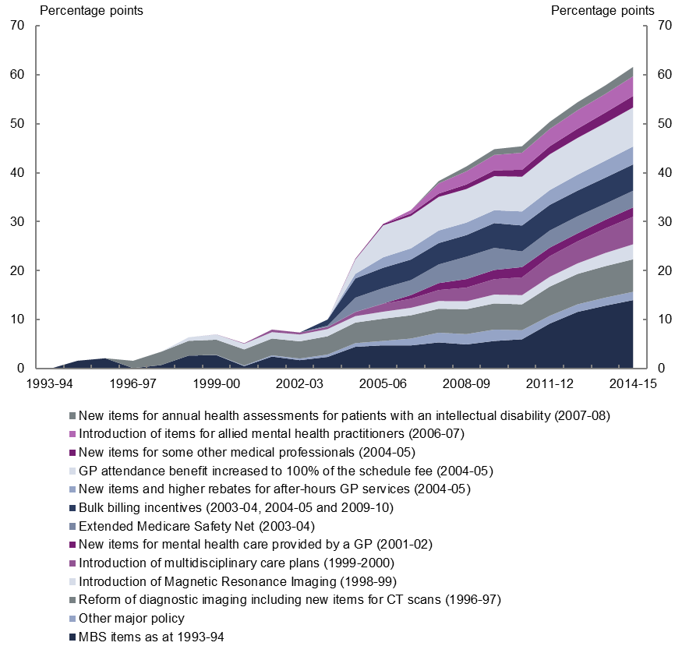  Medicare Benefits Schedule major policy | 1993-94 | 1994-95 | 1995-96 | 1996-97 | 1997-98 | 1998-99 | 1999-00 | 2000-01 | 2001-02 | 2002-03 | 2003-04 | 2004-05 | 2005-06 | 2006-07 | 2007-08 | 2008-09 | 2009-10 | 2010-11 | 2011-12 | 2012-13 | 2013-14 | 2014-15
MBS items as at 1993-94 | 0.0 | 1.7 | 2.2 | 0.2 | 0.8 | 2.7 | 2.8 | 0.5 | 2.5 | 1.8 | 2.4 | 4.5 | 4.8 | 4.8 | 5.4 | 5.0 | 5.7 | 6.0 | 9.2 | 11.6 | 12.9 | 14.0
Reform of diagnostic imaging including new items for CT scans (1996-97) | 0.0 | 0.0 | 0.0 | 1.5 | 2.7 | 3.0 | 3.1 | 3.3 | 3.4 | 3.5 | 3.7 | 4.2 | 4.5 | 4.7 | 4.9 | 5.1 | 5.3 | 5.3 | 6.0 | 6.2 | 6.4 | 6.6
Introduction of Magnetic Resonance Imaging (1998-99) | 0.0 | 0.0 | 0.0 | 0.0 | 0.0 | 0.7 | 1.1 | 1.2 | 1.3 | 1.4 | 1.5 | 1.3 | 1.4 | 1.5 | 1.6 | 1.6 | 1.8 | 1.9 | 2.0 | 2.1 | 2.7 | 3.1
Introduction of multidisciplinary care plans (1999-2000) | 0.0 | 0.0 | 0.0 | 0.0 | 0.0 | 0.0 | 0.0 | 0.1 | 0.5 | 0.4 | 0.4 | 0.8 | 1.6 | 1.8 | 2.3 | 2.8 | 3.1 | 3.6 | 4.2 | 4.5 | 5.0 | 5.6
New items for mental health care provided by a GP (2001-02) | 0.0 | 0.0 | 0.0 | 0.0 | 0.0 | 0.0 | 0.0 | 0.0 | 0.0 | 0.0 | 0.0 | 0.0 | 0.1 | 0.8 | 1.4 | 1.7 | 1.9 | 2.1 | 1.7 | 1.6 | 1.8 | 1.9
Extended Medicare Safety Net (2003-04) | 0.0 | 0.0 | 0.0 | 0.0 | 0.0 | 0.0 | 0.0 | 0.0 | 0.0 | 0.0 | 0.3 | 2.9 | 3.2 | 3.1 | 3.8 | 4.6 | 4.5 | 3.2 | 3.5 | 3.5 | 3.3 | 3.4
Bulk billing incentives (2003-04, 2004-05 and 2009-10) | 0.0 | 0.0 | 0.0 | 0.0 | 0.0 | 0.0 | 0.0 | 0.0 | 0.0 | 0.0 | 1.2 | 3.9 | 4.1 | 4.2 | 4.4 | 4.4 | 5.1 | 5.3 | 5.2 | 5.2 | 5.3 | 5.4
New items and higher rebates for after-hours GP services (2004-05) | 0.0 | 0.0 | 0.0 | 0.0 | 0.0 | 0.0 | 0.0 | 0.0 | 0.0 | 0.0 | 0.0 | 0.9 | 2.1 | 2.3 | 2.6 | 2.6 | 2.6 | 2.9 | 3.0 | 3.2 | 3.5 | 3.7
GP attendance benefit increased to 100% of the schedule fee (2004-05) | 0.0 | 0.0 | 0.0 | 0.0 | 0.0 | 0.0 | 0.0 | 0.0 | 0.0 | 0.0 | 0.0 | 2.9 | 6.5 | 6.6 | 6.9 | 6.8 | 7.0 | 7.1 | 7.3 | 7.5 | 7.7 | 8.0
New items for some other medical professionals (2004-05) | 0.0 | 0.0 | 0.0 | 0.0 | 0.0 | 0.0 | 0.0 | 0.0 | 0.0 | 0.0 | 0.0 | 0.1 | 0.3 | 0.5 | 0.7 | 0.9 | 1.2 | 1.4 | 1.7 | 1.9 | 2.1 | 2.3
Introduction of items for allied mental health practitioners (2006-07) | 0.0 | 0.0 | 0.0 | 0.0 | 0.0 | 0.0 | 0.0 | 0.0 | 0.0 | 0.0 | 0.0 | 0.0 | 0.0 | 0.7 | 2.1 | 2.7 | 3.1 | 3.5 | 3.5 | 3.8 | 3.8 | 4.0
New items for annual health assessments for patients with an intellectual disability (2007-08) | 0.0 | 0.0 | 0.0 | 0.0 | 0.0 | 0.0 | 0.0 | 0.0 | 0.0 | 0.0 | 0.0 | 0.0 | 0.0 | 0.0 | 0.5 | 1.0 | 1.2 | 1.3 | 1.5 | 1.6 | 1.7 | 1.9
Other major policy | 0.0 | 0.0 | 0.0 | 0.0 | 0.0 | 0.0 | 0.0 | 0.1 | 0.3 | 0.3 | 0.5 | 0.7 | 0.9 | 1.4 | 2.0 | 2.1 | 2.3 | 1.8 | 1.6 | 1.5 | 1.6 | 1.7
TOTAL | 0.0 | 1.7 | 2.2 | 1.6 | 3.5 | 6.4 | 7.0 | 5.1 | 7.8 | 7.1 | 9.6 | 21.7 | 28.7 | 31.0 | 36.3 | 39.2 | 42.5 | 43.6 | 48.8 | 52.8 | 56.2 | 61.6
Note: Figures provided are contributions to real growth in percentage points
Source: PBO analysis of MBS data from the Department of Human Services and ABS.
The major policy changes that drove the increased growth in MBS spending per person over the past decade largely impacted three broad service areas: general practitioners (GPs); allied health; and pathology and diagnostics. In addition, the introduction of the Extended Medicare Safety Net (EMSN) in 2003–04 contributed to the growth in spending on a number of MBS services.

General practitioners
The major drivers of the growth in spending on the MBS over the past decade were policy changes affecting GP services which contributed 44 per cent of the real growth in per person spending on the MBS over this period.
The increase in the GP rebate from 85 per cent to 100 per cent of the Schedule Fee in
2004–05, leading to higher government benefits being paid for GP services already provided, was the largest contributor to growth.
At the same time, bulk billing incentives for GPs were introduced and services were added for after-hours GP care, which significantly increased the number of services accessed by patients. Multidisciplinary care plans also contributed to the acceleration in spending growth through an increase in the number of services accessed by patients.
While decisions to expand the coverage of the MBS and increase MBS benefits were the key contributors to the growth in GP services, other factors also influenced spending growth. Utilisation of GP services was likely influenced by changes in the bulk billing rate which fell between 1993–94 and 2004–05 and then increased following the increase in the GP rebate and the introduction of bulk billing incentives. Variations in the number of GPs due to changes to the rules relating to migrant GPs and the opening of new medical schools also influenced the growth in GP services.

Allied health
Policy changes that extended the coverage of the MBS to certain allied health services contributed 16 per cent of the real growth in per person spending on the MBS over the past decade.
In particular, this reflected the inclusion of a wide range of allied health services such as physiotherapy and mental healthcare within the scope of the MBS from 2003–04 onwards.

Pathology and diagnostic services
The addition of diagnostic imaging services to the MBS in the late 1990s, along with the rapid growth in the number of these services accessed by patients, contributed 9 per cent of the real growth in per person spending on the MBS over the past decade.
Also contributing to growth in the number of services was an increase in the number of pathology services accessed by males aged 75 and over during the latter part of the past decade, reflecting a greater focus on chronic disease management and preventative health strategies. This group of older men rapidly increased the number of pathology and diagnostic services they accessed to a level above that of females aged 75 and over by
2014–15.
The rapid growth in the number of pathology and diagnostic services accessed over the past decade was partially offset by a decline in the benefit paid by the government for each service accessed by patients. Funding agreements between the government and the pathology and diagnostic industries capped growth in outlays on these services. Unlike other MBS services, pathology and diagnostic benefit levels have not been indexed since 1998. In addition, technology improvements in the pathology industry allowed significantly more services to be delivered for a given benefit level.

Extended Medicare Safety Net
The introduction of the EMSN in 2003–04 contributed 6 per cent of the real growth in per person spending on the MBS over the past decade.
The EMSN paid 80 per cent of out-of-hospital patient expenses over a set threshold. This meant that benefits were paid even when providers charged substantially more than the government-determined fee for service, that is, the Schedule Fee. The introduction of the EMSN primarily affected surgeries and treatments and specialist services by significantly increasing the benefit paid by the government for these services.
In response, the Government progressively introduced a range of Extended Medicare Safety Net benefit caps from 1 January 2010, which limited the out-of-pocket expenses the MBS covers for certain services. This resulted in slower growth over the latter part of the past decade.

Projected MBS spending over the next decade
Based on current policy settings, growth in MBS spending per person is projected to slow to 1.4 per cent annually in real terms over the next decade, reaching $36.6 billion in nominal terms by 2025–26. The historical and projected cumulative growth in MBS spending per person by service category is shown in Figure 2.
Figure 2: Cumulative real growth in spending per person on the Medicare Benefits Schedule, by category, actuals and projections
MBS category | 1993-94 | 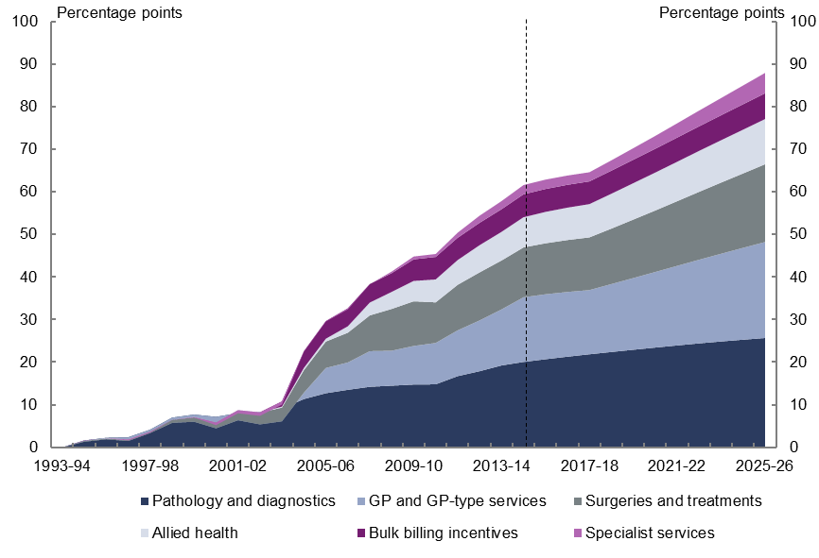  1994-95 | 1995-96 | 1996-97 | 1997-98 |  | 1998-99 |  | 1999-00 |  | 2000-01 |  | 2001-02 |  | 2002-03 |  | 2003-04 |  | 2004-05 |  | 2005-06 |  | 2006-07 |  | 2007-08 |  | 2008-09 |  | 2009-10 |  | 2010-11 |  | 2011-12 |  | 2012-13 |  | 2013-14 |  | 2014-15 |  | 2015-16 |  | 2016-17 | 2017-18 | 2018-19 | 2019-20 | 2020-21 | 2021-22 | 2022-23 | 2023-24 | 2024-25 | 2025-26
Pathology and diagnostics |  | 1.6 | 2.3 | 2.4 | 4.2 |  | 7.0 |  | 7.7 |  | 7.2 |  | 8.1 |  | 8.3 |  | 9.1 |  | 11.3 |  | 12.7 |  | 13.5 |  | 14.2 |  | 14.5 |  | 14.8 |  | 14.8 |  | 16.7 |  | 17.9 |  | 19.2 |  | 20.1 |  | 20.7 |  | 21.3 | 21.9 | 22.4 | 22.9 | 23.4 | 23.9 | 24.4 | 24.9 | 25.3 | 25.7
GP and GP-type services |  | -0.3 | -0.3 | -0.9 | -0.8 |  | -1.3 |  | -1.7 |  | -2.7 |  | -1.7 |  | -2.9 |  | -3.0 |  | 1.5 |  | 5.9 |  | 6.4 |  | 8.4 |  | 8.2 |  | 9.1 |  | 9.7 |  | 10.7 |  | 11.9 |  | 13.2 |  | 15.2 |  | 15.3 |  | 15.2 | 15.1 | 15.9 | 16.8 | 17.7 | 18.7 | 19.7 | 20.6 | 21.6 | 22.5
Surgeries and treatments |  | 0.2 | 0.2 | 0.3 | 0.3 |  | 0.7 |  | 1.0 |  | 1.4 |  | 2.3 |  | 2.7 |  | 3.2 |  | 5.3 |  | 6.2 |  | 7.0 |  | 8.4 |  | 9.8 |  | 10.5 |  | 9.5 |  | 10.7 |  | 11.3 |  | 11.5 |  | 11.7 |  | 12.0 |  | 12.2 | 12.4 | 13.0 | 13.7 | 14.4 | 15.2 | 15.9 | 16.7 | 17.5 | 18.3
Allied health |  | 0.0 | 0.1 | 0.1 | 0.0 |  | 0.0 |  | 0.1 |  | 0.0 |  | 0.1 |  | 0.1 |  | 0.2 |  | 0.5 |  | 0.7 |  | 1.5 |  | 3.0 |  | 4.0 |  | 4.8 |  | 5.4 |  | 5.8 |  | 6.4 |  | 6.7 |  | 7.1 |  | 7.4 |  | 7.6 | 7.8 | 8.2 | 8.5 | 8.9 | 9.3 | 9.6 | 9.9 | 10.3 | 10.6
Bulk billing incentives |  | 0.0 | 0.0 | 0.0 | 0.0 |  | 0.0 |  | 0.0 |  | 0.0 |  | 0.0 |  | 0.0 |  | 1.2 |  | 3.9 |  | 4.1 |  | 4.2 |  | 4.4 |  | 4.4 |  | 5.1 |  | 5.3 |  | 5.2 |  | 5.2 |  | 5.3 |  | 5.4 |  | 5.4 |  | 5.4 | 5.3 | 5.4 | 5.5 | 5.6 | 5.7 | 5.8 | 5.9 | 5.9 | 6.0
Specialist services |  | 0.1 | 0.0 | -0.2 | -0.2 |  | 0.0 |  | -0.1 |  | -0.6 |  | -0.7 |  | -0.8 |  | -0.8 |  | -0.1 |  | -0.1 |  | -0.3 |  | 0.0 |  | 0.4 |  | 0.7 |  | 0.7 |  | 1.2 |  | 1.7 |  | 1.9 |  | 2.2 |  | 2.2 |  | 2.2 | 2.1 | 2.4 | 2.7 | 3.0 | 3.4 | 3.7 | 4.1 | 4.4 | 4.8
TOTAL |  | 1.7 | 2.2 | 1.6 |  | 3.5 |  | 6.4 |  | 7.0 |  | 5.2 |  | 8.0 |  | 7.4 |  | 10.1 |  | 22.4 |  | 29.6 |  | 32.4 |  | 38.3 |  | 41.3 |  | 44.8 |  | 45.4 |  | 50.4 |  | 54.4 |  | 57.8 |  | 61.6 |  | 62.9 | 63.8 | 64.6 | 67.4 | 70.2 | 73.1 | 76.1 | 79.1 | 82.0 | 85.0 | 87.9
Note: Figures provided are the annual cumulative percentage point change from 1993–94.
Source: PBO analysis of MBS data from the Department of Human Services, ABS and Treasury.
The slower growth in projected spending compared to the past decade is expected to be predominantly driven by the decline in the benefit paid by the government for each service accessed. Following real growth of 0.7 per cent annually over the past decade, the benefit paid for each MBS service is projected to decline in real terms by 0.8 per cent annually over the next decade.
Marginally slower growth in the utilisation of services also contributes to the projected slowdown in spending growth, reflecting the recent slower growth in the utilisation of MBS services added during the past decade.
Growth in spending per person on GP services is projected to slow sharply to 1.2 per cent annually from 3.7 per cent annually over the past decade in real terms, largely due to a slowing in the growth in the benefit paid for each GP service. Strong growth in the benefit paid for each service over the past decade resulted from the one-off impact of the increase in the GP rebate from 85 to 100 per cent in 2004–05. The projected slower growth reflects the combination of the flat growth in the benefit paid since the one-off increase in the GP rebate and government decisions to pause the indexation of GP benefits until 2017–18.
Slightly slower growth in GP attendance rates, largely due to slower growth in attendance rates of males aged 75 and over, which have caught up to equivalent female attendance rates, also contributes marginally to the slowing in spending per person on GP services.

Growth in spending per person on pathology and diagnostics services is projected to slow considerably to 1.0 per cent annually from 2.4 per cent annually over the past decade in real terms. This largely reflects a slowing in growth in the number of pathology and diagnostic services used by males aged 75 and over which have caught up to that of equivalent services used by females over the past decade. The benefit paid per service is expected to continue to decline in real terms consistent with the trend of the past decade.
Growth in spending on allied health services per person is projected to slow to 2.9 per cent annually from 12.7 per cent annually over the past decade in real terms. This slowing in spending growth largely reflects the recent slower growth in the use of these services and, to a lesser degree, the benefit paid by the government for each service accessed.

The impact of ageing on projected growth in MBS spending
As noted earlier, MBS spending per person is projected to grow in real terms by 1.4 per cent from 2014–15 to 2025–26. As discussed in the 2015 Intergenerational Report, this growth will be largely driven by non-demographic factors such as rising income, wage costs in the health sector, changes in disease rates and technological change, which impact on the number of services used by patients and the benefits paid by the government for these services.
The ageing of the population (the increase in the proportion of the population in older age groups) is projected to account for around one third of the annual growth in spending per person between 2014–15 and 2025–26.

Medicare Benefits Schedule
The Medicare Benefits Schedule (MBS) was introduced in February 1984 as part of the broader Medicare health insurance scheme to provide universal access to government subsidised health services. Prior to this, except for a short period from the mid-1970s to 1981, most Australians had to either purchase private health insurance or provide for their own health care outside hospitals.
The MBS currently covers professional consultations with doctors, specialists and other health care professionals; pathology and other diagnostic services; and operations and procedures undertaken in surgeries and hospitals.
Each service funded through the MBS is allocated a unique item number associated with a full description of the service, a fee for service or ‘Schedule Fee’, and the relevant benefit level paid by the government.
The Schedule Fee for an item is determined at the time of listing and calculated in consultation with the medical profession. It takes into account the direct and indirect costs of providing the service (for example, the length and complexity of the service, any consumables used, administrative costs and rent for premises). The Schedule Fees for MBS items are generally indexed yearly by a combination of a wage index (the Safety Net Adjustment) and the Consumer Price Index. However, some MBS items, for example pathology and diagnostic services, have not been routinely indexed since 1998.
MBS items may also be reviewed and Schedule Fees adjusted when costs are considered to have changed (for example, due to technological improvements). The independent Medical Services Advisory Committee provides advice to the government in relation to medical services and the fee for service for items to be added to the MBS. However, the decisions to add, amend or remove items, and adjust fees are ultimately made by government.
The benefit level paid by the government varies depending on the type of service and where it is undertaken. In general, current benefit levels are as follows:
- 75 per cent of the Schedule Fee for services provided in hospital if admitted as a private patient
- 85 per cent of the Schedule Fee for services provided outside hospital
- 100 per cent of the Schedule Fee for GP consultations or services provided on behalf of a GP by other medical practitioners including nurses.
The patient pays any difference between the payment charged by the service provider and the benefit level. When the service provider agrees to accept the benefit level (75, 85 or 100 per cent of the Schedule Fee) as the full payment for that service and not charge any amount in excess of the benefit, this is referred to as bulk billing. The government pays this amount directly to the service provider for GP and GP-type services and pathology and diagnostic services.
Medical services provided in public hospitals for public patients are funded through agreements between the states, territories and the Commonwealth, and are not covered by the MBS.

Financing
The MBS is financed by the Australian Government. The Medicare levy was introduced with the MBS in 1984 in order to supplement taxation revenue and assist the government to meet the costs associated with the Medicare health insurance scheme.
The levy was initially set at 1 per cent of taxable income above a low income threshold to cover the additional expenditure of moving to a national health insurance scheme. It was expected to cover approximately 60 per cent of the total cost of the Medicare scheme. In 1993, the Medicare levy increased from 1 to 1.4 per cent and to 1.5 per cent in 1995.
From 1 July 2014, the Medicare levy increased from 1.5 to 2 per cent, with the revenue raised from the increase placed into a DisabilityCare Australia Fund for 10 years, which will help fund the additional costs of delivering the National Disability Insurance Scheme. In 2014–15, the Medicare and DisabilityCare Australia levy, as it is now known, and the Medicare levy surcharge raised an estimated $14.6 billion.

Expenditure
Australian Government health spending in 2014–15 totalled $65.7 billion. The MBS accounted for $20.2 billion, or 31 per cent of total health spending, and 5 per cent of total Australian Government expenditure.
Around one-third of the total cost of the MBS in 2014–15 was associated with GP and GP-type services (GP services), 30 per cent was related to pathology and diagnostic services such as blood tests and ultrasounds, and the remainder was split between surgeries and treatments (17 per cent), specialist services (10 per cent), allied health (6 per cent) and bulk billing incentives (3 per cent) (Figure 1–1). More detailed analysis of expenditure by these categories is provided in Chapter 3.
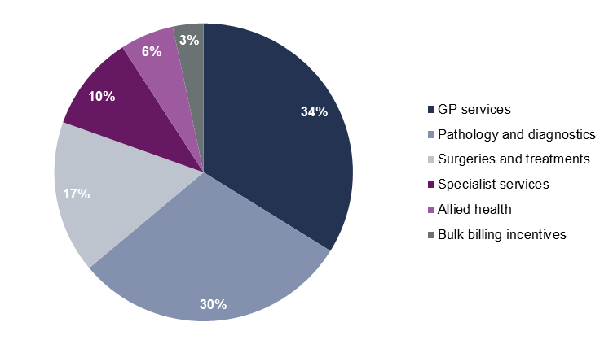
Figure 1–1: Medicare Benefits Schedule spending by category in 2014–15
MBS category | 2014-15
GP services | 34
Pathology and diagnostics | 30
Surgeries and treatments | 17
Specialist services | 10
Allied health | 6
Bulk billing incentives | 3
Note: Figures provided are per cent.
Source: PBO analysis of MBS data from the Department of Human Services.
Details of the categories used in this report are provided in Appendix A. Data used for the analysis are available at medicarestatistics.humanservices.gov.au/statistics/mbs_item.jsp.

Trends in aggregate Medicare Benefits Schedule spending
Spending per person on the MBS grew in real terms by 61.6 per cent between 1993–94 and 2014–15, or 2.3 per cent annually. In comparison, real growth in total government spending per person averaged 1.8 per cent annually over this period.
There were marked differences in the spending trends over the past two decades. Real growth in MBS spending per person was relatively modest up to 2003–04, averaging 1.0 per cent annually. From 2003–04 to 2014–15, it more than trebled, averaging 3.6 per cent annually, largely driven by a spike in growth in 2004–05 (Figure 2–1).
From 2014–15 to 2025–26, real growth in MBS spending per person is projected to slow to 1.4 per cent annually, based on current policy settings.
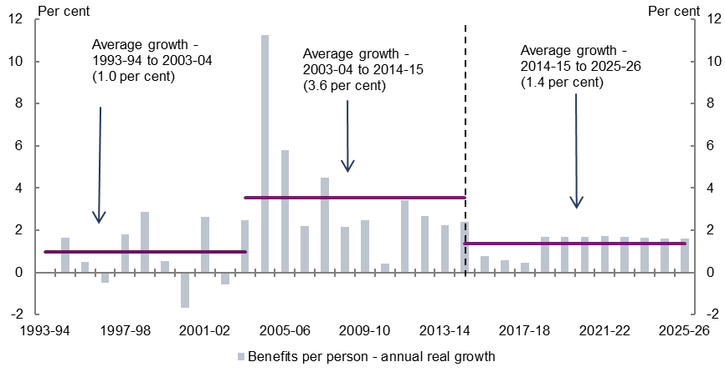
Figure 2–1: Annual real growth in government spending per person on the Medicare Benefits Schedule
Annual real growth in spending per person on the MBS | 1993-94 | 1994-95 | 1995-96 | 1996-97 | 1997-98 | 1998-99 | 1999-00 | 2000-01 | 2001-02 | 2002-03 | 2003-04 | 2004-05 | 2005-06 | 2006-07 | 2007-08 | 2008-09 | 2009-10 | 2010-11 | 2011-12 | 2012-13 | 2013-14 | 2014-15 | 2015-16 | 2016-17 | 2017-18 | 2018-19 | 2019-20 | 2020-21 | 2021-22 | 2022-23 | 2023-24 | 2024-25 | 2025-26
Benefits per person – annual real growth (per cent) | 0.0 | 1.7 | 0.5 | -0.5 | 1.8 | 2.9 | 0.5 | -1.7 | 2.6 | -0.6 | 2.5 | 11.3 | 5.8 | 2.2 | 4.5 | 2.2 | 2.5 | 0.4 | 3.4 | 2.7 | 2.2 | 2.4 | 0.8 | 0.6 | 0.5 | 1.7 | 1.7 | 1.7 | 1.7 | 1.7 | 1.6 | 1.6 | 1.6
 | 1993-94 to 2003-04 |  |  | 2003-04 to 2014-15 |  |  | 2014-15 to 2025-26
Benefits per person – average annual real growth over the decade (per cent) | 1.0 |  |  | 3.6 |  |  | 1.4
Source: PBO analysis of MBS data from the Department of Human Services, ABS and Treasury.
Spending on GP services, pathology and diagnostics, surgeries and treatments and allied health services grew strongly from 2003–04 to 2014–15. Spending on these categories accounted for around 90 per cent of the total growth in spending per person on the MBS over the period.
While growth for these categories is projected to slow over the period 2014–15 to 2024–25, together they are still projected to account for around 90 per cent of growth, although with some changes in the composition of this growth.
The share of real growth per person for pathology and diagnostics is projected to fall from one-third to one-fifth of the total, with surgeries and treatments increasing its share of real growth from one-fifth to one-quarter of the total between the historical and projection periods.
In real terms, government spending per person on GP services is projected to reach around $325 a year by 2025–26, above spending on pathology and diagnostic services ($280), surgeries and treatments ($175), specialist services ($100) and allied health ($70)
(Figure 2–2).
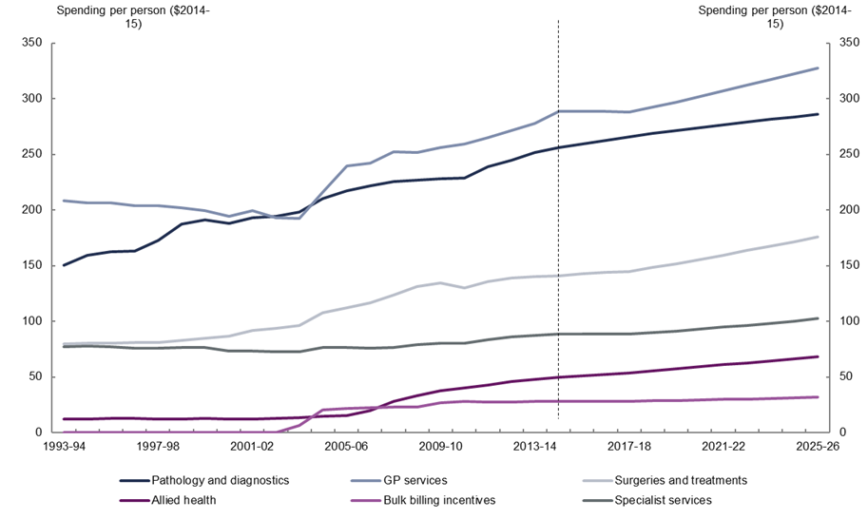
Figure 2–2: Medicare Benefits Schedule spending per person by category (2014–15 dollars)
MBS category | 1993-94 | 1994-95 | 1995-96 | 1996-97 | 1997-98 | 1998-99 | 1999-00 | 2000-01 | 2001-02 | 2002-03 | 2003-04 | 2004-05 | 2005-06 | 2006-07 | 2007-08 | 2008-09 | 2009-10 | 2010-11 | 2011-12 | 2012-13 | 2013-14 | 2014-15 | 2015-16 | 2016-17 | 2017-18 | 2018-19 | 2019-20 | 2020-21 | 2021-22 | 2022-23 | 2023-24 | 2024-25 | 2025-26
Pathology and diagnostics | 150.4 | 159.1 | 162.3 | 162.9 | 172.4 | 187.3 | 191.1 | 188.2 | 192.9 | 194.1 | 198.3 | 210.2 | 217.4 | 221.7 | 225.4 | 226.8 | 228.2 | 228.5 | 238.6 | 244.7 | 251.8 | 256.2 | 259.5 | 262.7 | 265.7 | 268.5 | 271.3 | 274.0 | 276.6 | 279.2 | 281.5 | 283.8 | 285.9
GP services | 208.4 | 206.7 | 206.5 | 203.7 | 204.1 | 201.8 | 199.5 | 194.1 | 199.5 | 193.1 | 192.7 | 216.2 | 239.7 | 242.2 | 252.5 | 251.7 | 256.2 | 259.5 | 265.0 | 271.3 | 277.8 | 288.5 | 288.8 | 288.5 | 287.9 | 292.5 | 297.2 | 302.0 | 307.0 | 312.0 | 317.1 | 322.1 | 327.2
Surgeries and treatments | 79.5 | 80.6 | 80.4 | 81.0 | 81.1 | 83.2 | 84.9 | 86.7 | 91.7 | 93.9 | 96.5 | 107.5 | 112.2 | 116.4 | 123.8 | 131.2 | 134.8 | 129.8 | 135.9 | 139.0 | 140.1 | 141.2 | 142.7 | 143.8 | 144.7 | 148.2 | 151.9 | 155.7 | 159.6 | 163.6 | 167.6 | 171.7 | 175.8
Allied health | 12.2 | 12.2 | 12.7 | 12.7 | 12.3 | 12.3 | 12.6 | 12.4 | 12.5 | 12.7 | 13.3 | 14.8 | 15.7 | 20.1 | 28.0 | 33.3 | 37.4 | 40.5 | 42.7 | 45.9 | 47.6 | 49.6 | 51.0 | 52.3 | 53.4 | 55.3 | 57.2 | 59.1 | 61.0 | 62.9 | 64.7 | 66.4 | 68.1
Bulk billing incentives | - | - | - | - | - | - | - | - | - | - | 6.6 | 20.8 | 21.9 | 22.2 | 23.0 | 23.2 | 26.7 | 27.9 | 27.7 | 27.7 | 28.0 | 28.4 | 28.4 | 28.3 | 28.2 | 28.6 | 29.0 | 29.5 | 29.9 | 30.4 | 30.9 | 31.4 | 31.8
Specialist services | 77.1 | 77.6 | 76.9 | 75.8 | 75.8 | 76.9 | 76.4 | 73.7 | 73.1 | 72.7 | 73.1 | 76.3 | 76.5 | 75.7 | 76.8 | 79.0 | 80.5 | 80.7 | 83.4 | 85.9 | 87.1 | 88.6 | 88.6 | 88.5 | 88.4 | 89.8 | 91.4 | 93.0 | 94.7 | 96.6 | 98.4 | 100.4 | 102.4
Total MBS spending per person | 527.5 | 536.2 | 538.8 | 536.1 | 545.8 | 561.5 | 564.5 | 555.0 | 569.7 | 566.6 | 580.5 | 645.9 | 683.4 | 698.3 | 729.5 | 745.3 | 763.8 | 767.0 | 793.3 | 814.4 | 832.5 | 852.4 | 859.0 | 864.1 | 868.2 | 883.0 | 898.0 | 913.2 | 928.8 | 944.6 | 960.2 | 975.7 | 991.3
Source: PBO analysis of MBS data from the Department of Human Services, ABS and Treasury.
Table 2–1 shows the amount spent on each MBS category in 2014–15 and the amount projected to be spent in 2025–26 in nominal terms. It also details the annual real growth rates per person, and the contributions and shares of these growth rates for each MBS category over the historical and projection periods.
Table 2–1: Medicare Benefit Schedule spending, 1993–94 to 2025–26
MBS category | MBS spending in nominal terms |  | Annual real growth per person |  |  |  | Contribution to real  growth per person |  |  |  | Share of real growth per person
 | 2014–15 | 2025–26 | 1993–94 to 2014–15 | 1993–94 to  2003–04 | 2003–04 to 2014–15 | 2014–15 to  2025–26 | 1993–94 to 2014–15 | 1993–94 to  2003–04 | 2003–04 to 2014–15 | 2014–15 to  2025–26 | 1993–94 to 2014–15 | 1993–94 to  2003–04 | 2003–04 to 2014–15 | 2014–15 to 2025–26
 | $ billions |  | per cent |  |  |  | percentage points |  |  |  | per cent
Pathology and diagnostics | 6.1 | 10.6 | 2.6 | 2.8 | 2.4 | 1.0 | 20.1 | 9.1 | 10.0 | 3.5 | 33 | 90 | 21 | 21
GP and GP-type services | 6.8 | 12.1 | 1.6 | -0.8 | 3.7 | 1.2 | 15.2 | -3.0 | 16.5 | 4.5 | 25 | -29 | 35 | 28
Surgeries and treatments | 3.3 | 6.5 | 2.8 | 2.0 | 3.5 | 2.0 | 11.7 | 3.2 | 7.7 | 4.1 | 19 | 32 | 16 | 25
Allied health | 1.2 | 2.5 | 6.9 | 0.9 | 12.7 | 2.9 | 7.1 | 0.2 | 6.2 | 2.2 | 12 | 2 | 13 | 13
Bulk billing incentives | 0.7 | 1.2 | - | - | 14.2 | 1.1 | 5.4 | 1.2 | 3.8 | 0.4 | 9 | 12 | 8 | 2
Specialist services | 2.1 | 3.8 | 0.7 | -0.5 | 1.8 | 1.3 | 2.2 | -0.8 | 2.7 | 1.6 | 4 | -8 | 6 | 10
TOTAL | 20.2 | 36.6 | 2.3 | 1.0 | 3.6 | 1.4 | 61.6 | 10.1 | 46.8 | 16.3 | 100 | 100 | 100 | 100
Source: PBO analysis of MBS data from the Department of Human Services, ABS and Treasury.

The historical and projected spending trends are explored in more detail below and in Chapter 3.

Historical trends
Spending per person on the MBS grew in real terms by 2.3 per cent annually over the past two decades. More than three quarters of this growth occurred over the past decade, due mainly to major policy changes that broadened the scope of the MBS or increased the benefits payable for existing services (Figure 2–3).
The remaining growth occurred in those MBS services that were in place before 1993–94, in particular due to increased utilisation of existing pathology, diagnostic and surgical services.
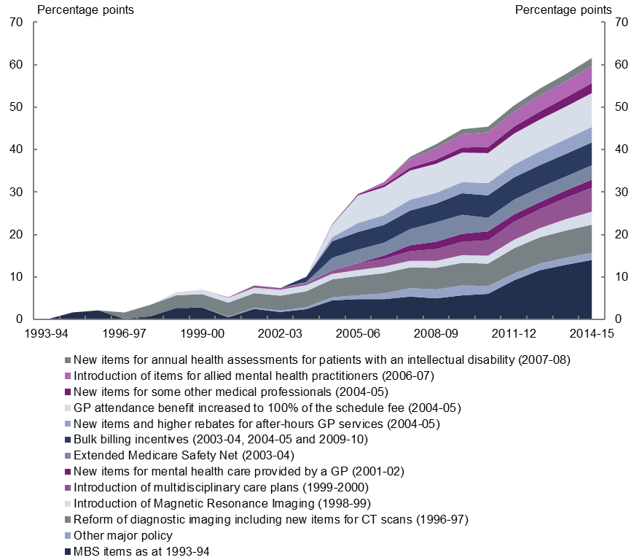
Figure 2–3: Cumulative real growth in spending per person on the Medicare Benefits Schedule
Medicare Benefits Schedule major policy | 1993-94 | 1994-95 | 1995-96 | 1996-97 | 1997-98 | 1998-99 | 1999-00 | 2000-01 | 2001-02 | 2002-03 | 2003-04 | 2004-05 | 2005-06 | 2006-07 | 2007-08 | 2008-09 | 2009-10 | 2010-11 | 2011-12 | 2012-13 | 2013-14 | 2014-15
MBS items as at 1993-94 | 0.0 | 1.7 | 2.2 | 0.2 | 0.8 | 2.7 | 2.8 | 0.5 | 2.5 | 1.8 | 2.4 | 4.5 | 4.8 | 4.8 | 5.4 | 5.0 | 5.7 | 6.0 | 9.2 | 11.6 | 12.9 | 14.0
Reform of diagnostic imaging including new items for CT scans (1996-97) | 0.0 | 0.0 | 0.0 | 1.5 | 2.7 | 3.0 | 3.1 | 3.3 | 3.4 | 3.5 | 3.7 | 4.2 | 4.5 | 4.7 | 4.9 | 5.1 | 5.3 | 5.3 | 6.0 | 6.2 | 6.4 | 6.6
Introduction of Magnetic Resonance Imaging (1998-99) | 0.0 | 0.0 | 0.0 | 0.0 | 0.0 | 0.7 | 1.1 | 1.2 | 1.3 | 1.4 | 1.5 | 1.3 | 1.4 | 1.5 | 1.6 | 1.6 | 1.8 | 1.9 | 2.0 | 2.1 | 2.7 | 3.1
Introduction of multidisciplinary care plans (1999-2000) | 0.0 | 0.0 | 0.0 | 0.0 | 0.0 | 0.0 | 0.0 | 0.1 | 0.5 | 0.4 | 0.4 | 0.8 | 1.6 | 1.8 | 2.3 | 2.8 | 3.1 | 3.6 | 4.2 | 4.5 | 5.0 | 5.6
New items for mental health care provided by a GP (2001-02) | 0.0 | 0.0 | 0.0 | 0.0 | 0.0 | 0.0 | 0.0 | 0.0 | 0.0 | 0.0 | 0.0 | 0.0 | 0.1 | 0.8 | 1.4 | 1.7 | 1.9 | 2.1 | 1.7 | 1.6 | 1.8 | 1.9
Extended Medicare Safety Net (2003-04) | 0.0 | 0.0 | 0.0 | 0.0 | 0.0 | 0.0 | 0.0 | 0.0 | 0.0 | 0.0 | 0.3 | 2.9 | 3.2 | 3.1 | 3.8 | 4.6 | 4.5 | 3.2 | 3.5 | 3.5 | 3.3 | 3.4
Bulk billing incentives (2003-04, 2004-05 and 2009-10) | 0.0 | 0.0 | 0.0 | 0.0 | 0.0 | 0.0 | 0.0 | 0.0 | 0.0 | 0.0 | 1.2 | 3.9 | 4.1 | 4.2 | 4.4 | 4.4 | 5.1 | 5.3 | 5.2 | 5.2 | 5.3 | 5.4
New items and higher rebates for after-hours GP services (2004-05) | 0.0 | 0.0 | 0.0 | 0.0 | 0.0 | 0.0 | 0.0 | 0.0 | 0.0 | 0.0 | 0.0 | 0.9 | 2.1 | 2.3 | 2.6 | 2.6 | 2.6 | 2.9 | 3.0 | 3.2 | 3.5 | 3.7
GP attendance benefit increased to 100% of the schedule fee (2004-05) | 0.0 | 0.0 | 0.0 | 0.0 | 0.0 | 0.0 | 0.0 | 0.0 | 0.0 | 0.0 | 0.0 | 2.9 | 6.5 | 6.6 | 6.9 | 6.8 | 7.0 | 7.1 | 7.3 | 7.5 | 7.7 | 8.0
New items for some other medical professionals (2004-05) | 0.0 | 0.0 | 0.0 | 0.0 | 0.0 | 0.0 | 0.0 | 0.0 | 0.0 | 0.0 | 0.0 | 0.1 | 0.3 | 0.5 | 0.7 | 0.9 | 1.2 | 1.4 | 1.7 | 1.9 | 2.1 | 2.3
Introduction of items for allied mental health practitioners (2006-07) | 0.0 | 0.0 | 0.0 | 0.0 | 0.0 | 0.0 | 0.0 | 0.0 | 0.0 | 0.0 | 0.0 | 0.0 | 0.0 | 0.7 | 2.1 | 2.7 | 3.1 | 3.5 | 3.5 | 3.8 | 3.8 | 4.0
New items for annual health assessments for patients with an intellectual disability (2007-08) | 0.0 | 0.0 | 0.0 | 0.0 | 0.0 | 0.0 | 0.0 | 0.0 | 0.0 | 0.0 | 0.0 | 0.0 | 0.0 | 0.0 | 0.5 | 1.0 | 1.2 | 1.3 | 1.5 | 1.6 | 1.7 | 1.9
Other major policy | 0.0 | 0.0 | 0.0 | 0.0 | 0.0 | 0.0 | 0.0 | 0.1 | 0.3 | 0.3 | 0.5 | 0.7 | 0.9 | 1.4 | 2.0 | 2.1 | 2.3 | 1.8 | 1.6 | 1.5 | 1.6 | 1.7
TOTAL | 0.0 | 1.7 | 2.2 | 1.6 | 3.5 | 6.4 | 7.0 | 5.1 | 7.8 | 7.1 | 9.6 | 21.7 | 28.7 | 31.0 | 36.3 | 39.2 | 42.5 | 43.6 | 48.8 | 52.8 | 56.2 | 61.6
Note: Figures provided are contributions to real growth in percentage points.
Source: PBO analysis of MBS data from the Department of Human Services and ABS.
Between 1993–94 and 2003–04, real growth in spending per person was relatively subdued. Growth over this period was largely due to the addition of new diagnostic imaging services. In 1996–97, benefits were made available for a wider range of Computed Tomography (CT) scans, while advances in technology resulted in the introduction of Magnetic Resonance Imaging (MRI) benefits in 1998–99. As well as broadening the scope of MBS services, these new services also contributed to higher benefits paid per service on average.
From 2003–04 to 2014–15, the significant increase in growth was due to major policy decisions that focussed on GPs. The increase in the GP rebate from 85 per cent to 100 per cent of the Schedule Fee and the introduction of bulk billing incentives resulted in higher government benefits being paid for GP services already provided. Services were also added for after-hours GP services at the same time.
Growth in spending on GP services also reflected earlier decisions to introduce multidisciplinary care plans which added a range of benefits that focussed on better coordinating the roles of GPs and specialists in caring for patients with chronic and/or complex care needs. Services were also added for GP mental health care as part of the ‘Better Outcomes in Mental Health Care’ program.
The addition of allied health services further broadened the scope of the MBS and contributed to real growth in spending per person. In particular, in 2004–05 benefits were made available for a wide range of allied health services (such as physiotherapy) and allied mental health services were added in 2006–07.
The Extended Medicare Safety Net (EMSN) was introduced in 2003–04 and paid 80 per cent of out-of-hospital patient expenses over a set threshold. This meant that benefits were paid even when providers charged substantially more than the government-determined fee for service, that is, the Schedule Fee. The introduction of the EMSN primarily affected surgeries and treatments and specialist services by significantly increasing the benefit paid by the government for these services.
In response, the Government progressively introduced a range of Extended Medicare Safety Net benefit caps from 1 January 2010, which limit the out-of-pocket expenses the MBS will cover for certain services. This resulted in slower growth over the latter part of the past decade.

Projected trends
The spending projections for the period 2014–15 to 2025–26 are based on current policy settings and make no allowance for future policy initiatives relating to the MBS. The assumptions underlying the spending projections are explained in Appendix C.
As with any medium-term projections there are uncertainties surrounding the numbers presented. In particular, when projecting MBS spending there is uncertainty regarding the ongoing impact of past policy changes and when they are likely to mature.
The analysis of projected MBS spending focusses on the number of services used by patients (services per person) and the benefit paid by government for these services (benefits paid per service). This gives an indication of both the ‘volume’ and ‘price’ influences on government spending.

Projected spending
From 2014–15 to 2025–26, MBS spending per person is projected to grow by 1.4 per cent annually in real terms, a significant slowing from the previous decade’s growth. Slower growth in projected spending is expected to be predominantly driven by the decline in the benefit paid per service. Also expected to drive the slowdown in projected growth is slower growth in the use of services which were added to the MBS in the past decade. The projections reflect recent slower growth in the use of these services (Figure 2–4).
Figure 2–4: Medicare Benefits Schedule, benefit paid per service (2014–15 dollars) and services per person
 | 1993-94 | 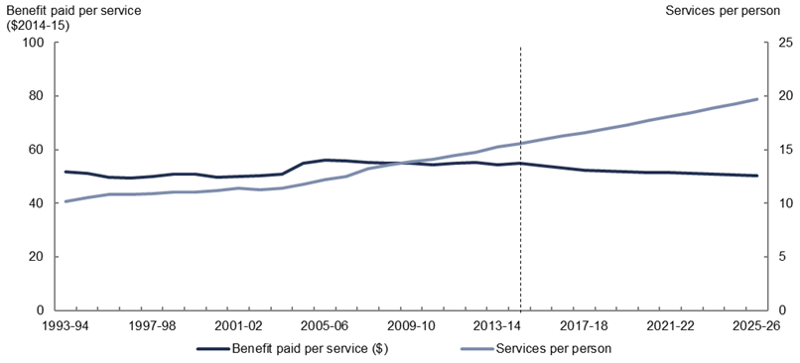  1994-95 | 1995-96 | 1996-97 | 1997-98 | 1998-99 | 1999-00 | 2000-01 | 2001-02 | 2002-03 | 2003-04 | 2004-05 | 2005-06 | 2006-07 | 2007-08 | 2008-09 | 2009-10 | 2010-11 | 2011-12 | 2012-13 | 2013-14 | 2014-15 | 2015-16 | 2016-17 | 2017-18 | 2018-19 | 2019-20 | 2020-21 | 2021-22 | 2022-23 | 2023-24 | 2024-25 | 2025-26
Benefit paid per service (2014-15 dollars) | 51.9 | 51.1 | 49.8 | 49.4 | 50.0 | 50.9 | 51.0 | 49.7 | 50.0 | 50.2 | 50.8 | 54.8 | 56.1 | 55.9 | 55.2 | 55.0 | 55.0 | 54.4 | 55.0 | 55.1 | 54.5 | 54.8 | 54.0 | 53.2 | 52.3 | 52.0 | 51.8 | 51.6 | 51.3 | 51.1 | 50.8 | 50.6 | 50.3
Number of services per person | 10.2 | 10.5 | 10.8 | 10.8 | 10.9 | 11.0 | 11.1 | 11.2 | 11.4 | 11.3 | 11.4 | 11.8 | 12.2 | 12.5 | 13.2 | 13.6 | 13.9 | 14.1 | 14.4 | 14.8 | 15.3 | 15.5 | 15.9 | 16.3 | 16.6 | 17.0 | 17.3 | 17.7 | 18.1 | 18.5 | 18.9 | 19.3 | 19.7
Source: PBO analysis of MBS data from the Department of Human Services, ABS and Treasury.
From 2014–15, the number of services per person is projected to increase by 2.2 per cent annually based on the number of services accessed within each category (see Chapter 3 for detailed analysis). This represents a slowing from the past decade growth of 2.8 per cent annually. Just over half of the increase in services accessed per person is projected to come from pathology and diagnostic services.
Growth in the number of services per person is partially offset by the decline in the average benefit paid per service. Following real growth of 0.7 per cent annually over the past decade, the benefit paid for each MBS service is projected to decline in real terms by 0.8 per cent annually over the next decade, largely due to a slowing in the growth in the benefit paid for each GP service. Strong growth in the benefit paid for each service over the past decade resulted from the one-off impact of the increase in the GP rebate from 85 to 100 per cent in 2004-05. The projected slower growth reflects the combination of the flat growth in the benefit paid since the one-off increase in the GP rebate and government decisions to pause the indexation of benefits more broadly until 2017–18 (see Chapter 3 for further details).

The impact of ageing on projected growth in Medicare Benefits Schedule spending
The growth in MBS spending is driven by demographic and non-demographic factors. Demographic factors such as population growth and the ageing of the population (the increase in the proportion of the population in older age groups) have partly driven the growth in spending. However, as discussed in the 2015 Intergenerational Report, the key drivers of health spending are non-demographic factors such as rising income, wage costs in the health sector, changes in disease rates, and technological change, which impact on the number of MBS services patients use and the benefits paid by the government for these services.
The ageing of the population is illustrated by the increase in the proportion of the older age cohorts within the population. In particular, this is highlighted by the change in the proportion of the population aged 75 and over, which is projected to increase from 4.7 to 8.3 per cent over the period from 1993–94 to 2025–26 (Figure 2–5).
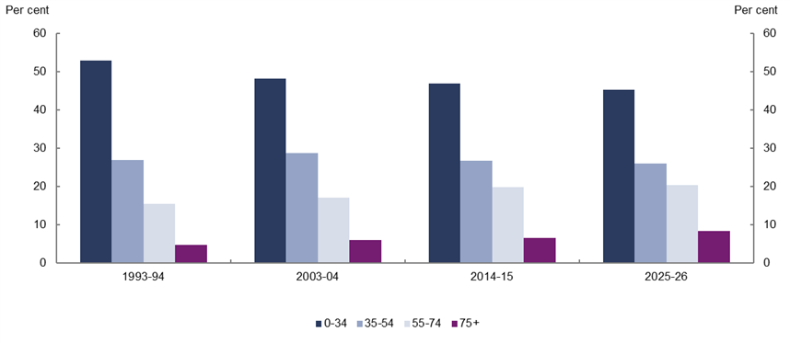
Figure 2–5: Proportion of the Australian population by age group
Age group | 1993-94 | 2003-04 | 2014-15 | 2025-26
 | (per cent)
0-34 | 53 | 48 | 47 | 45
35-54 | 27 | 29 | 27 | 26
55-74 | 15 | 17 | 20 | 20
75 and over | 5 | 6 | 6 | 8
Total | 100 | 100 | 100 | 100
Source: PBO analysis of MBS data from the Department of Human Services, ABS and Treasury.

The reason why the ageing of the population leads to growth in MBS spending is because spending on each older person is significantly greater than that of the average person. As shown in Figure 2–6, MBS spending per person on those aged 75 and over was three times that of those aged 0 to 34 years in 1993–94. By 2025–26, spending per person in real terms for those aged 75 and over is projected to be six times that of persons aged 0 to 34 years.
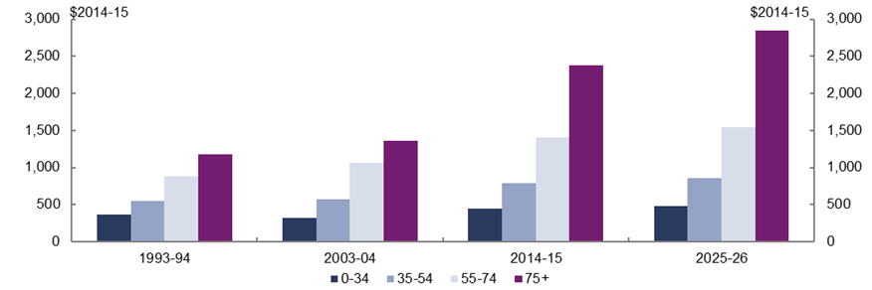
Figure 2–6: Medicare Benefit Schedule spending per person by age group (2014–15 dollars)
Age group | 1993-94 | 2003-04 | 2014-15 | 2025-26
 | (dollars)
0-34 | 361 | 320 | 447 | 474
35-54 | 545 | 568 | 783 | 862
55-74 | 875 | 1064 | 1404 | 1547
75 and over | 1173 | 1358 | 2380 | 2847
All age groups | 527 | 581 | 852 | 991
Source: PBO analysis of MBS data from the Department of Human Services, ABS and Treasury.
The contribution of ageing to projected real growth in MBS spending per person can be estimated by comparing this projected growth with the growth that would occur if the age profile of the population was held constant.
From 2014–15 to 2025–26, population ageing is projected to contribute around one third (or 0.5 percentage points) to the projected annual real growth in MBS spending per person of 1.4 per cent.
The effect of the ageing of the population and the higher and increasing spending per person on the older age groups has resulted in the proportion of MBS spending on older age groups increasing significantly over time. Spending in real terms on those aged 75 and over is projected to be almost seven times higher in 2025–26 than it was in 1993–94. This is double the increase in spending on those aged 55 to 74 years, which is projected to be around three and a half times higher in 2025–26 than it was in 1993–94 (Figure 2–7).
While only accounting for 8 per cent of the population in 2025–26, those aged 75 and over are projected to account for 25 per cent of total spending on the MBS in 2025–26.
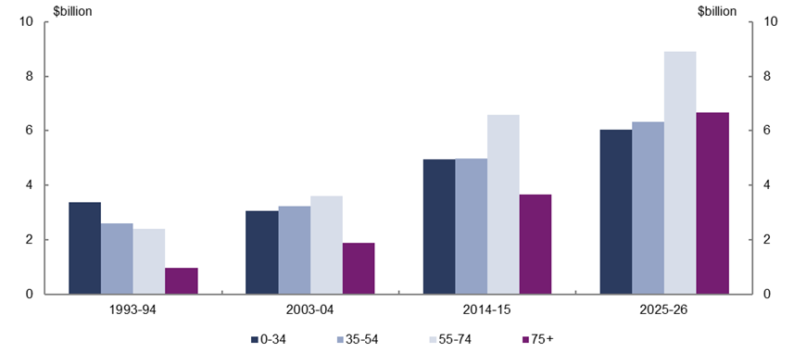
Figure 2–7: Medicare Benefits Schedule spending by age group (2014–15 dollars)
Age group | 1993-94 | 2003-04 | 2014-15 | 2025-26
 | (dollars billion)
0-34 | 3.4 | 3.1 | 5.0 | 6.1
35-54 | 2.6 | 3.2 | 5.0 | 6.3
55-74 | 2.4 | 3.6 | 6.6 | 8.9
75 and over | 1.0 | 1.9 | 3.7 | 6.7
All age groups | 9.3 | 11.8 | 20.2 | 28.0
Source: PBO analysis of MBS data from the Department of Human Services, ABS and Treasury.

Medicare Benefits Schedule spending by category
The analysis in this chapter focusses on the utilisation of services (services per person) and the costs to government of these services (benefits paid per service) within each MBS category. This gives an indication of both the ‘volume’ and ‘price’ influences on spending. The analysis highlights the key policy changes that have influenced services per person and benefits paid per service between 1993–94 and 2014–15 for each category, and includes projections for each category.

Pathology and diagnostics
Spending per person on pathology and diagnostics grew by 2.6 per cent annually in real terms between 1993–94 and 2014–15, accounting for around a third of the total real growth in spending per person on the MBS over the period. In 2014–15, pathology and diagnostic services accounted for 30 per cent of MBS spending.
Diagnostic services include imaging services such as ultrasounds and CT scans as well as diagnostic procedures such as electrocardiograms and colonoscopies. Pathology services include chemical and biological testing of samples such as blood and genetic tests.
From 1993–94 to 2014–15, the benefit paid per service for pathology and diagnostic services declined by 1.1 per cent annually in real terms aided by funding agreements between the Australian Government and the pathology and diagnostic industries designed to cap growth in outlays on these services. Unlike other MBS services, pathology and diagnostic benefit levels have not been indexed since 1998. In addition, technology improvements in the pathology industry allowed significantly more services to be delivered for a given benefit level. The impact of this was more than offset by increases in the number of services accessed per person which grew by 3.7 per cent annually (Figure 3–1).
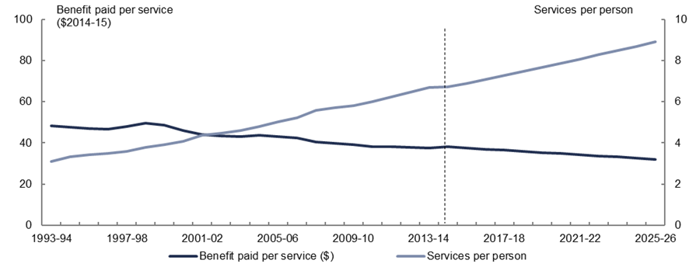
Figure 3–1: Pathology and diagnostics, benefit paid per service (2014–15 dollars) and services per person
Pathology and diagnostics | 1993-94 | 1994-95 | 1995-96 | 1996-97 | 1997-98 | 1998-99 | 1999-00 | 2000-01 | 2001-02 | 2002-03 | 2003-04 | 2004-05 | 2005-06 | 2006-07 | 2007-08 | 2008-09 | 2009-10 | 2010-11 | 2011-12 | 2012-13 | 2013-14 | 2014-15 | 2015-16 | 2016-17 | 2017-18 | 2018-19 | 2019-20 | 2020-21 | 2021-22 | 2022-23 | 2023-24 | 2024-25 | 2025-26
Benefit paid per service ($2014-15) | 48.3 | 47.6 | 47.2 | 46.7 | 47.9 | 49.7 | 48.8 | 46.2 | 44.2 | 43.5 | 43.1 | 43.9 | 43.2 | 42.4 | 40.5 | 39.7 | 39.3 | 38.1 | 38.2 | 37.9 | 37.6 | 38.1 | 37.6 | 37.0 | 36.5 | 35.9 | 35.4 | 34.8 | 34.2 | 33.7 | 33.1 | 32.6 | 32.0
Number of services per person | 3.1 | 3.3 | 3.4 | 3.5 | 3.6 | 3.8 | 3.9 | 4.1 | 4.4 | 4.5 | 4.6 | 4.8 | 5.0 | 5.2 | 5.6 | 5.7 | 5.8 | 6.0 | 6.2 | 6.5 | 6.7 | 6.7 | 6.9 | 7.1 | 7.3 | 7.5 | 7.7 | 7.9 | 8.1 | 8.3 | 8.5 | 8.7 | 8.9
Source: PBO analysis of MBS data from the Department of Human Services, ABS and Treasury.
The increase in the number of services per person was largely driven by growing utilisation of pathology services such as microbiology, haematology and chemical pathology. In particular, males aged 75 and over increased the number of pathology services they accessed during the latter part of the past decade, reflecting a greater focus on chronic disease management and preventative health strategies. This group of older men rapidly increased the number of pathology and diagnostic services they accessed to a level above that of females aged 75 and over by 2014–15.
The growth in utilisation of diagnostic services also contributed to growth in the number of services per person. Significant new services were added over the period but despite this the benefit paid per diagnostic service remained flat in real terms. The addition of new high-cost services such as CT scans (expanded in 1996–97) and MRI scans (introduced in 1998–99) was offset by real declines in benefits paid for other diagnostic services, as a consequence of funding agreements with radiologists.
Growth in spending per person on pathology and diagnostics is projected to slow to 1.0 per cent annually in real terms between 2014–15 and 2025–26. Growth in the number of services per person is projected to slow to 2.6 per cent annually over the period reflecting usage rates for pathology and diagnostic services for males aged 75 and over having caught up to equivalent female usage rates over the past decade. The benefit paid per service is projected to decline by 1.6 per cent annually in real terms over the period consistent with the trend of the past decade.

GP and GP-type services
Spending per person on GP and GP-type services (GP services) grew by 1.6 per cent annually in real terms between 1993–94 and 2014–15, accounting for around a quarter of the total real growth in spending per person on the MBS over the period. By 2014–15, spending on GP services accounted for around one-third of all MBS spending.
There were marked differences in the spending trends over the past two decades. From 1993–94 to 2003–04, spending per person on GP services (excluding the impact of bulk billing incentives) contracted by 0.8 per cent annually in real terms.
This contraction partly reflected the decline in the number of general practitioners per person over the period. In 1996, the Australian Government placed a cap on Commonwealth-funded medical places and restrictions on migrant GPs entering Australia, the implementation of which coincided with a fall in bulk billing rates. Subsequent policy changes to bulk billing incentives and increasing rebates for GP visits sought to address out-of-pocket costs for GP patients.
Despite the introduction of a number of new MBS items such as health assessments for those over 75 years of age, the number of GP services accessed per person declined by 1.0 per cent annually from 1993–94 to 2003–04, more than offsetting the slight rise in the benefit paid for services provided by GPs and those providing GP-type services (up 0.3 per cent annually in real terms) (Figure 3–2).
GP services was the only MBS category for which the benefit paid per service rose in real terms over the period 1993–94 to 2003–04, as a result of an increase in the benefits paid for GP and emergency after-hours attendances in 2001–02.
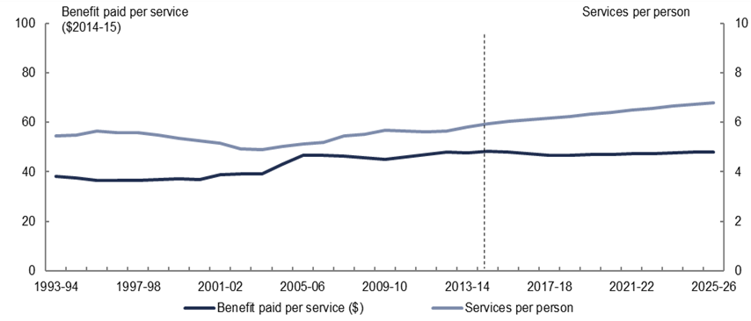
Figure 3–2: GP and GP-type services, benefit paid per service (2014–15 dollars) and services per person
GP and GP-type services | 1993-94 | 1994-95 | 1995-96 | 1996-97 | 1997-98 | 1998-99 | 1999-00 | 2000-01 | 2001-02 | 2002-03 | 2003-04 | 2004-05 | 2005-06 | 2006-07 | 2007-08 | 2008-09 | 2009-10 | 2010-11 | 2011-12 | 2012-13 | 2013-14 | 2014-15 | 2015-16 | 2016-17 | 2017-18 | 2018-19 | 2019-20 | 2020-21 | 2021-22 | 2022-23 | 2023-24 | 2024-25 | 2025-26
Benefits paid per service ($2014-15) | 38.3 | 37.6 | 36.6 | 36.4 | 36.6 | 36.8 | 37.2 | 36.9 | 38.7 | 39.1 | 39.2 | 43.0 | 46.7 | 46.7 | 46.3 | 45.6 | 45.1 | 45.9 | 47.1 | 48.0 | 47.8 | 48.5 | 47.9 | 47.3 | 46.6 | 46.8 | 47.0 | 47.1 | 47.3 | 47.5 | 47.7 | 47.9 | 48.0
Number of services per person | 5.4 | 5.5 | 5.6 | 5.6 | 5.6 | 5.5 | 5.4 | 5.3 | 5.2 | 4.9 | 4.9 | 5.0 | 5.1 | 5.2 | 5.5 | 5.5 | 5.7 | 5.7 | 5.6 | 5.7 | 5.8 | 6.0 | 6.0 | 6.1 | 6.2 | 6.3 | 6.3 | 6.4 | 6.5 | 6.6 | 6.6 | 6.7 | 6.8
Source: PBO analysis of MBS data from the Department of Human Services, ABS and Treasury.
From 2003–04 to 2014–15, the trend decline in spending per person on GP services over the previous decade reversed. Real growth in spending per person averaged 3.7 per cent annually driven by both higher real benefits paid per service (up 1.9 per cent annually) with rising numbers of services accessed per person (up 1.8 per cent annually).
Higher utilisation of both new and existing services was influenced by the introduction of multidisciplinary care plans and most likely by an increase in the MBS bulk billing rate with the introduction of bulk billing incentives. Changes to the rules relating to migrant GPs and the opening of new medical schools increased the number of GPs and is likely to have contributed to increased services provided over the period.
In addition to these effects, there was also a large increase in the utilisation of GP services by older males. In particular, from 2001–02 to 2014–15, males aged 75 and over increased their GP services accessed per person to be more in line with that of females aged 75 and over by the end of the period (Figure 3–3).
Figure 3–3: GP and GP-type services, services per person, males and females aged 75 and over
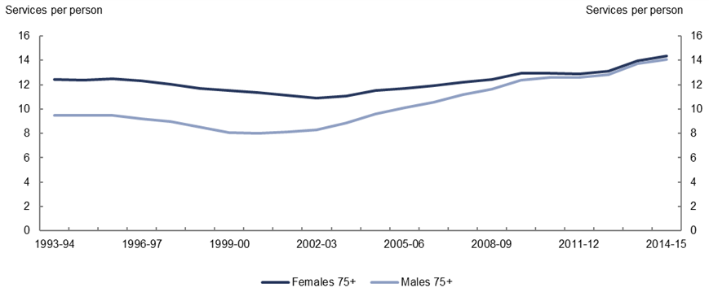  GP and GP-type services per person, persons aged 75 and over | 1993-94 | 1994-95 | 1995-96 | 1996-97 | 1997-98 | 1998-99 | 1999-00 | 2000-01 | 2001-02 | 2002-03 | 2003-04 | 2004-05 | 2005-06 | 2006-07 | 2007-08 | 2008-09 | 2009-10 | 2010-11 | 2011-12 | 2012-13 | 2013-14 | 2014-15
Females | 12.5 | 12.4 | 12.5 | 12.3 | 12.0 | 11.7 | 11.5 | 11.3 | 11.1 | 10.9 | 11.1 | 11.5 | 11.7 | 11.9 | 12.2 | 12.5 | 12.9 | 13.0 | 12.9 | 13.1 | 14.0 | 14.4
Males | 9.5 | 9.5 | 9.5 | 9.2 | 9.0 | 8.5 | 8.1 | 8.0 | 8.1 | 8.3 | 8.9 | 9.6 | 10.1 | 10.6 | 11.2 | 11.7 | 12.4 | 12.6 | 12.6 | 12.8 | 13.7 | 14.1
Source: PBO analysis of MBS data from the Department of Human Services, ABS and Treasury.
The major driver of the real increase in the benefit paid for GP services was the increase in the MBS benefit level from 85 per cent to 100 per cent of the Schedule Fee from 1 January 2005. This contributed to a rapid increase in the benefit paid per service up to 2005–06, which has since been relatively stable in real terms.
Compared to the past decade growth in spending per person on GP services is projected to slow to 1.2 per cent annually in real terms between 2014–15 and 2025–26. Growth in the number of services per person is projected to slow to 1.2 per cent annually over the period now that GP attendance rates for males aged 75 and over have caught up to equivalent female attendance rates. Benefits per service are projected to decline by 0.1 per cent annually in real terms over the period reflecting the combination of the flat growth in the benefit paid since the one-off increase in the GP rebate and government decisions to pause indexation of benefits for GP services in 2013–14 and from 2016–17 to 2017–18.

Surgeries and treatments
Spending per person on surgeries and treatments grew by 2.8 per cent annually in real terms between 1993–94 and 2014–15, accounting for around a fifth of the total real growth in spending per person on the MBS over the period. By 2014–15, spending on surgeries and treatments accounted for 17 per cent of MBS spending.
The number of surgeries and treatments per person grew by 2.9 per cent annually, driven by the addition of new items covering surgical operations and the introduction of the Relative Value Guide (RVG) for anaesthesia in 2001–02 (Figure 3–4). The RVG introduced new items and defined the benefits available for anaesthesia based on the degree of difficulty, length of operation and any additional complexities of the procedure (for example if anaesthesia is performed on a very young or very old patient).
In the past decade, new items for obstetrics and radiation oncology have also added to growth in services per person.
Figure 3–4: Surgeries and treatments, benefit paid per service (2014–15 dollars) and services per person
Surgeries and treatments | 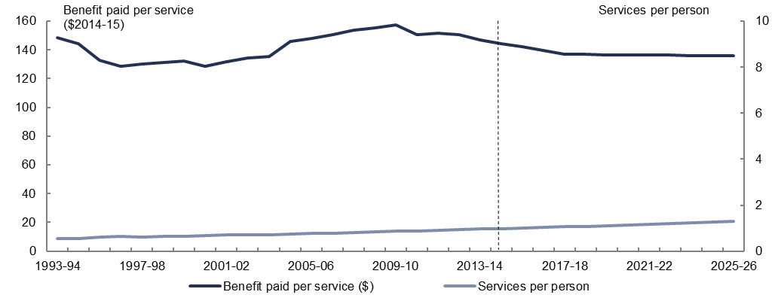  1993-94 | 1994-95 | 1995-96 | 1996-97 | 1997-98 | 1998-99 | 1999-00 | 2000-01 | 2001-02 | 2002-03 | 2003-04 | 2004-05 | 2005-06 | 2006-07 | 2007-08 | 2008-09 | 2009-10 | 2010-11 | 2011-12 | 2012-13 | 2013-14 | 2014-15 | 2015-16 | 2016-17 | 2017-18 | 2018-19 | 2019-20 | 2020-21 | 2021-22 | 2022-23 | 2023-24 | 2024-25 | 2025-26
Benefit paid per service ($2014-15) | 148.4 | 144.2 | 132.6 | 128.6 | 130.0 | 131.2 | 132.1 | 128.7 | 131.8 | 134.2 | 135.2 | 145.7 | 147.8 | 150.7 | 153.9 | 155.4 | 157.2 | 150.6 | 151.7 | 150.7 | 146.7 | 144.5 | 142.2 | 139.6 | 137.0 | 136.8 | 136.7 | 136.6 | 136.5 | 136.3 | 136.2 | 136.0 | 135.9
Number of services per person | 0.5 | 0.6 | 0.6 | 0.6 | 0.6 | 0.6 | 0.6 | 0.7 | 0.7 | 0.7 | 0.7 | 0.7 | 0.8 | 0.8 | 0.8 | 0.8 | 0.9 | 0.9 | 0.9 | 0.9 | 1.0 | 1.0 | 1.0 | 1.0 | 1.1 | 1.1 | 1.1 | 1.1 | 1.2 | 1.2 | 1.2 | 1.3 | 1.3
Source: PBO analysis of MBS data from the Department of Human Services, ABS and Treasury.
Part of the increase in spending is likely to have occurred from the impact of higher private health insurance cover and the resulting increased demand for private hospital-based services, which attract a benefit of 75 per cent of the Schedule Fee. Until 2000–01, the real decline in benefit paid per service as patients accessed more low-cost services was broadly offset by the increase in the number of services accessed per person. However, from
2001–02, the trend reversed, with the benefit paid per service growing by 0.7 per cent annually in real terms.
Some of the increase in the benefit paid per service is likely to have been driven by changes to the Medicare Safety Net from 2003–04 (discussed in more detail in section 3.7) which increased the benefits paid for services once patients reached an out-of-pocket threshold. The introduction of the first Medicare Safety Net caps in 1 January 2010, which limited the government’s contribution to out of pocket expenses, is likely to have accounted for some of the recent falls in real terms in the benefit paid per service.
Growth in spending per person on surgeries and treatments is projected to slow to 2.0 per cent annually in real terms between 2014–15 and 2025–26. This is driven by a projected decline in benefits paid per service of 0.6 per cent annually in real terms over the period, reflecting the pause in the indexation of benefits from 2013–14 to 2017–18 and the ongoing impact of the Medicare Safety Net caps. The number of services per person is projected to grow by 2.6 per cent annually consistent with the trend over the past decade.

Allied health
Spending per person on allied health services grew by 6.9 per cent annually in real terms between 1993–94 and 2014–15, accounting for 12 per cent of the total real growth in spending per person on the MBS over the period. In 2014–15, spending on allied health services accounted for 6 per cent of MBS spending.
From 1993–94 to 2003–04, the benefit paid per service for allied health services fell by 2.1 per cent annually in real terms, but the impact of this fall was more than offset by an increase in services per person (Figure 3–5). The number of services accessed per person grew by 3.1 per cent annually, primarily due to more frequent use of existing services and access to new optometry services introduced in 1994–95.
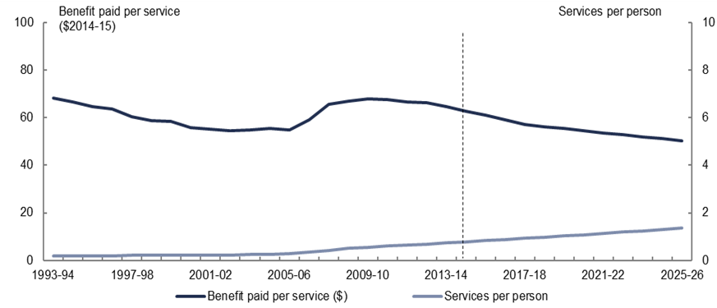
Figure 3–5: Allied health services, benefit paid per service (2014–15 dollars) and services per person
Allied health services | 1993-94 | 1994-95 | 1995-96 | 1996-97 | 1997-98 | 1998-99 | 1999-00 | 2000-01 | 2001-02 | 2002-03 | 2003-04 | 2004-05 | 2005-06 | 2006-07 | 2007-08 | 2008-09 | 2009-10 | 2010-11 | 2011-12 | 2012-13 | 2013-14 | 2014-15 | 2015-16 | 2016-17 | 2017-18 | 2018-19 | 2019-20 | 2020-21 | 2021-22 | 2022-23 | 2023-24 | 2024-25 | 2025-26
Benefit paid per service ($2014-15) | 68.3 | 66.6 | 64.5 | 63.7 | 60.5 | 58.9 | 58.5 | 55.7 | 55.1 | 54.6 | 55.0 | 55.4 | 54.9 | 59.1 | 65.6 | 66.9 | 67.8 | 67.6 | 66.6 | 66.3 | 64.5 | 62.8 | 60.9 | 59.0 | 57.1 | 56.2 | 55.4 | 54.5 | 53.7 | 52.8 | 52.0 | 51.2 | 50.4
Number of services per person | 0.2 | 0.2 | 0.2 | 0.2 | 0.2 | 0.2 | 0.2 | 0.2 | 0.2 | 0.2 | 0.2 | 0.3 | 0.3 | 0.3 | 0.4 | 0.5 | 0.6 | 0.6 | 0.6 | 0.7 | 0.7 | 0.8 | 0.8 | 0.9 | 0.9 | 1.0 | 1.0 | 1.1 | 1.1 | 1.2 | 1.2 | 1.3 | 1.4
Source: PBO analysis of MBS data from the Department of Human Services, ABS and Treasury.
Between 2003–04 and 2014–15, the number of services accessed per person more than trebled, driven by the rapid uptake of newly added allied health services such as psychology and physiotherapy, for which MBS benefits were made available if patients were referred through a GP Management Plan or Team Care arrangements. In addition to new MBS benefits added from 2003–04, a range of other allied health services were added to the MBS in later years including allied mental health services in 2006–07.
The addition of new higher cost services and rapid uptake of these services coincided with the benefit paid per service for allied health care services increasing by 1.2 per cent annually in real terms between 2003–04 and 2014–15. Most of this growth occurred between 2005–06 and 2008–09, with benefits paid per service remaining relatively stable or falling slightly from 2009–10 to 2014–15 in real terms. When combined, GP services and allied health services associated with the new plans accounted for a quarter of the increase in total MBS spending over the past decade.
Growth in spending per person on allied health is projected to slow to 2.9 per cent annually in real terms between 2014–15 and 2025–26. Growth in the number of services per person is projected to slow to 5.0 per cent annually, reflecting recent slower growth in the use of allied health services which were added to the MBS in the past decade. Benefits paid per service are projected to decline by 2.0 per cent annually in real terms over the period, reflecting the trend over the latter part of the past decade and the pause in the indexation of allied health benefits from 2013–14 to 2017–18.

Bulk billing incentives
Spending per person on bulk billing incentives accounted for 9 per cent of the total real growth in spending per person on the MBS between 1993–94 and 2014–15. Bulk billing incentives for GP services were introduced in 2003–04 and provide additional MBS funding to the service provider if they bulk bill a concession card holder or child patient for a particular service, that is accept the MBS benefit as full payment for the service.
Until 2009–10, incentives were directed almost entirely at encouraging bulk billing of GP services, after which incentives were expanded to diagnostic imaging and pathology services (Figure 3–6).
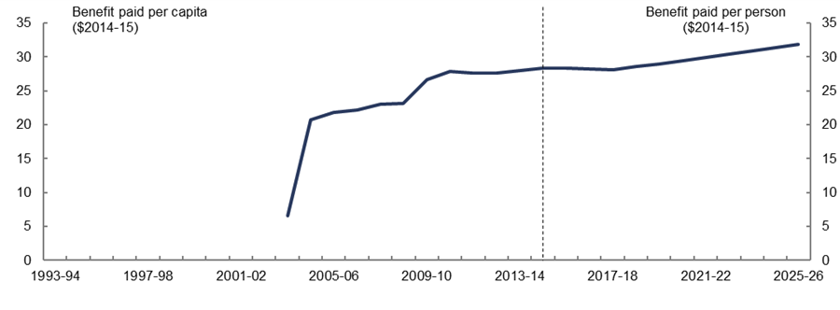
Figure 3–6: Bulk billing benefits paid per person (2014–15 dollars)
Bulk-billing incentives | 1993-94 | 1994-95 | 1995-96 | 1996-97 | 1997-98 | 1998-99 | 1999-00 | 2000-01 | 2001-02 | 2002-03 | 2003-04 | 2004-05 | 2005-06 | 2006-07 | 2007-08 | 2008-09 | 2009-10 | 2010-11 | 2011-12 | 2012-13 | 2013-14 | 2014-15 | 2015-16 | 2016-17 | 2017-18 | 2018-19 | 2019-20 | 2020-21 | 2021-22 | 2022-23 | 2023-24 | 2024-25 | 2025-26
Benefits per person ($2014-15) | - | - | - | - | - | - | - | - | - | - | 6.6 | 20.8 | 21.9 | 22.2 | 23.0 | 23.2 | 26.7 | 27.9 | 27.7 | 27.7 | 28.0 | 28.4 | 28.4 | 28.3 | 28.2 | 28.6 | 29.0 | 29.5 | 29.9 | 30.4 | 30.9 | 31.4 | 31.8
Note: Bulk-billing incentives were introduced in 2003–04.
Source: PBO analysis of MBS data from the Department of Human Services, ABS and Treasury.
Because bulk billing incentives are additional payments for services already provided (and recorded against other MBS categories), it has not been possible to identify the benefit paid per service or number of services per person for bulk billing.
Spending per person on bulk billing incentives is projected to grow broadly in line with GP expenditure, as most bulk billing is associated with GP attendances.

Specialist services
Spending per person on specialist services grew by 0.7 per cent annually in real terms between 1993–94 and 2014–15, accounting for 4 per cent of the total real growth in spending per person on MBS over the period. In 2014–15, spending on specialist services accounted for 10 per cent of MBS spending. From 1993–94 to 2003–04, spending on specialist services per person contracted by 0.5 per cent annually in real terms (Figure 3–7). Benefits paid per service declined by 1.1 per cent annually in real terms, as more lower-cost services were accessed. This more than offset the increase in services accessed per person, which grew by 0.6 per cent annually.
Figure 3–7: Specialist services, benefit paid per service (2014–15 dollars) and services per person
Specialist services | 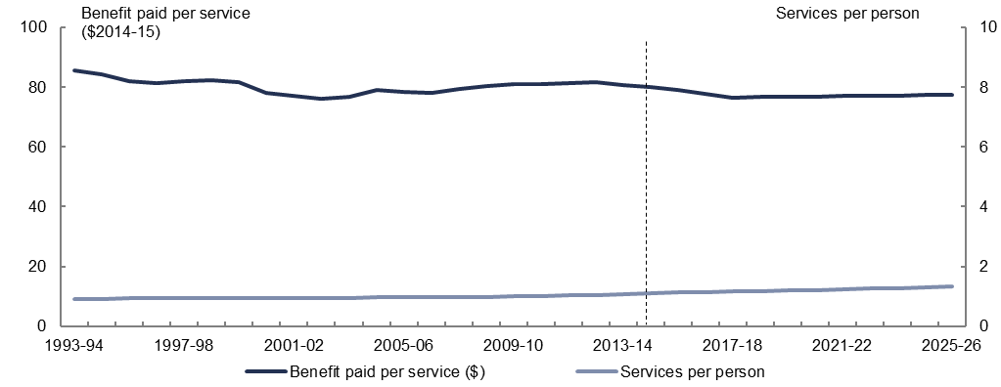  1993-94 | 1994-95 | 1995-96 | 1996-97 | 1997-98 | 1998-99 | 1999-00 | 2000-01 | 2001-02 | 2002-03 | 2003-04 | 2004-05 | 2005-06 | 2006-07 | 2007-08 | 2008-09 | 2009-10 | 2010-11 | 2011-12 | 2012-13 | 2013-14 | 2014-15 | 2015-16 | 2016-17 | 2017-18 | 2018-19 | 2019-20 | 2020-21 | 2021-22 | 2022-23 | 2023-24 | 2024-25 | 2025-26
Benefit paid per service ($2014-15) | 85.7 | 84.2 | 82.1 | 81.3 | 82.1 | 82.3 | 81.7 | 78.2 | 77.0 | 76.3 | 76.7 | 79.2 | 78.6 | 78.1 | 79.3 | 80.3 | 81.0 | 80.9 | 81.2 | 81.8 | 80.9 | 80.1 | 79.0 | 77.8 | 76.5 | 76.6 | 76.7 | 76.9 | 77.0 | 77.1 | 77.2 | 77.3 | 77.4
Number of services | 0.9 | 0.9 | 0.9 | 0.9 | 0.9 | 0.9 | 0.9 | 0.9 | 0.9 | 1.0 | 1.0 | 1.0 | 1.0 | 1.0 | 1.0 | 1.0 | 1.0 | 1.0 | 1.0 | 1.1 | 1.1 | 1.1 | 1.1 | 1.1 | 1.2 | 1.2 | 1.2 | 1.2 | 1.2 | 1.3 | 1.3 | 1.3 | 1.3
Source: PBO analysis of MBS data from the Department of Human Services, ABS and Treasury.
In 2003–04, the trend decline in benefits paid per service reversed, and spending per person increased by 1.8 per cent annually in real terms over the following decade, partly due to changes to the Medicare Safety Net discussed in Section 3.7. Nevertheless, the benefit paid for specialist services remained 6.5 per cent lower in real terms in 2014–15 than it was in 1993–94, at least in part due to the introduction of Medicare Safety Net caps from 1 January 2010.
Spending per person on specialist services is projected to increase to 1.3 per cent annually in real terms between 2014–15 and 2025–26. Growth in the number of services per person is projected to accelerate to 1.6 per cent annually, driven by the increasing demand for general specialist and consultant physician attendances, particularly by those aged 75 and over. The benefits paid per service is projected to decline by 0.3 per cent annually in real terms over the period, reflecting the indexation pause from 2013–14 to 2017–18. The decline in benefits paid per service also reflects the ongoing impact of the Medicare Safety Net caps on the benefit paid over the medium term.

Medicare Safety Net
Medicare safety net arrangements operate to assist individuals and families with high out-of-pocket costs for out-of-hospital services.
The Original Medicare Safety Net (OMSN) was introduced in 1984 and increased the benefit paid for out-of-hospital services from 85 to 100 per cent of the Schedule Fee once the relevant threshold had been met in a calendar year.
Changes made in 2003–04 and 2004–05 introduced the Extended Medicare Safety Net (EMSN). EMSN benefits, paid in addition to the standard MBS benefit and any benefit paid through the OMSN, were available to anyone once a threshold level of out-of-pocket costs was reached. In practice, this meant that once the relevant EMSN threshold was reached in a calendar year, 80 per cent of out-of-hospital patient expenses were reimbursed, so that benefits were paid even when providers charged substantially more than the Schedule Fee.
In response, the Australian Government progressively introduced a range of Extended Medicare Safety Net benefit caps from 1 January 2010, which limit the out-of-pocket expenses the MBS will cover for certain services. The general threshold for out-of-pocket costs for the EMSN was increased to $2,000 in 2013–14. The Australian Government has announced further tightening of the caps while at the same time combining the OMSN and EMSN into one new Medicare Safety Net from 1 July 2016.
Due to data limitations, spending associated with the OMSN and EMSN has not been projected separately, but is instead included in the projections for each individual category.

– PBO categories for analysis of the Medicare Benefits Schedule
Analysis of historic spending on the Medicare Benefits Schedule (MBS) has been based on the six categories detailed in Table A‒1. The PBO has aggregated MBS services to allow a general analysis of the drivers of spending trends and initiatives based on the purpose of the service provided, and/or the type of practitioner delivering the service.
The PBO categories are largely based on the MBS Broad Type of Services (BTOS) which has 17 classifications. A new grouping has been added for bulk billing incentives, and some MBS categories have been grouped differently. Definitions of the PBO categories are shown below.
Table A‒1: PBO categories
PBO MBS Category | MBS Groups/Subgroups/Items
GP and GP-type services | A1, A2, A5, A6, A7, A11, A14, A15, A17, A18, A19, A20, A22, A23, A25*, A27, A30#, M2*, M12.
Specialist services | A3, A4, A8, A12, A13, A16, A21, A24, A26, A28, A29.
Allied health  (incl. optometry and psychology) | A9, A10, M3, M4*, M6, M7, M8, M9, M10, M11, M13, M14#, M15
Bulk billing incentives | I6#, P12#, P13#, M1
Pathology and diagnostics  (incl. nuclear medicine) | D1#, D2#, I1, I2, I3, I4, I5, P1, P2, P3, P4, P5, P6, P7, P8, P9, P10, P11
Surgery and treatments (incl. anaesthetics and obstetrics) | T1, T2, T3, T4, T5, T6#, T7, T8, T9, T10, T11, O1-O11#, C1#, C2#, C3#
* Some Groups, Subgroups and Items no longer exist in current versions of the MBS, but are still included for the purposes of historical analysis. Where possible the PBO has attempted to capture all amendments to the schedule in the above categories.
# Deviations of the PBO categorisations from MBS BTOS classifications.
- GP and GP-type services—this category represents all professional attendances provided by a medical practitioner (including a general practitioner), and not a specialist. This category is consistent with all the BTOS non-referred attendances services.
- Specialist services—this category represents professional attendances provided by a specialist.
- Allied health—this category represents services provided by allied health professionals. Individual allied health services are available to patients with a chronic condition and/or complex care needs, on referral from a GP. The PBO category for allied health also includes optometry and psychology services, which are available more broadly under the MBS.
- Bulk billing incentives—this category includes the top-up funding provided to medical practitioners as an incentive to bulk bill.
- Pathology and diagnostics—this category includes all services provided under diagnostic procedures and investigations, including nuclear medicine; diagnostic imaging services; and all pathology services.
- Surgeries and treatments—this category includes oral and maxillofacial surgery services, and all therapeutic procedures, including: radiation oncology; therapeutic nuclear medicine, obstetrics; anaesthetics; regional or field nerve blocks, surgical operations; and botulinum toxin injections.

– Significant changes affecting the Medicare Benefits Schedule since 1993–94
Date | Change
1996–97 | Reforms to diagnostic imaging including expansion of Computed Tomography (CT) scan items.  Introduction of means tested rebates for private health insurance.
1997–98 | Medicare Services Advisory Committee established to oversee the assessment of new procedures and review existing MBS items.  Reduced benefits for second and subsequent patients seen during home-visits when more than one person is treated during the visit.
1998–99 | Addition of Magnetic Resonance Imaging to the MBS.
1999–2000 | Introduction of new MBS items for:  - Multidisciplinary care plans, coordinated care planning and case conferencing for patients with chronic and/or complex care needs  - Voluntary annual health assessments of patients 75 years and over.
2001–02 | Increased benefits paid for GP services and emergency after-hours services.  Introduction of new MBS items for:  - Mental health care provided by GPs and consultant psychologists.  - Domiciliary medication management reviews  - Asthma management plans.  Introduction of screening incentives for diabetes and cervical cancer.
2003–04 | Introduction of ‘A Fairer Medicare’ package and ‘MedicarePlus’ including  - Incentives for GPs to bulk bill patients with concession cards and children under 16  - Private health insurance rebate  - Expansion of existing Medicare Safety Net for concession card holders (to cover all out-of-hospital, out-of-pocket costs, not only the gap between the Schedule Fee and the 85% benefit level).
2004–05 | Additional ‘MedicarePlus’ measures introduced including the Extended Medicare Safety Net available to all individuals and families once threshold out-of-pocket costs reached.  Benefits paid for non-referred attendances outside hospital increased from 85% to 100% of the Schedule Fee.  Higher MBS rebates introduced for after-hours GP services.
2005–06 | Medicare Safety Net thresholds increased.
2006–07 | Expansion of access to allied mental health care practitioners through the MBS.
2007–08 | Introduction of rebates for annual health assessments for patients with an intellectual disability.  Addition of after-hours items to the MBS for urgent out-of-surgery visits.
2009–10 | Reform of the MBS including:  - New services review process for items added to the MBS.  - Introduction of a cap on benefits payable under the EMSN.  - Introduction of bulk billing incentives for diagnostic imaging and pathology services.  - Amendments to Schedule Fees for items where there is evidence that improvement in technologies have allowed services to be delivered more cheaply.  - Expansion of MBS rebates for nurse practitioners providing services equivalent to those of a GP.
2010–11 | Increased MBS rebates for long and complex GP consultations.  Greater access to medical specialists through the MBS.
2011–12 | Expanded access to diagnostic imaging through the MBS (including increased bulk billing incentives).  Reform of pathology service funding and allied mental health care funding through the MBS.
2013–14 | Increase of general threshold for EMSN to $2000.  Indexation of MBS fees was re-aligned with the financial year moving from 1 November 2013 to 1 July 2014.
2014–15 | Indexation of some MBS fees (GP fees excluded) is being paused for two years from 1 July 2014 to 30 June 2016.
2015–16 | Indexation of MBS fees for all GP services is being paused for three years from 1 July 2015 to 1 July 2018.  Proposed replacement of Original Medicare Safety Net, EMSN and Greatest Permissible Gap with the new Medicare Safety Net from 1 January 2016.
2016–17 | Proposed extension of indexation pause of MBS fees for all services provided by medical specialists, allied health and other health practitioners for a further two years from 1 July 2016 to 1 July 2018.

– Technical notes and sources
The report uses MBS services and benefits data published by the Department of Human Services in the analysis of historical trends from 1993–94 to 2014–15. Specifically, data has been sourced from:
- medicarestatistics.humanservices.gov.au/statistics/mbs_item.jsp

Methodology
MBS services and benefits data have been grouped into six categories (as outlined in Appendix A). The data are published by age and gender.
MBS services have been converted into services per person (using Treasury population estimates) and MBS benefits paid have been converted to benefits per service in 2014–15 dollars (deflating by the Consumer Price Index).
Services per person and real benefits per service for the six categories are projected by using historical average level changes in both services per person and real benefits per service in each category. The historical averages prior to 2014–15 used for each category are outlined in Table C‒1. For example, the 10-year average would be the average annual level change between 2005–06 and 2014–15.
In determining the average changes outlined in Table C‒1 the baseline position was to adopt the long-term 10-year historical averages for both services per person and benefits per service. For most categories a 10-year average is a suitable base from which to project future growth. The exceptions to this are in GP services and allied health. Using a 10-year historical average for these categories would not be representative of likely future growth, due to large policy changes in the past 10 years which impacted heavily on growth rates. For these categories, the PBO has departed from adopting a 10-year historical average, with the rationale included in Table C‒1.
In addition, adjustments have been made to the projections for certain age groups within some categories. These are also outlined in Table C‒1.
Table C‒1: Historical average level changes used for Medicare Benefit Schedule projections
Category | Services per person | Benefits per service
Pathology and diagnostics | 10-year average  Adjustments were made to pathology and diagnostic services for males aged 75 and over to ensure consistency between male and female utilisation in line with historical trends. | 10-year average
GP and GP-type services | 9-year average  A 9-year average has been adopted rather than a 10-year average, to exclude the rapid increase in growth in services per person that arose from the provision of bulk billing incentives and the increase in GP rebates prior to 2005–06. The 9-year average is more likely to be representative of future growth.  Adjustments were made to GP attendances for males aged 75 and over to ensure consistency between male and female utilisation in line with recent historical trends (see section 3.2). | 9-year average  A 9-year average has been adopted rather than a 10-year average, to exclude the spike in growth in benefits per service that arose from the increase in GP rebates prior to 2005–06. The 9-year average is more likely to be representative of future growth.
Surgeries and treatments | 10-year average | 10-year average
Allied health | 5-year average  A 5-year average has been adopted rather than a 10-year average, to exclude the rapid increase in growth in services per person that arose from the addition, and rapid uptake, of a large number of services in 2005–06 (and to a lesser extent in the subsequent years). The 5-year average is more likely to be representative of future growth.  Adjustments were made to allied health services for males aged 85 and over to ensure consistency with longer-term historical trends for this age group. | 5-year average  A 5-year average has been adopted rather than a 10-year average, to exclude the spike in growth in benefits per service that arose from the addition, and rapid uptake, of a large number of new higher cost services in 2005–06 (and to a lesser extent in the following years). The 5-year average is more likely to be representative of future growth.
Bulk Billing incentives | N/A | N/A
Specialist services | 10-year average | 10-year average

As with any medium-term projections there are uncertainties surrounding the numbers presented. In particular, when projecting Medicare spending there is uncertainty regarding the ongoing impact of past policy changes and when they are likely to mature.
    - Real growth rates
Nominal spending has been deflated by the Consumer Price Index to determine real spending in 2014–15 dollars.
Growth rates are compound annual average growth rates and cumulative contributions to growth. Contributions to growth are the percentage point contribution to total cumulative real growth over the relevant period.
    - Sources and references
Australia,, House of Representatives 1983, Debates, no. 132, 14 September, Canberra.
Centre for Health Economics Research and Evaluation 2011, Extended Medicare Safety Net: Review of Capping Arrangements, prepared for the Commonwealth Department of Health and Ageing, Canberra.
Commonwealth of Australia 1993–2015, Budget Papers, Updates, various, Commonwealth of Australia, Canberra.
Commonwealth of Australia 2015, 2015 Intergenerational Report, Commonwealth of Australia, Canberra.
Jolly, R 2009, Background Note: Medical practitioners, education and training in Australia, Parliamentary Library, Canberra.
This page is intentionally blank
www.pbo.gov.au

The Medicare Benefits Schedule (MBS) is one of three parts of the Medicare health insurance scheme funded by the Australian Government. In addition to the MBS, Medicare includes the Pharmaceutical Benefits Scheme and funding for public patients in public hospitals.
In 1981, access to free hospital and medical care was restricted to pensioners with health care cards, sickness beneficiaries and those meeting stringent means tests.
The benefit paid can also be affected by the Greatest Permissible Gap (GPG), which increases the benefit paid up to the Schedule Fee less $78.40 for non-bulk billed out-of-hospital patients. The Australian Government has announced changes to the GPG from 1 January 2016.
This is reduced by any payment received by a private health insurer in the case of medical services provided for admitted patients or out-of-hospital services.
These hospital agreements are part of the broader Medicare health insurance scheme.
Australia,, House of Representatives 1983, Debates, no. 132, 14 September, Canberra, p. 733.
From 1 July 1997, the Medicare levy surcharge was introduced for higher income earners without private health insurance.
The surgeries and treatments category covers in-hospital and out-of-hospital procedures and excludes physician consultations.
The specialist services category predominantly covers physician consultations.
Services provided by allied health professionals including optometry and psychology services.
While growth in nominal MBS spending is driven by a combination of population growth, demographic change, inflation, rising utilisation of services, and policy changes, the analysis in this report focusses on spending per person in real terms to isolate the specific drivers of increases in MBS spending from population growth and inflation.
Per person calculations are based on Treasury population estimates.
There is no annual real growth per person shown for bulk billing incentives over the period as they were introduced in 2003–04.
Major policy changes are those which are reported separately in the budget papers.
This also includes the addition or removal of minor services from the MBS since 1993–94, which are not reported separately in the budget.
For a full list of major policy changes refer to Appendix B.
Introduction of these items to the MBS followed a funding agreement between the Commonwealth and radiologists designed to control spending growth, which was already high.
Commonwealth of Australia 2015, 2015 Intergenerational Report, Commonwealth of Australia, Canberra.
Jolly, R 2009, Background Note: Medical practitioners, education and training in Australia, Parliamentary Library, Canberra.
The policy announced in the 2014–15 Budget to simplify the Medicare Safety Net from 1 July 2016 is designed to further reduce spending.
Allied health covered only optometry services up to and including 2002–03 before it was broadened in scope to other health services.
Bulk-billing incentives were introduced in 2003–04.
Specialist services predominantly cover physician consultations. These do not overlap with specialist surgeries and treatments.
The Greatest Permissible Gap (GPG), introduced in 1973, predates the Original Medicare Safety Net. The GPG requires the difference between the MBS fee for an item and the 85 per cent Medicare benefit must not be greater than a specified amount (eg $78.40 in 2015).
Also includes the GPG.
There is no service count for bulk billing as it is not an MBS item itself. This category is projected using trends in GP attendances, as most bulk billing is associated with GP attendances.

