Higher Education Loan Programme
Impact on the Budget
Report no. 02/2016

© Commonwealth of Australia 2016
ISBN 978-0-9944547-3-7 (Online)
This work is licensed under the Creative Commons Attribution-NonCommercial-NoDerivs 3.0 Australia License.
The details of this licence are available on the Creative Commons website: http://creativecommons.org/licenses/by-nc-nd/3.0/au/
Use of the Coat of Arms
The terms under which the Coat of Arms can be used are detailed on the following website: www.itsanhonour.gov.au/coat-arms
Produced by: Parliamentary Budget Office
Designed by: Studio Tweed
Assistant Parliamentary Budget Officer
Fiscal Policy Analysis Division
Parliamentary Budget Office
Parliament House
PO Box 6010
CANBERRA ACT 2600
Phone: (02) 6277 9500
Email: pbo@pbo.gov.au

Contents
Foreword iv
Overview v
1 What is HELP? 1
1.1 Background 1
1.2 Student numbers 3
1.3 Recent policy reform measures 4
2 Budget impact of HELP 5
2.1 Size of loan portfolio 5
2.2 Cost of HELP 6
2.3 Reporting on HELP 8
2.4 Net annual cash flows 9
2.5 Underlying cash balance impact 10
2.6 Impact of HELP on net debt 12
Appendix A – Methodology and key technical assumptions 15
Appendix B – Higher education policy reform measures, 2013–14 to 2014–15 17
References 20

Foreword
The Higher Education Loan Programme (HELP) is a large and growing government programme that supports participation in higher education. Although the costs of HELP are included in the budget financial statements, they are not separately identified to allow the impact of the programme on the budget to be readily assessed.
This report discusses the size and costs of HELP and provides an estimate of the impact of the programme on the underlying cash balance. The analysis in this paper is based on the Government’s announced policies as at the 2015–16 MYEFO.
I would like to thank the PBO staff involved in the preparation of this report: Tim Pyne, Paul Gardiner, Lok Potticary and Vijay Murik. The report was prepared for publication by Louise Milligan.
I also wish to thank the external referees who provided helpful comments and suggestions on the report, namely the Grattan Institute and Professor Bruce Chapman, Crawford School of Public Policy, Australian National University.
The assistance of external reviewers does not imply any responsibility on their part for the content of the final report, which rests solely with the Parliamentary Budget Office.
Phil Bowen PSM FCPA
Parliamentary Budget Officer
6 April 2016

Overview
The cost of the Higher Education Loan Programme (HELP) is growing strongly driven by the introduction of the demand driven approach to higher education funding, recently announced policy decisions to reduce subsidies for university courses and to allow universities to set their own course fees, and expansion of HELP loans to vocational education.
The Parliamentary Budget Office (PBO) projects that the annual cost of HELP loans on an underlying cash basis will rise from $1.7 billion in 2015–16 to $11.1 billion in 2025–26
(Figure 1).
Figure 1: HELP loan portfolio – annual cost on an underlying cash balance basis
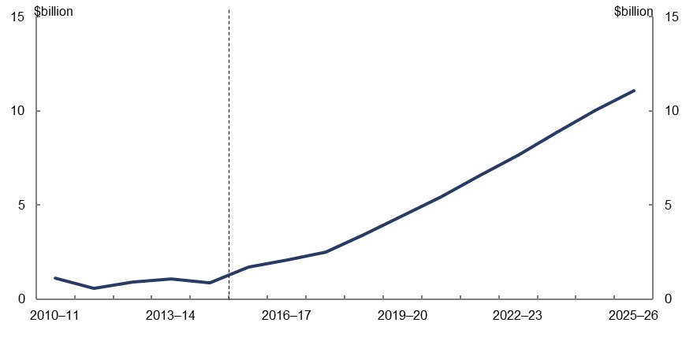 | 2010–11 | 2011–12 | 2012–13 | 2013–14 | 2014–15 | 2015–16 | 2016–17 | 2017–18 | 2018–19 | 2019–20 | 2020–21 | 2021–22 | 2022–23 | 2023–24 | 2024–25 | 2025–26
Annual net cash cost | 1.133 | 0.591 | 0.908 | 1.063 | 0.865 | 1.717 | 2.092 | 2.519 | 3.427 | 4.414 | 5.432 | 6.537 | 7.664 | 8.847 | 10.015 | 11.095
Source: PBO analysis of Department of Education and Training data.
The two key sources of the costs of HELP are the concessional interest rate charged on the loans and the doubtful debt cost of loans that are not expected to be repaid. The underlying cash balance reflects the concessional interest rate cost through the shortfall in annual interest receipts on the loans relative to annual public debt interest payments on borrowing used to finance the loans. It also indirectly reflects the doubtful debt costs through increasing public debt interest costs on the outstanding loans that are unlikely to be repaid.
Doubtful debt costs associated with new loans are projected to increase from $1.9 billion (or 19.0 per cent of new loans) in 2015–16 to $4.0 billion (or 21.8 per cent of new loans) in 2025–26. Concessional interest rate costs for new loans are projected to increase from around $1.0 billion (or 10.2 per cent of new loans) in 2015–16 to $2.4 billion (or 13.1 per cent of new loans) in 2025–26.
The full cost of HELP is included in the overall budget underlying cash balance but it is not separately identified in the budget papers. The growing impact of HELP is largely due to policy decisions taken since 2008, particularly the introduction of the demand driven funding model and the announced policies to reduce government subsidies and to allow universities to set their own fees.
The financial consequences of these policy changes were not fully transparent because the published impact of measures affecting HELP are presented on a fiscal balance basis which does not include doubtful debt costs. Also, the published impact of HELP measures does not include the public debt interest cost which is accounted for globally in the budget. As a result, the published costs of these measures only provide a partial picture of the budget impact of the policy decisions.
The annual cost of HELP on an underlying cash balance basis shown in Figure 1 highlights the long term consequences of policy decisions relating to HELP loans. It reinforces the importance of understanding the medium term costs of major programmes in considering policy priorities and fiscal sustainability.
HELP loans also increase the size of net debt because the borrowing used to fund these loans exceeds the value of loans on the balance sheet, which is reduced to account for the concessional interest rate and the provision for doubtful debt. Net debt attributable to the HELP portfolio is projected to rise from $13.4 billion in 2015–16 to $48.1 billion in 2025–26. This will see the proportion of net debt attributable to HELP increase from 4.8 per cent in 2015–16 to 18.3 per cent in 2025–26 (Figure 2).
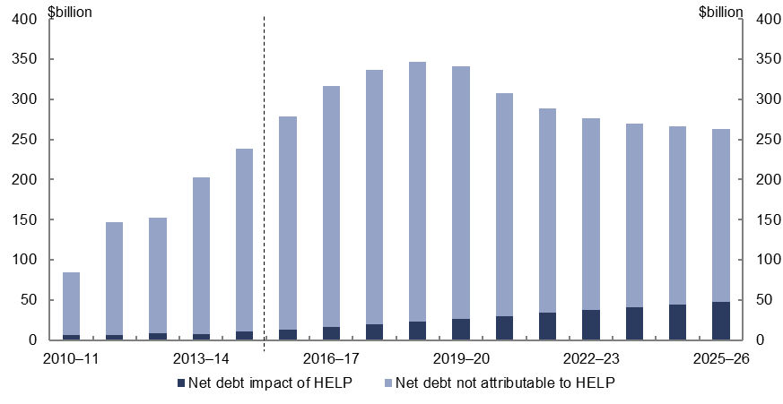
Figure 2: HELP loan portfolio – impact on net debt
Year | Net debt impact of HELP | Net debt not attributable to HELP
2010–11 | 6.9 | 77.66
2011–12 | 6.3 | 141.02
2012–13 | 8.1 | 144.88
2013–14 | 7.9 | 194.60
2014–15 | 11.1 | 227.58
2015–16 | 13.4 | 265.33
2016–17 | 16.1 | 300.43
2017–18 | 19.3 | 317.10
2018–19 | 22.7 | 323.86
2019–20 | 26.2 | 315.18
2020–21 | 30.0 | 277.83
2021–22 | 33.7 | 254.50
2022–23 | 37.4 | 239.18
2023–24 | 41.0 | 228.98
2024–25 | 44.6 | 221.40
2025–26 | 48.1 | 214.56
Source: 2015-16 MYEFO and PBO analysis.
The public debt interest cost of financing the HELP loan portfolio is projected by the PBO to grow strongly as the value of outstanding loans increases. Public debt interest attributable to the HELP loan portfolio is projected to rise from $2.2 billion in 2015–16 to $12.8 billion in 2025–26. The proportion of Australian Government public debt interest required to finance outstanding HELP loans is projected to increase from 15.4 per cent in 2015–16 to 46.3 per cent in 2025–26 (Figure 3).

Figure 3: HELP loan portfolio – impact on public debt interest
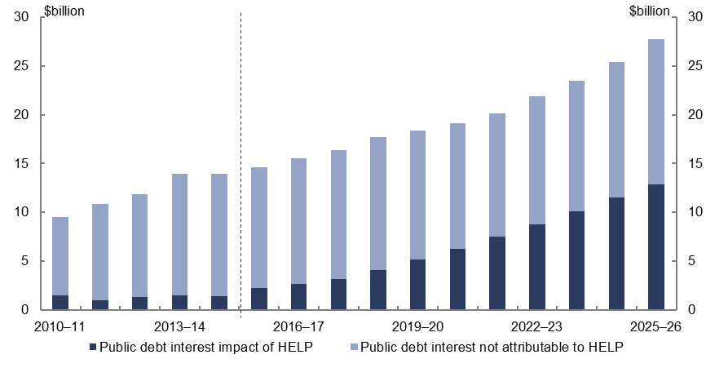 | 2010–11 | 2011–12 | 2012–13 | 2013–14 | 2014–15 | 2015–16 | 2016–17 | 2017–18 | 2018–19 | 2019–20 | 2020–21 | 2021–22 | 2022–23 | 2023–24 | 2024–25 | 2025–26
Public debt interest not attributable to HELP | 8.06 | 9.90 | 10.55 | 12.45 | 12.50 | 12.37 | 12.84 | 13.25 | 13.66 | 13.28 | 12.87 | 12.63 | 13.09 | 13.37 | 13.88 | 14.88
Public debt interest impact of HELP | 1.49 | 0.98 | 1.30 | 1.52 | 1.42 | 2.25 | 2.66 | 3.12 | 4.09 | 5.15 | 6.28 | 7.49 | 8.78 | 10.13 | 11.51 | 12.84
Source: 2015–16 MYEFO and PBO analysis.

What is HELP?
The Australian Government’s Higher Education Loan Programme (HELP) supports participation in higher education by providing income-contingent concessional loans to students to assist with the costs of education. The analysis in this paper is based on the Government’s announced policies as at the 2015–16 MYEFO, including those that are yet to be legislated. Key assumptions underpinning the analysis in this report are outlined in Appendix A.

Background
Since the Government introduced HELP in 1989, the scope and coverage of the scheme has grown to five constituent sub-programmes covering various types of loans to university and vocational education students.
The largest and original sub-programme, HECS-HELP, provides university fee loans on a concessional basis for students enrolled in Government subsidised university places known as Commonwealth Supported Places (CSP). HECS-HELP accounted for 56.6 per cent of new HELP loans over the period from 2010–11 to 2015–16.
The other significant sub-programmes are FEE-HELP and VET FEE-HELP. FEE-HELP provides loans for unsubsidised full-fee paying students enrolled in higher education courses, and accounted for 20.5 per cent of new HELP loans over the period from 2010–11 to 2015–16. VET FEE-HELP provides loans for vocational education and training courses at the advanced diploma level and higher, and accounted for 21.0 per cent of new HELP loans over the period from 2010–11 to 2015–16.
Loans from the separate sub-programmes are combined into a single pool of loans that are owed to the Government (‘HELP loan portfolio’).
HELP loans have two defining characteristics:
- Income contingency: Students are only required to repay their HELP loans once their income exceeds a repayment threshold.
- Concessionality: The outstanding loan balances are indexed annually to changes in the Consumer Price Index (CPI). Since CPI inflation is typically lower than the Government’s cost of borrowing, HELP loans are provided to students on a concessional basis.
Table 1–1: How HELP works
Students | Students enrol in an eligible course at an approved institution. Students elect to either pay their contributions (fees) upfront, or defer payment and take out a HELP loan from the Government.
Higher education institution | For CSP students, the Government provides a direct subsidy to the education institution for the CSP student under the Commonwealth Grant Scheme. For those CSP students who defer their fees and take out a HELP loan, the Government also pays the student contribution to the institution. The direct subsidy to the education institution and the student contribution, together, account for the total course fee received by the institution.
Concessional loan | The student contribution is treated as a loan to the student indexed to annual changes in the Consumer Price Index (CPI). The loan is concessional because CPI inflation (the rate of interest payable by the student) is typically lower than the Government’s cost of borrowing.
Government financing | The Government funds new HELP loans through Government borrowing taking the form of the issuance of Commonwealth Government Securities. In doing so, the Government incurs a cost for financing the loans in the form of public debt interest payments.
Income-contingent repayment | Subject to the level of the borrower’s income, the borrower repays his or her HELP loan to the Australian Taxation Office. Payments are made according to income thresholds and repayment rates that are set annually by the Government.  HELP loans are currently repaid by borrowers over an average of nine years, but the length of time taken for individuals to repay their loans varies widely depending on individual circumstances.
Doubtful debts | These are loans that are unlikely to be repaid because the taxable income of the borrower is below the repayment threshold, or they have moved overseas.
Source: PBO analysis.
Under current legislation, study fees for CSP students are capped at an amount per subject determined by the Government in consultation with education providers. Fees are based on three bands covering various fields of studies, with a maximum annual fee in 2016 ranging from $6,256 to $10,440. The Government’s announced policy is for fees to be deregulated from 2017 as discussed below.

Student numbers
The number of CSP students accessing loans through HECS-HELP has grown by 11.2 per cent annually over the past five years, rising from 308,000 in 2010 to 522,000 in 2015 on an equivalent full-time student load (EFTSL) basis (Figure 1–1). In recent years, growth in student numbers has been partly driven by the policy decision in 2009 to introduce a demand driven funding system for university education. Caps on enrolments were increased in 2010 and 2011, and completely removed from 2012.
There is also expected to be an increase in student numbers in 2017, following the extension of HELP to certain sub-bachelor courses and to non-university higher education providers.
Following the rise in demand for HECS-HELP loans associated with the expansion of the demand driven approach to university education, the PBO projects that HECS-HELP student numbers will increase in line with population growth, rising to 696,000 by 2026.
The number of vocational education and training students accessing loans through VET FEE-HELP has experienced a rapid expansion since its introduction in 2009, growing at a rate of 147 per cent per annum rising to 226,000 students in 2015. Growth in VET FEE-HELP student numbers is expected to slow markedly following measures introduced by the Government in 2015, including the decision to freeze the value of VET FEE-HELP loans for existing training providers at 2015 levels.
The number of full-fee paying students accessing loans through FEE-HELP has grown by 7.5 per cent annually over the past five years, and is projected to grow in line with population growth.
Figure 1–1: Student numbers (equivalent full-time student load)
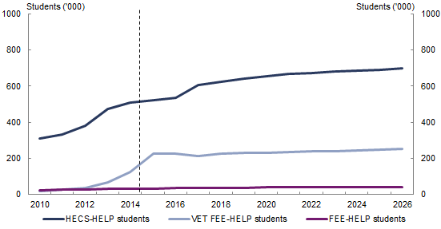 | HECS-HELP students | VET FEE-HELP students | FEE-HELP students
2010 | 307.949 | 20.108 | 23.313
2011 | 333.570 | 28.570 | 25.684
2012 | 380.274 | 37.716 | 25.860
2013 | 472.434 | 64.913 | 30.841
2014 | 507.114 | 123.017 | 32.218
2015 | 522.602 | 225.875 | 33.445
2016 | 537.035 | 227.269 | 34.783
2017 | 606.094 | 214.625 | 36.174
2018 | 623.838 | 225.298 | 37.621
2019 | 641.856 | 228.109 | 37.884
2020 | 654.443 | 231.084 | 38.154
2021 | 667.257 | 234.068 | 38.434
2022 | 673.017 | 237.085 | 38.704
2023 | 678.831 | 240.307 | 38.994
2024 | 684.701 | 243.550 | 39.269
2025 | 690.626 | 246.853 | 39.533
2026 | 696.361 | 250.262 | 39.829
Source: PBO analysis of Department of Education and Training data.

Recent policy reform measures
The 2014–15 Budget included a package of higher education reform measures. The then Minister for Education, the Hon Christopher Pyne MP, explained the package as follows:
‘By rebalancing the Commonwealth’s contribution towards course fees for new students with a reduction of 20 per cent on average, with effect from 1 January 2016, and allowing universities to determine the fees they charge, the Commonwealth will be able to sustainably meet the growth in students undertaking study, and will spread the opportunity of a higher education to more students.’
The 2014–15 Budget reforms were designed to decrease direct funding to universities, but allow universities to set their own course fees. The reforms recognised that the lower direct subsidies from the Government would mean that student contributions would rise. Under the reform package, higher student contributions could be expected to see an expansion in the HELP loan portfolio in the form of larger HELP loans.
On 1 October 2015 the Minister for Education and Training, Senator the Hon Simon Birmingham, announced that implementation of elements of the package of higher education reforms would be delayed until at least 2017 to allow the Government to undertake further consultations. As at March 2016, a number of elements of the 2014–15 Budget higher education reform package remain unlegislated.
A summary of major higher education policy measures announced by the Government from 2013–14 to 2015–16 is at Appendix B.

Budget impact of HELP

Size of loan portfolio
The HELP loan portfolio is a large and growing debt-funded financial asset on the Government’s balance sheet that involves costs to the Government. The size of the HELP loan portfolio can be characterised in two different ways:
- Nominal value: The total face value of the stock of outstanding HELP loans is known as its nominal value. The nominal value of the HELP loan portfolio increases with the issuing of new loans and with annual CPI indexation of existing loans. The nominal value declines as loans are repaid.
- Fair value: The fair value of a financial asset is the transaction price at which it could be bought or sold at market. However, due to the fact that a market does not exist for the HELP loan portfolio or its constituent HELP loans, its fair value to the Government must be estimated. This is done by estimating the net present value of the future cash flows associated with all loans in the HELP loan portfolio. The estimation depends on projected borrower behaviour and assumptions regarding future differences between the market interest rates on Commonwealth Government Securities and the concessional interest rate charged on loans.
The difference between the nominal and fair values of the HELP loan portfolio represents the total write-down of the value of the portfolio as reflected in the Government’s balance sheet.
Figure 2–1: HELP loan portfolio
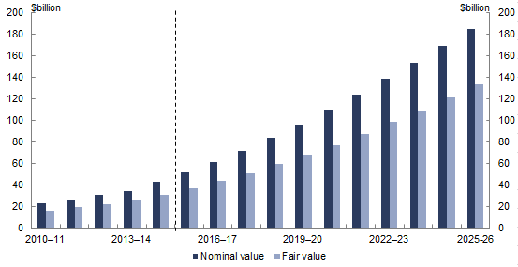  Year | Nominal value | Fair value
2010–11 | 23.1 | 15.6
2011–12 | 26.4 | 19.4
2012–13 | 30.3 | 21.7
2013–14 | 33.8 | 25.1
2014–15 | 42.3 | 30.4
2015–16 | 51.2 | 37.0
2016–17 | 60.8 | 43.6
2017–18 | 71.6 | 50.8
2018–19 | 83.3 | 58.9
2019–20 | 95.9 | 67.7
2020–21 | 109.5 | 77.1
2021–22 | 123.7 | 87.3
2022–23 | 138.5 | 98.1
2023–24 | 153.7 | 109.4
2024–25 | 169.3 | 121.1
2025-26 | 185.2 | 133.0
Source: PBO analysis of Department of Education and Training data.
From inception until 2014–15, the nominal value of the HELP loan portfolio has grown at a rate of 22.5 per cent annually to $42.3 billion. Over the same period, the fair value of the HELP loan portfolio has grown at a rate of 21.3 per cent annually to $30.4 billion. In other words, as at 30 June 2015, the value of the HELP loan portfolio has been written down by $11.9 billion.
The size of the HELP portfolio grew strongly over the past decade largely driven by increasing numbers of students taking out HELP loans. This reflected policy decisions to introduce a demand driven funding system for university education and to provide HELP loans for vocational education and training.
The size of the HELP loan portfolio is projected to grow rapidly through to 2025–26
(Figure 2–1), driven mainly by projected increases in student fees from 2017 due to the announced higher education reforms. The PBO projections assume that universities will increase their fees to recover the reductions in subsidies under the Commonwealth Grant Scheme. This will require an average increase in fees of 40 per cent for students affected by the changes. Beyond this increase, the PBO has used an indicative assumption that universities will increase their student fees by 2 per cent annually in real terms.
By 30 June 2026, the nominal value of the HELP loan portfolio is projected to be $185.2 billion, and the fair value of the HELP loan portfolio is projected to be $133.0 billion, meaning that the write-down in the value of the HELP loan portfolio is projected to increase to $52.2 billion.
The projected increase of $40.3 billion in the write-down of the HELP portfolio from $11.9 billion as at 30 June 2015 to $52.2 billion as at 30 June 2026 reflects the costs to the Government of new loans issued over this period.

Cost of HELP
The costs of HELP are comprised of two components:
- Doubtful debt costs are the estimated proportion of new loans made each year that are not expected to be repaid due to the borrower’s taxable income never rising above the income-contingent repayment threshold, or irrecoverable repayments due to the borrower permanently moving overseas. Doubtful debt costs are estimated to be 19.0 per cent of new loans issued in 2015–16.
- Concessional interest rate costs arise from HELP loans being indexed at the CPI inflation rate, which is typically lower than the yields on Commonwealth Government Securities that determine the Government’s borrowing costs to finance the programme.
Figure 2–2 presents the doubtful debt costs and concessional interest rate costs of new loans issued in a given year. Each bar represents the expected lifetime cost to the Government of the loans.
Figure 2–2: Expected total lifetime costs of new HELP loans
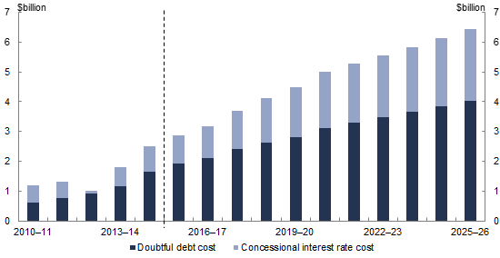 | 2010–11 | 2011–12 | 2012–13 | 2013–14 | 2014–15 | 2015–16 | 2016–17 | 2017–18 | 2018–19 | 2019–20 | 2020–21 | 2021–22 | 2022–23 | 2023–24 | 2024–25 | 2025–26
Doubtful debt cost | 0.6025 | 0.7495 | 0.9023 | 1.1551 | 1.6329 | 1.9118 | 2.1121 | 2.4101 | 2.6279 | 2.8169 | 3.1221 | 3.3083 | 3.4763 | 3.6517 | 3.8331 | 4.0198
Concessional interest rate cost | 0.5947 | 0.5739 | 0.1050 | 0.6351 | 0.8668 | 0.9515 | 1.0696 | 1.296 | 1.4856 | 1.6705 | 1.8736 | 1.9853 | 2.0862 | 2.1914 | 2.3003 | 2.4123
Source: PBO analysis of Department of Education and Training data.
The costs of new HELP loans are projected to grow significantly over the medium term in line with the projected increase in the value of new loans. Doubtful debt costs associated with new loans are projected to increase from $1.9 billion in 2015–16 to $4.0 billion in 2025–26. Concessional interest rate costs for new loans are projected to increase from around $1.0 billion in 2015–16 to $2.4 billion in 2025–26.
Rising projected costs are reflected in the widening gap between the nominal and fair values of the HELP loan portfolio over the medium term as shown in Figure 2–1. The difference of $52.2 billion between the projected nominal and fair values of the HELP loan portfolio as at 30 June 2026 represents the doubtful debts and concessional interest rate costs on outstanding loans. It is the cumulative effect of the doubtful debt and concessional interest costs shown in Figure 2–2 for those loans that remain outstanding.

Reporting on HELP

Budget financial statements
The Budget financial statements present the impact of all Government programmes on the balance sheet and the budget balances (the fiscal, headline cash and underlying cash balances).
The financial impacts of HELP are included in the underlying and headline cash balances in each fiscal update and the Final Budget Outcome, in accordance with the relevant accounting standards.
However, the budget papers do not separately identify the impact of HELP on the underlying and headline cash balances. It is also not possible to quantify the impact of HELP on the budget balances from any other publicly available information.
Although doubtful debts are one of the key costs associated with HELP, they are not classified as an expense under Australian Accounting Standard: AASB 1049 Whole of Government and General Government Sector Financial Reporting. As a result, doubtful debt costs are not included in the fiscal balance. These costs are included as Other Economic Flows in the operating result and are reflected in the Australian Government’s balance sheet. As the fiscal balance does not include doubtful debt costs, it does not present the full impact of HELP on the budget.
The underlying cash balance includes the impact of all costs, including indirectly the impact of doubtful debt costs. However, as noted above, the underlying cash balance impact of HELP is not separately identified in the budget papers.

Budget measures
The estimated costs of budget measures relating to HELP are published as part of the Government’s reporting of policy measures in Budget Paper No. 2 and the relevant section of other fiscal updates. However, the published impact of HELP measures is presented on a fiscal balance basis and does not include doubtful debt costs. Neither does the published impact of individual HELP budget measures include the associated public debt interest costs, which are accounted for globally in the budget papers. As a result, the published cost of these measures only provides a partial picture of the budget impact of HELP policy decisions.
The introduction of the demand driven approach to higher education funding and expansion of VET FEE-HELP has significantly increased the size and cost of the HELP programme. Recently announced policy decisions are also likely to increase the size of HELP loans to university students. However, the lack of information on the impact of HELP loans on the budget and the incomplete costs presented in budget measures relating to HELP has meant that the financial consequences of these policy changes are not transparent and therefore not well understood.
The following sections of the report outline the PBO’s projections of the annual cash flows of the HELP programme and the impact of HELP on the underlying cash balance over the period to 2025–26.
The PBO projections provide the full annual impact of the entire HELP portfolio (comprising new and existing loans), reflecting all substantive costs and receipts of the programme.

Net annual cash flows
Figure 2–3 shows the PBO’s estimates of the annual cash flows relating to HELP loans.
The repayments of principal and interest by HELP loan borrowers are recorded as cash receipts. New loans issued and public debt interest costs are recorded as payments. The difference between receipts and payments is the annual impact on the headline cash balance.
Doubtful debt costs are not directly accounted for in these annual cash flows. However, they have a significant indirect impact through lower principal and interest repayments from borrowers. These lower repayments result in higher public debt interest costs for the Government as the debt used to finance the HELP loans needs to be serviced even if borrowers are not making repayments.
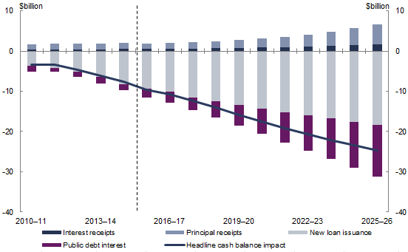
Figure 2–3: HELP loan portfolio — annual cash flows
 | 2010–11 | 2011–12 | 2012–13 | 2013–14 | 2014–15 | 2015–16 | 2016–17 | 2017–18 | 2018–19 | 2019–20 | 2020–21 | 2021–22 | 2022–23 | 2023–24 | 2024–25 | 2025–26
Interest receipts | 0.356 | 0.387 | 0.390 | 0.456 | 0.556 | 0.533 | 0.572 | 0.601 | 0.665 | 0.734 | 0.848 | 0.958 | 1.112 | 1.281 | 1.494 | 1.749
Principal receipts | 1.308 | 1.421 | 1.431 | 1.433 | 1.450 | 1.385 | 1.492 | 1.559 | 1.824 | 2.026 | 2.259 | 2.592 | 3.022 | 3.545 | 4.156 | 4.879
New loan issuance | -3.611 | -4.189 | -5.120 | -6.494 | -8.216 | -9.300 | -10.178 | -11.477 | -12.514 | -13.414 | -14.329 | -15.184 | -15.955 | -16.760 | -17.593 | -18.450
Public debt interest | -1.490 | -0.978 | -1.298 | -1.518 | -1.421 | -2.249 | -2.664 | -3.120 | -4.092 | -5.148 | -6.280 | -7.495 | -8.776 | -10.128 | -11.509 | -12.844
Headline cash balance impact | -3.436 | -3.359 | -4.597 | -6.123 | -7.630 | -9.632 | -10.778 | -12.437 | -14.117 | -15.802 | -17.502 | -19.129 | -20.597 | -22.062 | -23.452 | -24.665
Source: PBO analysis of Department of Education and Training data.
Given the projected growth in HELP loans, the issuing of new loans far outpaces principal and interest receipts over the period to 2025–26. This results in a rapidly growing public debt interest cost which is projected by the PBO to increase from $2.2 billion in 2015–16 to $12.8 billion in 2025–26. The negative impact of HELP on the headline cash balance is projected by the PBO to increase from $9.6 billion in 2015–16 to $24.7 billion by 2025–26.

Underlying cash balance impact
The underlying cash balance does not include the cash flows associated with the issuing of new loans and the receipt of loan repayments as these transactions only involve the exchange of one financial asset for another.
For HELP loans, the underlying cash balance impact comprises the shortfall in annual interest receipts relative to annual public debt interest payments (Figure 2–4). As such, the underlying cash balance impact reflects the concessional interest rate costs of the HELP loan portfolio.
As discussed in the preceding section, doubtful debt costs are not directly accounted for in the cash flows relating to HELP and are not separately accounted for in the underlying cash balance. However, doubtful debts have a significant indirect impact through lower interest repayments from borrowers and higher public debt interest costs for the Government as it finances the outstanding loans, including those that are unlikely to be repaid.
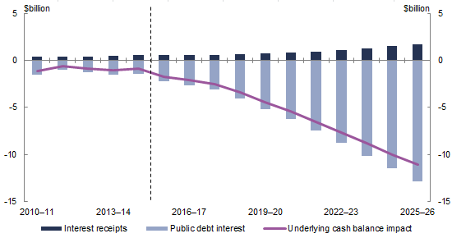
Figure 2–4: HELP loan portfolio – underlying cash balance impact
 | 2010–11 | 2011–12 | 2012–13 | 2013–14 | 2014–15 | 2015–16 | 2016–17 | 2017–18 | 2018–19 | 2019–20 | 2020–21 | 2021–22 | 2022–23 | 2023–24 | 2024–25 | 2025–26
Interest receipts | 0.356 | 0.387 | 0.390 | 0.456 | 0.556 | 0.533 | 0.572 | 0.601 | 0.665 | 0.734 | 0.848 | 0.958 | 1.112 | 1.281 | 1.494 | 1.749
Public debt interest | -1.490 | -0.978 | -1.298 | -1.518 | -1.421 | -2.249 | -2.664 | -3.120 | -4.092 | -5.148 | -6.280 | -7.495 | -8.776 | -10.128 | -11.509 | -12.844
Underlying cash balance impact | -1.133 | -0.591 | -0.908 | -1.063 | -0.865 | -1.717 | -2.092 | -2.519 | -3.427 | -4.414 | -5.432 | -6.537 | -7.664 | -8.847 | -10.015 | -11.095
Source: PBO analysis of Department of Education and Training data.
The PBO projects that the annual cost of the HELP loan portfolio on an underlying cash balance basis will rise from $1.7 billion in 2015–16 to $11.1 billion by 2025–26 (Figure 2–5).
Figure 2–5: HELP loan portfolio – annual cost on an underlying cash balance basis
 | 2010–11 | 2011–12 | 2012–13 | 2013–14 | 2014–15 | 2015–16 | 2016–17 | 2017–18 | 2018–19 | 2019–20 | 2020–21 | 2021–22 | 2022–23 | 2023–24 | 2024–25 | 2025–26
Annual net cash cost | 1.133 | 0.591 | 0.908 | 1.063 | 0.865 | 1.717 | 2.092 | 2.519 | 3.427 | 4.414 | 5.432 | 6.537 | 7.664 | 8.847 | 10.015 | 11.095
Source: PBO analysis of Department of Education and Training data.
Relative to the presentation of costs in Figure 2–2, which showed the expected lifetime costs of new loans issued in a given year, the PBO’s estimates of the impact of HELP on the underlying cash balance identifies the annual costs of the entire HELP loan portfolio.

Sensitivity of underlying cash balance impact to student fee assumptions
There is significant uncertainty in relation to the course fees that will be set by universities under the deregulated approach announced by the Government.
PBO projections assume that universities will increase their course fees to recover cuts in subsidies under the Commonwealth Grant Scheme. In addition, the PBO has made an indicative assumption that universities will increase their students’ fees by 2 per cent in real terms each year from 2018, over and above recouping cuts in the Commonwealth Grant Scheme.
The impact on the underlying cash balance of two alternative student fee scenarios are included to analyse the sensitivity of this assumption:
- Universities only increase their fees to recoup cuts in the Commonwealth Grant Scheme, and
- Universities increase their students’ fees by 4 per cent each year from 2018, over and above recouping cuts in the Commonwealth Grant Scheme.
The impact of the scenarios on the underlying cash balance in 2025–26 is shown in the following table.
Real annual increase in student fees (above recouping cuts in subsidy) | Total underlying cash balance cost of HELP in 2025–26
0 per cent | $10.7 billion
2 per cent | $11.1 billion
4 per cent | $11.5 billion
This suggests that, over the medium term, the underlying cash balance impact of HELP is not highly sensitive to moderate increases in student fees over and above recouping cuts in the Commonwealth Grant Scheme. Instead, the main driver of the cost of HELP is the assumption that universities will pass through cuts in subsidies under the Commonwealth Grant Scheme to students.

Impact of HELP on net debt
The HELP loan portfolio, and the Commonwealth Government Securities used to finance the portfolio, both form part of the net debt of the Australian Government. The issuing of HELP loans creates both an asset for the Government (the loan owed to the Government) and a liability (the Commonwealth Government Securities issued to finance the loan).
New HELP loans will increase the Government’s net debt by the difference between their nominal and fair value. This is because HELP loan assets are recognised on the Government’s balance sheet at a lower value (the fair value) relative to their corresponding Commonwealth Government Securities liabilities.
Net debt is projected by the Government to peak at $346.6 billion in 2018–19 and decline to $262.7 billion in 2025–26. With the projected expansion of the HELP loan portfolio, the component of net debt attributable to the HELP loan portfolio is projected to rise from $13.4 billion in 2015–16 to $48.1 billion in 2025–26. This means that the proportion of total Australian Government net debt that is attributable to the HELP loan portfolio is projected by the PBO to continue its upward trajectory, rising from 4.8 per cent in 2015–16 to 18.3 per cent in 2025–26 (Figure 2–6).
Figure 2–6: HELP loan portfolio – impact on net debt
Year | Net debt impact of HELP | Net debt not attributable to HELP
2010–11 | 6.9 | 77.66
2011–12 | 6.3 | 141.02
2012–13 | 8.1 | 144.88
2013–14 | 7.9 | 194.60
2014–15 | 11.1 | 227.58
2015–16 | 13.4 | 265.33
2016–17 | 16.1 | 300.43
2017–18 | 19.3 | 317.10
2018–19 | 22.7 | 323.86
2019–20 | 26.2 | 315.18
2020–21 | 30.0 | 277.83
2021–22 | 33.7 | 254.50
2022–23 | 37.4 | 239.18
2023–24 | 41.0 | 228.98
2024–25 | 44.6 | 221.40
2025–26 | 48.1 | 214.56
Source: 2015–16 MYEFO and PBO analysis.
As discussed previously, the public debt interest expenses associated with the HELP loan portfolio are projected by the PBO to grow strongly as the value of outstanding loans increases. The component of public debt interest attributable to the HELP loan portfolio is projected to rise from $2.2 billion in 2015–16 to $12.8 billion in 2025–26. The public debt interest payments associated with financing the HELP loan portfolio as a proportion of the Australian Government’s total public debt interest payments is projected by the PBO to rise from 15.4 per cent in 2015–16 to 46.3 per cent in 2025–26 (Figure 2–7).
Figure 2–7: HELP loan portfolio – impact on public debt interest
 | 2010–11 | 2011–12 | 2012–13 | 2013–14 | 2014–15 | 2015–16 | 2016–17 | 2017–18 | 2018–19 | 2019–20 | 2020–21 | 2021–22 | 2022–23 | 2023–24 | 2024–25 | 2025–26
Public debt interest not attributable to HELP | 8.06 | 9.90 | 10.55 | 12.45 | 12.50 | 12.37 | 12.84 | 13.25 | 13.66 | 13.28 | 12.87 | 12.63 | 13.09 | 13.37 | 13.88 | 14.88
Public debt interest impact of HELP | 1.49 | 0.98 | 1.30 | 1.52 | 1.42 | 2.25 | 2.66 | 3.12 | 4.09 | 5.15 | 6.28 | 7.49 | 8.78 | 10.13 | 11.51 | 12.84
Source: 2015–16 MYEFO and PBO analysis.
The public debt interest cost of funding the HELP loan portfolio is calculated on the stock of Commonwealth Government Securities liabilities that have been issued to finance the HELP loan portfolio. This stock of Commonwealth Government Securities liabilities is greater than the net debt impact of HELP, which is reduced by the value of the HELP loan portfolio.

– Methodology and key technical assumptions
Category | Description
New HELP loans | New loans issued are equal to student fees (total course fee less government subsidy) multiplied by the number of students electing to defer their fees.
Commonwealth Grant Scheme | The Government’s announced changes to the Commonwealth Grant Scheme are assumed to be implemented as follows:  - Grants are indexed by changes in the CPI from the 2017 calendar year (indexed to the Higher Education Growth Index prior to this)  - A 2 per cent efficiency dividend is applied in the 2017 calendar year  - A 1.25 per cent efficiency dividend is applied in the 2018 calendar year, and  - A 20 per cent reduction in Commonwealth Grant Scheme subsidies to new students is phased in over a three year period starting in the 2017 calendar year. The phasing accounts for the grandfathering of existing students.
University student fees | It is assumed that universities will immediately increase student fees from 2017 to fully recoup the lost revenue from reduced subsidies under the Commonwealth Grant Scheme.  It is likely that in a deregulated market, universities will further increase fees. The PBO has used an indicative assumption that universities will increase student fees by 2 per cent each year in real terms from 2018, over and above recouping cuts in the Commonwealth Grant Scheme.  Under this methodology, in 2026 the average annual student fee for a full-time university student in a Commonwealth Supported Place is projected to be $16,836 of the total annual course fee of $27,770.
Numbers of students | HECS-HELP student numbers are assumed to grow in line with growth in the 15 to 34 year old population cohort.  VET-FEE HELP and FEE-HELP student numbers are assumed to grow in line with total population growth.  Student numbers are on an EFTSL basis.
Nominal value of the HELP portfolio | The annual change in the nominal value of the HELP portfolio is calculated by taking the previous year end nominal value, adding new loans issued and interest indexation, then subtracting principal repayments and write-offs.
Indexation | Annual CPI inflation is assumed to rise from 1.7 per cent in December 2015 to be 2.5 per cent from 2019 onwards, consistent with the 2015–16 MYEFO.
Repayments | Repayments are projected based on past repayment behaviour assuming the repayment of new loans over a nine year period and adjusting for debts not expected to be repaid.  Seventy-three per cent of total annual cash repayments are assumed to be principal receipts, with the remaining 27 per cent assumed to be interest receipts.
Fair value | The fair value of the HELP portfolio is calculated by taking the net present value of all repayments using discount rates inferred from the Commonwealth Government Securities yield curve from mid-2015.  Doubtful debts are assumed to be 19 per cent of the value of new loans in 2015–16. This is assumed to rise to 20 per cent in  2016–17, 21 per cent in 2017–18, 2018–19 and 2019–20, and 22 per cent thereafter. The forward estimates are consistent with the doubtful debt figures cited in the 2015–16 Department of Education and Training Portfolio Budget Statement at p. 50.
Public debt interest | The public debt interest of financing the HELP portfolio is calculated by assuming that annual net issuance is financed exclusively by 10-year Commonwealth Government Securities.
Bond yields on Commonwealth Government Securities | For the purpose of calculating public debt interest payments associated with the HELP loan portfolio, 10-year bond yields on Commonwealth Government Securities are assumed to converge to 6 per cent in 2024–25 (rising from around 3 per cent), consistent with the assumption in the 2015–16 MYEFO.

– Higher education policy reform measures, 2013–14 to 2014–15

Legislated or otherwise implemented measures
HECS-HELP Discount and Voluntary HELP Repayment Bonus — ending discounting | This 2013–14 Budget measure removed the 10 per cent discount on up-front student contributions and the 5 per cent discount on voluntary payments over $500.
Student Start-up Scholarships — conversion to income contingent loans | This 2013–14 Budget measure converted student start-up scholarships to income contingent loans, similar to HELP. Student start-up scholarships were designed to assist with the upfront cost of study for eligible higher education students.
HELP — recovery of repayments from overseas debtors | This 2015–16 Budget measure extends the HELP repayment framework to debtors residing overseas. From 2016–17, HELP debtors residing overseas for six months or more will be required to make repayments of their HELP debt if their worldwide income exceeds the minimum repayment threshold at the same repayment rates as debtors in Australia.
HELP — strengthened compliance | This 2015–16 MYEFO measure provided $3.8 million over four years from 2015–16 to strengthen the compliance and enforcement arrangements for the recovery of HELP debts from Australians living overseas, including through the use of data matching with international agencies to identify debtors working overseas, registration of debtors who do not register voluntarily and financial penalties for non-compliance.
VET FEE-HELP — strengthened compliance | This 2015-16 MYEFO measure strengthened the compliance regime for the VET FEE-HELP scheme from 1 January 2016 by:  - freezing the total value of VET FEE-HELP loans for all existing accredited training providers at 2015 levels  - pausing approval of any new VET FEE-HELP providers, with some limited exceptions, until 2017  - introducing stronger reporting requirements and moving to payment in arrears for certain VET FEE-HELP providers, and  - pausing VET FEE-HELP payments for new enrolments to providers where there are concerns about performance.

Unlegislated measures
Higher Education Support Act 2003 — efficiency dividend | This 2013–14 Budget measure would apply an efficiency dividend of 2 per cent in the first year and 1.25 per cent in the next year on grants provided under the Higher Education Support Act 2003, including the Commonwealth Grant Scheme. This measure remains unlegislated as at March 2016.
Expanding opportunity — expansion of the demand driven system and sharing the cost fairly | The centrepiece of the higher education reform package, this  2014–15 Budget measure would have three main effects. It would:  - Extend the Commonwealth Grant Scheme to higher education courses at the diploma, advanced diploma, associate degree and bachelor degree level for accredited courses with registered higher education providers  - Alter the funding arrangements under the Commonwealth Grant Scheme, with some courses receiving lower subsidies, with final arrangements to be determined following a review by the Minister for Education, and  - Give higher education providers responsibility for setting their own course fees for new students accepting an offer to commence a course. Specifically, caps on student contributions that higher education providers are able to charge would be removed for these new students. Grandfathering arrangements would be put in place for existing students.  This measure remains unlegislated as at March 2016.
Expanding opportunity — Higher Education Indexation — revised arrangements | This 2014–15 Budget measure would index higher education grants to CPI rather than the Higher Education Grants Index (HEGI). It remains unlegislated as at March 2016.
A Sustainable Higher Education Loan Programme — repayment thresholds and indexation | This 2014–15 Budget measure would establish a new minimum threshold for the repayment of HELP debts, set at 90 per cent of the minimum threshold that would otherwise have applied in 2016–17. The new minimum threshold was estimated to be $50,638 in 2016–17. A new repayment rate of 2 per cent of repayment income would be applied to debtors with incomes above the new minimum threshold. This measure remains unlegislated as at March 2016.
A Sustainable Higher Education System — Research Training Scheme — student contributions | This 2014–15 Budget measure would implement a 10 per cent reduction in Research Training Scheme funding to institutions and allow students to defer their contributions to the Scheme deferrable through HELP loans. The loan component of this measure has not been legislated as at March 2016.
Expanding opportunity — FEE-HELP and VET FEE-HELP loan fee cessation | This 2014–15 Budget measure would remove the 25 per cent loan fee applied to FEE‑HELP loans for fee‑paying undergraduate courses and 20 per cent loan fee applied to VET FEE‑HELP loans for eligible full fee‑paying students in higher level vocational education and training courses. This measure remains unlegislated as at March 2016.
Higher Education Reforms — amendments | This 2014–15 MYEFO measure would make changes to higher education funding, including by:  - pausing indexation on HELP debts for people who earn below the minimum HELP repayment threshold and have primary care of a child under five years of age, and  - amending the Commonwealth Grant Scheme subsidies for non-university higher education providers and for sub-bachelor courses delivered by universities.  This measure remains unlegislated as at March 2016.
Higher Education Reform — delay | This 2015–16 MYEFO measure announced that the Government would delay the implementation of the Higher Education reforms announced in the 2014–15 Budget and the 2014–15 MYEFO by one year to undertake further consultation and that higher education funding arrangements for 2016 would be in line with legislated arrangements.

References
Australian Government 2015, 2015–16 Mid-Year Economic and Fiscal Outlook, Commonwealth of Australia, Canberra.
Birmingham, S (Minister for Education and Training) 2015, Keynote Address presented at the Times Higher Education World Academic Summit, Melbourne, 1 October, available at http://ministers.education.gov.au/birmingham/keynote-address-times-higher-education-world-academic-summit
Department of Education and Training 2014, Higher Education Report 2011–13, DET, Canberra.
Higgins, T & Sinning, M 2013, Modelling Income Dynamics for Public Policy Design: An Application to Income Contingent Student Loans, IZA DP No. 7556, Institute for the Study of Labour, Bonn.
Higgins, T & Chapman, B 2015, Feasibility and design of a tertiary education entitlement in Australia: Modelling and costing a universal income contingent loan, commissioned report to the Mitchell Institute for Health and Education Policy, Melbourne.
Norton, A 2014, Doubtful Debt: The Rising Cost of Student Loans, Report No. 2014–7, Grattan Institute, Melbourne.
O’Neill, M & Antcliff, S 2009, ‘The Higher Education Loan Programme (HELP/HECS): Microsimulation Modelling of Individual Repayment Prospects’, Proceedings of the Biennial Convention of the Institute of Actuaries of Australia, Sydney.
Pyne, C (Minister for Education) 2014, ‘Building a world-class higher education system’, media release, 13 May, available at http://ministers.education.gov.au/pyne/building-world-class-higher-education-system.

www.pbo.gov.au

HELP was originally known as the Higher Education Contribution Scheme (HECS). All debts under HECS and other former loan schemes for higher education tuition costs became HELP loans in 2005.
The remaining loan types are OS-HELP and SA-HELP, which together accounted for 1.9 per cent of HELP loans over the past decade. OS-HELP provides loans for short periods of overseas study, and SA-HELP for student amenities fees to universities.
These doubtful debts are written off when it is certain that they will not be repaid, mainly due to the death of the borrower.
In 2015, the Government legislated to create an overseas payment obligation for Australians living overseas with a HELP loan.
Pyne, C (Minister for Education) 2014, ‘Building a world-class higher education system’, media release, 13 May, available at http://ministers.education.gov.au/pyne/building-world-class-higher-education-system.
Birmingham, S (Minister for Education and Training) 2015, Keynote Address presented at the Times Higher Education World Academic Summit, Melbourne, 1 October, available at http://ministers.education.gov.au/birmingham/keynote-address-times-higher-education-world-academic-summit.
Total doubtful debt and interest subsidy costs for a new HELP loan are estimated with a present value calculation, which discounts the projected future cash flows of the loan back to the year the loan is issued. These estimates are updated in subsequent years to reflect new information relating to projected repayments, inflation and interest rates.
See the Australian Accounting Standard: AASB1049 Whole of Government and General Government Sector Financial Reporting. Available at http://www.aasb.gov.au/.
The financial impacts of HELP are also reflected in the financial statements of the Department of Education and Training, but do not include public debt interest costs and are not separately identified from the impacts of other loan programmes administered by the Department.
Write-downs are expensed in fiscal balance terms but are only a small component of doubtful debt costs, as they only occur when non repayment is certain due to the death of a borrower. Write-downs are projected to be $54 million in 2025–26.

