Higher Education Loan Programme — supplementary analysis
Supplement to Report no. 02/2016

© Commonwealth of Australia 2016
ISSN 978-0-9944547-5-1 (Online)
This work is licensed under the Creative Commons Attribution-NonCommercial-NoDerivs 3.0 Australia License.
The details of this licence are available on the Creative Commons website: http://creativecommons.org/licenses/by-nc-nd/3.0/au/
Use of the Coat of Arms
The terms under which the Coat of Arms can be used are detailed on the following website: www.itsanhonour.gov.au/coat-arms
Produced by: Parliamentary Budget Office
Designed by: Studio Tweed
First Assistant Parliamentary Budget Officer
Fiscal Policy Analysis Division
Parliamentary Budget Office
Parliament House
PO Box 6010
CANBERRA ACT 2600
Phone: (02) 6277 9560
Email: pbo@pbo.gov.au

Higher Education Loan Programme — supplementary analysis
This analysis supplements that provided in the Parliamentary Budget Office (PBO) report no. 02/2016 titled Higher Education Loan Programme – Impact on the Budget.
It shows the projected budget impacts of major policy decisions affecting the Higher Education Loan Programme (HELP).
It also outlines the projected budget impact of the related policy decision to reduce the level of subsidies provided to higher education institutions under the Commonwealth Grant Scheme.

Higher Education Loan Programme
The PBO projects that, under current policy settings, the annual cost of HELP on an underlying cash balance basis will rise from $1.7 billion in 2015–16 to $11.1 billion in 2025–26.
Figure 1 shows the projected growth attributable to HELP as it stood pre-2009 (the baseline scenario) and the impacts of major policy decisions taken since 2009. This was when access to HELP started to be broadened significantly following the recommendations of the 2008 Review of Australian Higher Education (Bradley Review).
Figure 1: HELP – annual cost of HELP on an underlying cash balance basis by major policy decisions
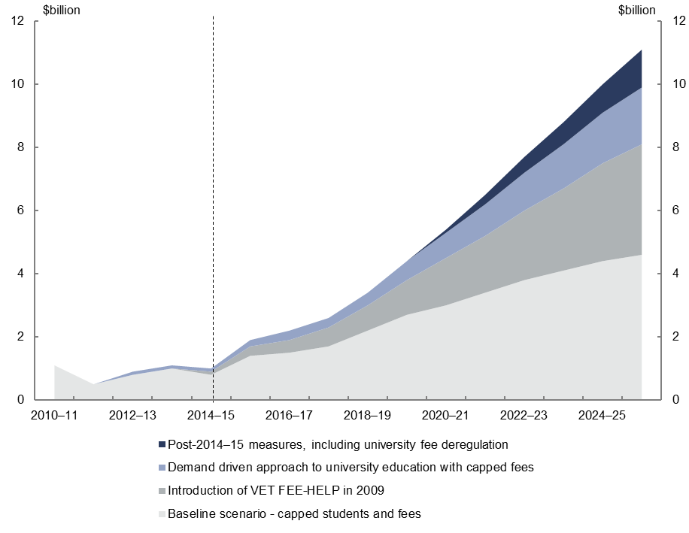 | 2010–11 | 2011–12 | 2012–13 | 2013–14 | 2014–15 | 2015–16 | 2016–17 | 2017–18 | 2018–19 | 2019–20 | 2020–21 | 2021–22 | 2022–23 | 2023–24 | 2024–25 | 2025–26
Post-2014–15 measures, including university fee deregulation | - | - | - | - | - | - | - | - | - | 0 | 0.1 | 0.3 | 0.5 | 0.7 | 0.9 | 1.2
Demand driven approach to university education with capped fees | 0 | 0 | 0.1 | 0.1 | 0.1 | 0.2 | 0.3 | 0.3 | 0.4 | 0.6 | 0.8 | 1 | 1.2 | 1.4 | 1.6 | 1.8
Introduction of VET FEE-HELP in 2009 | 0 | 0 | 0 | 0 | 0.1 | 0.3 | 0.4 | 0.6 | 0.8 | 1.1 | 1.5 | 1.8 | 2.2 | 2.6 | 3.1 | 3.5
Baseline scenario - capped students and fees | 1.1 | 0.5 | 0.8 | 1 | 0.8 | 1.4 | 1.5 | 1.7 | 2.2 | 2.7 | 3 | 3.4 | 3.8 | 4.1 | 4.4 | 4.6

The baseline scenario projects the annual cost of HELP under the higher education funding approach that applied up to 2009 in which university student places and student contributions were capped. The baseline scenario accounts for 34 per cent ($3.2 billion) of the projected growth in the annual cost of HELP over the period 2015–16 to 2025–26.
The baseline scenario assumes that from 2009 onwards, student numbers increase in line with growth in the total population and student contributions grow in line with the Higher Education Growth Index (HEGI).
The upward trend in the annual cost of HELP under the baseline scenario was suppressed over the period 2011–12 to 2014–15 due to record low interest rates resulting in falling public debt interest costs associated with HELP over this period. The increasing cost over the projection period partly reflects the assumption that yields on Commonwealth Government Securities converge to 6 per cent in 2025–26, consistent with the assumption in the
2015–16 MYEFO.
The introduction of VET FEE-HELP accounts for 35 per cent ($3.3 billion) of the projected growth in the annual cost of HELP over the period 2015–16 to 2025–26.
This largely reflects the significant growth in the number of students taking out VET FEE-HELP loans from 2009 to 2015, and assumes that the Government’s 2015 measures to constrain growth in the number of VET FEE-HELP loans continue.
The introduction of the demand driven approach to university education accounts for 17 per cent ($1.6 billion) of the projected growth in the annual cost of HELP over the period 2015–16 to 2025–26.
This reflects the significant growth in student numbers that occurred between 2009 and 2015.
The fee deregulation policy accounts for 13 per cent ($1.2 billion) of the projected growth in the annual cost of HELP over the period 2015–16 to 2025–26.
The PBO has assumed that universities will increase student fees to fully recoup the Government’s 20 per cent reduction in subsidies and the efficiency dividends to be applied to the Commonwealth Grant Scheme (2.5 per cent in 2017 and 1.25 per cent in 2018). The PBO has also used an indicative assumption that, in a deregulated environment, universities will increase student fees by 2 per cent each year in real terms from 2018, over and above recouping the reductions in Commonwealth grants. This may be a conservative assumption in a fully deregulated environment.

Commonwealth Grant Scheme
As part of the 2014–15 Budget higher education reform package that included the deregulation of university fees, the Government announced reductions in the levels of grants payable to universities under the Commonwealth Grant Scheme.
Under the revised policy, the cost of the Commonwealth Grant Scheme is projected by the PBO to increase from $6.6 billion in 2015–16 to $8.0 billion in 2025–26. This represents a projected saving in 2025–26 of $1.3 billion.
Figure 2 below shows the PBO’s projections of the cost of the Commonwealth Grant Scheme with and without the Government’s savings measures.
Figure 2: Commonwealth Grant Scheme – impact of the Government’s announced savings measures
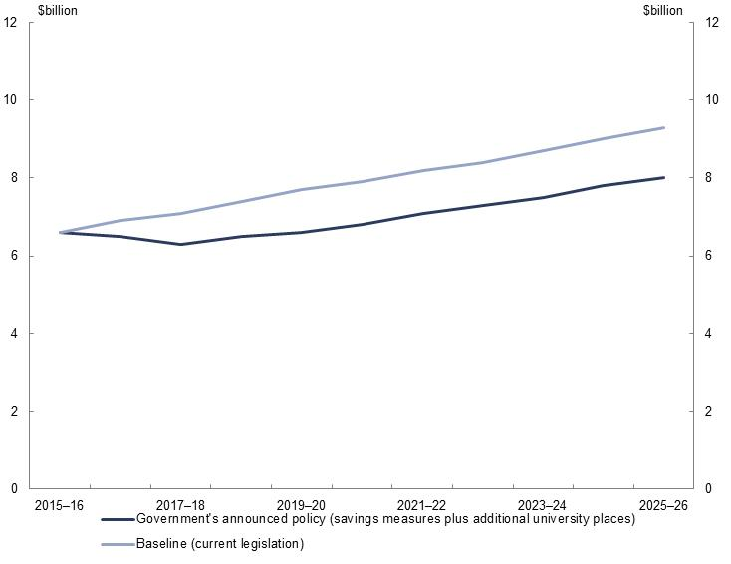 | 2014–15 | 2015–16 | 2016–17 | 2017–18 | 2018–19 | 2019–20 | 2020–21 | 2021–22 | 2022–23 | 2023–24 | 2024–25 | 2025–26
Baseline (current legislation) | 6.4 | 6.6 | 6.9 | 7.1 | 7.4 | 7.7 | 7.9 | 8.2 | 8.4 | 8.7 | 9 | 9.3
Government's announced policy (savings measures plus additional university places) | 6.4 | 6.6 | 6.5 | 6.3 | 6.5 | 6.6 | 6.8 | 7.1 | 7.3 | 7.5 | 7.8 | 8
The PBO has assumed that the changes to the Commonwealth Grant Scheme, which have been delayed due to the non-passage of legislation, will be implemented from the 2017 calendar year.
The projections also incorporate the impact of the Government’s policy to extend the Commonwealth Grant Scheme to certain sub-bachelor courses and to non-university higher education providers.

www.pbo.gov.au

