Australian Government spending

Part 1: Historical trends from 2002-03 to 2012-13

02/2013

© Commonwealth of Australia 2013
ISBN 978-0-9874429-5-6 (Print)
ISBN 978-0-9874429-6-3 (Online)
This work is licensed under the Creative Commons Attribution-NonCommercial-NoDerivs 3.0 Australia License.
The details of this licence are available on the Creative Commons website:
http://creativecommons.org/licenses/by-nc-nd/3.0/au/
Use of the Coat of Arms
The terms under which the Coat of Arms can be used are detailed on the following website:
www.itsanhonour.gov.au/coat-arms
Produced by: Parliamentary Budget Office
Design consultants: Wilton Hanford Hanover Pty Ltd
Assistant Parliamentary Budget Officer
Fiscal Policy Analysis Division
Parliamentary Budget Office
Parliament House
PO Box 6010
CANBERRA ACT 2600
Phone: (02) 6277 9500
Email: pbo@pbo.gov.au

Contents
Foreword v
Summary 1
1 Total government spending 3
2 Social security and welfare expenses 10
3 Other purposes expenses 16
4 Health expenses 20
5 Education expenses 25
6 General public services expenses 30
7 Defence and public order and safety expenses 35
8 Industry and economic affairs expenses 40
9 Community amenities and infrastructure expenses 45
10 Net capital investment 50
11 States and Territories 53
Lists of data sources and references 58
Lists of figures and tables 61
Attachments
A Technical notes 63
B Variations to expenses 65
C Fiscal stimulus spending 69
D Expenses by sub-functions tables 70
This page is intentionally left blank.

Foreword
Comprehensive information on trends in and key drivers of government spending is important for an understanding of the level of sustainability of government spending and the future direction of fiscal policy.
This is the first part of a two-part report on Australian Government spending. Part 1 of the report examines historical trends in government spending over the period 2002-03 to 2012-13 (the latest year for which actual spending data is available).
Part 2 of the report will address forecast and projected spending trends over the 2013-14 Budget forward estimates period. The second part of the report will be published after the Government releases the 2013-14 Mid-Year Economic and Fiscal Outlook (MYEFO) report to ensure that it encompasses the most up to date official economic and fiscal forecasts.
The report examines real growth in government spending compared with growth in real GDP. This approach eliminates the distortionary impact that the significant, likely temporary, increase in the terms of trade has had on nominal spending to nominal GDP ratios over the period of the analysis.
The first task in preparing this report was to compile a consistent time series of spending data at the function and sub-function level. This data is currently not published.
Also, disaggregated spending data is not routinely adjusted to account for changes in the classification of spending, revised accounting treatments and administrative rearrangements. This means that not all reported spending at the function level and below is comparable from one year to the next.
The Parliamentary Budget Office has, to the extent possible, compiled a consistent time series of spending data by back-casting reported spending to adjust for the changes outlined above. This data set is included in the report and is available for general use.
The compilation and publication of a consistent time series of disaggregated spending data on an ongoing basis would assist the work of fiscal policy makers in the future.
Phil Bowen PSM FCPA
Parliamentary Budget Officer
10 December 2013

This page is intentionally left blank.

Summary
Australian Government spending grew 27 per cent faster in real terms than the annual rate of growth of real GDP over the decade 2002-03 to 2012-13. Spending growth averaged 3.8 per cent annually while GDP growth averaged 3.0 per cent annually.
In the first half of the decade, from 2002-03 to 2007-08, government spending grew in real terms by 13 per cent more than the annual rate of growth of real GDP. Growth in spending averaged 4.0 per cent annually while GDP growth averaged 3.6 per cent annually.
The rate of spending growth in the second half of the decade initially accelerated due to the fiscal stimulus measures adopted to combat the effects of the global financial crisis. These measures had been withdrawn by 2012-13.
While growth in real GDP slowed to 2.4 per cent annually over the period 2007-08 to 2012-13, underlying spending grew in real terms by 3.6 per cent annually or 47 per cent faster than the annual rate of growth of real GDP.
The largest contributors to growth in spending over the period from 2002-03 to 2012-13 were social security and welfare, and health. Together, spending on these items accounted for over one half of the growth in total spending over the period.
Social security and welfare spending contributed one third of spending growth and contained four of the major program contributors to overall spending growth over the period: the Age Pension, the Disability Support Pension (DSP), Family Tax Benefit, and Aged Care.
Health spending contributed a further 19 per cent of total spending growth due mainly to higher spending on the Medicare Benefits Schedule, and increased payments to the States and Territories for public hospital services under the National Health Reform payment.
Ten programs accounted for more than half of the real growth in spending over the decade.
The Age Pension made the largest contribution accounting for 11 per cent of total spending growth, mainly due to increases in the pension rate and growing pensioner numbers.
Payments under the Medicare Benefits Schedule contributed over 6 per cent of total growth, driven by the increased demand for and cost of Medicare services.
Goods and Services Tax (GST) payments to the States and Territories, despite the slow growth in GST revenue, contributed 6 per cent of total spending growth due to the large size of this program.
Public debt interest accounted for over 5 per cent of the growth in total spending, due to the budget deficits accumulated from 2008-09, as well as the financing of equity investments in government corporations such as NBN Co and the Clean Energy Finance Corporation.
The DSP contributed 5 per cent of the total spending growth driven by increases in the rate of the pension and increases in the number of recipients.
Defence spending, including net capital investment, accounted for almost 5 per cent of total spending growth, driven mainly by long term funding commitments arising from Defence white papers.
Aged care contributed over 4 per cent of total growth driven largely by increases in the number of government subsidised aged care places, and increases in the cost of care.
Family Tax Benefit accounted for almost 4 per cent of total spending growth due largely to increases in benefit levels.
Government superannuation benefits contributed more than 3 per cent of total spending growth. This was mainly due to the impact of lower discount rates used to value the superannuation liability, reflecting lower bond yields, particularly in 2012-13.
The National Health Reform payment accounted for 3 per cent of total spending growth driven by increased base funding by the Commonwealth and the impact of indexation factors.
Government spending includes funding provided to the States and Territories. Over the decade this funding grew in real terms by 2.8 per cent annually, slower than annual growth in real GDP of 3.0 per cent, and slower than Commonwealth own-purpose spending which grew at 4.1 per cent annually.
The composition of the funding provided to the States and Territories changed over the period. The proportion of funding provided as general revenue assistance declined from 64 per cent in 2002-03 to 56 per cent in 2012-13, reflecting a reduction in the proportion of flexible funding and an increase in the proportion of funding provided under specific agreements with the Commonwealth Government.

Total government spending
This report examines historical trends in Australian Government spending, including expenses and net capital investment, from 2002-03 to 2012-13. The analysis commences in 2002-03 as there is greater data consistency from this year onwards and concludes in 2012-13, the last year for which actual spending data is available.
In Chapter 1, total government spending comprises expenses and net capital investment. The majority of chapters analyse spending at a functional level based on expenses only. Net capital investment is treated separately and is discussed in Chapter 10. However, as Defence has the largest proportion of net capital investment of all government functions, Chapter 7 on defence and public order and safety also includes a discussion of total defence spending including net capital investment.
Consistent with the Australian Government Budget papers, this report uses the accrual accounting measure of spending and net capital investment.
The report compares real growth in spending to growth in real GDP. The report should be read on the basis that growth in spending and GDP are measured in real terms unless otherwise specified, and annual growth rates are average compounded growth rates.
A detailed discussion on the methodology used for collating this data, and the reasons for comparing real spending growth with real GDP are at Attachment A. The PBO has made a number of adjustments to the data reported in Final Budget Outcome reports to ensure consistency across time. The details of these adjustments are at Attachment B. The data is published in Attachment D and as a separate Excel workbook accompanying this report.

Composition of government spending
Spending by the Australian Government is an important part of the economy, totalling $384 billion in 2012-13 or just over a quarter of nominal GDP. The composition of spending in this report follows the budget’s functional presentation except that certain functions have been aggregated. The composition of spending is shown in Figure 1.1 below.
Figure 1.1: Composition of government spending in 2012-13
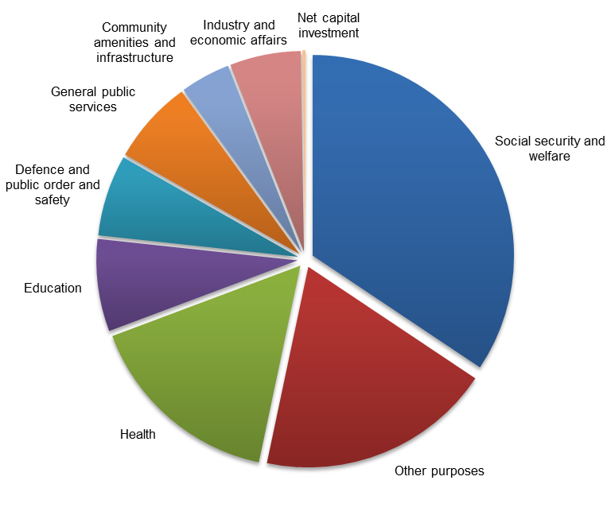
Source: Australian Government Final Budget Outcome 2012-13
Social security and welfare was the largest component of government spending totalling $132 billion in 2012-13, or 34 per cent of the total. This included programs such as the Age Pension ($36 billion), the Disability Support Pension ($15 billion) and Family Tax Benefit ($19 billion), as well as assistance to the unemployed and sick and assistance to veterans and dependents, together totalling $15 billion.
Spending on other purposes was the second largest component of government spending at $73 billion, or 19 per cent of the total in 2012-13. This included general purpose payments to the States, Territories and local government totalling $51 billion or 13 per cent of all government spending. This is the Australian Government’s largest single spending item, mainly comprising the payment of GST to the States and Territories, which totalled $49 billion in 2012-13.
Health spending comprised 16 per cent of total spending in 2012-13 at $61 billion. This included spending of $19 billion on the Medicare Benefits Schedule (MBS), the National Health Reform Payment to the States for public hospitals ($13 billion), and the Pharmaceutical Benefits Scheme ($9 billion).
Together, social security and welfare, other purposes and health spending made up over two thirds of total government spending.
The remaining one third was spent on education at $28 billion (7 per cent of the total), which included spending on higher education and schools; general public services including foreign aid at $26 billion (7 per cent); defence, public order and safety at $25 billion (7 per cent); industry and economic affairs at $22 billion (6 per cent); community amenities and infrastructure at $15 billion (4 per cent); and net capital investment at $1 billion (0.3 per cent).

Trends in government spending
Australian Government spending grew faster than GDP over the period 2002-03 to 2012-13.
Figure 1.2 below shows the growth in aggregate government spending and GDP over this period.
Figure 1.2: Growth in government spending and GDP
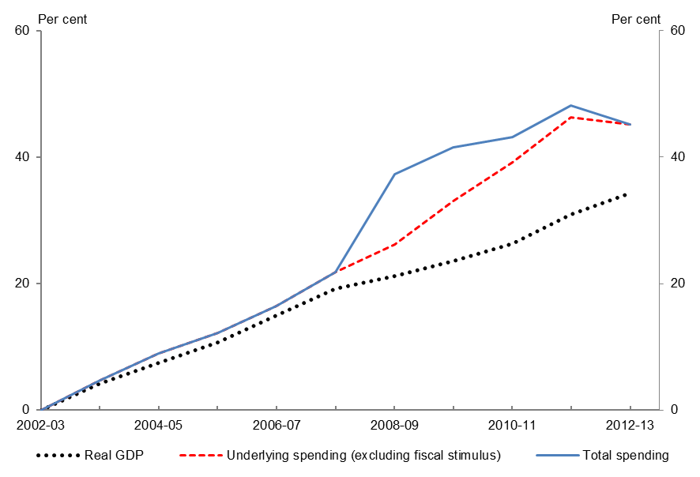
Sources: Australian Government Final Budget Outcomes and Australian Bureau of Statistics (ABS)
From 2002-03 to 2012-13, government spending grew by 45.2 per cent, or 3.8 per cent annually compared with GDP growth of 34.3 per cent or 3.0 per cent annually.
From 2002-03 to 2007-08, government spending grew by 4.0 per cent annually, which was 13 per cent faster than GDP growth of 3.6 per cent annually.
The rate of spending growth in the second half of the decade initially accelerated due to the fiscal stimulus measures adopted to combat the effects of the global financial crisis. These measures had been withdrawn by 2012-13. Details on the fiscal stimulus spending are at Attachment C.
While real growth in GDP slowed to 2.4 per cent annually over the period 2007-08 to 2012-13, underlying spending grew in real terms by 3.6 per cent annually or 47 per cent faster than the annual rate of growth of real GDP.

Drivers of growth in government spending
Over the period 2002-03 to 2012-13, all areas of government spending at the functional level grew at a faster rate than GDP with the exception of other purposes and defence, public order and safety.
Figure 1.3 and Table 1.1 show the growth in government spending over the period 2002-03 to 2012-13, and the contributors to this growth.
Figure 1.3: Contributions to growth in government spending
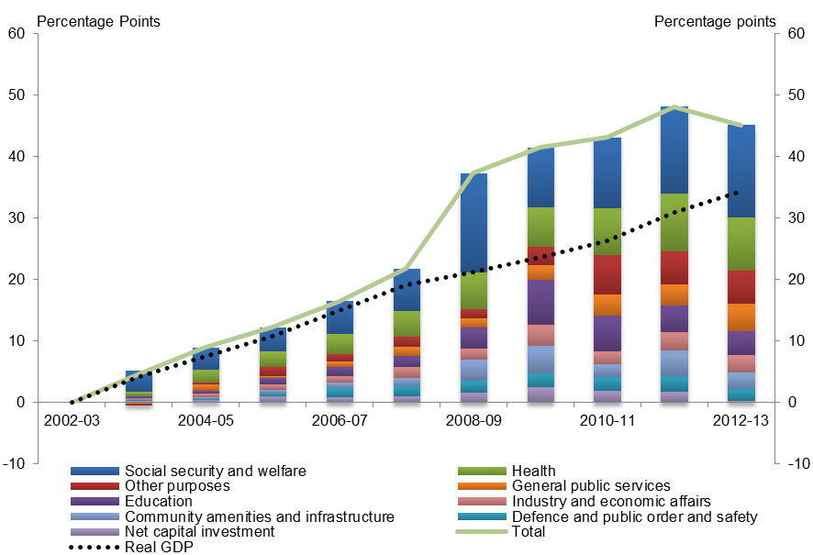
Sources: Australian Government Final Budget Outcomes and ABS
Table 1.1: Summary of drivers of government spending
Category | Share of  2012-13 total | Real spending growth 2002-03 to 2012-13
 |  | Annual growth | Contribution to  total growth
Unit | % | % | percentage points
Social security and welfare | 34.4 | 3.7 | 15.0
Other purposes | 18.9 | 2.2 | 5.4
Health | 16.0 | 4.8 | 8.6
Education | 7.4 | 4.6 | 3.9
General public services | 6.8 | 6.1 | 4.4
Defence and public order and safety | 6.5 | 2.4 | 2.0
Industry and economic affairs | 5.7 | 4.3 | 2.8
Community amenities and infrastructure | 4.0 | 6.3 | 2.7
Net capital investment | 0.3 | 10.1 | 0.2
Total government spending | 100.0 | 3.8 | 45.2
Memo item
GDP |  | 3.0
The key drivers of the 45.2 per cent increase in government spending over the period 2002-03 to 2012-13 were increases in spending on social security and welfare, and health which, together, contributed more than half of the overall growth in spending.
Other significant drivers of spending growth were increased spending for other purposes, general public services, and education, which together contributed 30 per cent to the overall growth in spending.
Social security and welfare spending represented more than a third of total spending and contributed approximately a third of the overall growth in spending. Assistance to the aged contributed almost half of this growth, mainly due to increases in the rate of the Age Pension and growing pensioner numbers. Assistance to people with disabilities contributed a further 29 per cent, primarily because of increases in the number of Disability Support Pension (DSP) recipients and payment rates. A further 21 per cent was contributed by spending on assistance to families with children, mainly due to increases in Family Tax Benefit (FTB) and Baby Bonus payments and the introduction of the Child Care Tax Rebate, Schoolkids Bonus and Paid Parental Leave.
Health spending represented 16 per cent of total spending and, because of its relatively rapid growth rate, contributed 19 per cent of the overall growth in spending. More than 40 per cent of this growth was attributable to increased spending on medical benefits and services. Growth in this area was driven by increases in the use of health care services, and the Australian Government’s funding contribution for these services under the MBS. Around a quarter of this growth was contributed by the increasing spending on health services, including programs that support access to the supply of blood and blood products; population health; mental health initiatives; hearing services; and infrastructure and research.
Other purposes spending grew around three quarters the rate of growth in GDP but, because it represented 19 per cent of total spending, contributed 12 per cent of the overall growth in spending. Public debt interest contributed 45 per cent of this growth. This reflected the impact of financing the budget deficits accumulated since 2008-09 and the equity investments in government corporations such as NBN Co and the Clean Energy Finance Corporation. General revenue assistance to the States also grew, although at a much slower rate than GDP, contributing a further 43 per cent of the growth in this function.
General public services spending represented 6.8 per cent of total spending, grew at twice the rate of GDP and contributed 10 per cent to the overall growth in spending. Around 45 per cent of this growth was attributable to increased expenses for government superannuation benefits, as a result of the historically lower discount rate used to calculate expenses in 2012-13. Financial and fiscal affairs was another large driver of spending, accounting for 29 per cent of growth due to expenses associated with the Australian Taxation Office (ATO), in particular compliance activities. Foreign affairs and economic aid accounted for nearly a quarter of the growth, due to a steady increase in overseas aid over this period.
Education spending represented 7.4 per cent of total spending, grew at 4.6 per cent annually and contributed 9 per cent of the overall growth in spending. A third of this growth was attributable to spending on higher education driven by increases to the base rate of funding per student and a move to funding Commonwealth supported students based on demand. Spending on non-government schools accounted for a further third of the growth reflecting the indexation of contributions per student, and some growth in enrolments in the sector.
Major contributors to spending growth by program
The discussion of government spending by function identified the major program contributors to government spending within each function. Table 1.2 contains the ten programs that contributed most to growth in total government spending over the period.
Table 1.2: Major contributors to government spending, by program
Category | Share of  2012-13 total | Real spending growth 2002-03 to 2012-13
 |  | Annual growth | Contribution to  total growth
Unit | % | % | percentage points
Age Pension | 9.5 | 4.6 | 5.0
Medicare Benefits Schedule | 4.9 | 5.8 | 3.0
Goods and Services Tax payments | 12.8 | 1.5 | 2.6
Public debt interest | 3.3 | 7.5 | 2.4
Disability Support Pension | 3.9 | 5.3 | 2.3
Defence, including net capital investment | 6.0 | 2.9 | 2.2
Aged care | 3.1 | 6.1 | 2.0
Family Tax Benefit | 4.9 | 2.9 | 1.8
Government superannuation benefits | 2.0 | 8.3 | 1.6
National Health Reform payment | 3.5 | 3.2 | 1.3
Subtotal – major contributors by program | 53.8 | 3.8 | 24.2
Total government spending | 100.0 | 3.8 | 45.2
The top ten programs combined account for just over half of the growth in total government spending from 2002-03 to 2012-13.

Net capital investment
Net capital investment provides a measure of the overall growth in assets owned by the Commonwealth after taking account of the acquisitions and disposals of non-financial assets by the Commonwealth and depreciation in the value of these assets as they age. The funding provided by the Commonwealth to States and local government for capital investment (such as for building roads) is not counted in this measure because the resultant assets are not owned by the Commonwealth.
In 2012-13, net capital investment amounted to $987 million (or 0.3 per cent of total spending).
Most capital investment occurs in Defence for aircraft, ships and the building of support facilities. Other capital acquisitions include buildings, software and (in recent years) the purchase of water entitlements. Disposals of assets, including the sales of radio spectrum licences, can cause substantial volatility in net annual capital investment.
Over the period 2002-03 to 2012-13, net capital investment grew 10.1 per cent annually, while GDP grew 3.0 per cent annually. There was a rapid increase in net capital investment from 2002-03 to a peak in 2009-10, with growth of 52 per cent annually. This growth was largely driven by increased acquisition of military equipment and facilities by Defence and the purchase of water entitlements. This was followed by a large fall in net capital investment reflecting lower investment by Defence and the increased sale of spectrum licences to telecommunications carriers.

Social security and welfare expenses
Total spending on social security and welfare was $131.9 billion in 2012-13, or around one third of total government spending. The composition of this spending is shown in Figure 2.1 below.
Figure 2.1: Composition of social security and welfare expenses in 2012-13
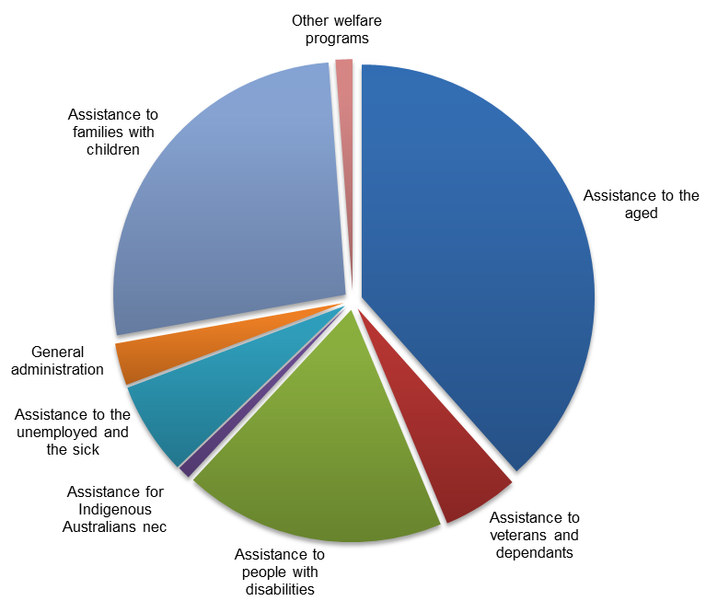
Source: Australian Government Final Budget Outcome 2012-13
Assistance to the aged amounted to $50.7 billion in 2012-13, or 38 per cent of social security and welfare spending. This included the Age Pension and aged care spending (which is primarily residential and flexible care for the aged). Spending on assistance to families with children was $35.1 billion (27 per cent of the total), and included Family Tax Benefit (FTB), Parenting Payment and child care assistance programs. Spending on assistance to people with disabilities was $24.0 billion (18 per cent of spending in this area), and included the Disability Support Pension (DSP), payments to carers and funding for services for people with a disability.
Spending on assistance to the unemployed and the sick was $8.5 billion (6 per cent) in 2012-13, and included Newstart Allowance (the unemployment benefit) and Youth Allowance for job seekers. Assistance to veterans and dependants was $7.0 billion (5 per cent), and included veterans’ income support and allowances, veterans’ disability support and assistance to Defence widow/ers and dependants. Spending on assistance for Indigenous Australians not elsewhere classified (nec) was $1.2 billion (1 per cent). This included programs relating to Indigenous economic development, housing, infrastructure, land rights and some of the spending relating to the Stronger Futures in the Northern Territory package (previously known as the Northern Territory Emergency Response).
The other programs in this area are general administration, at $3.9 billion (3 per cent), which included expenses associated with delivering social welfare programs; and other welfare programs, at $1.6 billion (1 per cent), which included the Superannuation Co-contribution and the Low Income Superannuation Contribution.

Trends in social security and welfare expenses
Over the period 2002-03 to 2012-13, social security and welfare spending grew by 43.2 per cent, or 3.7 per cent annually. This exceeded GDP growth of 34.3 per cent over the same period, or 3.0 per cent annually. There were some sub-periods where spending grew at a different rate. There was a large one-off increase in various payments in 2008-09 due to the fiscal stimulus and spending grew particularly strongly in 2010-11 and 2011-12 due to increased payments to pensioners and families with children.
The cumulative growth in spending on this function is shown in Figure 2.2 below.
Figure 2.2: Contributions to growth in social security and welfare expenses
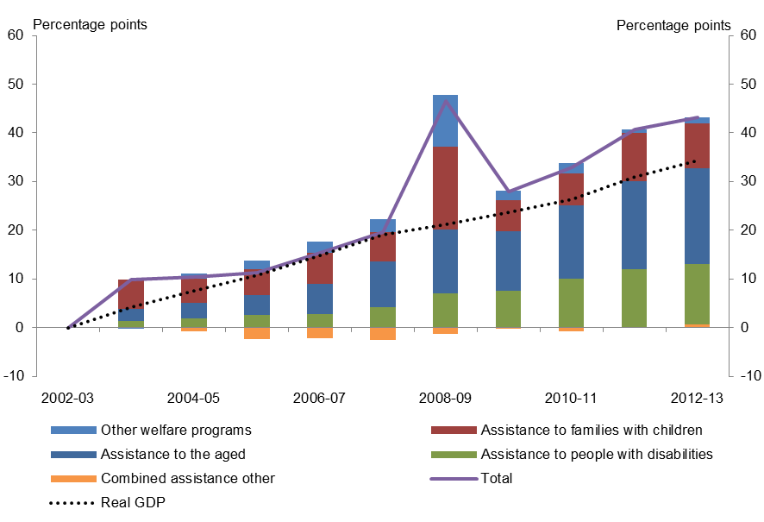
Sources: Australian Government Final Budget Outcomes and ABS
The fiscal stimulus package increased social security and welfare expenses by $20.1 billion in 2008-09, made up of a variety of one-off payments to households. These included one-off payments to pensioners of $1,400 to singles and $2,100 to couples. These payments (along with additional payments to veterans, widows and carers) totalled $4.9 billion in 2008-09.

There was also a one-off payment in 2008-09 of $1,000 per FTB Part A (FTB-A) eligible child, costing $3.9 billion, a Back to School Bonus of $950 per eligible child in 2008-09 costing $2.7 billion, and payment of $950 per family receiving FTB Part B (FTB-B), also in 2008-09, costing $1.4 billion. In addition, there was a payment of up to $950 to Australians who paid tax in 2007-08 (the Tax Bonus for Working Australians), of $7.8 billion in total, with $7.4 billion of this spent in 2008-09.
Table 2.1 summarises the trends in social security and welfare spending.
Table 2.1: Summary of social security and welfare expenses trends
Category | Share of  2012-13 total | Real spending growth 2002-03 to 2012-13
 |  | Annual growth | Contribution to  total growth
Unit | % | % | percentage points
Assistance to the aged | 38.4 | 4.5 | 19.6
Assistance to families with children | 26.6 | 2.8 | 9.3
Assistance to people with disabilities | 18.2 | 6.7 | 12.5
Assistance to the unemployed and the sick | 6.5 | 0.6 | 0.5
Assistance to veterans and dependants | 5.3 | -0.5 | -0.4
General administration | 2.9 | 2.8 | 1.0
Other welfare programs | 1.2 | 14.4 | 1.2
Assistance for Indigenous Australians nec | 0.9 | -3.5 | -0.5
Total | 100.0 | 3.7 | 43.2
Contribution from assistance to the aged
Over the period 2002-03 to 2012-13, the largest contributor to overall growth in social security and welfare was assistance to the aged, which contributed 19.6 percentage points of the total growth of 43.2 per cent (or almost half of total growth).
The annual growth rate in assistance to the aged from 2002-03 to 2012-13 was 4.5 per cent, with around 70 per cent of this coming from growth in spending on the Age Pension, and around 30 per cent from growth in aged care expenses.
Age Pension
Spending on the Age Pension increased by 4.6 per cent annually from 2002-03 to 2012-13 as a result of increases in the real rate of the pension, and increases in the number of pensioners.
Following the decision to formally benchmark the single rate of the Age Pension to 25 per cent of male total average weekly earnings (MTAWE) in the 1997-98 Budget, the Age Pension is now effectively indexed to wages. As wages have generally grown faster than inflation, the real rate of the Age Pension has been growing over time.

There were also several policy changes that further increased the rate of the pension. The single pension rate and Pension Supplement were increased in the 2009-10 Budget at a cost of $14.2 billion over five years from 2008-09, with the benchmark for the single rate of the Age Pension increased to 27.7 per cent of MTAWE. Further increases were provided as part of the Clean Energy Future package, which made a one-off payment to pensioners in late 2011-12 and increased the maximum pension rates by 1.7 per cent from March 2013.
There have also been a number of changes to eligibility criteria which have altered both the average payment per recipient of the Age Pension and the number of recipients. The pension assets test was relaxed in September 2007 as part of Simpler Superannuation changes, at a cost of $2.4 billion over four years from 2006-07. Partly offsetting the cost of this decision was an increase in the pension income test taper rate announced in the 2009-10 Budget, which provided savings of $1.6 billion over five years from 2008-09.
As a consequence of the indexation and the policy changes above, the real Age Pension payment per recipient increased by 2.2 per cent annually in the period 2002-03 to 2012-13.
The other main factor driving the increase in spending on the Age Pension is the number of pensioners. The number of Age Pension recipients grew 2.3 per cent annually from 2002 to 2011, which is greater than annual population growth of 1.5 per cent over the same time period. Factors driving this increase in pension recipient numbers include the ageing of the population and changes to economic conditions and government policies that have impacted on eligibility for the Age Pension, including the relaxation of the pension assets test in 2007 (see above).
Aged care
Also contributing to the increase in assistance to the aged was the increase in aged care spending, which grew by 6.1 per cent annually from 2002-03 to 2012-13. Factors driving this growth include growth in the number of government subsidised aged care places associated with the ageing of the population and the Investing in Australia’s aged care: more places, better care package in the 2004-05 Budget. This package provided $2.2 billion over five years to improve the quality and availability of aged care services.
Contribution from assistance to people with disabilities
The second largest contributor to growth in spending on social security and welfare over the period 2002-03 to 2012-13 was spending on assistance to people with disabilities. This spending grew at 6.7 per cent annually and contributed 12.5 percentage points or almost one third of the total growth. Around half of this growth was from the DSP and just under a quarter from increases in the Carer Payment.
The increase in spending on the DSP was driven by increases in the rate of this payment, which is indexed to wages (similar to the Age Pension), and increases in the number of recipients which grew over the period 2002 to 2011 by 2.4 per cent annually, significantly above annual population growth of 1.5 per cent.
The largest driver of the increase in Carer Payment spending was the 12.0 per cent annual growth in the number of recipients of this payment over the period 2002 to 2011, compared to annual population growth of 1.5 per cent. The Carer Payment is also indexed to wages. Further increases in payments to carers resulted from the payment of carer bonuses each year from 2003-04 to 2007-08, the introduction of the Carer Supplement (of $600 per eligible carer) in June 2009, and commencement of the Child Disability Assistance Payment (of $1,000 for each eligible child) in July 2007. The Carer Supplement and Child Disability Assistance Payment are not indexed and have therefore declined in real terms over the period.
Contribution from assistance to families with children
The next largest contributor to growth in spending on social security and welfare was assistance to families with children, which contributed 9.3 percentage points to overall growth, or around one fifth of total growth. A significant driver was the More Help for Families package costing around $4 billion annually starting in 2003-04. This package increased FTB-A by $600 per year, reduced the taper rate on this payment, relaxed the income test for FTB-B and introduced a Maternity Payment (subsequently renamed the Baby Bonus).
Of the 9.3 percentage points contribution to growth in social security and welfare from assistance to families with children, the growth in 2003-04 alone made up 6.1 percentage points. A large part of the increase after 2003-04 was due to increases in child care payments and the introduction of Paid Parental Leave. The Child Care Tax Rebate was introduced in the 2004-05 MYEFO, providing a rebate of 30 per cent of costs not reimbursed by the Child Care Benefit. This rebate was converted to a direct payment in the 2007-08 Budget, and was increased to 50 per cent in 2008-09. The rebate cost $2.2 billion in 2012-13. Paid Parental Leave was introduced from January 2011, and cost $1.4 billion in 2012-13 (this payment is taxable, so the costs are partly offset by higher income tax revenue and reduced family assistance payments).
The introduction of the Schoolkids Bonus from 2011-12, also increased spending on assistance to families with children. The Schoolkids Bonus provides $410 annually for each primary school student and $820 annually for each secondary school student for families entitled to FTB-A.
The contribution of these factors to spending growth was partly offset by the following:
- a change in indexation of FTB-A, to link it to inflation rather than wages, announced in the
2009-10 Budget;
- the tightening of income tests for FTB-B announced in the 2008-09 Budget;
- a pause in indexation of the upper income threshold for FTB-A and FTB-B in the 2009-10 Budget;
- a pause to indexation of FTB supplements, upper limits and thresholds announced in the
2011-12 Budget;
- reductions in the age of eligibility for FTB-A announced in the 2012-13 Budget; and
- ongoing declines in the number of recipients of the Parenting Payment driven by tighter eligibility requirements for this payment, with the number of recipients declining annually by 3.6 per cent over the period 2002 to 2011.
Other contributions to growth
Other welfare programs contributed 1.2 percentage points to overall growth in social security and welfare spending, mainly driven by the introduction of the Superannuation Co-contribution in 2003-04 and the Low Income Superannuation Contribution in 2012-13.
Other welfare programs made a small contribution to growth overall because it is a small proportion of overall spending, even though it grew by 14.4 per cent annually from 2002-03 to 2012-13.
General administration relating to social security and welfare contributed 1.0 percentage point, driven by increased staffing levels to administer new programs and increases in the number of recipients of existing programs. The impact of these increases has been partly offset by ongoing efficiencies in service delivery (including the merging of Centrelink and Medicare Australia with the Department of Human Services). In Figure 2.2 above, this sub-function is included in ‘combined assistance other’.
Assistance to the unemployed and the sick contributed 0.5 percentage points to growth in social security and welfare, driven mainly by increases in spending on the Newstart Allowance (the unemployment benefit). Total spending on this payment fell until the global financial crisis and has since been growing strongly, in conjunction with changes in employment in the economy.
Changes in spending on the Newstart Allowance have been almost exclusively driven by the change in the number of recipients rather than the rate of payment. This is because Newstart is indexed to inflation, so the payment rate remains broadly unchanged in real terms over time unless there are policy changes. From 2002-03 to 2007-08, spending on the Newstart Allowance declined by 25 per cent, reflecting the 23 per cent decline in the average number of people unemployed over the same time period. From 2007-08 to 2012-13, the costs of Newstart increased by 57 per cent, while the average number of unemployed increased by 40 per cent.
In Figure 2.2 above, assistance to the unemployed and the sick is included in ‘combined assistance other’.
Offsets to spending growth
The contributions to overall social security and welfare spending growth of 43.2 per cent outlined above were partly offset by reduced levels of spending in several categories. In Figure 2.2 above, these categories are included in ‘combined assistance other’.
Assistance for Indigenous Australians nec made a negative contribution to growth in spending on social security and welfare of 0.5 percentage points. This was partly due to changes to the Community Development Employment Projects (CDEP) program over the period. These changes included the conversion of some CDEP positions into government jobs, resulting in the transfer of expenses from this category to various other spending categories.
Assistance to veterans and dependants made a negative contribution of 0.4 percentage points, driven by ongoing declines in the number of people eligible for assistance. From 2002 to 2011, the number of recipients of the veterans’ service pension and income support declined by 4.7 per cent annually. The impact of declining recipient numbers was partly offset by increases in payment rates which have grown in a similar manner to the Age Pension. Like the Age Pension, the service pension is effectively indexed to wages and thus has grown in real terms over time. There were also several policy decisions to increase payment rates over the period, including the increase to pensions in the 2009-10 Budget and the 1.7 per cent increase as part of the Clean Energy Future household assistance package.

Other purposes expenses
Other purposes spending was $72 6 billion or 18.9 per cent of total government spending in 2012-13. The composition of this spending is shown in Figure 3.1 below.
Figure 3.1: Composition of other purposes expenses in 2012-13
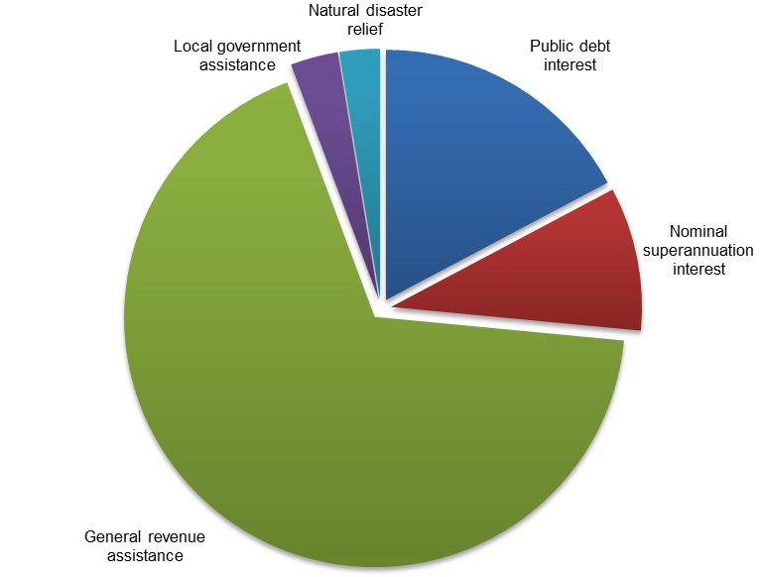
Source: Australian Government Final Budget Outcome 2012-13
The Commonwealth pays general revenue assistance to the States and Territories on an untied basis. These payments were $49.2 billion in 2012-13 and made up two thirds of other purposes spending. General revenue assistance primarily represents the payment to the States and Territories of revenue generated from the Goods and Services Tax (GST). States and Territories can allocate the payments to their individual priorities.
Public debt interest is paid by the Commonwealth on its borrowings and was $12.5 billion in 2012-13, or around 17 per cent of other purposes spending.
In 2012-13, the Commonwealth had nominal superannuation interest expenses of $6.7 billion or 9 per cent of other purposes spending. This spending represents the imputed nominal interest expense accrued during the period on unfunded liabilities for government superannuation benefits. Government superannuation benefits expense discussed in Chapter 6 is different from nominal superannuation interest as it is the accrued Commonwealth superannuation liabilities for employees in a given financial year.
In 2012-13, the Commonwealth provided $2.2 billion in local government financial assistance, which represented financial assistance grants to local councils. These grants were made to States and Territories, to be distributed to local councils that can direct these grants to their individual priorities.
Natural disaster relief represents government expenses on assistance for communities that have been affected by events such as floods, fires and cyclones. In 2012-13, the Commonwealth spent $1.9 billion on natural disaster relief.

Trends in other purposes expenses
Over the period 2002-03 to 2012-13, other purposes spending grew by 24.6 per cent, or 2.2 per cent annually. This was significantly slower than GDP growth of 34.3 per cent, or 3.0 per cent annually. A major reason why growth in other purposes was slower than GDP growth was that GST revenue collections and hence GST payments to the States grew more slowly than GDP. In addition, growth in nominal interest incurred on unfunded superannuation liabilities was below that of GDP.
The cumulative growth in expenses on this function is shown in Figure 3.2 below.
Figure 3.2: Contributions to growth in other purposes expenses
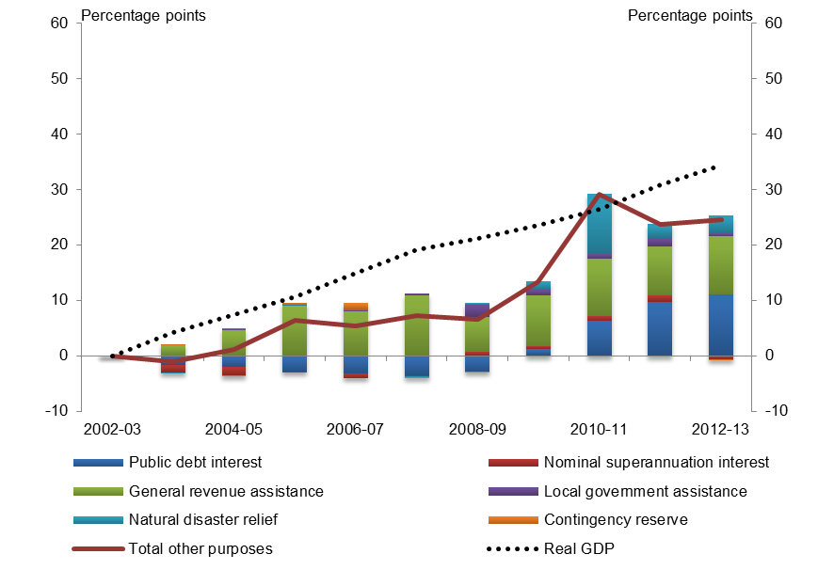
Sources: Australian Government Final Budget Outcomes and ABS
In some sub-periods, components of other purposes grew faster than GDP growth. In particular, public debt interest grew more quickly than GDP from 2009-10 to 2012-13 due to increased borrowings to finance the budget deficits accumulated in the period from 2008-09. There was also a spike in spending on other purposes due to the need to provide additional natural disaster relief in the wake of the natural disasters that occurred in 2010-11.

Table 3.1: Summary of other purposes expenses trends
Category | Share of  2012-13 total | Real spending growth 2002-03 to 2012-13
 |  | Annual growth | Contribution to  total growth
Unit | % | % | percentage points
General revenue assistance | 67.8 | 1.3 | 10.5
Public debt interest | 17.2 | 7.5 | 11.1
Nominal superannuation interest | 9.3 | -0.5 | -0.6
Local government assistance | 3.1 | 1.6 | 0.6
Natural disaster relief | 2.6 | 38.5 | 3.1
Total | 100 | 2.2 | 24.6
Contribution from public debt interest
Over the period 2002-03 to 2012-13, the largest contributor to growth in other purposes expenses was public debt interest with a cumulative contribution to growth of 11.1 percentage points, or 45 per cent of the total growth. The increase in public debt interest was driven by the change in the government’s position as a net lender to a net borrower from 2008-09 onwards, as well as the financing of equity investments in government corporations such as NBN Co and the Clean Energy Finance Corporation.
Contribution from general revenue assistance
The second largest contributor to overall growth in this function was general revenue assistance, principally the transfer of GST revenue to the States, which contributed 10.5 percentage points, or 43 per cent of the total growth. This spending was driven by consumer spending that was subject to GST.
Over the period, growth in consumer spending that was subject to GST was slower than total consumer spending. As a result, consumer spending that was subject to GST fell as a proportion of total household spending from around 61 per cent in 2002-03 to 55 per cent in 2012-13 (see Figure 3.3). The declining share of consumer spending on goods and services subject to GST was largely driven by divergent movements in prices for goods and services. The prices of goods and services that are subject to GST decreased over the period. In contrast, the prices of goods and services that were not subject to GST, such as education services and rent and other dwelling services, increased significantly (Figure 3.4).
Figure 3.3: Consumption subject to GST | Figure 3.4: Household consumption prices
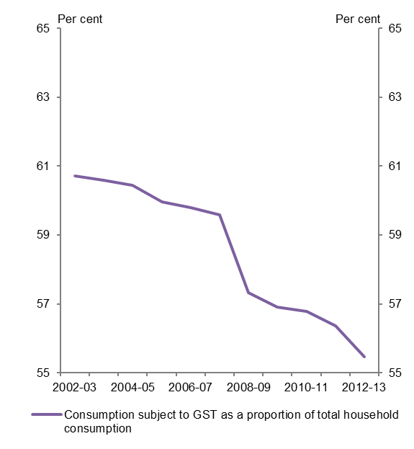 | 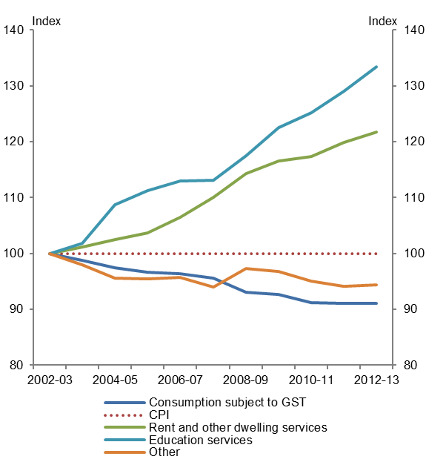
Source: ABS
Other contributions
The contribution to growth from natural disaster relief over the period 2002-03 to 2012-13 was 3.1 percentage points, or 13 per cent of total growth in other purposes. Within the period, there was a significant peak in spending on natural disaster relief in 2010-11 in response to the Queensland and Victorian floods and Queensland cyclones that occurred around January 2011.
Nominal superannuation interest made a negative contribution to growth of 0.6 percentage points reflecting an annual decline of 0.5 per cent.

Health expenses
In 2012-13, health spending was $61.3 billion, which accounted for 16.0 per cent of total government spending. The composition of this spending is shown in Figure 4.1 below.
Figure 4.1: Composition of health expenses in 2012-13
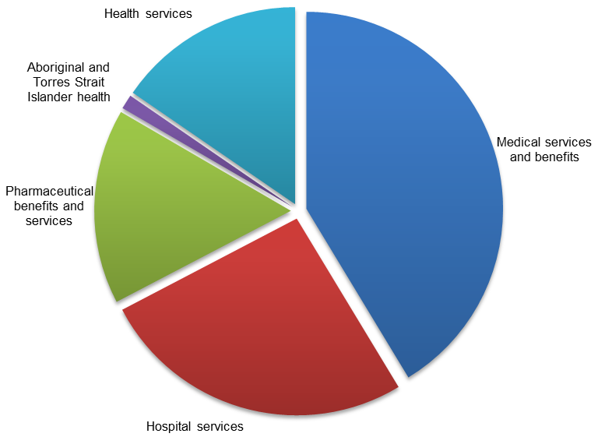
Source: Australian Government Final Budget Outcome 2012-13
The largest area of health spending in 2012-13 was on medical services and benefits of $25.3 billion, or 41 per cent of health spending. This mainly comprised spending of $18.6 billion on the Medicare Benefits Schedule (MBS), which provides access to free or subsidised treatment by health professionals, and private health insurance rebate expenses of $5.2 billion.
Commonwealth spending on hospital services was 26 per cent of health spending, and totalled $15.9 billion in 2012-13, of which $13.3 billion was provided to the States and Territories to assist with funding for the provision of free public hospital services under the National Health Reform program.
In 2012-13, spending on pharmaceutical benefits and services totalled $9.8 billion, the majority of which was spent on the Pharmaceutical Benefits Scheme (PBS), which provides Australians with access to free or subsidised medicines.
The Commonwealth spent $9.5 billion on health services in 2012-13, which included funding for general administration (which includes the cost of delivering health programs) as well as numerous health programs, such as measures to support population health, including treatment for chronic disease, contributions to the National Blood Authority to support access to the supply of blood and blood products, hearing services, research capacity and quality, and targeted assistance with aids and appliances.
The area of Aboriginal and Torres Strait Islander health, which includes funding for programs specifically targeted towards improving the health of Aboriginal and Torres Strait Islander peoples represented the smallest area of health spending, accounting for $0.7 billion of spending in 2012-13.

Trends in health expenses
Over the period 2002-03 to 2012-13, Commonwealth spending on health grew by around 59 per cent (4.8 per cent annually), which is substantially faster than growth in GDP of 34.3 per cent (3.0 per cent annually).
The cumulative growth in spending on this function is shown in Figure 4.2 below.
Figure 4.2: Contributions to growth in health expenses
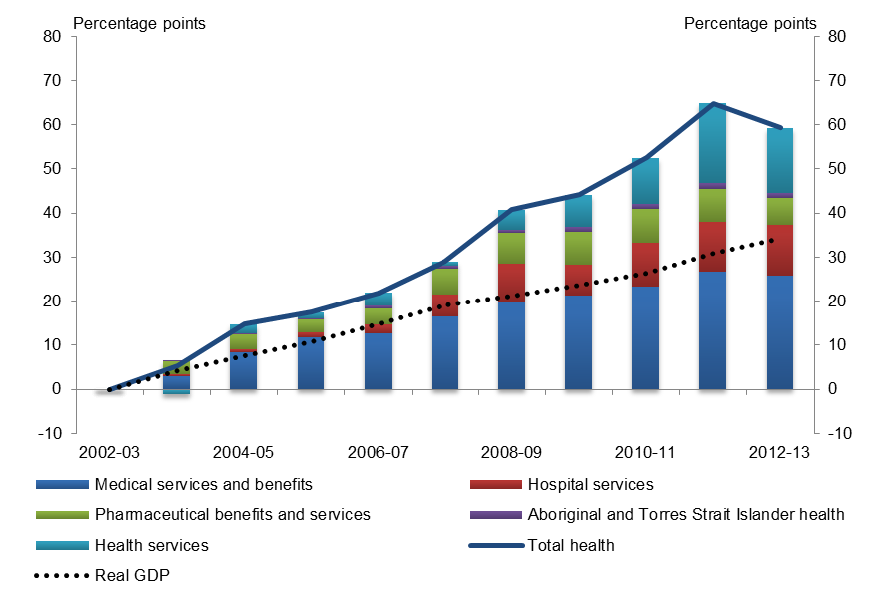
Sources: Australian Government Final Budget Outcomes and ABS
Over the past ten years, spending on health was driven by continued growth in some of the Australian Government’s largest programs which include the MBS, the PBS and payments to the States and Territories for National Health Reform, and the Private Health Insurance rebate.
As part of its response to the economic downturn in 2009, the Government engaged in fiscal stimulus spending. Fiscal stimulus spending in health included the provision of an additional $750 million to the States for emergency departments in 2008-09, as well as the Nation Building package of Health and Hospitals Fund (HFF) projects of around $2.4 billion from 2008-09 to 2011-12, announced in the 2009-10 Budget.

A summary of health spending is provided in Table 4.1 below.
Table 4.1: Summary of health expenses trends
Category | Share of  2012-13 total | Real spending growth 2002-03 to 2012-13
 |  | Annual growth | Contribution to  total growth
Unit | % | % | percentage points
Medical services and benefits | 41.3 | 5.1 | 25.9
Hospital services | 26.0 | 3.3 | 11.5
Pharmaceutical benefits and services | 16.0 | 2.7 | 6.0
Health services | 15.4 | 9.6 | 14.7
Aboriginal and Torres Strait Islander health | 1.2 | 10.3 | 1.2
Total health | 100.0 | 4.8 | 59.3
Contribution from medical services and benefits
Over the period 2002-03 to 2012-13, the largest contributor to overall growth in health spending was medical services and benefits, which contributed 25.9 percentage points, or 44 per cent of the total growth. This has been driven by the growth in demand for Medicare services, with the volume of MBS services claimed growing in excess of population growth, and prices paid by the Commonwealth growing faster than inflation. Growth in expenses on medical services and benefits averaged 5.1 per cent annually between 2002-03 and 2012-13.
The average number of MBS services claimed annually per person enrolled in Medicare increased from 10.8 to 14.8 between 2002-03 and 2012-13. The growth in volume of MBS services claimed has been facilitated by the expansion of the primary health care workforce. Between 2007 and 2011, the supply of employed medical practitioners per person increased by 10.7 per cent, with the number of full-time equivalent practitioners per 100,000 population increasing from around 345 to 381.
In addition, as a result of new and amended listings on the MBS over time to account for advancements in medical technology and improved medical practices, the number of claimable medical services under Medicare has increased. This has also facilitated the increase in the volume of Medicare services claimed.
Price effects have also contributed to the growth in the Commonwealth’s spending on Medicare services. Between 2002-03 and 2012-13, the average MBS benefit received per person enrolled in Medicare increased from $395.35 to $802.40 annually. Over this same period, the average schedule fee paid by the Commonwealth for an MBS item increased from $36.65 to $54.15.
This is partly a reflection of an increase in prices for MBS services, as well as a substitution towards MBS items that attract higher schedule fees. The schedule fees of most MBS items are indexed by a weighted index that combines changes in wage and non-wage costs. From 2002-03 to 2011-12, the fees charged for Medicare services increased by around 36 per cent, while economy-wide prices (as measured by CPI) increased by around 28 per cent.
There was also significant growth in spending on the Extended Medicare Safety Net (EMSN). Between 2004 and 2009, growth in spending on the EMSN was 133 per cent, with spending of over $500 million in 2009.

From 2002-03 to 2012-13, growth in spending on the Private Health Insurance rebate averaged 6.2 per cent annually. Over this period, the combined impact of the increased take up and higher premiums underpinned this increase, which contributed ten per cent of the growth in total health expenses.
Contribution from health services
The next largest contributor, health services which includes general administration, grew by 9.6 per cent annually and contributed 14.7 percentage points or a quarter of the total growth in health spending over the ten years to 2012-13. Under health services, the Commonwealth funds many health programs that cumulatively have a significant impact on the Budget. These programs include funding to support access to the supply of blood and blood products; population health; mental health initiatives; hearing services, infrastructure and research.
Almost a quarter of this contribution was a result of the increase in administered expenses by the National Blood Authority (NBA), which experienced annual growth of 16.0 per cent (2.0 percentage point contribution to growth in total health spending). Commonwealth spending on access to a secure supply of blood products under the National Blood Agreement has increased from $175 million in 2002-03 to $1.0 billion in 2012-13. The increasing demand for blood and blood products, combined with cost increases has also pushed up the NBA’s operational costs.
Spending from the Health and Hospitals Fund (HHF) also contributed to growth in health services spending. The Nation Building package of HHF projects announced in the 2009-10 Budget included spending on health infrastructure, cancer centres, and medical research and workforce infrastructure.
Funding for mental health was also a substantial contributor to growth in health services, largely as a result of funding for implementation of the $2.2 billion over five years National Mental Health Reform package announced in the 2011-12 Budget.
Contribution from hospital services
The next largest contributor was hospital services spending. By 2012-13, funding on hospital services accounted for 11.5 percentage points, or 19 per cent of the total growth since 2002-03.
Since the inception of Medicare, the Commonwealth has made substantial financial contributions to the States for the provision of free, universal access to public hospital services. The Australian Health Care Agreements (AHCAs) signed in 2003 specified that the Commonwealth would provide up to $42 billion of funding to the States between 2003-04 and 2007-08. Since 2008-09, COAG agreements have substantially increased the amount of Commonwealth funding provided to the States through changes to base funding and indexation factors.
Contribution from pharmaceutical benefits and services
Spending on pharmaceutical benefits and services contributed around 6.0 percentage points, or 10 per cent of total growth in health spending from 2002-03 to 2012-13. Generally, the growth in the volume of medicines claimed under the PBS and the Repatriation Pharmaceutical Benefits Scheme (RPBS) has kept roughly in line with population growth. From 2002-03 to 2012-03, while the total number of items claimed under the PBS and the RPBS increased by 21 per cent, the number of items claimed per person remained relatively constant at around nine per year.

Whilst the volume of medicines claimed under the PBS and RPBS grew in line with population growth, prices paid by the Commonwealth for medicines under these schemes increased over the period, largely explaining the growth in PBS spending per person up to 2011-12. The average Commonwealth benefit paid under these schemes per person increased by about 50 per cent from $256.74 in 2002-03 to $386.89 in 2011-12. This increase is mainly due to changes in consumer demand for pharmaceuticals which is increasing, and a substitution towards more expensive drugs.
This growth has been partly moderated by successive policy changes to constrain the price paid by the government for medicines under the PBS. This has included increases to the PBS safety net thresholds in the 2005-06 Budget, which was expected to save $140.2 million over four years, a mandatory price reduction of at least 12.5 per cent on new brand listings to the PBS in the
2005-06 Budget, which was estimated to save $1.0 billion over five years, and increases to the co-payments for PBS medicines paid by patients in 2005.
Contribution from Aboriginal and Torres Strait Islander health
The smallest contributor to the growth in health expenses over the historical period was spending on Aboriginal and Torres Strait Islander health.
Although Aboriginal and Torres Strait Islander health spending grew by 10.3 per cent annually from 2002-03 and 2012-13, it contributed only 1.2 per cent to growth overall because it represented only a small proportion of health spending.

Education expenses
Education spending was $28.5 billion in 2012-13, or 7.4 per cent of total government spending. The composition of this spending is shown in Figure 5.1 below.
Figure 5.1: Composition of education expenses in 2012-13
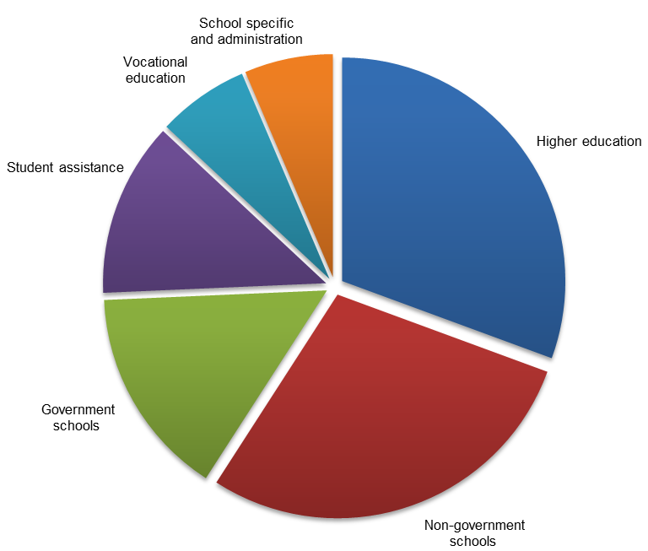
Source: Australian Government Final Budget Outcome 2012-13
Higher education spending totalled $8.7 billion in 2012-13, or 31 per cent of total education spending. This included base funding provided by the Australian government to higher education institutions, investment provided for research in these institutions, and international education support.
Spending on non-government schools was $8.1 billion (29 per cent of the total), and included the National Schools Specific Purpose Payment (National SPP) for Independent and Catholic providers and funding through nine National Partnership Payments (NPPs). Spending on government schools was $4.3 billion (15 per cent), and included the government school component of the National SPP and 25 NPPs.
Spending on student assistance was $3.6 billion (13 per cent) and included Youth Allowance for students, Austudy, ABSTUDY, the Veterans' Children Education Supplement Scheme and expenses associated with the provision of concessional loans through the Higher Education Loan Program.
Spending on vocational education and training was $1.9 billion (7 per cent) and included the National Skills and Workforce Development SPP (Skills SPP), and the Adult Migrant English Program.
School specific and administration spending was $1.8 billion (6 per cent), and included expenses relating to the National Plan for Literacy and Numeracy, Digital Education Revolution, Rewards for Great Teachers and other targeted programs.

Trends in education expenses
Education spending grew by 57.3 per cent from 2002-03 to 2012-13, or 4.6 per cent annually compared with the growth in GDP over the same period of 34.3 per cent, or 3.0 per cent annually. Spending on education grew most significantly between 2008-09 and 2011-12 coinciding with spending through the Building the Education Revolution (BER) program.
The cumulative growth in spending on this function is shown in Figure 5.2 below.
Figure 5.2: Contributions to growth in education expenses
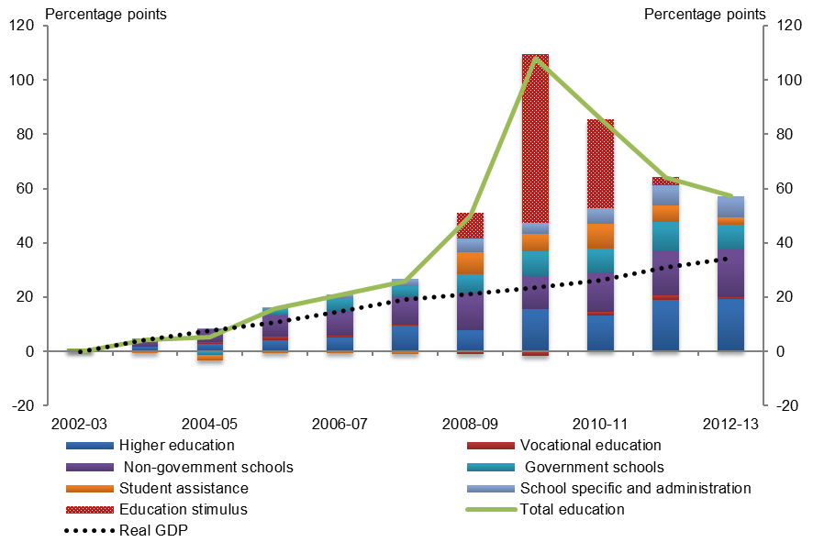
Sources: Australian Government Final Budget Outcomes and ABS
As part of the fiscal stimulus measures announced in the 2009 Updated Economic and Fiscal Outlook (UEFO), $16.2 billion was spent on building and facility maintenance, primary school upgrades and the construction of science and language centres through the BER. At its peak in 2009-10, the BER program comprised 26.9 per cent of all spending on education amounting to $9.4 billion.
In 2010-11, spending through the BER decreased to $5.4 billion and totalled 16.7 per cent of spending on education. By 2011-12, spending through the BER reduced to $406 million. This was in line with historical annual spending on capital projects in schools.
Over the fiscal stimulus period an additional $776 million was also spent on higher education projects announced in the 2009 UEFO package. A further $1.1 billion was spent on capital projects and for additional places in the vocational education sector.
In addition to the significant additional temporary spending on capital projects in schools through the BER, there was substantial underlying growth over the period which is discussed below.
A summary of trends in education spending is contained in Table 5.1.
Table 5.1: Summary of education expenses trends
Category | Share of  2012-13 total | Real spending growth 2002-03 to 2012-13
 |  | Annual growth | Contribution to  total growth
Unit | % | % | Percentage Point
Schools | 43.7 | 5.0 | 26.6
Non-government schools | 28.5 | 5.1 | 17.5
Government schools | 15.2 | 5.0 | 9.2
Higher education | 30.6 | 5.2 | 19.3
Student assistance | 12.6 | 1.4 | 2.6
Vocational education | 6.6 | 0.8 | 0.8
School specific and administration | 6.4 | 16.7 | 8.0
Total education | 100.0 | 4.6 | 57.3
Contribution from schools
The largest contributor to overall growth in education spending was schools, which contributed 26.6 percentage points, or 46 per cent of total growth in education. Annual growth in school spending was 5.0 per cent.
Contribution from non-government schools
The Commonwealth is the primary funder of non-government schools which comprise a mix of Independent and Catholic providers. Over the period from 2002 to 2012, enrolments in non-government schools grew from 31.6 per cent to 34.9 per cent of all students.
Over the period 2002-03 to 2012-13, non-government schools contributed almost a third of total growth in spending on education. Non-government schools accounted for 17.5 percentage points of the overall growth in education spending of 57.3 per cent.
This growth has been underpinned by changes in the application of the Australian Government School Recurrent Cost (AGSRC) index, its rates, and capital grants over the period.
The AGSRC index has been used to determine the level of Commonwealth funding provided for Independent schools since 2001 and Catholic schools since 2005. The final amount allocated has been weighted based on the SES score for a school with adjustments also made to maintain levels of funding to schools with above average SES scores.
The AGSRC index grew by 61.3 per cent between 2003 and 2012, more than double that of the Consumer Price Index (CPI) at 28.0 per cent over the same period. Significant drivers of growth in the AGSRC are employee expenses mainly due to wage growth and changes in student-to-staff ratios. Based on data reported in the 2011 Review of Funding for Schooling, these employee expenses contributed around two thirds of the AGSRC increase.
Contribution from government schools
From 2002-03 to 2012-13, government schools accounted for 9.2 percentage points, or 16 per cent of the total growth in education spending.
This growth was driven by increases in the base rate per student provided by the Commonwealth to the States according to increases in the AGSRC.
In 2009-10, payments to the States for government schools including recurrent, capital, targeted and Indigenous strategic initiative grants were consolidated into a single SPP. Under this arrangement, government school spending was still linked to the AGSRC and full-time equivalent enrolments, and is tied to outcomes and performance benchmarks set out in the National Education Agreement.
Contribution from higher education
Higher education spending accounted for around a third of overall growth in spending on education from 2002-03 to 2012-13, contributing 19.3 percentage points to the 57.3 per cent of total growth.
Strong growth in spending between 2002-03 and 2007-08 was attributable to increases in spending per student and enrolment numbers driven by government decisions in the 2003-04 and 2004-05 Budgets.
The Our Universities – Backing Australia’s Future package in the 2003-04 Budget increased Commonwealth funding per student by an additional 2.5 per cent in 2005, 5 per cent in 2006 and 7.5 per cent in 2007, and expanded the number of Commonwealth supported university places by linking increases from 2007 to population growth. The Backing Australia’s Ability package announced in the 2004-05 Budget also increased spending on higher education through additional funding for research infrastructure.
From 2007-08 to 2012-13, increases in student numbers from the progressive uncapping and eventual move to the current demand driven enrolment model have underpinned significant growth in spending. Along with this, increasing base funding and providing a socioeconomic status (SES) loading on university places contributed a further $1.7 billion in spending from 2007-08 onwards.
School specific and administration
Administration and school specific programs contributed 8.0 percentage points, or 14 per cent of overall growth in spending on education from 2002-03 to 2012-13. This was driven by a growing number of NPPs over the period including on Digital Education commencing in 2007-08, and the National Plan for Numeracy and Literacy and teacher quality reward payments commencing in 2008-09.
Contribution from student assistance
Student assistance contributed 2.6 percentage points, or 5 per cent of overall growth in spending on education from 2002-03 to 2012-13. This includes spending on Youth Allowance (student), Austudy, ABSTUDY, the former Student Financial Supplement Scheme, Veterans’ Education Tax Supplement and expenses relating to the Higher Education Loan Program (HELP).
This growth was driven by increases in spending on Youth Allowance (student), Austudy, and ABSTUDY, which together accounted for over 90 per cent of spending on student assistance in
2012-13. Expenses on these three payments fell over the period 2002-03 to 2007-08, reflecting a fall in recipient numbers, but grew through to 2012-13 as recipient numbers rose, partly in response to the uncapping of student numbers.
Much of the remainder of the growth in student assistance expenses resulted from expenses related to HELP. Student assistance spending on HELP reflects the cost associated with providing loans at a concessional rather than market rate and discounts for up-front and voluntary repayments. Consistent data on this spending is not available because the costs associated with providing these loans have not been calculated in the same way over time and no attempt has been made to do this retrospectively. In particular, expenses for HELP have not been recorded for the years prior to 2005-06 which prevents an analysis of the growth in these expenses over the period 2002-03 to 2012-13.
The value of HELP loans was $21.6 billion in 2012-13, and is estimated to nearly double to $42.1 billion in 2016-17 as a result of the move to the demand driven model of student enrolments.
Contributions from vocational education and training
Vocational education and training (VET) spending contributed less than one percentage point of overall growth in spending on education from 2002-03 to 2012-13.
This growth was due to an increase in the amount of funding provided to States for the sector under the National Skills and Workforce SPP. There has been limited growth in Commonwealth spending through States in this area reflecting a focus on providing support directly to students, apprentices and the sector which is discussed in Chapter 8.

General public services expenses
General public services spending was $26.0 billion in 2012-13, or 6.8 per cent of total government spending. The composition of this spending is shown in Figure 6.1 below.
Figure 6.1: Composition of general public services expenses in 2012-13
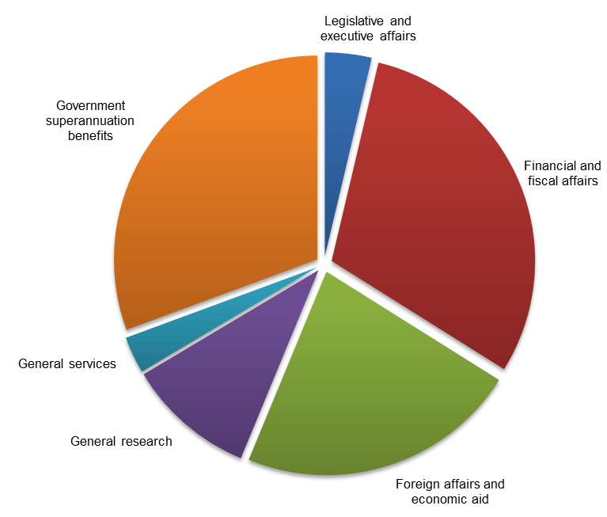
Source: Australian Government Final Budget Outcome 2012-13
Government superannuation benefits totalled $7.9 billion or 31 per cent of general public services spending. This includes Australian Government superannuation schemes for civilian and military personnel, and Senators and Members of Parliament. Government superannuation benefits represent the increase in Commonwealth superannuation liabilities for employees over a given financial year. This is distinct from nominal superannuation interest which represents the imputed nominal interest expense accrued during the period on unfunded liabilities for government superannuation benefits, and is discussed in more detail in Chapter 3.
Financial and fiscal affairs spending amounted to $7.8 billion in 2012-13, or 30 per cent of general public services spending. This includes funding for the Treasury, the Australian Taxation Office (ATO) and the Australian Bureau of Statistics (ABS). Spending on foreign affairs and economic aid was $5.8 billion, about a quarter of general public services spending, and includes programs under the Department of Foreign Affairs and Trade (DFAT), and Official Development Assistance (ODA).
General research spending includes funding provided to the Commonwealth Scientific and Industrial Research Organisation (CSIRO), the Australian Research Council (ARC) and for research and innovation programs, and accounted for $2.7 billion or 10 per cent of total spending.
Spending on legislative and executive affairs amounted to $959 million, making up around 4 per cent of general public services spending. This includes parliamentary services, Ministerial entitlements, electoral services and support for the Prime Minister and Governor-General.
General services spending was $759 million (3 per cent of the total), and included the Australian Public Service Commission, safety, rehabilitation and compensation spending administered by Comcare, and the parts of the Department of Finance responsible for insurance and the management of Australian Government properties.

Trends in general public services expenses
Government spending on general public services increased by 80.4 per cent, or 6.1 per cent annually, from 2002-03 to 2012-13, more than double GDP growth of 34.3 per cent, or 3.0 per cent annually. This was mainly driven by growth in government superannuation benefits, financial and fiscal affairs, and foreign affairs and economic aid.
There have been noticeable year to year fluctuations over this period with increases in some areas offset by reductions in others, as shown in Figure 6.2 below.
Figure 6.2: Contributions to growth in general public services expenses
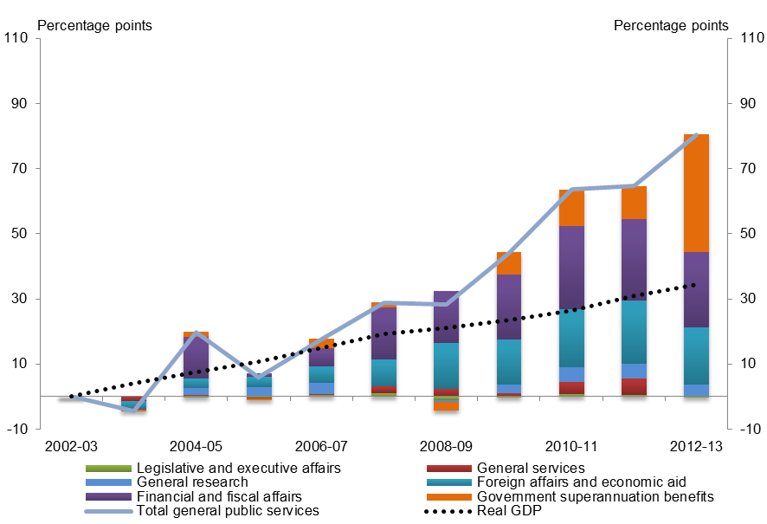
Sources: Australian Government Final Budget Outcomes and ABS

Table 6.1: Summary of general public services expenses trends
Category | Share of  2012-13 total | Real spending growth 2002-03 to 2012-13
 |  | Annual growth | Contribution to  total growth
Unit | % | % | Percentage points
Government superannuation benefits | 30.6 | 11.2 | 36.2
Financial and fiscal affairs | 30.2 | 5.6 | 23.0
Foreign affairs and economic aid | 22.3 | 5.9 | 17.7
General research | 10.2 | 2.1 | 3.5
Legislative and executive affairs | 3.7 | 0.0 | 0.0
General services | 2.9 | 0.2 | 0.1
Total | 100.0 | 6.1 | 80.4
Contributions from government superannuation benefits
Expenses for government superannuation benefits contributed 36.2 percentage points, or 45 per cent of growth in general public services spending from 2002-03 to 2012-13. This was the largest contribution of all areas, increasing by 11.2 per cent annually over this period.
The growth in spending on government superannuation benefits over the period largely reflected the methodology used to calculate these expenses. Superannuation benefits expenses are calculated using the long term government bond rate at the end of the financial year as the discount rate. Changes in this discount rate have the largest impact on superannuation benefit expenses.
The increase in superannuation benefits expenses between 2002-03 and 2012-13 reflects the decrease in the long term bond rate. In particular, the use of the 3.1 per cent long term government bond rate for 2012-13 resulted in a substantial increase in expenses in that year.
Contributions from financial and fiscal affairs
The second largest contributor to growth in spending on general public services was financial and fiscal affairs at 23.0 percentage points, or 29 per cent of the growth in the function from 2002-03 to 2012-13. Spending on this area increased by 5.6 per cent annually over this period largely due to:
- additional funding for the ATO for the improvement of services and compliance;
- an increase in the ATO’s penalty remission expenses;
- increased investment expenses as financial assets accumulated in the Future Fund, administered by the Future Fund Management Agency; and
- increases in funding for the Australian Bureau of Statistics in 2005-06, 2006-07, 2010-11 and 2011-12 for the Census.

Contributions from foreign affairs and economic aid
Foreign affairs and economic aid spending accounted for 17.7 percentage points, or 21.9 per cent of total growth in general public service spending from 2002-03 to 2012-13.
Figure 6.3: Cumulative growth in foreign affairs and economic aid expenses
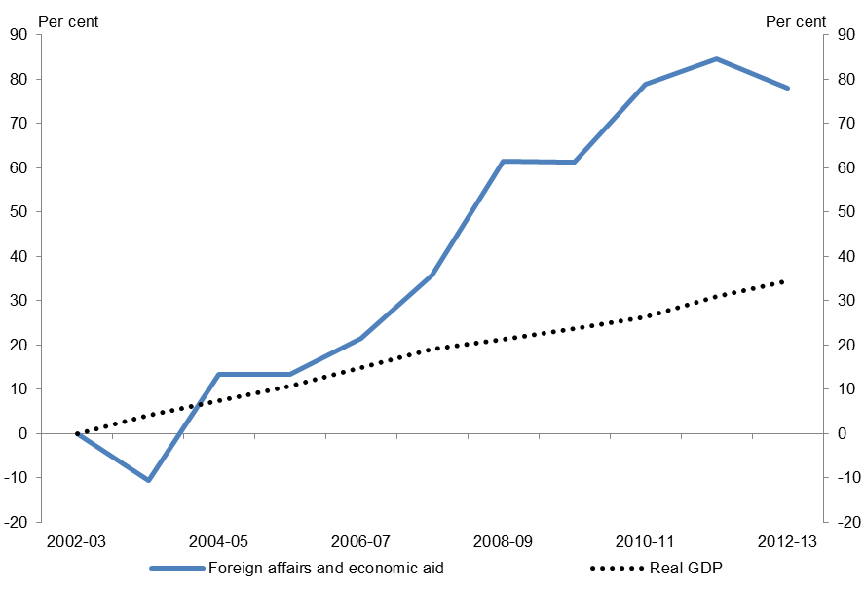
Sources: Australian Government Final Budget Outcomes and ABS
Spending on foreign affairs and economic aid increased by 5.9 per cent annually from 2002-03 to 2012-13, outstripping GDP growth since 2004-05 due primarily to the increase in ODA, as shown in Figure 6.3 above. The increase in ODA reflected the 2006 announcement outlined in the Government’s 2006 White Paper – Australian Aid: Promoting Growth and Stability to increase overseas aid to around $4 billion annually by 2010; and the commitment in 2008 to increase ODA to 0.5 per cent of Gross National Income.
Contributions from legislative and economic affairs, general research and general services
Legislative and executive affairs, general research and general services were small contributors to growth in spending reflecting the relatively small amount of spending on these areas.
As shown in Table 6.1 there has been no change in spending in real terms for legislative and executive affairs over the period 2002-03 to 2012-13. At the same time, spending on general research contributed 3.5 percentage points to growth and general services increased slightly contributing only 0.1 of a percentage point.
Expenses for legislative and executive services fluctuated over the period reflecting increases in spending by the Australian Electoral Commission for federal elections in 2004, 2007, 2010 and 2013, and expenses related to Australia’s hosting duties for events such as the Commonwealth Heads of Government Meeting in 2002 and 2011 and the Asian Pacific Economic Cooperation forum in 2007.

General research spending increased by 2.1 per cent annually from 2002-03 to 2012-13. Over the period growth was partly due to measures announced in the Backing Australia’s Ability statements. These included an additional $1 billion over four years from 2001-02 for general research measures as part of An innovation Action Plan for the Future and $2 billion over five years for general research measures in Building Our Future through Science and Innovation from 2004-05.
From 2008-09 to 2011-12, increases in expenses were largely due to the Super Science initiative which provided around $900 million over five years for research infrastructure including for the Australian Nuclear Science and Technology Organisation, the Australian Institute of Marine Science, and Commonwealth Scientific and Industrial Research Organisation.

Defence and public order and safety expenses
In 2012-13, defence and public order and safety expenses totalled $25.1 billion, accounting for 6.5 per cent of total government spending. The composition of this spending is shown in Figure 7.1 below.
Figure 7.1: Composition of defence and public order and safety expenses in 2012-13
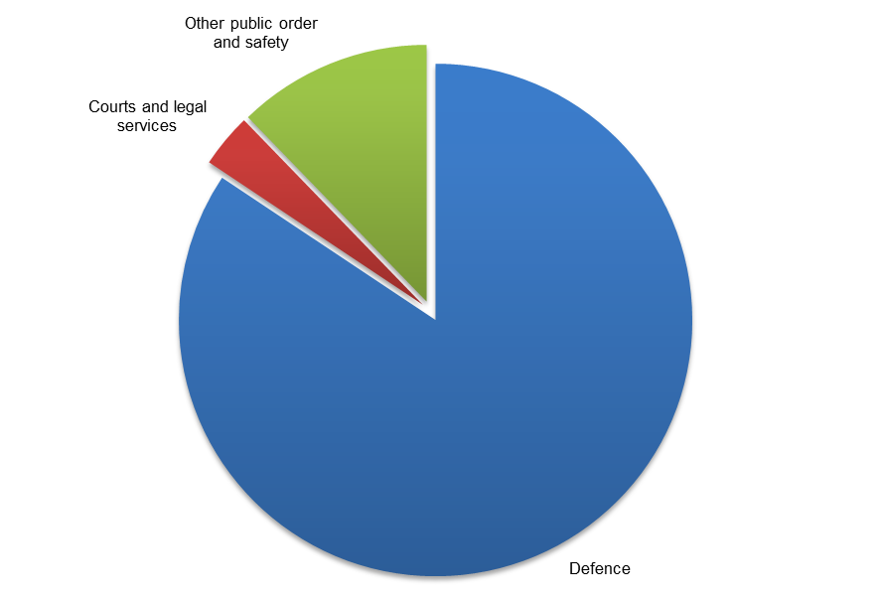
Source: Australian Government Final Budget Outcome 2012-13
Most of this spending, 84 per cent, was for defence and included the Department of Defence; the Australian Defence Force (ADF), which includes the navy, army and air force; and the Defence Materiel Organisation (DMO).
Spending on other public order and safety included the Australian Federal Police (AFP), the Australian Customs and Border Protection Service (Customs), and the Australian Security Intelligence Organisation (ASIO) and totalled $3.1 billion in 2012-13 or 12 per cent of spending.
Courts and legal services spending amounted to $0.9 billion in 2012-13 or 3 per cent of defence and public order and safety spending. It included programs such as the provision of legal services, legal aid, and the administration of federal courts.

Trends in defence and public order and safety spending
From 2002-03 to 2012-13, defence and public order and safety expenses grew by 27.1 per cent, or 2.4 per cent annually. This was slower than GDP growth of 34.3 per cent, or 3.0 per cent annually.
Defence expenses made the largest contribution to cumulative growth in defence and public order and safety (20.3 percentage points), compared with 6.4 percentage points for other public order and safety and 0.4 percentage points for courts and legal services.
Figure 7.2: Contributions to growth in defence and public order and safety expenses
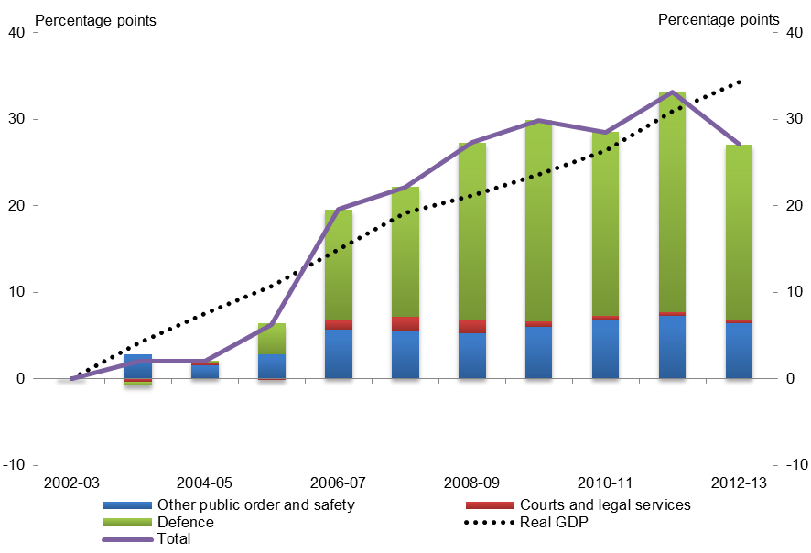
Sources: Australian Government Final Budget Outcomes and ABS
As illustrated by the Figure 7.2 above, spending for defence, public order and safety increased broadly in line with economic growth until 2012-13 when there was a marked reduction in defence expenses.
Over this period, trends were influenced by policy decisions which for defence included the enhancement of capabilities (army, navy and air force) and overseas military operations, and, for other public order and safety, increased spending to strengthen domestic security.
The following table provides a summary of trends in defence, public order and safety expenses.
Table 7.1: Summary of defence and public order and safety expenses trends
Category | Share of  2012-13 total | Real spending growth 2002-03 to 2012-13
 |  | Annual growth | Contribution to  total growth
Unit | % | % | percentage points
Defence | 84.4 | 2.1 | 20.3
Other public order and safety | 12.3 | 5.4 | 6.4
Courts and legal services | 3.4 | 1.0 | 0.4
Total | 100.0 | 2.4 | 27.1

Contribution from Defence
Over the period 2002-03 to 2012-13, the largest contributor to overall growth in defence, public order and safety was defence, which contributed 20.3 percentage points of the total growth of 27.1 per cent (or three quarters of total growth). Over this period, spending was strongest from 2005-06 to 2010-2011 when it outstripped growth in GDP before a marked reduction from 2011-12 to 2012-13 as shown in Figure 7.2. Over the decade defence expenses grew at 2.1 per cent annually compared with GDP growth of 3.0 per cent annually.
Growth in expenses across much of this period was influenced by the policy agenda in the White Paper Defence 2000: Our Future Defence Force, which outlined the Australian Government’s defence strategy over the following decade and included the Defence Capability Plan which provided for enhancement of army, navy, air force and intelligence capabilities, as well as investment in capital required to meet these aims. Growth in funding associated with Defence 2000 was projected to average 3 per cent annually over the following ten years.
Other long term funding commitments included an extension of the 3 per cent annual growth to 2015-16 announced in the 2006-07 Budget with funding of $10.7 billion over five years from 2011-12, and new funding commitments associated with the 2009 White Paper: Force 2030 totalling $146.1 billion in 2029-30.
Additional contributors to growth since 2002-03 included funding for specific capabilities including:
- an increase to the size of the army by one battalion (at a cost of $4.1 billion over 11 years from 2006-07); and increased spending to improve the army‘s combat capabilities ($1.5 billion over ten years provided in the 2006-07 Budget);
- the acquisition of the F/A18F Super Hornet aircraft ($6.6 billion over 13 years from 2007-08); and
- the acquisition of heavy lift aircraft ($2.2 billion over six years in the 2006-07 Budget and $1.4 billion announced in the 2007-08 Budget).
Australia’s involvement in overseas operations including Afghanistan beginning in 2001, Iraq in 2003, and East Timor was a key component of defence spending from 2002-03 to 2012-13. The cost to Defence of the Afghanistan operation (Operation Slipper) over this period was $6.1 billion; the total cost of the Iraq operation (Operation Catalyst), which ended in 2009-10, was $2.4 billion; and the cost of the operation in East Timor (Operation Astute) was $2.3 billion over the period to 2012-13.
The cost of overseas operations did not grow significantly over the period 2002-03 to 2012-13 but involvement in these operations was substantial across the period. In 2002-03 and 2003-04 there was substantial spending on operations in East Timor and Iraq. As spending on these operations declined, this was offset by increased spending on the Afghanistan operation.
The growth in Defence expenses provided in the long-term funding commitments was reduced by a number of decisions commencing in the 2009-10 Budget, largely involving the deferral of capital acquisitions and the associated operating and maintenance costs.
As shown in Figure 7.2, the impact of these savings measures is particularly evident in 2012-13 where there is a decline in defence expenses. Significant savings measures included a rephasing of $2 billion of measures announced in the 2009-10 Budget, $1.2 billion in efficiency savings and a rephasing of capital investment generating savings of $1.3 billion in the 2011-12 Budget and $5.4 billion efficiency and reprogramming savings in the 2012-13 Budget.

Total defence spending
Defence has the largest proportion of net capital investment of all government functions and its inclusion provides a more comprehensive measure of total defence spending. As illustrated by Figure 7.3, total defence spending, which includes net capital investment, increased by 33.5 per cent from 2002-03 to 2012-13, compared to an increase of 23.3 per cent in defence expenses. Defence spending including net capital investment contributed 2.2 percentage points to total government spending growth of 45.2 per cent. This reflects an annual growth rate of 2.9 per cent from 2002-03 to 2012-13 compared with growth in GDP of 3.0 per cent annually.
Figure 7.3: Cumulative growth in total defence spending
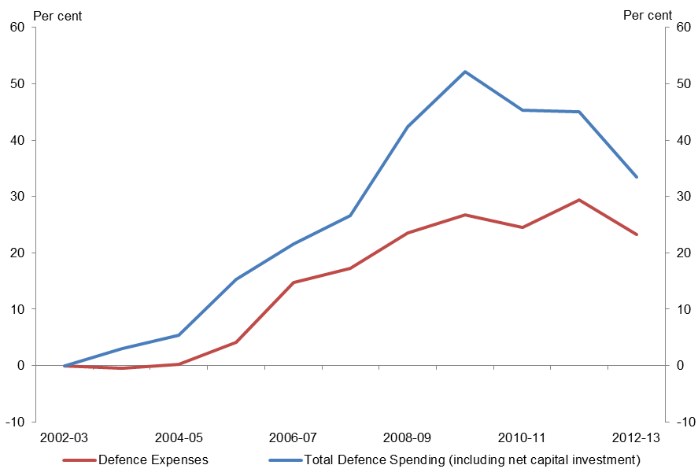
Source: Australian Government Final Budget Outcomes
Contribution from other public order and safety
Other public order and safety spending grew by 5.4 per cent annually from 2002-03 to 2012-13 mainly due to increases in spending for the AFP, Customs, and ASIO. Spending by the AFP grew 4.8 per cent annually and contributed 2.0 percentage points to total growth in defence, public order and safety. Annual growth in spending by Customs was 4.1 per cent contributing 1.8 percentage points and spending by ASIO grew 13.4 per cent annually, contributing 1.5 percentage points.
The increase in spending reflects the focus on security after 11 September 2001 as part of the Upgrading Domestic Security package outlined in the 2002-03 Budget which saw increases in funding for agencies including ASIO, AFP and Customs for initiatives relating to aviation security and the identification of and response to security threats such as terrorist incidents. Around $1.3 billion of funding was provided for initiatives in this package over five years from 2002-03.
Subsequent packages included A Safer Australia ($411 million over five years) in the 2003-04 Budget, Investing in Australia’s Security ($754 million over five years) in the 2004-05 Budget, and the National Security – Preventing Terrorism package, which provided an additional $1.5 billion over five years from 2005-06. This package included funding of $394 million for increased staffing at ASIO, $252 million for the continuation of ASIO measures that would otherwise end, $355 million for the AFP for security at airports and $112 million for the AFP for protective security.
Contribution from courts and legal services
Spending on courts and legal services grew by 1.0 per cent annually from 2002-03 to 2012-13. This slight increase was driven by spending on Legal Aid. Significant measures relating to courts and legal services over this period include:
- increased funding for legal aid announced in the 2004-05 Budget to maintain equitable access to Commonwealth legal aid and the establishment of a National Crime Prevention Programme;
- increased funding from 2005-06 to 2009-10 for the family law system, the refurbishment of the Sydney Law Courts and increased prosecutions relating to federal law announced in the 2005-06 Budget; and
- expenses relating to new measures including for Strengthening national security – implementing the Anti-Terrorism Act (No.2) 2005.

Industry and economic affairs expenses
Industry and economic affairs spending was $21.9 billion or 5.7 per cent of total government spending in 2012-13. The composition of this spending is shown in Figure 8.1 below.
Figure 8.1: Composition of industry and economic affairs expenses in 2012-13
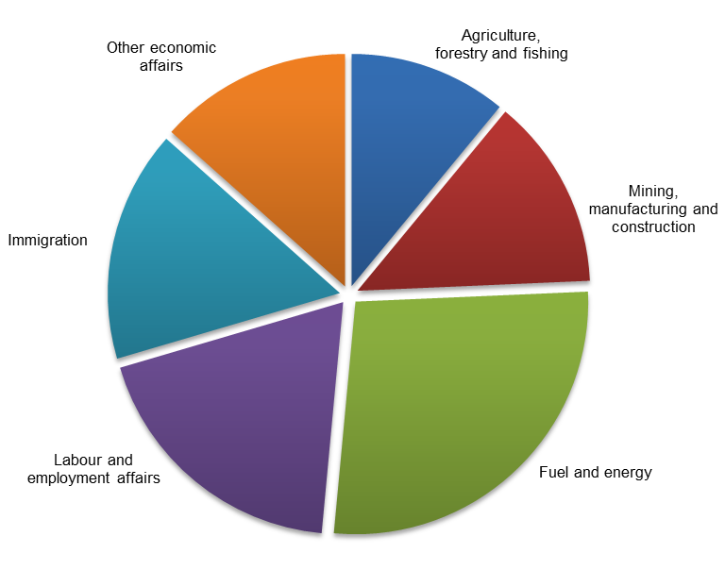
Source: Australian Government Final Budget Outcome 2012-13
In 2012-13, expenses on fuel and energy amounted to $6.0 billion or 27 per cent of total expenses on industry and economic affairs. Fuel and energy consisted mainly of fuel tax credits to businesses which amounted to $5.5 billion in 2012-13, or around 92 per cent of fuel and energy expenses. These tax credits are provided to businesses for fuel used in machinery, plant, equipment and heavy vehicles. The remaining 8 per cent of the fuel and energy component was made up of resources and energy related initiatives which included ongoing subsidy schemes such as the ethanol production subsidy ($109 million in 2012-13).
Expenses on labour and employment affairs included labour and employment affairs; industrial relations expenses; and vocational and industry training expenses. These amounted to $4.2 billion in 2012-13 or 19 per cent of total spending on industry and economic affairs. Labour market assistance ($1.7 billion) refers to employment services such as Job Services Australia and the Indigenous employment program. Industrial relations expenses ($801 million in 2012-13) included the general employee entitlements and redundancy scheme (GEERS), which cost $224 million and expenses by the Fair Work Commission and the Office of the Fair Work Ombudsman. Vocational and industry training expenses ($1.6 billion in 2012-13) included programs to provide support for apprenticeships and programs to improve workforce skills.

Immigration expenses included visa and migration services, settlement and multicultural services and management of irregular maritime arrivals. In 2012-13, administered expenses for onshore and offshore detention amounted to 53.7 per cent of total immigration expenses. Expenses on immigration were $3.5 billion in 2012-13 or 16.1 per cent of total spending on industry and economic affairs.
Industry and economic affairs expenses also included industry assistance programs located in the component, other economic affairs. Expenses for other economic affairs were $2.9 billion in 2012-13 or 13.4 per cent of total expenses on industry and economic affairs. These included funding for regulatory agencies including the Australian Securities and Investment Commission (ASIC) ($411 million), the Australian Competition and Consumer Commission (ACCC) ($177 million) and the Bureau of Meteorology ($353 million). They also include programs under Innovative Industry which provide incentives for innovation, green energy and assistance to commercialisation ($299 million), export assistance through the export market development grants scheme ($126 million) and tourism and area promotion ($190 million).
Mining, manufacturing and construction expenses in 2012-13 were $2.9 billion or 13 per cent of total expenses on industry and economic affairs. The research and development tax incentive ($2.2 billion) made up most of the expenses. The rest included industry specific programs, such as for automotive, steel and textiles.
Agriculture, forestry and fishing expenses were $2.4 billion or 11 per cent of total expenses for industry and economic affairs. This component refers to assistance to primary industries, rural assistance (including drought programs) and natural resources development (including water reform).
Trends in industry and economic affairs expenses
The contributions of the different components to growth in industry and economic affairs expenses are shown in the Figure 8.2 below.
Figure 8.2: Contributions to growth in industry and economic affairs expenses
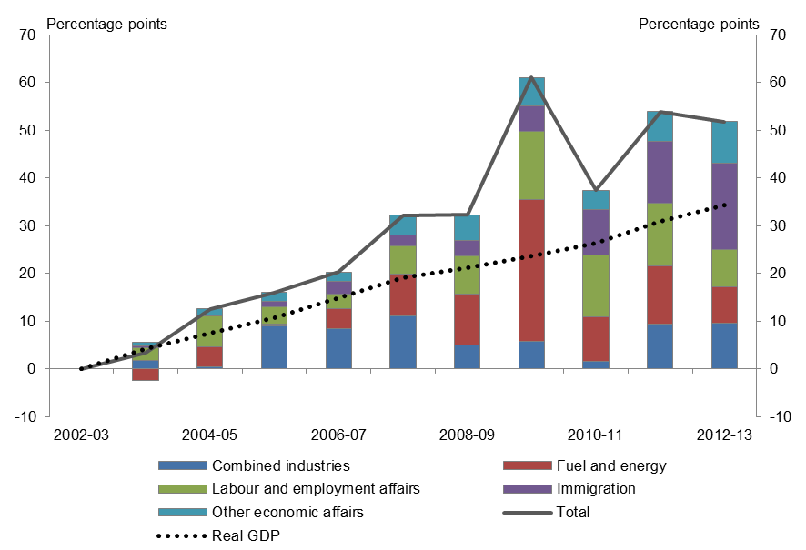
Sources: Australian Government Final Budget Outcomes and ABS
From 2002-03 to 2012-13, industry and economic affairs expenses grew by 51.8 per cent (or 4.3 per cent annually) which was higher than GDP growth of 34.3 per cent (or 3.0 per cent annually). Expenses growth in this area had been strong throughout the period with fluctuations arising from temporary spending priorities such as drought assistance which peaked in 2007-08 and the implementation of the fiscal stimulus over the period 2008-09 to 2010-11.
Table 8.1: Summary of industry and economic affairs expenses trends
Category | Share of  2012-13 total | Real spending growth 2002-03 to 2012-13
 |  | Annual growth | Contribution to  total growth
Unit | % | % | percentage points
Fuel and energy | 27.2 | 2.1 | 7.6
Labour and employment affairs | 19.0 | 3.3 | 7.9
Immigration | 16.1 | 14.3 | 18.1
Other economic affairs | 13.4 | 5.7 | 8.7
Mining, manufacturing and construction | 13.3 | 6.7 | 9.6
Agriculture, forestry and fishing | 11.0 | -0.1 | -0.1
Total | 100.0 | 4.3 | 51.8

Contribution from immigration
Immigration made the largest contribution to growth in industry and economic affairs expenses, accounting for 18.1 percentage points, or a third of total growth in this function.
The growth in immigration spending was 14.3 per cent annually over the period but significant growth, largely from 2009-10 onwards, was driven primarily by costs associated with increased irregular maritime arrivals. In 2010-11, irregular maritime arrivals held in immigration detention increased by 41 per cent on the previous year. the total number of people in immigration detention increased by 34 per cent. To accommodate this large increase, new transit accommodation, new detention centres and expansions and upgrades to existing facilities were commissioned in 2010-11. Administrative expenses associated with offshore detention were $1.8 billion in 2012-13. (This does not include capital investment which is discussed in Chapter 10.)
Contribution from labour and employment affairs
From 2002-03 to 2012-13 the contribution of labour and employment affairs to overall growth was 7.9 percentage points of total growth of 51.8 per cent. Annual growth was 3.3 per cent over the period, largely driven by an increase in funding for vocational and industry training from 2005-06 to 2009-10 of 154.8 per cent. This was mainly driven by the 2006 Skills for the Future package which provided additional skills training for adult workers and incentives for mid-career apprentices, and the 2008-09 Budget package Skilling Australia for the Future which provided additional places for vocational education and training, additional Australian apprenticeship places, as well as grants for school students to participate in on-the-job training.
Contribution from fuel and energy
Fuel and energy contributed 7.6 percentage points to the growth in industry and economic affairs and grew by 2.1 per cent annually year over the period.
As shown in Figure 8.2, fuel and energy was the key driver when expenses peaked in 2009-10. This was due to increased expenses as part of the fiscal stimulus package under the Nation Building and Jobs Plan (Energy Efficient Homes), the Solar Homes and Communities program and the National Solar Schools program. After the implementation of the fiscal stimulus packages, growth in fuel and energy expenses fell back to levels consistent with previous years driven largely by modest growth in fuel tax credits.
Contribution from mining, manufacturing and construction
Mining, manufacturing and construction made a contribution of 9.6 percentage points to growth in industry and economic affairs in the period 2002-03 to 2012-13. Expenses grew by 6.7 per cent annually driven by an increase of 891.4 per cent in the research and development tax offsets over the period. Spending on these tax offsets more than doubled in 2011-12 following the replacement in 2010-11 of the previous Research and Development Tax Concession with the more generous Research and Development Tax Incentive. The newer scheme provided a 45 per cent refundable tax offset on R&D spending, available to companies with an annual turnover of less than $20 million, and a 40 per cent offset for larger companies.
The increase in the Research and Development Tax Incentive was partly offset by the reduction in expenses over the period for industry specific programs, including the Automotive Transformation Scheme (previously the Automotive Competitiveness and Investment Scheme), Assistance to the Textile Clothing and Footwear Industries and the Pharmaceutical Industry Investment Program.
Contribution from other economic affairs
Expenses from other economic affairs contributed 8.7 percentage points to growth in industry and economic affairs over 2002-03 to 2012-13, with annual growth in spending of 5.7 per cent.
The largest driver of growth was the increased provision for refund of unclaimed monies which contributed 3.3 percentage points or 38.1 per cent of the contribution of other economic affairs to industry and economic affairs. This was attributable to measures in the 2012-13 Mid-Year Economic and Fiscal Outlook to amend the transfer of unclaimed company monies and monies in inactive bank accounts and life insurance policies to the Australian Securities and Investment Commission (ASIC), including a reduction in the period of inactivity before monies are transferred, from seven to three years.
Over the period, the departmental expenses of agencies which are included in other economic affairs also contributed to its growth. ASIC grew annually by 6.2 per cent; the Bureau of Meteorology grew annually by 5.0 per cent; and the Australian Competition and Consumer Commission by 6.3 per cent. Together, these agencies contributed 2.8 percentage points, or 30.5 per cent of the contribution of other economic affairs to industry and economic affairs.
These increases were partially offset by reductions in spending on export market development grants which fell by 4.4 per cent annually, and spending on trade, education and investment (administered by the Australian Trade Commission) which fell by 3.2 per cent annually.
Contribution from agriculture, forestry and fishing
Agriculture, forestry and fishing expenses detracted slightly from growth in industry and economic affairs with an annual decrease of 0.1 per cent. Agriculture, forestry and fishing made a contribution of 13.5 percentage points, or 41.8 per cent of cumulative growth in industry and economic affairs up to 2007-08. This was driven by increases in rural assistance, largely drought assistance. After 2007-08, the contribution of agriculture, forestry and fishing decreased due to the decline in drought related assistance and a decrease in expenses in water reform.

Community amenities and infrastructure expenses
In 2012-13, $15.4 billion was spent on community amenities and infrastructure, which was 4.0 per cent of total government spending. The composition of this spending is shown in Figure 9.1 below.
Figure 9.1: Composition of community amenities and infrastructure expenses in 2012-13
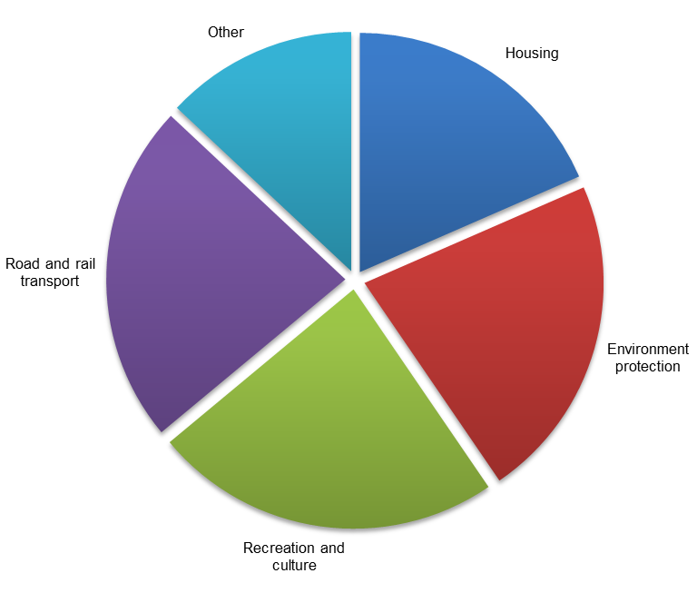
Source: Australian Government Final Budget Outcome 2012-13
Recreation and culture was the largest component of community amenities and infrastructure spending in 2012-13, amounting to $3.6 billion, or 24 per cent of community amenities and infrastructure spending. This included spending on public broadcasting, arts and cultural heritage, sport and recreation activities and the management and protection of national parks and other world heritage areas. Some of the larger areas of recreation and culture spending include the Australian Broadcasting Corporation (ABC) at $1.2 billion, the Special Broadcasting Service Corporation (SBS) at $0.3 billion and the Australian Sports Commission (including the Australian Institute of Sport) at $0.3 billion. Other spending included the Australian Screen Production Incentive which provides tax incentives for film, television and other screen production in Australia.
The next largest component was road and rail transport at $3.5 billion, or 23 per cent of community amenities and infrastructure spending in 2012-13. This was predominantly made up of funding to the States for road and rail projects.
Spending on environment protection was around $3.4 billion in 2012-13, or 22 per cent of community amenities and infrastructure spending. This included spending on the protection and conservation of the environment, water and waste management, pollution abatement and environmental research. The largest component of spending on environment protection in 2012-13 related to free carbon permits issued under the Carbon Pricing Mechanism (CPM).
Housing spending was $2.8 billion in 2012-13. This represented 18 per cent of community amenities and infrastructure spending and was largely comprised of funding to the States to support affordable housing services ($1.8 billion) and the expenses of Defence Housing Australia ($1.0 billion).
Other spending is made up of urban and regional development, communication and other transport expenses (including air and sea transport). Spending in these areas was $2.0 billion in 2012-13, or 13 per cent of the total.
Trends in community amenities and infrastructure expenses
Over the period 2002-03 to 2012-13, spending on community amenities and infrastructure grew by 83.5 per cent, or 6.3 per cent annually. This was significantly faster than GDP growth which was 34.3 per cent over the same period, or 3.0 per cent annually.
Overall, growth in community amenities and infrastructure spending was driven by strong growth in spending on environment protection and road and rail transport. Underlying this overall growth was a particularly volatile spending profile from 2008-09 onwards.
Much of this volatility can be attributed to fiscal stimulus spending, the introduction of the CPM and fluctuations inherent in infrastructure spending. This volatility was also due to government decisions to change the funding profile for various infrastructure projects during the period.
Figure 9.2 shows the cumulative growth in spending on community amenities and infrastructure.
Figure 9.2: Contributions to growth in community amenities and infrastructure expenses
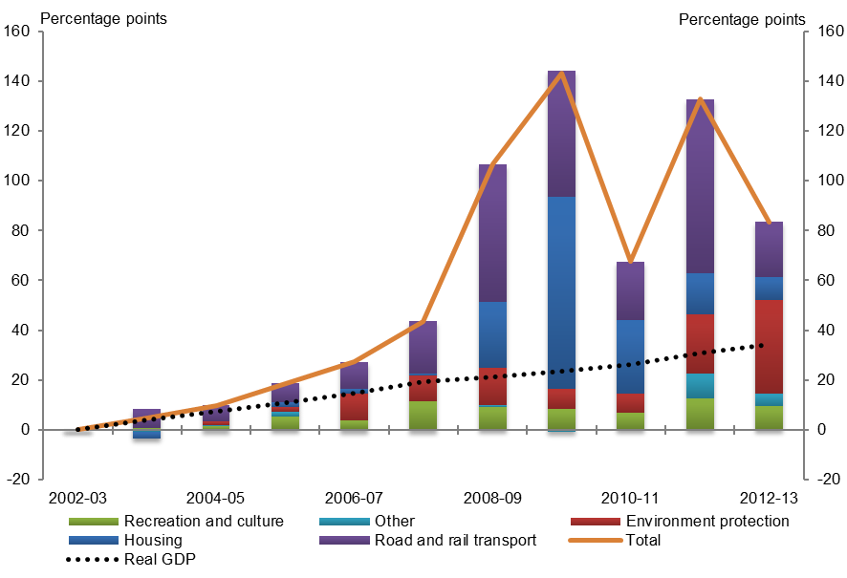
Sources: Australian Government Final Budget Outcomes and ABS
Fiscal stimulus measures were responsible for driving the strong growth in spending on community amenities and infrastructure in 2008-09 and 2009-10. The majority of this temporary spending was funding to the States for the First Home Owners Boost, social housing and initiatives to address homelessness, along with additional Defence Housing Australia dwellings.
Fiscal stimulus spending on housing was $1.5 billion in 2008-09, $5.3 billion in 2009-10, $1.5 billion in 2010-11 and $0.2 billion in 2011-12.
The remainder of the fiscal stimulus was for road and rail transport, largely comprising spending from the Building Australia Fund and the acceleration of funding for various projects. Fiscal stimulus spending on road and rail transport was $1.6 billion in 2008-09, $1.0 billion in 2009-10, $0.7 billion in 2010-11 and $2.0 billion in 2011-12.
Table 9.1 provides a summary of trends in community amenities and infrastructure spending.
Table 9.1: Summary of community amenities and infrastructure expenses trends
Category | Share of  2012-13 total | Real spending growth 2002-03 to 2012-13
 |  | Annual growth | Contribution to  total growth
Unit | % | % | percentage points
Recreation and culture | 23.5 | 2.5 | 9.4
Road and rail transport | 23.0 | 7.7 | 22.1
Environment protection | 22.0 | 30.8 | 37.6
Housing | 18.5 | 3.2 | 9.1
Other | 13.0 | 2.5 | 5.2
Total | 100.0 | 6.3 | 83.5
Contribution from environment protection
Over the period 2002-03 to 2012-13, the largest contributor to overall growth in spending on community amenities and infrastructure was environment protection, which contributed 37.6 percentage points of the 83.5 per cent growth, or over two fifths of total growth. The annual growth rate in environment protection spending was 30.8 per cent.
The main driver of the growth in environment protection spending was the introduction of assistance for electricity generation and emissions-intensive trade-exposed activities under the CPM from
2011-12, largely through the allocation of free carbon permits.
Contribution from road and rail transport
The second largest contributor to growth in spending on community amenities and infrastructure was road and rail transport, which contributed 22.1 percentage points of the 83.5 per cent growth. This was around one quarter of total growth in community amenities and infrastructure spending.
Spending on road and rail transport grew by 7.7 per cent annually over the period 2002-03 to 2012-13, more than double GDP growth of 3.0 per cent annually.
Growth in road and rail transport spending resulted from government decisions to increase funding for road and rail projects over the period. The irregular nature of infrastructure spending was responsible for the volatility in road and rail transport spending over the period.
Spending on road and rail transport almost doubled over the period 2002-03 to 2007-08. This was mainly due to decisions in the 2004-05 Budget and 2004-05 MYEFO to spend an additional $1.3 billion over four years from 2004-05 on road and rail links of national importance under the AusLink program. In addition, the 2006-07 Budget provided funding of $0.6 billion in 2006-07 and 2007-08 for the States to invest in highways on the AusLink national network, with additional funding in later years.
The 2007-08 Budget also increased funding for the original AusLink program by $400 million and provided $16.8 billion in funding from 2009-10 for a second five-year tranche, significantly increasing road and rail transport spending through to 2013-14.
Spending on road and rail transport was particularly strong in 2008-09, reflecting a number of government decisions in the 2009-10 Budget to increase funding for road and rail infrastructure as part of the fiscal stimulus. Examples of projects that were funded include the Ipswich Motorway in Queensland, the Hunter Expressway in New South Wales and the Regional Rail Express in Victoria. Funding for these projects was provided from the Building Australia Fund, established in the 2008-09 Budget to provide financing for infrastructure projects. Spending on road and rail transport was also high in 2008-09 as a result of the bringing forward of funding for major road projects as part of the fiscal stimulus.
Spending on road and rail transport peaked in 2011-12, with spending more than doubling relative to the previous year. A large part of this fluctuation was due to the announcement in the
2011-12 MYEFO of the bringing forward of $1.4 billion of funding originally scheduled for later years for a number of major infrastructure projects.
Contribution from recreation and culture
The next largest contributor to growth in spending on community amenities and infrastructure was recreation and culture, which contributed 9.4 percentage points of the total 83.5 per cent growth, or around one tenth of total growth.
Spending on recreation and culture grew slower than GDP over the period at 2.5 per cent annually, with some volatility between years. Some of this volatility comes from the one-off nature of expenses associated with staging events such as the 2006 Melbourne Commonwealth Games and World Youth Day in 2008.
Contribution from housing
Housing contributed 9.1 percentage points of the total 83.5 per cent growth in community amenities and infrastructure spending, or around one tenth of total growth.
Spending on housing increased by 3.2 per cent annually over the period 2002-03 to 2012-13 compared with GDP growth of 3.0 per cent annually.
Spending on housing was relatively flat over the period 2002-03 to 2007-08 before doubling in 2008-09. This was largely due to the temporary increase in the First Home Owners Boost as part of the fiscal stimulus package which increased housing spending in 2008-09 and 2009-10 by $2.1 billion.

Spending on housing more than doubled again in 2009-10 as a result of the implementation of the Social Housing Initiative as part of the fiscal stimulus. The Social Housing Initiative provided $5.6 billion over four years from 2008-09 to the States to build new dwellings and for repairs and maintenance. Spending under this initiative peaked at $3.8 billion in 2009-10. The Social Housing Initiative and the First Home Owners Boost were also responsible for driving the peak in spending on community amenities and infrastructure as a whole in 2009-10.
Excluding fiscal stimulus spending, housing expenditure still grew strongly from 2008-09. Factors driving this growth include the commencement of the National Affordable Housing Agreement with the States, additional funding for remote Indigenous housing and the introduction of the National Rental Affordability Scheme in the 2008-09 Budget.
Contribution from other community amenities and infrastructure spending
The remaining 5.2 percentage points of the 83.5 per cent growth in spending on community amenities and infrastructure over the period 2002-03 to 2012-13 were contributed by a variety of other related programs such as urban and regional development and communication. Over this period, spending on other community amenities and infrastructure programs grew by 2.5 per cent annually.
Spending on other community amenities and infrastructure programs was relatively flat from 2002-03 to 2010-11 before jumping by around 50 per cent in 2011-12. This was mainly associated with payments made to Telstra in relation to the roll-out of the National Broadband Network (NBN). These included $321.6 million to support the agreements made regarding the use of Telstra’s infrastructure and the progressive migration of Telstra’s customers to the NBN, and a further $100 million to retrain employees following the implementation of the National Broadband Network.
Also contributing to growth in this area through to 2012-13 was the introduction of the Regional Infrastructure Fund and the Regional Development Australia Fund. The Regional Infrastructure Fund was announced in the 2010-11 Budget to invest in urgent infrastructure needs, particularly in relation to the mining sector. The Regional Development Australia Fund was launched in 2010-11 to support projects to meet the infrastructure needs of regional Australia.

Net capital investment
Net capital investment provides a measure of the overall growth in assets owned by the Commonwealth after taking account of the acquisition and disposal of non-financial assets by the Commonwealth and depreciation in the value of these assets as they age.
In 2012-13, Commonwealth net capital investment was $987 million, or 0.3 per cent of total government spending. This consisted of $8.0 billion of purchases, less $1.7 billion of sales, less $6.4 billion depreciation, plus $1.1 billion of changes in inventories and other movements in
non-financial assets.
Usually, the largest component of capital investment is in the defence portfolio and includes the acquisition of aircraft and ships and the construction of support facilities. Other smaller components of investment include buildings, infrastructure and intangibles such as computer software. In recent years, significant funds have also been invested in the purchase of water entitlements for the environment.
Subtracting from this investment is the disposal of assets owned by the Commonwealth, such as the sale of radio spectrum licences. Net capital investment can be very volatile, and can be negative when asset sales outweigh purchases.
The funding provided by the Commonwealth to States and local government for capital investment (such as for building roads) is not counted in this measure because the resultant assets are not owned by the Commonwealth.
Net capital investment does not include equity injections into public corporations, such as the injection of $27.5 billion to the National Broadband Network announced in the 2011-12 Budget. These transactions generally do not impact on the fiscal balance, cash balance or net capital investment, because they are the exchange of one type of Commonwealth financial asset for another.

Trends in net capital investment
Over the period 2002-03 to 2012-13, net capital investment grew 10.1 per cent annually, while GDP grew 3.0 per cent annually. There was a rapid increase in net capital investment from 2002-03 to a peak in 2009-10, with growth of 51.6 per cent annually. This was followed by a large fall in net capital investment.
The volatility in the series, as shown in Figure 10.1 below, is mainly due to variations in the number and size of large purchases of non-financial assets, as well as major disposals of assets.

Figure 10.1: Net capital investment (2012-13 dollars)
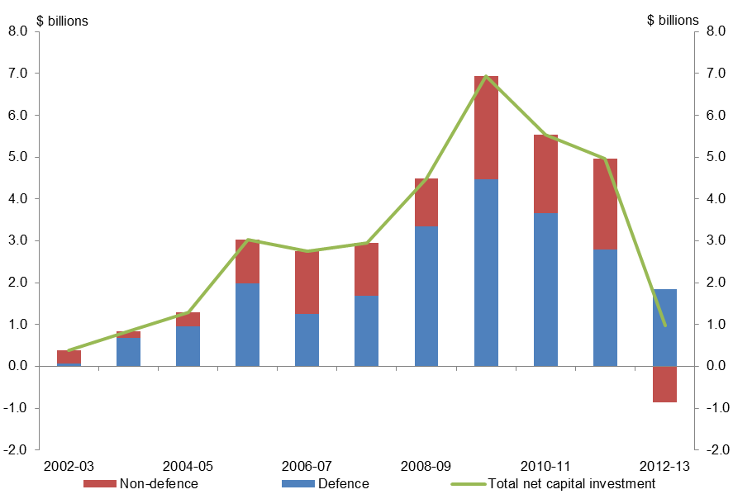
Source: Australian Government Final Budget Outcomes
Over the period 2002-03 to 2012-13, capital purchases grew by 6.7 per cent annually. The trends in capital purchases broadly follow the net capital investment trends shown in Figure 10.1. There was a very rapid increase in purchases from 2002-03 to the peak year in 2009-10 (when purchases were $11.6 billion). There was subsequently a decline in purchases from 2009-10 to 2012-13.
Defence capital purchases
Of all government agencies, the Department of Defence is consistently the largest contributor to the acquisition of non-financial assets by the general government sector. Expansion of military capability by the Department of Defence made a significant contribution to the surge in net capital investment in the period 2007-08 to 2009-10. The peak in net capital investment in 2009-10 was predominately related to additional military equipment and construction of defence support facilities.
Specialist military equipment consistently takes a dominant share of total acquisition of new infrastructure plant and equipment by the general government sector. From 2002-03 to 2009-10, purchase of specialist military equipment increased by 65.6 per cent.
At the peak in 2009-10, purchase of specialist military equipment was $5.5 billion, or almost half of total purchases of non-financial assets by the general government sector. Significant defence purchases included the Bridging Air Combat Capability Super Hornets, the Air Warfare destroyer and the Multi Role Helicopter.
Apart from specialist military equipment, Defence is also the largest purchaser of other infrastructure and buildings in the general government sector. Defence acquisition of buildings rose sharply between 2002-03 and 2009-10, increasing by 315.1 per cent.

Significant acquisition of buildings and infrastructure by Defence included the Heavy Airlift Capability Permanent Facilities and Multi Role Helicopter facilities. There were also capital works funding for the Army, through The Hardened and Networked Army – Phase 2 measure in the 2006-07 Budget. This provided funding of $1.5 billion over ten years to enhance the Army's protection and capabilities, upgrade facilities and relocate a battalion to Adelaide.
In 2009-10, Defence acquisition of buildings was $1.4 billion or 56.5 per cent of total acquisition of buildings by the general government sector. Defence acquisition of infrastructure plant and equipment, other than specialist equipment, was $420 million, or 27.2 per cent of total acquisition of these assets by the general government sector.
For a comparison of defence net capital investment with defence expenses, refer to Chapter 7.
Non-defence capital purchases
Purchases of buildings and infrastructure plant and equipment by government agencies other than Defence are smaller and tend to be lumpy, such as new offices and buildings. The most significant of these was the construction and fit-out of a new ASIO central office building at a cost of $633 million between 2008-09 and 2012-13. Another example was the $300 million purchase of the Ayers Rock Resort at Yulara by the Indigenous Land Corporation in 2010-11.
There were also significant acquisitions of buildings by the former Department of Immigration and Citizenship (DIAC), relating to immigration processing and detention facilities. From 2008-09 to 2012-13, DIAC spent $626 million on the acquisition of new buildings, or around 6.5 per cent of the total spent on new buildings by the general government sector.
Purchases of plant and equipment, other than specialist military equipment, also make an important contribution to net capital investment growth. The agency with the largest recurrent purchases is the Commonwealth Scientific and Industrial Research Organisation, which spent $720 million on plant and equipment between 2002-03 and 2012-13. Another major purchaser of plant and equipment is the Bureau of Meteorology which spent $598 million between 2002-03 and 2012-13. This included measures announced in the 2009-10 Budget for the installation of new weather radars and a roll-out of advanced weather forecasting and warning technology.
Intangible assets
While trends in the acquisition of buildings and of infrastructure plant and equipment are largely consistent with the net capital investment trends in Figure 10.1, in particular years, acquisition or disposal of intangible assets has contributed to volatility in non-defence net capital investment.
The purchase of water entitlements by the former Department of the Environment, Water, Heritage and the Arts under the Water for the Future Initiative made a significant contribution to net capital investment growth. From 2008-09 to 2012-13, purchase of water entitlements amounted to $2.5 billion.
In 2012-13, the sales of spectrum licences had a significant impact on decreasing net capital investment as shown in Figure 10.1. This offset the total acquisition of non-financial assets by agencies other than Defence. Almost $1.5 billion was generated through the renewal of the telecommunications carriers’ licences by the Australian Communications and Media Authority in 2012-13.

States and Territories
Chapters 2 to 9 of this report explore trends in government spending by functions, such as health or education. Most of these functions comprise both Commonwealth own-purpose spending for Australian Government programs and funding provided to States and Territories.
This chapter briefly discusses trends in funding provided to States under the Federal Financial Relations framework from 2002-03 to 2012-13.
In 2012-13, $92.3 billion or 24 per cent of all Australian Government spending was provided to the States. This comprised general revenue assistance for use at the discretion of recipient States and funding to be used in specific sectors or to deliver programs agreed in partnership between States and the Australian Government.
Trends in funding to the States are compared to Commonwealth own-purpose spending to provide an indication of the scale of this spending relative to the overall Australian government budget.
Figure 11.1: Composition of funding to States in 2012-13
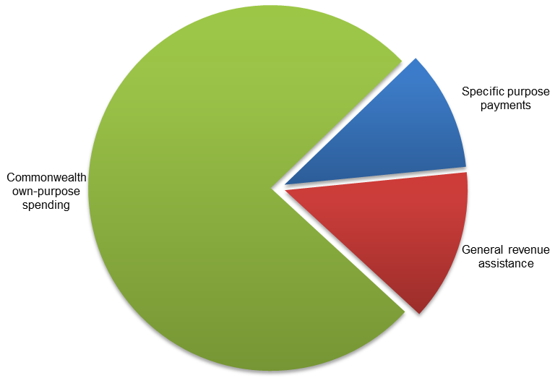
Source: Australian Government Final Budget Outcome 2012-13

General revenue assistance, which is largely revenue from the Goods and Services Tax (GST) and is provided to States for use for any purpose, totalled $51.5 billion or 13 per cent of the Australian Government spending in 2012-13. This also included $2.2 billion in local government assistance.
Specific purpose payments totalled $40.8 billion or 11 per cent of total Australian Government spending in 2012-13. These included National Specific Purpose Payments (National SPPs) in the disability, health, education and housing sectors and National Partnership Payments for programs agreed in partnership between States and the Australian Government.
Trends in funding to States
From 2002-03 to 2012-13, funding to States grew by 32.3 per cent, or 2.8 per cent annually. This was slower than GDP growth of 34.3 per cent, or(3.0 per cent annually and markedly slower than Commonwealth own-purpose spending of 49.8 per cent, or 4.1 per cent annually.
Growth in funding to States compared with Commonwealth own-purpose spending is shown in Figure 11.2.
Figure 11.2: Growth in funding to States compared to Commonwealth own-purpose
spending
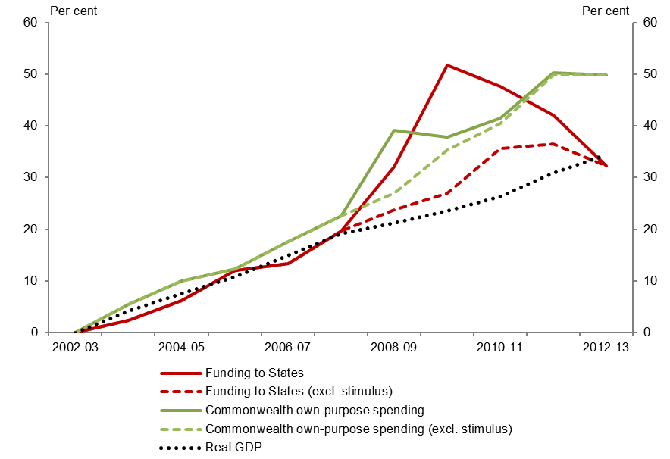
Sources: Australian Government Final Budget Outcomes, Australian Government Budgets and ABS
The comparatively slower growth in funding to States was primarily driven by slowing growth in general revenue assistance reflecting reduced growth in GST receipts.
The transfer to the Commonwealth of responsibilities for certain health and hospital costs from 2008-09, and aged care services from 2010-11 also resulted in reductions in specific purpose funding to States and corresponding increases in Commonwealth own-purpose spending.
Within funding to the States, general revenue assistance grew at a significantly slower rate than specific purpose payments from 2002-03 to 2012-13. The difference in growth is shown in Figure 11.3.
Figure 11.3: Growth in funding to States
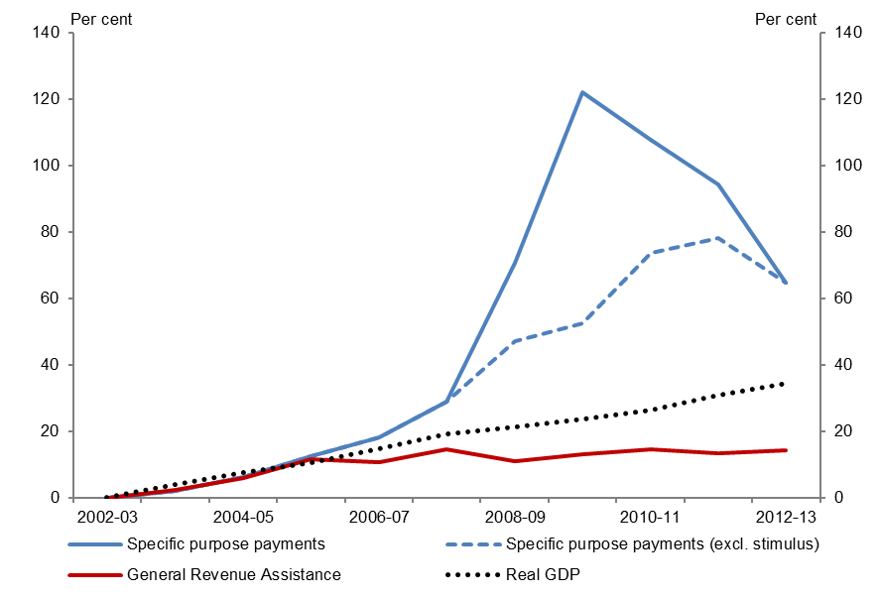
Sources: Australian Government Final Budget Outcomes, Australian Government Budgets and ABS
Over the period, specific purpose payments grew by 64.8 per cent while general revenue assistance grew by 14.4 per cent. This compares with GDP growth of 34.3 per cent.
Funding to States has decreased from 26 per cent of total Australian Government spending in 2002-03 to 24 per cent in 2012-13.
As a result of slowing growth, general revenue assistance decreased from 17.0 per cent of Australian Government spending in 2002-03 to 13.4 per cent in 2012-13. Over the period, the proportion of specific purpose funding increased slightly from 9.4 per cent of Australian Government spending in 2002-03 to 10.6 per cent in 2012-13.
Collectively, the reduction in the proportion of general revenue assistance funding and the moderate increase in specific purpose funding reduced the proportion of more flexible funding available to States, as shown in Figure 11.4.
Figure 11.4: Composition of funding to States
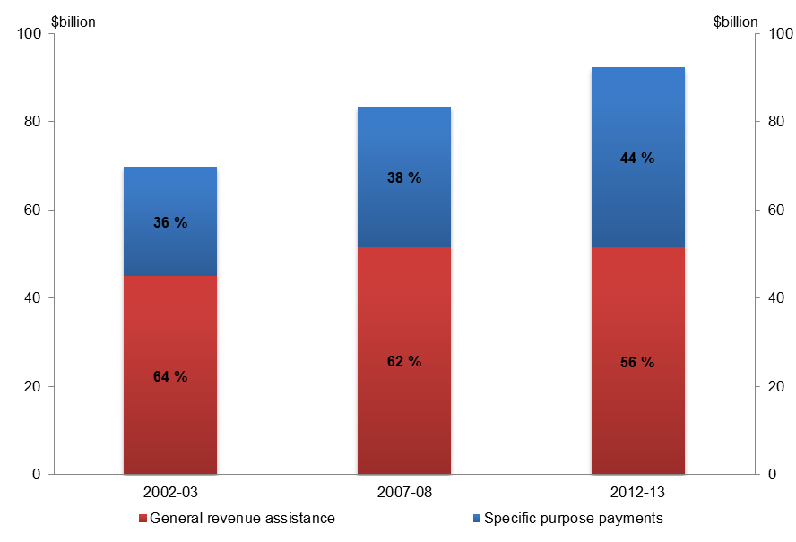
Source: Australian Government Final Budget Outcomes
The proportion of funding provided to the States as general revenue assistance declined from 64 per cent in 2002-03 to 56 per cent in 2012-13. Over the same period the proportion of specific purpose payments increased from 36 per cent to 44 per cent of total payments to the States. This reflected a reduction in the proportion of flexible funding and an increase in the amount provided under specific agreements to deliver services in areas or programs determined in partnership with the Australian Government.
Specific purpose funding to States
Specific purpose payments have driven growth in funding to States from 2002-03 to 2012-13. These are provided to States on the condition that the funds are used in particular sectors or to deliver specific programs agreed between the States and the Australian Government.
Funding to sectors is provided under National SPPs in health, education, housing and disability services providing States with some flexibility on how this is spent. In addition, funding is provided through National Partnership Payments which are linked to particular programs or outcomes agreed in partnership between States and the Australian Government.
National partnership payments to States were used to deliver over $33.2 billion in fiscal stimulus spending from 2008-09 to 2011-12. This comprised $5.3 billion for roads and rail infrastructure, $8.3 billion for housing, $16.4 billion for education and $3.2 billion for health.
Noticeable temporary increases in funding to States in addition to the fiscal stimulus also occurred in 2010-11 and 2011-12. In 2010-11, an additional $6.1 billion was spent on a one-off payment for natural disaster relief. In 2011-12, $1.4 billion in roads funding was brought forward with a corresponding decrease in 2012-13.
Funding to States for education, health and community amenities and infrastructure have driven underlying growth in specific purpose payments from 2002-03 to 2012-13. Together, payments in these areas account for around three quarters of total growth in specific purpose funding to States.
Growth in education funding to States has been driven by the National SPP for the sector and an increase in the number of National Partnership Payments from 2008-09. The latter include the Digital Education Revolution and reward payments for achieving targets in literacy and numeracy that are now drawing to a conclusion.
Health funding to States grew largely as a result of the Commonwealth assuming greater responsibility for funding the health and hospitals system from 2008-09 through the National Health Reform Agreement and associated reward funding.

Lists of data sources and references

Data sources
Australian Bureau of Statistics, 2013, Australian Demographic Statistics, 2013, Cat. No. 3101.0, Canberra.
Australian Bureau of Statistics, 2013, Australian National Accounts: National Income, Expenditure and Product, Cat. No. 5206.0, Canberra.
Australian Bureau of Statistics, 2013, Consumer Price Index, Australia, Cat. No. 6401.0, Canberra.
Australian Bureau of Statistics, 2013, Labour Force, Australia, Cat. No. 6202.0, Canberra.
Australian Bureau of Statistics, Year Book Australia, 2007, 2008, 2012, 2013, Cat. No. 1301.0, Canberra.
Australian Government Agencies, Annual Reports, 2002-03 to 2012-13, Canberra.
Australian Government Departments, Annual Reports, 2002-03 to 2012-13, Canberra.
Australian Government, Budget Papers, 2002-03 to 2013-14, Canberra.
Australian Government, Final Budget Outcome, 2002-03 to 2012-13, Canberra.
Australian Government, 2010, Intergenerational Report 2010: Australia to 2050: future challenges, Canberra.
Australian Government, Mid-Year Economic and Fiscal Outlook, 2002-03 to 2012-13, Canberra.
Australian Government, 2008, Nation Building: Rail, Road, Education & Research and Business, Canberra.
Australian Government, Portfolio Additional Estimates Statements, 2002-03 to 2012-13, Canberra.
Australian Government, Portfolio Budget Statements, 2002-03 to 2012-13, Canberra.
Australian Government, 2011, Review of Funding for Schooling: Final Report, Canberra.
Australian Government, 2009, Updated Economic and Fiscal Outlook, Canberra.
Australian Institute of Health and Welfare, 2013, Health Expenditure 2011-12, Canberra. Available at
https://www.aihw.gov.au/WorkArea/DownloadAsset.aspx?id=60129544656
Australian Institute of Health and Welfare, 2013, Medical workforce 2011, Canberra. Available at
http://www.aihw.gov.au/WorkArea/DownloadAsset.aspx?id=60129542629
Australian Security Intelligence Organisation, ASIO Report to Parliament, 2002-03 to 2012-13, Canberra.
Centre for Health Economics Research and Evaluation, 2011, Extended Medicare Safety Net – Review of Capping Arrangements Report 2011, Sydney. Available at
http://www.health.gov.au/internet/main/publishing.nsf/Content/2011_Review_Extended_Medicare_Safety_Net/$File/Final%20Report%20-%20Review%20of%20EMSN%20benefit%20capping%20June%202011.pdf
Council of Australian Governments, 2008, Communique 29 November 2008, Canberra.
Council of Australian Governments, 2012, National Education Agreement, Canberra.
Council of Australian Governments, 2011, National Health Reform Agreement, Canberra.
Council of Australian Governments, 2009, National Partnership Agreement on Hospital and Health Workforce Reform, 5 February 2009, Canberra.
Council of Australian Governments, 2009, National Partnership Agreement on the Nation Building and Jobs Plan, 5 February 2009, Canberra.
Department of Defence, 2000, Defence 2000 Our Future Defence Force, Canberra. Available at
http://www.defence.gov.au/publications/wpaper2000.PDF
Department of Families, Housing, Community Services and Indigenous Affairs, 2013, Income Support Customers: A Statistical Overview 2011, Statistical Paper No. 10, Canberra. Available at
http://www.dss.gov.au/about-fahcsia/publications-articles/research-publications/social-policy-research-paper-series/statistical-paper-no-10
Department of Foreign Affairs and Trade, 2006, Australian Aid: Promoting Growth and Stability, Canberra. Available at http://aid.dfat.gov.au/Publications/Documents/whitepaper.pdf
Department of Health, 2003, Health Fact Sheet 2 – Australian Health Care Agreements 2003-2008, Canberra. Available at
http://www.health.gov.au/internet/main/publishing.nsf/Content/health-budget2003-fact-hfact2.htm
Department of Human Services, 2013, Medicare Australia Statistics – Medicare Group Reports, Canberra. Available at https://www.medicareaustralia.gov.au/statistics/mbs_group.shtml
Department of Human Services, 2013, Medicare Australia Statistics - Pharmaceutical Benefits Schedule Group Reports, Canberra. Available at
https://www.medicareaustralia.gov.au/statistics/pbs_group.shtml
Department of Social Services, 2013, Age Pension Forward Estimates Model, Canberra.
Minister for Foreign Affairs and Parliamentary Secretary for International Development Assistance, 2008, ‘Australia’s International Development Assistance Program 2008-09’, 2008-09 Ministerial Statement, 13 May 2008, Canberra. Available at
http://www.budget.gov.au/2008-09/content/ministerial_statements/download/ausaid.pdf
National Health Amendment (Pharmaceutical Benefits – Budget Measures) Act 2004.
The Auditor-General, 2010, Performance Audit: Home Insulation Program, Audit Report No. 12 2010-11, Australian National Audit Office, Canberra.
The Treasury, 2012, Tax Expenditures Statement, Canberra.
The Treasury and Department of Finance and Administration, Pre-Election Economic and Fiscal Outlook, 2007, 2010 and 2013, Canberra.

References
Australian Government Agencies, Annual Reports, 2002-03 to 2012-13, Canberra.
Australian Government Departments, Annual Reports, 2002-03 to 2012-13, Canberra.
Australian Government, Budget Papers, 2002-03 to 2012-13, Canberra.
Australian Government, Mid-Year Economic and Fiscal Outlook, 2002-03 to 2012-13, Canberra.
Australian Government, Final Budget Outcome, 2002-03 to 2012-13, Canberra.
Daley, J., 2013. 'Is there still a budget emergency?' Speech to National Press Club of Australia, 9 October 2013. Available at http://grattan.edu.au/events/event/is-there-still-a-budget-emergency/
Department of Finance and Deregulation, 2010, Finance Circular No. 2010/02: Classification of Payments to the States and Territories and Commonwealth Own-Purpose Expenses, Financial Reporting Branch, Canberra, 14 October 2010.
Laurie, K., and McDonald, J., 2008, 'A Perspective on Trends in Australian Government Spending', Economic Roundup, Summer 2008. Available at
http://archive.treasury.gov.au/documents/1352/HTML/docshell.asp?URL=03_spending_growth.asp
Parliamentary Budget Office, 2012, Work Plan 2012-13, Canberra. Available at
http://www.aph.gov.au/~/media/05%20About%20Parliament/54%20Parliamentary%20Depts/548%20Parliamentary%20Budget%20Office/PBO_WorkPlan2012_13.ashx
Parliamentary Budget Office, 2013, Estimates of the Structural Budget Balance of the Australian Government 2001-02 to 2016-17, Canberra. Available at
http://www.aph.gov.au/~/media/05%20About%20Parliament/54%20Parliamentary%20Depts/548%20Parliamentary%20Budget%20Office/Parliamentary%20Budget%20Office%20Stuctural%20Budget%20Balance.ashx
Parliamentary Budget Office, 2013, Post-election Report of Election Commitments 2013 General Election, Canberra. Available at
http://www.aph.gov.au/About_Parliament/Parliamentary_Departments/Parliamentary_Budget_Office/2013_Election
The Treasury, 2009, Treasury Briefing Paper for the Senate Inquiry into the Economic Stimulus Package, Canberra.

Lists of figures and tables

Figures
Figure 1.1: Composition of government spending in 2012-13 4
Figure 1.2: Growth in government spending and GDP 5
Figure 1.3: Contributions to growth in government spending 6
Figure 2.1: Composition of social security and welfare expenses in 2012-13 10
Figure 2.2: Contributions to growth in social security and welfare expenses 11
Figure 3.1: Composition of other purposes expenses in 2012-13 16
Figure 3.2: Contributions to growth in other purposes expenses 17
Figure 3.3: Consumption subject to GST 19
Figure 3.4 Household consumption prices 19
Figure 4.1: Composition of health expenses in 2012-13 20
Figure 4.2: Contributions to growth in health expenses 21
Figure 5.1: Composition of education expenses in 2012-13 25
Figure 5.2: Contributions to growth in education expenses 26
Figure 6.1: Composition of general public services expenses in 2012-13 30
Figure 6.2: Contributions to growth in general public services expenses 31
Figure 6.3: Growth in foreign affairs and economic aid expenses 33
Figure 7.1: Composition of defence and public order and safety expenses in 2012-13 35
Figure 7.2: Contributions to growth in defence and public order and safety expenses 36
Figure 7.3: Cumulative growth in total defence spending 38
Figure 8.1: Composition of industry and economic affairs expenses in 2012-13 40
Figure 8.2: Contributions to growth in industry and economic affairs expenses 42
Figure 9.1: Composition of community amenities and infrastructure expenses in 2012-13 45
Figure 9.2: Contributions to growth in community amenities and infrastructure expenses 46
Figure 10.1 Net capital investment (2012-13 dollars) 51
Figure 11.1: Composition of funding to States in 2012-13 53
Figure 11.2: Growth in funding to States compared to Commonwealth own-purpose spending 54
Figure 11.3: Growth in funding to States 55
Figure 11.4: Composition of funding to States 56

Tables
Table 1.1: Summary of drivers of government spending 7
Table 1.2: Major contributors to government spending, by program 8
Table 2.1: Summary of social security and welfare expenses trends 12
Table 3.1: Summary of other purposes expenses trends 18
Table 4.1: Summary of health expenses trends 22
Table 5.1: Summary of education expenses trends 27
Table 6.1: Summary of general public services expenses trends 32
Table 7.1: Summary of defence and public order and safety expenses trends 36
Table 8.1: Summary of industry and economic affairs expenses trends 42
Table 9.1: Summary of community amenities and infrastructure expenses trends 47
Table C.1: Summary of fiscal stimulus spending 69

Technical notes

Growth rates versus proportion of GDP
Government spending trends are sometimes presented as a proportion of nominal GDP to show the change in government involvement in economic activity. On this basis, nominal spending as a proportion of nominal GDP fell from 25.2 per cent in 2002-03 to 24.0 per cent in 2007-08 before peaking at 26.7 per cent in 2009-10 and subsequently declining back to 25.2 per cent in 2012-13.
The large increase in the terms of trade from 2001-02 to 2011-12 significantly boosted nominal GDP. As discussed in the Estimates of the Structural Budget Balance of the Australian Government 2001-02 to 2016-17 (PBO 2013) this strong rise in the terms of trade is expected to be temporary. It has declined from its peak and is projected to continue to decline over the medium term. Therefore, examining spending as a ratio of nominal GDP over the period when the terms of trade rose strongly has the effect of masking underlying trends in spending.
This point has been made by Daley (2013) and Laurie and McDonald (2008) who note that substantial changes in the terms of trade have eroded the effectiveness of the spending to GDP ratio as a measure of government resource use. The analysis in these separate reports examines growth in real spending compared with growth in real GDP. Indeed, Laurie and McDonald argue that using real rather than nominal GDP as a comparator may be a better indicator of the sustainability of government finances in the long-run.
Due to this distortionary effect of the strong temporary increase in the terms of trade over the period of analysis, this report compares growth in real government spending, which is nominal spending deflated using the Consumer Price Index (CPI). Real government spending is compared with growth in real GDP to examine trends in spending over time.
Deflating government spending by the CPI is also consistent with the budget’s presentation which generally uses CPI to determine real spending, rather than a measure of GDP price changes (the non-farm GDP deflator). This “provides a more accurate depiction of real government spending growth…the non-farm GDP deflator incorporates fluctuations in global commodity prices which are not relevant for Government expenditures…[and]…distorts trends in real spending growth” (2013-14 Budget).

Period of analysis
The period of analysis for this report is from 2002-03 to 2012-13. It commences in 2002-03 because there is greater consistency in spending data from this point and concludes in 2012-13. The latter is the latest year for which actual spending data is available.

Spending data
This report uses the accrual accounting approach for consistency with the Budget. It measures spending as expenses and net capital investment at the aggregate level. Spending by functions refer to expenses except where explicitly identified as including net capital investment.
The alternative approach, cash accounting, reports on payments. Differences between cash and accrual accounting relate to timing, changes in economic value, and depreciation.

Data sources and adjustments
Historical expenses data are sourced from Australian Government Final Budget Outcomes.
Where possible, adjustments have been made to historical expenses data to ensure that spending is classified consistently over the period of analysis. In some instances, it has not been possible to make adjustments because the necessary information has been either incomplete or unavailable.
Adjustments have been made to the historical series of expenses data used in this report to ensure that where possible programs are reported in a single function from 2002-03 to 2012-13. Therefore, where a program has moved between functions that program is back-cast to reflect the current classification as at the 2012-13 Final Budget Outcome.
Where possible, adjustments have also been made to ensure that the accounting treatment of program expenses is consistent over the historical series. This allows for real trends and movements to be captured in the analysis. It also ensures that each year is reporting the amount spent on the same or comparable government programs calculated in a consistent way from 2002-03 to 2012-13.
Additional information has been sourced from departments to make relevant adjustments or clarify spending data. However, as noted above, in some cases it has not been possible to make adjustments as the required information is not available. This includes details of some functional classification changes and consistent expenses series for programs such as HELP.
More detailed discussion on adjustments made to spending reported in Final Budget Outcomes is at Attachment B.

Variations to expenses
This attachment details the construction of a historical expenses data set by sub-function for the Australian Government general government sector for the period 2002-03 to 2012-13.
Expenses by sub-function are published in Australian Government Budget papers for the current financial year and the forward estimates period. However, a consistent historical series is not published.
The Australian Government Budget papers provide a historical series for total expenses. These figures are typically not identical to those reported in the Final Budget Outcome reports because of revisions, variations to accounting treatments and reclassifications for each financial year. The PBO has created a consistent data set that is broken down by sub-function which accounts for these changes in expenses over time.
Data Limitations
The data set has a number of limitations that can affect the comparability of data across years. Currently, underlying Government Finance Statistics (GFS) data are provided by agencies in accordance with Australian Equivalents to International Financial Reporting Standards (AEIFRS). Prior to 2005-06, underlying GFS data was based on data provided by agencies in accordance with Australian Accounting Standards (AAS).
Adjustments have been made using information sourced from government departments. However, information on all necessary adjustments, in particular functional reclassifications, is not available. The necessary adjustments can only be determined once the underlying program data can be fully reconciled. The PBO will make further adjustments as program information becomes available.
There remains an inconsistency within the Higher Education Loan Program (HELP) concessional loan expenses because the choice of discount rate that is used to value the liability has changed between years. The long-term discount rate of 6 per cent was used prior to 2010-11; the 10-year bond rate was used for the 2010-11 and 2011-12 years; and the 2012-13 FBO used the yield curve to estimate a discount rate. A consistent series for HELP concessional loan expenses using a consistent discount rate methodology was not available.
Data Changes to the Historical Series
The Australian Government budget papers are based on the Whole of Government and General Government Financial Reporting accounting standard, known as AASB 1049. AASB 1049 harmonises the accounting standards, the Australian Bureau of Statistics (ABS) accrual GFS and the AAS into a single set of financial statements with departures from each accounting standard disclosed in the budget papers.
The Treasury maintains a historical series for total expenses in accordance with AASB 1049 which starts from 1996-97. When there is a change in accounting treatment that affects the measurement of total expenses, the Treasury adjusts the historical series to maintain a consistent time series to the extent that data is available.
Since the implementation of AEIFRS, some changes resulting from revisions in accounting treatments have only been revised back to 2005-06. Prior to that time, underlying financial data is in accordance with AAS.
The PBO has allocated each revision to the expenses series to the relevant expense function for this report.
The adjustments that have been made back to 2005-06 are as follows:
- In the 2013-14 Budget, the methodology to calculate superannuation interest expenses changed to using the government bond rate. Prior to this, superannuation interest expenses were based on the expected return on superannuation defined benefit plan assets. The Treasury adjusted total expenses back to 2005-06 to account for this change in accounting treatment. The PBO adjusted the function other purposes and the sub-function nominal superannuation interest from 2005-06 to 2011-12 for this change.
- In the 2007-08 FBO, the accounting treatment of the superannuation liability for current employees was changed to require the use of the government bond rate at balance date rather than using the long-term cost report discount rate of 6 per cent. The Treasury adjusted total expenses back to 2005-06 to account for this change in the accounting treatment. The PBO adjusted the function general public services and the sub-function financial and fiscal affairs for the years 2005-06 and 2006-07.
- The accounting treatment for concessional loans was changed in the 2007-08 FBO. After a review that occurred at the time of the 2008-09 Budget, it was determined that the AAS treatment of concessional loans at their fair value was a superior treatment to the ABS GFS treatment at their market value. The Treasury adjusted total expenses back to 2005-06 for this change. The PBO has reflected this adjustment for HELP concessional loans in the function education and the sub-function student assistance for the years 2005-06 and 2006-07.
Other revisions to total expenses are as follows:
- In the 2010-11 Final Budget Outcome (FBO), the accounting treatment for the Natural Disaster Relief and Recovery Arrangements program was changed to recognise expenses in the financial year that the disaster occurs rather than when States and Territories lodge a claim for reimbursement following the completion of reconstruction works. To reflect this change, the Treasury back-cast total expenses to 1996-97. The PBO adjusted the function other purposes and the sub-function natural disaster relief over the period 2002-03 to 2009-10.
- In the 2009-10 Budget, the Export Finance and Insurance Corporation National Interest Account was reclassified from the public financial sector to the general government sector. The Treasury back-cast total expenses to 1998-99 for this reclassification. The PBO adjusted the function general public services and its sub-function foreign affairs and economic aid over the period 2002-03 to 2006-07.
- In the 2008-09 Budget, the reporting of the Goods and Services Tax (GST) was changed from a State tax to a Commonwealth tax and the payment of this revenue to the States was included as a Commonwealth expense. The Treasury, adjusted total expenses from the inception of the GST in 2000-01. The PBO adjusted the function other purposes and the sub-function general revenue assistance over the period 2002-03 to 2006-07.

- In the 2008-09 Budget, the accounting treatment of defence weapons was changed from an operating expense to a purchase of a non-financial asset. The Treasury adjusted both net capital investment and total expenses from 1999-2000 by removing defence weapons from total expenses and adding defence weapons to net capital investment. The PBO adjusted the function defence over the period 2002-03 to 2006-07.
- In the 2007-08 Mid-Year Economic and Fiscal Outlook (MYEFO), the accounting treatment for education grants was changed to reflect the recognition of these when they were due to be paid rather than when the Ministerial determination was signed. The Treasury adjusted total expenses from 2000-01 to reflect this change. The PBO adjusted the function education and its sub-functions schools and higher education over the period 2002-03 to 2006-07.
- From the 2006-07 Budget, Fringe Benefit Tax (FBT) paid by Australian government agencies was included in expenses. The Treasury adjusted total expenses back to 1999-2000 to account for this change in accounting treatment. The PBO accounted for this adjustment across functions over the period 2002-03 to 2004-05 using available government agency financial data.
- In the 2006-07 Budget, the accounting treatment of when the Australian Taxation Office used the Tax Liability Method or Economic Transactions Method was changed. This change in accounting treatment affected the reporting of fuel tax credits and Family Tax Benefit arrangements. The Treasury adjusted total expenses back to 2000-01 to reflect this change. The PBO adjusted the function social security and welfare and the sub-function assistance to families with children and the function fuel and energy for the years 2002-03 and 2003-04.
- In the 2004-05 MYEFO, expenses were increased to include the dairy structural adjustment fund. The Treasury back-cast total expenses to 1999-2000. The PBO adjusted the function agriculture, forestry and fishing and the sub-function dairy industry for the 2002-03 year.
- In the 2003-04 FBO, expenses were increased to include Telstra’s Universal Service Obligation. The Treasury back-cast total expenses to 1999-2000. The PBO adjusted the function transport and communication and the sub-function communication for the 2002-03 year.
Reclassifications between functions
Over time, the reporting of programs has changed from one function to another and this data set has been adjusted where data is available.
These necessary adjustments are as follows:
- In the 2007-08 FBO, the accounting treatment for concessional loans was changed, as specified in the section above, and the adjustments were recorded against higher education. In 2009-10, concessional loans for HELP were moved from higher education and are now reported against student assistance. The data set has been adjusted from 2005-06 to 2008-09, so that the historical series is consistent with the current treatment for concessional loans in the sub-function student assistance.
- The implementation of the review Operation Sunlight in 2009-10 caused some specific purpose payments and program data to be reclassified to different sub-functions without affecting aggregate expenses. These movements have been back-cast to the specific sub-functions where data is available from 2002-03 to 2008-09.

Programs that have been reclassified because of Operation Sunlight include:
- Common youth allowance was reported as a sub-function in the social security and welfare function until the 2009-10 FBO. It contained four programs, youth allowance (school student), youth allowance (higher education), youth allowance (VET) and youth allowance (other) which were reported in other functions from 2009-10. The data set has been adjusted to reflect these movements of these programs between functions. Youth allowance (other) was moved to assistance to the unemployed and the sick in the function social security and welfare, and the other three programs were moved to student assistance in the function education.
- The programs crisis accommodation assistance and supported accommodation assistance were moved from the assistance to families with children sub-function to housing.
- The program services to territories was reclassified from the sub-function financial and fiscal affairs to the urban and regional development sub-function.
- The program innovative industry was reclassified from the general research sub-function to the other economic affairs sub-function.
- Some of the former Department of Education, Employment and Workplace Relations departmental expenses were reclassified to the education function’s general administration sub-function.
- Health assistance to the aged was reported as a sub-function in the health function until the 2008-09 FBO. It was reclassified to the assistance to the aged sub-function.
- The Australian Antarctic Division was reclassified from the environmental protection sub-function to the national estate and parks sub-function.
- The programs trade, education and investment development and the export development grant scheme were reclassified from the mining, manufacturing and construction function to the other economic affairs nec sub-function.

Fiscal stimulus spending

Estimates of fiscal stimulus spending
In response to the Global Financial Crisis, the Australian Government engaged in temporary fiscal stimulus spending. Given its large size and its temporary nature, the analysis contained in this report identifies expenses by categories that contain fiscal stimulus spending.
To determine the size and profile of the fiscal stimulus, the PBO examined spending packages identified in Treasury (2009) and adjusted these figures to ensure that the fiscal stimulus only included expense items that were one-off in nature. These figures were also updated for actual expenses data where information was publicly available. On this basis, the fiscal stimulus spending comprised policy decisions announced as part of the Economic Security Strategy Package, the Nation Building and Jobs Plan and the Nation Building Package, all reported in the 2009 Updated Economic and Fiscal Outlook, and some non-ongoing COAG reform and infrastructure spending announced in the 2009-10 Budget.
The size of the temporary fiscal stimulus expenses is estimated to be $26.6 billion in 2008-09, $20.6 billion in 2009-10, $10.1 billion in 2010-11 and $4.8 billion in 2011-12. This is a total of $62.1 billion over the period 2008-09 to 2011-12.
Treasury (2009) estimated the fiscal stimulus totalled $87.7 billion over 2008-09 to 2011-12, higher than the estimates contained in this report. The difference between the two estimates is due to the inclusion by Treasury of revenue measures for small business and general business tax breaks from the Nation Building and Jobs Plan, and the exclusion by the PBO of measures which were considered to be ongoing spending including the pension reforms in the 2009-10 Budget and most of the spending under the 2008 COAG reform package.
A summary of the identified fiscal stimulus expenses by function between 2008-09 and 2011-12 is provided in the Table C.1 below.
Table C.1: Summary of fiscal stimulus spending
Category | $ billion
 | 2008-09 | 2009-10 | 2010-11 | 2011-12 | Total
Social security and welfare | 20.1 | 0.4 | .. | .. | 20.5
Education | 1.5 | 10.4 | 5.7 | 0.5 | 18.1
Community amenities and infrastructure | 3.2 | 6.3 | 2.2 | 2.2 | 13.9
Industry and economic affairs | 0.3 | 2.5 | 1.2 | 0.2 | 4.3
Health | 0.9 | 0.3 | 0.7 | 1.3 | 3.2
General public services | .. | 0.4 | 0.4 | 0.7 | 1.5
Other purposes | 0.5 | 0.3 | 0.0 | 0.0 | 0.7
Total fiscal stimulus | 26.6 | 20.6 | 10.1 | 4.8 | 62.1
Numbers may not add due to rounding
.. Not zero, but rounded to zero
 | 2002-03 | 2003-04 | 2004-05 | 2005-06 | 2006-07 | 2007-08 | 2008-09 | 2009-10 | 2010-11 | 2011-12 | 2012-13
Total expenses - as published | 169247 | 181238 | 195293 | 206096 | 219362 | 280109 | 324569 | 339239 | 356100 | 377739 | 382644
 | 2002-03 | 2003-04 | 2004-05 | 2005-06 | 2006-07 | 2007-08 | 2008-09 | 2009-10 | 2010-11 | 2011-12 | 2012-13
General public services - as published | 10988 | 10848 | 13935 | 12790 | 14615 | 16615 | 17197 | 19202 | 22481 | 23153 | 25956
Legislative and executive affairs - as published | 732 | 732 | 728 | 768 | 870 | 961 | 728 | 840 | 1039 | 1003 | 959
Accounting change - FBT inclusion | 0 | 0 | 5
Legislative and executive affairs - total | 732 | 732 | 733 | 768 | 870 | 961 | 728 | 840 | 1039 | 1003 | 959
Financial and fiscal affairs - as published | 3476 | 3522 | 5189 | 3958 | 4641 | 6102 | 6331 | 6845 | 7834 | 7982 | 7843
Accounting change
Superannuation contribution |  |  |  | 20 | 18
FBT inclusion | 13 | 11 | 12
Reclassification
Operation sunlight - services to territories | -30 | -31 | -107 | -100 | -103 | -102 | -141
Financial and fiscal affairs - total | 3458 | 3502 | 5094 | 3878 | 4555 | 6000 | 6190 | 6845 | 7834 | 7982 | 7843
Foreign affairs and economic aid - as published | 2334 | 2162 | 2844 | 2955 | 3282 | 3881 | 4763 | 4869 | 5564 | 5878 | 5796
Accounting change
FBT inclusion | 15 | 12 | 19
EFIC reclassification to general government sector | 134 | 100 | 90 | 90 | 78
Foreign affairs and economic aid - total | 2483 | 2274 | 2953 | 3045 | 3360 | 3881 | 4763 | 4869 | 5564 | 5878 | 5796
General research - as published | 1790 | 1910 | 2157 | 2346 | 2476 | 2146 | 2237 | 2358 | 2687 | 2764 | 2651
Accounting change
FBT inclusion | 2 | 2 | 5
Reclassification
Operation sunlight - innovative industry | -154 | -206 | -200 | -216 | -209 | -235 | -352
General research - total | 1639 | 1706 | 1962 | 2130 | 2267 | 1911 | 1885 | 2358 | 2687 | 2764 | 2651
General services - as published | 566 | 453 | 631 | 560 | 667 | 925 | 995 | 818 | 1208 | 1432 | 759
Accounting change -FBT inclusion | 0 | 0 | 7
General services - total | 566 | 453 | 638 | 560 | 667 | 925 | 995 | 818 | 1208 | 1432 | 759
Government superannuation benefits | 2090 | 2069 | 2386 | 2203 | 2679 | 2600 | 2142 | 3472 | 4150 | 4094 | 7947
General public services - total | 10969 | 10737 | 13766 | 12584 | 14398 | 16278 | 16704 | 19202 | 22481 | 23153 | 25956
 | 2002-03 | 2003-04 | 2004-05 | 2005-06 | 2006-07 | 2007-08 | 2008-09 | 2009-10 | 2010-11 | 2011-12 | 2012-13
Defence - as published | 13307 | 12937 | 14346 | 16194 | 16854 | 17670 | 19190 | 20150 | 20408 | 21692 | 21146
Accounting change
FBT inclusion | 276 | 325 | 290
Defence weapons reclassification to capital investment | -506 | 64 | -887 | -1446 | -125
Defence - total | 13077 | 13326 | 13749 | 14748 | 16729 | 17670 | 19190 | 20150 | 20408 | 21692 | 21146
- Expenses by sub-functions tables²⁰, 21
 | 2002-03 | 2003-04 | 2004-05 | 2005-06 | 2006-07 | 2007-08 | 2008-09 | 2009-10 | 2010-11 | 2011-12 | 2012-13
Public order and safety - as published | 1968 | 2386 | 2345 | 2558 | 3318 | 3506 | 3558 | 3593 | 3823 | 3999 | 3923
Courts and legal services - as published | 589 | 549 | 656 | 612 | 841 | 950 | 981 | 826 | 803 | 829 | 852
Accounting change - FBT inclusion | 0 | 0 | 4
Courts and legal services - total | 589 | 549 | 660 | 612 | 841 | 950 | 981 | 826 | 803 | 829 | 852
Other public order and safety - as published | 1378 | 1837 | 1689 | 1945 | 2477 | 2556 | 2578 | 2767 | 3020 | 3170 | 3071
Reclassification
Operation sunlight - specific purpose payment |  |  |  |  |  |  | 1
Other public order and safety - total | 1378 | 1837 | 1689 | 1945 | 2477 | 2556 | 2579 | 2767 | 3020 | 3170 | 3071
Public order and safety - total | 1968 | 2386 | 2349 | 2558 | 3318 | 3506 | 3559 | 3593 | 3823 | 3999 | 3923
 | 2002-03 | 2003-04 | 2004-05 | 2005-06 | 2006-07 | 2007-08 | 2008-09 | 2009-10 | 2010-11 | 2011-12 | 2012-13
Fuel and energy - as published | 3395 | 3494 | 4369 | 4046 | 4635 | 5361 | 5806 | 8473 | 5914 | 6464 | 5954
Accounting change - ATO ETM/TLM inclusion | 305 | 28
Fuel and energy - total | 3700 | 3522 | 4369 | 4046 | 4635 | 5361 | 5806 | 8473 | 5914 | 6464 | 5954
 | 2002-03 | 2003-04 | 2004-05 | 2005-06 | 2006-07 | 2007-08 | 2008-09 | 2009-10 | 2010-11 | 2011-12 | 2012-13
Agriculture, forestry and fishing - as published | 1772 | 2038 | 1813 | 2780 | 2831 | 3834 | 2723 | 2816 | 2546 | 2953 | 2407
Wool industry | 76 | 57 | 56 | 49 | 58 | 57 | 46 | 46 | 57 | 62 | 57
Grains industry | 115 | 129 | 124 | 130 | 110 | 110 | 118 | 132 | 156 | 169 | 184
Dairy industry - as published | 276 | 114 | 98 | 105 | 81 | 69 | 55 | 48 | 48 | 51 | 51
Accounting change - dairy structural adjustment fund | 73
Dairy industry | 349 | 114 | 98 | 105 | 81 | 69 | 55 | 48 | 48 | 51 | 51
Cattle, sheep and pig industry | 121 | 130 | 130 | 145 | 168 | 165 | 164 | 171 | 166 | 170 | 168
Fishing, horticulture and other agriculture - as published | 178 | 168 | 188 | 300 | 483 | 353 | 256 | 230 | 225 | 228 | 217
Accounting change - FBT inclusion | 2 | 1 | 1
Fishing, horticulture and other agriculture - total | 180 | 169 | 189 | 300 | 483 | 353 | 256 | 230 | 225 | 228 | 217
General assistance not allocated to specific industries | 299 | 384 | 411 | 399 | 137 | 456 | 102 | 19 | 21 | 24 | 25
Rural assistance | 224 | 452 | 321 | 570 | 856 | 1343 | 1006 | 684 | 498 | 256 | 119
Natural resources development | 318 | 423 | 312 | 886 | 405 | 766 | 388 | 941 | 769 | 1327 | 951
General administration - as published | 164 | 181 | 173 | 194 | 532 | 516 | 587 | 546 | 606 | 667 | 635
Accounting change - FBT inclusion | 0 | 0 | 2
General administration - total | 164 | 181 | 175 | 194 | 532 | 516 | 587 | 546 | 606 | 667 | 635
Agriculture, forestry and fishing - total | 1846 | 2039 | 1816 | 2780 | 2831 | 3834 | 2723 | 2816 | 2546 | 2953 | 2407

 | 2002-03 | 2003-04 | 2004-05 | 2005-06 | 2006-07 | 2007-08 | 2008-09 | 2009-10 | 2010-11 | 2011-12 | 2012-13
Education - as published | 12109 | 13398 | 14362 | 15883 | 16898 | 18433 | 22601 | 34889 | 32106 | 29050 | 28468
Higher education - as published | 4017 | 4549 | 4910 | 5362 | 5839 | 6850 | 7013 | 7750 | 7722 | 8533 | 8714
Accounting change
Concessional loans |  |  |  | 443 | 545
Education grants - multijurisdictional adj | 45 | -106 | -572 | -216 | -299
Education grants - non-profit adj | 2 | -2 | -3 | -1 | -21
Education grants - trade training adj | 17 | -7 | 446 | 37 | 0
Reclassification
reversal of concessional loans from higher education sub-function |  |  |  | -443 | -545 | -528 | -696
DEEWR departmental expenses to education general admin | -93 | -83 | -169 | -233 | -266 | -192 | -220
Higher education -total | 3988 | 4352 | 4613 | 4949 | 5252 | 6130 | 6097 | 7750 | 7722 | 8533 | 8714
Vocational and other education | 1323 | 1332 | 1444 | 1617 | 1592 | 1554 | 1881 | 2017 | 1887 | 1998 | 1887
Schools - as published | 6013 | 6735 | 7393 | 8324 | 8870 | 9163 | 11416 | 19550 | 11188 | 12243 | 12442
Non-government schools - as published | 3869 | 4452 | 4990 | 5414 | 5743 | 6085 | 7210 | 9575 | 7261 | 7737 | 8116
Accounting change
Education grants | -35 | -211 | -276 | -97 | -66
Reclassification
DEEWR departmental expenses to education general admin | -57 | -63 | -67 | -61 | -81 | -129 | -103
Non-government schools - total | 3777 | 4178 | 4647 | 5256 | 5596 | 5956 | 7107 | 9575 | 7261 | 7737 | 8116
Government schools - as published | 2143 | 2284 | 2404 | 2910 | 3127 | 3078 | 4206 | 9974 | 3926 | 4505 | 4326
Accounting change
Education grants | -77 | -97 | -426 | -343 | -80
Reclassification
DEEWR departmental expenses to education general admin | -31 | -32 | -28 | -29 | -43 | -65 | -60
Government schools - total | 2035 | 2155 | 1950 | 2538 | 3004 | 3013 | 4146 | 9974 | 3926 | 4505 | 4326
Schools - total | 5812 | 6332 | 6596 | 7793 | 8600 | 8968 | 11253 | 19550 | 11188 | 12243 | 12442
Student assistance - as published | 641 | 650 | 509 | 467 | 456 | 472 | 1532 | 3954 | 4567 | 4110 | 3597
Reclassification
Concessional loans |  |  |  | 443 | 545 | 528 | 696
Common youth allowance | 1737 | 1777 | 1710 | 1566 | 1592 | 1584 | 1953
Student assistance - total | 2378 | 2427 | 2219 | 2476 | 2593 | 2584 | 4181 | 3954 | 4567 | 4110 | 3597

Education - continued | 2002-03 | 2003-04 | 2004-05 | 2005-06 | 2006-07 | 2007-08 | 2008-09 | 2009-10 | 2010-11 | 2011-12 | 2012-13
General administration - as published | 0 | 0 | 0 | 0 | 0 | 5 | 38 | 343 | 387 | 263 | 276
Accounting change
FBT inclusion | 1 | 1 | 4
Reclassification
DEEWR departmental expenses from higher education | 88 | 95 | 95 | 91 | 124 | 195 | 163
DEEWR departmental expenses from schools | 93 | 83 | 169 | 233 | 266 | 192 | 220
General administration - total | 182 | 179 | 268 | 323 | 390 | 392 | 421 | 343 | 387 | 263 | 276
School education - specific funding - as published | 115 | 130 | 106 | 112 | 140 | 389 | 721 | 1276 | 6355 | 1903 | 1552
Accounting change
Operation sunlight - specific purpose payments |  |  |  |  |  |  | 33
School education - specific funding -total | 115 | 130 | 106 | 112 | 140 | 389 | 754 | 1276 | 6355 | 1903 | 1552
Education - total | 13797 | 14752 | 15245 | 17271 | 18566 | 20017 | 24587 | 34889 | 32106 | 29050 | 28468
 | 2002-03 | 2003-04 | 2004-05 | 2005-06 | 2006-07 | 2007-08 | 2008-09 | 2009-10 | 2010-11 | 2011-12 | 2012-13
Health - as published | 29400 | 31771 | 35561 | 37549 | 39948 | 44397 | 49146 | 51426 | 56070 | 62012 | 61302
Medical services and benefits - as published | 11726 | 12897 | 14890 | 16398 | 17213 | 19089 | 20767 | 21878 | 23247 | 25081 | 25342
Accounting change - FBT inclusion | 0 | 1 | 1
Medical services and benefits - total | 11726 | 12898 | 14891 | 16398 | 17213 | 19089 | 20767 | 21878 | 23247 | 25081 | 25342
Hospital services | 1537 | 1599 | 1386 | 1540 | 1549 | 1791 | 3023 | 1817 | 2627 | 2944 | 2632
Pharmaceutical benefits and services | 5732 | 6752 | 7073 | 7130 | 7634 | 8593 | 9210 | 9653 | 10040 | 10188 | 9832
Aboriginal and Torres Strait Islander health | 209 | 255 | 286 | 323 | 397 | 500 | 523 | 623 | 650 | 736 | 730
Health services - as published | 1559 | 2111 | 3114 | 2962 | 3622 | 2876 | 3720 | 4608 | 5627 | 7359 | 6294
Accounting change
FBT inclusion |  | 0
Reclassification
Operation sunlight - specific purpose payment |  |  |  |  |  |  | 5
Health services - total | 1559 | 2111 | 3114 | 2962 | 3622 | 2876 | 3725 | 4608 | 5627 | 7359 | 6294
General administration - as published | 1333 | 506 | 566 | 599 | 576 | 764 | 1291 | 1544 | 1817 | 3159 | 3164
Accounting change - FBT inclusion | 2 | 0 | 2
General administration - total | 1335 | 506 | 568 | 599 | 576 | 764 | 1291 | 1544 | 1817 | 3159 | 3164
Health assistance to the aged - as published | 64 | 139 | 257 | 227 | 89 | 816 | 107
Reclassification
Operation sunlight - Health assistance to the aged | -64 | -139 | -257 | -227 | -89 | -816 | -107
Health assistance to the aged - total | 0 | 0 | 0 | 0 | 0 | 0 | 0
National Health Reform Payment | 7240 | 7512 | 7989 | 8369 | 8867 | 9968 | 10505 | 11303 | 12063 | 12544 | 13309
Health - total | 29338 | 31633 | 35307 | 37321 | 39858 | 43581 | 49044 | 51426 | 56070 | 62012 | 61302

 | 2002-03 | 2003-04 | 2004-05 | 2005-06 | 2006-07 | 2007-08 | 2008-09 | 2009-10 | 2010-11 | 2011-12 | 2012-13
Social security and welfare - as published | 71263 | 80103 | 82962 | 86219 | 92075 | 97842 | 124581 | 109197 | 117093 | 126747 | 131901
Assistance to the aged - as published | 24834 | 27164 | 28092 | 29839 | 32437 | 35454 | 40367 | 40776 | 44493 | 48231 | 50688
Reclassification
Operation sunlight - Health assistance to the aged | 64 | 139 | 257 | 227 | 89 | 816 | 107
Assistance to the aged - total | 24898 | 27303 | 28349 | 30066 | 32526 | 36270 | 40474 | 40776 | 44493 | 48231 | 50688
Assistance to veterans and dependants - as published | 5579 | 5737 | 5982 | 5588 | 6244 | 6395 | 6902 | 6851 | 7022 | 7090 | 6968
Accounting change - FBT inclusion | 1 | 0 | 2
Assistance to veterans and dependants - total | 5580 | 5737 | 5984 | 5588 | 6244 | 6395 | 6902 | 6851 | 7022 | 7090 | 6968
Assistance to people with disabilities | 9551 | 10694 | 11453 | 12316 | 12826 | 14368 | 17229 | 18041 | 20734 | 23016 | 24018
Assistance to families with children - as published | 19595 | 24600 | 25181 | 26219 | 27810 | 28528 | 38381 | 30063 | 31286 | 34919 | 35119
Accounting change | 874 | 739
ATO ETM/TLM inclusion
Reclassification
Operation sunlight - crisis accommodation assistance | -40 | -40 | -40 | -41 | -41 | -42 | -21
Operation sunlight - supported accommodation assistance | -167 | -171 | -175 | -179 | -177 | -186 | -96
Assistance to families with children - total | 20262 | 25128 | 24966 | 26000 | 27592 | 28300 | 38264 | 30063 | 31286 | 34919 | 35119
Assistance to the unemployed and the sick - as published | 5651 | 5529 | 5219 | 4929 | 4799 | 4371 | 5098 | 6965 | 6965 | 7448 | 8518
Reclassification
Common youth allowance | 498 | 471 | 503 | 536 | 482 | 452 | 551
Assistance to the unemployed and the sick - total | 6149 | 6000 | 5722 | 5465 | 5281 | 4823 | 5649 | 6965 | 6965 | 7448 | 8518
Common youth allowance - as published | 2235 | 2248 | 2213 | 2102 | 2074 | 2026 | 2504
Reclassification
Common youth allowance | -2235 | -2248 | -2213 | -2102 | -2074 | -2026 | -2504
Common youth allowance - total | 0 | 0 | 0 | 0 | 0 | 0 | 0
Other welfare payments | 309 | 303 | 1141 | 1629 | 2201 | 2464 | 9235 | 1950 | 2174 | 992 | 1555
Assistance for Indigenous Australians nec - as published | 1275 | 1429 | 1336 | 1403 | 1304 | 1418 | 1703 | 1317 | 1180 | 1162 | 1172
Accounting change
FBT inclusion | 0 | 1
Reclassification
Operation sunlight - specific purpose payment |  |  |  |  |  |  | -382
Assistance for Indigenous Australians nec - total | 1275 | 1430 | 1336 | 1403 | 1304 | 1418 | 1321 | 1317 | 1180 | 1162 | 1172
General administration - as published | 2233 | 2398 | 2346 | 2193 | 2380 | 2818 | 3163 | 3234 | 3241 | 3889 | 3863
Accounting change - FBT inclusion | 2 | 1 | 1
General administration - total | 2235 | 2399 | 2347 | 2193 | 2380 | 2818 | 3163 | 3234 | 3241 | 3889 | 3863
Social security and welfare - total | 70258 | 78995 | 81299 | 84659 | 90355 | 96856 | 122237 | 109197 | 117093 | 126747 | 131901

 | 2002-03 | 2003-04 | 2004-05 | 2005-06 | 2006-07 | 2007-08 | 2008-09 | 2009-10 | 2010-11 | 2011-12 | 2012-13
Housing and community amenities - as published | 1763 | 1634 | 2012 | 2248 | 2909 | 2910 | 5080 | 9029 | 5543 | 6180 | 6766
Housing - as published | 1381 | 1247 | 1432 | 1634 | 1679 | 1646 | 3430 | 7944 | 4352 | 3387 | 2844
Reclassification
Operation sunlight - specific purpose payments |  |  |  |  |  |  | 344
Operation sunlight - crisis accommodation assistance | 40 | 40 | 40 | 41 | 41 | 42 | 21
Operation sunlight - supported accommodation assistance | 167 | 171 | 175 | 179 | 177 | 186 | 96
Housing - total | 1588 | 1458 | 1647 | 1853 | 1897 | 1874 | 3891 | 7944 | 4352 | 3387 | 2844
Urban and regional development - as published | 113 | 138 | 192 | 175 | 151 | 164 | 139 | 263 | 354 | 595 | 531
Reclassification
Operation sunlight - services to territories | 30 | 31 | 107 | 100 | 103 | 102 | 141
Urban and regional development - total | 143 | 169 | 299 | 275 | 254 | 266 | 280 | 263 | 354 | 595 | 531
Environment protection - as published | 268 | 250 | 388 | 439 | 1079 | 1100 | 1511 | 822 | 837 | 2197 | 3391
Reclassification
Operation sunlight - Australian Antarctic Division | -92 | -91 | -107 | -124 | -128 | -136 | -151
Environment protection - total | 176 | 159 | 281 | 315 | 951 | 964 | 1360 | 822 | 837 | 2197 | 3391
Housing and community amenities - total | 1908 | 1786 | 2227 | 2443 | 3102 | 3103 | 5530 | 9029 | 5543 | 6180 | 6766
 | 2002-03 | 2003-04 | 2004-05 | 2005-06 | 2006-07 | 2007-08 | 2008-09 | 2009-10 | 2010-11 | 2011-12 | 2012-13
Mining, manufacturing and construction - as published | 1502 | 1589 | 1702 | 1905 | 1920 | 1410 | 1911 | 1630 | 1456 | 2245 | 2920
Accounting change
FBT inclusion | 0 | 0 | 5
Reclassification
Operation sunlight - trade, education and investment development | -182 | -179 | -183 | -196 | -195 | -194 | -206
Operation sunlight - export development grant scheme | -150 | -151 | -131 | -146 | -154 | -161 | -200
Mining, manufacturing and construction - total | 1169 | 1259 | 1393 | 1564 | 1570 | 1055 | 1505 | 1630 | 1456 | 2245 | 2920

 | 2002-03 | 2003-04 | 2004-05 | 2005-06 | 2006-07 | 2007-08 | 2008-09 | 2009-10 | 2010-11 | 2011-12 | 2012-13
Recreation and culture - as published | 2062 | 2168 | 2246 | 2585 | 2561 | 3207 | 3107 | 3280 | 3252 | 3809 | 3625
Broadcasting - as published | 1030 | 1097 | 1153 | 1245 | 1226 | 1320 | 1495 | 1464 | 1489 | 1608 | 1665
Accounting change - FBT inclusion | 4 | 4 | 10
Broadcasting - total | 1034 | 1101 | 1163 | 1245 | 1226 | 1320 | 1495 | 1464 | 1489 | 1608 | 1665
Arts and cultural heritage - as published | 671 | 679 | 686 | 812 | 829 | 1267 | 1092 | 1037 | 1081 | 1221 | 1167
Accounting change - FBT inclusion | 0 | 0 | 6
Arts and cultural heritage - total | 671 | 679 | 692 | 812 | 829 | 1267 | 1092 | 1037 | 1081 | 1221 | 1167
Sport and recreation - as published | 151 | 207 | 194 | 314 | 273 | 450 | 339 | 351 | 349 | 523 | 403
Accounting change - FBT inclusion | 0 | 0 | 2
Sport and recreation - total | 151 | 207 | 196 | 314 | 273 | 450 | 339 | 351 | 349 | 523 | 403
National estate and parks - as published | 210 | 185 | 212 | 213 | 232 | 171 | 180 | 428 | 333 | 457 | 389
Accounting change
FBT inclusion | 0 | 0 | 2
Reclassification
Operation sunlight - Australian Antarctic Division | 92 | 91 | 107 | 124 | 128 | 136 | 151
National estate and parks - total | 302 | 276 | 321 | 337 | 360 | 307 | 331 | 428 | 333 | 457 | 389
Recreation and culture - total | 2159 | 2264 | 2372 | 2708 | 2688 | 3344 | 3257 | 3280 | 3252 | 3809 | 3625

 | 2002-03 | 2003-04 | 2004-05 | 2005-06 | 2006-07 | 2007-08 | 2008-09 | 2009-10 | 2010-11 | 2011-12 | 2012-13
Transport and communication - as published | 2174 | 2816 | 2769 | 3075 | 3296 | 4129 | 6941 | 6641 | 4664 | 9129 | 5023
Communication - as published | 429 | 529 | 508 | 636 | 546 | 534 | 509 | 478 | 428 | 861 | 637
Accounting change
FBT inclusion | 0 | 0 | 2
Telstra USO inclusion | 166
Communication - total | 595 | 529 | 510 | 636 | 546 | 534 | 509 | 478 | 428 | 861 | 637
Rail transport | 17 | 450 | 174 | 305 | 51 | 186 | 254 | 587 | 539 | 1045 | 1025
Air transport - as published | 153 | 176 | 139 | 155 | 143 | 141 | 167 | 155 | 196 | 228 | 213
Accounting change - FBT inclusion | 1 | 0 | 2
Air transport - total | 154 | 176 | 141 | 155 | 143 | 141 | 167 | 155 | 196 | 228 | 213
Road transport | 1271 | 1356 | 1629 | 1616 | 2173 | 2853 | 5490 | 4939 | 2980 | 6341 | 2521
Sea transport | 203 | 204 | 194 | 198 | 226 | 239 | 289 | 276 | 282 | 290 | 310
Other transport and communication | 100 | 101 | 124 | 165 | 157 | 177 | 232 | 207 | 239 | 364 | 316
Transport and communication - total | 2340 | 2817 | 2772 | 3075 | 3296 | 4129 | 6941 | 6641 | 4664 | 9129 | 5023

 | 2002-03 | 2003-04 | 2004-05 | 2005-06 | 2006-07 | 2007-08 | 2008-09 | 2009-10 | 2010-11 | 2011-12 | 2012-13
Other economic affairs - as published | 3803 | 4286 | 4895 | 4874 | 5165 | 5926 | 6507 | 8628 | 9046 | 10054 | 10631
Tourism and area promotion - as published | 156 | 135 | 216 | 209 | 196 | 207 | 192 | 162 | 158 | 177 | 190
Accounting change - FBT inclusion | 0 | 0 | 2
Tourism and area promotion - total | 156 | 135 | 218 | 209 | 196 | 207 | 192 | 162 | 158 | 177 | 190
Total labour and employment affairs | 2300 | 2651 | 3166 | 2922 | 2931 | 3403 | 3764 | 4694 | 4669 | 4783 | 4156
Immigration | 705 | 753 | 757 | 903 | 1105 | 1102 | 1276 | 1571 | 2206 | 2740 | 3533
Other economic affairs nec - as published | 642 | 748 | 757 | 840 | 934 | 1213 | 1275 | 2200 | 2013 | 2354 | 2752
Accounting change
FBT inclusion | 3 | 3 | 2
Reclassification
Operation sunlight - trade, education and investment development | 182 | 179 | 183 | 196 | 195 | 194 | 206
Operation sunlight - export development grant scheme | 150 | 151 | 131 | 146 | 154 | 161 | 200
Operation sunlight - innovative industry | 154 | 206 | 200 | 216 | 209 | 235 | 352
Other economic affairs nec - total | 1131 | 1287 | 1273 | 1397 | 1493 | 1803 | 2033 | 2200 | 2013 | 2354 | 2752
Other economic affairs – total | 4292 | 4826 | 5414 | 5431 | 5725 | 6515 | 7265 | 8628 | 9046 | 10054 | 10631
 | 2002-03 | 2003-04 | 2004-05 | 2005-06 | 2006-07 | 2007-08 | 2008-09 | 2009-10 | 2010-11 | 2011-12 | 2012-13
Other purposes - as published | 13743 | 11771 | 11975 | 13393 | 12338 | 54868 | 56222 | 60283 | 71696 | 70253 | 72623
Public debt interest | 4629 | 4001 | 3880 | 3628 | 3592 | 3544 | 3946 | 6303 | 9273 | 11421 | 12521
Nominal superannuation interest - as published | 5409 | 4898 | 5005 | 5582 | 5470 | 6011 | 6715 | 6687 | 6997 | 7376 | 6729
Accounting change - to government bond rate |  |  |  | 161 | 120 | 81 | 55 | 174 | 253 | 265
Nominal superannuation interest - total | 5409 | 4898 | 5005 | 5743 | 5590 | 6092 | 6770 | 6861 | 7250 | 7641 | 6729
General revenue assistance - as published | 2141 | 1264 | 1450 | 2306 | 869 | 43479 | 42395 | 44830 | 46964 | 47149 | 49244
Accounting change
From State tax to Commonwealth tax | 30731 | 33265 | 35190 | 37595 | 39751
General revenue assistance - total | 32872 | 34529 | 36640 | 39901 | 40620 | 43479 | 42395 | 44830 | 46964 | 47149 | 49244
Local government assistance | 1457 | 1511 | 1554 | 1630 | 1704 | 1798 | 2854 | 2327 | 2334 | 2791 | 2236
Natural disaster relief - as published | 95 | 62 | 77 | 211 | 115 | 28 | 312 | 136 | 6129 | 1516 | 1893
Accounting change - timing recognition | -39 | -17 | 3 | -5 | -5 | -2 | -12 | 796
Natural disaster relief - total | 56 | 45 | 80 | 206 | 111 | 26 | 301 | 932 | 6129 | 1516 | 1893
Contingency reserve | 11 | 35 | 11 | 36 | 589 | 8 | 0 | 0 | 0 | 0 | 0
Other purposes - total | 44434 | 45020 | 47170 | 51145 | 52206 | 54947 | 56265 | 61252 | 71950 | 70518 | 72623

 | 2002-03 | 2003-04 | 2004-05 | 2005-06 | 2006-07 | 2007-08 | 2008-09 | 2009-10 | 2010-11 | 2011-12 | 2012-13
Total Expenses | 201254 | 215362 | 229247 | 242330 | 259277 | 280199 | 324611 | 340208 | 356355 | 378004 | 382644
 | 2002-03 | 2003-04 | 2004-05 | 2005-06 | 2006-07 | 2007-08 | 2008-09 | 2009-10 | 2010-11 | 2011-12 | 2012-13
Net capital investment - as published | -219 | 724 | 147 | 1052 | 2208 | 2593 | 4064 | 6433 | 5297 | 4850 | 987
Defence weapons adjustment | 506 | -64 | 887 | 1446 | 125
Net capital investment - total | 287 | 660 | 1034 | 2498 | 2333 | 2593 | 4064 | 6433 | 5297 | 4850 | 987
 | 2002-03 | 2003-04 | 2004-05 | 2005-06 | 2006-07 | 2007-08 | 2008-09 | 2009-10 | 2010-11 | 2011-12 | 2012-13
Total government spending - with adjustments | 201540 | 216022 | 230282 | 244827 | 261609 | 282792 | 328675 | 346641 | 361652 | 382854 | 383631

²⁰ Figures have been rounded to the nearest whole number.
²¹ Figures may not add due to rounding.

Nominal government spending has been converted to real government spending using the Consumer Price Index.
The category defence and public order and safety combines defence and public order and safety functional expenses. The category industry and economic affairs combines fuel and energy, agriculture, forestry and fishing, mining, manufacturing and construction, transport and communication, and other economic affairs. The category community amenities and infrastructure combines housing and community amenities and recreation and culture functional expenses.
Government spending at the functional level represents forms of government spending by area, and this report has been adjusted for changes in accounting treatment and reclassifications between functions.
Other purposes consists of general revenue assistance to States and Territories, public debt interest, nominal interest on unfunded superannuation liabilities, assistance to local governments, natural disaster relief and the contingency reserve.
A more detailed discussion on the methodology applied to calculate government superannuation expenses is provided in Chapter 6.
‘Combined assistance other’ incorporates assistance to the unemployed and the sick, assistance to Indigenous Australians (nec), assistance to veterans and dependants and general administration.
The increase was $32.49 per week for single pensioners on the full rate of pension, and $10.14 per week for couple pensioners on the full rate of pension. The increase in the Pension Supplement was $2.49 per week for singles and $10.14 per week for couples. The increase took effect from 20 September 2009.
The Budget costs relating to the Age Pension here and in the rest of this section include the costs of other pensions, such as service pensions and the Disability Support Pension.
This change meant that the single pension is reduced by 50 cents in the dollar (previously 40 cents) for every dollar in income above the relevant threshold; and the couple pension is reduced by 25 cents (previously 20 cents) for income above the relevant threshold.
The contingency reserve in the period covered by this report contained expenses that are related to the sale of assets that occurred between 2002-03 to 2007-08. For the rest of the historical period, 2008-09 to 2012-13, the contingency reserve contained zero expenses at year end. As the contingency reserve did not contribute to the growth of other purposes spending and did not make up a proportion of other purposes expenses in 2012-13, it has been excluded from the discussion and Table 3.1.
Australian Government Final Budget Outcome 2012-13, p. 44.
Australian Government, 2013-14 Budget Paper No. 1, Statement 7: Asset and Liability Management, p. 7-13, Canberra, 2013
‘Combined industries’ incorporates agriculture, forestry and fishing and mining, manufacturing and construction.
Functions are based on the International Monetary Fund Government Finance Statistics classification framework adapted for Australian government budget reporting.
This is Australian government spending on its own general government sector including goods, services and related transfers and total spending on net capital investment in 2012-13. Commonwealth own-purpose spending amounted to $291.4 billion or 75.9 per cent of total Australian government spending in 2012-13.
Hereafter referred to as States.
See Chapter 3 on Other Purposes for a more detailed discussion.
See Chapter 5 on Education for a more detailed discussion.
See Chapter 4 on Health for a more detailed discussion.

