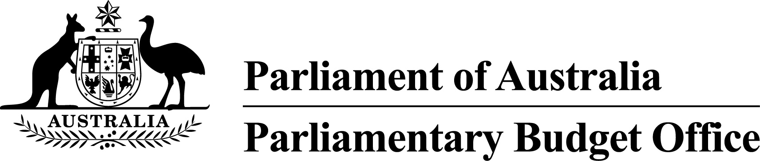PBO Guidance 02/2017

# PBO publication of responses that have been publicly released by parliamentarians

Following the 2016 General Election, the Joint Committee of Public Accounts and Audit (JCPAA) commissioned an independent review of the operations of the Parliamentary Budget Office (PBO). In March 2017, the *Parliamentary Budget Office Review 2016–17 – report of the Independent Review Panel* was released*.*

In relation to the issue of confidentiality of costing requests and the associated benefits, the Review included the recommendation that:

The PBO should publish regular data regarding the number of policy announcements made with reference to PBO costings, and whether or not, and when, the underlying PBO costing response document was released by the party or parliamentarian concerned.

The PBO has accepted this recommendation and, henceforth, will be regularly capturing and publishing this information. Furthermore, with effect from today, where the parliamentarian (or their party) that makes a confidential request to the PBO releases the full underlying PBO response document, the PBO will adopt the practice of publishing that document on the PBO website.

In the circumstance that the full underlying PBO response document is released by a body other than the parliamentarian or their party, the PBO will consult with the relevant parliamentarian or their party about whether the document will be published on the PBO website.

These arrangements will make it easier for the public to locate PBO responses that have been legitimately released into the public domain and treat these documents in an equivalent manner to documents that the PBO is required to release publicly.

Jenny Wilkinson

Parliamentary Budget Officer

|  |  |
| --- | --- |
| Release date | 11 August 2017 |
| Contact Officer(s) | Colin Brown  First Assistant Parliamentary Budget Officer  Budget Analysis Division  (02) 6277 9530 |