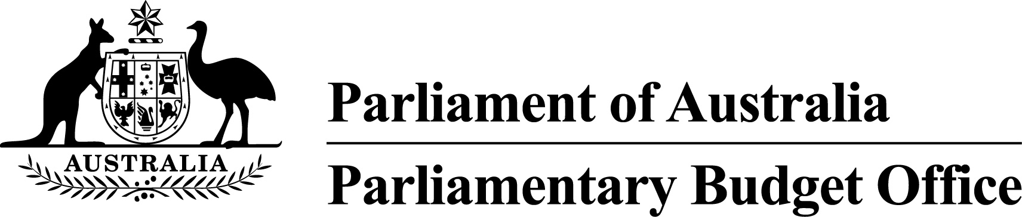PBO Guidance 02/2015

Public Debt Interest (PDI) payments in PBO costings

This guidance has been prepared to confirm the treatment of Public Debt Interest (PDI) payments in Parliamentary Budget Office (PBO) costings.

The PBO is required to prepare costings in accordance with the *Charter of Budget Honesty Policy Costing Guidelines* (the Guidelines). The Guidelines were issued jointly by the Secretaries of the Treasury and the then Department of Finance and Deregulation in 2012.

The Guidelines state that ‘Costings will generally not account for the impact on PDI payments’. This is because for most individual policies the associated PDI impacts are relatively small and, in the budget, they are accounted for in the total PDI payment figure that is derived from the overall budget financing requirement. This is the approach adopted by the PBO in costing most policy proposals.

The Guidelines also state that ‘This [the above approach] does not apply where there is an explicit policy objective to affect the level of interest payments, or the policy involves transactions of financial assets (such as loan schemes)’. This is because the PDI impact of a policy of this nature represents a material proportion of the policy’s aggregate impact on the budget. Accordingly, when costing such policies, the PBO will include the PDI impact as an integral part of the policy costing.

The PBO’s post-election report of election commitments will show the full budget impact of individual policies including, where appropriate, the PDI impact. The total PDI impact of a party’s election commitments will take into account PDI impacts already included in individual policy costings.

Phil Bowen PSM FCPA

Parliamentary Budget Officer

|  |  |
| --- | --- |
| Release date: | 3 November 2015 |
| Contact Officer: | Colin Brown  First Assistant Parliamentary Budget Officer  Budget Analysis Division  (02) 6277 9530 |