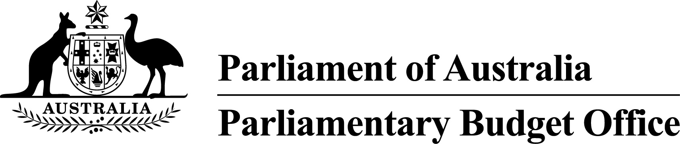PBO Guidance 01/2017

# Replacement of reliability ratings in costing responses

Following the 2016 General Election, the Joint Committee of Public Accounts and Audit (JCPAA) commissioned an independent review of the operations of the Parliamentary Budget Office (PBO).

In relation to the PBO’s practice of including reliability ratings in its costing responses, the *Parliamentary Budget Office Review 2016–17 – report of the Independent Review Panel* included the recommendation that:

The PBO should replace the reliability rating in its costing response documents with a statement on the factors that can affect the uncertainty of that type of policy costing. The PBO’s costing response documents should expand existing qualitative comments on reliability to highlight particularly uncertain elements of the specific policy when that is appropriate.

The Independent Review Panel noted that while the reliability ratings are “intended to provide a shorthand indication of the level of confidence a user of the costing can have that the actual outcome of a costing would correspond to the costing estimate”, they “continue to be widely misinterpreted as a reflection on the quality of the PBO’s estimates rather than the uncertainty inherent in the policy costing process”.

In these circumstances, pending the outcome of the JCPAA’s consideration of the Review report, the PBO will adopt the Independent Review Panel’s recommendation with immediate effect.

Phil Bowen PSM FCPA

Parliamentary Budget Officer

|  |  |
| --- | --- |
| Release date | 31 March 2017 |
| Contact Officer(s) | Colin Brown  First Assistant Parliamentary Budget Officer  Budget Analysis Division  (02) 6277 9530 |