30 June 2016

Mr Phil Bowen
Parliamentary Budget Officer
Parliament House
CANBERRA ACT 2600

Dear Mr Bowen

I formally request the following revenue proposals be costed by the Parliamentary Budget Office for public release.

- Saving the Reef
- Protecting our precious places
- Energy Storage Revolution
- After Coal Transition Package
- Green Buildings Plan
- National Urban Forests
- Repowering Public and Community Housing
- Keep the Climate Change Authority
- Sustainable Schools Fund
- Confronting the Domestic Violence Crisis
- Access to affordable abortions
- Australia’s Film Industry
- A living wage for artists
- Community Sports
- Migrant Communities Employment Fund
- Guaranteed access to PrEP

I appreciate you may require further information from us to complete the request. Should you require any further clarification, please contact Jay Tilley from my office on 0408 473 379

Yours sincerely
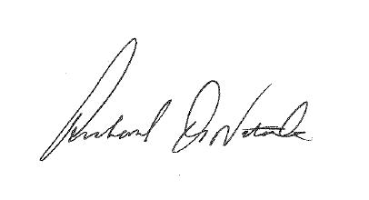
Senator Richard Di Natale

