OFFICIAL: Sensitive

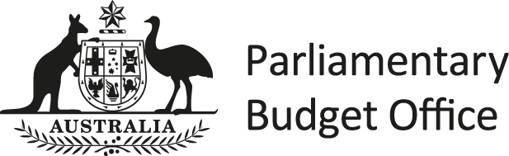

Request for budget analysis

2019 Indi Election Commitments
Person/party requesting the analysis: | Dr Helen Haines MP, Member for Indi
Date analysis completed: | 15 March 2022
Expiry date of the analysis: | Release of the next economic and fiscal outlook report.
Status at time of request: | Submitted outside the caretaker period
 | ☒ Confidential | - Not confidential
Summary of request:
The request sought the following information related to the McKoy Street Overpass project and the
Melbourne to Albury-Wodonga High Speed Rail Business Case:
- Committed Australian Government funding recorded in the National Partnership Agreement (NPA) schedule, as at the latest update and as at the announcement of the project.
- The number of jobs each project is expected to create, as detailed during the settling of the projects in the NPA schedule.
- Approved Australian Government funding.
- Payments to date and a high-level description of the current project status’ (In planning, Under Construction, Completed).
- Expected start and end dates for construction, as at the latest update and as at the announcement of the projects.

Overview
The requested information is presented in Attachment A.

Data sources
The Department of Infrastructure, Transport, Regional Development and Communications provided the information related to the McKoy Street Overpass project and the Melbourne to Albury-Wodonga High Speed Rail Business Case.

PBO reference PR-2022-8740 Page 1 of 2
OFFICIAL: Sensitive

OFFICIAL: Sensitive

Attachment A – 2019 Indi Election Commitments

Table A1: 2019 Indi Election Commitments

Project Name | Original Australian Government Commitment  Date | Current Australian Government Committed  ($m) | Original Australian Government Committed  ($m) | Expected Number of Jobs | Australian Government Approved spending ($m) | Payments to date ($m) | Current Project Status | Current Start Date | Current End Date | Original Start Date | Original End Date
McKoy Street - Hume Freeway Intersection Upgrade^{(a)} | 2019 Election | 168.0 | 64.0 | 520 | 3.5 | 3.5 | In Planning | 31/12/2023 | 31/05/2025 | N/a | N/a
Victorian Faster Rail Corridor Investigations^{(b)} | 2019-20  Budget | $16m for the  Victorian Faster Rail Corridor Investigations | Melbourne to  Albury- Wodonga ($8m) and Melbourne to  Traralgon  ($8m) | This is a planning project and does not  have job numbers | 8.0 | - | Underway | 30/12/2020 | 01/07/2022 | 30/12/2020 | 30/12/2021
- There were no original construction dates at the time of Australian Government commitment.
- The Australian Government has not committed to a high-speed rail business case to Albury-Wodonga. In the 2019-20 Budget the Australian Government committed $16 million to investigate faster rail opportunities for Melbourne to Albury-Wodonga and Melbourne to Traralgon rail corridors. Subsequently in 2021, it was agreed between the Australian and Victorian Governments to combine these into one broader faster rail corridor investigation covering the five major regional rail corridors in Victoria – including Melbourne to Warrnambool, Bendigo, Ballarat, Albury-Wodonga and Traralgon. The corridor investigations are underway and should be completed by mid-2022.
- Indicates nil.

Page 2 of 2
OFFICIAL: Sensitive

