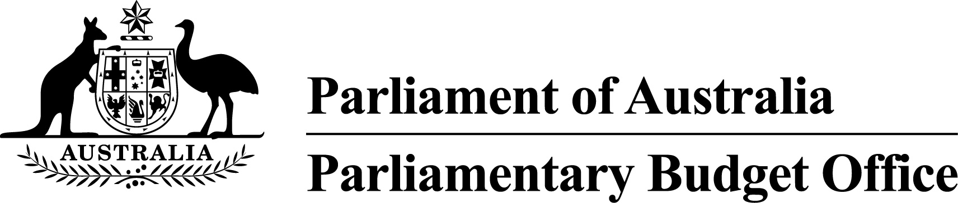

Submission to the Standing Committee on Economics inquiry into
tax deductibility
21 January 2016

Contents
Executive summary 3
Introduction 5
Personal income tax deductions 7
Total deductions 7
Rental expenses 16
Company interest deductions 20
Attachment A 24
Acronyms 30

Executive summary
The Parliamentary Budget Office’s (PBO) mandate includes the preparation of submissions to inquiries of Parliamentary Committees on request, with the request and the PBO’s response to be made public.
The Secretary of the House of Representatives Standing Committee on Economics wrote to the PBO on 15 December 2015 requesting the preparation of a submission to the Committee’s inquiry into tax deductibility. The matters to be examined by the Committee include deductions against individuals’ non-business income and the deductibility of interest incurred by companies.
This submission utilises the PBO’s access to de-identified taxation information to provide factual information on the level, type and distribution of deductions to inform the Committee’s deliberations. Consistent with the PBO’s mandate, the submission does not make policy recommendations.
Tax deductions impact on taxation revenue by reducing taxable income. The impact on tax revenue is equal to the combined total of the reduction in taxable income for each affected taxpayer multiplied by their respective effective marginal tax rate.
The most recent comprehensive information on tax deductions is from the 2012–13 income year.
In 2012–13, total deductions of $31.3 billion were claimed by personal taxpayers against $704 billion in taxable income, or around 4.5 per cent of taxable income.
Work-related expenses (WREs) comprised nearly two thirds of total deductions (or $19.7 billion), followed by personal superannuation contributions of $2.9 billion (9.3 per cent), and deductions for managing tax affairs and charitable gifts/donations each comprising about $2.3 billion (7.5 and 7.3 per cent of total deductions respectively).
The most common type of WRE was car expenses ($8.0 billion or around 40 per cent of WREs), followed by other WREs (comprising home office costs and tools, equipment and other assets) of around $7.0 billion, work-related travel expenses ($2.0 billion), uniform costs ($1.6 billion) and work-related self-education costs ($1.1 billion).
The income tax return (and the Australian Taxation Office’s (ATO) Taxation Statistics) includes rental expenses in the calculation of net rental income that is included as part of total income rather than as an element of total deductions.
In 2012–13 rental expenses of $41.7 billion were claimed against $36.5 billion of rental income. Two thirds of taxpayers with rental income in 2012–13 had net rental expenses exceeding rental income and these individuals recorded combined net rental losses of $12.0 billion.
Both total deductions and net rental losses increased with total income. The principal exception is WREs, where the average deduction remains around $3,000 for individuals with taxable income above $100,000.
In 2012–13 Australian companies claimed $45 billion in interest deductions, representing 2.3 per cent of company deductions. Very large companies (turnover in excess of $250 million), claimed $29.1 billion in interest deductions, or around 2.6 per cent of their deductions.
The property and real estate services, and the electricity, gas and water supply sectors claimed the highest proportion of interest deductions (around 6.6 per cent of total expenses), while the mining industry and the manufacturing sectors comprised the largest share of interest deductions, accounting for 20 per cent and 15 per cent of interest deductions for companies.
Well over half of companies are subject to the ‘thin capitalisation’ restrictions on interest deductibility. For companies subject to the ‘thin capitalisation’ rules, interest deductions comprised 3.2 per cent of all deductions, compared to 1.6 per cent for other companies.

Introduction
- The purpose of the PBO is to inform the Parliament by providing independent and non-partisan analysis of the budget cycle, fiscal policy and the financial implications of proposals.
- In particular, the PBO aims to help level the playing field for all parliamentarians by providing access to costing and budget analysis services, and enhance the transparency and public understanding of election commitments and the budget and fiscal policy settings.
- Consistent with the PBO’s mandate, this submission does not include policy recommendations. Instead, it presents a factual analysis on the volume and nature of certain tax deductions in Australia and is intended to help inform the work of the Committee.
- Under income tax systems, taxable income is derived by subtracting deductions from assessable income. As a general rule, the tax law allows expenses incurred in deriving assessable income to be deducted except where they are of a capital, private or domestic nature.
- There are also some specific provisions that alter this general rule to make some items of spending tax deductible (such as charitable donations) and deny deductibility to other items (such as fines). Depreciation provisions provide for deductions to recoup the cost of capital expenditure incurred in producing assessable income over the effective life of the assets concerned.
- The 2009 Australia’s Future Tax System (AFTS) Review recommended that eligibility for allowable WREs be tightened to improve targeting of deductions and to prevent expenses only loosely related to generating income being claimed. The AFTS Review recommended that a standard deduction should be introduced to cover WREs and the cost of managing tax affairs, and that ‘there should be a tighter nexus between the deductibility of the expense and its role in producing income.’
- Similarly, recent discussions on company tax reform, both domestically and internationally, have paid particular focus to rules relating to the deductibility of interest. The Organisation for Economic Co-operation and Development (OECD) has noted that the mobility and fungibility of money mean that interest deductions present opportunities for multinational companies to shift profits to low tax jurisdictions.
- In Australia, various provisions exist to limit these behaviours. For example, the thin capitalisation rules apply to Australian companies investing overseas, foreign controlled Australian companies and foreign companies investing in Australia. These rules disallow a company’s debt deductions where the amount of debt exceeds certain limits.
- This submission provides information on the level of tax deductions for individuals and companies in Australia. For individuals, particular focus is paid to WREs and net rental losses. For companies, in keeping with the terms of reference of this review, the analysis is limited to an examination of interest deductions.
- While international comparisons are included, it is noted that caution should be applied as countries use different approaches to quantifying and reporting tax deductions, and have considerable differences in taxation structures.
- In quantifying the level of deductions, it is important to recognise that these figures do not translate into a costing on the financial impact of removing all, or a portion of deductions in Australia. An estimation of the financial impact would require:
- for individuals, the change in taxable income to be multiplied by the effective marginal tax rate for each individual
- for companies, the change in taxable income to be multiplied by the company tax rate, a consideration of whether a claimed deduction is allowed and whether a company could utilise the deduction in their current income year, or carry it forward to a future income year
- a consideration (and calculation) of the responses by individuals and companies to adjust their behaviour and taxation arrangements in response to any policy change; and
- a consideration of the broader macroeconomic impacts.

Personal income tax deductions
- The way personal income deductions are reported is not perfectly aligned with the definition of deductions in the Income Tax Assessment Act 1997 (ITAA97).
- In particular, the income tax return (and the ATO’s Taxation Statistics) does not include expenses incurred in deriving rental incomes in the calculation of ‘total deductions’. Instead, these rental expenses are included in the calculation of net rent, which is a component of total income.
- To avoid confusion, the analysis in this submission is presented in a manner consistent with the ATO’s Taxation Statistics, with deductions associated with rental expenses analysed separately to other deductions.
- De-identified personal income taxation information from the 2012–13 income year is utilised to provide factual information on the level, type and distribution of deductions. The 2012–13 financial year data is the most recent comprehensive information on tax deductions, with the lag in reporting reflecting the timing of personal income tax collections.
- Detailed tables supporting the analysis in this submission are included at Attachment A.

Total deductions
- In 2012–13, over 80 per cent of Australian taxpayers made use of personal income tax deductions. There were approximately $31.3 billion in deductions claimed in that year, which represented 4.5 per cent of taxable income. The mean deduction amount claimed by those reporting deductions was approximately $3,025.
- Tax deductions as a proportion of taxable income have fallen steadily since 2006–07, both as a result of fewer deductions being claimed and rising incomes. Figure 1 below presents a time series on the total value of deductions as well as deductions as a proportion of taxable income. The decline in the level of claimed deductions primarily reflects a fall in non-employer sponsored super contributions in response to tighter rules pertaining to contributions.
Figure 1: Personal income tax deductions, 2006-07 to 2012-13
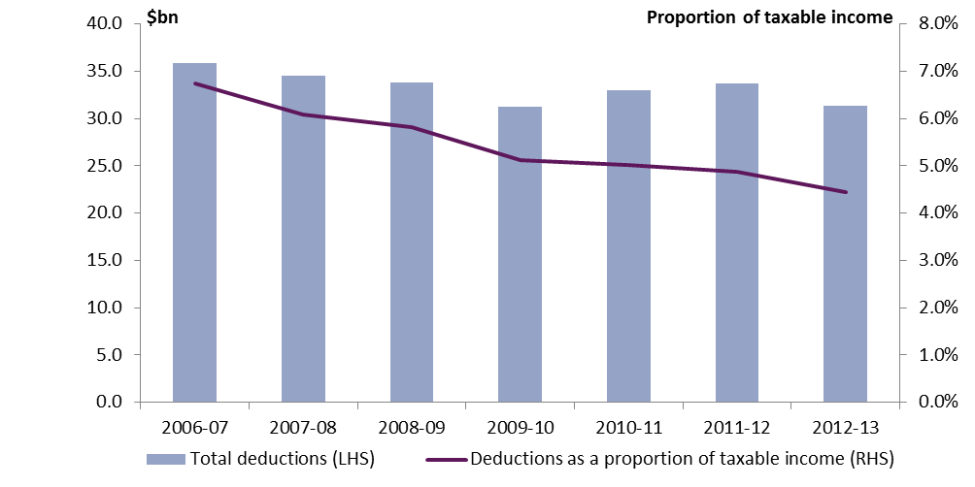 | 2006-07 | 2007-08 | 2008-09 | 2009-10 | 2010-11 | 2011-12 | 2012-13
Total deductions ($billion | 35.9 | 34.6 | 33.8 | 31.3 | 33 | 33.7 | 31.4
Deductions as a proportion of taxable income (%) | 6.7 | 6.1 | 5.8 | 5.1 | 5.0 | 4.9 | 4.4
Source: ATO 2015, Taxation Statistics 2012–13, ATO, Canberra.
- Those who earn more claim a higher level of deductable expenses in absolute terms. Taxpayers in the highest income bracket, for example, comprised less than 3 per cent of taxpayers in 2012–13 in absolute terms, yet claimed over 12 per cent of the total value of deductions. This is despite taxpayers in the lower tax brackets claiming a higher level of deductions as a proportion of taxable income than those in higher tax brackets. Table 1 below provides a disaggregation of deductions by taxable income.
Table 1: Deductions by taxable income, 2012–13
Taxable income bracket | Average deduction per taxpayer ($) | Deductions as a proportion of taxable income  or loss (%) | Proportion of value of total deductions (%) | Proportion of taxpayers (%)
Less than or equal to $18,200 | 579 | 7.7 | 4.7 | 20.0
$18,201 to $37,000 | 1,420 | 5.2 | 14.0 | 24.3
$37,001 to $80,000 | 2,618 | 4.7 | 39.8 | 37.3
$80,001 to $180,000 | 4,549 | 4.1 | 29.3 | 15.8
$180,000 or more | 11,239 | 3.3 | 12.2 | 2.7
Total | 2,453 | 4.5 | 100.0 | 100.0
Source: PBO analysis based on data from the ATO.
- There is also a significant difference in the level of deductions claimed by gender. The average male claimed a higher level of deductions than the average female at all levels of taxable income (both in absolute terms and as a proportion of taxable income). The gender difference is highest at lower levels of taxable income. Table 2 below presents the average value of deductions claimed by gender and taxable income in 2012–13.
Table 2: Deductions by taxable income and gender, 2012–13
Taxable income bracket | Average deduction per taxpayer ($) |  |  | Deductions as a proportion of taxable income or loss (%)
 | Female | Male | Female/Male ratio | Female | Male
Less than or equal to $18,200 | 465 | 745 | 0.62 | 5.8 | 10.5
$18,201 to $37,000 | 1,231 | 1,676 | 0.73 | 4.5 | 6.1
$37,001 to $80,000 | 2,184 | 2,991 | 0.73 | 4.1 | 5.3
$80,001 to $180,000 | 3,937 | 4,803 | 0.82 | 3.7 | 4.3
$180,000 or more | 10,598 | 11,433 | 0.93 | 3.2 | 3.4
Total | 1,777 | 3,082 | 0.58 | 4.1 | 4.7
Source: PBO analysis based on data from the ATO.
- Not only do higher income earners claim more deductions on average, but each dollar of deductions claimed also results in a greater reduction in tax liability, reflecting the higher marginal tax rates faced by higher income earners.

Deductions by type
- In 2012–13, WREs accounted for approximately 63 per cent of the value of all deductions claimed by individuals, with more than two in three taxpayers claiming some expenses. WREs deductions are discussed in further detail in the following section.
- The next most common type of deduction in 2012–13 was personal superannuation contributions (9.3 per cent of all deductions). Personal superannuation contribution deductions are available to those who earn less than 10 per cent of their income through salary and wages. The annual allowable deduction is limited by the superannuation concessional contributions cap.
- Deductions for expenses incurred in managing tax affairs and charitable gifts and donations each totalled $2.3 billion (7.5 per cent and 7.3 per cent of total deductions respectively) in 2012–13. In 2012–13, 73.5 per cent of Australians lodged their tax return via a tax agent.
- The remaining reported deductions (13.0 per cent) included expenses associated with earning dividend and interest income, election expenses and low value pool deductions.
- For all types of deductions, the average value of expenses claimed was larger for individuals in the highest income bracket than in the lower brackets; however, the nature of this relationship is not identical for all types of deductions.
- With the exception of WREs, the average value of deductions increased steadily up to taxable incomes of around $180,000 and then sharply increased for incomes higher than this level. For WREs, on the other hand, the average deduction remained around $3,000 for individuals with taxable income above $100,000.
- Figures 2 and 3 present the mean value of selected deductions, as well as the proportion of taxpayers claiming deductions, by type and by taxable income for 2012–13.
Figure 2: Selected mean value of deductions by type and taxable income, 2012–13
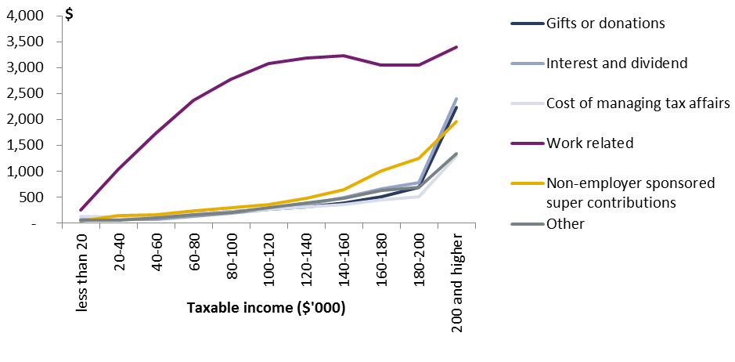
Taxable income ($’000) | Mean deduction ($)
 | Gifts or donations | Interest and dividend | Cost of managing tax affairs | Work-related | Non-employer sponsored super contributions | Other
Less than 20 | 52 | 80 | 127 | 257 | 41 | 61
20-40 | 97 | 66 | 116 | 1,044 | 153 | 64
40-60 | 124 | 75 | 145 | 1,738 | 168 | 101
60-80 | 176 | 127 | 181 | 2,366 | 236 | 158
80-100 | 226 | 197 | 218 | 2,783 | 305 | 213
100-120 | 275 | 267 | 268 | 3,084 | 366 | 294
120-140 | 312 | 365 | 320 | 3,189 | 488 | 386
140-160 | 387 | 491 | 364 | 3,227 | 648 | 476
160-180 | 518 | 663 | 446 | 3,052 | 1,015 | 637
180-200 | 692 | 786 | 508 | 3,046 | 1,247 | 691
200 and higher | 2,230 | 2,393 | 1,290 | 3,390 | 1,956 | 1,346
Source: PBO analysis based on data from the ATO.
Figure 3: Proportion of taxpayers claiming deductions by type and taxable income, 2012–13
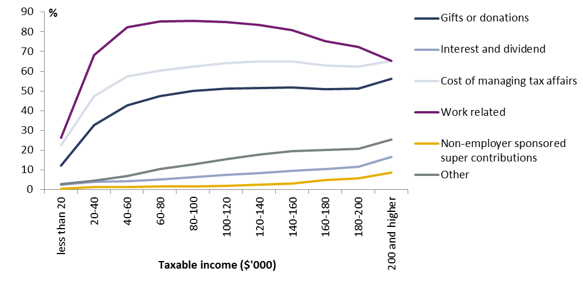  Taxable income ($’000) | Proportion of taxpayers (%)
 | Gifts or donations | Interest and dividend | Cost of managing tax affairs | Work-related | Non-employer sponsored super contributions | Other
less than 20 | 12.2 | 2.6 | 22.5 | 26.3 | 0.4 | 2.7
20-40 | 32.7 | 3.9 | 47.4 | 68.1 | 1.3 | 4.6
40-60 | 42.7 | 4.3 | 57.4 | 82.4 | 1.3 | 7
60-80 | 47.4 | 5.2 | 60.2 | 85.1 | 1.5 | 10.3
80-100 | 50 | 6.2 | 62.3 | 85.6 | 1.7 | 12.9
100-120 | 51.3 | 7.5 | 64.1 | 85 | 2 | 15.5
120-140 | 51.6 | 8.4 | 65 | 83.4 | 2.4 | 17.8
140-160 | 51.7 | 9.5 | 64.9 | 80.7 | 3.1 | 19.4
160-180 | 50.8 | 10.5 | 62.8 | 75.3 | 4.8 | 20.2
180-200 | 51.1 | 11.7 | 62.5 | 72.3 | 5.7 | 20.8
200 and higher | 56.2 | 16.6 | 65.4 | 65.2 | 8.7 | 25.4
Source: PBO analysis based on data from the ATO.

Work-related expenses
- In 2012–13, taxpayers claimed an average of $1,545 in WREs, for a combined total of $19.7 billion (Figure 4).
Figure 4: Total claimed WRE deductions by type, 2012–13
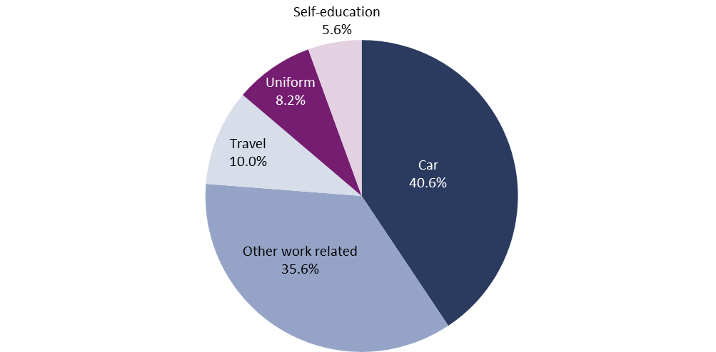  Car | Other work-related | Travel | Uniform | Self-education
40.6% | 35.6% | 10.0% | 8.2% | 5.6%

Source: PBO analysis based on data from the ATO.
- The most common WREs claimed in 2012–13 was car expenses, with $8.0 billion claimed (40.6 per cent of the value of all claimed WREs). ‘Other work-related expenses’, such as home office costs and tools, equipment and other assets was the next largest category of WREs at $7.0 billion (35.6 per cent). Individuals also claimed deductions for work-related travel expenses ($2.0 billion), uniform and clothing costs ($1.6 billion) and work-related self-education costs ($1.1 billion).
- Written evidence is required for individuals to claim $300 or more in WREs.
- The average value of deductions claimed per taxpayer increased with taxable income for all WREs types, with the exception of self-education and uniform expenses, which remained relatively flat across the income distribution.
- Figures 5 and 6 present the mean value of WREs deductions and the proportion of taxpayers claiming deductions by type and taxable income.
Figure 5: Mean value of WRE deductions by type and taxable income, 2012–13
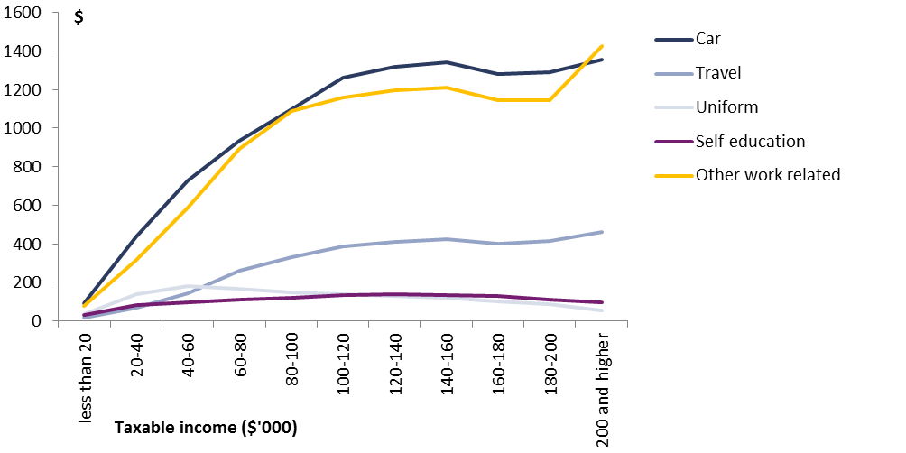  Taxable income ($’000) | Medium deduction ($)
 | Car | Travel | Uniform | Self-education | Other work-related | All work-related expenses
less than 20 | 91 | 16 | 37 | 33 | 80 | 257
20-40 | 437 | 67 | 141 | 83 | 316 | 1,044
40-60 | 728 | 146 | 182 | 96 | 586 | 1,738
60-80 | 934 | 259 | 168 | 111 | 893 | 2,366
80-100 | 1,097 | 329 | 150 | 122 | 1,086 | 2,783
100-120 | 1,262 | 386 | 140 | 135 | 1,160 | 3,084
120-140 | 1,316 | 411 | 131 | 137 | 1,194 | 3,189
140-160 | 1,341 | 425 | 119 | 132 | 1,208 | 3,227
160-180 | 1,278 | 402 | 100 | 128 | 1,144 | 3,052
180-200 | 1,289 | 416 | 87 | 112 | 1,143 | 3,046
200 and higher | 1,352 | 464 | 55 | 96 | 1,423 | 3,390
Total | 628 | 154 | 127 | 86 | 550 | 1,545
less than 20 | 91 | 16 | 37 | 33 | 80 | 257
Source: PBO analysis based on data from the ATO.
Figure 6: Proportion of taxpayers claiming WREs by type and taxable income, 2012–13
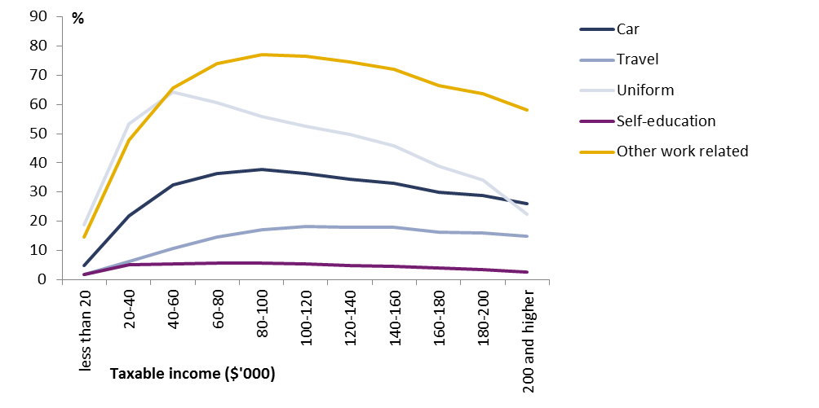  Taxable income ($’000) | Proportion claiming (%)
 | Car | Travel | Uniform | Self-education | Other work-related
less than 20 | 5 | 2 | 19 | 2 | 15
20-40 | 22 | 6 | 54 | 5 | 48
40-60 | 33 | 11 | 64 | 5 | 66
60-80 | 36 | 15 | 61 | 6 | 74
80-100 | 38 | 17 | 56 | 6 | 77
100-120 | 36 | 18 | 53 | 5 | 77
120-140 | 34 | 18 | 50 | 5 | 75
140-160 | 33 | 18 | 46 | 5 | 72
160-180 | 30 | 16 | 39 | 4 | 66
180-200 | 29 | 16 | 34 | 4 | 64
200 and higher | 26 | 15 | 22 | 3 | 58
Total | 24 | 9 | 48 | 4 | 52
Source: PBO analysis based on data from the ATO.
- Similar to total deductions, there is also a difference in the WRE deductions by gender. On average males claimed a higher level of deductions than females at all levels of taxable income (both in absolute terms and as a proportion of taxable income). In contrast to total deductions, however, the gender difference in WRE deductions increases as taxable income rises. Table 3 below presents the average value of deductions claimed by gender and taxable income in 2012–13.
Table 3: WRE deductions by gender and taxable income, 2012–13
Taxable income bracket | Average deduction per taxpayer ($) |  |  | Deductions as a proportion of taxable income or loss (%)
 | Female | Male | Female/Male ratio | Female | Male
Less than or equal to $18,200 | 213 | 244 | 0.87 | 2.7 | 3.4
$18,201 to $37,000 | 840 | 1,089 | 0.77 | 3.1 | 4.0
$37,001 to $80,000 | 1,555 | 2,222 | 0.70 | 2.9 | 3.9
$80,001 to $180,000 | 2,226 | 3,282 | 0.68 | 2.1 | 2.9
$180,000 or more | 2,234 | 3,644 | 0.61 | 0.7 | 1.1
Total | 1,102 | 1,957 | 0.56 | 2.5 | 3.0
Source: PBO analysis based on data from the ATO.

International comparison of personal deductions
- The Committee’s terms of reference include an examination of the system of deductions in comparable jurisdictions.
- International comparisons on the level of total taxable deductions have not been attempted in this submission given fundamental differences in taxation structures and reporting of taxation revenue across countries. However, some commentary on deductions for charitable donations and WREs is set out below.

Charitable donations
- Tax relief for donations to charitable organisations is almost universal among OECD countries. Tax relief often takes the form of either tax deductions or tax credits. Tax deductions provide a benefit to the donor at the donor’s effective marginal tax rate, while tax credits provide a benefit at a fixed proportion of the amount donated.
- In practice, however, the specific rules and requirements differ considerably. For example, the United Kingdom offers assistance through the ‘Gift Aid’ program. The value of this rebate is equivalent to a tax deduction, but the first 20 pence per pound of donation (equivalent to the marginal tax rate for most individuals) is payable to the charity rather than the individual.

Work-related expenses
- Distinguishing between private and work expenses is not always simple and the 2009 AFTS Review found that ‘the law for WREs is complex.’ A number of OECD countries have circumvented this issue by having tighter definitions for WREs or by making use of a standard tax allowance for employment income.
- For example, in the United Kingdom the majority of claimable expenses must be items or services that are solely used for work (not utilised at all in private life) and are essential for the employee’s duties. The United Kingdom has a similar tax structure and reporting system to Australia, and for 2012–13 the value of deductions as a proportion of total income was 3.0 per cent, compared to 4.2 per cent for Australia.
- New Zealand disallowed deductible WREs in the late 1980s in order to broaden the taxable income base and also to fund a reduction in personal income tax rates.
- Table 4 below provides a comparison of tax relief arrangements for WREs across a subset of 10 OECD countries. In contrast to Australia’s tax-free threshold, a number of OECD countries have standard lump-sum or tapered tax allowances (or tax credits), a portion of which are intended to cover expenses in earning income.. These expenses do not need to be substantiated or separately reported.
Table 4: Tax relief for work-related expenses for selected OECD countries
Country | Standard tax allowance for employment expenses | WREs deductions (above standard allowance) | Scope of deductible work-related expenses
Australia | No | Yes | Incurred in gaining or producing an employee’s assessable income.
Canada | No | Yes-limited | Only deductions specifically legislated are allowed, including accounting and legal fees.
Denmark | Yes | Yes | Wage or salary earners can fully deduct work-related expenses from income, after a standard deduction has been applied.
Ireland | Yes | Yes-limited | Expenses incurred wholly, exclusively and necessarily in the performance of duties.
Japan | Yes | Yes | Specific deductions that exceed the standard deduction for employment income are allowed. Specific deductions include travelling expenses.
Netherlands | No | Yes-limited | Most work-related expenses are not deductible; in limited circumstances exceptions apply for transport, education and home office expenses.
New Zealand | No | No | n/a
Spain | Yes | No | n/a
Switzerland | Yes | No | n/a
United Kingdom | No | Yes-limited | Most claimable expenses must be incurred wholly, exclusively and necessarily in the performance of an employee’s duties, a condition that precludes the deduction of many employment related expenses.
United States | No | Yes | Employees can deduct work-related expenses subject to limits (expenses generally only deductible to the extent they exceed 2 per cent of adjusted gross income). Taxpayers have the option of claiming a standard deduction in lieu of itemising deductions.
Source: Adapted from Box A1-2 of the AFTS Review and the OECD’s Taxing Wages.

Rental expenses
- The tax return form does not include rental expenses in the ‘total deductions’ field, however rental expenses can be claimed against gross rental income to give ‘net rent’ which is then included in taxable income.
- Rental expenses provide a useful point of analysis, both in aggregate terms and by focusing solely on those reporting a rental loss.

Aggregate rental expenses
- In 2012–13, $41.7 billion in rental expenses were claimed. These expenses are reported in three categories: interest ($22.4 billion), capital works ($2.4 billion) and ‘other’ ($16.9 billion). As with total deductions, the value of these claimed expenses increased with income.
- Figure 7 below presents a time series on the total value of rental expenses as well as rental expenses as a proportion of rental income. The graph shows that rental expenses have increased broadly in line with rental income over recent years.
Figure 7: Rental expenses and rental income, 2006–07 to 2012–13
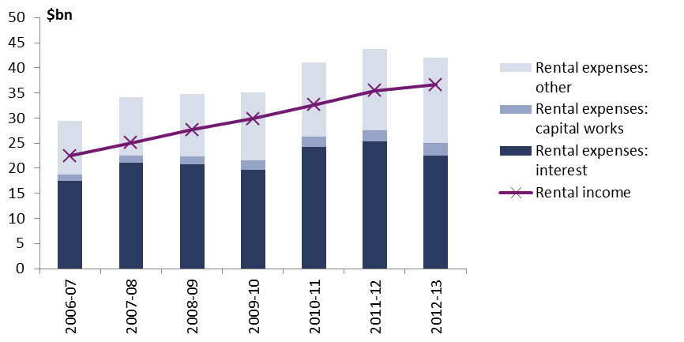 | 2006-07 | 2007-08 | 2008-09 | 2009-10 | 2010-11 | 2011-12 | 2012-13
 | $billion
Rental expenses: interest | 17 | 21 | 21 | 20 | 24 | 25 | 23
Rental expenses: capital works | 1 | 1 | 2 | 2 | 2 | 2 | 2
Rental expenses: other | 11 | 12 | 12 | 14 | 15 | 16 | 17
Gross rental income | 22 | 25 | 28 | 30 | 33 | 35 | 37
Source: ATO 2015, Taxation Statistics 2012–13, ATO, Canberra.
- Figure 8 below presents the mean value of expense claims in 2012–13 by taxable income for the three types of rental expenses.
- Figure 9 below presents the proportion of those with rental income claiming rental expenses in 2012–13 by rental income for the three types of rental expenses. Nearly all taxpayers with rental income claim ‘other’ rental expenses, while 81 per cent claim rental interest expenses and 44 per cent claim capital works expenses.

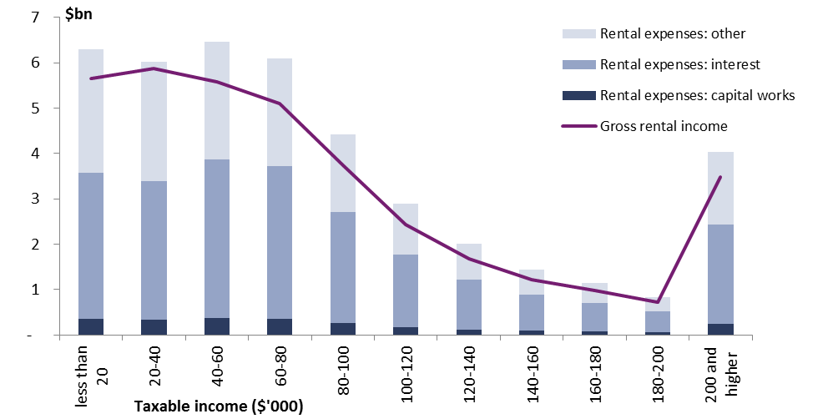
Figure 8: Total value of rental expenses and gross rental income by taxable income for those with rental income, 2012–13
Taxable income ($’000) | Total value ($bn)
 | Rental expenses: capital works | Rental expenses: interest | Rental expenses: other | Gross rental income
less than 20 | 0.4 | 3.2 | 2.7 | 5.7
20-40 | 0.3 | 3.1 | 2.6 | 5.9
40-60 | 0.4 | 3.5 | 2.6 | 5.6
60-80 | 0.4 | 3.4 | 2.4 | 5.1
80-100 | 0.3 | 2.4 | 1.7 | 3.7
100-120 | 0.2 | 1.6 | 1.1 | 2.4
120-140 | 0.1 | 1.1 | 0.8 | 1.7
140-160 | 0.1 | 0.8 | 0.6 | 1.2
160-180 | 0.1 | 0.6 | 0.4 | 1.0
180-200 | 0.1 | 0.5 | 0.3 | 0.7
200 and higher | 0.2 | 2.2 | 1.6 | 3.5
Total | 2.4 | 22.4 | 16.9 | 36.5
Source: PBO analysis based on data from the ATO.
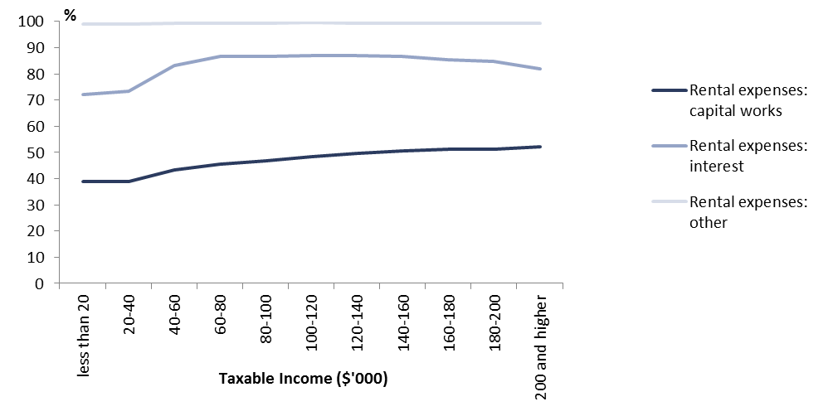
Figure 9: Proportion of taxpayers with rental income claiming rental expenses by type and taxable income, 2012–13
Taxable income ($’000) | Proportion claiming (%)
 | Rental expenses: capital works | Rental expenses: interest | Rental expenses: other
less than 20 | 38.9 | 72.1 | 98.9
20-40 | 38.9 | 73.3 | 99.0
40-60 | 43.2 | 83.3 | 99.4
60-80 | 45.6 | 86.5 | 99.4
80-100 | 46.8 | 86.8 | 99.4
100-120 | 48.5 | 87.0 | 99.5
120-140 | 49.7 | 87.1 | 99.4
140-160 | 50.6 | 86.8 | 99.4
160-180 | 51.1 | 85.4 | 99.4
180-200 | 51.3 | 84.8 | 99.2
200 and higher | 52.1 | 82.0 | 99.2
Total | 43.8 | 80.8 | 99.2
Source: PBO analysis based on data from the ATO.

Analysis of those claiming a rental loss
- Of the 1.9 million taxpayers with rental income in 2012–13, just over one third reported a rental profit, while just under two thirds reported a rental loss.
- The median net rental income for individuals with a rental loss was -$5,964, with the total loss equating to approximately $12.0 billion. In contrast, the median net rental income for those with positive rental income was $5,302 for a total gain of approximately $6.6 billion.
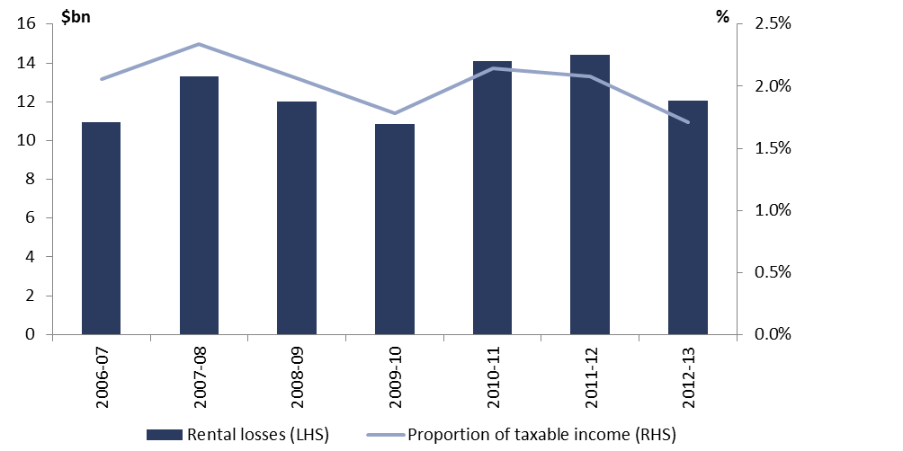
Figure 10: Rental losses for those with negative net rental income, 2006-07 to 2012–13
 | 2006-07 | 2007-08 | 2008-09 | 2009-10 | 2010-11 | 2011-12 | 2012-13
Total deductions ($billion) | 11 | 13 | 12 | 11 | 14 | 14 | 12
Deductions as a proportion of taxable income (%) | 2.1 | 2.3 | 2.1 | 1.8 | 2.1 | 2.1 | 1.7

Source: ATO 2015, Taxation Statistics 2012–13, ATO, Canberra.
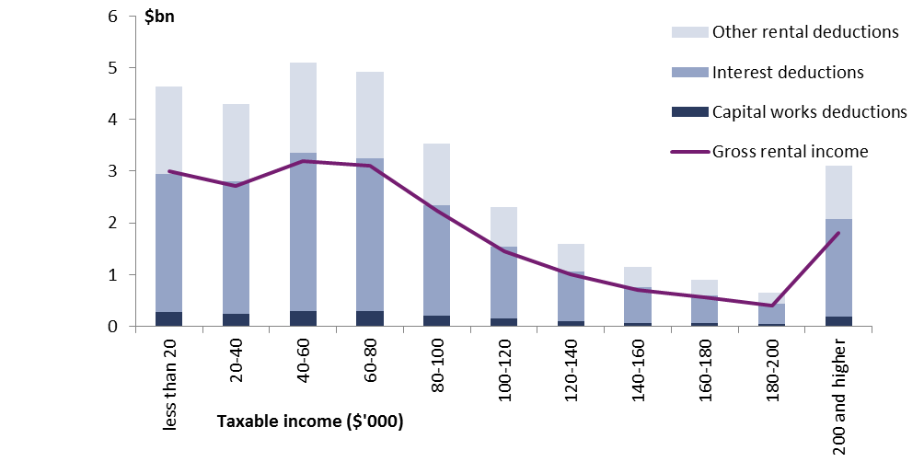
Figure 11: Rental expenses for those with negative net rental income by taxable income, 2012–13
Taxable income ($’000) | Total value ($bn)
 | Rental expenses: capital works | Rental expenses: interest | Rental expenses: other | Gross rental income
less than 20 | 0.3 | 2.7 | 1.7 | 3.0
20-40 | 0.2 | 2.6 | 1.5 | 2.7
40-60 | 0.3 | 3.1 | 1.7 | 3.2
60-80 | 0.3 | 3.0 | 1.7 | 3.1
80-100 | 0.2 | 2.1 | 1.2 | 2.2
100-120 | 0.1 | 1.4 | 0.8 | 1.4
120-140 | 0.1 | 1.0 | 0.5 | 1.0
140-160 | 0.1 | 0.7 | 0.4 | 0.7
160-180 | 0.1 | 0.5 | 0.3 | 0.6
180-200 | 0.0 | 0.4 | 0.2 | 0.4
200 and higher | 0.2 | 1.9 | 1.0 | 1.8
Total | 1.9 | 19.2 | 11.0 | 20.2
Source: PBO analysis based on data from the ATO.
Figure 12: Rental losses for those with negative net rental income by taxable income, 2012–13
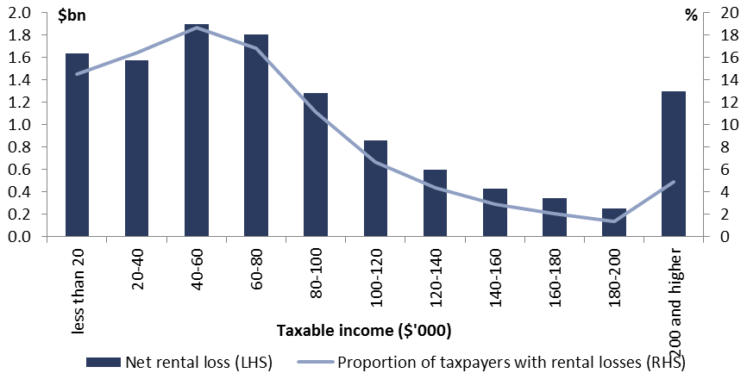  Taxable income ($’000) | Net rental loss ($bn) | Proportion of tax payers with rental losses
less than 20 | 1.6 | 14.5
20-40 | 1.6 | 16.5
40-60 | 1.9 | 18.7
60-80 | 1.8 | 16.8
80-100 | 1.3 | 11.2
100-120 | 0.9 | 6.7
120-140 | 0.6 | 4.3
140-160 | 0.4 | 2.9
160-180 | 0.3 | 2.1
180-200 | 0.3 | 1.4
200 and higher | 1.3 | 4.9
Total | 12.0 | 100.0
Source: PBO analysis based on data from the ATO.

Company interest deductions
- In keeping with the terms of reference for this review this submission focuses on the deductibility of interest for companies.
- This section presents information relevant to interest expenses reported by domestic and multinational companies operating in Australia.
- De-identified company income taxation information from the 2012–13 income year is utilised to provide factual information on the level and distribution of company interest deductions. The 2012–13 financial year data is the most recent comprehensive information on tax deductions, with the lag in reporting reflecting the timing of company tax collections.
- In 2012–13 interest expenses claimed by all companies in their tax returns (excluding finance and insurance companies) totalled $45 billion, which represented 2.3 per cent of total expenses reported by these companies.
- Table 5 examines company interest expenses by company size (based on annual turnover). In 2012–13, $29.1 billion or 64 per cent of interest expenses claimed were attributable to 921 very large companies (with turnover greater than $250 million).
Table 5: Company interest deductions by company size (turnover), 2012–13
Company turnover | Number of companies | Total interest expenses ($m) | Percentage of total interest expenses claimed (%) | Total expenses ($m) | Interest as a percentage of total expenses (%)
<$ 2million (micro) | 627,294 | 3,690 | 8.2 | 173,020 | 2.1
<$10 million (small) | 51,321 | 2,760 | 6.1 | 202,760 | 1.4
<$100 million (medium) | 13,625 | 5,340 | 11.8 | 340,730 | 1.6
<$250 million (large) | 1,089 | 4,290 | 9.5 | 162,840 | 2.6
>$250 million (very large) | 921 | 29,130 | 64.4 | 1,114,890 | 2.6
Total (excluding finance and insurance) | 694,250 | 45,220 | 100.0 | 1,994,230 | 2.3
Source: PBO analysis based on data from the ATO.
- In 2012–13, interest expenses claimed by very large companies accounted for around 2.6 per cent of their total expenses claimed. Figure 13 shows that this proportion has declined steadily over recent years, with interest expenses claimed declining from 3.6 per cent of total expenses claimed by very large companies in 2006–07.
- This decline in interest expenses claimed as a proportion of total expenses claimed may reflect a number of factors, including the general decrease in interest rates over this period.
Figure 13: Company interest deductions by company size, 2006–07 to 2012–13
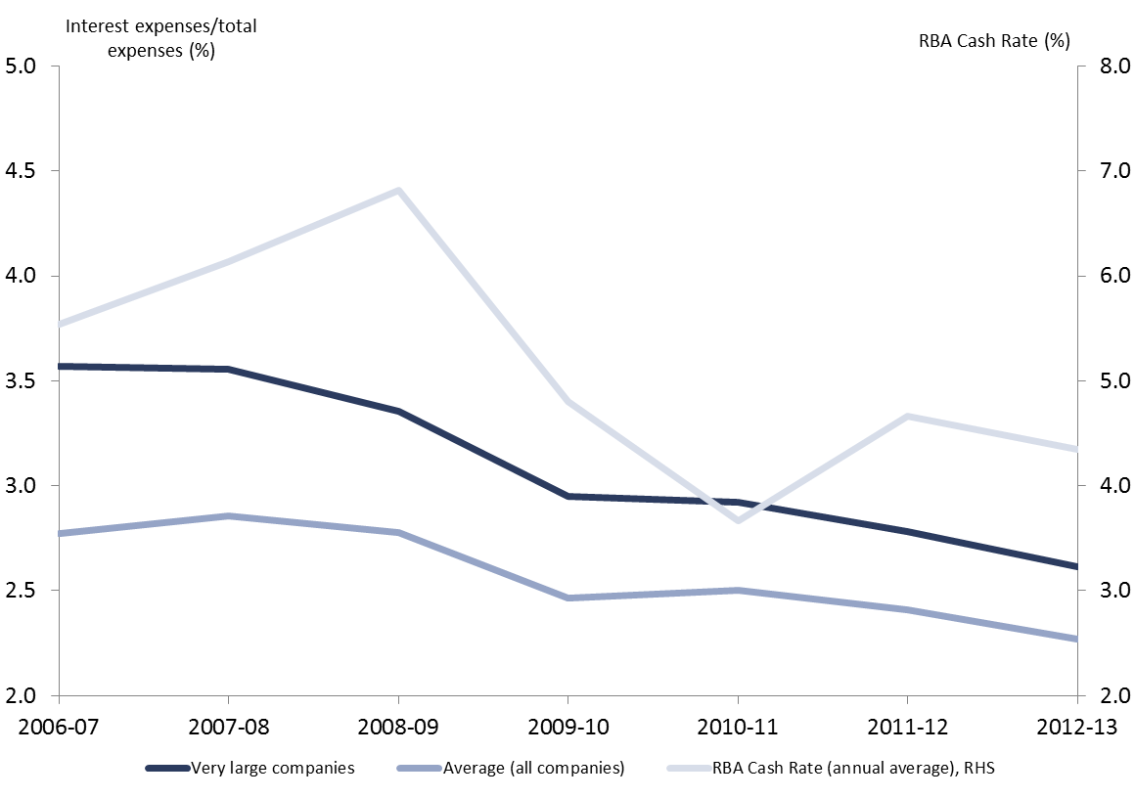 | 2006-07 | 2007-08 | 2008-09 | 2009-10 | 2010-11 | 2011-12 | 2012-13
Very large companies | 3.569663 | 3.55776 | 3.352953 | 2.948266 | 2.921376 | 2.781118 | 2.612877
Average (all companies) | 2.771954 | 2.854815 | 2.777029 | 2.465179 | 2.5011.91 | 2.407427 | 2.267312
RBA Cash Rate (annual average), RHS | 5.541502 | 6.13745 | 6.815 | 4.804563 | 3.667331 | 4.663347 | 4.345618
Source: PBO analysis based on data from the ATO and the Reserve Bank of Australia.

Interest deductions by industry
- Table 6 shows the break-down of interest expenses of very large companies by broad industry category.
- The largest interest expense claims (taken as a proportion of total expenses claimed) were in the rental, hiring and real estate services industry and the electricity, gas, water and waste services industry, with interest expenses accounting for around 6.6 per cent of reported expenses in these industries. In absolute terms the mining industry and the manufacturing industry had the largest interest expenditure, accounting for 20 per cent and 15 per cent of total reported interest expenses, respectively.
- There are several non-tax related factors which may influence the level of interest expenses of different industries and companies including their funding structure and level of risk.
Table 6: Interest expenses claimed by very large companies by industry type, 2012–13
Industry^{(a)} | Number of companies | Total interest expenses ($m) | Percentage of total interest expenses claimed (%) | Total expenses ($m) | Interest as a percentage of total expenses (%)
Construction | 62 | 790 | 2.7 | 41,630 | 1.9
Electricity, gas, water and waste services | 32 | 2,850 | 9.8 | 43,330 | 6.6
Manufacturing | 169 | 4,380 | 15.0 | 167,730 | 2.6
Mining | 117 | 5,810 | 19.9 | 157,350 | 3.7
Professional scientific and technical services | 88 | 710 | 2.4 | 66,850 | 1.1
Retail trade | 71 | 1,340 | 4.6 | 180,080 | 0.7
Information, media and telecommunications | 35 | 2,710 | 9.3 | 56,150 | 4.8
Transport, postal and warehousing | 57 | 3,910 | 13.4 | 69,370 | 5.6
Wholesale trade | 185 | 3,010 | 10.3 | 231,880 | 1.3
Other^{(b)} | 105 | 3,620 | 12.4 | 100,520 | 3.6
Total (excluding. finance and insurance) | 921 | 29,130 | 100.0 | 1,114,890 | 2.6
Finance and insurance services | 168 | 109,090 | Not Applicable | 422,970 | 25.8
Source: PBO analysis based on data from the ATO.
- Industry categories are based on used by the ATO in the Taxation Statistics publication, 2012–13.
- These numbers have been aggregated due to the small number of very large companies operating in these industries (<20). The industries included under ‘other’ are accommodation and food services, administration and support services, agriculture, forestry and fishing, rental, hiring and real estate services, administrative and support services, public administration and safety, education and training, health care and social assistance, arts and recreation services and other services.

Interest deductions for multinational enterprises
- Discussions about further reform in relation to interest deductions have generally focused on the interest deductions of multinational companies.
- The mobility and fungibility of money make interest deductions a relatively simple means for multinational companies to shift profits between different tax jurisdictions.
- The PBO has examined reported interest expenses of companies (excluding finance and insurance companies) that were subject to the thin capitalisation rules in 2012–13 as an indication of the interest expenses claimed by multinational companies operating in Australia.
- Table 7 shows that in 2012–13, $26 billion of interest deductions were subject to thin capitalisation rules (57 per cent of total interest deductions), of which $20.6 billion (around 80 per cent) related to 612 very large companies.
- Table 7 also shows that companies that were subject to thin capitalisation rules in 2012–13 reported higher relative interest expenses on average than companies not subject to the rules. Interest expenses made up 3.2 per cent of all expenses claimed by companies subject to thin capitalisation rules compared to 2.3 per cent for all companies (including 1.6 per cent for companies not subject to the thin capitalisation rules).
Table 7: Interest expenses of multinational companies by size (turnover), 2012–13
Industry^{(a)} | Number of companies | Total interest expenses ($m) | Percentage of total interest expenses claimed (%) | Total expenses ($m) | Interest as a percentage of total expenses (%)
<$ 2million (micro) | 372 | 100 | 0.4 | 510 | 19.6
<$10 million (small) | 340 | 250 | 1.0 | 2,090 | 12.0
<$100 million (medium) | 1,031 | 2,330 | 8.9 | 39,380 | 5.9
<$250 million (large) | 368 | 2,770 | 10.6 | 55,250 | 5.0
>$250 million  (very large) | 612 | 20,610 | 79.1 | 714,530 | 2.9
Total  (excluding finance  and insurance) | 2,723 | 26,060 | 100.0 | 811,760 | 3.2
Source: PBO analysis based on data from the ATO.

Attachment A
Table A1: Individual’s tax deductions by type and taxable income 2012–13 ($million)
Taxable income | Gifts or donations | Interest and dividends | Cost of managing tax affairs | Work-related expenses | Non-employer sponsored super contributions | Other | Total | Deductions as a percentage of taxable income (%) | Number of taxpayers
less than $20,000 | 149 | 229 | 366 | 739 | 119 | 177 | 1,779 | 7.0 | 2,878,048
$20,000 to less than $40,000 | 318 | 215 | 381 | 3,417 | 502 | 210 | 5,043 | 5.2 | 3,272,475
$40,000 to less than $60,000 | 324 | 195 | 378 | 4,528 | 438 | 264 | 6,126 | 4.8 | 2,604,884
$60,000 to less than $80,000 | 292 | 211 | 301 | 3,926 | 392 | 262 | 5,384 | 4.7 | 1,659,118
$80,000 to less than $100,000 | 213 | 186 | 206 | 2,627 | 288 | 201 | 3,721 | 4.4 | 944,116
$100,000 to less than $120,000 | 133 | 128 | 129 | 1,483 | 176 | 142 | 2,190 | 4.2 | 481,061
$120,000 to less than $140,000 | 89 | 105 | 92 | 915 | 140 | 111 | 1,452 | 3.9 | 287,053
$140,000 to less than $160,000 | 70 | 88 | 66 | 581 | 117 | 86 | 1,007 | 3.7 | 180,079
$160,000 to less than $180,000 | 66 | 85 | 57 | 392 | 130 | 82 | 813 | 3.7 | 128,369
$180,000 to less than $200,000 | 58 | 66 | 42 | 255 | 104 | 58 | 583 | 3.7 | 83,719
$200,000 and higher | 573 | 615 | 332 | 872 | 503 | 346 | 3,241 | 3.3 | 257,144
Total | 2,286 | 2,124 | 2,348 | 19,735 | 2,908 | 1,938 | 31,339 | 4.5 | 12,776,066
% of total taxable income | 0.3% | 0.3% | 0.3% | 2.8% | 0.4% | 0.3% | 4.4%
% of total deductions | 7.3% | 6.8% | 7.5% | 63.0% | 9.3% | 6.2% | 100.0%
Source: PBO analysis based on 100 per cent de-identified sample personal income tax returns for the 2012–13 financial year (extracted 12 February 2015).
Table A2: Percentage of individuals claiming deductions by type and taxable income 2012–13 (%)
Taxable income | Gifts or donations | Interest and dividends | Cost of managing tax affairs | Work-related expenses | Non-employer sponsored super contributions | Other | Total (not equal  to sum of parts  as people can  claim more than one type) | Number of taxpayers | Percentage of taxpayers (%)
less than $20,000 | 12.2 | 2.6 | 22.5 | 26.3 | 0.4 | 2.7 | 45.9 | 2,878,048 | 22.53
$20,000 to less than $40,000 | 32.7 | 3.9 | 47.4 | 68.1 | 1.3 | 4.6 | 85.2 | 3,272,475 | 25.61
$40,000 to less than $60,000 | 42.7 | 4.3 | 57.4 | 82.4 | 1.3 | 7.0 | 93.4 | 2,604,884 | 20.39
$60,000 to less than $80,000 | 47.4 | 5.2 | 60.2 | 85.1 | 1.5 | 10.3 | 95.0 | 1,659,118 | 12.99
$80,000 to less than $100,000 | 50.0 | 6.2 | 62.3 | 85.6 | 1.7 | 12.9 | 95.4 | 944,116 | 7.39
$100,000 to less than $120,000 | 51.4 | 7.5 | 64.1 | 85.0 | 2.0 | 15.5 | 95.7 | 481,061 | 3.77
$120,000 to less than $140,000 | 51.6 | 8.4 | 65.0 | 83.4 | 2.5 | 17.8 | 95.5 | 287,053 | 2.25
$140,000 to less than $160,000 | 51.8 | 9.5 | 64.9 | 80.7 | 3.1 | 19.5 | 94.9 | 180,079 | 1.41
$160,000 to less than $180,000 | 50.8 | 10.5 | 62.8 | 75.3 | 4.8 | 20.2 | 94.1 | 128,369 | 1
$180,000 to less than $200,000 | 51.1 | 11.7 | 62.5 | 72.3 | 5.7 | 20.8 | 93.0 | 83,719 | 0.66
$200,000 and higher | 56.2 | 16.6 | 65.4 | 65.2 | 8.7 | 25.4 | 93.4 | 257,144 | 2.01
Total | 35.5 | 4.7 | 48.5 | 66.3 | 1.4 | 7.6 | 81.1 | 12,776,066 | 100.00
Source: PBO analysis based on 100 per cent de-identified sample personal income tax returns for the 2012–13 financial year (extracted 12 February 2015).
Table A3: Percentage of individuals claiming deductions by type, gender and taxable income 2012–13
Taxable income | Gifts or donations |  | Interest and dividends |  | Cost of managing tax affairs |  | Work-related expenses |  | Non-employer sponsored super contributions |  | Other |  | Total (not equal to sum of parts as people can claim more than one type) |  | Number of taxpayers¹
 | F | M | F | M | F | M | F | M | F | M | F | M | F | M | F | M
less than $20,000 | 14.2 | 9.9 | 2.6 | 2.6 | 22.3 | 23.3 | 28.9 | 23.5 | 0.3 | 0.5 | 2.3 | 3.3 | 47.6 | 44.7 | 1,622,176 | 1,228,078
$20,000 to less than $40,000 | 37.4 | 26.5 | 4.0 | 3.8 | 47.9 | 46.7 | 72.0 | 63.0 | 0.9 | 1.9 | 3.7 | 5.8 | 87.1 | 82.5 | 1,873,958 | 1,398,514
$40,000 to less than $60,000 | 48.0 | 37.6 | 4.6 | 3.9 | 55.9 | 58.9 | 83.7 | 81.3 | 0.9 | 1.7 | 5.7 | 8.1 | 94.0 | 92.9 | 1,258,644 | 1,346,237
$60,000 to less than $80,000 | 53.1 | 43.6 | 5.7 | 4.8 | 57.1 | 62.3 | 83.8 | 86.0 | 1.4 | 1.6 | 8.6 | 11.5 | 94.7 | 95.1 | 669,476 | 989,640
$80,000 to less than $100,000 | 54.7 | 47.5 | 6.7 | 6.0 | 58.5 | 64.3 | 82.2 | 87.4 | 2.0 | 1.6 | 10.9 | 13.9 | 94.6 | 95.8 | 324,027 | 620,089
$100,000 to less than $120,000 | 55.7 | 49.8 | 8.6 | 7.1 | 58.8 | 66.0 | 77.7 | 87.7 | 2.8 | 1.6 | 12.9 | 16.4 | 94.1 | 96.3 | 129,071 | 351,990
$120,000 to less than $140,000 | 55.0 | 50.6 | 9.9 | 8.0 | 58.8 | 66.9 | 72.4 | 86.7 | 4.2 | 1.9 | 14.6 | 18.8 | 93.0 | 96.2 | 66,747 | 220,306
$140,000 to less than $160,000 | 53.4 | 51.3 | 11.1 | 9.1 | 58.1 | 66.9 | 66.9 | 84.7 | 5.6 | 2.4 | 15.5 | 20.6 | 91.8 | 95.8 | 40,437 | 139,642
$160,000 to less than $180,000 | 50.3 | 51.0 | 11.0 | 10.4 | 55.6 | 65.3 | 59.4 | 80.7 | 8.1 | 3.7 | 14.8 | 22.0 | 90.5 | 95.3 | 32,381 | 95,988
$180,000 to less than $200,000 | 49.5 | 51.6 | 11.9 | 11.6 | 55.6 | 65.0 | 56.1 | 77.9 | 9.4 | 4.4 | 15.3 | 22.7 | 89.3 | 94.3 | 21,653 | 62,066
$200,000 and higher | 55.3 | 56.4 | 16.4 | 16.6 | 61.3 | 66.5 | 50.6 | 69.4 | 12.0 | 7.7 | 19.0 | 27.2 | 91.3 | 94.1 | 57,932 | 199,212
Total | 37.0 | 34.2 | 4.5 | 4.9 | 44.9 | 51.9 | 64.5 | 68.2 | 1.1 | 1.8 | 5.3 | 9.7 | 79.6 | 82.8 | 6,096,502 | 6,651,762
¹ The remaining taxpayers did not specify their gender.
Source: PBO analysis based on 100 per cent de-identified sample personal income tax returns for the 2012–13 financial year (extracted 12 February 2015).
Table A4: Individual’s tax deductions by type, 2006–07 to 2012–13 ($billions)
Taxable Income | 2006–07 | 2007–08 | 2008–09 | 2009–10 | 2010–11 | 2011–12 | 2012–13
Work-related expenses | 15.0 | 16.5 | 17.1 | 17.9 | 19.0 | 19.9 | 19.8
Personal superannuation contributions | 8.3 | 7.5 | 6.3 | 4.0 | 4.3 | 4.5 | 2.9
Cost of managing tax affairs | 1.5 | 1.8 | 2.0 | 2.2 | 2.3 | 2.4 | 2.4
Gifts or donations | 2.0 | 2.4 | 2.1 | 2.0 | 2.3 | 2.3 | 2.3
Interest and dividend deductions | 3.8 | 4.2 | 3.4 | 3.0 | 3.1 | 2.7 | 2.1
Other | 5.3 | 2.1 | 2.8 | 2.1 | 1.9 | 2.0 | 1.9
Total | 35.9 | 34.6 | 33.8 | 31.3 | 33.0 | 33.7 | 31.4
Total deductions as a proportion of taxable income (%) | 6.7% | 6.1% | 5.8% | 5.1% | 5.0% | 4.9% | 4.4%
Source: ATO 2015, Taxation Statistics 2012–13, ATO, Canberra.
Table A5: Individual’s work-related expenses by type, 2006–07 to 2012–13 ($millions)
Taxable Income | 2006–07 | 2007–08 | 2008–09 | 2009–10 | 2010–11 | 2011–12 | 2012–13
Total work-related car expenses | 6,036 | 6,629 | 6,971 | 7,263 | 7,666 | 8,029 | 8,026
Work-related travel expenses | 1,324 | 1,506 | 1,570 | 1,737 | 1,912 | 2,028 | 1,972
Total work-related uniform/clothing expenses | 1,337 | 1,457 | 1,487 | 1,545 | 1,602 | 1,651 | 1,624
Total work-related self-education expenses | 956 | 1,085 | 1,110 | 1,144 | 1,202 | 1,161 | 1,100
Other work-related expenses | 5,395 | 5,868 | 6,003 | 6,250 | 6,639 | 7,002 | 7,039
Total | 15,048 | 16,543 | 17,141 | 17,939 | 19,021 | 19,871 | 19,761
Total WRE deductions as a proportion of taxable income (%) | 2.8% | 2.9% | 2.9% | 2.9% | 2.9% | 2.9% | 2.8%
Source: ATO 2015, Taxation Statistics 2012–13, ATO, Canberra.
Table A6: Individual’s rental deductions by type and taxable income for those with rental expenses, 2012–13 ($million)
Taxable Income | Deductions claimed |  |  | Proportion claiming (%)
 | Rental expenses: capital works | Rental expenses: interest | Rental expenses: other | Rental expenses: capital works | Rental expenses: interest | Rental expenses: other
less than $20,000 | 360 | 3,239 | 2,723 | 38.9 | 72.5 | 99.5
$20,000 to less than $40,000 | 334 | 3,072 | 2,638 | 39.0 | 73.8 | 99.5
$40,000 to less than $60,000 | 368 | 3,509 | 2,615 | 43.0 | 83.5 | 99.6
$60,000 to less than $80,000 | 356 | 3,387 | 2,383 | 45.3 | 86.6 | 99.6
$80,000 to less than $100,000 | 262 | 2,458 | 1,728 | 46.5 | 87.0 | 99.5
$100,000 to less than $120,000 | 176 | 1,605 | 1,132 | 48.2 | 87.1 | 99.6
$120,000 to less than $140,000 | 121 | 1,107 | 782 | 49.3 | 87.2 | 99.5
$140,000 to less than $160,000 | 88 | 800 | 559 | 50.2 | 86.9 | 99.5
$160,000 to less than $180,000 | 69 | 631 | 447 | 50.7 | 85.6 | 99.6
$180,000 to less than $200,000 | 52 | 461 | 326 | 51.0 | 85.0 | 99.5
$200,000 and higher | 245 | 2,196 | 1,613 | 51.8 | 82.2 | 99.4
Total | 2,430 | 22,464 | 16,943 | 43.7 | 81.1 | 99.5
Source: PBO analysis based on 100 per cent de-identified sample personal income tax returns for the 2012–13 financial year (extracted 12 February 2015).

Acronyms
AFTS | Australia’s Future Tax System Review
ATO | Australian Taxation Office
OECD | Organisation for Economic Co-operation and Development
PBO | Parliamentary Budget Office
WREs | Work-related expenses

Note for some individuals the effective marginal tax rate may change in the absence of deductions.
It should be noted that the ‘thin capitalisation’ rules were tightened with effect from 1 July 2014. The available data covers the period before this change.
Section 8-1 of the Income Tax Assessment Act 1997 (ITAA97) states that losses or outgoings that are incurred in gaining or producing assessable income can be deducted so long as these expenses are not private, domestic or capital in nature.
Section 12-5 of ITAA97 outlines a list of permissible and disallowable deductions.
Henry, K, Harmer, J, Piggott, J, Ridout, H & Smith, G 2009, Australia’s future tax system, Report to the Treasurer: Part 1, Commonwealth of Australia, Canberra, available at http://www.taxreview.treasury.gov.au/content/downloads/final_report_part_1/00_AFTS_final_report_consolidated.pdf
Henry, K, Harmer, J, Piggott, J, Ridout, H & Smith, G 2009, Australia’s future tax system, Report to the Treasurer: Part 1, Commonwealth of Australia, Canberra, available at http://www.taxreview.treasury.gov.au/content/downloads/final_report_part_1/00_AFTS_final_report_consolidated.pdf, p. 83
Organisation for Economic Co-operation and Development 2015, Limiting Base Erosion Involving Interest Deductions and Other Financial Payments, Action 4 – 2015 Final Report, OECD/G20 Base Erosion and Profit Shifting Project, OECD Publishing, Paris, available at http://www.oecd.org/tax/limiting-base-erosion-involving-interest-deductions-and-other-financial-payments-action-4-2015-final-report-9789264241176-en.htm
These rules were recently strengthened. In the 2013–14 Budget the Government reduced the maximum debt to equity ratio (‘safe harbour’ limit) for multinationals claiming debt deductions from 75 per cent to 60 per cent. This change took effect from income years after 1 July 2014.
Note the income tax return does not include expenses incurred in deriving rental incomes in the calculation of ‘total deductions’. Instead, these rental expenses are included in the calculation of net rent, which is a component of total income.
There are some minor differences in this data to those published in Tax Statistics as this submission uses more recent data (taking into account additional late tax returns).
Detailed data for 2013–14 will be available shortly. The lag in the availability of detailed tax data reflects late lodgements of personal income tax collections, amendments made after lodgement, and the need for data integrity checks.
Table A4 in Attachment A disaggregates the level of deductions by type for the years 2006–07 to 2012–13.
The amount of deductable superannuation contributions fell considerably in 2009–10 reflecting a halving of the concessional contribution gap from $50,000 to $25,000.
The individual impact of deductions on tax paid by individuals is equal to the reduction in taxable income multiplied by the effective marginal tax rate.
De-identified 100 per cent sample of personal income tax returns for 2012–13.
Salary sacrificing arrangements allow employees to achieve an equivalent taxation arrangement, however this is not recorded as a deduction, as employer superannuation contributions are not included in assessable incomes.
The concessional contributions cap in 2012–13 was $25,000. The amount of deductable superannuation contributions fell considerably in 2009–10 reflecting a halving of the concessional contribution gap from $50,000 to $25,000.
Australian Taxation Office 2015, Taxation Statistics 2012–13, ATO, Canberra.
Organisation for Economic Co-operation and Development 2015, Taxing Wages 2013-14, OECD Publishing, Paris, available at http://www.oecd.org/ctp/tax-policy/taxing-wages-20725124.htm
Government of the United Kingdom 2016, Tax relief when you donate to a charity, available at https://www.gov.uk/donating-to-charity/gift-aid
Henry, K, Harmer, J, Piggott, J, Ridout, H & Smith, G 2009, Australia’s future tax system, Report to the Treasurer: Part 2 Volume 1, Commonwealth of Australia, Canberra, p. 55, available at http://taxreview.treasury.gov.au/content/Content.aspx?doc=html/pubs_reports.htm
Government of the United Kingdom 2016, Tax relief for employees, available at https://www.gov.uk/tax-relief-for-employees/overview
HM Revenue & Customs 2015, Income and deductions: 2012 to 2013, HMRC, available at https://www.gov.uk/government/statistics/income-and-deductions-2010-to-2011; Australian Taxation Office 2015, Taxation Statistics 2012–13, ATO, Canberra.
Commonwealth of Australia 2015, Re:think: Tax discussion paper, The Treasury, Canberra, available at http://bettertax.gov.au/publications/discussion-paper/
Organisation for Economic Co-operation and Development 2015, Taxing Wages 2013-14, OECD Publishing, Paris, available at http://www.oecd.org/ctp/tax-policy/taxing-wages-20725124.htm
This includes rates, body corporate fees, maintenance costs, agent expenses and asset depreciation.
There are some minor differences in this data to those published in Tax Statistics as this submission uses more recent data (taking into account additional late tax returns).
The nature of the finance and insurance industry means that companies operating in this sector are highly leveraged. In 2012–13, companies in the finance and insurance sector claimed $118 billion in interest expenses. The figures presented in this section exclude the finance and insurance sectors as including them would significantly skew the data.
Due to the small number of very large companies in the rental, hiring and real estate services industry, the figures for this industry have been included under ‘Other’ in Table 4.
Organisation for Economic Co-operation and Development 2015, Limiting Base Erosion Involving Interest Deductions and Other Financial Payments, Action 4 - 2015 Final Report, OECD/G20 Base Erosion and Profit Shifting Project, OECD Publishing, Paris, available at http://www.oecd.org/tax/limiting-base-erosion-involving-interest-deductions-and-other-financial-payments-action-4-2015-final-report-9789264241176-en.htm

