JOINT COMMITTEE OF PUBLIC ACCOUNTS AND AUDIT
PO Box 6021, Parliament House, Canberra ACT 2600 | Phone: (02) 6277 4615 | Fax: (02) 6277 2220 | Email: jcpaa@aph.gov.au | www.aph.gov.au/jcpaa

Mr. Phil Bowen
Parliamentary Budget Officer

By email: Phil.Bowen@pbo.gov.au

Dear Mr. Bowen

Review of the Parliamentary Budget Office

As you are aware, the Joint Committee of Public Accounts and Audit (JCPAA) have an oversight role in relation to the Parliamentary Budget Office (PBO). The statutory duties of the committee include, consideration of the operations of the PBO and reporting to the Parliament on any matters arising out of that consideration.

On 17 July 2014, the JCPAA resolved to inquire into the operations of the PBO and will report to Parliament by the end of the year.

On behalf of the committee, I invite you to make a submission addressing the terms of reference, by 11 August 2014.

As set out in the terms of reference, the Committee will consider and report to Parliament on the following matters:
- PBO statutory information gathering powers and access to information, including the Contingency Reserve
- PBO reporting of Government progress against a new set of fiscal rules, as recommended by the National Commission of Audit
- PBO reporting against medium-term projections of fiscal outlook beyond the forward estimates
- best practice for independent fiscal institutions, as identified by the International Monetary Fund
- PBO implementation of the recommendation from Australian National Audit Office Report No. 36 (2013-14), and
- the need for any legislative change.

Further information about the inquiry may be found on the Committee’s website, www.aph.gov.au/jcpaa. Submissions can be emailed to jcpaa@aph.gov.au.

A hearing for the inquiry will be held on 28 August 2014, and further details will be provided closer to the date.

In the meantime, if you have any questions regarding the inquiry, please contact the Inquiry Secretary, Jane Hearn, on 02 6277 4574, or email jane.hearn.reps@aph.gov.au.

I look forward to receiving the submission of the PBO, and thank you for assisting the Committee with its inquiry.

Yours sincerely

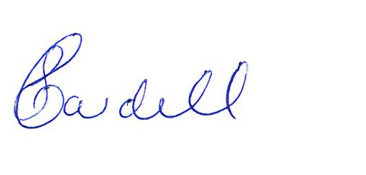

Susan Cardell
Committee Secretary

21 July 2014

