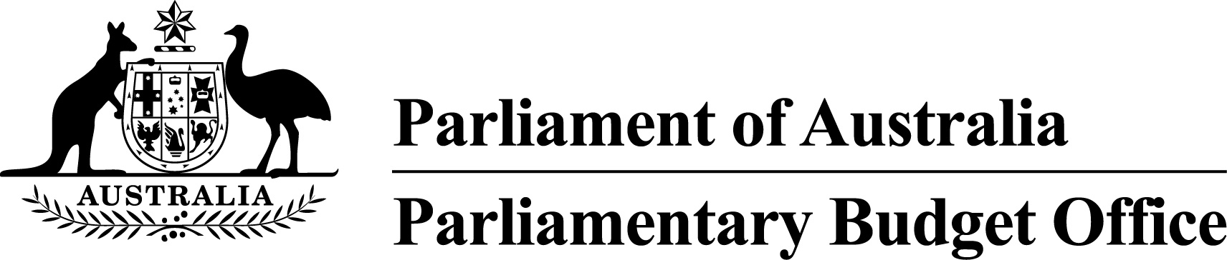

Report to the Senate Finance and
Public Administration Legislation Committee on PBO activity
22 February 2017

Overview
This activity report provides an update on PBO activities since the last report to the Committee (12 October 2016).

Independent review of the PBO
Section 64T of the Parliamentary Service Act 1999 enables the Joint Committee of Public Accounts and Audit (JCPAA) to seek an independent review of the operations of the PBO after a general election. On 14 November 2016, the JCPAA announced an independent review into the PBO, focusing on how the PBO can build on the foundations it has established and continue to strengthen its ability to achieve its aims.
The review is being conducted by Dr Ian Watt AC (Chair), former Secretary, Department of Prime Minister and Cabinet, and Mr Barry Anderson, former Deputy Director, US Congressional Budget Office. The review is expected to be completed in April 2017.

Requests from parliamentarians and parliamentary parties
In the first half of 2016–17, the PBO responded to 877 requests from parliamentarians at an average turnaround time of 11.5 business days and a median time to completion of seven business days (refer to Table 1). A large number of these requests related to costings prepared for the post-election report of election commitments, after which the demand for costings quickly resumed with the resumption of Parliament following the election.
In the same period, the PBO received 145 responses from Commonwealth agencies to information requests at an average turnaround time of 6.9 business days and with an average punctuality of 3.8 business days early (refer to Table 2). Many of these requests relate to the provision of information following the Mid-Year Economic and Fiscal Outlook (MYEFO) update under standing arrangements with a number of agencies. Table 3 contains details of the responsiveness of Commonwealth agencies to information requests during the first half of 2016–17.

Self-initiated research program
On 2 November 2016, the PBO released Report No. 03/2016 National fiscal outlook – As at 2016–17 budgets. The report provided an update of the national fiscal outlook based on Commonwealth and state government 2016–17 budgets.
On 14 December 2016, the PBO released Report No. 04/2016 National Broadband Network: Impact on the Budget. The report analysed the budget impact of the Commonwealth’s equity and debt financing of the National Broadband Network and the associated fiscal risks.
On 12 January 2017, the PBO released the 2016–17 Mid-Year Economic and Fiscal Outlook – charts which provided a graphical summary of the impacts of policy decisions and other factors between the 2016–17 MYEFO and Budget.
On 7 February 2017, the PBO released an update of Unlegislated measures carried forward in the budget estimates – February 2017 update. The report provided an update of the projected impact of unlegislated measures on current budget estimates and over the medium term.
On 8 February 2017, the PBO released Report No. 01/2017 Future Fund drawdown scenarios: Budget implications. The report discussed scenarios for the drawdown of funds from the Future Fund to meet unfunded superannuation cash payments and the budget implications of those scenarios.
Current work in progress includes a report on 2016–17 MYEFO medium-term projections.

PBO staffing
The PBO has a staffing establishment of approximately 40 positions and receives additional funding every third year in the lead up to a general election to boost its staffing. At 31 December 2016, the PBO had 45 staff (refer to Table 4), reflecting the higher staffing level associated with the general election and the continuing demand for policy costing services. In addition, the PBO currently has one secondee under the 2017 Parliament of Australia graduate program.

Requests from parliamentarians and parliamentary parties for costings and budget analyses
Table 1: Costing and budget analysis requests from parliamentarians and parliamentary parties to
31 December 2016
 | 2012–13  Total | 2013–14  Total | 2014–15  Total | 2015–16  Total | 2016–17  Q1 | 2016–17  Q2 | 2016–17  Total
Requests outstanding at start of period | – | 463 | 76 | 138 | 20 | 203 | 20
Requests received in period | 1,146 | 1,297 | 973 | 4,146 | 787 | 755 | 1,542
Requests withdrawn in period | 19 | 162 | 42 | 1,013 | 28 | 307 | 335
Requests completed in period | 664 | 1,522 | 869 | 3,251 | 576 | 301 | 877
Average time to completion (business days) | 33.9 | 13.8 | 19.7 | 18.6 | 5.8 | 20.7 | 11.5
Median time to completion (business days) | n/a | 6 | 12 | 16 | 6 | 13 | 7
Requests outstanding at end of period | 463 | 76 | 138 | 20 | 203 | 350 | 350
Note: The table identifies the number of ‘options’ received by the PBO, noting that a single request can contain multiple options.
Figure 1: PBO response times for completed requests in 2016–17 to 31 December 2016
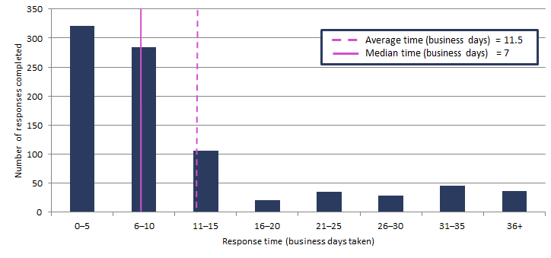

Requests by the PBO for information from agencies
Table 2: Information requests to agencies to 31 December 2016
 | 2012–13  Total | 2013–14  Total | 2014–15  Total | 2015–16  Total | 2016–17  Q1 | 2016–17  Q2 | 2016–17  Total
Requests outstanding at start of period | – | 28 | 16 | 3 | 1 | 7 | 1
Requests sent in period | 360 | 388 | 203 | 743 | 36 | 184 | 220
Requests received in period | 332 | 400 | 216 | 745 | 30 | 115 | 145
Requests received by due date | 149 | 209 | 147 | 695 | 29 | 113 | 142
Requests received after due date | 183 | 191 | 69 | 50 | 1 | 2 | 3
Percentage late | 55.1 | 47.8 | 31.9 | 6.7 | 3.3 | 1.8 | 2.1
Average time taken to respond (business days) | 13.1 | 12.6 | 13.5 | 6.5 | 13.7 | 5.1 | 6.9
Average punctuality (business days late) | 3.0 | 5.3 | 2.9 | -1.3 | -2.5 | -4.6 | -3.8
Average lateness of late requests (business days) | 6.5 | 11.9 | 11.2 | 3.5 | 1.0 | 1.0 | 1.0
Requests outstanding at end of period | 28 | 16 | 3 | 1 | 7 | 76 | 76
As at 31 December 2016, no requests were overdue.
Figure 2: Agencies’ response times for completed information requests in 2016–17 to 31 December 2016
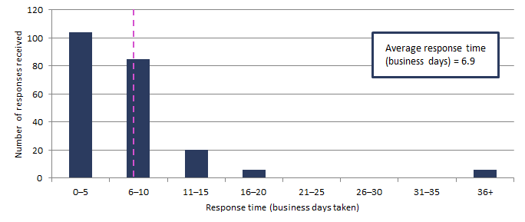
Figure 3: Timeliness of response by agencies to information requests in 2016–17 to 31 December 2016
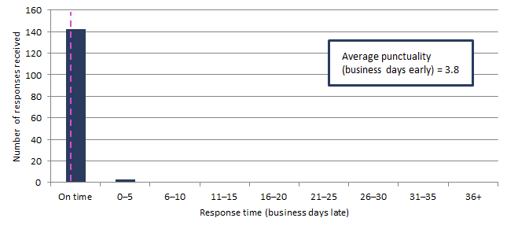
‘On time’ responses include responses provided before the due date.

Table 3: Information request responsiveness by agencies in 2016–17 to 31 December 2016
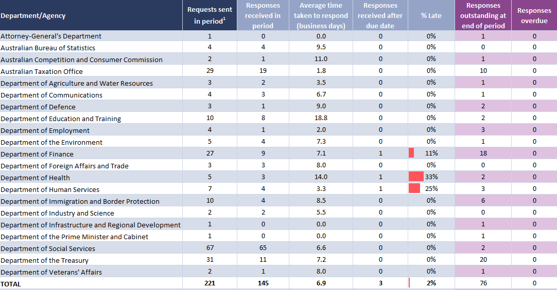
¹ Includes one outstanding request as at 30 June 2016 carried over to 2016–17.

PBO staff by function and employment level
Table 4: PBO staff by function and employment level as at 31 December 2016
Classification | PBO Executive | Budget Analysis Division | Fiscal Policy Analysis Division | Corporate Strategy Branch | Total
Parliamentary Budget Officer (PBO) | 1 | - | - | - | 1
Senior Executive Service Band 2 (SES B2) | - | 1 | 1 | - | 2
Senior Executive Service Band 1 (SES B1) ¹ | - | 2 | 1 | 1 | 4
Parliamentary Executive Level 2 (PEL2) | - | 4 | 2 | 2 | 8
Parliamentary Executive Level 1 (PEL1) ¹ | - | 12 | 4 | 1 | 17
Parliamentary Service Level 6 (PSL6) | 1 | 7 | 1 | - | 9
Parliamentary Service Level 5 (PSL5) | - | - | 1 | 2 | 3
Parliamentary Service Level 4 (PSL4) ¹ | - | - | - | 1 | 1
Total staff | 2 | 26 | 10 | 7 | 45
¹ One SES B1, two PEL1 and one PSL4 ongoing employees are on long term leave and are not included in these totals.
In addition, one PEL1 employee is on secondment to the Australian Taxation Office and is not included in the above totals.
Figure 4: PBO staff by function and employment level as at 31 December 2016

