Memorandum of Understanding
between the
Parliamentary Budget Officer and the Heads of Commonwealth
Bodies in relation to the
Provision of Information and Documents
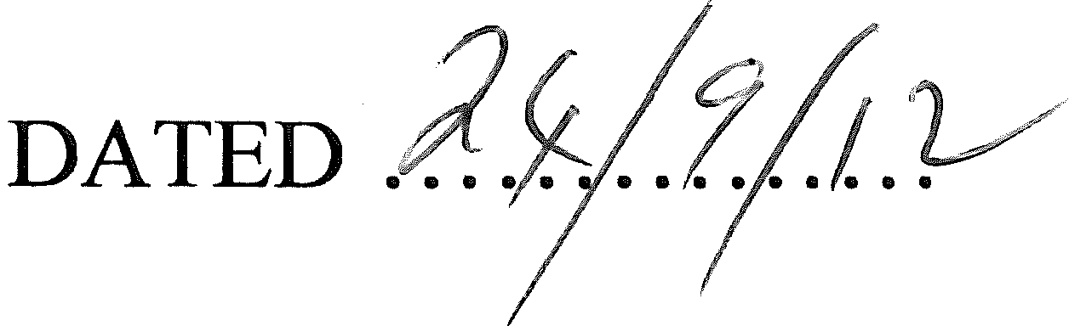
NOTE: This MOU template has been developed to inform negotiations between the Secretaries to the Department of the Treasury and of the Department of Finance and Deregulation (Finance), with the Parliamentary Budget Officer about arrangements for the provision of information. Other Commonwealth entities, including agencies under the Financial Management and Accountability Act 1997 and bodies under the Commonwealth Authorities and Companies Act 1997, may elect to be covered under this agreement, as identified at Attachment A. Specific schedules may be developed under this MOU to reflect specific issues that arise for Commonwealth bodies.
NOTE: Where bodies elect to negotiate a separate arrangement with the PBO Officer, they must use this template as the basis for the development of an alternative arrangement, in consultation with the Treasury and Finance Secretaries.

STATEMENT OF INTENT
This Memorandum of Understanding (MOU) is made between the Heads of the Department of the Treasury (Treasury) and the Department of Finance and Deregulation (Finance) - and on behalf of the Heads of those Commonwealth bodies listed at Attachment A - and the Parliamentary Budget Officer (Officer) (the Parties) in relation to the provision of information and documents to support the functions of the Parliamentary Budget Office (PBO) (the Activity).
The purpose of this MOU is to facilitate the formation of a collaborative, productive and collegiate working relationship between the Parties.
This MOU assists by supporting the ready and open exchange of information, documents, knowledge and views between the Parties. The MOU also outlines the roles and responsibilities of each Party.
In establishing this MOU, the Parties undertake to engage in a cooperative manner which supports the provision of high-quality advice and support to Australian Senators and Members of the House of Representatives, and which supports the maintenance and improvement of government systems.
The MOU is consistent with the Australian Government Protocols Governing the Engagement between Commonwealth Bodies and the Parliamentary Budget Officer.

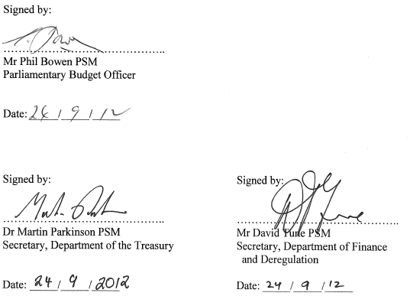

PURPOSE
  - The purpose of this MOU is to outline the arrangement between the Parties for the Officer to obtain information to perform his or her statutory functions. Specifically, this MOU covers:
- the commitment by the Head to provide information to the Officer;
- the format for both requesting information from the Head and for providing information to the Officer;
- the circumstances under which the information is to be provided;
- the use of the information by the Officer; and
- administrative arrangements governing the operation and conduct of the Parties.
  - The statutory functions of the Officer are established under section 64E of the Parliamentary Service Act 1999, as amended, namely:
- outside the caretaker period for a general election - to prepare policy costings on request by Senators or Members of the House of Representatives;
- during the caretaker period for a general election - to prepare policy costings on request by authorised members of Parliamentary parties or independent members;
- to prepare responses (other than policy costings) to requests relating to the budget by Senators or Members of the House of Representatives;
- to prepare submissions to inquiries of Parliamentary committees on request by such committees;
- to conduct, on his or her own initiative (including in anticipation of requests referred to in paragraphs (a) to (d)), research on and analysis of the budget and fiscal policy settings.

COMMENCEMENT AND DURATION
This MOU commences on the date it is signed by both Parties.

STATUS OF THIS MOU

Non-legally Binding
This MOU does not create legally enforceable obligations between the Parties.

Legislative Authority
This MOU is intended to be an arrangement for the Officer to obtain information and documents from Commonwealth bodies for the purposes of section 64F of the Parliamentary Service Act 1999.

ROLES AND RESPONSIBILITIES OF PARTIES TO THIS MOU

Mutual Assistance
The Parties will be open, honest, cooperative and responsive to each other, respecting each other's functions and roles, and assisting and supporting each other whenever possible.

Roles and Responsibilities of Parties
The Parties have a number of specific roles and responsibilities in relation to this MOU.
The roles and responsibilities of the Heads are to establish appropriate arrangements to ensure:
- compliance with the Australian Government Protocols Governing the Engagement between Commonwealth Bodies and the Parliamentary Budget Officer;
- a cooperative working relationship is maintained with the Officer and employees/staff of the PBO on all matters related to this MOU;
- efforts are made by the Heads, or a person authorised by the Heads, to respond to requests received from the Officer with sufficient information and in an appropriate timeframe, as appropriate;
- information provided to the Officer is the most relevant, accurate and current information held or utilised;
- a pro-disclosure approach is maintained to enable open discussion of information sources, methodologies and analytical approaches; and
- where specifically requested by the Officer, all requests for information and documents, including the details of each request, are treated confidentially consistent with the need-to-know principle.
The roles and responsibilities of the Officer are to establish appropriate arrangements to ensure that:
- a cooperative working environment is maintained with the Heads, and their employees/staff, on all matters related to this MOU;
- reasonable contextual detail is provided in relation to each request for information provided to the Heads to allow a response to be relevant, accurate and current;
- consistent with section 64V of the Parliamentary Service Act 1999, appropriate safeguards are established to ensure that all information received from the Heads is treated confidentially at all times; and
- all employees/staff/contracted officers of the PBO maintain appropriate security classifications and treat information in a confidential manner at an times.

ACCESS TO INFORMATION

Requesting Information and Documents – The Officer requesting information from the Head
In relation to submitting requests for information to the Head, the Officer is to ensure that:
- each request for information is submitted via email to the Head, or a person authorised by the Head;
  - in circumstances where the Head is not the Secretary of either the Department of the Treasury (Treasury) or the Department of Finance and Deregulation (Finance), the Officer is also to ensure that the Heads of both Treasury and Finance receive a copy of such requests to facilitate co-ordination and liaison in processing and responding to requests;
- each request for information is made using the 'Request for Information' form at Attachment B including an Information Request Reference Number;
- each request for information contains a clear and specific description of the information requested and how the information will be used;
- each request for information identifies whether the request is routine or urgent in nature; and
- each request for information identifies whether the request is to be treated as confidential because a direction to keep the request confidential has been made under 64H(3)(d) or 64M.
The Officer, or a person authorized by the Officer, may make direct contact with the Head, or a person authorised by the Head, to discuss a request for information.

Providing Information and Documents - The Head providing information to the Officer
In relation to providing information in response to a request received from the Officer, the Head is to ensure that:
- each request for information received from the Officer is acknowledged, via email, within 24 hours of its receipt on the next business day;
- relevant consultation is undertaken with other Commonwealth bodies, as required, to ensure that the Officer is provided with the appropriate information and documents in response to each request;
- relevant and accurate information is provided to the Officer in response to each request; and
- a response is provided within a reasonable timeframe using the 'Provision of Information' form at Attachment C, with the indicative timeframe being that:
- urgent requests are responded to within 5 working days of receipt, depending on complexity; and
- routine requests are responded to within 10 working days of receipt, depending on complexity.
The Head may negotiate alternative timeframes with the Officer based on factors such as the complexity of the request, the level of involvement of other agencies, and workload pressures, including where an unusually large number of requests have been received from the PBO. Further, there may be circumstances when additional time constraints arise - for example, during an estimates update, or during an election period. In these circumstances, the Head may seek to discuss with the Officer the critical workload pressures and alternative arrangements for the provision of information.
The Head may negotiate specific confidentiality requirements with the Officer, in relation to particular information provided to the Officer, as per clause 7.1.
In keeping with the spirit of this MOU, the Head should aim to provide sufficient relevant information to satisfy each request but provide, at a minimum, those documents that would be made available if a formal request was made under the Freedom of Information Act 1982. Where, however, it is not possible to release certain information, the Head should provide a written explanation outlining the reason for the non or partial release – this might include commercial- or cabinet-in-confidence information, intellectual property rights or the application of other relevant legislative provisions relating to the handling of government information and data such as the Privacy Act 1988.
Prior to the explanation being provided to the Officer, however, the Head should consult with the Secretaries to determine whether there are alternative ways of satisfying the request from the Officer.

Using Information
The Officer may only use information and documents provided by the Heads to support the Officer's statutory functions as established under section 64E of the Parliamentary Service Act 1999, and outlined in clause 4.2 of this MOU.
The Parties may discuss and agree on issues related to the timing of the release of certain data, models or information, and any limitations or restrictions that may apply to the release of the data, models or information.

Fees
No fees are payable by the Officer or the PBO for the provision of, or for access to, information under this MOU.
Specific arrangements may need to be negotiated between the parties to obtain information held under license.

QUALITY OF INFORMATION

Data Integrity and Protection – Information provided to the Officer
In relation to the information provided to the Officer under this MOU, the Heads will:
- take reasonable measures to ensure that information provided is free from malicious computer codes or viruses; and
- review and, as required, amend information provided to the Officer within a reasonable time of being formally notified by the Officer of a possible inaccuracy, omission, defect or error in that information.

Data Integrity and Protection – Information received from the Heads
In relation to any information received from the Head under this MOU, the Officer will:
- take all reasonable measures to maintain the confidentiality of the information, including any confidentiality requirements negotiated with the Head;
- ensure that the information is only used for the purposes for which the information was provided, and is only accessed by employees/staff of the PBO in accordance with the need-to-know principle;
- notify the Head as soon as practicable of any possible errors or defect in that information;
- ensure that the information is safeguarded against loss, destruction, transfer, or unauthorised access, modification, disclosure, or use; and
- notify the Head as soon as practicable of any actual or potential breach of security or confidentiality in relation to the information.

Review of Data Integrity Procedures and Systems
The Parties recognise that the integrity of the information provided under this MOU relies on both Parties implementing and maintaining appropriate security procedures and systems.
The Head may ask the Officer for information about the procedures and systems that the Officer has in place for maintaining the confidentiality and integrity of the information provided by the Head. In requesting this information:
- the Head is to make a request in writing; and
- the Officer is to respond to a request within 10 working days of its receipt.
The Parties may meet to discuss issues related to the security procedures and systems established to maintain data integrity.

USE AND RELEASE OF INFORMATION

Confidentiality
The Parties undertake to maintain the confidentiality of information provided to them under this MOU in accordance with the requirements of the Party providing the information; and to comply with all laws that govern the use and release of information.

The Parliamentary Service Act 1999 allows for the Officer to provide confidential advice to parliamentarians on non-costing matters at any time, as well as confidential policy costings during non-caretaker periods, upon request.
To support this arrangement and ensure the confidentiality of requests for information:
- the Heads of Commonwealth bodies and their staff must not disclose the details of a request for information and the subsequent response to the Government if the request is specifically requested to be treated confidentially;
- Government Ministers and their staff will not ask the Heads of Commonwealth bodies or their staff to provide them with any information which would disclose the nature of a confidential request from the Officer; and
- the Heads of Commonwealth bodies and their staff must not disclose the details of a request for information and the subsequent response to a third party, other than a Commonwealth body, unless required to do so by law.
However, it is appropriate for Commonwealth bodies to provide information to their Minister/s on the resourcing impacts of their interactions with the PBO in aggregate terms, so long as confidential information is not disclosed by the provision of such advice.
Where a Head has provided information to the Officer, the Officer may only disclose the information as provided to a Non Party if that disclosure is made:
- with the prior written approval of the Head including complying with any terms . and conditions requested by the Head; and
- as required by applicable government direction, policy or law.

Security
The Parties undertake:
- to maintain the security of information provided to them according to the requirements of the Party providing the information;
- to ensure that all employees/staff/contractors have, and maintain at all times, appropriate security clearances to access Australia Government information; and
- to meet the requirements of the Australian Government Protective Security Manual, at a minimum, in relation to the storage and handling of information provided by the other Party.

Intellectual property
The Parties agree that pre-existing intellectual property will be recognised and respected under this MOU and will only be used as authorised by the owner of the intellectual property as permitted under law.

Sub-contracts and third party contracts
If a Party to this MOU (the first Party) contracts with another party to carry out any part of the activities the first Party is to perform under this MOU, the first Party will be solely responsible for:
- compliance with all legal and regulatory requirements in relation to subcontracting;
- the engagement, management, coordination, and payment of, and all communications with, such contractors;
- all other matters in connection with that contract and/or those contractors; and
- maintaining security as per this MOU.

GOVERNANCE ARRANGEMENTS FOR THIS MOU

Monitoring and Evaluation
Parties may appoint an MOU Manager to monitor and evaluate the operation of this MOU on their behalf. In the absence of a specific appointment, the Head and the Officer are taken to be the MOU Managers.
Parties agree to monitor the workload implications, for both themselves and the other Party, of providing, exchanging and discussing information and data requests, including processes related to submitting and responding to requests for information. Where distinct workload pressures emerge, either Party may seek advice from the other Party about prioritising requests for information.

Review of MOU
The terms and conditions of this MOU are to be reviewed by the Parties within four years of the date of commencement of this MOU.
Either Party may seek to review the terms and conditions of this MOU at any time.

Variation
Either Party may undertake to negotiate changes to this MOU. All variations must be documented in writing, and agreed by both Parties in writing. All variations agreed by both Parties will be included as an Attachment to this MOU.

Notices
Notices under this MOU are to be made in writing, marked for the attention of the recipient MOU Manager, and sent to that MOU Manager's address by e-mail transmission or facsimile.
Notices will be taken to be received by the recipient on the business day next following the day on which the transmission was sent in its entirety to the recipient's email address or facsimile machine.

DISPUTE RESOLUTION
Parties agree to attempt to resolve any dispute arising in relation to this MOU by negotiation. Parties agree that dispute resolution will be at the lowest, most informal level practicable, and will incorporate alternative dispute resolution procedures.
As a starting principle, the Parties agree to continue to perform their obligations under this MOU pending resolution of any dispute.
In the first instance, the MOU Managers are responsible for undertaking to resolve a dispute.
Where a dispute is not resolved by the MOU Managers:
- either Party may provide the other with a written notice setting out the specific details of the dispute and reporting the failure of negotiations to resolve it; and
- both Parties are to refer the dispute to the Officer or Head, as appropriate, for resolution.
Where the dispute is not resolved by the Officer and Head, both parties shall refer the dispute to the Secretaries of Treasury and Finance for resolution.
Where the Head is the Secretary of Treasury or Finance, the Head is to refer the matter to the Secretary of the Department of the Prime Minister and Cabinet.
At any time either Party may request the appointment of an independent mediator - for example the Australian Public Service Commissioner - to resolve a dispute, whose appointment is to be agreed between both Parties. The outcome of any negotiated dispute is to be documented in writing.
The Parties agree to bear their own costs in complying with this clause.

INTERPRETATION

In this MOU, unless the contrary intention appears:
- an attachment, schedule or other annexure to this MOU forms part of this MOU; and
- the singular includes the plural and vice versa, and each gender includes the other gender.

The following definitions apply to this MOU and any attachments, schedules or annexure:
Caretaker period – has the same meaning as in Schedule 1 to the Charter of Budget Honesty Act 1998 being "the period starting when the House of Representatives expires or is dissolved, and ending:
- when it is clear that the Government has been re-elected; or
- if there is a change of Government, when the new Government has been sworn in".

Commonwealth body – means:
- an Agency within the meaning of the Financial Management and Accountability Act 1997; or
- a Commonwealth authority within the meaning of the Commonwealth Authorities and Companies Act 1997; or
- a Commonwealth company within the meaning of the Commonwealth Authorities and Companies Act 1997;
- or the High Court of Australia.
Head – means the Chief Executive/Secretary/CEO, or equivalent, of a Commonwealth body, however described.
Information – includes models that are involved in the generation of the information.
Intellectual Property – means all rights and interests arising from intellectual activity in the scientific, literary, artistic and industrial fields, including those in the nature of copyright, patents, designs, trade and service marks, and trade and business names, whatever they are called and wherever and however they arise.
Non Party – means persons that are not Parties to this MOU and are not contracted by a Party to this MOU.
Officer – means the holder of the statutory office of the Parliamentary Budget Officer as established under section 64C of the Parliamentary Service Act 1999, or a person authorised by the Parliamentary Budget Officer.
Parties – means the Officer, and the Head, that are parties to this MOU.
PBO – means the Commonwealth Parliamentary Budget Office as established under section 64A of the Parliamentary Service Act 1999.
Presiding Officer means:
- in relation to the Senate—the President of the Senate; and
- in relation to the House of Representatives—the Speaker of the House of Representatives.
Unless the contrary intention appears, a reference to the Presiding Officers means the Presiding Officers acting jointly.
Third parties – means persons that are not Parties to this MOU but are contracted by a Party to this MOU to carry out any of the activities of that Party under this MOU.

ATTACHMENT A

COMMONWEALTH BODIES COVERED BY THIS
MEMORANDUM OF UNDERSTANDING
The Commonwealth bodies listed below have elected to be covered under this agreement.
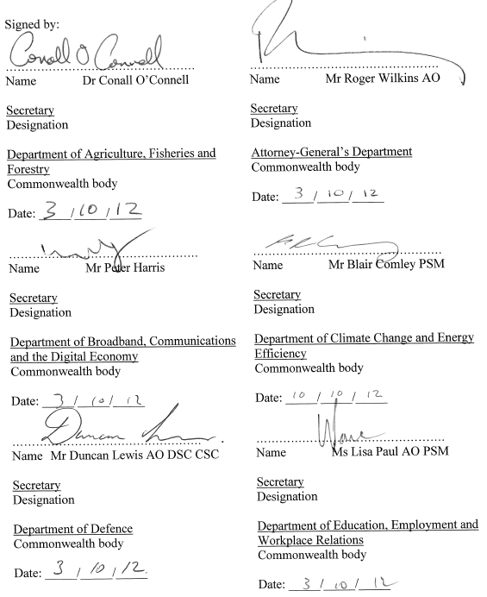
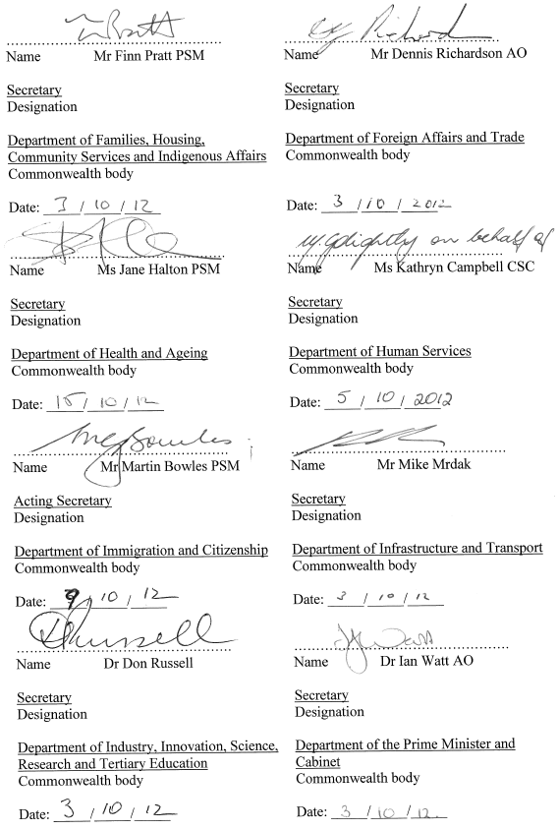
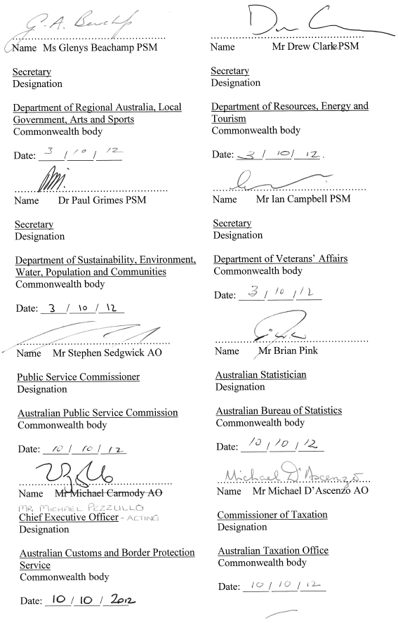

ATTACHMENT B

REQUEST FOR INFORMATION TEMPLATE
This template is to be utilised by the Parliamentary Budget Officer when submitting a request for information to a Commonwealth Government body.
REQUEST FOR INFORMATION BY THE PARLIAMENTARY BUDGET OFFICER
Page 1 of 2
- Information Request Reference Number: | For example, 001-2012
- Request submitted to: | For example, Department of Finance and Deregulation
- Date request submitted: | For example, 1 January 2012
- PBO Contact Officer for this request: | For example:  John Smith  Work contact number  Work email
- Is this request confidential? (Y/N) | For example, Y
- Is this request routine or urgent? | For example, Routine
- Description of request: | For example, the PBO has been asked to prepare a costing on a change Family Tax Benefit Part  PBO to insert relevant detail

REQUEST FOR INFORMATION BY THE PARLIAMENTARY BUDGET OFFICER
Page 2 of 2
- Description of the specific information and/or data that is requested: | For example, models containing indexation parameters and demand trends.  PBO to insert relevant details
- How does the request relate to the work and mandate of the PBO? | For example, preparation of policy costings outside the caretaker period (section 64E(1)(a) of the Parliamentary Service Act 1999).
- Date information required by: | 15 January 2012
- Request cleared by: | For example, Parliamentary Budget Officer

ATTACHMENT C

PROVISION OF INFORMATION TEMPLATE
This template is to be utilised by Commonwealth Government bodies when submitting information to the Parliamentary Budget Officer.
PROVISION OF INFORMATION TO THE PARLIAMENTARY BUDGET OFFICER
Page 1 of 3
- Information Request Reference Number: |  | For example, 001-2012
- Date of request: |  | For example, 10 October 2012
- Date response requested by: |  | For example, 15 October 2012
- PBO Contact Officer for this request: |  | For example:  John Smith  Work contact number  Work email
- Is this request confidential? (Y/N) |  | For example, Y
- Was the request routine or urgent? |  | For example, Routine
- Description of request received: |  | For example, request for a costing on a change to the eligibility for Family Tax Benefit Part A.
- Date information provided to the PBO (including, if relevant, the reason for any delay in submitting the information) |  | For example, 15 October 2012
- Details of any external parties consulted in preparing this response: |  | For example, Not applicable
PROVISION OF INFORMATION TO THE PARLIAMENTARY BUDGET OFFICER
Page 2 of 3
- Summary of the response in
relation to this request:
- Is the detailed response attached? (Y/N) | For example, Yes
- Are there any restrictions or sensitivities on the use or public disclosure of the information? If so, please specify: | For example, forecasts provided in-confidence, privacy laws, taxpayer confidentiality laws, third party licensing or IP arrangements
- Indicate currency of information and expiry date for information: | For example, data current as at 15 June 2012 based on population for 2009-10. Data updated twice a year in July and January; relies on forecasts updated at Budget and MYEFO.  Expiry date for information: eg 31 December 2012  Note: This information is deemed suitable for use until the expiry date, however, other unexpected events such as <insert as necessary, eg changes in the economy or population> may render this information unsuitable prior to that date.
- Are there any other notes, qualifiers or sensitivities associated with the information? | For example, reliability may be low due to volatility of input data; impact of behavior changes; uncertainty over parameter forecasts etc.
PROVISION OF INFORMATION TO THE PARLIAMENTARY BUDGET OFFICER
Page 3 of 3
- Agency response contact officer | For example:  Betty Smith  <insert agency name and section>  Work contact number  Work email
- Agency response cleared by: | For example:  Assistant Secretary, Budget  Work contact number  Work email

