AUSTRALIAN GOVERNMENT PROTOCOLS GOVERNING THE ENGAGEMENT BETWEEN COMMONWEALTH BODIES AND THE PARLIAMENTARY BUDGET OFFICER

Preamble
The Parliament of Australia has established the Parliamentary Budget Office (PBO), headed by the Parliamentary Budget Officer (the Officer), to provide Senators and Members of the House of Representatives with independent and non-partisan analysis of the budget cycle, fiscal policy and the financial implications of policy proposals.
The PBO also prepare submissions to inquiries of Parliamentary Committees on request, conduct research on and analysis of the budget and fiscal policy settings and prepare a post-election report to include costings of the election commitments of Parliamentary parties after a general election.
The PBO is established under the Parliamentary Service Act 1999 (PSA Act), as amended by the Parliamentary Service Amendment (Parliamentary Budget Officer) Act 2011.
In order to perform its statutory functions, the PBO will require access to information and documents owned, held, managed or administered by Commonwealth bodies. Commonwealth bodies comprise agencies under the Financial Management and Accountability Act 1997 and bodies under the Commonwealth Authorities and Companies Act 1997.

This is a statement of the Australian Government’s intent to support the Officer in the performance of his or her functions.
These Protocols are Government policy and promote the Government’s basis for Heads of Commonwealth bodies and their staff to manage their interactions with the PBO. They also seek to facilitate and promote the ready and open exchange of views and information between Commonwealth bodies and the PBO, and to ensure a high-level of consistency and transparency across government.
The aim is for these Protocols to be observed by all Commonwealth bodies and to be reflected in any arrangement made for the provision of information to the Officer.
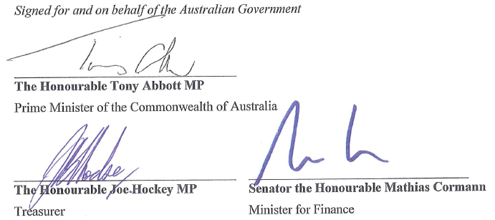

ROLE OF THE PROTOCOLS
These Protocols have been developed to:
- ensure that relevant information is provided to the Officer;
- outline the responsibilities of the Heads of Commonwealth bodies, and their staff, in engaging with the Officer;
- establish procedures to ensure the consistency and confidentiality of information provided to and by the PBO; and
- ensure that the integrity of the Government’s official budget estimates are maintained.

PROVISION OF INFORMATION TO THE PBO
Commonwealth bodies should aim to provide the Officer with information or documents held by the body that may be relevant to a request received from the PBO or to any discussions held in relation to a request for information.
In determining whether information will be released to the Officer, the Heads of Commonwealth bodies should have regard to:
- the Government’s intent to support the Officer in the performance of his/her functions as defined in the PBO’s enabling legislation;
- the accessibility of the information under the Freedom of Information Act 1982; and
- the application of other relevant legislative provisions relating to the handling of government information and data including, for example, the Privacy Act 1988.
Commonwealth bodies are to recognise and respect the pre-existing intellectual property of any information they hold and/or utilise that has been produced by third parties.

RESPONSIBILITIES OF THE HEADS OF COMMONWEALTH BODIES
Requests for information from the Officer are to be actioned by the Head of a Commonwealth body, or a person authorised by the Head.
In responding to requests for information from the Officer, or in otherwise engaging with the PBO, the Heads of Commonwealth bodies are to:
- ensure that all reasonable efforts are made to respond to requests from the Officer in a timely manner and, where there is no legislative impediment, with the information requested;
- ensure, to the greatest extent possible, that information provided to the Officer reflects the economic forecasts and parameters and fiscal estimates contained in the most recent relevant reports released under Parts 5, 6, and 7 of Schedule 1 to the Charter of Budget Honesty Act 1998;
- ensure that they and their staff are accessible should the Officer request discussions and/or informal dialogue in relation to a request for information; and
- take appropriate measures to maintain the confidentiality of a request and the related response, if requested by the Officer.

PROCEDURES TO ENSURE CONFIDENTIALITY
The PSA Act allows for the Officer to provide confidential advice to parliamentarians on non-costing matters at any time, as well as confidential policy costings during non-caretaker periods, upon request.
To support this arrangement and ensure the confidentiality of requests for information:
- The Heads of Commonwealth bodies and their staff must not disclose to the Government the details of a request for information and the subsequent response if the request is specifically requested to be treated confidentially;
- Government Ministers and their staff will not ask the Heads of Commonwealth bodies or their staff to provide them with any information which would disclose the nature of a confidential request from the Officer; and
- The Heads of Commonwealth bodies and their staff must not disclose the details of a request for information and the subsequent response to a third party, other than a Commonwealth body, unless required to do so by law.
However, it is appropriate for Commonwealth bodies to provide information to their Minister/s on the resourcing impacts of their interactions with the PBO in aggregate terms, so long as confidential information is not disclosed by the provision of such advice.

INTEGRITY OF THE GOVERNMENT’S OFFICIAL BUDGET ESTIMATES
Commonwealth bodies are to inform the Department of the Treasury (Treasury) and the Department of Finance and Deregulation (Finance) in writing (email) of the details of a request from the Officer once it has been received.
For some requests, a Commonwealth body or Treasury or Finance may play a coordinating role in preparing the response, as agreed between the bodies. The need for coordination may arise in cases where information relevant to a request is based on information or analysis contributed by several Commonwealth bodies. In such cases, the other parties are entitled to review the response before it is released to the Officer.
A Commonwealth body must consult Treasury and/or Finance in advance of providing information to the PBO if the Head of a Commonwealth body, or the Secretary of either the Treasury or Finance, could reasonably deem that information to be significantly inconsistent with the official budget estimates as contained in the Central Budget Management System.
Finally, Commonwealth bodies are to provide the Treasury and Finance with an update on the status of a request for information, if requested, and a copy of all formal responses to the PBO.

