Senate ECONOMICS REFErENCES COMMITTEE

Inquiry into the Effectiveness of the Trade Practices Act 1974
in Protecting Small Business

submission by metcash trading limited

DATED: 12 SEPTEMBER 2003

ENQUIRIES TO BE DIRECTED TO:

ANDREW REITZER, CEO - METCASH TRADING LIMITED
4 NEWINGTON ROAD, SILVERWATER, NSW 2128
TEL: 02-9741-3000
FAX: 02-9741-3027

CONTENTS Page
1. Purpose 2
2. Background & Context 6
2.1 Industry Structure 6
2.2 An Increasingly Highly Concentrated Industry 16
3. The Part Metcash Play in the Grocery Marketplace 34

3.1 History – The Metcash Story 35
3.2 How the Independent Sector Operates 45
3.3 The Metcash Value-Add (Services Provided) 47
3.4 Logistical Efficiency 55
3.5 Independent Retailer Testimonials 69

4. Marketing/ Branding Success 85

4.1 Market Share 86
4.2 Community is a Central Theme 91
4.2.1 Community Chest 91
4.2.2 Community Testimonials 96
4.3 Consumer Research 104

5. Merchandising & Promotions 109
5.1 Merchandising – a Core Competency for Metcash 109
5.2 Retailer Strategy Execution 113
5.3 Price Discrimination 114
6. NECG Findings - Summary 117

Annexure
NECG – Report to ACCC re Creeping Acquisitions

1. PURPOSE
The purpose of this particular Submission is to supplement the Submission presented to the Inquiry by The National Association of Retail Grocers of Australia (NARGA).

Metcash Trading Limited (Metcash) fully supports the position, findings and recommendations contained in NARGA’s Submission.

NARGA’s Submission makes mention of the Independent Grocery Retailer’s position in the marketplace and the criticality of adequate legal recourse being afforded to this segment of the market in light of recent Case Law judgments referencing S.46 of the Trade Practices Act.

NARGA is concerned that following the High Court’s decision in the Boral case (handed down in February 2003), the Trade Practices Act’s prohibition against abuses of market power by large corporations has been rendered impotent in dealing with predatory pricing conduct or other abuses of market power. Indeed, NARGA believes that the High Court has now applied a test of market power under the Act that no corporation other than a monopolist, or one in a dominant position, could be caught by.

NARGA is not lobbying in the name of protectionism but rather, seeks to redress the overly narrow interpretation of S.46 by the High Court in the Boral and Melway cases in favour of restoring the original parliamentary intention behind the amendments made to S.46 back in 1986. Please refer to NARGA’s Submission for the detail of its arguments, but before moving on, it is pertinent to be reminded of a recent quote from former Chairman of the ACCC, Alan Fels: “Despite a record of general vigour and success in litigation the Commission has won only one S. 46 case since 1991. Does anyone believe that there has only been one instance in which an Australian business with substantial market power has misused it to harm competition in that period?”

We are also encouraged by the ACCC's Submission, which we see as a significant step in the right direction. Metcash as a member of "big business" is conscious of its own position in the context s.46. Nevertheless, it is also conscious of the fact that unlike many others from “the big end of town”, Metcash depends critically on the success of its "small business" customers, who in turn depend on the efficacy of Metcash’s buying strength. In this regard, Metcash supports the need to clarify section 46 and section 51AC. However, the key and urgent issue for Metcash relates to "creeping acquisitions" by the Chains and the Commission does not address this issue specifically. In this regard Metcash strongly supports the changes to section 50 proposed in the NARGA Submission.

Metcash has assembled this Submission to assist the Inquiry in its deliberations generally, and in particular, to ensure it has an informed view of the Independent sector of the grocery retail marketplace.

The Submission primarily aims to ensure the Inquiry Committee is adequately informed of the role Metcash plays in championing the interests and survival of the Independent Retail Grocer.

It is critical that the Inquiry understand the competitive tension that a vibrant ‘third force’ comprised of Independent Grocery Retailers brings to an otherwise dramatically concentrated marketplace – one which has been characterised by an ‘erosionary’ level of creeping acquisitions by the Chains since 1995.

Metcash services the needs of the Independent Grocery Retailer by providing the critical buying muscle to enable Independent Grocers to compete with the Chains. Metcash also provides a range of other ‘value-adding’ services that enable the Independent sector to thrive and grow. Without these services it is arguable whether many Independent Retailers could survive, with serious flow-on implications for consumers deprived of choice and adequate service, particularly in regional areas beyond the reach of the Chains.

This Submission does not seek to convince the Inquiry of the need to institute protectionist measures on behalf of the Independent Grocery sector. Rather it seeks to stress the importance of allowing fair competition to dictate price and choice to the end consumer who, without such competition would ultimately be worse off.

It is critical that the Inquiry recognise that the ongoing ‘duopolisation’ of the Grocery sector is not in the interest of the following four distinct stakeholders:
- The end consumer on a localised / micro-economic basis who currently enjoys the increased choice and pricing competition that flows from having a “third full-service player” on hand;
- The balance of remaining Independent Grocers existent in the marketplace whose buying power and brand is diminished every time one of the Chains ‘cherry-picks’ another large and successful Independent store. This has the ongoing effect of diminishing the competitiveness of the remaining Independents thereby reducing their profitability and the value of the goodwill invested in their business (value that for many retailers represents their superannuation after a lifetime’s work building their business);
- The wholesalers who supply those Independent Grocers and the shareholders, employees and other stakeholders invested therein; and
- The suppliers facing an emerging monopsonist marketplace (that is, one where dominant market power is exercised by buyers) which can be as harmful to the efficiency desired from effectively balanced market forces as market power on the selling side.

Illustrating its symbiotic relationship with its Independent Retailer customer base, Metcash has assembled this Submission on behalf of those interests and for the better edification of the Inquiry Committee.
2. BACKGROUND & CONTEXT

2.1 Industry Structure
The Goods
Products supplied through retail grocery outlets comprise a range of food (often differentiated in the industry between ‘dry’ – being canned and packaged foods - and ‘perishable’ – being fresh and frozen) and non-food items, such as cleaning products, toiletries, and other general merchandise designed to meet basic household needs.

The Shop-Type
Household grocery shopping tends to be characterised by a large regular supermarket shop plus additional ‘top up’ and ‘convenience’ purchases in between. In recent years there has been a trend towards more frequent grocery shopping trips, but this is now edging down with the national average number of shopping trips being 2.6 trips per week in 2002 compared to 2.8 in 2000.

These shopping patterns are reflected in the range of grocery store types, with large supermarkets, able to carry the necessary product range, catering to the ‘weekly shop’ and smaller stores catering for ‘top up’ and ‘convenience’ purchases. Increasingly however, supermarkets also cater for the latter, particularly since the deregulation of shopping hours in most states.

Some ‘top up’ and ‘convenience’ items are also supplied by a range of specialist stores, such as butchers, green grocers, delicatessens and pharmacies. Albeit, these too are being marginalised by the expanding coverage of the Chains both geographically and through expanded opening hours and offer (eg Woolworth’s recent announcement of its entry into full service in-store pharmacy, following on from petrol).

The Players
The supply side of the supermarket industry in the eastern states is characterised by three main players, Woolworths/Safeway, Coles/Bi-Lo and the independent sector, plus the limited range discounter Aldi.

The Chains
Woolworths and Coles are both vertically integrated chains, buying products direct from manufacturers and growers and distributing these to stores via a network of state based warehouses. Coles has differentiated its retail offering between its Coles and Bi-Lo stores, with the latter targeting the more price conscious consumers. Both Coles and Woolworths have expanded their range of store types to include a number of smaller stores, called ‘Metro’ and ‘Express’ stores, catering to the ‘top up’ and ‘convenience’ shopper. Coles’ Bi-Lo stores also cater for the smaller ‘footprint’ offer.

… and Petrol
Both Woolworths and Coles have now launched a petrol offering, through Caltex/ Petrol Plus and Shell outlets respectively, which links their convenience shopping offer with petrol stations. The impact of the Chains entry to petrol retailing has already been significant and is likely to accelerate the demise of the independent petrol retailer.

David Purchase, who heads the Victorian Automobile Chamber of Commerce which represents 4500 businesses in the retail automotive industry in Victoria and Tasmania recently wrote an article summing up the lot of small business: “Most are under pressure from big business diversifying into small business markets, most are struggling with an onerous regime of compliance, red tape and regulation, and most are weighed down by the demands of a tax system. This impedes their cash flows and takes them away from the business of ‘doing business’ ”.

Pointing to the recent Chain forays into petrol retailing he asked a simple question: “How can independents compete fairly when the wholesale price they pay for petrol supplies is higher than the retail price of these powerful competitors? We keep hearing from big business and government that it’s all great because the consumer is getting lower prices. Yeah, sure, for how long? And can a petrol saving disappear when a customer is loading up a shopping trolley? I think we know the answer.”

This is a salutary lesson in how the Chains can use their market dominance to over-ride established competitive norms. David Purchase hones in on the nub of the concern emanating from duopolisation: ultimately a duopoly has less incentive to compete on price, quality, range and service and the danger of collusion, whether actual or tacit, increases.

Aldi … An ‘Imperfect Competitor’
Returning to the structure of the Industry, Aldi offers a strictly limited range and depth of product lines compared to the Chains and Independent supermarkets. Its stores tend to be relatively small, the store environment is very basic and they do not accept credit cards. Geographic coverage is also limited, though growing. Their focus is on providing very low prices for a limited range of basic items, which are largely house brand products.

According to A. C. Nielsen data, only 21 per cent of households in NSW shopped at Aldi in the 26 weeks up to 3 August 2002, compared to 70–90 per cent who shopped at Coles and Woolworths. Those who did shop there spent around the same amount per trip as for trips to Coles and Woolworths, but made only about one third as many trips there compared to trips to Coles and Woolworths.

This is consistent with the common perception that consumers tend to use Aldi to stock up on basic items at low prices at infrequent intervals: for example, they may go there every second week or even monthly compared to a weekly or more frequent shop at Coles or Woolworths. Evidence in the UK, where Aldi and other limited range discounters have been established for longer, suggests that consumers do not regard the product range and depth offered by these stores to be a close substitute for the one-stop shopping available at mainstream supermarkets.

Clearly, while offering a degree of pricing constraint on the other industry players, Aldi provides a very imperfect substitute, in both the product and geographic dimensions of competition. Aldi, while offering significant price competition on a limited range, does not offer most consumers an acceptable alternative for their “weekly” shop. Aldi has a very different business model and caters for a monthly stocking up of basic items rather than the “weekly grocery shop”. Any assumption that Aldi could eventually provide full competition as the effective ‘third force’ in the grocery marketplace would therefore be erroneous.

The Independent Sector
Moving on to the Independent sector finally: Following the series of mergers between state based independent wholesalers in the 1990s and the closure of AIW in 2002, Metcash is now virtually the sole supplier of wholesale groceries to Independent retailers in the eastern states and South Australia, other than the Action supermarkets in Queensland which are supplied by Foodland.

These Independent retailers comprise both supermarkets, top up stores and convenience stores. Not only does the Independent sector display great diversity in terms of size, but also in terms of its price/ product/ service offering. Independent supermarkets include the ‘new Franklins’ chain, owned by Interfrank, which appeals to the budget conscious consumer, as well as a whole range of independently owned ‘IGA supermarkets’, many of which offer a high level of customer service compared to the chains.

All of these stores compete with the vertically integrated Chains to a greater or lesser degree depending on product range and location. Their ability to compete effectively depends on the product range, terms and conditions and support services provided by Metcash, as well as their own efforts and entrepreneurship. Metcash’s ability to secure and offer competitive trading terms is in turn significantly affected by the market share of its Independent customers and hence the volume Metcash can acquire from suppliers and put through its warehouses and distribution operations.

The Importance Of Critical Mass
The diagram below shows the distribution of these stores by wholesale purchases and indicates that Metcash’s customer base comprises a core of larger supermarkets, who account for the majority of wholesale purchases and a ‘tail’ of numerous smaller top up and convenience stores.
Metcash’s Customer Base in Order of Wholesale Purchases 2002
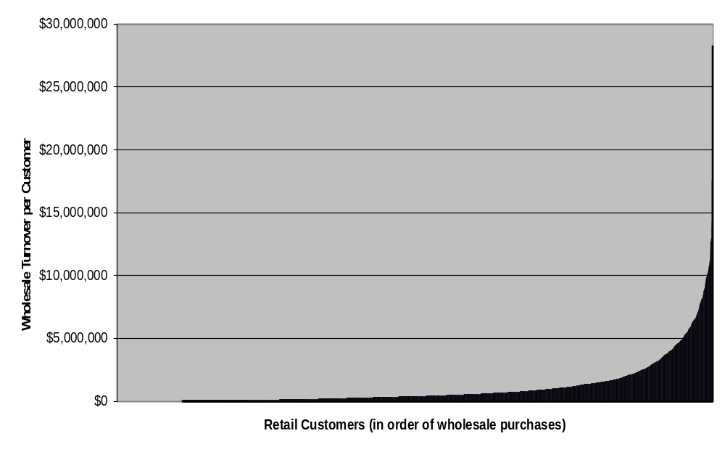
The latter point is of critical structural concern to the viability of the Independent sector. The majority of the volume comes out of a proportionately small number of larger Independent supermarkets. That volume facilitates both the purchasing and logistical efficiencies enjoyed by all Independents serviced by Metcash. Continuing ‘cherry-picking’ of those larger Independents by the Chains significantly undermines the viability of all Independents.

It would be a mistake to interpret these statements as an attempt to ‘talk up’ the supposed benefits of protecting Metcash, which as a publicly listed company in the ASX top 100 inherently gets labeled as part of the ‘big end of town’. As a wholesaler, Metcash is in a high volume small margin business and there is no doubt that any loss of volume is detrimental to its own financial viability. However, the flow-on impact of even a moderate loss of volume to the well being of the Independent sector is significant and this aspect is further considered later in the Submission. Yet the impact does not just end with the demise of Independent retailers themselves, it also flows on to the end-consumer as the lessening of localised competitive tension in the market place allows prices to creep higher.

“Location, Location, Location”.
Research by A C Nielsen indicates that consumers’ choice of grocery store is most strongly influenced by location and convenience, followed by product range and choice, with price lagging behind these factors in importance. This has important implications for market definition and market power in the grocery industry. Location confers significant market advantage on individual stores and hence a degree of market power.

The Research showed that most shoppers were not prepared to travel to any particular store unless it was as easy to get to as their most convenient store. However, shoppers were prepared to travel somewhat further to go to a Coles or Woolworths supermarket than other types of supermarkets. Woolworths, which has around 50 per cent more stores nationally than Coles, derives significant market share advantage from this.

Consider this research in the context the NECG’s findings on local price competition (refer Section 6 below), and the impact on the end-consumer of continuing creeping acquisitions can be substantial on a localised basis. Why?

From a geographic perspective, each supermarket has a unique locational advantage conferring some degree of market power (as discussed above) depending on the proximity of other stores, and in particular whether they are located within the first store’s catchment area. Given the importance attached to convenience, the closer these other stores are geographically, the more substitutable they will be in the geographic dimension. Accordingly, local retail markets can be defined in relation to each store, or each group of stores located in close proximity, in line with the primary catchment area of that store or stores.

Thus, local retail markets are defined as ‘circles of competition’ – the price/ quality/ service package offered at the centre is constrained by stores within the circle. Indeed, it may be relevant to link some circles of competition into a single market where the areas of overlap are substantial, such that pricing constraints are transmitted from one to another through a ‘ripple effect’.

In any case, the NECG analysis of local price data suggests that the Chains largely exhibit limited price variations across local retail markets - that is prices for many of the items supplied by the Chains appear to be set on a multi-location basis. This likely reflects the considerable transactional cost savings and other advantages arising from uniform pricing. Yet, the NECG analysis goes on to indicate that the Chains’ pricing is actually characterised by multiple, though limited, price points. What’s more, the lower Chain store prices tend to be statistically significantly associated with both more local players and in particular the presence of Independents.

Their regression analysis suggests that local market structure has a significant impact on which price point is adopted in a particular location for a large number of products. Specifically, the prices of many products in the Chain stores are reduced when an Independent is present in a location. This is a surprisingly strong result given the advantages of uniform pricing to the Chains and the problems associated with modeling local price variations.

Accordingly, where a particular acquisition reduces the number of players in a location, and specifically where it removes an Independent retailer, it is likely to increase at least some Chain store prices in that location. Put another way, the presence of Independents in a locality protects consumers from local market power and higher prices than would otherwise prevail. Additionally, non-price factors in the local supermarket offering are likely to be significant and the presence of Independents likely adds to the pressure on the Chains to provide a greater range of amenities.

Given this, it is not surprising the chains are seeking to knock out the bigger, more aggressive independents.

Market Dominance + Brand = Monopsony
Both Coles and Woolworths appear to have strong brand loyalty, derived from their perceived superiority in terms of fresh food, product range and store environment. From the NECG analysis, a high percentage of people described themselves as mainly Woolworths or mainly Coles shoppers, at 48 and 36 per cent respectively. These shoppers also tend to be particularly loyal compared to people describing themselves as mainly a Franklins or other store type shopper, spending a higher percentage of their total grocery spending at their main store.

A. C. Nielsen has constructed a ‘store equity index’ for each of the chains, which is essentially a measure of brand loyalty, reflecting shopper loyalty and their willingness to pay more to shop at that particular store type. A score of three or more is regarded as strong brand loyalty: the store equity index is 4.1 for Woolworths and 3.2 for Coles, compared to 0.9 for IGA and Action, 0.8 for Aldi and 0.3 for Franklins. It is also interesting to compare these stores to brand equity indexes for manufacturers: only 15 per cent of manufacturers had a brand equity index greater than three.

Both of these factors have implications not only for market definition and market power in relation to the supply of groceries to final consumers, but also in relation to the market power of the Chains as acquirers of groceries from manufacturers and growers: because of the importance of location and the brand loyalty of consumers to Coles and Woolworths, suppliers will only be able to reach certain groups of consumers if they can get their product onto Coles or Woolworths shelves.
2.2 an increasingly highly concentrated industry

Market Composition
The Retail Grocery Market on the Eastern Seaboard and South Australia is characterised by an increasing ‘duopolisation’ of the industry. The two major vertically integrated chains (Coles/ Bi-Lo and Woolworth’s/ Safeway) supply approximately 76% of dry groceries nationally.

The remaining 24% of the market comprises the following:
- The publicly listed FAL-controlled (Foodland Associated Limited) Action chain, which is also vertically integrated from manufacturer’s door to retail consumer. FAL operates primarily in Western Australia (where it supplies both its own retail outlets and those owned by Independent operators) along with approximately 40 (ex-Franklins) stores in Queensland (6.2% of the Queensland market and 5.2% Nationally);
- The discount chain Aldi, which operates approximately 40 stores in NSW (approximately 3.2% market share in NSW and 1.2% Nationally) and has recently commenced operations in Victoria with 9 stores now open and 4 more on the way;
- The Pick n’Pay controlled (through its subsidiary Interfrank) Franklins Chain in NSW of approximately 80 stores (approximately 7.8% market share in NSW and 2.5% Nationally) and supplied by Metcash;
- Independent Retailers comprising IGA-bannered stores as the most significant element plus a range of other smaller branded and unbranded stores. In total, Independent stores represent 15.7% market share Nationally (which includes the ‘new’ Franklins) and are supplied by Metcash; and
- ‘Other’ outlets representing approximately 3.2% Nationally (which includes Aldi as detailed above).

Ongoing Market Concentration
Just how far this concentration of market power has shifted into the hands of the two leading chains can best be appreciated from the following two charts (data from AC Nielsen):
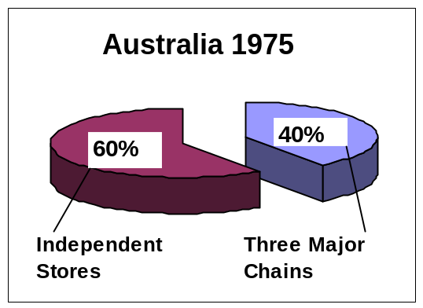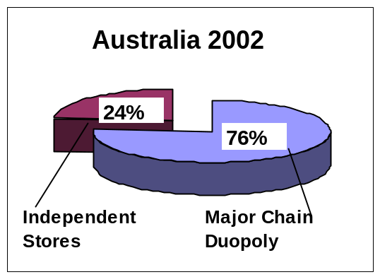

Recent years have seen a relentless flow of creeping acquisitions by the Chains. Between January 1995 and July 2001, the Chains acquired 60 independent retailers on the Eastern Seaboard and South Australia.

The impact of this activity on market share can be seen quite clearly in the following diagram, which plots the national market share statistics between the Chains and Metcash/ Independents since 1995. The red bars show the dramatic drop off in Metcash/ Independent market share (with the corresponding kick in Chain market share) up until 2000. From this point the market share for Metcash/ Independents started to improve as the banner rationalisation strategy started to take effect and IGA was re-launched. Onwards from there saw the demise of the ‘old’ Franklins and its sell-down to both the Chains and Independents, followed by the closure of Woolworths AIW wholesale division with the defection of key customer groups back to the Metcash fold.

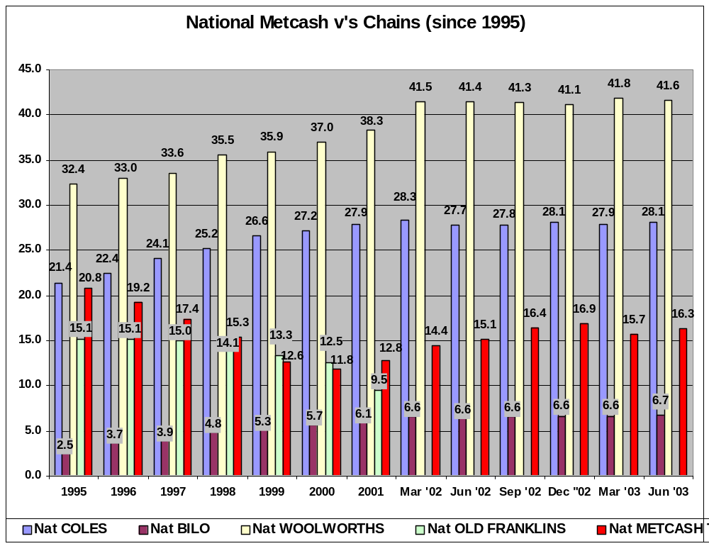

The following diagram provides a graphic illustration of the cumulative effect of the creeping acquisitions, which when measured in today’s dollars amounts to 13% of Metcash current sales volume on a constant dollar basis.

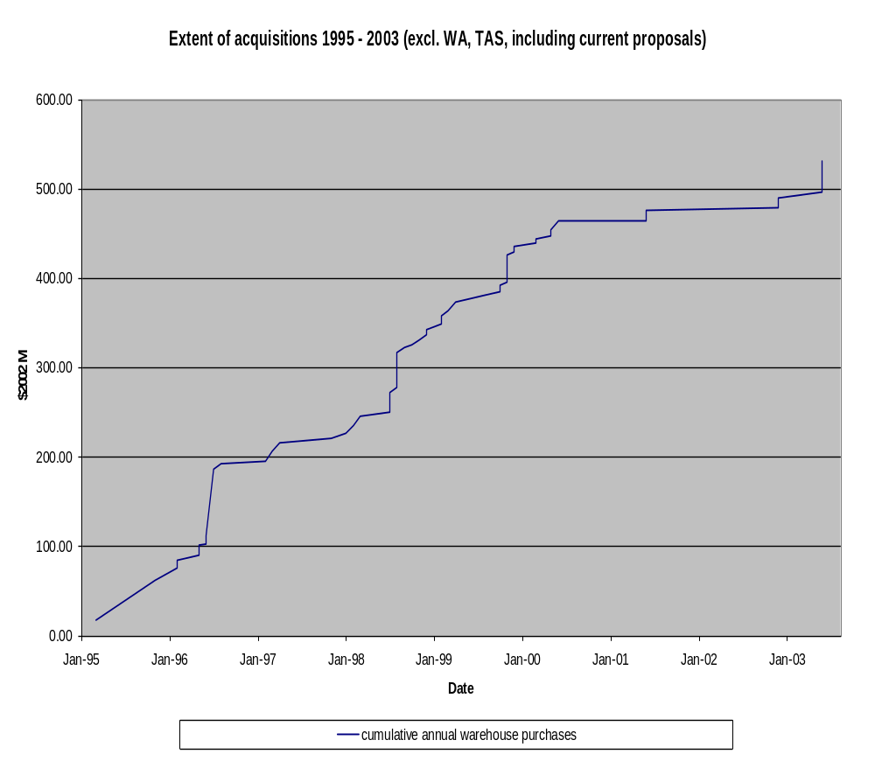

In the last 26 months 20 stores have been lost to creeping acquisitions by the Chains. More significant still is the fact that 17 of these acquisitions have occurred since September 2002 signaling a concerted and targeted strategy by the Chains (and Coles in particular). In Victoria, where most of these acquisitions have occurred, Metcash has lost 1.40% market share in the last 3 months alone.

Indeed, the fact that all of the recent acquisitions have been by Coles/ Bi-Lo signifies the adoption of a specific predatory strategy by that Chain. This is of further interest in the context of public statements by Coles Myer Chief Executive John Fletcher who said earlier this year that the grocery industry risked chronic overcapacity because of the boom in supermarket openings. Mr. Fletcher went on to say that growth rates across the $60b-plus sector would drop to about 3% by 2005 and revenues and margins would eventually come under pressure such that it was hard to see how the Chains vying for profit growth to satisfy shareholder demands could deliver appropriate returns on investment.

In such an environment, buying up established and profitable Independents seems like one of the few quick-fix growth strategies available to Coles. In many circumstances it addresses two key growth criteria: it provides instant market share and it removes a competitor. Anecdotal evidence exists to show that the strategy is so obvious that Coles have mistakenly walked into the wrong store offering to purchase it - suggesting no meaningful due diligence was performed and tending to confirm the ‘cheque-book’ mentality.

It is arguable also whether there is a ‘predatory pricing’ aspect to this activity, since Coles’ balance sheet is undoubtedly able to carry the ‘excess’ goodwill inherent in the above-market purchase multiples being used to acquire these Independents without a significant degradation of its Return on Equity targets. Similarly, it’s profit and loss account is able to bear the resulting amortisation; its shear size enabling the cost to be born over a larger base.

Details of the stores lost and their associated volume loss to Metcash are as follows:

 | Stores Lost to Chain Acquisition since June 2001
 | Store | Brand | Date lost | Annual W/house sales
 |  |  |  | $ 000s
 | VIC
1 | Narrandera | IGA | Sep-02 | 3,363
2 | Mooroopna | IGA | Nov-02 | 5,355
3 | Ararat | IGA | Nov-02 | 4,760
4 | Myrtleford | IGA | Feb-03 | 4,023
5 | Brunswick | IGA | Mar-03 | 7,928
6 | Daylesford | IGA | Jul-03 | 7,570
7 | Cowes | IGA | Aug-03 | 7,619
8 | Keysborough | IGA | Aug-03 | 2,758
9 | Drouin | AUR | Aug-03 | 5,200
10 | Wallan | AUR | Aug-03 | 4,160
 |  |  |  | 52,736
 | NSW
1 | Coonabarabran | IGA | Mar-03 | 2,080
2 | Gulgong | IGA | May-03 | 2,860
3 | Umina | IGA | Aug-03 | 6,240
 |  |  |  | 11,180
 | QLD
1 | Palm Beach | IGA | Feb-03 | 6,188
2 | Charters Towers | IGA | Apr-03 | 4,108
 |  |  |  | 10,296
 | SA
1 | Clarke's Barmera | Foodland IGA | May-03 | 3,224
2 | Broken Hill South | Foodland IGA | Nov-02 | 1,872
3 | Clarke's Loxton | Foodland IGA | Jun-01 | 3,640
4 | Clarke's Waikerie | Foodland IGA | Jun-01 | 3,432
5 | Clarke's Berri | Foodland IGA | Jun-01 | 2,808
 |  |  |  | 14,976
20 | Total |  |  | 89,188

The Impact on Metcash
Taking the above total of Annualised Warehouse Sales Lost and expressing it as a proportion of MTT’s FY2003 Sales yields a percentage of business lost of 2.4% (on a simple annualised basis). The Network Economics Consulting Group (NECG), in it’s “Report to ACCC re: Creeping Acquisitions” states that a loss of 10% volume would almost wipe out Metcash’s EBIT as the Independent sector disintegrates into a vicious downward spiral of declining competitiveness. (Note: the findings contained in the NECG Report are summarised in Section 6 of this Submission and the full report is also attached as an Annexure).

NECG calculate that a 10% loss of business would increase Metcash on-invoice costs by more than 1%. In addition, the corresponding drop in effective transport utilisation would result in an 11.8% increase in transport costs.

At a 6% volume loss, Metcash’s return on equity is reduced to the level of interest costs. At or before this point Metcash would be unable to attract equity, becoming an unviable competitor. Even before this point, Metcash’s ability to provide effective retail support services would be jeopardised.

At a 6% loss in volume – and we are now over 33% of the way there already – the Independent Sector would be in serious trouble and unable to act as a strong competitive “third force”.

In fact, if you extrapolate the current loss rate Metcash will have lost 10% market share somewhere around December 2004. This isn’t as fanciful as it sounds with some market commentary suggesting Coles have targeted in the region of 60 Independent stores for acquisition. The impact is shown diagrammatically below.

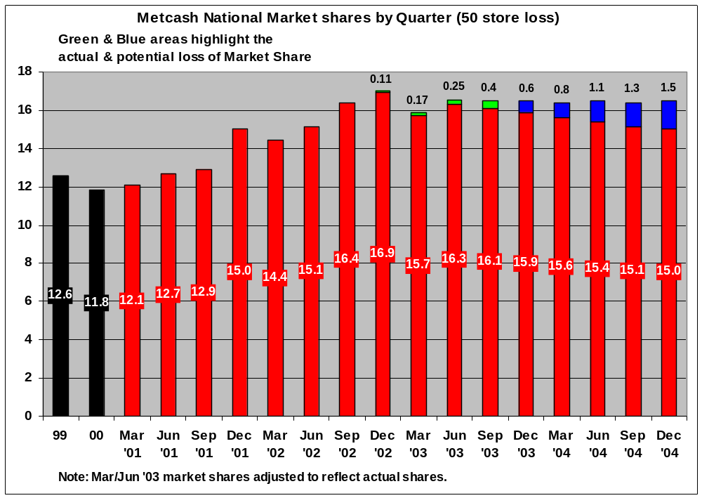

The NECG-calculated 1.8% volume loss is more than one quarter of the 6% viability threshold; and their revised figure of 2.2% is more than one third. Volume losses to the independent sector since 1995 have been more than double the 6% viability threshold.

NECG factor their analysis on 16 identified creeping acquisitions (all included in the list above), collectively accounting for 1.8% of Metcash’s volume, which they estimate would cause a 17% decline in EBIT if Metcash chose to absorb the cost impact. The effect of creeping acquisitions is to shift the demand curve facing Metcash to the left, forcing it to move up its cost curves (as illustrated in the diagram below), both in terms of logistics costs and buying prices – i.e. “on-invoice costs” and “off invoice contributions”.

Creeping Acquisitions and Metcash’s Cost Base
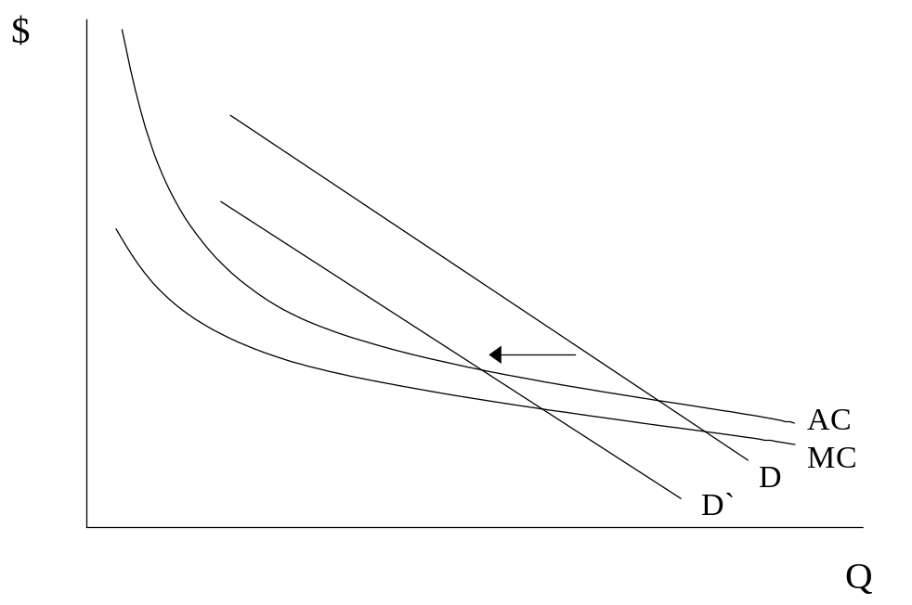
D – Currecnt Demand
D’ – New Demand after effect of acquisition dimunition
AC – Average Cost Curve
MC – Marginal Cost Curve

It is important to understand the terms “on-invoice costs” and “off invoice contributions” as they are a critical aspect of the wholesaler’s business and its ability to provide competitive product prices to its Independent retailers.

Suppliers achieve cost savings by delivering their products in whole truckloads or some other minimum order quantity. In order to incentivise wholesalers to order in quantities that are convenient to deliver, it is common practice for suppliers to offer ‘quantity buy allowances’, or ‘volume discounts’. These discounts appear on the wholesaler’s invoice and they are generally passed directly on to the wholesaler’s own customers.
A firm the size of Metcash deals with a great many suppliers, and for many of these the quantity buy allowance is not under immediate threat. Nevertheless, there are a number of important product lines where Metcash’s quantity buy allowance would be affected in the event of a relatively small but sustained decrease in market share.

Metcash has identified those suppliers whose quantity buy allowances would be at risk if Metcash reduced order quantities by 10 per cent. Taking a sample of the 10 ‘most at risk suppliers’ showed them to represent 20% of Metcash’s purchases of groceries. On the basis that each of these important suppliers (they each offer significant quantity buy allowances) either withdraw or reduce these allowances in the event that Metcash orders 10 per cent less from the supplier on a sustained basis, this would increase its weighted average on-invoice costs by 1.1 per cent. Ordering the reduced volume in the minimum buy-order quantities less frequently would not be a substitutable option as there would be higher warehousing costs flowing from slower stock turns and increased working capital costs. The cost of product to Metcash’s Independent retailers would inevitably increase, thereby reducing their competitiveness.

Yet the volume effects on ‘off-invoice’ contributions are likely to be the most important effects in dollar terms. These contributions consist of such things as rebates paid by suppliers to a wholesaler to reward achievement of certain pre-determined sales volume, sales growth, or promotional success targets on a whole of relationship basis. These rewards are not invoice-specific, as they do not relate to any specific product or any specific purchase. They include promotional monies, prepayment of advertising expenses, and a range of benefits that are commercially negotiated between suppliers and wholesalers. The range of possible forms these benefits might take is wide yet the benefits are all quantified in supplier agreements. Additionally, the benefits are all contingent upon Metcash continuing to succeed in selling the supplier’s product. Any reduction in Metcash’s sales of a supplier’s product will have adverse consequences for these off-invoice benefits.

In their analysis NECG estimate that a 10% volume reduction would result in a 1.3% reduction in net supplier payments to Metcash. Metcash could either choose to bear this reduction through its own EBIT line or pass it on to Independent retailers. Irrespective, the ultimate impact on Independent competitiveness is the same as either Metcash goes out of business or the Independent retailer does, and eventually both.

The Impact on Metcash’s Customers
Targeted stores tend to be the larger and most profitable independent supermarkets, involving significant loss of volume to Metcash and thereby buying capacity to the whole Independent sector. More significantly from a competition perspective, the presence of an independent supermarket in a local retail market has a significant downward impact on the prices of a large number of products in an average basket of goods, particularly vis-a-vis Coles which lately has been the most rampant predator.

Indeed, as previously indicated, NECG found that the number of products with the lowest average Chain store price, increases both with the number of local players and when the composition of a local duopoly or triopoly shifts towards independents. This is illustrated in the following analysis assembled by NECG:

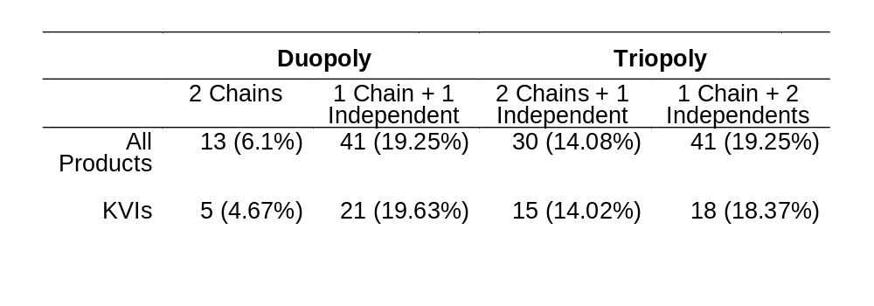Number of Lowest Average Chain Store Prices by type of Duopoly/Triopoly
KVI = Known value items – those items supermarkets believe consumers are price sensitive to

The Impact on Metcash’s End-Consumers
This implies that prices vary across locations according to the degree of price constraint imposed by the local market structure. The more local market players there are, and specifically the more independent supermarkets there are, the lower will be Chain store prices. As a result, individual acquisitions which reduce the number of local rivals, and specifically remove an independent supermarket from a location, are likely to have an adverse effect on local prices, and most likely on non-price competition as well.

If the cost increases resulting from the 1.8% volume reduction were passed on to retailers, this would increase retailers’ costs by 0.4 per cent, equivalent to a 12.4 per cent increase in the wholesale service fee (ie the ‘price’ of the wholesale service). A 10% volume reduction would increase retailers’ costs by 2.4 per cent, equivalent to a 56 per cent increase in the wholesale service fee. If this increase was passed through to final consumers and matched by the Chains, it would equate to an additional $10.92 on the average household’s monthly grocery bill, and likely increase the Chains after tax net profit by more than 50 per cent.

A 7% volume loss would reduce a retailer’s returns to less than their cost of debt—meaning that independent retail store ownership would become unviable unless they could raise prices to consumers.

Thus, it must be recognised that a ‘cosy duopoly’ structure would lend itself to a significant reduction in head-to-head price competition on the vast bulk of items purchased by consumers.

However, this risk is substantially reduced when an independent sector is present. Independents will generally operate to a somewhat different cost structure from the Chains and may well have differing objectives from the Chains. Additionally, the fact that there is a degree of vertical separation between the independent sector and the Chains makes price coordination in the presence of an effective independent ‘third force’ extremely unlikely.

Were this the case, a further move to a Chain store duopoly, effected through a sequence of individually small-scale acquisitions of independent supermarkets, could substantially lessen competition in Australian grocery markets. Such an effect is all the more likely to occur since the barriers to entry into these markets are significant so that competition, once removed, is not readily re-established.

Barriers To Entry
Creeping acquisitions can only be effective in decreasing competition and raising costs to consumers if there are significant barriers to entry in the market for the distribution of groceries to the public. Otherwise the threat or reality of entry would replace the competitive constraint imposed by the independent sector. Indeed it is really barriers to entry at the retail level that are the most critical. Given the decreasing average costs (both real and pecuniary) associated with the scale of wholesaling operations (whether independent or vertically integrated), a potential entrant at the wholesale level must be able to accrue a critical mass of customers to compete effectively with the Chains.

If creeping acquisitions have undermined the cost base of Metcash, any potential independent wholesale entrant would have to be able to both acquire and expand the Metcash customer base in order to provide an equivalent effective competitive constraint on the Chains, and hence would have to be able to attract or sponsor new retail entry. Similarly, to replicate the competitive constraint currently imposed by the independent sector, a vertically integrated entrant would have to establish enough of its own retail outlets, either by acquiring some or all of the remaining independent customer base and/or by establishing its own new outlets. (Even then, a vertically integrated operator may not impose the same degree of competitive constraint as the independent sector now does as its cost structures and objectives are likely to be more closely similar to those of the Chains). In either case, it is clear that the ability of a new player to replace the competitive constraint the independent sector now imposes depends critically on barriers to entry at the retail level.

Barriers to entry at the retail level arise from access to scarce retail sites, economies of scale and sunk costs. While there may be no shortage of potential retail sites in some absolute sense, there is clearly a scarcity of valuable sites. A potential retail site is only valuable if it is likely to attract a critical mass of customers. This will depend on its location in relation to population and other supermarkets and retail outlets and convenience of access.

The importance of attracting a critical mass of customers is, in turn, linked to economies of scale at the store level. Retail operating costs (excluding the cost of goods) comprise primarily property costs, heat and power bills, equipment and vehicle costs, insurance, wrapping and other consumables, wages and advertising costs. Wages and labour on-costs comprise approximately half of a retailers’ total operating expenses. While a retailer has some scope to adjust these costs in relation to volume, there will also be a base level of staffing that is required to fill shelves, operate checkouts and so on. The UK Competition Commission’s examination of retail labour costs found significant scale economies up to store sizes of 3,000m2 and, more significantly, increases in sales density (sales per m2) of stores was associated with significantly smaller increases in staff costs.

Other operating costs are essentially fixed, apart from the extent to which rent is linked to retail turnover. Again the UK Competition Commission found significant scale economies, and more especially economies of sales density, associated with these costs.

Accordingly, there will be significant cost economies associated with a larger customer base. Sunk costs at the retail level would include the unrecoverable elements of property costs, stock costs, the costs of store fitout, advertising and promotion. Obviously these costs will vary by location and store size.

In 1995 the cost of a new supermarket development, in terms of fit out and stock, was approximately $4 million and the cost of a major refurbishment around $1 million. Applying a CPI adjustment to these figures, in 2002 prices the cost of a new supermarket development would be $4.7m, and the cost of a major refurbishment would be $1.18m. The combination of significant economies of scale together with some level of sunk costs at the retail level can be a significant barrier to entry: a potential entrant must sink costs in establishing a new store, but will be unable to recover those costs and is unlikely to be profitable unless it can capture a critical mass of customers.

Access to retail sites is also a significant barrier to retail entry, most particularly for independent retailers. As discussed above, there is necessarily a shortage of valuable supermarket sites. In addition, independent retailers face particular problems in accessing these sites because the stores are owned and operated by individuals who do not generally present developers and potential buyers of retail developments with a ‘known entity’, such as Coles, Woolworths and Aldi. As the OECD noted in 1992:

“A close link exists between the planned shopping centres and the large multi-site, diversified retail chains. Developing a shopping centre entails high sunk costs — and hence considerable exposure to risk. To control this risk, developers seek tenants whose product mix and operating type are known and successful, and with a predictable ability to attract customers and generate revenue”
If a developer can secure one of the Chains as an anchor tenant, the site becomes more valuable to potential buyers and hence they are able to pay more to acquire it. Rents are calculated in relation to retail turnover and property owners are often prepared to accept a lower but less risky return from a Chain store than the unknown entity of an independent supermarket. In addition, specialty stores are prepared to pay higher rents to be co-located in a shopping centre with a Coles or Woolworths than with an independent. The Tribunal noted the difficulties encountered by independent retailers in gaining access to retail sites in its 1995 determination Re: QIW, and noted the significance of Foodland’s role in securing independent access to retail sites in Western Australia through direct involvement in shopping centres, which had assisted the independent sector to maintain its market share in that state.

The sunk costs of entry as a pure wholesaler are not huge in an absolute sense. Warehousing can be rented and transport services sub-contracted. Other sunk costs would include the establishment of logistics and other systems such as pricing support, and the not insignificant, but difficult to quantify, costs of establishing relationships with suppliers and developing a reputation for reliability in the marketplace. For a player such as Foodland, with an established base in Western Australia, many of these systems and relationships are already in place.

However, regardless of this, the substantial cost economies associated with large scale wholesaling, make the establishment or acquisition of a critical mass of retail customers essential for entry. While a base of 40 supermarkets may be sufficient to achieve the major cost economies associated with warehousing and logistics, this is clearly not the case in relation to the cost economies associated with on- and particularly off-invoice terms available from manufacturers.

This is consistent with the findings of the Tribunal in 1995, which recorded the evidence of one industry participant that effective new entry to compete against the Chains would be “almost impossible” because of the advantages of scale in relation to buying power, access to capital, advertising effectiveness and so on. Given the importance of achieving a large critical mass of retailers for effective wholesale entry, the barriers to retail entry also become barriers to wholesale entry. The Tribunal concluded that “this massing of retail sales volume is the key ‘sunk cost’ that would make new entry on a national scale almost impossible.” This implies that once lost, the competitive discipline imposed by the independent sector is unlikely to be regained.

3. THE PART Metcash PLAY IN THE Grocery MARKETPLACE

Overview

Diagrammatically, the essence of the role that Metcash plays in the grocery marketplace can be summarized as follows:

Competitive Structure of the Grocery Industry

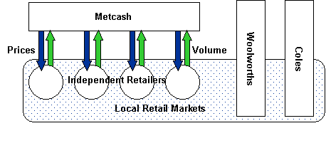

However, the above is simplistic in that it really only hints at the range of services and the key role Metcash plays as wholesaler, service provider and champion of the Independent sector. Before exploring the varied aspects to Metcash’s “value-add” proposition let us first provide some context by recapping the Metcash story.

3.1 History – The Metcash Story

… Starting In May 1998
Metro Cash & Carry Limited gained control of more than 70% of the issued share capital of the then ‘ailing’ Davids Limited in May 1998. At that time the Company was in serious financial trouble and was experiencing poor relationships with both its customer base and its suppliers. At the time Metcash acquired Davids it comprised four divisions:
- Davids Distribution – now IGA Distribution – which serviced the needs of approximately 4400 independent retailers. This division also incorporated a Retail arm comprising approximately 100 predominantly Jewel supermarkets;
- Australian Liquor Marketers (ALM – 50% owned) – being the leading broad range liquor wholesaler operating throughout Australia with 12 warehouses serving over 11,000 customers;
- Campbells Cash and Carry – comprising 36 wholesale cash and carry warehouses carrying 12,000 food and related items serving the needs of some 25,000 active customers in the grocery, food service, convenience store and small business sectors on the Eastern seaboard of Australia and South Australia;
- John Lewis Foodservice – which comprised 14 specialist food service warehouses carrying 8,000 catering products serving the needs of over 9,000 customers including restaurants, hotels, canteens, fast food outlets, clubs and other catering establishments.
Metcash has since sold John Lewis Foodservice after a strategic review of its core operations in 2001. In May 1999 Davids/ Metcash purchased the other 50% of ALM.

The Financials
The financial turn-around in Metcash’s fortunes can be best summarised via the following Financial and Statistical Highlights extracted from recent Annual Reports.

FINANCIAL & STATISTICAL HIGHLIGHTS - FIVE YEAR REVIEW (Incl 10 month 1999 period)
 |  |  |  |  |  |  | 10 Months
 |  |  | 2003 | 2002 | 2001 | 2000 | 1999 | 1998
 |  |  | $'000 | $'000 | $'000 | $'000 | $'000 | $'000
INCOME STATEMENT
 | Net Sales |  | 6,695,519 | 5,769,379 | 5,378,293 | 5,147,653 | 3,372,341 | 4,566,274
 | Earnings before amortisation, interest and tax |  | 152,704 | 117,481 | 91,072 | 74,607 | 48,764 | 19,037
 | EBIT |  | 133,549 | 98,915 | 69,101 | 55,344 | 37,095 | 7,405
 | Interest |  | 7,503 | 9,689 | 15,058 | 14,442 | 8,966 | 24,725
 | Operating profit before tax |  | 126,046 | 89,226 | 57,043 | 40,902 | 28,129 | (17,320)
BALANCE SHEET
 | Shareholders Equity |  | 427,105 | 343,634 | 354,004 | 341,946 | 356,972 | 408,513
 | Net Tangible Assets/ Share (cents) |  | 29 | 16 | (12) | (21) | (8) | 0
 | Debt/ Equity (%) |  | 29 | 51 | 66 | 76 | 46 | 38
OTHER STATISTICS
 | EPS |  | 13 | 9 | 4 | (3) | 0 | (3)
 | Dividends per share |  | 8.6 | 5 | 1.5 | 0.5 | 0 | 0
 | No Employees |  | 4,202 | 4,156 | 5,220 | 8,460 | 10,463 | 12,109

The Turnaround Strategy
At the time of the acquisition, a drastic restructuring of the Davids operations and the way in which it conducted its business was required. The main aspects of the restructuring involved:
  - The disposal of more than 100 retail stores to individual operators now running them as IGA bannered stores. This recognised that the Company’s core competency was not in retail but rather in wholesale and that it did not belong as a competitor in the same market as its customer base;
  - The reduction of banner groups from 29 to 3 (discussed further below);
  - The restoration of the faith and support of suppliers and manufacturers;
  - The restructure of the Group into four separate business units with appropriate delegated responsibilities and accountabilities (as opposed to the previous unsatisfactory position where all decisions were centralized);
  - The achievement of significant cost savings and efficiencies in our distribution centres throughout the country.

The successful implementation of these strategies and the achievement of targeted objectives restored the Group to profitability in Financial Year 2000 and enabled resumption of dividend payments (refer Table above). The turnaround also facilitated the change of the Company’s name to Metcash Trading Limited in September 2000.

Shortly after its acquisition by Metcash, Davids’ share of grocery sales reached a trough. Whilst a significant part of this long term downward trend in market share was associated with the ‘creeping acquisition’ of Independent retailers by the Chains (as detailed previously), matters were not helped by a fragmented and confused marketing offer in the Independent sector.

At that time, Davids supported 19 different banner groups in NSW, 17 in Victoria, 8 in Queensland and 5 in South Australia. These multiple banners have since been consolidated into essentially three different IGA banner groups: Supermarkets, Everyday and Friendly Grocer or Express. The IGA brand is effectively controlled by Metcash in Australia and licensed to Independent store operators. This rationalisation has enabled promotional spending by retailers to be more effectively utilised and focused, with each individual banner receiving a much larger share of promotional funds, increasing exposure and the number of promotional slots over the year. IGA now spends in the region of $34 million annually on advertising.

The larger scale of individual promotional programs also makes it worthwhile for manufacturers to invest in unique and dedicated marketing programs for those banners. This banner rationalisation has been a major reason for the subsequent resurgence of both the Independent Sector and the corresponding success of Metcash.

Through a combination of good management and good fortune, Metcash has managed to rebuild the ‘market’ share of the Independent sector in the Eastern States and South Australia, as can be seen in the diagram below.

Metcash’s share of packaged grocery sales (excluding tobacco)
1995–2002

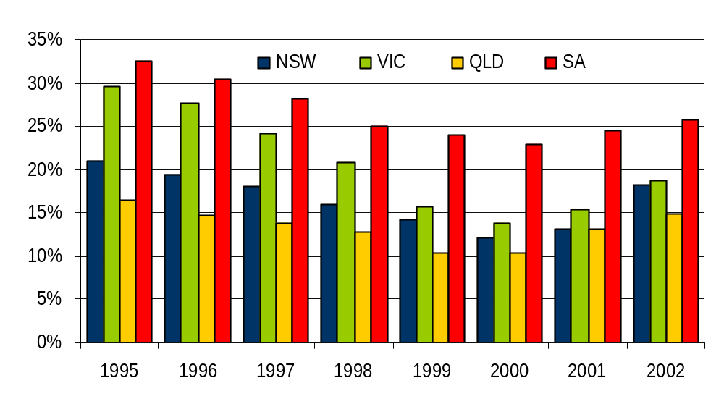

Note: Data includes all volume through the Metcash warehouses, including IGA, Franklins, Foodworks, AUR and Campbells Cash & Carry.

Besides rationalising banner groups and promotional programs, Metcash has also focused on increased Independent store discipline in relation to pricing and store standards. Stores have to meet certain standards, in terms of pricing, product range, floor space and quality of service, to be eligible to join any particular banner group. The increased promotional funds available to the rationalised banners itself encourages greater promotional price discipline, as the stakes are now higher.

The other critical leg to the turnaround strategy was to renegotiate supply terms with manufacturers, both of grocery items sold in the stores and other inputs used by retail grocers, from shopping trolleys and storage racks to delivery vans.

Finally, Metcash dramatically improved retail support services, such as assisting retailers with store design and refurbishment plans; provision of food retail specialists to better range and merchandise stores; facilitation of a $200 million Grocery Sector Finance Policy with Westpac enabling access to funding for store acquisition, refurbishment and extension; facilitation of a Succession Planning Program enabling retailers to better plan for effective exit strategies from their businesses as well as bring new blood into the sector; provision of domestic and overseas study tours enabling retailers to keep abreast of emerging retail trends; provision of expert retail systems services to enable retailers to leverage technology improvements; to name but a few of the broad range of value adding services Metcash offers its customer base.

The Expansion
In 2001 Dairy Farm, which owned Franklins Ltd, decided to undertake a managed exit from the Australian grocery industry. Woolworths acquired 72 stores, with the balance of 200 stores being offered to Independent retailers through the Joint Independent Divestiture Alliance (JIDA) program, operated jointly by Franklins and Metcash. Metcash customers eventually acquired 104 stores. Fifty of these stores are owned by Interfrank (a subsidiary of Pick n Pay) operating under the ‘Franklins’ brand and are supplied by Metcash. Foodland acquired 40 stores, operating under the ‘Action’ brand and supplied from their own warehouse in Queensland. Coles/Bi-Lo acquired 32 stores.

This process resulted in the entry of two new independent retail chains in the eastern states, Interfrank Holdings Pty Ltd which also acquired the ‘Franklins’ brand, and Foodland, operating under the Action brand. As a result of various undertakings given to the Australian Competition and Consumer Commission (ACCC) in relation to the Woolworths and JIDA acquisitions, there was a twelve-month moratorium on the acquisition of any JIDA stores by the chains.

The JIDA process boosted Metcash’s ‘market’ share significantly, since the former Franklins stores acquired by Independents (excluding FAL controlled Action stores) were now supplied by Metcash. In 2002 Metcash’s market share was further boosted by winning contracts to supply Foodworks and Foodway stores, previously supplied by Woolworths AIW wholesale operations, which subsequently closed down. Importantly, this boost to market share further contributed to strengthening the competitive position of all Independent retailers because it has assisted Metcash in gaining improved terms of trade from grocery manufacturers

However, even excluding the impact of the Franklins and Foodworks acquisitions, Metcash’s market share has been growing, albeit less rapidly, adding approximately two percentage points in market share in each state in which it operates other than NSW between 2000 and 2002. This most likely reflects the improved terms of trade, rationalisation of banner groups, retail support and store discipline which Metcash has introduced to the business.

Accordingly, by the second half of 2002, Independent retailers, supported by Metcash, were in a strong position to provide a significant competitive challenge to the chains. This is reflected in A. C. Nielsen Homescan data showing that ‘other supermarkets’ (IGA, Action and Aldi) made the greatest gains from shoppers switching stores in 2002, with Woolworths and Bi-Lo actually showing a net loss to these stores. However, this position is now threatened by the re-emergence of the creeping acquisition of Independent retailers, particularly by Coles, which we understand has been looking to acquire 30–60 new stores threatening to undermine the Independent sector’s volume and hence the competitive position of all Independent retailers.

Metcash Today
In summary, Metcash now comprises three profitable and highly effective divisions:
- IGA Distribution
  - Who’s self appointed role is to be the ‘Champion of the Independent Retailer’.
  - Acting as marketing and distribution specialists, supplying over 4,500 Independent grocery outlets in NSW, Queensland, Victoria and South Australia.
  - Providing expertise, tailored to the Independent Retailer’s requirements. From the full range of marketing, merchandising, buying and distribution services to the 1,138 IGA stores to distribution for the 70 Franklins stores, the 180 Foodworks stores and over 500 AUR stores.
  - Operating 8 major distribution centres, benchmarked to international standards, to deliver 20,000 SKU’s of dry, chilled and frozen groceries to 4,500 independent retail grocery stores spread far and wide across the Eastern seaboard and South Australia.
- Australian Liquor Marketers
  - Broad range liquor wholesaler, supplying over 13,000 hotels, liquor stores, restaurant and other licensed premises throughout Australia and New Zealand.
  - Major focus on providing outstanding customer service including strong marketing support and to fulfill all orders in full, on time, every time.
  - Provides retailers with a one-stop shop that allows them to receive all their liquor supplies in one delivery, on one invoice, with pricing maintained specifically for each marketing group.
  - Operates out of 21 distribution centres throughout Australia and New Zealand ranging from the recently commissioned Laverton warehouse of 10,000sqm to the smaller regional warehouses such as Hastings in New Zealand at 1,000 sqm.
  - Specialist on-premise liquor supply and support to the on-premise liquor supply and support to the on-premise sector including bars, restaurants and hotels through Harbottle On-Premise.
- Campbells Cash and Carry
  - Operates 38 self-service and distribution warehouse facilities across NSW, Victoria, Queensland, South Australia and the Northern Territory.
  - Carries a broad range of fast moving consumer goods and services to more than 8,000 business customers.
  - Recently launched CStore Distribution warehouses in Sydney, Melbourne and Adelaide to provide an efficient marketing and distribution solution to the petrol and convenience sector and other independent convenience store operators.

Metcash’s purpose …
In the Independent sector is best summarised by its ……

Mission statement
“To be the Marketing and distribution leader in food and other fast moving consumer goods”

Whilst it aims to conduct it’s everyday business with the following core values underpinning its culture:

OUR
Championing the Customer
Our Stakeholders are Entitled to Added Value
Responsibility and Personal Accountability
Empowering our People and Supporting our Communities

VALUES
- are nothing without integrity.

3.2 How the independent sector operates

The Diagram below usefully summarises the transaction flows existent between Metcash and Independent Retailer.

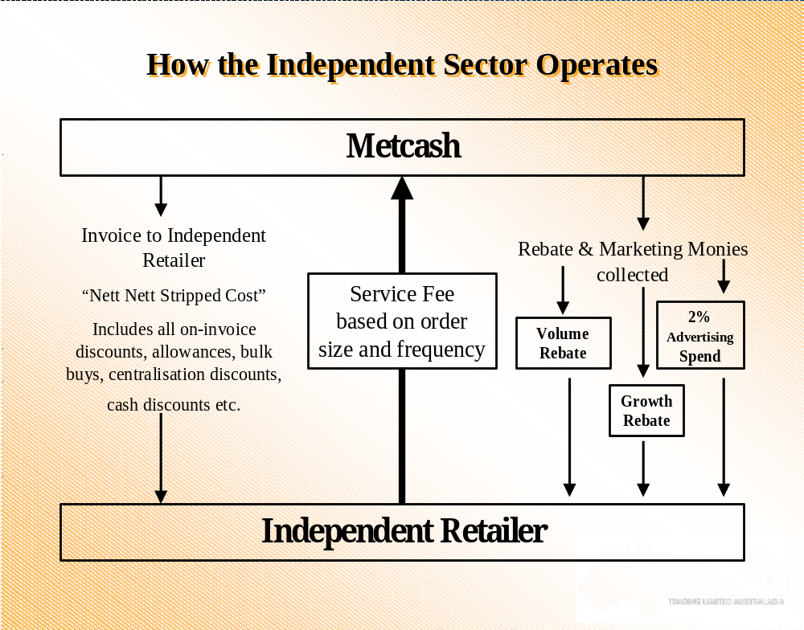
Working from left to right it shows how Metcash charges the retailer “Nett Nett Stripped Cost” (this represents the supplier’s normal cost less all on-invoice discounts, allowances, bulk buys, centralisation discounts, cash discounts etc).

Metcash recovers a service fee from the Retailer based on the order size and frequency. It also recovers the freight delivery cost.

Finally, it passes on Rebate and marketing monies collected from suppliers. The methods of passing these monies on vary from volumetric rebates to growth incentive rebates to advertising funds.

A core question to be addressed is: “surely, as a ‘middleman’, Metcash just adds cost to the supply chain such that the Independent Sector is an inefficient competitor anyhow?”

In fact, the following diagram illustrates the efficiency with which Metcash plays its role of Wholesale Distributor to Independent Retailers.
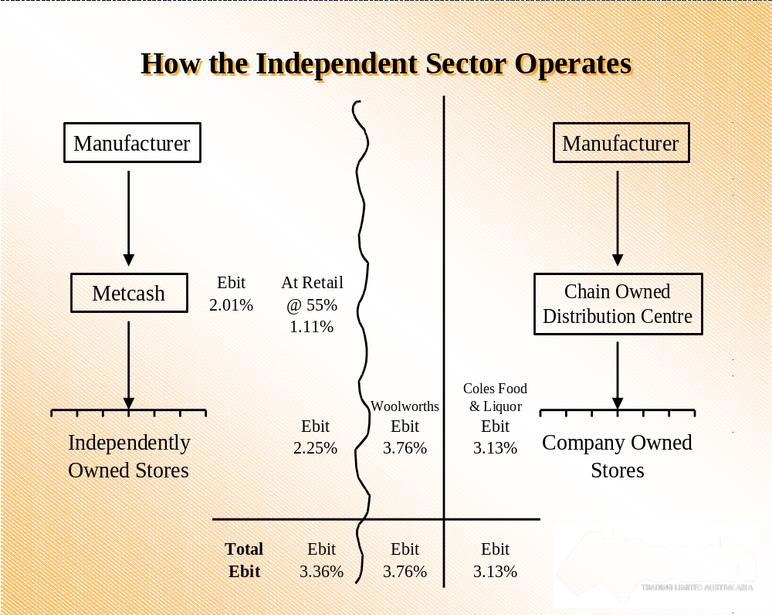

It quite clearly shows that when Metcash and its Independent Retailer Customer are treated as a ‘virtual chain’ and their respective EBIT’s are aggregated, they are comparable and certainly competitive with the Chains. It is arguable that were comparable supplier terms allowed to Independents (via Metcash) the relative EBIT performance would be even closer.
In addition, Section 3.4 below outlines the world-benchmarked logistical efficiency by which Metcash runs their distribution operation.

3.3 THE METCASH VALUE-ADD (SERVICES PROVIDED)

Besides the core competency of warehousing and distribution of fast moving consumer goods, Metcash also offers a vast range of ancilliary value-added services. This is best exemplified by its service offer via its IGA Distribution division to its IGA branded stores.

What It Means To Be Branded An IGA Store

The following Introductory Letter from Lou Jardin, CEO of IGA Distribution is useful in summarising what it means to be a part of the IGA family:

Grocery retailing is an exciting, dynamic industry to work within. Over 1,000 IGA retailers in Australia have developed a unique style and enthusiasm for their businesses. The IGA brand has been accepted and embraced in the marketplace and continues to evolve with new initiatives, programs, promotions and sales drivers.

IGA is the leading Independent retail grocery brand in this country, and as such, has benefits that no other brand can offer.

IGA Distribution is the ‘champion of the Independent Retailer’. A professional and intrinsic support network, backed by volume buying and negotiating power allows IGA retailers the comfort of knowing that they are part of the IGA family, and that their needs are more than met by their wholesaler.

The successful partnership of IGA Distribution and IGA retailers has built a dominant, market-leading brand in Australia.

Lou Jardin
Chief Executive Officer
IGA Distribution

Basic Philosophy
At the heart of Australian IGA Retailers is the Philosophy of personal service, the type that has been built on a special sense of community spirit and pride. IGA businesses do not just happen to be successful, they are made successful by retailers who care for their customers, who personalise the shopping experience and who give back to the local community that supports their store.

The IGA brand stands for community involvement and local, personal service. This brand positioning is no accident. IGA retailers are passionate about their customers and are given the tools and programs that both perpetuate and reinforce this advantage.

As independents unified under one brand, IGA retailers benefit from national marketing exposure, but impact locally on their communities and immediate customer base.

Actively promoting ‘It’s your IGA’ is the responsibility of everyone who comes into contact with the brand. After all, IGA belongs to everyone. IGA belongs to the consumer, as their local store. IGA belongs to the retailer, as their livelihood. IGA belongs to the warehouse, as their core business.

The Range Of Services Provided to IGA Independent Retailers

Equity Finance
- By means of a unique and totally exclusive deal, IGA retailers have access to $200 million for use in store re-investment and refurbishment and new store opportunities.

- The equity finance deal (between Westpac, IGA Distribution and Datacaap) differs from the traditional bricks and mortar loan that banks have offered in the past. IGA stores have the advantage of belonging to a group of more that 1,000, which gives each store the benefits associated with being a Chain, but the ability to act locally. Standards, disciplines and compliance under IGA means that money can be lent, based on business performance and projections without the need for traditional security (conditions do apply).

Retail Merchandise Service (RMS)
- An RMS function resides within the Distribution Centre that provides General Merchandise service and support at store level. This department has the track record to improve your store’s profitability, sales and performance within the General Merchandise area.

File Hosting
- IGA Distribution provides pricing support to retailers. By downloading the host pricing file to the store’s back office, the retailer can have IGA Distribution provide different pricing fields by competitive area, sales, or categories.

IGA Brand Range
- IGA retailers have access to the exclusive IGA Brand, with a range of over 300 SKU’s.

Benchmarking
- Chain stores have the advantage of being able to monitor individual store performance benchmarked against the total group, or stores of similar size and customer demographics. This invaluable benchmarking tool allows management to sharpen certain aspects of the business and see in which areas stores can outperform others.

- IGA Retailers have the opportunity to use the services of Datacaap (an independent benchmarking company) and under a scaled fee structure, detailed, on-going reports are provided. Budgeting, wages, department performance and a variety of other business indicators are benchmarked against IGA stores across the country, assisting retailers with their business plans to help grow and re-invest in their business.

The IGA Coca-Cola Training Institute
- The IGA Coca-Cola Training Institute has a complete library of training programs that have been tailored to the independent grocery industry, while others are accredited business performance course.

- Courses range from basic levels through to advanced, covering topics that extend from customer service to business accounting.

Business Manager Specialist Support
- The IGA field force actively works with IGA retailers on a day to day basis. Their objective is to assist retailers in improving store performance and profitability, while assessing standards for the benefits of the entire group.

- Each region is supported by a Retail Business Manager who is a critical link between and IGA store and IGA Distribution. They are there to assist in growing IGA businesses, as well as the store’s sales and profitability.

- Store contact and support extends beyond the role of the business Manager and into the areas of fresh food. A team of specialists works with IGA retailers to actively improve the standards and performance of these departments within a store.

- Strategies and plans are developed, and knowledge and information shared, as the IGA Distribution team and IGA retailers work together to gain more from these specialised areas.

Retail Development
- IGA Distribution can assist new retailers by designing layouts, upgrading an existing store to meet IGA standards, selecting equipment – in fact everything that you need to build a successful store and business. The Retail Development team has the knowledge and expertise to design, build and fit-out a store from the ground up.

- Equipment purchasing is also part of the Retail Development function and with the added advantage of collective buying power, IGA Retailers can be assured of a great deal.

- The IGA brand represents an alternative to the Chains and developers are continually approaching IGA Distribution to present new store opportunities. Developers are gaining a greater understanding and confidence in independent operators through the performance that IGA has delivered.

Buying
- The buying power of a national/international operative means that prices are competitive and promotion programs are strong within each of the IGA channels.

Space Management
- A web-based Retail Space service provides retailers with the latest shelf management research and data. Downloadable plan-o-grams and reports allow IGA retailers to maximise their sales space and product performance.

Non-Trade
- The buying power of over 1,000 IGA stores, combined with the overall buying power of Metcash (incorporating all of the Metcash businesses), means that retailers benefit from a host of deals and savings on expense items, including Internet charges, STD and Local call charges, EFTPOS fees and charges, ATM fees and equipment, Fuel discounts, Computer hardware and packages, electricity and much more.

The Metcash Expo and IGA National Conference
- The combined Metcash Expo and IGA National Conference is the single biggest event in the independent calendar. It is the showcase of all the latest in what the industry has to offer. State-based IGA conferences and Retailer of the Year award programs also take place annually which lead to the national event in July.

Communication
- IGA’s success has largely been attributed to the Retailer/Wholesaler partnership. Decisions are made jointly and the strategic direction of IGA is shaped by equal representation of retailers and IGA Distribution staff and management.
- The consultative process between both IGA Distribution and elected retailers exists on three levels: IGA Regional Meetings, IGA State Boards, and the IGA National Board.

- The forums are honest, constructive communication of the future of all business in the partnership, and each level plays a significant role in progressing and developing the brand.
- At a State level, retailer committees representing each channel provide additional opportunities for communication.

- IGA was built on the unification of 27 different banners. Combining these stores and trading names into one clear brand in the market was a milestone for Independents, who are now reaping the benefits of the decision to unite under IGA.

Athletics Australia
- IGA has signed a four-year agreement with Athletics Australia in a partnership that sees IGA heavily involved in athletics in schools.

- There are a number of elements to IGA’s partnership that includes visual branding recognition on shirts and at events, and branding on equipment that is used in athletics programs being run as part of the curriculum of all Australian schools.

- The various elements and programs of the partnership arrangement have all been grouped under the term ‘playathletics’. The IGA brand will also be recognised at major athletics grand prix events throughout the year, and IGA are the principle sponsor of the Australian Junior Athletics team in National and International Events.

Community Chest
- Community Chest is the most important element of the IGA marketing program (and is discussed in more detail in Section 4.2 below).

- A portion of all IGA products sold, as well as a portion from selected lines throughout the year, is set aside for each store. At the end of the year, this money is given to the store to donate to a charity, sporting club or organisation in their local community.

- IGA stores automatically participate in the program, with no costs to them.

- The Community Chest brand provides a platform for individual ideas and local marketing initiatives that help and support the customers who shop in IGA stores.

IGA Invests in Consumer Research in All States
- To keep pace with our brand, overall performance and market place perception, IGA invests in consumer research in all States.

- Through a host of techniques, valuable information is obtained that allows a more appropriate strategic direction to be planned. Information is shared with stores through the National and State Board structure, and together IGA Distribution and IGA retailers work to maximise the presence of IGA in the marketplace.

3.4 Logistical Efficiency

Over the last few years Metcash has worked on enhancing its capabilities in delivering products and services to customers in the most efficient and cost effective way. Logistically speaking its aim is to deliver in full, on time all the time.

Back in 2000, Metcash put in place a series of strategies to deliver seamless supply chain efficiency to its customers, combining the delivery of the lowest cost to serve with high order fulfillment accuracy.

Logistics Quadrant Strategy
The Logistics Quadrant Strategy as depicted below became the guiding light upon which all Logistical projects in Metcash were determined and founded.
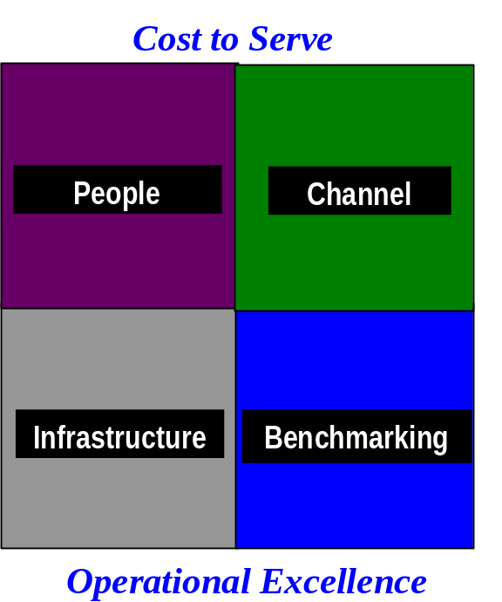

Strategy 1 - Infrastructure
The first strategy is Infrastructure development. This fundamental strategy is about ensuring that each and everyone in IGA Distribution Operations has the correct tools to carry out the duties to the best of their abilities This is about having the right equipment and infrastructure in place such as state of the art material handling equipment
to Warehouses designed and built for maximum efficiency.

Examples of the initatives to date include replacing the materials handling fleet with the most up to date equipment. Other initiatives include developing and building new facilities for IGA Distribution in Laverton. This state of the art complex houses three Warehouses each serving different sectors. Other facility upgrades are planned for all our other major centers over the next two years.

One of the most important projects to date has been the implementation of the latest version of the Warehouse Management Software – EXE. This enables the Warehouse to monitor the performance of the Warehouse down to each individual associate level. The Warehouse Management Software also manages the flow of the goods from arrival at the Warehouse, to put away and replenishment to picking, staging and dispatched out of the Warehouse. All nine IGA Warehouses are now on version 5.2 of EXE.

In summary, this strategy is about ensuring that our physical logistics network is capable of delivering the business strategy set by Metcash.

Strategy 2 - People
The second strategy is People management and is directed at people management skills. The Logistics focus in this area is not so much from a Human Resources perspective but more from a workplace efficiency / effectiveness view point.

Everything Metcash does can only be achieved through and with committed motivated teams of people. It is the role of Metcash Logistics to ensure that the work practices, systems, processes etc that are provided for Operations teams throughout the business are the best methods to achieve the outcomes required for its customers.

The Key elements of the strategy in this area to date are:
- Training and Development in the use of systems such as Voice directed picking.
- Managing and auditing the performance standards process. A key focus is to ensure consistent standard operating procedures across all Distribution Centres.
- Supporting a reward and recognition program such as the Warehouse Incentive System to ensure people are appropriately motivated by rewarding effort achieved above expectations.
- Constantly work to improve communication at all levels to ensure all personnel are informed on progress and what changes will be occurring in the future (logistically speaking).

Examples of the projects implemented to date include introducing the Warehouse Incentive program. This incentive program was designed to reward employees in Warehouses who consistently achieve better than required productivity as measured by EXE (Warehouse Management System). In addition, all IGAD warehouses have been independently audited to ensure the “standards” or performance requirements set in place are according to internationally accredited guidelines.

Strategy 3 – Channel Alignment
The “Channel” Quadrant of the logistics strategic plan is all about alignment. The goal here is to align all the elements of a particular supply chain, from suppliers to customers and extract maximum value for all stakeholders

The key of the Channel Strategy is that different customer groups have very diverse and distinct characteristics from order size to order frequency just to name a few. Therefore it is paramount that tailored Logistical solutions are made available to these customers ensuring they get the most cost efficient outcome.

Metcash strives to continuously explore ways of improving supply chain efficiency in all its customer groups and defining specific channel strategies for each of these groups to optimise the cost to delivery whilst achieving operational excellence.

Examples of the projects implemented to date include implementing the single item technology “Put to light”, implementing a Warehouse goods receiving technology called Radio Frequency Receiving and Voice Directed Picking. Voice Directed Picking in particular has been a huge success (see Results below) impacting significantly to the efficiency of the Warehouse Operations. Voice Directed Picking will be available in all major Warehouses by April '04.

Strategy 4 - Benchmarking
The “Benchmarking” aspect of the strategic plan is all about developing a process of “continual improvement” recognising that what is done today will not be good enough to compete tomorrow. Underlying this concept is being better than your competitors at what you do and aiming to be the leader in the market place.

Last year for example Metcash visited a major wholesale grocery operation in the USA with whom benchmark information was exchanged on many levels. Metcash has discovered through this exercise that on many dimensions it out performed the benchmark. It also discovered that from a Logistics perspective the US operation was about to implement many of the strategies Metcash had already installed. This confirmed that Metcash is headed in the right direction and that it has a competitive offer on a global basis.

In fact “Benchmarking” has helped crystallize some of Metcash’s strategic thinking. Many initiatives put in place were adopted from Wal Mart – the undoubted Logistics benchmark worldwide. Metcash followed their lead by introducing Voice Directed Picking and Put to Light technology. Metcash is now achieving the benefits that Wal Mart has achieved.

Confidential Section

Confidential Section

Confidential Section

Conclusions

The company’s commitment to become a leader in Supply Chain Management is unquestionable. It has budgeted to spend at least $3.5 million in Capital Expenditure for the Voice Directed Picking project alone this financial year in additional to many thousands of dollars budgeted for Operational expenditure to get the technological solutions in place.

Working With Suppliers

From a supplier perspective it is critical that Metcash demonstrate one of its core competencies in being an Efficient Supply Chain Partner with Suppliers

With this in mind, Metcash has initiated a number of supply chain initiatives with key suppliers, which enable significant costs to be removed from the supply chain.

Current Options in use:
- Ordering in manufacturers full pallets
- Reduction in number of weekly orders
- Preferential time slots
- Orders coming directly from manufacturing plant
- Full truck order policy
- Reduced demurrage

The focus of these supply chain programmes is to identify practices and methods, which can be streamlined with the resulting cost savings shared between the supplier and Metcash and thereby onwards via reduced cost to its customers.
Metcash Initiatives vs Chains Initiatives

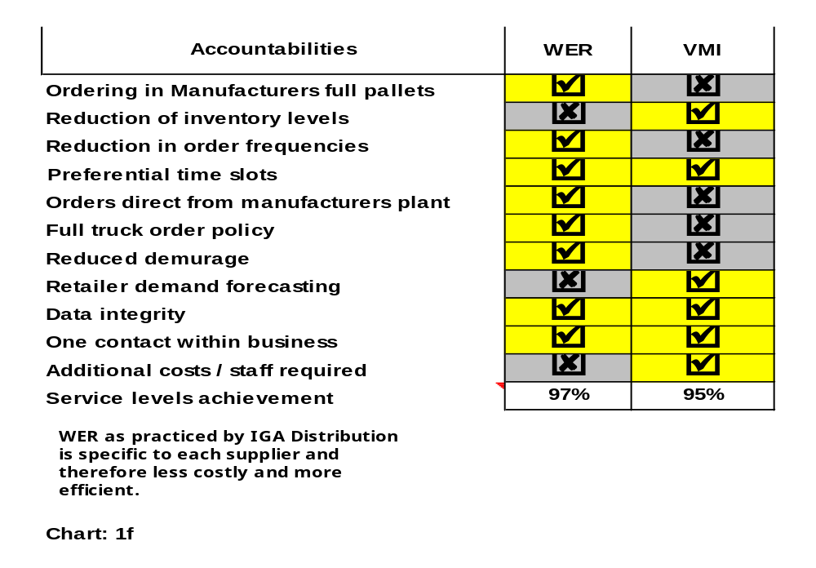

Metcash provide a better service level than the chains.

Note: WER = Warehouse Efficiency Rebate (Metcash)
VMI = Vendor Managed Inventory (Chains)

An example of one supplier on this programme is:

Colgate Palmolive Pty Ltd
- Order in full manufacturer pallet specifications
- Consolidate to full truck utilisation
- Order directly from manufacturing plant (within state)

Range Of Distribution Service

Metcash delivers smaller loads, more frequently, to more distant locations than Chains.

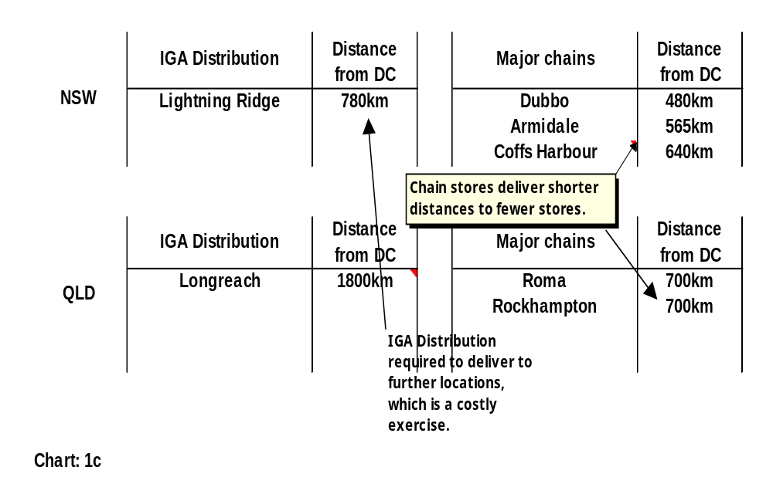

Metcash deliver to more distant locations than the chains

Further illustrative of the extreme geographic breadth of service that Metcash offer their customer base is the following state analyses for Victoria, NSW and Queensland.

Victoria
Nth West -Laverton to Mildura is 7 hours drive or 556klms.
Nth East -Laverton to Young is 8 hours drive or 620klms.
East -Laverton to Eden is 7 hours drive or 560klms.
West -Laverton to Mt Gambier is 6 hours drive or 501klms.
Laverton also deliver to Tasmania via sea freight.

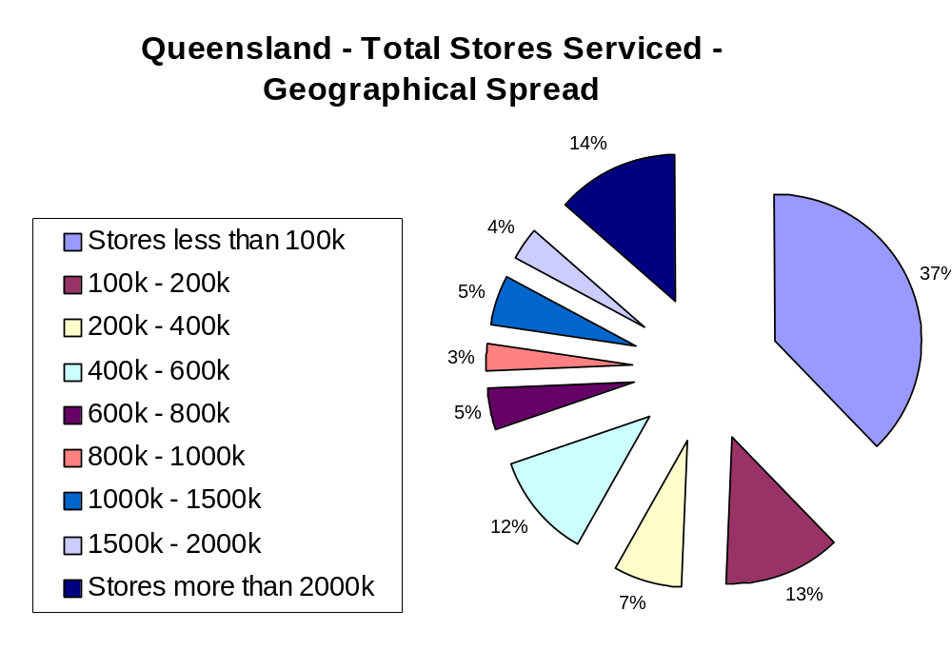
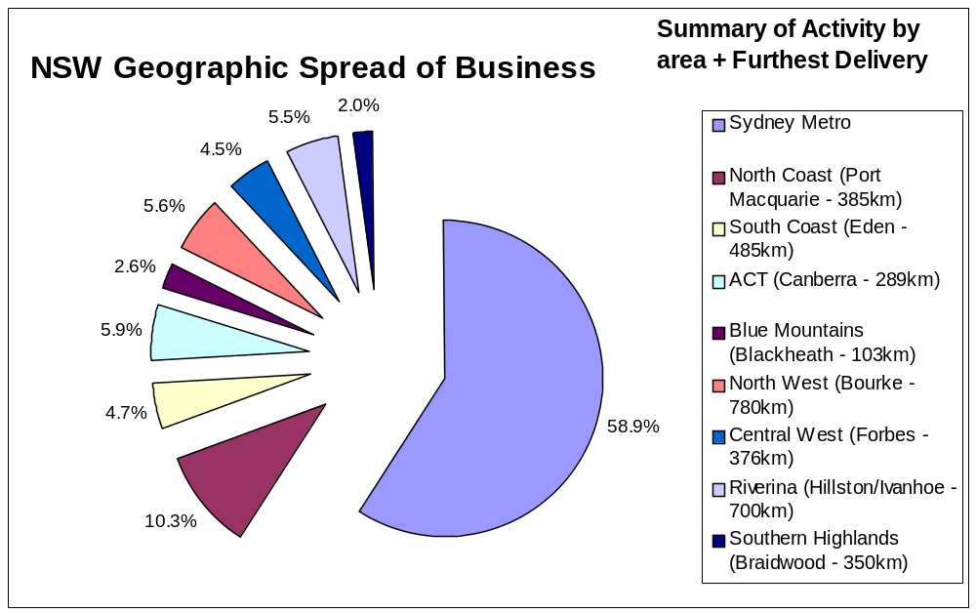

Frequency Of Distribution Service

Metcash deliver smaller loads more frequently than the Chains, as illustrated by the following analysis. This reinforces the cost efficiency with which it serves its Independent customer base, since previous analysis has shown that the Independent sector overall can be considered competitive with the Chains in EBIT terms. To be faced with a less economic distribution equation and yet still provide a cost effective solution to customers is testament to Metcash’s world class logistical efficiency.

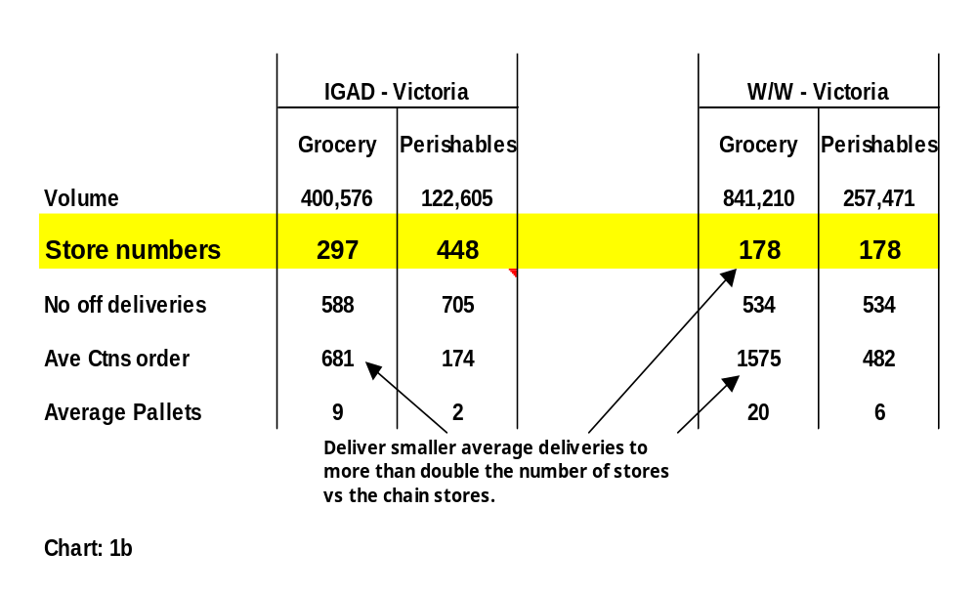

Service Levels

One of the most critical KPI’s by which customers judge the performance of the warehouse by (and thereby Metcash measures itself by) is Service Level. Simply put this seeks to measure the ability of the warehouse to satisfy an order by a customer. It effectively measures the ability of the warehouse to ensure it has purchased from suppliers what it has offered to customers as being available for delivery.

This aspect of the Davids business when Metcash first took over the business in 1998 was very poor (as evidenced by the red line in the graph below – plotted merely as a reference point). Since then this critical KPI has shown dramatic improvement as purchasing efficiency has improved, supplier relationships have flourished and communications with customers and their faith in the warehouse’s ability to adequately service their needs has improved.
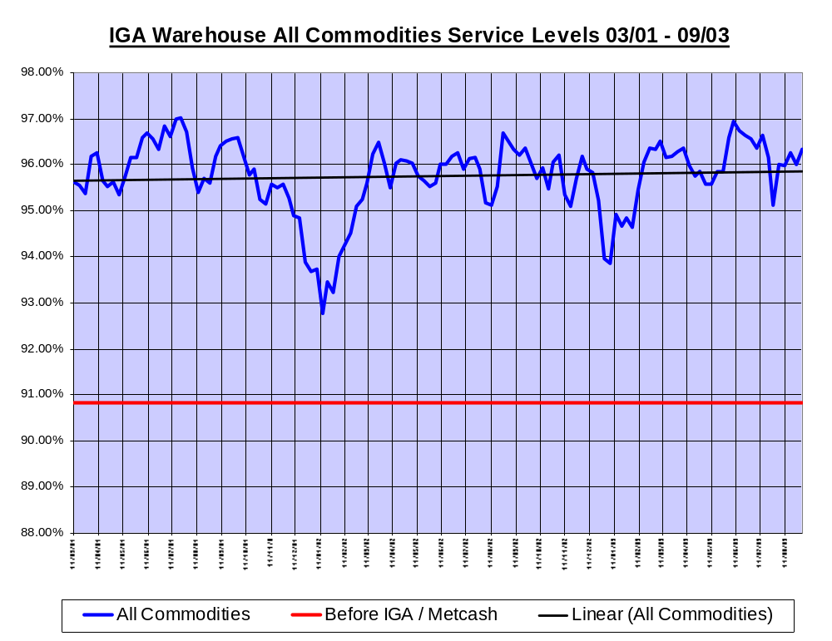
3.5 INDEPENDENT RETAILER TESTIMONIALS

Further demonstrating the interdependent relationship between Metcash and its Independent retail customers, the latter have provided the following testimony to form an integral part of this submission:




2nd September 2003

To Whom It May Concern,

Re: Senate Submission

I would like to provide a written submission, to be presented before The Senate, in regards to independent supermarket retailing.

I am the Chief Executive Officer of the largest licenced supermarket chain in Australia – Ritchies Stores Pty. Ltd. The independent supermarket sector, the basis of food and liquor retailing in Australia, is under siege. Unfortunately the multi national chain operators in Woolworth and Coles have been selectively picking off prime independent sites, particularly in Victoria and converting them to chain stores. This has the effect of weakening the market share and buying power of independents and further removes independent competition from the market place.

As the largest licenced supermarket retailer in Australia, we fear for our future, unless there is government intervention, regulating and capping the market share of multi national chains. It is unhealthy that in Australia, two players control more than 80% of the grocery market. Our strength is within the independent supermarket sector and we rely on fellow independent operators and our wholesaler IGA Distribution, to remain economically viable and committed to the industry long term. Whilst a number of retailers have opted to sell out, businesses such as ours have been more than willing to pay the monies the chain stores are offering, to acquire independent sites. Ritchies have acquired more than twenty other independent supermarket sites, across Victoria over the past six years.

In my opinion, a du-opoly does not promote competition. In fact, as Coles and Woolworths increase their market share, supermarket pricing rises and our gross profits over the past six years form testament to this. It is our policy to match Woolworth and Coles on key selling lines and in doing so, we have seen our gross profit margins increase, particularly at grocery level, during the past six years. As price fighting operations are wiped out – such as Jewel, Franklins and many other independents, then the chains are able to increase their profit margin and as we line price key items, we too have been able to increase our gross margins. Remove independents altogether and the profits the multi national chains make, will be far greater than current levels. Currently we have the chains talking of EBIT’s at 4% or greater. Without a strong and vibrant independent sector, this figure will soon rise to 5% and 6%. Surely this does not indicate a competitive market. Companies like Ritchies, whilst line pricing key items, also offer many other advantages to our customers and provide cheaper prices on a weekly basis, through aggressive specialling.
…/2

Whilst the relationship between IGA Distribution and Ritchies remain as two separate entities, the very nature of our business means that for both parties to prosper, a strong bond must exist. Our success is IGA Distribution’s success. Conversely, we rely on our wholesaler to purchase stock at competitive prices, to ensure our retail offer is in line with that of the chain stores.

To emphasise the strong relationship between IGA Distribution and Ritchies the retailer, can I make the following comments.

Wholesale Perspective

IGA Retailers, in conjunction with our wholesaler IGA Distribution have the ability to leverage aggregated volume to secure a competitive price based on purchases. IGA Distribution, on behalf of retailers, negotiate case deals and special negotiations with all suppliers, for the betterment of retailers. Furthermore, once these negotiations are completed, we are then provided with the distribution of goods through the IGA Distribution Warehouse.

Naturally buying and selling stock is integral to our retail business and it is important the IGA Distribution Warehouse has an extensive range of goods and provide us with service levels whereby all our orders are fulfilled accordingly.

As part of the commitment IGA Distribution make to IGA Retailers, it is imperative we are first to market with new lines and ranges. New products are the life blood of our business and we need to be able to source these products the moment they are available in the market place. Furthermore, an important part of our range is a generic and house brand offer. IGA Distribution provide this very competitive and quality range, through their Black & Gold and IGA branded products. Both these product categories have shown outstanding growth in recent years and with the advent of ALDI, it becomes more critical the range is further increased and becomes even more price competitive.

There are many other services provided by IGA Distribution. From a customer’s perspective, IGA supermarkets are seen as an alternate to Woolworth and Coles. Even though the IGA stores are independently owned, we are a “virtual chain” in the eyes of the public. Metcash, through IGA Distribution, provide assistance with retail operations at store level ie. store standards and assessments, help develop green field sites and refurbish existing businesses by providing buying power, advice and support with procurement of refrigeration, shelving and the like. Furthermore, we are provided with a general merchandise service through the R.M.S division. R.M.S take full responsibility for the ranging and presentation of general merchandise in most IGA stores across Australia. This is of valuable assistance in that general merchandise is a very specialised category and it is important we have knowledgeable and trained people working in our stores, on the retailer’s behalf.

…/3

Naturally in any retail business, marketing, advertising and building the brand is integral to the future development of the IGA logo. Assistance is provided by IGA Distribution in each of these aspects and collectively between the retail and IGA Distribution Team, competitive handbills, television and radio advertising is in the market place, fifty two weeks a year.

A positive initiative introduced by IGA Distribution during the past twelve months has been the Royal Rewards Program. Royal Rewards was an initiative provided by IGA Distribution for retailing compliance. Suppliers met with the IGA Distribution team and put forward a proposal where retailers would be financially rewarded for adhering to predetermined initiatives, decided between IGA Distribution and the appropriate supplier. This has proved very successful, with many large IGA supermarkets receiving $10,000 payments over the past twelve months for such compliance.

Furthermore, IGA Distribution provide financial assistance to the retailer, should a major project such as a green field site or a store development take place. This is very important to the retailer, as such upgrades are expensive and whilst money can be sourced from the bank, it also eases the burden on the retailer in having the wholesaler’s support.

Retailer Perspective

As Independent Retailers, our strength is that we provide our various market places with points of difference. We are not a chain, we stand for a different set of value criteria and have a single minded focus in providing our customers with “outstanding customer service.” This is not an emotional argument, but a well regarded fact within the industry. Chain stores operate to a set wage cost per hour, no matter how busy or quiet they are. This can mean customers waiting in long queues for lengthy periods of time. Independents pride themselves on serving customers quickly and this is a clear point of different between our philosophies. As Independents, we are about providing customers with helpful, personal and friendly service. In many instances, Independent supermarket customers are known on a first name basis.

Furthermore, it is nice to have a “feel good” aspect to our business, yet the reality remains that we must be price competitive. As mentioned earlier, IGA Distribution do an excellent job in negotiating with suppliers on our behalf, to ensure our day to day pricing and our weekly specials are more than competitive with that of the chains. In fact, it is accepted in the industry that promotional pricing through Independents supermarkets is cheaper than that of the chains.

One of the great strengths and improvements made by IGA retailers in recent years is our fresh food offer. Much time and emphasis, including extensive upgrades and refurbishment of equipment, have been implemented by IGA retailers to improve our produce, meat and deli offer. Rather than just carry a standard range, as the chain stores do, we tailor our offer to suit local community needs.
…/4
There is no doubt that Independent supermarkets excel with community support. IGA Distribution, through their Community Chest initiative and in conjunction with IGA retailers, have been able to donate near on $500,000 in Victoria alone, to the CFA and Starlight Foundation, in the past year. This Community Chest initiative exists in other states and similar amounts of money have also been donated to other organisations. Ritchies, through our own Community Benefit Card program, donate 1% of each cardholders shop, to that customer’s nominated club, school or charity. Currently we are donating in excess of $2 million per annum, to more than 3000 local clubs, schools and charities. To date, Ritchies have donated near on $10 million to these same organisations. This is outstanding community support and symbolic of IGA’s commitment to supporting our local community.

Not only does IGA support local clubs, schools and charities, we also are involved with global sponsorships, such as Athletics Australia. This has been a very successful initiative, whereby we sponsor potential Australian athletes.

IGA has a great mix of stores both through rural and metro Australia. In fact there are many small IGA supermarkets in rural communities, which are not serviced by a chain store. Chains will pick and choose their sites and will only go to locations where high dollar sales potentially exist. Independents however will service small communities, something which the chains are just not prepared to do. Furthermore there are many IGA supermarkets who can compete, “toe to toe,” with chain stores on price and range. These particular IGA stores are a clear alternative to the chains and proof that IGA Independents can compete head to head with chains, where required.

In most instances, IGA supermarkets are owner operated and can be generally classified as a small business. We are great employers of local people and we are the back bone of the Australian retail landscape.

Ritchies, as with the majority of Independents across Australia, are committed to providing our customers with a retail offer that is more than competitive with that of our chain competitors. We have significantly grown our business over the past five years and are committed to the future. However, to stop the creeping chain acquisitions, Independent supermarkets need support from the government to ensure our side of the industry remains strong and vibrant. The two chain stores currently have enormous market share and exert undue pressure on suppliers and other retailers. We need the government to stand up and say “enough is enough” and cap chain store market share!

A strong relationship exists between IGA retailers and our wholesaler IGA Distribution. For us to compete successfully against the chains, we need a team approach and this can only happen if there is co-ordination and co-operation between retailer and wholesaler. Our respective market share increases in recent years are testimony to our ability to compete at a national level and we welcome any available support from our Federal Politicians.
…/5
Should any further information be required, please do not hesitate to contact the undersigned.

Yours Faithfully,
RITCHIES STORES PTY LTD

FRED HARRISON
Chief Executive Officer



3rd September 2003

SENATE SUBMISSION – TESTIMONY

Roger King
Chairman IGA Supermarket Group - Victoria

The independent supermarkets, grocery stores and convenience general stores currently under threat from the market dominance of the Coles/Woolworths duopoly provide a complex and vital component to the communities they serve. They provide important social cohesiveness in the communities in which they operate and if they are to be obliterated by the two big chains, our urban and regional culture will be damaged beyond repair.

It is absolutely vital that any person assessing our industry understands that the chain domination of independents is not one of simply an offer the consumer has chosen: a dominant proportion of the chains’ growth has been due to the purchase of the stores of the many incredibly successful Independents.

We, the Independents, are not a chain – we band together to advertise and still enjoy greater store-by-store growth than the chains even though the chains out advertise us by many millions of dollars. Our true worth is that in the five and a half years of IGA in Victoria the consumer has selected to support our stores better than store-by-store chain growth. Why?

- we are part of their community
- we live in it
- we shop in it
- we use local trades people and services (the flow on effect of which should not be underestimated)
- we provide better, friendlier service (including C.O.D deliveries in many cases)
- we are the community in many remote areas
- all stores give huge amounts to local charities, sporting bodies, scouts, bowling clubs etc.
- as a group we raise and give hundreds of thousands to the CFA and The Starlight Foundation through our Community Chest program
- we own the store – so the vitality to serve each and every nuance of customer need is not only more “driven” in the Independents, but better delivered and “one on one”.

- It’s our Lead Specials the others react to and match the price
- It’s our Meat department that reflect the needs and culture of our community
- Despite the hype and logos our Fresh produce is delivered with care and skill and with 50% less waste of product. The shrinkage in the chain systems forces prices higher to the consumer.

On an individual basis my store contributes many thousands of dollars to our community. We sponsor $3000 plus time and effort to our local Carols by Candlelight; a similar amount to the Netball Teams; and every request from our community, no matter how trivial, is supported.

Whilst we are able to serve our community and match competition, this would not be possible if we did not have an arm to buy the goods in bulk and competitively from the manufacturer. We have chosen over the history of grocers in Victoria to support central buying warehouses as we have not the funds, expertise, nor can we remove focus from customers to be a supply chain. It has evolved that only one warehouse is left in Victoria, but it supplies the three bands of Independents who compete against each other and is well aware of chain cost buying to negotiate.

We are not a chain – but we can act as a chain. We are not dictated to in any manner by the warehouse, in fact the reverse is often the case. Our groups are run by elected committees of retailers who meet weekly to run the groups’ day-to-day affairs – especially it’s pricing. For Metcash to thrive it must sell us volumes of groceries and fresh goods so they offer up prices for us to select to group advertise. Metcash would cease to exist without us as we would without Metcash or its equivalent. Whilst we have a huge interdependence, we also have an adversarial relationship as we pressure them to serve us better. The relationship exists to maximize our mutual strengths. Metcash supply us 90% of items and in one delivery as any alternative would be absurd or impossible. Over the years many support warehouses developed a range of services that is now the norm, but they are offered on a competitive tender basis.

Without Metcash or its like we could not develop a group housebrandor generic, nor get ready access to equipment, advertising, design departments for upgrades, refurbishing and greenfield sites. There is a multitude of financial services and non trade negotiations, e.g. power contracts, EFT fees etc. We are in fact a virtual chain with all the components of a chain but we have the flexibility and commitment that only comes from small business and people who have their house, livelihood and (ability to loose the funds to support their children’s future where the need arises) firmly on the chopping block.

Customers assess our price offer as competitive and often better than the chains. The axe we constantly face is the economy, and government regulation, chain acquisitions of our bigger stores, bank charges and fees – but mostly the consumer who in our store becomes a true customer or even client. If the option of the Independent is lost to the customers of Australia our social fabric will change for the worse, we are often the biggest employer in our community but we will not survive without a reasonable percentage of the whole market. The more big stores that are bought the more little stores will be unsustainable and many small towns, and urban community shopping strips will die.

- Our Team are all locals and in most cases belong like part of the family. They are not promoted in then out of a community at the whim of a head office.

- Our Stores have backed Athletics Australia to support every Primary School child in every school to learn healthy active life patterns at an early age. This $2 million input is backed up by our people buying equipment and sending our Team (staff) to help run fun activity days and competitions.

- Our Investment in our stores in the past decade has been immense – this is another reason the chains buy our best my paying absurdly high prices so they don’t need to compete against us in the communities in which we serve – they know they would not win when an even playing field is offered.

- We are Convenient, Convivial and Community.

Please do not discount the vital role played by Independents in serving the community and keeping prices down.

Yours Sincerely,

Roger King
Chairman
IGA Supermarket Group - Victoria




Portland’s
M.Daly & Sons Since 1916

“KEVMILLE PTY LTD” ACN: 089 590 536 ABN: 57089590536 KOROIT ABN: 64789783361

Metcash – IGA Distribution

As an independent retailer that does compete head on with the two chains in the Australian market place being Coles Myer and Woolworths I cannot state emphatically enough the importance of our wholesaler and the relationship that we have with them. This is so important for us in order to compete on a level playing field with this duopoly that exists.

IGA Distribution has to, at all times combine our total volumes across all channels and banners to enable themselves to negotiate on our behalf, competitive base pricing of goods and services. This is only the launching pad if you like for them to then negotiate a promotional program from all suppliers that involves case deals that are equal to or better than the chains which allow us to advertise our “specials” on a weekly basis and to be very competitive.

One of the key areas that we rely on our wholesaler is the area of distribution. – No matter whether you are just down the road from the warehouse or on the border of two states our ability to trade and prosper relies on the stock being delivered in time, in good order and condition and at the right price. This is not unlike the relationship we have with our customers at store level.

We are retail outlets and not warehouses although sometimes I think some suppliers think we are. The warehouse is there to hold large quantities of stock that we are able to order on a regular basis. To do this successfully a warehouse has to maintain a certain service level and IGA are continually striving for world’s best practice in this area.

We need a strong communication process to initiate things like “New Lines” and it is crucial that suppliers allow us the same rights that the chains demand and that is to be “first to market” (at least at the same time as the chains). Our strengths continue to grow in the areas of generic and house branded products. There is now a national acceptance of our long established “Black & Gold” range which offers true value for money and our fast growing house brand of IGA products which offer our customers items which are equal to, if not superior the national branded lines. The national branded lines often have an inflated value attached to them to pay for things like marketing and advertising.

Metcash offer all IGA channels a variety of ancillary services that are crucial to our structure so that we can operate in the same way a chain operates. We have business managers who form part of the retail operations, a retail development arm that does store design, contracts, project management, equipment tenders etc. There is a non trade procurement department that addresses areas such as telephones, ATM’s, computers etc. The Westpac Data Caap alliance, which assists retailers in seeking finance, is another initiative that has help drive our independent sector.

IGA Distribution deliver marketing, advertising and branding facilities and opportunity’s for all IGA stores. Via this arrangement we have seen the IGA brand grow and develop to the point where we have something that has a definite value both to the retailer and to our customers. Our advertising and marketing continue to lead which intern assists in building the brand. Bolted onto this are the areas of merchandising that deliver value directly back to the retailer such as the “Royal Rewards Program” and incentive rebates for sales growth, corporate branding etc.

Over the last few years IGA have formed an alliance with a company called Daatacap and the Westpac bank to open up a two hundred million dollar facility for Independent supermarket operators. Daatacap do industry benchmarking and also prepare and submit applications on behalf of the retailer to Westpac bank. While all retailers will not have to access this type of facility to grow their business, the option is there for any retailer to meet a criteria and be eligible to borrow. Cash flow lending of this type has previously been limited to big listed companies and large organisations.

From a retail point of view we are not a chain operation because we operate on very different values than the chains. For instance we recognise that our incomes and that of all our employees comes from our local customers and so our support of community organisations, sporting and charitable institutions, sponsorships and support is concentrated on a local level. If we grow, our communities essentially grow with us, as do our employees. We pride ourselves on giving the same offer to all our customers without any form of discrimination.

Our motto is service and always has been – to be helpful and provide personal service where by our staff do know our customers and can react to their needs on a one to one basis. We want our staff to be able to make a decision that will assist our customers. It might be a product request or a hard to get line (often we stock lines to our own detriment to satisfy our customers requirements – it might be diet or lifestyle).

As far as price is concerned we can and do match it with the chains. Suppliers need us as competent competitors if they are to survive the negotiation strategies of the two chains. We are a relevant player and pour customers do vote with their feet. Otherwise how would we be getting the growth that we have shown on a like for like basis over the last few years. The independents do not BUY market share like the chains, so our growth is organic and it is real, and not manufactured. My customers tell me that price is not everything – Older customers love our carry to care service, young mums like our service because they know they will not have to wait in long queues at the checkout as all our staff can attend a cash register at any time.

If all independent IGA supermarkets collectively added up what they donate to the community on an annual basis it would be absolutely staggering and make the chains look like embarrassed and greedy. We never say “no” to all the local community groups, charities, sports clubs, schools, kinders etc. that we give donations of stock and cash on an almost daily basis. Our community chest program has been an outstanding success and the CFA and the Starlight foundation in Victoria have been the major benefactors receiving several hundred thousand dollars over the last few years.

We can, and always will support both rural and metropolitan communities. Our stores range from small, medium and large so that no region, town or city is excluded from what we do offer. This is one of the keys to our point of difference. The chains are not interested in small rural communities because they cannot make a buck there. They are not interested in medium size communities or in competing with one of their large chain counterparts who might have the majority of the market. One thing I have noticed recently though, is that they will go in and set up against an independent that is established in order to destroy that business. A case in point is Camperdown in Victoria where the demographics say clearly that there are not enough dollars in that town to support a large independent and a small independent (both already long established business’s). Someone will suffer and you can bet it won’t be the chain operator as their market share grows (they might even run that particular store at a loss and amortise that loss across their entire business thus having a minuscule impact in the overall scheme of things).
As independents we are usually all owner-operated stores and can make the decisions that assist our customers right there and then without waiting for a head office response.
Michael Daly
Chairman, Everyday Committee, Victoria


159 Henley Beach Road
Torrensville 5031
Telephone (08) 8234 2990
Facsimile (08) 8234 1915
31st August, 2003

The Secretary
Senate Economics Reference Committee
Room SG.64
Canberra A. C. T. 2600
Parliament House

Re Inquiry into effectiveness of the trade practices act 1974 in protecting small business.

Dear Sir,

I am concerned that section 46 of the trade act does not adequately deal with predator pricing and the abuse of market power by the large Corporations, mainly Coles Myer and Woolworth s.

As part of the SME's sector who run a family business in South Australia Adelaide and operate 32 supermarkets and employ 2800 staff I am continually targeted by Coles Myer and Woolworths selling products that are substantially under our purchase price.

Our store at Golden Grove Village which has a Woolworth's supermarket on one side and a Big W on the other is visited on a daily basis by staff from Woolworths checking our prices and then going back to their store and undercutting them.

Big W will have large displays of products and compare our price but will not put the comparison against their trading partner Woolworths supermarket surely if they are comparing other supermarkets they should also compare against their own company supermarket.

I have written many letters to the ACCC complaining about their market power but only to be told that is competition.

In some of the price checks that we have conducted there is no doubt that Coles Myer and Woolworths are at least 3% higher when there is no third competitor in the area as can be confirmed by Adelaide's prices and that of the south eastern Queensland district.

South Australia continually does well in the price surveys and I believe this is because the presence of good strong independent retailers.

Both Coles Myer and Woolworths have tried to purchase our company (cheque book acquisition) but we believe there needs to be a third player to keep the bastards honest.

Competition is great for the country and the community but it is important to make sure that the two big players Woolworths and Coles Myers are not allowed to continue their unhealthy market dominance before we don't have any competition left.

Major chain dominance is against the public interest because if it is allowed to continue unchecked it will erode and eventually destroy the critical mass necessary to maintain a viable independent grocery sector. If this is allowed to happen, consumers will lose their fundamental right to choose where to shop.

In addition, those consumers, who are for reasons of location or mobility already limited in choice, will lose their accessibility to basic goods and services.

Without the independents to keep the big chains honest, the consumer will end up paying higher prices.

Most independent supermarket operators are very much a part of the community they offer a point of difference compared to the major chains and have been a backbone of the Australian community.

Independent operators can only sustain so much unfair competition and I can assure you once that operator has either closed or sold their business to the major chains they will increase their prices and the consumer will pay more for their groceries.

I support the submission and recommendations being put forward by NARGA.

Yours faithfully

DRAKE FOODMARKETS
Roger Drake, Managing Director

Senate Submission

From:
Michael Whitehead
IGA North Sydney
Greenwood Plaza
North Sydney
Tel: 02 9957 6978

My concerns on small business versus large business are:

1. LEASES - WHAT HAPPENS WHEN A “MAJOR” COMES TO TOWN?
2. PREDATORY PRICING

- Leases

Example: The current tenant (small business) has been a good tenant for the term of the lease, but if a Major were to talk to the landlord regarding taking over the lease when the current lease expires, there would be little doubt that the landlord would look at this in favour of the Major. In my view, if the Major wins the debate on who gets the new lease it should pay the small business compensation for the loss of his business.
In a small country town where there has been an Independent Supermarket forever, and a Major, e.g. Bi LO comes to town and either puts the Independent out of business, or severely affects his business, in my view, the Independent should be compensated. In small towns, you can see the devastating effects where a Major has come to town. A lot of small businesses have closed down. The Major affects the supermarket, the fruit shop, the butcher shop, and now it is affecting the petrol station in the area. They will soon be affecting the pharmacy in the towns and suburbs. I just wonder what percentage of the disposable dollar is the Government going to let the two major retailers have?
- Predatory Pricing
There is little doubt that this practice is carried out by the major retailers. The TV Current Affairs program has done a number of programs on this, but the Government still lets this practice carry on.

Senate Submission

From:
Mel Luke
IGA Coolum
Chairman Queensland State Board

TO WHOM IT MAY CONCERN:

My family and I have been retailing in Coolum Beach, Queensland for the past 18 years.

Our business has been under threat from the chains for the past 7 years coming in and wiping us out. If it wasn’t for the support of the residents of Coolum who have been very outspoken about our business’ survival we would not still be in business.

We are an owner-operated supermarket and we enjoy a very strong relationship with all the major community groups. We are extremely competitive and this is reflected in the support we get from the local residents.

We are able to give back to the town a percentage of our sales and this is done at the end of each year.

Our customers appreciate the employment we create for over 120 local staff.

My wife and I are passionate about our roles in the community by: -
- Employing over 120 staff with 40 school based traineeships from the local
schools.
- Patron of the Senior Citizens Association.
- Member of the management committee of the Coolum Beach Progress &
Ratepayers Association.
- Member of the Rotary Club of Coolum.
- Member of the Coolum Chamber of Commerce.
- Member of the management committee of the Coolum Cliffs Boardwalk Inc.
(A boardwalk that was built along the cliff face of Coolum).

At the Australia Day Celebrations in 2002 Gill and I were honoured with the Citizens of the Year Award.

This is the point of difference between independent operators to the chains; we are able to put so much more back into our communities in many different ways.

CONCLUSION:

We need our wholesaler, Metcash Trading Ltd., to have access to the same trading terms as our major competitors, Coles and Woolworths. It is only with this assistance can we continue to be a major employer in our communities.

Coles & Woolworths, by their dominance in the market, are having an unacceptable monopoly on the grocery industry, pharmacies, liquor and are aggressively taking over fuel.

Mel Luke

IGA Coolum
Chairman Queensland State Board
4. Marketing/ Branding sUCCESS

Background
Metcash has performed strongly over the past three years in market share improvement resulting primarily from the successful marketing of the IGA Group and the acquisition of additional customers via the Franklins sell down and the demise of AIW.

The success of the IGA-specific market share growth is also attributable to a stronger promotional and marketing support programme provided by suppliers as they have gained confidence, achieved sales growth, and experienced an improved market prominence and stronger compliance and commitment to their promotional and marketing funds.

Suppliers invest resources and marketing funds relative to sales growth and overall share.

These funds are highly discretionary and take the following forms:

- Merchandising and Field Support
- Promotional case deals to discount selling prices
- Bonus pack products
- Exclusive IGA promotions and free giveaways
- Preferential support funds on new products
- Subsidised press advertising
- Exclusive product developments
- Trade show funds
- Point of sale advertising and display materials
- Retailers own label magazine advertising funds
- Additional funds to increase the frequency of promotions
- Sales incentive programmes

Metcash has achieved increasing levels of support in all of the various forms of additional supplier expenditure as it has achieved sales and market share growth.

It is our view that suppliers have moved Metcash from the “Disinvest” area (sales and market share declining) to the “Increase Investment” area (sales and market share increasing).

4.1 Market Share

Much has already been said of the various reasons for the significant improvement in Metcash’s market share performance in the sections above. Some additional insight is provided in this section.

… At the Macro Level
The Metcash National market share has increased 38% since December 2000, from 11.8% to a June 2003 quarter share of 16.3%. (Refer back to Section 2.2 for comparative National Market Shares.

It is interesting to note though, before moving on, that Retail World recently published the AC Nielsen Grocery Report for 2003. This showed Woolworths national market share as 35.5% compared to 41.4% the year before. It defies belief to suggest that Woolworths’ market share has actually dropped year on year. In fact the lower share reported, results from AC Nielsen using a different methodology (‘Homescan’ rather than ‘ScanTrac’) to come up with the market share measures. There is little doubt that the lower percentage is more palatable to Woolworths. On the basis that the prior year figure did not include a full year of the Franklins-acquired stores, a market share moving steadfastly towards 50% becomes an increasingly ‘hotter potato’ to juggle.

Branding Success as a Key Driver
A significant part of this improvement was as a result of the rationalisation and amalgamation of 29 different Independent banner groups, which were rebranded under the one banner of IGA. The relaunch of these stores under this brand and the ongoing marketing programme employed to support, merchandise and develop them has provided the impetus for the growth.

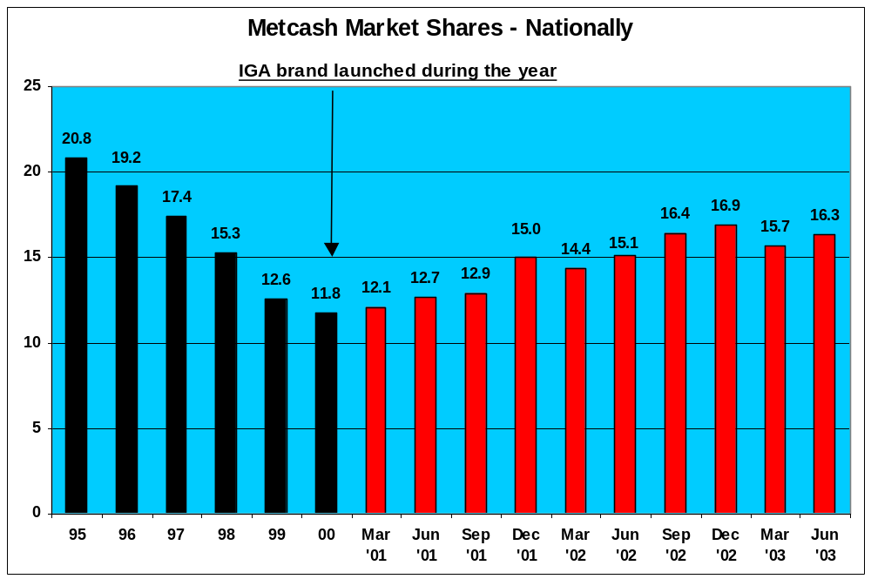
IGA Stores are now aligned to 3 separate market positions or channels under the IGA branded umbrella reflecting their differing size, range and offer. In order to differentiate between the markets it is necessary to have a channel ‘logo’ or name to best communicate to customers the different offer available in each of these channels:

- IGA Supermarkets – full offer, extended range supermarkets, compete fully with Chains
- IGA Everyday – community based, medium range stores
- IGA Friendly Grocer / X-press – community based small supermarkets providing a selected range

This strategy has been a key factor in the market share turnaround since 2000 as IGA creates a united front that can:

- Build a common name that grows the value of the business through brand recognition and associated goodwill growth.
- Be used as a national platform to negotiate from.
- Maximise advertising effectiveness.
- Facilitate promotional compliance.
- Provide consumers with a friendly, local, convenient shopping experience.
- Attract greater supplier benefits and promotional support.

… And at the Micro Level (Capital Investment as a Driver of Market Share and Category Performance)

In June 2002, Metcash opened a state of the art Perishable Distribution Centre and Warehouse in Laverton Victoria. This $11 million investment has enabled Metcash to expand range and promotional programmes for Independent Retailers in Victoria.

A substantial increase in sales and market share in Dairy products and Frozen Foods has resulted, as Retailers have refurbished their supermarkets and expanded their consumer offer in these categories. The key aspect to note from the diagrams shown below (for Dairy, Cheese and Margarine categories) is not only the nominal Metcash increase in trend sales (the black line), but also the relevant performance versus the market over the period (the purple columns versus the blue columns).



