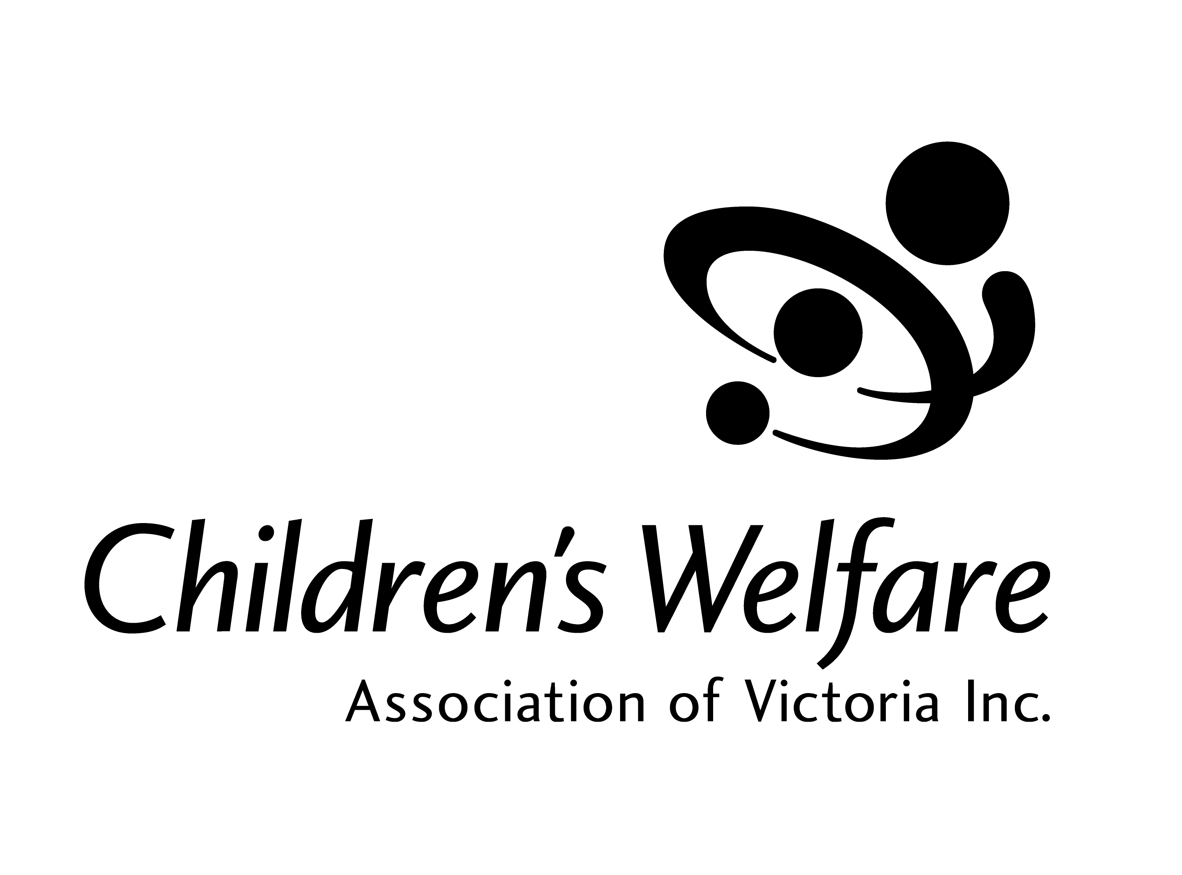
Centre for Excellence for Child and Family Welfare
Level 5, 50 Market Street, Melbourne, Victoria 3000
Tel: (03) 96141577; Fax (03) 96141774
Email: admin@cwav.asn.au

Submission to the Senate Community Affairs References Committee Inquiry into
Children in Institutional Care
July 2003

1 About CWAV
The Children’s Welfare Association of Victoria (CWAV) is the voice of the child welfare and family support sector. We provide information and liaise with media, Government Departments and the community to ensure children, young people and families have access to appropriate services as and when they are needed. CWAV represents 81 community-based organisations that deliver a diverse range of services for children, young people and families. CWAV membership covers small, medium and large organisations spread across the State of Victoria in metropolitan and country areas.
The services our members provide are varied. They include residential care, family support, counselling, parenting support, day programs, alternative education, financial counselling, foster care, respite care, support for families with children with a disability, unemployment services, drug and alcohol counselling, sexual abuse counselling, women’s refuges, domestic violence services, supported accommodation, youth support services, school support and assistance for families in crisis. CWAV also has a small body of associate members and life members who are supportive organisations and individuals not involved in direct service delivery.

2 Background to this submission
CWAV’s submission has focused on current issues with the child protection system in Victoria and practices observed in the system that are considered improper and unsafe for children and young people under the care of the State. Many of the issues discussed in this paper are, in CWAV’s view, likely to have a longer term impact on the children and young people who pass through the child protection system and on their ability to lead normal lives as adult citizens of this country. This submission has drawn together facts about the system in Victoria gained from research in this field and feedback from the CWAV membership.

CWAV’s response to the inquiry
Over the last decade, societies worldwide have come face to face with some of the most horrendous abuse perpetrated on children and young people by the adults who were charged with their care. Starting with the 1984 allegations of sexual misconduct by a Roman Catholic priest in the US to the unearthing of a massive breakdown in societal protection and institutional response in Canada and Scotland (“Unholy Orders” movie by Geraldine Gandolfo and Catherine Dyson), we are witnessing a groundswell of evidence of institutional abuse of children and young people.

The 1999 Queensland Commission of Inquiry into Abuse of Children (the Forde Inquiry) is perhaps the first official inquiry in Australia into allegations of abuse of children in institutional care. The inquiry found that until the early 1960s there was very little understanding of the emotional needs of children and even less, of the impact of harsh emotional and physical treatment on children’s later lives. The inquiry concluded that the history of institutional care in Queensland up until the 1980s has been one of sacrificing children’s interests to expedience. Children were being cared for by over-extended, unskilled workers in environments lacking in love and support and has deprived many of educational opportunities and adequate life skills; and it has allowed conditions to flourish that led at times to the most brutal abuse and neglect. Similar allegations of abuse against children in institutional care have been documented in other states in Australia in recent times.

From its origins in the nineteenth century in the orphanages and children’s homes run by religious and voluntary groups, the care system in Victoria has come a long way. As with other systems, along the way the care system has also undergone radical transition reflecting the changes in societal views regarding the nurture and care of our most vulnerable children. In more recent history, the system has seen a shift in responsibility for investigating suspected abuse from the police to the State Government Department for Community Services (now Human Services). Major reviews of the system, including the review by Justice Fogarty, have also seen reforms to the system and the introduction of the Children and Young Person’s Act in 1989.

The introduction of mandatory reporting of suspected child abuse in 1993 is another milestone which aims to strengthen the community’s responsibility in the role of protecting children. The shift from the institutional model of providing care for children, to providing care in a community based setting either in foster homes or in residential units are all aimed at ensuring transparency and accountability in the provision of care and protection to children who are wards of the State. The shift in the focus of out-of-home care from an institutional model to a community-based model is evident from the AIHW figures for 2001-2002 which shows that of approximately 4,000 children who are in care in Victoria, 84% are in home-based care (foster care and kinship care) and 11% are in residential care.

However, the crucial question is whether these changes to the child protection system are less abusive to the many children and young people who go through the system every year? The answer to this question lies in our understanding of what constitutes abuse. The Forde Report states (Forde: 11) that social and cultural attitudes play a major role in defining what is abusive. Various forms of abuse such as emotional abuse, sexual abuse, physical abuse, neglect and systems abuse are identified in that report.

It would be fair to say that sexual, physical and emotional abuse as they are documented in the context of institutional abuse may not exist in the current system which has a strong focus on the well-being and rights of the child as the paramount consideration. However, in CWAV’s experience, systems abuse is evident in the current environment. Cashmore et al (1994) define systems abuse as preventable harm done to children in the context of policies or programs which are designed to provide care or protection. Such abuse may result from what individuals do or fail to do or from the lack of suitable policies, practices or procedures within systems or institutions. In its simplest but probably least recognised form, systems abuse may occur when a child’s needs are simply not considered; they are effectively invisible.

A look at the current system of child protection will confirm the view that a lot of harm is done to children and young people due to lack of suitable policies and procedures that will ensure that the developmental needs of children are met. Children enter the care system in Victoria at various ages. However, documented evidence suggests that the care experience can be less than ideal for young people. For example, the median number of placements for children in out-of-home care in Victoria is five. The Department of Human Services audit also confirms that high levels of placement changes were experienced by some children in their sample group. Five placements were the median of the current period of involvement (median 30 months). Stability in care has been identified as a critical factor that determines long-term outcomes for children in care. A NSW study into leaving care has identified that overall outcomes for children who had spent at least 75 per cent of their time in care in one long-term placement were better than those who had not. Some of the significant achievements of children with stability in care, identified by the study, were that they completed at least Year-10 at school and were able to 'make ends meet' after leaving care.
A recent study by the Uniting Care Connections, Victoria , highlights the negative impacts of instability in care. The study found that children who had moved many times during their placement in out-of-home care suffered from the following:
- Relationship trauma with long-term issues in relation to personality development
- Mental illness, suicidal tendencies, depression, persistent self-harming behaviour and substance abuse
- Attachment disorder
- Poor concentration resulting from lack of motivation to concentrate, rather than from ADHD.

Lack of stability in care can be directly attributed to the mismatch between the child and the placement. CWAV's recent research into occupational assaults and trauma in residential care facilities for children in Victoria found that in a vast majority of cases, placements were being made without a proper assessment of the child's needs and an informed decision about whether the placement would be appropriate for the child who is being placed and for children already residing in the residential unit. The placement system is so attuned to responding to crisis that finding a safe place and a bed for the children takes priority over every other consideration. This constant state of crisis in the care system is a barrier to the physical, emotional and mental development and wellbeing of children in care.
This shows that there is a need for a shift in policy from crisis response towards early identification of 'at risk' children and implement programs that work with the children's families to ensure their safety and well being. For the children that need to be removed from their families despite best efforts, this process will ensure that the removal is done on an informed basis with sufficient background information regarding the child's needs. There needs to be a robust assessment processes at the intake stage, aimed at placing children appropriately in an environment that will fulfil their developmental needs. The Sector has to be supported by the Government to develop the capacity for such placements to be made.

The role of education in the development of children and in determining their life outcomes cannot be understated. While there are debates around what constitutes education, there is no denying that labour market expectations around formal education have undergone a transformation in the last few decades. However, for many children in care, particularly adolescents, education is a major concern.

A 2001 audit by the Victorian Department of Human Services into children and young people in out-of-home care shows that 89% of school aged children and young people within the sample were enrolled in school. However, only half of these children were assessed as having educational attainment levels appropriate to their age. 29% had a history of school suspensions. A CWAV study into young people leaving care shows that pre-care and in-care experiences contribute to a lack of educational attainment for young people leaving care. According the study, young people entering the care system have often had traumatic and stressful experiences that have a direct impact on their education. All too often, the care experience will compound and continue this educational disruption rather than compensate for it. Frequent moves in placement, the low priority sometimes given to education, along with low expectations have a direct impact on both attendance at school and educational attainment.

CWAV's leaving care study shows that only 10 to 15% of young people leaving care complete high school compared to an estimated national rate of retention to year 12 of 80% for young people in the general community. Without educational qualifications or trade skills young people are at a distinct disadvantage in finding employment and the disadvantage cycle is perpetuated through future generations.

It is crucial for Governments to invest in specialist resources in mainstream schools to ensure that children from disadvantaged and troubled families are adequately supported to assist with their effective participation in the education system. The more the government is able to ensure these children stay within mainstream schools the better the opportunities for these children to engage with the community they live in.

The consequences of the lack of appropriate development of children in care are witnessed at the downstream end when children leave care at 18 years of age (or prior). CWAV's research into leaving care shows that young people leaving care:
- Have inadequate preparation for and assistance with independent living
- Leave care with very low levels of education and experience high rates of unemployment
- Have inadequate income and face difficulties with money management
- Are more likely to become parents at a young age; and
- Face high levels of homelessness
Social exclusion, isolation, low self esteem, poverty, lack of basic life skills and education, homelessness and unemployment are significant issues for children who leave care. The disadvantage cycle is thus perpetuated.

Why is the system in such a state? In the last two decades, the child protection service delivery system has undergone significant changes, the principal among which has been the drive for fiscal austerity. A focus on economic bottom line has resulted in a reactive system that focuses on the demand and supply of services in the short term without any emphasis on cohesive long-term planning for services and investment in research and evaluation of the effectiveness of current services. Under this model, community service organisations that provide service to children are not fully-funded resulting in a situation where they are utilising their own resources to subsidise services. Investment by Government in child protection is drip-fed from budget to budget, failing to achieve any significant impact on the system or the young people. The unintended consequence of these policies and measures is that children in care have very poor care experiences and tend to miss out on opportunities to maximise their development, particularly during critical growth periods.

These are the very same issues identified by the Forde Inquiry in Queensland into the institutional abuse of children. The inquiry found that the cost rather than the quality of care was often the prevailing criterion in determining how children should be housed and managed. In turn, that unwillingness to spend money in funding care provision has resulted in children being kept in conditions that were at best spartan and at worst squalid. While the lack of adequate funding has not led to the type of abuse in institutional care settings we have come to know, it is CWAV’s view that the system in its current form is not preparing children and young people for life beyond the care setting.

CWAV also considers it important for this inquiry to look at issues relating to recruitment and pre-employment checks of staff who work very closely with children and young people. CWAV’s position is that it is essential for such pre-employment checks to adopt a holistic approach and look beyond a mere police clearance, if they are to succeed in protecting our vulnerable children from potential harm. Whether such a system can be devised and if so what form it should take is a crucial issue that needs to be debated jointly by government and the sector.
CWAV would also like to highlight some of the work undertaken by the Victorian Department of Human Services in recent times aimed at making the system more transparent and focussed on the wellbeing of children and young people in care. Some examples are:
- The introduction of minimum standards for residential care services which came into effect in July 2002.
- The Looking After Children initiative designed to provide community service organisations with a common framework for their client records systems which contains all of the information they require to look after a child or young person in the care of their organisation.
- Development of a state-wide protocol to deal with allegations of physical and sexual abuse against carers in home-based-care services (currently in draft form).
- The pilot Innovations Projects aimed at strengthening family services to families with children at risk of abuse.
CWAV commends these crucial initiatives as a step in the right direction. However, it is important for government to ensure that these initiatives gain in momentum and do not just stop with being show-case projects if we are serious about our aim to eradicate abuse of all forms from the child protection system and provide a caring and nurturing environment for vulnerable children.

CWAV also commends the work of the Care Leavers of Australia Network (CLAN) for their initiatives in supporting older care leavers and to acknowledge the support provided by the Victorian and New South Wales Government to further their work in this important area. Finally, CWAV would like to thank the Senate Community Affairs References Committee for the opportunity to present this submission.

For further information, please contact Coleen Clare, Chief Executive Officer on (03) 9614 1577 or at coleen.clare@cwav.asn.au

Chapter 5: Orphanages and other residential institutions – 1930-1980, p 107
Carter, J., 2002, … towards better foster care.. reducing the risks
DHS, 2001, The Audit of Children and Young People in Home Based Care Services, p2
Cashmore J. and Paxman M., 1996, Wards Leaving Care: A Longitudinal Study, Executive Summary ii
Uniting Care Connections, 2003, Getting off the Roundabout: Troubled Children moving through the care system, p 20
DHS, 2001, An audit of children and young people in home-based care services, p3
Sue Green & Amanda Jones, 1999, Improving outcomes for young people leaving care in Victoria, p16

